Application to Obtain Vote-by-Mail Ballot Request Information

1. Per section 101.62, F.S., only the following persons and entities listed in law are entitled to access files pertaining to voters who have requested vote-by-mail ballots in the event of an election.
- a canvassing board
- a political party or official thereof
- a candidate who has filed qualification papers and is opposed in an upcoming election
- registered political committees

2. Account: To access these files online, an online account must first be created. Visit: https://countyballotfiles.floridados.gov/Account/Register to establish an account.

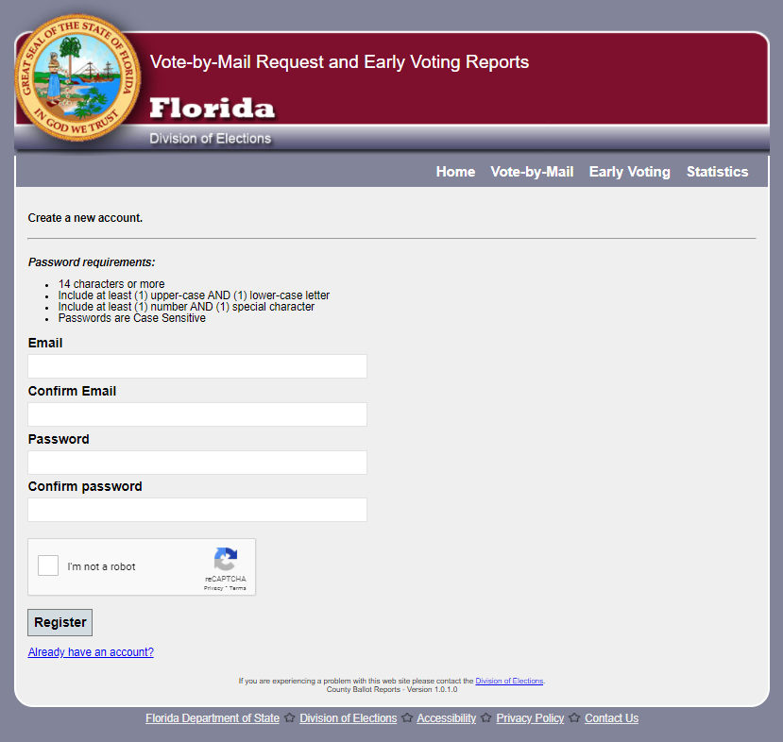

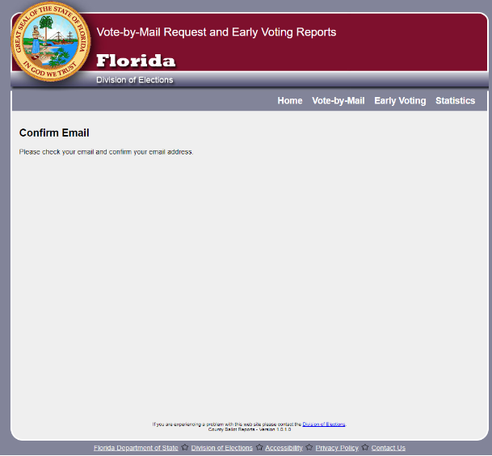
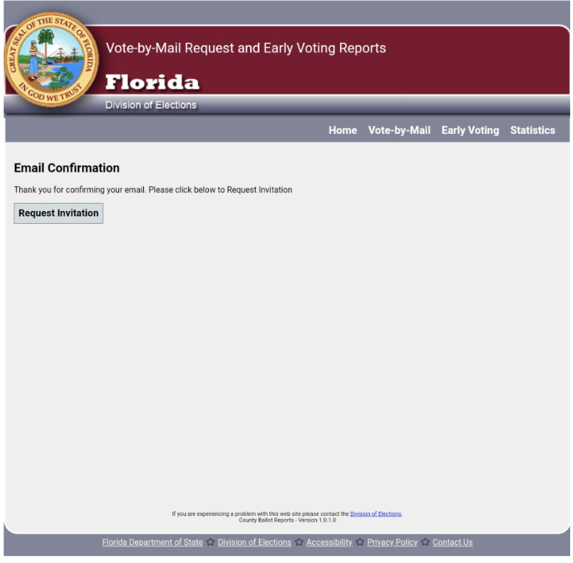

2. Online Application: Once the email is confirmed and online account created, the applicant must complete an online application:

