Florida Department of Education Form FCAPE-02,
Florida Career and Professional Education Act Career-Themed Course Registration Form
Rule 6A-6.0576, F.A.C.

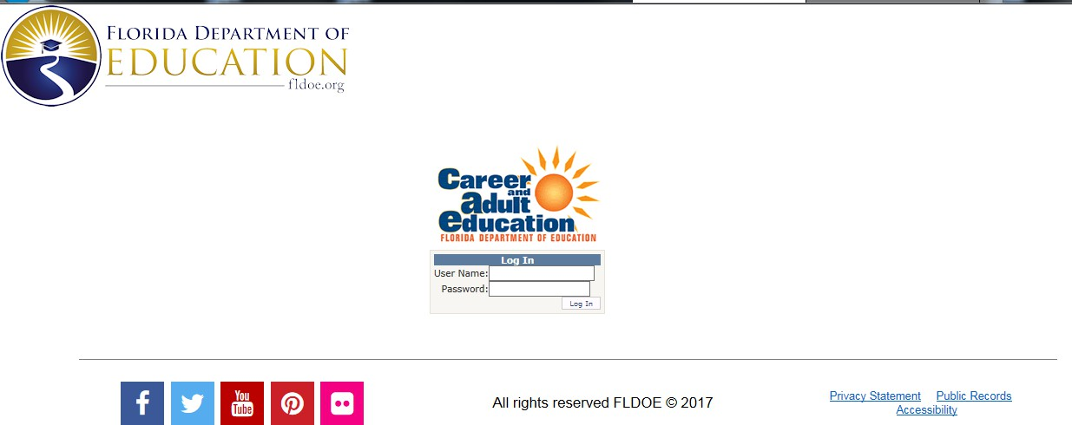


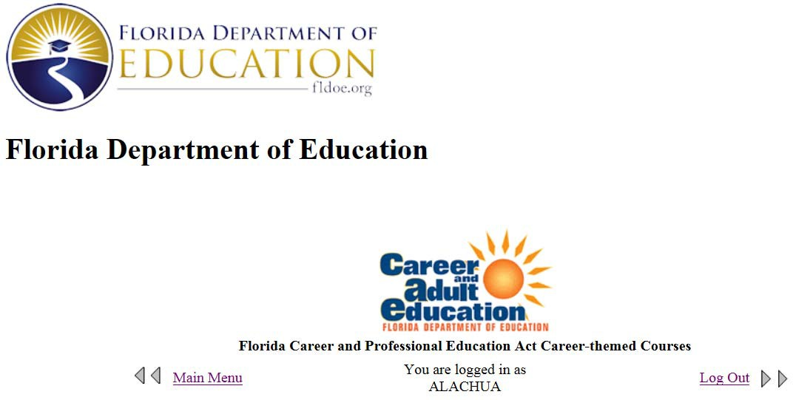

Main Menu
Welcome to the main registration page for the Career and Professional Education (CAPE) Career-themed Courses. This system is only for the registration of Career-themed Courses. All Career-themed courses must be registered each year. Courses may be registered individually or by submitting a batch file. Registration of career-themed courses through which students earn CAPE Industry Certifications and CAPE Acceleration Industry Certifications is required for funding in the FEFP.
IMPORTANT: Districts are responsible for reviewing the Department’s Non-Aligned List and applicable Department-approved linkage resources prior to submitting Career-themed Course registrations. Career-themed Courses should only be registered with certification-to-program linkages that meet Department requirements.

Districts are allowed to register both Secondary courses and Dual Enrollment courses. Dual Enrollment
courses must be registered separately. See headings below to locate these sections.

Within both Secondary and Dual Enrollment, two methods are provided for registration:

Batch Upload Registration
Use this method to upload multiple Career-themed courses from multiple schools. See Section I for instructions.

Individual Course Registration
Use this method to register courses one-at-a-time. See Section II for instructions.

Secondary Courses

Section I: Batch Upload Registration

Instructions

To access a list of courses eligible for registration see the following link:

Districts are responsible for maintaining documentation that demonstrates alignment for each course-to-certification combination registered as a CTC.

Academic course-to-certification alignments require Department approval on a one-to-one basis. Approval of a course alignment to one certification does not authorize alignment to additional certifications.

Course-to-certification alignments identified on the Non-Aligned List may not be registered as Career-themed Courses. Districts are responsible for reviewing the Non-Aligned List prior to submitting registrations.

Prior to registering CTCs, districts should review the CAPE CTC Resources webpage at the following link: https://www.fldoe.org/academics/career-adult-edu/cape-secondary/cape-ctc-resources.stml to identify eligible course-to-certification alignments.

The following file format must be used to submit a batch upload. The system will reject all files that do not meet these specifications. Visual Guide Instructions Batch Upload Template

To submit a file, please use the link below.

File Upload

Records with invalid District ID, School ID, Course Number, and Certification Code will be rejected. Duplicate records that match a currently registered District ID/ School ID/ Course Number/Cert code will also be rejected. After each batch upload, you should access the summary and rejected records reports provided below under the “Reports – Secondary Courses” heading.

Section II: Individual Course Registration

Instructions
Use the matrix below to activate Available Schools for a new Career-themed Course registration.

- Select the Folder icon () to activate the school. Once selected, the school should appear under the “Schools” heading below. You may need to refresh your browser.
- If a school has at least one registered course, you will see this icon: (). Skip to the “Schools” heading to register additional courses.

Available Schools
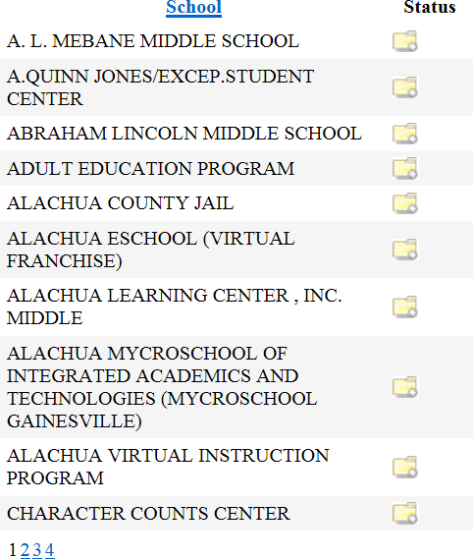

Schools

- Select the edit icon () to edit an existing career-themed course or to add a new career-themed course.
- If a school does not appear in the “Schools” table and records were submitted using the “Batch” upload process in Section I, please check the “Rejected Records Report” under the “Reports” header below to see if the submitted records were rejected.

Reports – Secondary Courses

Career-Themed Course Status Report – Secondary Courses
This report shows all courses submitted in Step One or certified in Step Two. It will include all courses submitted through “Batch Upload Registration” or “Individual Course Registration” methods.
Career-Themed Course Status Report - Secondary

Validation Reports – Secondary Courses
These reports include courses which have been registered through the batch upload process and do not include any courses that have been registered individually.
Batch Upload Submission Report - Secondary Rejected Records Report - Secondary

Dual Enrollment Courses

Section I: Batch Upload Registration - Dual Enrollment

Instructions
Districts are responsible for maintaining documentation that demonstrates alignment for each course-to-certification combination registered as a CTC.

Dual Enrollment course-to-certification alignments require Department approval on a one-to-one basis. Approval of a course alignment to one certification does not authorize alignment to additional certifications.

Course-to-certification alignments identified on the Non-Aligned List may not be registered as Career-themed Courses. Districts are responsible for reviewing the Non-Aligned List prior to submitting registrations.

Prior to registering CTCs, districts should review the CAPE CTC Resources webpage at the following link: https://www.fldoe.org/academics/career-adult-edu/cape-secondary/cape-ctc-resources.stml to identify eligible course-to-certification alignments.

The following file format must be used to submit a batch upload. The system will reject all files that do not meet these specifications. Visual Guide Instructions Batch Upload Dual Enrollment Template

To submit a file, please use the link below.

File Upload

Records with invalid District ID, School ID, Course Number, and Certification Code will be rejected. Duplicate records that match a currently registered District ID/ School ID/ Course Number/Cert code will also be rejected. There is no requirement for nonpublic postsecondary institutions to use the Statewide Course Numbering System. Therefore, Course Number will not be rejected for nonpublic institutions. Postsecondary Course Number registered must match the course record submitted with the Industry Certification.

After each batch upload, you should access the summary and rejected records reports provided below under the “Reports – Dual Enrollment Courses” heading.

Section II: Individual Course Registration - Dual Enrollment

Instructions
Use the matrix below to activate Available Postsecondary Schools for a new Career-Themed Course registration.

- Select the Folder icon () to activate the school. Once selected, the school should appear under the “Postsecondary Schools” heading below. You may need to refresh your browser.
- If a school has at least one registered course, you will see this icon: (). Skip to the “Postsecondary Schools” heading to register additional courses.

Available Postsecondary Schools
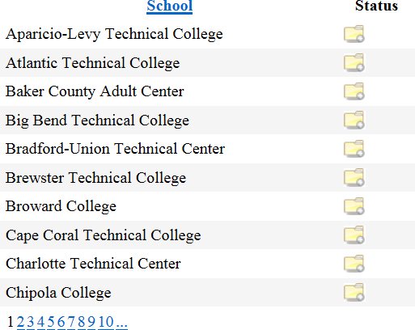

Postsecondary Schools
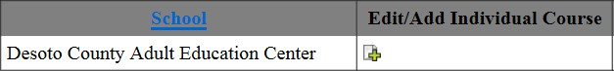

- Select the edit icon () to edit an existing career-themed dual enrollment course or to add a new career-themed dual enrollment course.
- If a school does not appear in the “Postsecondary Schools” table and records were submitted using the “Batch” upload process in Section I, please check the “Rejected Records Report” under the “Reports – Dual Enrollment Courses” header below to see if the submitted records were rejected.
- If a school does not appear in the “Postsecondary Schools” table and no records have been submitted through the “Batch” process by adding an individual enrollment course, see Section II for directions on adding an eligible postsecondary school.

Reports – Dual Enrollment Courses

Career-Themed Course Status Report – Dual Enrollment
This report shows all courses submitted in Step One or certified in Step Two. It will include all courses submitted through “Batch Upload Registration – Dual Enrollment” or “Individual Course Registration –
Dual Enrollment” methods.
Career-Themed Course Status Report - Dual Enrollment

Validation Reports – Dual Enrollment
These reports include dual enrollment courses which have been registered through the “Batch Upload Process – Dual Enrollment” and do not include any courses that have been registered individually.
Batch Upload Submission Report - Dual Enrollment Rejected Records Report - Dual Enrollment

If you have questions contact industrycertification@fldoe.org.

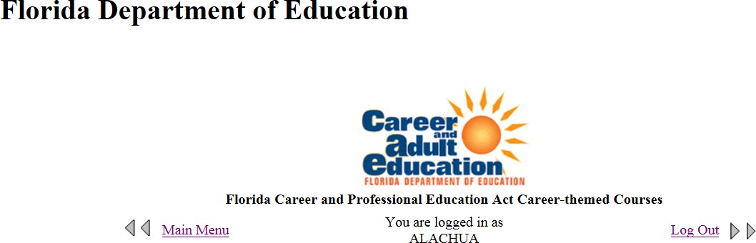
Note: This page is accessed by clicking on any of the edit icons ( ) from the “Available Schools” matrix.
The purpose of this registration is the identification of the career-themed courses operating in the current school year which meet the requirements in s. 1003.493, Florida Statutes. By registering, your district is certifying that these courses 1) meet the statutory requirements of the Florida Career and Professional Education Act and 2) have students enrolled 3) are not identified on the Non-Aligned List 4) have documentation on file to support each registered course-to-certification alignment.

SECONDARY COURSES
Section I: School Information

Section II: Edit Currently Registered Courses Registered Courses

Action | Course  Number | Course Title | Cert 1 | Cert 2 | Cert 3 | Cert 4 | Cert 5 | Cert 6 | Cert 7 | Cert 8 | Cert 9 | Cert 10 | Cert 11 | Cert 12 | Cert 13 | Cert 14 | Cert 15 | Date  Submitted | Status
Edit/ Delete | 8720320 | Building Construction Technologies 2/Level 2 | NCCER005 | NCCER032 | ADESK002 |  |  |  |  |  |  |  |  |  |  |  |  | 08/28/2018 | Submitted
Edit/ Delete | 9009110 | Information and Communications Technology (ICT) Essentials 1 | MICRO069 | COMPT016 |  |  |  |  |  |  |  |  |  |  |  |  |  | 08/28/2018 | Submitted

Section III: Add a New Career-Themed Course

A “Career-themed Course” is a course, or a course in a series of courses, that leads to an industry certification identified on the CAPE Industry Certification Funding List pursuant to rules adopted by the State Board of Education. Registered career-themed courses must meet the requirements of section 1003.493(1)(b), F.S. If career-themed courses do not meet these requirements, certifications earned in these courses do not qualify for funding in the Florida Education Finance Program (FEFP) under s. 1011.62, F.S. Career-themed courses have industry-specific curriculum aligned directly to priority workforce needs established by the regional workforce board or the Department of Economic Opportunity.

To register an individual career-themed course, please select the course and when prompted provide up to fifteen certifications offered. At least one certification must be selected for each course. Documentation may be required to

add additional courses to the course list available to be registered as career-themed courses. To submit multiple courses through a file upload please return to the main menu.

If you have questions contact industrycertification@fldoe.org.

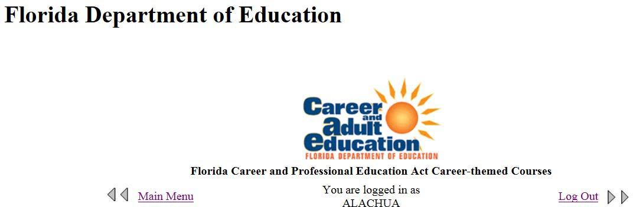
Note: This page is accessed by clicking on any of the edit icons ( ) from the “Available Postsecondary Schools” matrix.
The purpose of this registration is the identification of the career-themed courses operating in the current school year which meet the requirements in s. 1003.493, Florida Statutes. By registering, your district is certifying that these courses 1) meet the statutory requirements of the Florida Career and Professional Education Act and 2) have students enrolled 3) are not identified on the Non-Aligned List 4) have documentation on file to support each registered course-to-certification alignment.

DUAL ENROLLMENT COURSES
Section I: School Information

Section II: Edit Currently Registered Courses Registered Courses

Action | Course  Number | Course Title | Cert 1 | Cert 2 | Cert 3 | Cert 4 | Cert 5 | Cert 6 | Cert 7 | Cert 8 | Cert 9 | Cert 10 | Cert 11 | Cert 12 | Cert 13 | Cert 14 | Cert 15 | Date  Submitted | Status
Edit/ Delete | ACR0047 | Air Conditioning, Refrigeration and Heating Mechanic 1 | HVACE001 | NCCER018 | HVACE001 |  |  |  |  |  |  |  |  |  |  |  |  | 08/28/2018 | Submitted
Edit/ Delete | HSC1531 | TERMINOLOGY | MICRO069 | ADOBE022 |  |  |  |  |  |  |  |  |  |  |  |  |  | 08/31/2018 | Submitted
 | ACG1015 | ACCOUNTING II | MICRO069 | COMPT002 |  |  |  |  |  |  |  |  |  |  |  |  |  | 09/04/2018 | Certified

Section III: Add a New Career-themed Course

A “Career-themed Course” is a course, or a course in a series of courses, that leads to an industry certification identified on the CAPE Industry Certification Funding List pursuant to rules adopted by the State Board of Education. Career-themed courses have industry-specific curriculum aligned directly to priority workforce needs established by the regional workforce board or the Department of Economic Opportunity.

To register an individual career-themed course, please select the course and when prompted provide up to ten certifications offered. At least one certification must be selected for each course. To submit multiple courses through a file upload please return to the main menu.

If you have questions contact industrycertification@fldoe.org.

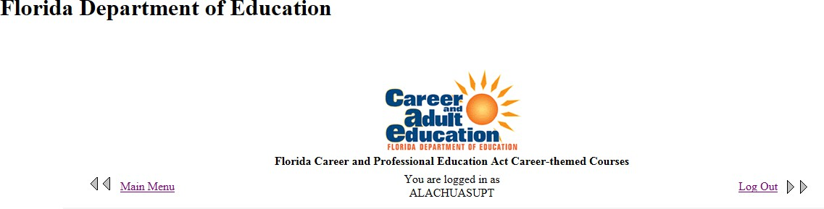

Registration of Career-themed Courses - Secondary Florida Career and Professional Education Act

Pursuant to the Florida Career and Professional Education Act, Sections 1003.491 – 1003.493, Florida Statutes, all districts shall offer at least two career-themed courses. A career-themed course is “a course, or a course in a series of courses, that leads to an industry certification identified in the Industry Certification Funding List pursuant to rules adopted by the State Board of Education. Career-themed courses have industry-specific curriculum aligned directly to priority workforce needs established by the regional workforce board or the Department of Economic Opportunity.”

All career-themed courses shall be registered in order to be eligible to generate the additional full-time equivalent membership funding based on the completion of industry certifications (Rule 6A.6.0576, Florida Administrative Code).

Newly Registered Courses – Secondary

The following career-themed courses have been newly registered for your district for the current school year. To finalize the registration process, use the Status column to select the courses and select the Certify button below. Once finalized, all registered career-themed courses for the current school year will appear in the section below.

Status | School Name | Course Number | Course Title | Cert 1 | Cert 2 | Cert 3 | Cert 4 | Cert 5 | Cert 6 | Cert 7 | Cert 8 | Cert 9 | Cert 10 | Cert 11 | Cert 12 | Cert 13 | Cert 14 | Cert 15 | Date  Step 1 Submitted
 |  |  | Information and
 | SANTA FE HIGH  SCHOOL | 9009110 | Communications  Technology (ICT) | MICRO069 | ADOBE  020 |  |  |  |  |  |  |  |  |  |  |  |  |  | 08/31/2018
 |  |  | Essentials 1
 |  |  | Digital
 | WESTWOOD MIDDLE  SCHOOL | 8207310 | Information  Technology/Level | MICRO069 |  |  |  |  |  |  |  |  |  |  |  |  |  |  | 08/28/2018
 |  |  | 2
 |  |  | Building
 | ABRAHAM LINCOLN  MIDDLE SCHOOL | 8720320 | Construction  Technologies | NCCER005 | NCCER  032 | ADESK  002 |  |  |  |  |  |  |  |  |  |  |  |  | 08/28/2018
 |  |  | 2/Level 2
 |  |  | Information and
 | ABRAHAM LINCOLN  MIDDLE SCHOOL | 9009110 | Communications  Technology (ICT) | MICRO069 | COMPT  016 |  |  |  |  |  |  |  |  |  |  |  |  |  | 08/28/2018
 |  |  | Essentials 1

By selecting the button below you are certifying that the selected list of career-themed courses above meet the statutory requirements of the Florida Career and Professional Education Act, ss. 1003.491 – 1003.493, F.S.
The following career-themed courses have completed the registration process. To generate a print ready report please go to the “Reports – Secondary Courses” section below.

School Name | Course Number | Course Title | Cert 1 | Cert 2 | Cert 3 | Cert 4 | Cert 5 | Cert 6 | Cert 7 | Cert 8 | Cert 9 | Cert 10 | Cert 11 | Cert 12 | Cert 13 | Cert 14 | Cert 15 | Date Submitted
WESTWOOD MIDDLE SCHOOL | 0100300 | Advanced Placement Art History | ABAYC003 |  |  |  |  |  |  |  |  |  |  |  |  |  |  | 08/31/2018

Reports – Secondary Courses
Registered Career-Themed Courses
This includes secondary courses which have been registered and certified by your district superintendent. Registered Career-Themed Courses Report - Secondary

If you have questions contact industrycertification@fldoe.org.

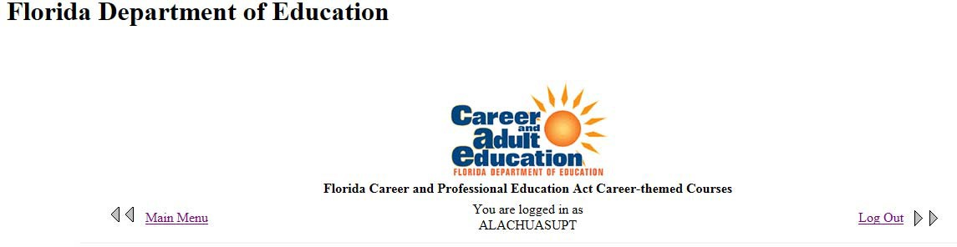

Registration of Career-Themed Courses - Dual Enrollment Florida Career and Professional Education Act

Pursuant to the Florida Career and Professional Education Act, Sections 1003.491 – 1003.493, Florida Statutes, all districts shall offer at least two career-themed dual enrollment courses. A career-themed dual enrollment course is “a course, or a course in a series of courses, that leads to an industry certification identified in the Industry Certification Funding List pursuant to rules adopted by the State Board of Education. Career-themed dual enrollment courses have industry-specific curriculum aligned directly to priority workforce needs established by the regional workforce board or the Department of Economic Opportunity.”

All career-themed dual enrollment courses shall be registered in order to be eligible to generate the additional full-time equivalent membership funding based on the completion of industry certifications (Rule 6A.6.0576, Florida Administrative Code).

Newly Registered Dual Enrollment Courses
The following career-themed dual enrollment courses have been newly registered for your district for the current school year. To finalize the registration process, use the Status column to select the courses and select the Certify button below. Once finalized, all registered career-themed dual enrollment courses for the current school year will appear in the section below.

Status | School Name | Course Number | Course Title | Cert 1 | Cert 2 | Cert 3 | Cert 4 | Cert 5 | Cert 6 | Cert 7 | Cert 8 | Cert 9 | Cert 10 | Cert 11 | Cert 12 | Cert 13 | Cert 14 | Cert 15 | Date  Step 1 Submitted
 | Embry-Riddle Aeronautical University, Bunnell (Branch Campuses at Fort Lauderdale and Daytona Beach) | ASC256 0 | UNMANNED AERIAL VEHICLES AND SYSTEMS (L) | MICRO069 | COMPT 002 |  |  |  |  |  |  |  |  |  |  |  |  |  | 08/31/2018
 | Santa Fe College | ACR004 7 | Air Conditioning, Refrigeration and Heating Mechanic 1 | HVACE001 | NCCER 018 | HVACE 002 |  |  |  |  |  |  |  |  |  |  |  |  | 08/28/2018
 | Emerald Coast Technical College | ACG101 2 | ACCOUNTING II (AS TRANSFER ONLY) | ADESK023 | ACSMD 002 | NIFMS0 08 | ADO BE01 3 | ADO BE02 1 | ADO BE00 7 |  |  |  |  |  |  |  |  |  | 08/28/2018
 | Emerald Coast Technical College | ACG108 0 | INTRERMEDIAT E ACCOUNTING II | ADESK023 | ACSMD 002 | NIFMS0 08 | ADO BE01 3 | AME DT00 5 |  |  |  |  |  |  |  |  |  |  | 08/28/2018

By selecting the button below you are certifying that the selected list of career-themed dual enrollment courses above meet the statutory requirements of the Florida Career and Professional Education Act, ss. 1003.491 – 1003.493, F.S.
The following career-themed dual enrollment courses have completed the registration process. To generate a print ready report please go to the “Reports – Dual Enrollment Courses” section below.

School Name | Course Number | Course Title | Cert 1 | Cert 2 | Cert 3 | Cert 4 | Cert 5 | Cert 6 | Cert 7 | Cert 8 | Cert 9 | Cert 10 | Cert 11 | Cert 12 | Cert 13 | Cert 14 | Cert 15 | Date  Submitted
Santa Fe College | ACG101 5 | ACCOUNTING II | MICRO069 | COMPT 002 |  |  |  |  |  |  |  |  |  |  |  |  |  | 09/04/2018
University of Florida | ABE201 2 | INTRO TO DESIGN & ANALYSIS | ADOBE011 |  |  |  |  |  |  |  |  |  |  |  |  |  |  | 09/04/2018

Reports – Dual Enrollment Courses
Registered Career-Themed Courses - Postsecondary
This includes postsecondary courses which have been registered and certified by your district superintendent.
Registered Career-Themed Courses Report - Postsecondary

If you have questions contact industrycertification@fldoe.org.

