FLORIDA AGRICULTURAL INSPECTION STATIONS
Rule 5A-16.003, F.A.C.
June 2025



Florida Department of Agriculture and Consumer Services
Office of Agricultural Law Enforcement
2005 Apalachee Parkway, Suite B
Tallahassee, FL, 32399

PREFACE

The Florida Department of Agriculture and Consumer Services maintains 24 agricultural inspection stations staffed by sworn law enforcement officers of the Office of Agricultural Law Enforcement. Eighteen of the inspection stations are located along a line referred to as the Florida agricultural production zone boundary. This boundary is roughly framed by the Suwannee and St. Marys Rivers in North Florida. The Suwannee River flows from the Okefenokee Swamp in Georgia and enters Florida just west of US 441 in Columbia County and continues southwest to its confluence with the Gulf of America near the town of Suwannee in Dixie County. The St. Marys River flows from the Okefenokee Swamp in an easterly direction to the Atlantic Ocean, forming a portion of the border between Georgia and Florida. The area south of this boundary comprises Florida’s agricultural production zone.

The remaining two inspection stations are located on US 231 in Campbellton, Jackson County, and eastbound Interstate 10 in Pensacola, Escambia County.

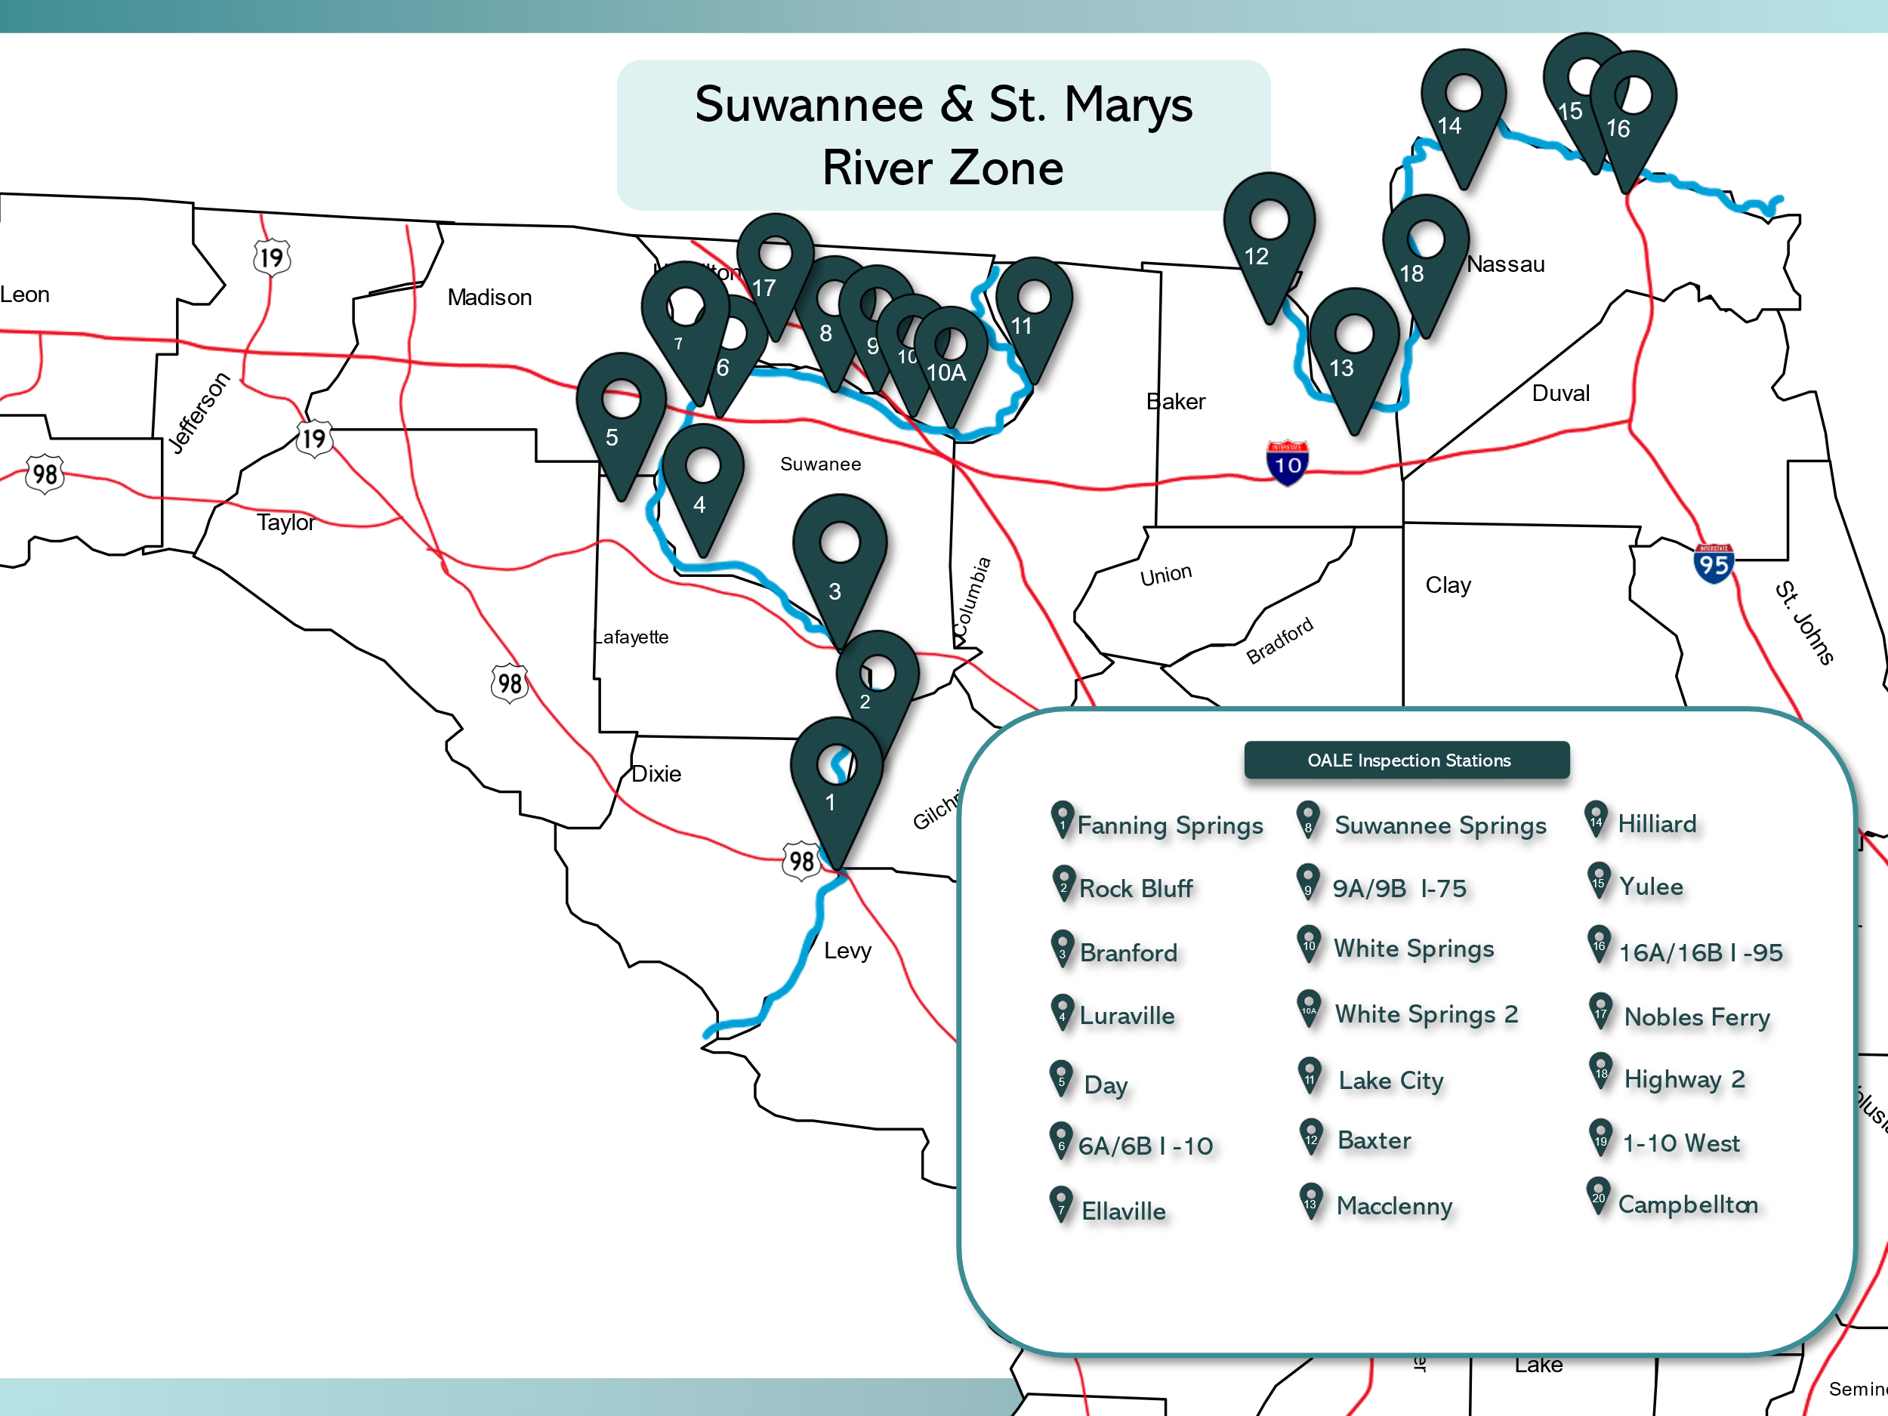

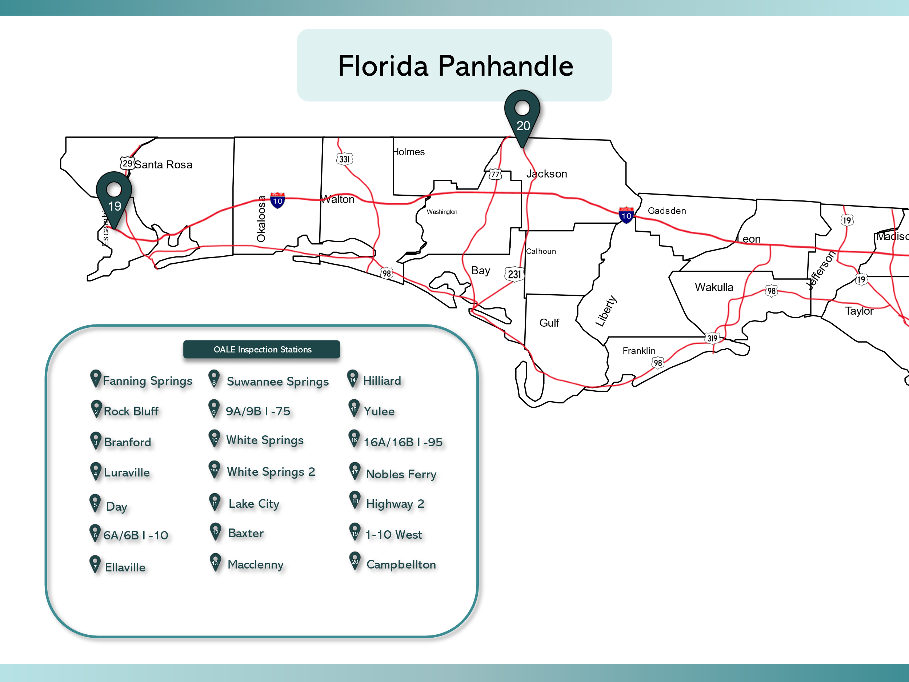

Station | Location | Address | Telephone
1 | Fanning Springs | 7289 US Hwy. 19  Trenton, FL 32693 | (352) 463-3133
2 | Rock Bluff | 6599 NW County Road 340  Bell, FL 32619 | (386) 935-1973
3 | Branford | 603 SW Highway 27  Branford, FL 32008 | (386) 935-1906
4 | Luraville | 18071 State Road 51  Live Oak, FL 32060 | (386) 776-1242
5 | Mayo | 1763 County Road 250 NW  Mayo, FL 32066 | (386) 294-1150
6A | I-10 Westbound  Suwannee County | 19517 Interstate 10  Live Oak, FL 32060 | (386) 362-4828
6B | I-10 Eastbound  Suwannee County | 19517 Interstate 10  Live Oak, FL 32068 | (386) 362-4925
7 | Ellaville | 20387 US 90  Live Oak, FL 32060 | (386) 362-2947
8 | Suwannee Springs | 3264 US 129 N  Live Oak, FL 32060 | (386) 362-1329

9A | I-75 Southbound  Hamilton County | 13106 Interstate 75  White Springs, FL 32096 | (386) 397-2295
9B | I-75 Northbound  Hamilton County | 13099 Interstate 75  White Springs, FL 32096 | (386) 397-2732
10 | White Springs  Hwy 41 | 10874 NW Hwy. 41  White Springs, FL 32096 | (386) 397-2252
10A | White Springs  CR 136 | 141 NW Thunder Ct.  White Springs, FL 32096 | (386) 397-1214
11 | Lake City | 21145 N US Hwy 441  White Springs, FL 32096 | (386) 758-0547
12 | Baxter | 11556 State Road 2  Sanderson, FL 32087 | (904) 259-7357
13 | Macclenny | 16007 State Rd. 121 N.  Macclenny, FL 32063 | (904) 259-6886
14 | Hilliard | 553893 US Hwy. 1  Hilliard, FL 32046 | (904) 845-2400
15 | Yulee | 852732 US Hwy. 17  Yulee, FL 32097 | (904) 548-0862

16A | I-95 Southbound  Nassau County | 752300 Interstate 95  Yulee, FL 32097 | (904) 225-5839
16B | I-95 Northbound  Nassau County | 752301 Interstate 95  Yulee, FL 32097 | (904) 225-5836
17 | Nobles Ferry | 6884 SW CR 751  Jasper, FL 32052 | (386) 792-2356
18 | Nassau County  State Rd. 2 | 2803 State Rd. 2  Hilliard, FL 32052 | (904) 879-5600
19 | I-10 Eastbound  Escambia County | 101 Interstate 10 W  Pensacola, FL 32534 | (850) 941-6013
20 | Campbellton  US 231 | (To Be Determined) | (To Be Determined)

