FGCC PMW-3180 – Request for Waiver

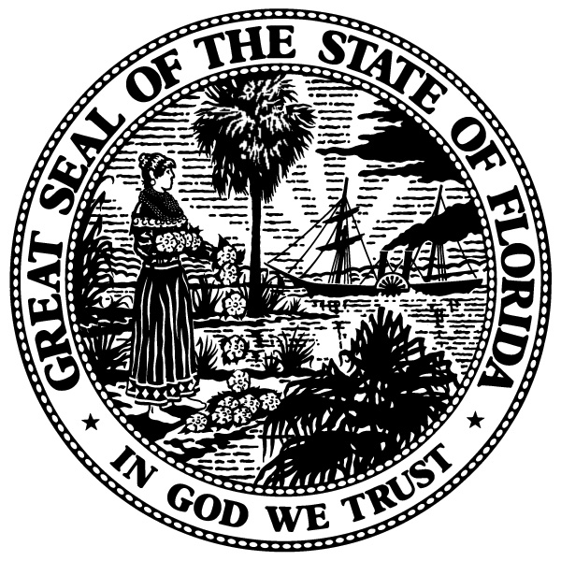 | STATE OF FLORIDA  FLORIDA GAMING CONTROL COMMISSION  DIVISION OF PARI-MUTUEL WAGERING  www.flgaming.gov www.fgcc.fl.gov

TO: ___________________________ ___________________ ___________________ _____________
Full Legal Name of Applicant Social Security Number or License Individual/Entity
Date of Birth Authorization to Work Number Org. Number

If you are a new applicant to Florida and have been convicted of any felony, regardless of whether adjudication was withheld, or if you are renewing your pari-mutuel occupational license in Florida and have been convicted of any of the crimes listed below, you must first request and receive a waiver from the Executive Director in order to receive a Florida Pari-Mutuel Wagering Occupational License or Cardroom License. Please check the appropriate box(es) below that best describes your situation:

For Pari-Mutuel and Cardroom Occupational License Applicants Only:

❑ A conviction in this state, in any other state, or under the laws of the United States of a capital felony, a felony or an offense in any other state which would be a felony under the laws of Florida involving arson; trafficking in, conspiracy to traffic in, smuggling, importing, conspiracy to smuggle or import, or delivery, sale, or distribution of a controlled substance; or a crime involving a lack of good moral character. A felony or misdemeanor in this state, in any other state, or under the laws of the United States, if such felony or misdemeanor is related to gambling or bookmaking, as contemplated in Section 849.25, Florida Statutes, or involves cruelty to animals.

❑ Currently under Suspension, Declared Ineligible, Ruled Off, Revoked, Denied, Ejected, Unpaid Fine, in this or any other racing jurisdiction. Specify discipline and jurisdiction:

❑ New applicant to Florida who has been convicted of any felony, regardless whether adjudication was withheld.

For Cardroom Occupational License Applicants Only:

❑ A conviction in this state, in any other state, or under the laws of the United States of a capital felony, a felony or an offense in any other state which would be a felony under the laws of Florida involving arson; trafficking in, conspiracy to traffic in, smuggling, importing, conspiracy to smuggle or import, or delivery, sale, or distribution of a controlled substance; or a crime involving a lack of good moral character. A felony or misdemeanor in this state, in any other state, or under the laws of the United States, if such felony or misdemeanor is related to gambling or bookmaking, as contemplated in Section 849.25, Florida Statutes, or involves cruelty to animals.

❑ New applicant to Florida who has been convicted of any felony, regardless whether adjudication was withheld.

❑ A misdemeanor involving forgery, larceny, extortion, or conspiracy to defraud, in this state or any other state, or under the laws of the United States.

For Slot Machine Occupational License Applicants Only:

❑ A conviction of a felony or misdemeanor in this state, in any other state, or under the laws of the United States if such felony or misdemeanor is related to gambling or bookmaking, regardless of whether adjudication was withheld.

❑ A misdemeanor involving forgery, larceny, extortion, or conspiracy to defraud, in this state or any other state, or under the laws of the United States.

If you choose to request a waiver, please sign this form below and return it with your completed application, license, and fingerprint fees. After an investigation is conducted, the Florida Gaming Control Commission will either grant or deny the request for waiver. You will be notified of the decision by mail at the address provided on your application.

UNTIL YOU ARE LICENSED:

1) You are not permitted to engage in any activity which requires a pari-mutuel occupational license, a cardroom occupational license or a slot machine occupational license at any pari-mutuel facility in Florida. If you are found to be working without a license, you will be subject to arrest for trespassing and your waiver request may be denied.

2) You are forbidden from accessing any of the restricted areas of any pari-mutuel facility in Florida.

I hereby request a waiver for the situation(s) or conviction(s) noted above and acknowledge that license and fingerprint fees are non-refundable in the event the waiver request is denied. I hereby acknowledge that my failure to participate in a waiver interview or to disclose any pertinent information regarding convictions, rulings, revocations, or denials from other jurisdictions will result in a denial of the request for waiver. I hereby waive the Section 120.60, Florida Statutes, timeline requirement regarding the processing of this application.

Signature of Applicant Date

TO BE CONSIDERED FOR A WAIVER, APPLICANTS MUST COMPLETE FORM FGCC PMW-3195 – REQUEST FOR RELEASE OF INFORMATION AND AUTHORIZATION TO RELEASE INFORMATION, AND PARTICIPATE INSHEDULE A WAIVER INTERVIEW WITH THE OFFICE OF INVESTIGATIONS.

