Florida Wildlife Trapping Education Course Instructions
The following are the complete instructions to access the information and materials in the “Wildlife Trapping Education Course,” accessed in the FWC eLearning portal. These instructions are provided to assist individuals who wish to participate in the trapping of wildlife to comply with the education course and permitting requirements as provided by 68A-32.001(2), F.A.C. The hyperlink to the eLearning portal is: https://learningmyfwc.remote-learner.net.
Creation of User Profile
The individual must create a user profile in the eLearning portal prior to registering for the Wildlife Trapping education course, unless an individual already has a user profile for the portal. The following are required to create a user profile:
- First and last name.
- E-mail address.
- Creation of login credentials: username and password.

After creation of the profile, or logging into an existing profile, the individual shall select one of the six trapper education courses from the available list of registrations to begin the course.
Trapping Education Course(s)
To aid those who desire to use just one style of trap in Florida, there are five trap-specific training options offered. There is also a course covering all trapping devices that is approved by the International Hunter Education Association and recognized for meeting the minimum qualifications for trapper education in Florida as well as all other states. Each course includes the Florida rules.
Individuals who view the entire course and successfully complete the test questions provided within the course for any of the six courses shall receive a one-time unique identification code. The code will appear on the individual’s Certificate of Completion for the specific trapping education course. This certificate shall provide verification that an individual meets the requirements in Rule 68A-32.001(2), F.A.C.

Follow this link to the training for using Foothold traps in Florida.
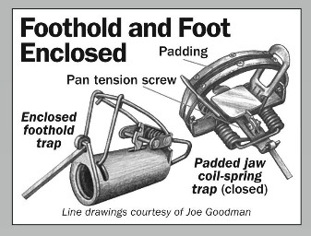
Follow this link to the training for using Body Gripping traps in Florida.
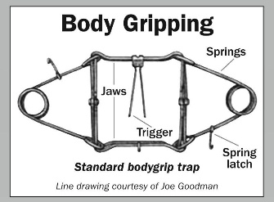
Follow this link to the training for using Cage traps in Florida.
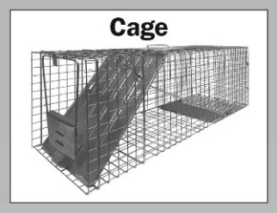
Follow this link to the training for using Cable Restraints to trap in Florida.
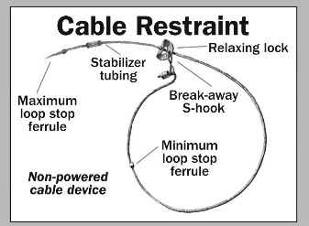
Follow this link to the training for using Corral traps in Florida.
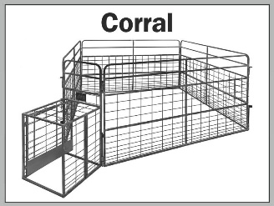
Follow this link to the training for using all trapping devices in Florida as well as many other states.
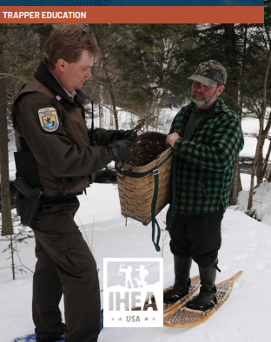

Questions
For questions, or to request an alternate format of the trapping education courses, contact:
FWC Hunter and Trapper Education Section
620 S. Meridian Street
Tallahassee, FL 32399
(850) 413-0085

