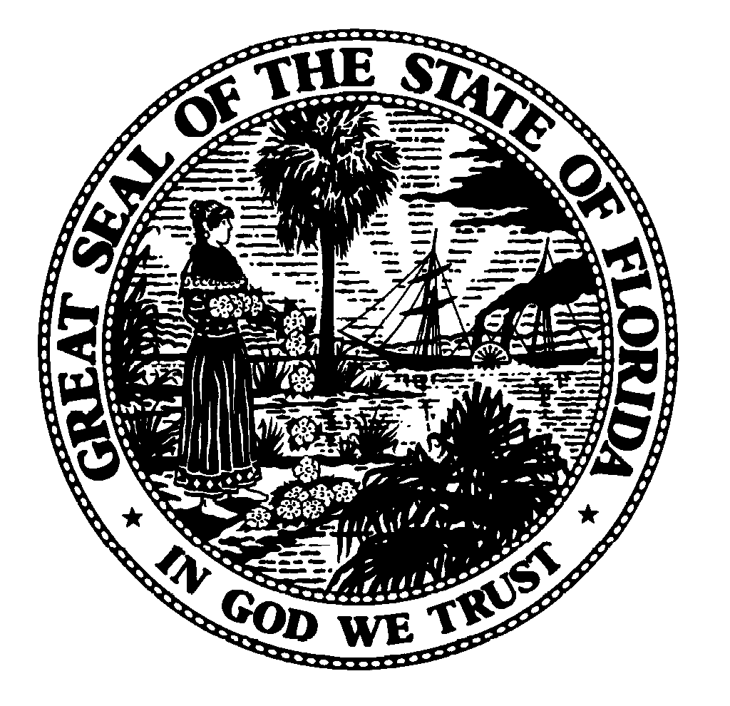
.
NVRA Voter Registration Agencies
(Designated by NVRA and s. 97.058, F.S.)
Quarterly Activities Report Form

Reporting Periods: Due dates for the 1st, 2nd, 3rd and 4th calendar quarterly reports are April 15, July 15, October 15, and
January 15 for the preceding 3-month calendar period, respectively. DS-DE 131 (eff. 01/2012)(Rule 1S-2.048)

1. Voter Registration Agency: ______________________ 2. Coordinator Name: ___________________________

3. Check reporting quarter: Q1___Q2___Q3___Q4___ 4. Indicate calendar year of reporting quarter: ______

Please provide data for your agency, by county.
1. How many clients declined to register or update his or her voter registration record?

Alachua |  | Gilchrist |  | Manatee |  | Suwannee
Baker |  | Glades |  | Monroe |  | Taylor
Bay |  | Gulf |  | Marion |  | Union
Bradford |  | Hamilton |  | Martin |  | Volusia
Brevard |  | Hardee |  | Nassau |  | Wakulla
Broward |  | Hendry |  | Okaloosa |  | Walton
Calhoun |  | Hernando |  | Okeechobee |  | Washington
Charlotte |  | Highlands |  | Orange
Citrus |  | Hillsborough |  | Osceola
Clay |  | Holmes |  | Palm Beach
Collier |  | Indian River |  | Pasco
Columbia |  | Jackson |  | Pinellas
Dade |  | Jefferson |  | Polk
DeSoto |  | Lafayette |  | Putnam
Dixie |  | Lake |  | Santa Rosa
Duval |  | Lee |  | Sarasota
Escambia |  | Leon |  | Seminole
Flagler |  | Levy |  | St. Johns
Franklin |  | Liberty |  | St. Lucie
Gadsden |  | Madison |  | Sumter

2. How many clients sought new or renewal of agency services or assistance or made
an address change with an agency in each category: (please answer 2a. – 2 f.)

2a. In Person
Alachua |  | Gilchrist |  | Manatee |  | Suwannee
Baker |  | Glades |  | Monroe |  | Taylor
Bay |  | Gulf |  | Marion |  | Union
Bradford |  | Hamilton |  | Martin |  | Volusia
Brevard |  | Hardee |  | Nassau |  | Wakulla
Broward |  | Hendry |  | Okaloosa |  | Walton
Calhoun |  | Hernando |  | Okeechobee |  | Washington
Charlotte |  | Highlands |  | Orange
Citrus |  | Hillsborough |  | Osceola
Clay |  | Holmes |  | Palm Beach
Collier |  | Indian River |  | Pasco
Columbia |  | Jackson |  | Pinellas
Dade |  | Jefferson |  | Polk
DeSoto |  | Lafayette |  | Putnam
Dixie |  | Lake |  | Santa Rosa
Duval |  | Lee |  | Sarasota
Escambia |  | Leon |  | Seminole
Flagler |  | Levy |  | St. Johns
Franklin |  | Liberty |  | St. Lucie
Gadsden |  | Madison |  | Sumter

2b. By Mail
Alachua |  | Gilchrist |  | Manatee |  | Suwannee
Baker |  | Glades |  | Monroe |  | Taylor
Bay |  | Gulf |  | Marion |  | Union
Bradford |  | Hamilton |  | Martin |  | Volusia
Brevard |  | Hardee |  | Nassau |  | Wakulla
Broward |  | Hendry |  | Okaloosa |  | Walton
Calhoun |  | Hernando |  | Okeechobee |  | Washington
Charlotte |  | Highlands |  | Orange
Citrus |  | Hillsborough |  | Osceola
Clay |  | Holmes |  | Palm Beach
Collier |  | Indian River |  | Pasco
Columbia |  | Jackson |  | Pinellas
Dade |  | Jefferson |  | Polk
DeSoto |  | Lafayette |  | Putnam
Dixie |  | Lake |  | Santa Rosa
Duval |  | Lee |  | Sarasota
Escambia |  | Leon |  | Seminole
Flagler |  | Levy |  | St. Johns
Franklin |  | Liberty |  | St. Lucie
Gadsden |  | Madison |  | Sumter

2c. Via online
Alachua |  | Gilchrist |  | Manatee |  | Suwannee
Baker |  | Glades |  | Monroe |  | Taylor
Bay |  | Gulf |  | Marion |  | Union
Bradford |  | Hamilton |  | Martin |  | Volusia
Brevard |  | Hardee |  | Nassau |  | Wakulla
Broward |  | Hendry |  | Okaloosa |  | Walton
Calhoun |  | Hernando |  | Okeechobee |  | Washington
Charlotte |  | Highlands |  | Orange
Citrus |  | Hillsborough |  | Osceola
Clay |  | Holmes |  | Palm Beach
Collier |  | Indian River |  | Pasco
Columbia |  | Jackson |  | Pinellas
Dade |  | Jefferson |  | Polk
DeSoto |  | Lafayette |  | Putnam
Dixie |  | Lake |  | Santa Rosa
Duval |  | Lee |  | Sarasota
Escambia |  | Leon |  | Seminole
Flagler |  | Levy |  | St. Johns
Franklin |  | Liberty |  | St. Lucie
Gadsden |  | Madison |  | Sumter

2d. Webservice or electronic remote location
Alachua |  | Gilchrist |  | Manatee |  | Suwannee
Baker |  | Glades |  | Monroe |  | Taylor
Bay |  | Gulf |  | Marion |  | Union
Bradford |  | Hamilton |  | Martin |  | Volusia
Brevard |  | Hardee |  | Nassau |  | Wakulla
Broward |  | Hendry |  | Okaloosa |  | Walton
Calhoun |  | Hernando |  | Okeechobee |  | Washington
Charlotte |  | Highlands |  | Orange
Citrus |  | Hillsborough |  | Osceola
Clay |  | Holmes |  | Palm Beach
Collier |  | Indian River |  | Pasco
Columbia |  | Jackson |  | Pinellas
Dade |  | Jefferson |  | Polk
DeSoto |  | Lafayette |  | Putnam
Dixie |  | Lake |  | Santa Rosa
Duval |  | Lee |  | Sarasota
Escambia |  | Leon |  | Seminole
Flagler |  | Levy |  | St. Johns
Franklin |  | Liberty |  | St. Lucie
Gadsden |  | Madison |  | Sumter

2e. By telephone
Alachua |  | Gilchrist |  | Manatee |  | Suwannee
Baker |  | Glades |  | Monroe |  | Taylor
Bay |  | Gulf |  | Marion |  | Union
Bradford |  | Hamilton |  | Martin |  | Volusia
Brevard |  | Hardee |  | Nassau |  | Wakulla
Broward |  | Hendry |  | Okaloosa |  | Walton
Calhoun |  | Hernando |  | Okeechobee |  | Washington
Charlotte |  | Highlands |  | Orange
Citrus |  | Hillsborough |  | Osceola
Clay |  | Holmes |  | Palm Beach
Collier |  | Indian River |  | Pasco
Columbia |  | Jackson |  | Pinellas
Dade |  | Jefferson |  | Polk
DeSoto |  | Lafayette |  | Putnam
Dixie |  | Lake |  | Santa Rosa
Duval |  | Lee |  | Sarasota
Escambia |  | Leon |  | Seminole
Flagler |  | Levy |  | St. Johns
Franklin |  | Liberty |  | St. Lucie
Gadsden |  | Madison |  | Sumter

2f. Through home site visit
Alachua |  | Gilchrist |  | Manatee |  | Suwannee
Baker |  | Glades |  | Monroe |  | Taylor
Bay |  | Gulf |  | Marion |  | Union
Bradford |  | Hamilton |  | Martin |  | Volusia
Brevard |  | Hardee |  | Nassau |  | Wakulla
Broward |  | Hendry |  | Okaloosa |  | Walton
Calhoun |  | Hernando |  | Okeechobee |  | Washington
Charlotte |  | Highlands |  | Orange
Citrus |  | Hillsborough |  | Osceola
Clay |  | Holmes |  | Palm Beach
Collier |  | Indian River |  | Pasco
Columbia |  | Jackson |  | Pinellas
Dade |  | Jefferson |  | Polk
DeSoto |  | Lafayette |  | Putnam
Dixie |  | Lake |  | Santa Rosa
Duval |  | Lee |  | Sarasota
Escambia |  | Leon |  | Seminole
Flagler |  | Levy |  | St. Johns
Franklin |  | Liberty |  | St. Lucie
Gadsden |  | Madison |  | Sumter

3. How many voter registration applications were mailed to clients?

Alachua |  | Gilchrist |  | Manatee |  | Suwannee
Baker |  | Glades |  | Monroe |  | Taylor
Bay |  | Gulf |  | Marion |  | Union
Bradford |  | Hamilton |  | Martin |  | Volusia
Brevard |  | Hardee |  | Nassau |  | Wakulla
Broward |  | Hendry |  | Okaloosa |  | Walton
Calhoun |  | Hernando |  | Okeechobee |  | Washington
Charlotte |  | Highlands |  | Orange
Citrus |  | Hillsborough |  | Osceola
Clay |  | Holmes |  | Palm Beach
Collier |  | Indian River |  | Pasco
Columbia |  | Jackson |  | Pinellas
Dade |  | Jefferson |  | Polk
DeSoto |  | Lafayette |  | Putnam
Dixie |  | Lake |  | Santa Rosa
Duval |  | Lee |  | Sarasota
Escambia |  | Leon |  | Seminole
Flagler |  | Levy |  | St. Johns
Franklin |  | Liberty |  | St. Lucie
Gadsden |  | Madison |  | Sumter

4. How many clients submitted voter registration information or an application to the agency (including by mail)?
Alachua |  | Gilchrist |  | Manatee |  | Suwannee
Baker |  | Glades |  | Monroe |  | Taylor
Bay |  | Gulf |  | Marion |  | Union
Bradford |  | Hamilton |  | Martin |  | Volusia
Brevard |  | Hardee |  | Nassau |  | Wakulla
Broward |  | Hendry |  | Okaloosa |  | Walton
Calhoun |  | Hernando |  | Okeechobee |  | Washington
Charlotte |  | Highlands |  | Orange
Citrus |  | Hillsborough |  | Osceola
Clay |  | Holmes |  | Palm Beach
Collier |  | Indian River |  | Pasco
Columbia |  | Jackson |  | Pinellas
Dade |  | Jefferson |  | Polk
DeSoto |  | Lafayette |  | Putnam
Dixie |  | Lake |  | Santa Rosa
Duval |  | Lee |  | Sarasota
Escambia |  | Leon |  | Seminole
Flagler |  | Levy |  | St. Johns
Franklin |  | Liberty |  | St. Lucie
Gadsden |  | Madison |  | Sumter

5. How many voter registration applications were forwarded for each county to
the Supervisor of Elections’ office, regardless of whether they
were invalid, incomplete or duplicative?

Alachua |  | Gilchrist |  | Manatee |  | Suwannee
Baker |  | Glades |  | Monroe |  | Taylor
Bay |  | Gulf |  | Marion |  | Union
Bradford |  | Hamilton |  | Martin |  | Volusia
Brevard |  | Hardee |  | Nassau |  | Wakulla
Broward |  | Hendry |  | Okaloosa |  | Walton
Calhoun |  | Hernando |  | Okeechobee |  | Washington
Charlotte |  | Highlands |  | Orange
Citrus |  | Hillsborough |  | Osceola
Clay |  | Holmes |  | Palm Beach
Collier |  | Indian River |  | Pasco
Columbia |  | Jackson |  | Pinellas
Dade |  | Jefferson |  | Polk
DeSoto |  | Lafayette |  | Putnam
Dixie |  | Lake |  | Santa Rosa
Duval |  | Lee |  | Sarasota
Escambia |  | Leon |  | Seminole
Flagler |  | Levy |  | St. Johns
Franklin |  | Liberty |  | St. Lucie
Gadsden |  | Madison |  | Sumter

