Florida’s State Academic Standards -Benchmarks for Excellent Student Thinking (B.E.S.T.) Mathematics, 2020

Rule 6A-1.09401

Florida’s State Academic Next Generation
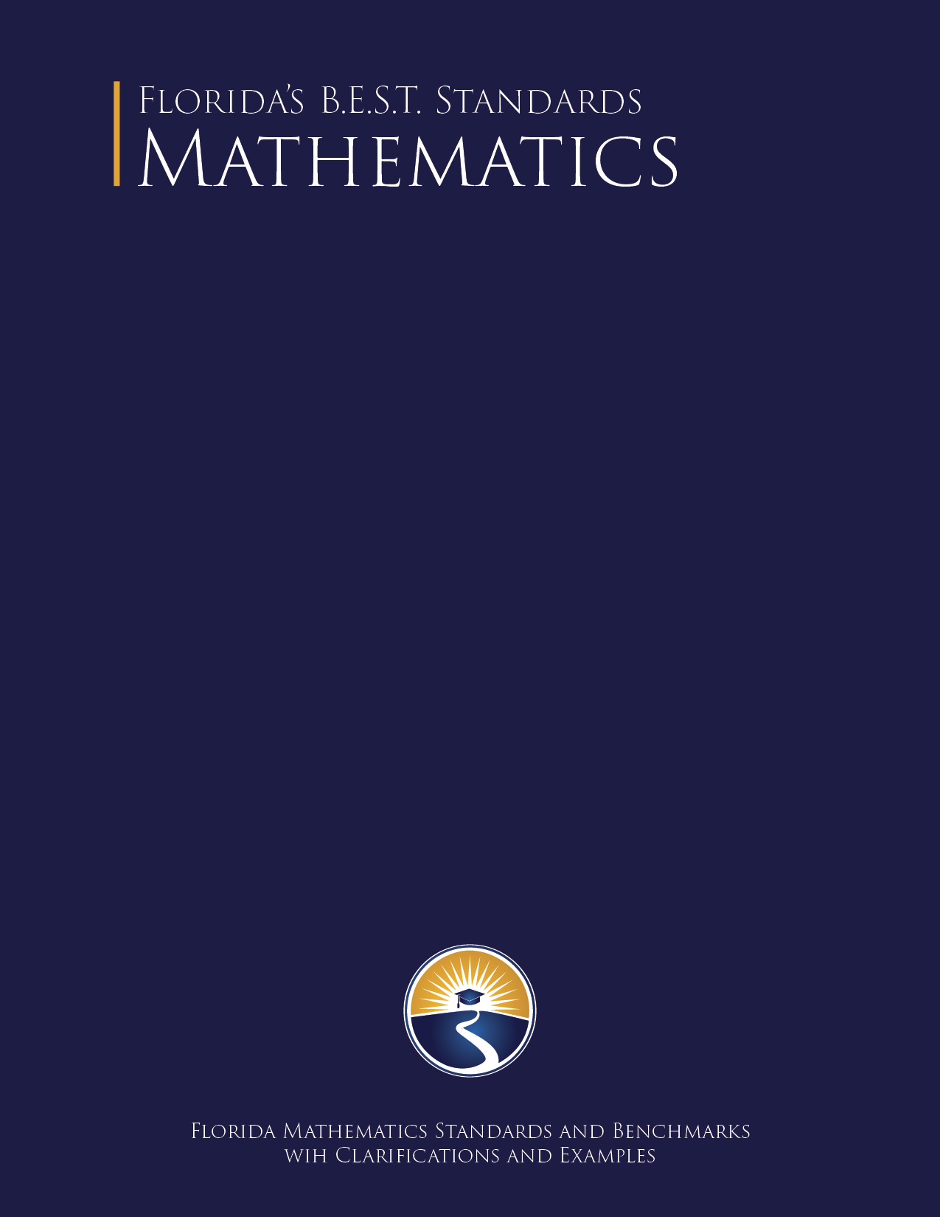
2026

Rule 6A-1.09401, F.A.C.
Rule 6A-1.09401, F.A.C.
Table of Contents

Introduction 1
Florida’s B.E.S.T. Standards for Mathematics Coding Scheme 3
Progression of Florida’s B.E.S.T. Standards for Mathematics 4
Fluency with Arithmetic Operations and Automaticity with Basic Arithmetic Facts 5
Mathematical Thinking and Reasoning Standards 7
Mathematical Thinking and Reasoning Standards 8
Standards for Mathematics K-5 12
Kindergarten 13
Number Sense and Operations 13
Algebraic Reasoning 15
Measurement 16
Geometric Reasoning 17
Data Analysis and Probability 18
Grade 1 19
Number Sense and Operations 19
Fractions 21
Algebraic Reasoning 21
Measurement 23
Geometric Reasoning 24
Data Analysis and Probability 25
Grade 2 26
Number Sense and Operations 26
Fractions 28
Algebraic Reasoning 28
Measurement 30
Geometric Reasoning 31
Data Analysis and Probability 32
Grade 3 34
Number Sense and Operations 34
Fractions 36
Algebraic Reasoning 38
Measurement 40
Geometric Reasoning 41
Data Analysis and Probability 43
Grade 4 44
Number Sense and Operations 44
Fractions 46
Algebraic Reasoning 49
Measurement 51
Geometric Reasoning 52
Data Analysis and Probability 53
Grade 5 55
Number Sense and Operations 55
Fractions 57
Algebraic Reasoning 59
Measurement 62
Geometric Reasoning 62
Data Analysis and Probability 64
Mathematics 6-8 66
Grade 6 67
Number Sense and Operations 67
Algebraic Reasoning 70
Geometric Reasoning 74
Data Analysis and Probability 76
Grade 7 78
Number Sense and Operations 78
Algebraic Reasoning 79
Geometric Reasoning 82
Data Analysis and Probability 84
Grade 8 87
Number Sense and Operations 87
Algebraic Reasoning 89
Functions 91
Geometric Reasoning 92
Data Analysis and Probability 94
Mathematics 9-12 Courses: Algebra 1 and Geometry 96
9-12 Course Overview 97
Algebra I 97
Geometry 109
Mathematics 9-12 117
9-12 Overview 118
9-12 Number Sense and Operations Strand 119
9-12 Algebraic Reasoning Strand 123
9-12 Functions Strand 138
9-12 Financial Literacy Strand 142
9-12 Geometric Reasoning Strand 149
9-12 Trigonometry Strand 159
9-12 Data Analysis and Probability Strand 162
9-12 Logic and Discrete Theory Strand 171
9-12 Calculus Strand 175
Appendix A: Situations Involving Operations with Numbers 183
Situations Involving Addition and Subtraction 184
Situations Involving Multiplication and Division 185
Appendix B: Fluency and Automaticity Chart 186
Fluency and Recall with Automaticity throughout Grade Levels 187
Appendix C: K-12 Mathematics Glossary 190
K-5 Mathematics Glossary 191
6-12 Mathematics Glossary 203
Appendix D: Properties of Operations, Equality and Inequality 223
Properties of Operations 224
Properties of Equality 225
Properties of Inequality 226
Appendix E: K-12 Formulas 227
K-12 Formulas 228



Introduction

Access to high-quality education is a fundamental value provided to Florida’s students through the Florida Constitution. It is in the best interest of all Floridians to give our children the B.E.S.T., Benchmarks for Excellent Student Thinking, an education fully preparing them for success. Florida leaders have a duty to ensure students are prepared to be civically engaged and knowledgeable citizens who positively impact our communities.

To reach these goals, Florida’s B.E.S.T. Standards for Mathematics were developed with input from thousands of Floridians and countless hours of work from dedicated Florida educational leaders and mathematics teachers. Through this work, Florida’s leaders are sending a strong, clear message that they are unwilling to be complacent. Our students are capable of unprecedented success. It is our responsibility to implement the infrastructure necessary to help them thrive.

High-quality academic standards are the foundation of a high-quality system to which assessments and instructional materials must be aligned. With these new and improved standards, Florida builds on past strengths and learns from past lessons. Built on the foundations of reading, writing, and arithmetic, our state standards are the B.E.S.T. in the nation.

Florida’s B.E.S.T. Standards for Mathematics reflect the concerns of parents, feedback from stakeholders and the practical experience of teachers. These new standards will lay the foundation for higher quality instructional materials, streamlined assessments, and ultimately high school graduates fully prepared for the responsibilities associated with American citizenship.

Throughout this year-long process of evaluating, listening, rethinking and ultimately rewriting Florida’s standards, the Department engaged numerous stakeholders, including many educators, repeatedly, through a multi-faceted public input process. The success of this process was rooted therein, in the collective thought and input of many Floridians who held student-centered results close to heart. Therefore, in addition to the B.E.S.T. standards herein, it is also recommended that this review process be repeated every seven years, if not sooner.

Development of Florida’s B.E.S.T. Standards for Mathematics
The development of these standards and benchmarks is based upon Executive Order 19-32 issued by Governor Ron DeSantis on January 31, 2019. Florida’s B.E.S.T. Standards for Mathematics were written by workgroups consisting of Florida mathematics teacher experts. The teacher experts represent the individuals in Florida who have leadership roles in K-12 mathematics and the Florida College System. Throughout the development of the standards and benchmarks, the workgroups were focused on writing standards and benchmarks that are clear, concise and provide enough guidance so that districts, test developers, publishers and other related stakeholders are able to align curriculum, instruction and assessment. The mathematics teacher expert workgroups drew on the work of the National Council of Teachers of Mathematics (NCTM); expectations from national and international assessments such as ACT, SAT, NAEP and TIMSS; comments from public and specialty stakeholders and feedback from national mathematics and standards experts.

Changes and Improvements
- Simplicity
There is less emphasis now on students using multiple strategies just for the sake of multiple strategies. Parents will better understand their children’s work in mathematics.
- Practicality
Statements that were unnecessarily complicated, or too difficult to implement, are streamlined. Statements are more focused now on the learning goal, with less verbiage than before about the means to get there.
- Specificity
Florida’s B.E.S.T. Standards for Mathematics 9-12 are organized in a way that allows for multiple pathways for the students of Florida.

Guiding Principles for Change
- High Expectations
Florida’s B.E.S.T. standards were designed to provide students with a world class education. These standards maintain high expectations for Florida’s students, ensuring equity and access for all.
- Clarity
Florida’s B.E.S.T. standards were written to provide clear and concise language for students, parents, and educators. Clarifications were included to ensure a comprehensive understanding of the intentions of the benchmarks and to increase transparency of expectations.
- Alignment
Florida’s B.E.S.T. standards are a consistent progression of mathematical strands, ensuring vertical alignment across grade levels and horizontal alignment at the course level.

The Florida Department of Education would like to thank all of the Floridians that contributed to this project. In particular, we would like to thank the teacher experts who served on review committees to represent Florida teachers and students.

Florida’s B.E.S.T. Standards for Mathematics Coding Scheme

Design of Standards
The standards are designed to be user-friendly, so every stakeholder will understand what students are expected to master. Taken together, the benchmarks, clarifications, and examples represent the expected outcomes for students of Florida and carry the full weight of the standards.

Florida has a unique coding scheme defined by 5-character places in an alphanumeric coding: the subject, grade level, strand, standard and benchmark. For Kindergarten through grade 8, the coding scheme is defined by each individual grade level. For grades 9-12, the scheme is banded and organized by strands. The strand is a focal group of related standards. Standards are overarching criteria for the grade level or grade band. The benchmark is a specific expectation for the grade level or grade band that falls within the standard. The mathematical content within the benchmarks is to be learned during the year and mastered by the end of the year. It is important to note that benchmarks from different strands may be closely related because mathematics is an interconnected subject.
K-8 Example
Subject | Grade Level | Strand | Standard | Benchmark
MA. | 2. | NSO. | 2. | 1
Mathematics | Grade 2 | Number Sense and Operations | Add and subtract two- and three-digit whole numbers. | Recall addition facts with sums to 20 and related subtraction facts with automaticity.
9-12 Example
Subject | Grade Level | Strand | Standard | Benchmark
MA. | 912. | GR. | 3. | 3
Mathematics | Grades 9-12 | Geometric Reasoning | Use coordinate geometry to solve problems or prove relationships. | Use coordinate geometry to solve mathematical and real-world problems on the coordinate plane involving perimeter or area of polygons.

Mathematical Thinking and Reasoning Standards for Students Example
Subject | Grade Level | Strand | Standard | Benchmark
MA. | K12. | MTR. | 6. | 1
Mathematics | Kindergarten through grade 12 | Mathematical Thinking and Reasoning | Assess the reasonableness of solutions. | no meaning

It is important to note that the 5th place will always be a “1” for the Mathematical Thinking and Reasoning Standards for Students. The “1” has no meaning but serves as a placeholder in fulfilling Florida’s unique coding scheme.

Progression of Florida’s B.E.S.T. Standards
for Mathematics
The table below illustrates the Florida’s B.E.S.T. strands. For each strand in Kindergarten through grade 12, the shaded areas indicate the grade levels where it is addressed. Strands with similar mathematical content are shaded with a different variation of color. These strands support the major strands (Number Sense and Operations, Algebraic Reasoning, Geometric Reasoning and Data Analysis and Probability) in various grade bands. Most of the strands span multiple grade levels, which lends itself to the progression of mathematics and the coherence across courses.
K | 1 | 2 | 3 | 4 | 5 | 6 | 7 | 8 | 9-12
Number Sense and Operations (NSO)
 | Fractions (FR)
Algebraic Reasoning (AR)
 |  |  |  |  |  |  |  | Functions (F)
 |  |  |  |  |  |  |  |  | Financial Literacy (FL)
Measurement (M)
Geometric Reasoning (GR)
 |  |  |  |  |  |  |  |  | Trigonometry (T)
Data Analysis and Probability (DP)
 |  |  |  |  |  |  |  |  | Logic and Discrete Theory (LT)
 |  |  |  |  |  |  |  |  | Calculus (C)
Mathematical Thinking and Reasoning Standards (MTR)

Fluency with Arithmetic Operations and
Automaticity with Basic Arithmetic Facts
Throughout this document, benchmark expectations regarding arithmetic operations within the Number Sense and Operations (NSO) strand have been developed with a hierarchy in mind consisting of three stages: exploration, procedural reliability and procedural fluency. Students will first explore arithmetic operations with no fluency expectations, then will be able to show procedural reliability and finally they will carry out these operations with procedural fluency. Interwoven into this hierarchy is the development of direct recall of basic arithmetic facts. Basic arithmetic facts are first derived, then utilized while becoming procedurally reliable or fluent and finally recalled with automaticity. Refer to Appendix B: Proficiency and Procedural Fluency Chart.

Stage 1: Exploration
The expectation is to develop understanding through the use of manipulatives, visual models, discussions, estimation and drawings. An example of an “exploration” benchmark is shown below.

MA.1.NSO.2.4 | Explore the addition of a two-digit number and a one-digit number with sums to 100.
Benchmark Clarifications:
Clarification 1: Instruction focuses on combining ones and tens and composing new tens from ones, when needed.
Clarification 2: Instruction includes the use of manipulatives, number lines, drawings or models.

Stage 2: Procedural reliability
The expectation is to utilize skills from the exploration stage to develop an accurate, reliable method that aligns with the student’s understanding and learning style. Students may need the teacher’s help to choose a method, and they will learn how to use a method without help. An example of a “procedural reliability” benchmark is shown below.

MA.2.NSO.2.3 | Add two whole numbers with sums up to 100 with procedural reliability. Subtract a whole number from a whole number, each no larger than 100, with procedural reliability.
Example: The sum $41+23$ can be found by using a number line and “jumping up” by two tens and then by three ones to “land” at 64.
Example: The difference $87-25$ can be found by subtracting 20 from 80 to get 60 and then 5 from 7 to get 2. Then add 60 and 2 to obtain 62.
Benchmark Clarifications:
Clarification 1: Instruction focuses on helping a student choose a method they can use reliably.

Stage 3: Procedural fluency
The expectation is to utilize skills from the procedural reliability stage to become fluent with an efficient and accurate procedure, including a standard algorithm. An example of a “procedural fluency” benchmark is shown below.

MA.3.NSO.2.1 | Add and subtract multi-digit whole numbers including using a standard algorithm with procedural fluency.

Embedded within Stage 1 – Stage 3: Automaticity
The expectation is to directly recall basic arithmetic facts from memory. Automaticity is the ability to act according to an automatic response which is easily retrieved from long-term memory. It usually results from repetition and practice. An example of an “automaticity” benchmark is shown below.

MA.2.NSO.2.1 | Recall addition facts with sums up to 20 and related subtraction facts with automaticity.

Mathematical Thinking and
Reasoning Standards

Mathematical Thinking and Reasoning Standards
MTR: Because Math Matters

Florida students are expected to engage with mathematics through the Mathematical Thinking and Reasoning (MTR) Standards. These standards are written in clear language so all stakeholders can understand them and students can use them as self-monitoring tools. The MTR Standards promote deeper learning and understanding of mathematics. The clarifications are included to guide teachers in the integration of the MTR Standards within mathematics instruction.

MA.K12.MTR.1.1 Actively participate in effortful learning both individually and collectively.
Mathematicians who participate in effortful learning both individually and with others:
- Analyze the problem in a way that makes sense given the task.
- Ask questions that will help with solving the task.
- Build perseverance by modifying methods as needed while solving a challenging task.
- Stay engaged and maintain a positive mindset when working to solve tasks.
- Help and support each other when attempting a new method or approach.
Clarifications:
Teachers who encourage students to participate actively in effortful learning both individually and with others:
- Cultivate a community of growth mindset learners.
- Foster perseverance in students by choosing tasks that are challenging.
- Develop students’ ability to analyze and problem solve.
- Recognize students’ effort when solving challenging problems.

MA.K12.MTR.2.1 Demonstrate understanding by representing problems in multiple ways.
Mathematicians who demonstrate understanding by representing problems in multiple ways:
- Build understanding through modeling and using manipulatives.
- Represent solutions to problems in multiple ways using objects, drawings, tables, graphs and equations.
- Progress from modeling problems with objects and drawings to using algorithms and equations.
- Express connections between concepts and representations.
- Choose a representation based on the given context or purpose.
Clarifications:
Teachers who encourage students to demonstrate understanding by representing problems in multiple ways:
- Help students make connections between concepts and representations.
- Provide opportunities for students to use manipulatives when investigating concepts.
- Guide students from concrete to pictorial to abstract representations as understanding progresses.
- Show students that various representations can have different purposes and can be useful in different situations.
MA.K12.MTR.3.1 Complete tasks with mathematical fluency.
Mathematicians who complete tasks with mathematical fluency:
- Select efficient and appropriate methods for solving problems within the given context.
- Maintain flexibility and accuracy while performing procedures and mental calculations.
- Complete tasks accurately and with confidence.
- Adapt procedures to apply them to a new context.
- Use feedback to improve efficiency when performing calculations.
Clarifications:
Teachers who encourage students to complete tasks with mathematical fluency:
- Provide students with the flexibility to solve problems by selecting a procedure that allows them to solve efficiently and accurately.
- Offer multiple opportunities for students to practice efficient and generalizable methods.
- Provide opportunities for students to reflect on the method they used and determine if a more efficient method could have been used.

MA.K12.MTR.4.1 Engage in discussions that reflect on the mathematical thinking of self and others.
Mathematicians who engage in discussions that reflect on the mathematical thinking of self and others:
- Communicate mathematical ideas, vocabulary and methods effectively.
- Analyze the mathematical thinking of others.
- Compare the efficiency of a method to those expressed by others.
- Recognize errors and suggest how to correctly solve the task.
- Justify results by explaining methods and processes.
- Construct possible arguments based on evidence.
Clarifications:
Teachers who encourage students to engage in discussions that reflect on the mathematical thinking of self and others:
- Establish a culture in which students ask questions of the teacher and their peers, and error is an opportunity for learning.
- Create opportunities for students to discuss their thinking with peers.
- Select, sequence and present student work to advance and deepen understanding of correct and increasingly efficient methods.
- Develop students’ ability to justify methods and compare their responses to the responses of their peers.
MA.K12.MTR.5.1 Use patterns and structure to help understand and connect mathematical concepts.
Mathematicians who use patterns and structure to help understand and connect mathematical concepts:
- Focus on relevant details within a problem.
- Create plans and procedures to logically order events, steps or ideas to solve problems.
- Decompose a complex problem into manageable parts.
- Relate previously learned concepts to new concepts.
- Look for similarities among problems.
- Connect solutions of problems to more complicated large-scale situations.
Clarifications:
Teachers who encourage students to use patterns and structure to help understand and connect mathematical concepts:
- Help students recognize the patterns in the world around them and connect these patterns to mathematical concepts.
- Support students to develop generalizations based on the similarities found among problems.
- Provide opportunities for students to create plans and procedures to solve problems.
- Develop students’ ability to construct relationships between their current understanding and more sophisticated ways of thinking.

MA.K12.MTR.6.1 Assess the reasonableness of solutions.
Mathematicians who assess the reasonableness of solutions:
- Estimate to discover possible solutions.
- Use benchmark quantities to determine if a solution makes sense.
- Check calculations when solving problems.
- Verify possible solutions by explaining the methods used.
- Evaluate results based on the given context.
Clarifications:
Teachers who encourage students to assess the reasonableness of solutions:
- Have students estimate or predict solutions prior to solving.
- Prompt students to continually ask, “Does this solution make sense? How do you know?”
- Reinforce that students check their work as they progress within and after a task.
- Strengthen students’ ability to verify solutions through justifications.
MA.K12.MTR.7.1 Apply mathematics to real-world contexts.
Mathematicians who apply mathematics to real-world contexts:
- Connect mathematical concepts to everyday experiences.
- Use models and methods to understand, represent and solve problems.
- Perform investigations to gather data or determine if a method is appropriate.
- Redesign models and methods to improve accuracy or efficiency.
Clarifications:
Teachers who encourage students to apply mathematics to real-world contexts:
- Provide opportunities for students to create models, both concrete and abstract, and perform investigations.
- Challenge students to question the accuracy of their models and methods.
- Support students as they validate conclusions by comparing them to the given situation.
- Indicate how various concepts can be applied to other disciplines.

Standards for Mathematics K-5

Kindergarten
In Kindergarten, instructional time will emphasize three areas:

(1) developing an understanding of counting to represent the total number of objects in a set and to order the objects within a set;
(2) developing an understanding of addition and subtraction and the relationship of these operations to counting and
(3) measuring, comparing and categorizing objects according to various attributes, including their two- and three-dimensional shapes.

Number Sense and Operations
 | MA.K.NSO.1 Develop an understanding for counting using objects in a set.
MA.K.NSO.1.1 |  | Given a group of up to 20 objects, count the number of objects in that group and represent the number of objects with a written numeral. State the number of objects in a rearrangement of that group without recounting.
Benchmark Clarifications:
Clarification 1: Instruction focuses on developing an understanding of cardinality and one-to-one correspondence.
Clarification 2: Instruction includes counting objects and pictures presented in a line, rectangular array, circle or scattered arrangement. Objects presented in a scattered arrangement are limited to 10.
Clarification 3: Within this benchmark, the expectation is not to write the number in word form.

MA.K.NSO.1.2 |  | Given a number from 0 to 20, count out that many objects.
Benchmark Clarifications:
Clarification 1: Instruction includes giving a number verbally or with a written numeral.

MA.K.NSO.1.3 |  | Identify positions of objects within a sequence using the words “first,” “second,” “third,” “fourth” or “fifth.”
Benchmark Clarifications:
Clarification 1: Instruction includes the understanding that rearranging a group of objects does not change the total number of objects but may change the order of an object in that group.

MA.K.NSO.1.4 |  | Compare the number of objects from 0 to 20 in two groups using the terms less than, equal to or greater than.
Benchmark Clarifications:
Clarification 1: Instruction focuses on matching, counting and the connection to addition and subtraction.
Clarification 2: Within this benchmark, the expectation is not to use the relational symbols $=, > or <$.

 |  | MA.K.NSO.2 Recite number names sequentially within 100 and develop an understanding for place value.
MA.K.NSO.2.1 |  |  | Recite the number names to 100 by ones and by tens. Starting at a given number, count forward within 100 and backward within 20.
Benchmark Clarifications:
Clarification 1: When counting forward by ones, students are to say the number names in the standard order and understand that each successive number refers to a quantity that is one larger. When counting backward, students are to understand that each succeeding number in the count sequence refers to a quantity that is one less.
Clarification 2: Within this benchmark, the expectation is to recognize and count to 100 by the end of Kindergarten.

 | MA.K.NSO.2.2 |  | Represent whole numbers from 10 to 20, using a unit of ten and a group of ones, with objects, drawings and expressions or equations.
 |  |  | Example: The number 13 can be represented as the verbal expression “ten ones and three ones” or as “1 ten and 3 ones”.
 | MA.K.NSO.2.3 |  | Locate, order and compare numbers from 0 to 20 using the number line and terms less than, equal to or greater than.
Benchmark Clarifications:
Clarification 1: Within this benchmark, the expectation is not to use the relational symbols $=, >$ or $<$.
Clarification 2: When comparing numbers from 0 to 20, both numbers are plotted on the same number line.
Clarification 3: When locating numbers on the number line, the expectation includes filling in a missing number by counting from left to right on the number line.

 | MA.K.NSO.3 Develop an understanding of addition and subtraction operations with one-digit whole numbers.
MA.K.NSO.3.1 |  | Explore addition of two whole numbers from 0 to 10, and related subtraction facts.
Benchmark Clarifications:
Clarification 1: Instruction includes objects, fingers, drawings, number lines and equations.
Clarification 2: Instruction focuses on the connection that addition is “putting together” or “counting on” and that subtraction is “taking apart” or “taking from.” Refer to Situations Involving Operations with Numbers (Appendix A).
Clarification 3: Within this benchmark, it is the expectation that one problem can be represented in multiple ways and understanding how the different representations are related to each other.

MA.K.NSO.3.2 | Add two one-digit whole numbers with sums from 0 to 10 and subtract using related facts with procedural reliability.
Example: The sum $2+7$ can be found by counting on, using fingers or by “jumps” on the number line.
Example: The numbers 3, 5 and 8 make a fact family (number bonds). It can be represented as 5 and 3 make 8; 3 and 5 make 8; 8 take away 5 is 3; and 8 take away 3 is 5.
Benchmark Clarifications:
Clarification 1: Instruction focuses on helping a student choose a method they can use reliably.

Algebraic Reasoning
 | MA.K.AR.1 Represent and solve addition problems with sums between 0 and 10 and subtraction problems using related facts.
MA.K.AR.1.1 |  | For any number from 1 to 9, find the number that makes 10 when added to the given number.
Benchmark Clarifications:
Clarification 1: Instruction includes creating a ten using manipulatives, number lines, models and drawings.

MA.K.AR.1.2 |  | Given a number from 0 to 10, find the different ways it can be represented as the sum of two numbers.
Benchmark Clarifications:
Clarification 1: Instruction includes the exploration of finding possible pairs to make a sum using manipulatives, objects, drawings and expressions; and understanding how the different representations are related to each other.

MA.K.AR.1.3 |  | Solve addition and subtraction real-world problems using objects, drawings or equations to represent the problem.
Benchmark Clarifications:
Clarification 1: Instruction includes understanding the context of the problem, as well as the quantities within the problem.
Clarification 2: Students are not expected to independently read word problems.
Clarification 3: Addition and subtraction are limited to sums within 10 and related subtraction facts. Refer to Situations Involving Operations with Numbers (Appendix A).

 | MA.K.AR.2 Develop an understanding of the equal sign.
MA.K.AR.2.1 |  | Explain why addition or subtraction equations are true using objects or drawings.
 |  | Example: The equation $7=9-2$ can be represented with cupcakes to show that it is true by crossing out two of the nine cupcakes.
Benchmark Clarifications:
Clarification 1: Instruction focuses on the understanding of the equal sign.
Clarification 2: Problem types are limited to an equation with two or three terms. The sum or difference can be on either side of the equal sign.
Clarification 3: Addition and subtraction are limited to sums within 20 and related subtraction facts.

Measurement
 | MA.K.M.1 Identify and compare measurable attributes of objects.
MA.K.M.1.1 |  | Identify the attributes of a single object that can be measured such as length, volume or weight.
Benchmark Clarifications:
Clarification 1: Within this benchmark, measuring is not required.

MA.K.M.1.2 |  | Directly compare two objects that have an attribute which can be measured in common. Express the comparison using language to describe the difference.
Benchmark Clarifications:
Clarification 1: To directly compare length, objects are placed next to each other with one end of each object lined up to determine which one is longer.
Clarification 2: Language to compare length includes short, shorter, long, longer, tall, taller, high or higher. Language to compare volume includes has more, has less, holds more, holds less, more full, less full, full, empty, takes up more space or takes up less space. Language to compare weight includes heavy, heavier, light, lighter, weighs more or weighs less.

MA.K.M.1.3 |  | Express the length of an object, up to 20 units long, as a whole number of lengths by laying non-standard objects end to end with no gaps or overlaps.
 |  | Example: A piece of paper can be measured using paper clips.
Benchmark Clarifications:
Clarification 1: Non-standard units of measurement are units that are not typically used, such as paper clips or colored tiles. To measure with non-standard units, students lay multiple copies of the same object end to end with no gaps or overlaps. The length is shown by the number of objects needed.

Geometric Reasoning
 | MA.K.GR.1 Identify, compare and compose two- and three-dimensional figures.
MA.K.GR.1.1 |  | Identify two- and three-dimensional figures regardless of their size or orientation. Figures are limited to circles, triangles, rectangles, squares, spheres, cubes, cones and cylinders.
Benchmark Clarifications:
Clarification 1: Instruction includes a wide variety of circles, triangles, rectangles, squares, spheres, cubes, cones and cylinders.
Clarification 2: Instruction includes a variety of non-examples that lack one or more defining attributes.
Clarification 3: Two-dimensional figures can be either filled, outlined or both.

MA.K.GR.1.2 |  | Compare two-dimensional figures based on their similarities, differences and positions. Sort two-dimensional figures based on their similarities and differences. Figures are limited to circles, triangles, rectangles and squares.
 |  | Example: A triangle can be compared to a rectangle by stating that they both have straight sides, but a triangle has 3 sides and vertices, and a rectangle has 4 sides and vertices.
Benchmark Clarifications:
Clarification 1: Instruction includes exploring figures in a variety of sizes and orientations.
Clarification 2: Instruction focuses on using informal language to describe relative positions and the similarities or differences between figures when comparing and sorting.

MA.K.GR.1.3 |  | Compare three-dimensional figures based on their similarities, differences and positions. Sort three-dimensional figures based on their similarities and differences. Figures are limited to spheres, cubes, cones and cylinders.
Benchmark Clarifications:
Clarification 1: Instruction includes exploring figures in a variety of sizes and orientations.
Clarification 2: Instruction focuses on using informal language to describe relative positions and the similarities or differences between figures when comparing and sorting.

MA.K.GR.1.4 |  | Find real-world objects that can be modeled by a given two- or three-dimensional figure. Figures are limited to circles, triangles, rectangles, squares, spheres, cubes, cones and cylinders.

MA.K.GR.1.5 | Combine two-dimensional figures to form a given composite figure. Figures used to form a composite shape are limited to triangles, rectangles and squares.
 | Example: Two triangles can be used to form a given rectangle.
Benchmark Clarifications:
Clarification 1: This benchmark is intended to develop the understanding of spatial relationships.

Data Analysis and Probability
 | MA.K.DP.1 Develop an understanding for collecting, representing and comparing data.
MA.K.DP.1.1 |  | Collect and sort objects into categories and compare the categories by counting the objects in each category. Report the results verbally, with a written numeral or with drawings.
 |  | Example: A bag containing 10 circles, triangles and rectangles can be sorted by shape and then each category can be counted and compared.
Benchmark Clarifications:
Clarification 1: Instruction focuses on supporting work in counting.
Clarification 2: Instruction includes geometric figures that can be categorized using their defining attributes.
Clarification 3: Within this benchmark, it is not the expectation for students to construct formal representations or graphs on their own.

Grade 1
In grade 1, instructional time will emphasize four areas:

(1) understanding the place value of tens and ones within two-digit whole numbers;
(2) extending understanding of addition and subtraction and the relationship between them;
(3) developing an understanding of measurement of physical objects, money and time and
(4) categorizing, composing and decomposing geometric figures.

Number Sense and Operations
 | MA.1.NSO.1 Extend counting sequences and understand the place value of two-digit numbers.
MA.1.NSO.1.1 |  | Starting at a given number, count forward and backwards within 120 by ones. Skip count by 2s to 20 and by 5s to 100.
Benchmark Clarifications:
Clarification 1: Instruction focuses on the connection to addition as “counting on” and subtraction as “counting back”.
Clarification 2: Instruction also focuses on the recognition of patterns within skip counting which helps build a foundation for multiplication in later grades.
Clarification 3: Instruction includes recognizing counting sequences using visual charts, such as a 120 chart, to emphasize base 10 place value.

MA.1.NSO.1.2 |  | Read numbers from 0 to 100 written in standard form, expanded form and word form. Write numbers from 0 to 100 using standard form and expanded form.
 |  | Example: The number seventy-five written in standard form is 75 and in expanded form is $70 + 5$.
MA.1.NSO.1.3 |  | Compose and decompose two-digit numbers in multiple ways using tens and ones. Demonstrate each composition or decomposition with objects, drawings and expressions or equations.
 |  | Example: The number 37 can be expressed as$3 tens + 7 ones$, $2 tens+17 ones$ or as $37 ones$.

MA.1.NSO.1.4 | Plot, order and compare whole numbers up to 100.
 | Example: The numbers 72, 35 and 58 can be arranged in ascending order as 35, 58 and 72.
Benchmark Clarifications:
Clarification 1: When comparing numbers, instruction includes using a number line and using place values of the tens and ones digits.
Clarification 2: Within this benchmark, the expectation is to use terms (e.g., less than, greater than, between or equal to) and symbols ($<$, $>$ or $=$).

 | MA.1.NSO.2 Develop an understanding of addition and subtraction operations with one- and two-digit numbers.
MA.1.NSO.2.1 |  | Recall addition facts with sums to 10 and related subtraction facts with automaticity.
MA.1.NSO.2.2 |  | Add two whole numbers with sums from 0 to 20, and subtract using related facts with procedural reliability.
Benchmark Clarifications:
Clarification 1: Instruction focuses on helping a student choose a method they can use reliably.
Clarification 2: Instruction includes situations involving adding to, putting together, comparing and taking from.

MA.1.NSO.2.3 |  | Identify the number that is one more, one less, ten more and ten less than a given two-digit number.
Example: One less than 40 is 39.
Example: Ten more than 23 is 33.

MA.1.NSO.2.4 |  | Explore the addition of a two-digit number and a one-digit number with sums to 100.
Benchmark Clarifications:
Clarification 1: Instruction focuses on combining ones and tens and composing new tens from ones, when needed.
Clarification 2: Instruction includes the use of manipulatives, number lines, drawings or models.

MA.1.NSO.2.5 | Explore subtraction of a one-digit number from a two-digit number.
 | Example: Finding $37-6$ is the same as asking “What number added to 6 makes 37?”
Benchmark Clarifications:
Clarification 1: Instruction focuses on utilizing the number line as a tool for subtraction through “counting on” or “counting back”. The process of counting on highlights subtraction as a missing addend problem.
Clarification 2: Instruction includes the use of manipulatives, drawings or equations to decompose tens and regroup ones, when needed.

Fractions
 | MA.1.FR.1 Develop an understanding of fractions by partitioning shapes into halves and fourths.
MA.1.FR.1.1 |  | Partition circles and rectangles into two and four equal-sized parts. Name the parts of the whole using appropriate language including halves or fourths.
Benchmark Clarifications:
Clarification 1: This benchmark does not require writing the equal sized parts as a fraction with a numerator and denominator.

Algebraic Reasoning
 | MA.1.AR.1 Solve addition problems with sums between 0 and 20 and subtraction problems using related facts.
MA.1.AR.1.1 |  | Apply properties of addition to find a sum of three or more whole numbers.
 |  | Example: $8+7+2$ is equivalent to $7+8+2$ which is equivalent to $7+10$ which equals $17$.
Benchmark Clarifications:
Clarification 1: Within this benchmark, the expectation is to apply the associative and commutative properties of addition. It is not the expectation to name the properties or use parentheses. Refer to Properties of Operations, Equality and Inequality (Appendix D).
Clarification 2: Instruction includes emphasis on using the properties to make a ten when adding three or more numbers.
Clarification 3: Addition is limited to sums within 20.

MA.1.AR.1.2 | Solve addition and subtraction real-world problems using objects, drawings or equations to represent the problem.
Benchmark Clarifications:
Clarification 1: Instruction includes understanding the context of the problem, as well as the quantities within the problem.
Clarification 2: Students are not expected to independently read word problems.
Clarification 3: Addition and subtraction are limited to sums within 20 and related subtraction facts. Refer to Situations Involving Operations with Numbers (Appendix A).

 | MA.1.AR.2 Develop an understanding of the relationship between addition and subtraction.
MA.1.AR.2.1 |  | Restate a subtraction problem as a missing addend problem using the relationship between addition and subtraction.
 |  | Example: The equation $12-7=?$ can be restated as $7+?=12$ to determine the difference is 5.
Benchmark Clarifications:
Clarification 1: Addition and subtraction are limited to sums within 20 and related subtraction facts.

MA.1.AR.2.2 |  | Determine and explain if equations involving addition or subtraction are true or false.
Example: Given the following equations,
$8=8$, $9-1=7$, $5+2=2+5$ and $1=9-8$,
$9-1=7$ can be determined to be false.
Benchmark Clarifications:
Clarification 1: Instruction focuses on understanding of the equal sign.
Clarification 2: Problem types are limited to an equation with no more than four terms. The sum or difference can be on either side of the equal sign.
Clarification 3: Addition and subtraction are limited to sums within 20 and related subtraction facts.

MA.1.AR.2.3 |  | Determine the unknown whole number in an addition or subtraction equation, relating three whole numbers, with the unknown in any position.
Example: $9+?=12$
Example: $17=□+5$
Example: $?-4=8$
Benchmark Clarifications:
Clarification 1: Instruction begins the development of algebraic thinking skills where the symbolic representation of the unknown uses any symbol other than a letter.
Clarification 2: Problems include the unknown on either side of the equal sign.
Clarification 3: Addition and subtraction are limited to sums within 20 and related subtraction facts. Refer to Situations Involving Operations with Numbers (Appendix A).

Measurement
 | MA.1.M.1 Compare and measure the length of objects.
MA.1.M.1.1 |  | Estimate the length of an object to the nearest inch. Measure the length of an object to the nearest inch or centimeter.
Benchmark Clarifications:
Clarification 1: Instruction emphasizes measuring from the zero point of the ruler. The markings on the ruler indicate the unit of length by marking equal distances with no gaps or overlaps.
Clarification 2: When estimating length, the expectation is to give a reasonable number of inches for the length of a given object.

MA.1.M.1.2 |  | Compare and order the length of up to three objects using direct and indirect comparison.
Benchmark Clarifications:
Clarification 1: When directly comparing objects, the objects can be placed side by side or they can be separately measured in the same units and the measurements can be compared.
Clarification 2: Two objects can be compared indirectly by directly comparing them to a third object.

 | MA.1.M.2 Tell time and identify the value of coins and combinations of coins and dollar bills.
MA.1.M.2.1 |  | Using analog and digital clocks, tell and write time in hours and half-hours.
Benchmark Clarifications:
Clarification 1: Within this benchmark, the expectation is not to understand military time or to use a.m. or p.m.
Clarification 2: Instruction includes the connection to partitioning circles into halves and to semi-circles.

MA.1.M.2.2 |  | Identify pennies, nickels, dimes and quarters, and express their values using the ¢ symbol. State how many of each coin equal a dollar.
Benchmark Clarifications:
Clarification 1: Instruction includes the recognition of both sides of a coin.
Clarification 2: Within this benchmark, the expectation is not to use decimal values.

MA.1.M.2.3 | Find the value of combinations of pennies, nickels and dimes up to one dollar, and the value of combinations of one, five and ten dollar bills up to $100. Use the ¢ and $ symbols appropriately.
Benchmark Clarifications:
Clarification 1: Instruction includes the identification of a one, five and ten-dollar bill and the computation of the value of combinations of pennies, nickels and dimes or one, five and ten dollar bills.
Clarification 2: Instruction focuses on the connection to place value and skip counting.
Clarification 3: Within this benchmark, the expectation is not to use decimal values or to find the value of a combination of coins and dollars.

Geometric Reasoning
 | MA.1.GR.1 Identify and analyze two- and three-dimensional figures based on their defining attributes.
MA.1.GR.1.1 |  | Identify, compare and sort two- and three-dimensional figures based on their defining attributes. Figures are limited to circles, semi-circles, triangles, rectangles, squares, trapezoids, hexagons, spheres, cubes, rectangular prisms, cones and cylinders.
Benchmark Clarifications:
Clarification 1: Instruction focuses on the defining attributes of a figure: whether it is closed or not; number of vertices, sides, edges or faces; and if it contains straight, curved or equal length sides or edges.
Clarification 2: Instruction includes figures given in a variety of sizes, orientations and non-examples that lack one or more defining attributes.
Clarification 3: Within this benchmark, the expectation is not to sort a combination of two- and three-dimensional figures at the same time or to define the attributes of trapezoids.
Clarification 4: Instruction includes using formal and informal language to describe the defining attributes of figures when comparing and sorting.

MA.1.GR.1.2 |  | Sketch two-dimensional figures when given defining attributes. Figures are limited to triangles, rectangles, squares and hexagons.

MA.1.GR.1.3 | Compose and decompose two- and three-dimensional figures. Figures are limited to semi-circles, triangles, rectangles, squares, trapezoids, hexagons, cubes, rectangular prisms, cones and cylinders.
Example: A hexagon can be decomposed into 6 triangles.
Example: A semi-circle and a triangle can be composed to create a two-dimensional representation of an ice cream cone.
Benchmark Clarifications:
Clarification 1: Instruction focuses on the understanding of spatial relationships relating to part-whole, and on the connection to breaking apart numbers and putting them back together.
Clarification 2: Composite figures are composed without gaps or overlaps.
Clarification 3: Within this benchmark, it is not the expectation to compose two- and three- dimensional figures at the same time.

MA.1.GR.1.4 | Given a real-world object, identify parts that are modeled by two- and three-dimensional figures. Figures are limited to semi-circles, triangles, rectangles, squares and hexagons, spheres, cubes, rectangular prisms, cones and cylinders.

Data Analysis and Probability
 | MA.1.DP.1 Collect, represent and interpret data using pictographs and tally marks.
MA.1.DP.1.1 |  | Collect data into categories and represent the results using tally marks or pictographs.
 |  | Example: A class collects data on the number of students whose birthday is in each month of the year and represents it using tally marks.
Benchmark Clarifications:
Clarification 1: Instruction includes connecting tally marks to counting by 5s.
Clarification 2: Data sets include geometric figures that are categorized using their defining attributes and data from the classroom or school.
Clarification 3: Pictographs are limited to single-unit scales.

MA.1.DP.1.2 |  | Interpret data represented with tally marks or pictographs by calculating the total number of data points and comparing the totals of different categories.
Benchmark Clarifications:
Clarification 1: Instruction focuses on the connection to addition and subtraction when calculating the total and comparing, respectively.

Grade 2
In grade 2, instructional time will emphasize four areas:

(1) extending understanding of place value in three-digit numbers;
(2) building fluency and algebraic reasoning with addition and subtraction;
(3) extending understanding of measurement of objects, time and the perimeter of geometric figures and
(4) developing spatial reasoning with number representations and two-dimensional figures.

Number Sense and Operations
 | MA.2.NSO.1 Understand the place value of three-digit numbers.
MA.2.NSO.1.1 |  | Read and write numbers from 0 to 1,000 using standard form, expanded form and word form.
Example: The number four hundred thirteen written in standard form is 413 and in expanded form is $400+10+3$.
Example: The number seven hundred nine written in standard form is 709 and in expanded form is $700+9$.

MA.2.NSO.1.2 |  | Compose and decompose three-digit numbers in multiple ways using hundreds, tens and ones. Demonstrate each composition or decomposition with objects, drawings and expressions or equations.
 |  | Example: The number 241 can be expressed as $2 hundreds + 4 tens + 1 one$ or as $24 tens + 1 one$ or as $241 ones$.
MA.2.NSO.1.3 |  | Plot, order and compare whole numbers up to 1,000.
 |  | Example: The numbers 424, 178 and 475 can be arranged in ascending order as 178, 424 and 475.
Benchmark Clarifications:
Clarification 1: When comparing numbers, instruction includes using a number line and using place values of the hundreds, tens and ones digits.
Clarification 2: Within this benchmark, the expectation is to use terms (e.g., less than, greater than, between or equal to) and symbols ($<$, $>$ or $=$).

MA.2.NSO.1.4 |  | Round whole numbers from 0 to 100 to the nearest 10.
 |  | Example: The number 65 is rounded to 70 when rounded to the nearest 10.
Benchmark Clarifications:
Clarification 1: Within the benchmark, the expectation is to understand that rounding is a process that produces a number with a similar value that is less precise but easier to use.

 | MA.2.NSO.2 Add and subtract two- and three-digit whole numbers.
MA.2.NSO.2.1 |  | Recall addition facts with sums to 20 and related subtraction facts with automaticity.
MA.2.NSO.2.2 |  | Identify the number that is ten more, ten less, one hundred more and one hundred less than a given three-digit number.
 |  | Example: The number 236 is one hundred more than 136 because both numbers have the same digit in the ones and tens place, but differ in the hundreds place by one.
MA.2.NSO.2.3 |  | Add two whole numbers with sums up to 100 with procedural reliability. Subtract a whole number from a whole number, each no larger than 100, with procedural reliability.
Example: The sum $41+23$ can be found by using a number line and “jumping up” by two tens and then by three ones to “land” at 64.
Example: The difference $87-25$ can be found by subtracting 20 from 80 to get 60 and then 5 from 7 to get 2. Then add 60 and 2 to obtain 62.
Benchmark Clarifications:
Clarification 1: Instruction focuses on helping a student choose a method they can use reliably.

MA.2.NSO.2.4 |  | Explore the addition of two whole numbers with sums up to 1,000. Explore the subtraction of a whole number from a whole number, each no larger than 1,000.
Example: The difference $612-17$ can be found by rewriting it as $612-12-5$ which is equivalent to $600-5$ which is equivalent to $595$.
Example: The difference $1,000-17$ can be found by using a number line and making a “jump” of 10 from 1,000 to 990 and then 7 “jumps” of 1 to 983.
Benchmark Clarifications:
Clarification 1: Instruction includes the use of manipulatives, number lines, drawings or properties of operations or place value.
Clarification 2: Instruction focuses on composing and decomposing ones, tens and hundreds when needed.

Fractions
 | MA.2.FR.1 Develop an understanding of fractions.
MA.2.FR.1.1 |  | Partition circles and rectangles into two, three or four equal-sized parts. Name the parts using appropriate language, and describe the whole as two halves, three thirds or four fourths.
Benchmark Clarifications:
Clarification 1: Within this benchmark, the expectation is not to write the equal-sized parts as a fraction with a numerator and denominator.
Clarification 2: Problems include mathematical and real-world context.

MA.2.FR.1.2 |  | Partition rectangles into two, three or four equal-sized parts in two different ways showing that equal-sized parts of the same whole may have different shapes.
 |  | Example: A square cake can be cut into four equal-sized rectangular pieces or into four equal-sized triangular pieces.

Algebraic Reasoning
 | MA.2.AR.1 Solve addition problems with sums between 0 and 100 and related subtraction problems.
MA.2.AR.1.1 |  | Solve one- and two-step addition and subtraction real-world problems.
Benchmark Clarifications:
Clarification 1: Instruction includes understanding the context of the problem, as well as the quantities within the problem.
Clarification 2: Problems include creating real-world situations based on an equation.
Clarification 3: Addition and subtraction are limited to sums up to 100 and related differences. Refer to Situations Involving Operations with Numbers (Appendix A).

 | MA.2.AR.2 Demonstrate an understanding of equality and addition and subtraction.
MA.2.AR.2.1 |  | Determine and explain whether equations involving addition and subtraction are true or false.
 |  | Example: The equation $27+13=26+14$ can be determined to be true because 26 is one less than 27 and 14 is one more than 13.
Benchmark Clarifications:
Clarification 1: Instruction focuses on understanding of the equal sign.
Clarification 2: Problem types are limited to an equation with three or four terms. The sum or difference can be on either side of the equal sign.
Clarification 3: Addition and subtraction are limited to sums up to 100 and related differences.

MA.2.AR.2.2 |  | Determine the unknown whole number in an addition or subtraction equation, relating three or four whole numbers, with the unknown in any position.
 |  | Example: Determine the unknown in the equation $45+\underline{}=23+46$.
Benchmark Clarifications:
Clarification 1: Instruction extends the development of algebraic thinking skills where the symbolic representation of the unknown uses any symbol other than a letter.
Clarification 2: Problems include having the unknown on either side of the equal sign.
Clarification 3: Addition and subtraction are limited to sums up to 100 and related differences. Refer to Situations Involving Operations with Numbers (Appendix A).

 | MA.2.AR.3 Develop an understanding of multiplication.
MA.2.AR.3.1 |  | Represent an even number using two equal groups or two equal addends. Represent an odd number using two equal groups with one left over or two equal addends plus 1.
Example: The number 8 is even because it can be represented as two equal groups of 4 or as the expression $4+4$.
Example: The number 9 is odd because it can be represented as two equal groups with one left over or as the expression $4+4+1$.
Benchmark Clarifications:
Clarification 1: Instruction focuses on the connection of recognizing even and odd numbers using skip counting, arrays and patterns in the ones place.
Clarification 2: Addends are limited to whole numbers less than or equal to 12.

MA.2.AR.3.2 | Use repeated addition to find the total number of objects in a collection of equal groups. Represent the total number of objects using rectangular arrays and equations.
Benchmark Clarifications:
Clarification 1: Instruction includes making a connection between arrays and repeated addition, which builds a foundation for multiplication.
Clarification 2: The total number of objects is limited to 25.

Measurement
 | MA.2.M.1 Measure the length of objects and solve problems involving length.
MA.2.M.1.1 |  | Estimate and measure the length of an object to the nearest inch, foot, yard, centimeter or meter by selecting and using an appropriate tool.
Benchmark Clarifications:
Clarification 1: Instruction includes seeing rulers and tape measures as number lines.
Clarification 2: Instruction focuses on recognizing that when an object is measured in two different units, fewer of the larger units are required. When comparing measurements of the same object in different units, measurement conversions are not expected.
Clarification 3: When estimating the size of an object, a comparison with an object of known size can be used.

MA.2.M.1.2 |  | Measure the lengths of two objects using the same unit and determine the difference between their measurements.
Benchmark Clarifications:
Clarification 1: Within this benchmark, the expectation is to measure objects to the nearest inch, foot, yard, centimeter or meter.

MA.2.M.1.3 |  | Solve one- and two-step real-world measurement problems involving addition and subtraction of lengths given in the same units.
 |  | Example: Jeff and Larry are making a rope swing. Jeff has a rope that is 48 inches long. Larry’s rope is 9 inches shorter than Jeff’s. How much rope do they have together to make the rope swing?
Benchmark Clarifications:
Clarification 1: Addition and subtraction problems are limited to sums within 100 and related differences.

 | MA.2.M.2 Tell time and solve problems involving money.
MA.2.M.2.1 |  | Using analog and digital clocks, tell and write time to the nearest five minutes using a.m. and p.m. appropriately. Express portions of an hour using the fractional terms half an hour, half past, quarter of an hour, quarter after and quarter til.
Benchmark Clarifications:
Clarification 1: Instruction includes the connection to partitioning of circles and to the number line.
Clarification 2: Within this benchmark, the expectation is not to understand military time.

MA.2.M.2.2 |  | Solve one- and two-step addition and subtraction real-world problems involving either dollar bills within $100 or coins within 100¢ using $ and ¢ symbols appropriately.
Benchmark Clarifications:
Clarification 1: Within this benchmark, the expectation is not to use decimal values.
Clarification 2: Addition and subtraction problems are limited to sums within 100 and related differences. Refer to Situations Involving Operations with Numbers (Appendix A).

Geometric Reasoning
 | MA.2.GR.1 Identify and analyze two-dimensional figures and identify lines of symmetry.
MA.2.GR.1.1 |  | Identify and draw two-dimensional figures based on their defining attributes. Figures are limited to triangles, rectangles, squares, pentagons, hexagons and octagons.
Benchmark Clarifications:
Clarification 1: Within this benchmark, the expectation includes the use of rulers and straight edges.

MA.2.GR.1.2 |  | Categorize two-dimensional figures based on the number and length of sides, number of vertices, whether they are closed or not and whether the edges are curved or straight.
Benchmark Clarifications:
Clarification 1: Instruction focuses on using formal and informal language to describe defining attributes when categorizing.

MA.2.GR.1.3 | Identify line(s) of symmetry for a two-dimensional figure.
 | Example: Fold a rectangular piece of paper and determine whether the fold is a line of symmetry by matching the two halves exactly.
Benchmark Clarifications:
Clarification 1: Instruction focuses on the connection between partitioning two-dimensional figures and symmetry.
Clarification 2: Problem types include being given an image and determining whether a given line is a line of symmetry or not.

 | MA.2.GR.2 Describe perimeter and find the perimeter of polygons.
MA.2.GR.2.1 |  | Explore perimeter as an attribute of a figure by placing unit segments along the boundary without gaps or overlaps. Find perimeters of rectangles by counting unit segments.
Benchmark Clarifications:
Clarification 1: Instruction emphasizes the conceptual understanding that perimeter is an attribute that can be measured for a two-dimensional figure.
Clarification 2: Instruction includes real-world objects, such as picture frames or desktops.

MA.2.GR.2.2 |  | Find the perimeter of a polygon with whole-number side lengths. Polygons are limited to triangles, rectangles, squares and pentagons.
Benchmark Clarifications:
Clarification 1: Instruction includes the connection to the associative and commutative properties of addition. Refer to Properties of Operations, Equality and Inequality (Appendix D).
Clarification 2: Within this benchmark, the expectation is not to use a formula to find perimeter.
Clarification 3: Instruction includes cases where the side lengths are given or measured to the nearest unit.
Clarification 4: Perimeter cannot exceed 100 units and responses include the appropriate units.

Data Analysis and Probability
 | MA.2.DP.1 Collect, categorize, represent and interpret data using appropriate titles, labels and units.
MA.2.DP.1.1 |  | Collect, categorize and represent data using tally marks, tables, pictographs or bar graphs. Use appropriate titles, labels and units.
Benchmark Clarifications:
Clarification 1: Data displays can be represented both horizontally and vertically. Scales on graphs are limited to ones, fives or tens.

MA.2.DP.1.2 | Interpret data represented with tally marks, tables, pictographs or bar graphs including solving addition and subtraction problems.
Benchmark Clarifications:
Clarification 1: Addition and subtraction problems are limited to whole numbers with sums within 100 and related differences.
Clarification 2: Data displays can be represented both horizontally and vertically. Scales on graphs are limited to ones, fives or tens.

Grade 3
In grade 3, instructional time will emphasize four areas:

(1) adding and subtracting multi-digit whole numbers, including using a standard algorithm;
(2) building an understanding of multiplication and division, the relationship between them and the connection to area of rectangles;
(3) developing an understanding of fractions and
(4) extending geometric reasoning to lines and attributes of quadrilaterals.

Number Sense and Operations
 | MA.3.NSO.1 Understand the place value of four-digit numbers.
MA.3.NSO.1.1 |  | Read and write numbers from 0 to 10,000 using standard form, expanded form and word form.
 |  | Example: The number two thousand five hundred thirty written in standard form is 2,530 and in expanded form is $2,000+500+30$.
MA.3.NSO.1.2 |  | Compose and decompose four-digit numbers in multiple ways using thousands, hundreds, tens and ones. Demonstrate each composition or decomposition using objects, drawings and expressions or equations.
Example: The number 5,783 can be expressed as
$5 thousands + 7 hundreds + 8 tens + 3 ones$ or as
$56 hundreds + 183 ones$.

MA.3.NSO.1.3 |  | Plot, order and compare whole numbers up to 10,000.
 |  | Example: The numbers 3,475; 4,743 and 4,753 can be arranged in ascending order as 3,475; 4,743 and 4,753.
Benchmark Clarifications:
Clarification 1: When comparing numbers, instruction includes using an appropriately scaled number line and using place values of the thousands, hundreds, tens and ones digits.
Clarification 2: Number lines, scaled by 50s, 100s or 1,000s, must be provided and can be a representation of any range of numbers.
Clarification 3: Within this benchmark, the expectation is to use symbols ($<$, $>$ or $=$).

MA.3.NSO.1.4 |  | Round whole numbers from 0 to 1,000 to the nearest 10 or 100.
Example: The number 775 is rounded to 780 when rounded to the nearest 10.
Example: The number 745 is rounded to 700 when rounded to the nearest 100.

 |  | MA.3.NSO.2 Add and subtract multi-digit whole numbers. Build an understanding of multiplication and division operations.
MA.3.NSO.2.1 |  |  | Add and subtract multi-digit whole numbers including using a standard algorithm with procedural fluency.
MA.3.NSO.2.2 |  |  | Explore multiplication of two whole numbers with products from 0 to 144, and related division facts.
Benchmark Clarifications:
Clarification 1: Instruction includes equal groups, arrays, area models and equations.
Clarification 2: Within the benchmark, it is the expectation that one problem can be represented in multiple ways and understanding how the different representations are related to each other.
Clarification 3: Factors and divisors are limited to up to 12.

MA.3.NSO.2.3 |  |  | Multiply a one-digit whole number by a multiple of 10, up to 90, or a multiple of 100, up to 900, with procedural reliability.
Example: The product of 6 and 70 is 420.
Example: The product of 6 and 300 is 1,800.
Benchmark Clarifications:
Clarification 1: When multiplying one-digit numbers by multiples of 10 or 100, instruction focuses on methods that are based on place value.

 | MA.3.NSO.2.4 |  |  | Multiply two whole numbers from 0 to 12 and divide using related facts with procedural reliability.
Example: The product of 5 and 6 is 30.
Example: The quotient of 27 and 9 is 3.
Benchmark Clarifications:
Clarification 1: Instruction focuses on helping a student choose a method they can use reliably.

Fractions
 | MA.3.FR.1 Understand fractions as numbers and represent fractions.
MA.3.FR.1.1 |  | Represent and interpret unit fractions in the form $\frac{1}{n}$ as the quantity formed by one part when a whole is partitioned into n equal parts.
 |  | Example: $\frac{1}{4}$ can be represented as $\frac{1}{4}$ of a pie (parts of a shape), as 1 out of 4 trees (parts of a set) or as $\frac{1}{4}$ on the number line.
Benchmark Clarifications:
Clarification 1: This benchmark emphasizes conceptual understanding through the use of manipulatives or visual models.
Clarification 2: Instruction focuses on representing a unit fraction as part of a whole, part of a set, a point on a number line, a visual model or in fractional notation.
Clarification 3: Denominators are limited to 2, 3, 4, 5, 6, 8, 10 and 12.

MA.3.FR.1.2 |  | Represent and interpret fractions, including fractions greater than one, in the form of $\frac{m}{n}$ as the result of adding the unit fraction $\frac{1}{n}$ to itself $m$ times.
 |  | Example: $\frac{9}{8}$ can be represented as $\frac{1}{8}+\frac{1}{8}+\frac{1}{8}+\frac{1}{8}+\frac{1}{8}+\frac{1}{8}+\frac{1}{8}+\frac{1}{8}+\frac{1}{8}$.
Benchmark Clarifications:
Clarification 1: Instruction emphasizes conceptual understanding through the use of manipulatives or visual models, including circle graphs, to represent fractions.
Clarification 2: Denominators are limited to 2, 3, 4, 5, 6, 8, 10 and 12.

MA.3.FR.1.3 |  | Read and write fractions, including fractions greater than one, using standard form, numeral-word form and word form.
 |  | Example: The fraction $\frac{4}{3}$ written in word form is four-thirds and in numeral-word form is $4 thirds$.
Benchmark Clarifications:
Clarification 1: Instruction focuses on making connections to reading and writing numbers to develop the understanding that fractions are numbers and to support algebraic thinking in later grades.
Clarification 2: Denominators are limited to 2, 3, 4, 5, 6, 8, 10 and 12.

 | MA.3.FR.2 Order and compare fractions and identify equivalent fractions.
MA.3.FR.2.1 |  | Plot, order and compare fractional numbers with the same numerator or the same denominator.
 |  | Example: The fraction $\frac{3}{2}$ is to the right of the fraction $\frac{3}{3}$ on a number line so $\frac{3}{2}$ is greater than $\frac{3}{3}$.
Benchmark Clarifications:
Clarification 1: Instruction includes making connections between using a ruler and plotting and ordering fractions on a number line.
Clarification 2: When comparing fractions, instruction includes an appropriately scaled number line and using reasoning about their size.
Clarification 3: Fractions include fractions greater than one, including mixed numbers, with denominators limited to 2, 3, 4, 5, 6, 8, 10 and 12.

MA.3.FR.2.2 |  | Identify equivalent fractions and explain why they are equivalent.
Example: The fractions $\frac{1}{1}$ and $\frac{3}{3}$ can be identified as equivalent using number lines.
Example: The fractions $\frac{2}{4}$ and $\frac{2}{6}$ can be identified as not equivalent using a visual model.
Benchmark Clarifications:
Clarification 1: Instruction includes identifying equivalent fractions and explaining why they are equivalent using manipulatives, drawings, and number lines.
Clarification 2: Within this benchmark, the expectation is not to generate equivalent fractions.
Clarification 3: Fractions are limited to fractions less than or equal to one with denominators of 2, 3, 4, 5, 6, 8, 10 and 12. Number lines must be given and scaled appropriately.

Algebraic Reasoning
 | MA.3.AR.1 Solve multiplication and division problems.
MA.3.AR.1.1 |  | Apply the distributive property to multiply a one-digit number and two-digit number. Apply properties of multiplication to find a product of one-digit whole numbers.
Example: The product $4×72$ can be found by rewriting the expression as
$4×(70+2)$ and then using the distributive property to obtain
$\left(4×70\right)+(4×2)$ which is equivalent to 288.
Benchmark Clarifications:
Clarification 1: Within this benchmark, the expectation is to apply the associative and commutative properties of multiplication, the distributive property and name the properties. Refer to K-12 Glossary (Appendix C).
Clarification 2: Within the benchmark, the expectation is to utilize parentheses.
Clarification 3: Multiplication for products of three or more numbers is limited to factors within 12. Refer to Properties of Operations, Equality and Inequality (Appendix D).

MA.3.AR.1.2 |  | Solve one- and two-step real-world problems involving any of four operations with whole numbers.
 |  | Example: A group of students are playing soccer during lunch. How many students are needed to form four teams with eleven players each and to have two referees?
Benchmark Clarifications:
Clarification 1: Instruction includes understanding the context of the problem, as well as the quantities within the problem.
Clarification 2: Multiplication is limited to factors within 12 and related division facts. Refer to Situations Involving Operations with Numbers (Appendix A).

 | MA.3.AR.2 Develop an understanding of equality and multiplication and division.
MA.3.AR.2.1 |  | Restate a division problem as a missing factor problem using the relationship between multiplication and division.
 |  | Example: The equation $56÷7=?$ can be restated as $7×?=56$ to determine the quotient is 8.
Benchmark Clarifications:
Clarification 1: Multiplication is limited to factors within 12 and related division facts.
Clarification 2: Within this benchmark, the symbolic representation of the missing factor uses any symbol or a letter.

MA.3.AR.2.2 | Determine and explain whether an equation involving multiplication or division is true or false.
 | Example: Given the equation $27÷3=3×3$ , it can be determined to be a true equation by dividing the numbers on the left side of the equal sign and multiplying the numbers on the right of the equal sign to see that both sides are equivalent to 9.
Benchmark Clarifications:
Clarification 1: Instruction extends the understanding of the meaning of the equal sign to multiplication and division.
Clarification 2: Problem types are limited to an equation with three or four terms. The product or quotient can be on either side of the equal sign.
Clarification 3: Multiplication is limited to factors within 12 and related division facts.

MA.3.AR.2.3 |  | Determine the unknown whole number in a multiplication or division equation, relating three whole numbers, with the unknown in any position.
Benchmark Clarifications:
Clarification 1: Instruction extends the development of algebraic thinking skills where the symbolic representation of the unknown uses any symbol or a letter.
Clarification 2: Problems include the unknown on either side of the equal sign.
Clarification 3: Multiplication is limited to factors within 12 and related division facts. Refer to Situations Involving Operations with Numbers (Appendix A).

 | MA.3.AR.3 Identify numerical patterns, including multiplicative patterns.
MA.3.AR.3.1 |  | Determine and explain whether a whole number from 1 to 1,000 is even or odd.
Benchmark Clarifications:
Clarification 1: Instruction includes determining and explaining using place value and recognizing patterns.

MA.3.AR.3.2 |  | Determine whether a whole number from 1 to 144 is a multiple of a given one-digit number.
Benchmark Clarifications:
Clarification 1: Instruction includes determining if a number is a multiple of a given number by using multiplication or division.

MA.3.AR.3.3 | Identify, create and extend numerical patterns.
 | Example: Bailey collects 6 baseball cards every day. This generates the pattern $6, 12, 18,…$ How many baseball cards will Bailey have at the end of the sixth day?
Benchmark Clarifications:
Clarification 1: The expectation is to use ordinal numbers (1st, 2nd, 3rd, …) to describe the position of a number within a sequence.
Clarification 2: Problem types include patterns involving addition, subtraction, multiplication or division of whole numbers.

Measurement
 | MA.3.M.1 Measure attributes of objects and solve problems involving measurement.
MA.3.M.1.1 |  | Select and use appropriate tools to measure the length of an object, the volume of liquid within a beaker and temperature.
Benchmark Clarifications:
Clarification 1: Instruction focuses on identifying measurement on a linear scale, making the connection to the number line.
Clarification 2: When measuring the length, limited to the nearest centimeter and half or quarter inch.
Clarification 3: When measuring the temperature, limited to the nearest degree.
Clarification 4: When measuring the volume of liquid, limited to nearest milliliter and half or quarter cup.

MA.3.M.1.2 |  | Solve real-world problems involving any of the four operations with whole-number lengths, masses, weights, temperatures or liquid volumes.
 |  | Example: Ms. Johnson’s class is having a party. Eight students each brought in a 2-liter bottle of soda for the party. How many liters of soda did the class have for the party?
Benchmark Clarifications:
Clarification 1: Within this benchmark, it is the expectation that responses include appropriate units.
Clarification 2: Problem types are not expected to include measurement conversions.
Clarification 3: Instruction includes the comparison of attributes measured in the same units.
Clarification 4: Units are limited to yards, feet, inches; meters, centimeters; pounds, ounces; kilograms, grams; degrees Fahrenheit, degrees Celsius; gallons, quarts, pints, cups; and liters, milliliters.

 | MA.3.M.2 Tell and write time and solve problems involving time.
MA.3.M.2.1 |  | Using analog and digital clocks tell and write time to the nearest minute using a.m. and p.m. appropriately.
Benchmark Clarifications:
Clarification 1: Within this benchmark, the expectation is not to understand military time.

MA.3.M.2.2 |  | Solve one- and two-step real-world problems involving elapsed time.
 |  | Example: A bus picks up Kimberly at 6:45 a.m. and arrives at school at 8:15 a.m. How long was her bus ride?
Benchmark Clarifications:
Clarification 1: Within this benchmark, the expectation is not to include crossing between a.m. and p.m.

Geometric Reasoning
 | MA.3.GR.1 Describe and identify relationships between lines and classify quadrilaterals.
MA.3.GR.1.1 |  | Describe and draw points, lines, line segments, rays, intersecting lines, perpendicular lines and parallel lines. Identify these in two-dimensional figures.
Benchmark Clarifications:
Clarification 1: Instruction includes mathematical and real-world context for identifying points, lines, line segments, rays, intersecting lines, perpendicular lines and parallel lines.
Clarification 2: When working with perpendicular lines, right angles can be called square angles or square corners.

MA.3.GR.1.2 |  | Identify and draw quadrilaterals based on their defining attributes. Quadrilaterals include parallelograms, rhombi, rectangles, squares and trapezoids.
Benchmark Clarifications:
Clarification 1: Instruction includes a variety of quadrilaterals and a variety of non-examples that lack one or more defining attributes when identifying quadrilaterals.
Clarification 2: Quadrilaterals will be filled, outlined or both when identifying.
Clarification 3: Drawing representations must be reasonably accurate.

MA.3.GR.1.3 | Draw line(s) of symmetry in a two-dimensional figure and identify line-symmetric two-dimensional figures.
Benchmark Clarifications:
Clarification 1: Instruction develops the understanding that there could be no line of symmetry, exactly one line of symmetry or more than one line of symmetry.
Clarification 2: Instruction includes folding paper along a line of symmetry so that both halves match exactly to confirm line-symmetric figures.

 | MA.3.GR.2 Solve problems involving the perimeter and area of rectangles.
MA.3.GR.2.1 |  | Explore area as an attribute of a two-dimensional figure by covering the figure with unit squares without gaps or overlaps. Find areas of rectangles by counting unit squares.
Benchmark Clarifications:
Clarification 1: Instruction emphasizes the conceptual understanding that area is an attribute that can be measured for a two-dimensional figure. The measurement unit for area is the area of a unit square, which is a square with side length of 1 unit.
Clarification 2: Two-dimensional figures cannot exceed 12 units by 12 units and responses include the appropriate units in word form (e.g., square centimeter or sq.cm.).

MA.3.GR.2.2 |  | Find the area of a rectangle with whole-number side lengths using a visual model and a multiplication formula.
Benchmark Clarifications:
Clarification 1: Instruction includes covering the figure with unit squares, a rectangular array or applying a formula.
Clarification 2: Two-dimensional figures cannot exceed 12 units by 12 units and responses include the appropriate units in word form.

MA.3.GR.2.3 |  | Solve mathematical and real-world problems involving the perimeter and area of rectangles with whole-number side lengths using a visual model and a formula.
Benchmark Clarifications:
Clarification 1: Within this benchmark, the expectation is not to find unknown side lengths.
Clarification 2: Two-dimensional figures cannot exceed 12 units by 12 units and responses include the appropriate units in word form.

MA.3.GR.2.4 | Solve mathematical and real-world problems involving the perimeter and area of composite figures composed of non-overlapping rectangles with whole-number side lengths.
 | Example: A pool is comprised of two non-overlapping rectangles in the shape of an “L”. The area for a cover of the pool can be found by adding the areas of the two non-overlapping rectangles.
Benchmark Clarifications:
Clarification 1: Composite figures must be composed of non-overlapping rectangles.
Clarification 2: Each rectangle within the composite figure cannot exceed 12 units by 12 units and responses include the appropriate units in word form.

Data Analysis and Probability
 | MA.3.DP.1 Collect, represent and interpret numerical and categorical data.
MA.3.DP.1.1 |  | Collect and represent numerical and categorical data with whole-number values using tables, scaled pictographs, scaled bar graphs or line plots. Use appropriate titles, labels and units.
Benchmark Clarifications:
Clarification 1: Within this benchmark, the expectation is to complete a representation or construct a representation from a data set.
Clarification 2: Instruction includes the connection between multiplication and the number of data points represented by a bar in scaled bar graph or a scaled column in a pictograph.
Clarification 3: Data displays are represented both horizontally and vertically.

MA.3.DP.1.2 |  | Interpret data with whole-number values represented with tables, scaled pictographs, circle graphs, scaled bar graphs or line plots by solving one- and two-step problems.
Benchmark Clarifications:
Clarification 1: Problems include the use of data in informal comparisons between two data sets in the same units.
Clarification 2: Data displays can be represented both horizontally and vertically.
Clarification 3: Circle graphs are limited to showing the total values in each category.

Grade 4
In grade 4, instructional time will emphasize four areas:

(1) extending understanding of multi-digit multiplication and division;
(2) developing the relationship between fractions and decimals and beginning operations with both;
(3) classifying and measuring angles and
(4) developing an understanding for interpreting data to include mode, median and range.

Number Sense and Operations
 | MA.4.NSO.1 Understand place value for multi-digit numbers.
MA.4.NSO.1.1 |  | Express how the value of a digit in a multi-digit whole number changes if the digit moves one place to the left or right.
MA.4.NSO.1.2 |  | Read and write multi-digit whole numbers from 0 to 1,000,000 using standard form, expanded form and word form.
Example: The number two hundred seventy-five thousand eight hundred two written in standard form is 275,802 and in expanded form is
$200,000+70,000+5,000+800+2$ or
$(2×100,000)+(7×10,000)+(5×1,000)+(8×100)+(2×1)$.

MA.4.NSO.1.3 |  | Plot, order and compare multi-digit whole numbers up to 1,000,000.
 |  | Example: The numbers 75,421; 74,241 and 74,521 can be arranged in ascending order as 74,241; 74,521 and 75,421.
Benchmark Clarifications:
Clarification 1: When comparing numbers, instruction includes using an appropriately scaled number line and using place values of the hundred thousands, ten thousands, thousands, hundreds, tens and ones digits.
Clarification 2: Scaled number lines must be provided and can be a representation of any range of numbers.
Clarification 3: Within this benchmark, the expectation is to use symbols ($<$, $>$ or $=$).

MA.4.NSO.1.4 |  | Round whole numbers from 0 to 10,000 to the nearest 10, 100 or 1,000.
Example: The number 6,325 is rounded to 6,300 when rounded to the nearest 100.
Example: The number 2,550 is rounded to 3,000 when rounded to the nearest 1,000.

MA.4.NSO.1.5 | Plot, order and compare decimals up to the hundredths.
 | Example: The numbers 3.2; 3.24 and 3.12 can be arranged in ascending order as 3.12; 3.2 and 3.24.
Benchmark Clarifications:
Clarification 1: When comparing numbers, instruction includes using an appropriately scaled number line and using place values of the ones, tenths and hundredths digits.
Clarification 2: Within the benchmark, the expectation is to explain the reasoning for the comparison and use symbols ($<$, $>$ or $=$).
Clarification 3: Scaled number lines must be provided and can be a representation of any range of numbers.

 | MA.4.NSO.2 Build an understanding of operations with multi-digit numbers including decimals.
MA.4.NSO.2.1 |  | Recall multiplication facts with factors up to 12 and related division facts with automaticity.
MA.4.NSO.2.2 |  | Multiply two whole numbers, up to three digits by up to two digits, with procedural reliability.
Benchmark Clarifications:
Clarification 1: Instruction focuses on helping a student choose a method they can use reliably.
Clarification 2: Instruction includes the use of models or equations based on place value and the distributive property.

MA.4.NSO.2.3 |  | Multiply two whole numbers, each up to two digits, including using a standard algorithm with procedural fluency.
MA.4.NSO.2.4 |  | Divide a whole number up to four digits by a one-digit whole number with procedural reliability. Represent remainders as fractional parts of the divisor.
Benchmark Clarifications:
Clarification 1: Instruction focuses on helping a student choose a method they can use reliably.
Clarification 2: Instruction includes the use of models based on place value, properties of operations or the relationship between multiplication and division.

MA.4.NSO.2.5 | Explore the multiplication and division of multi-digit whole numbers using estimation, rounding and place value.
Example: The product of 215 and 460 can be estimated as being between 80,000 and 125,000 because it is bigger than $200×400$ but smaller than $250×500$.
Example: The quotient of 1,380 and 27 can be estimated as 50 because 27 is close to 30 and 1,380 is close to 1,500. 1,500 divided by 30 is the same as $150 tens$ divided by $3 tens$ which is $5 tens$, or 50.
Benchmark Clarifications:
Clarification 1: Instruction focuses on previous understanding of multiplication with multiples of 10 and 100, and seeing division as a missing factor problem.
Clarification 2: Estimating quotients builds the foundation for division using a standard algorithm.
Clarification 3: When estimating the division of whole numbers, dividends are limited to up to four digits and divisors are limited to up to two digits.

MA.4.NSO.2.6 | Identify the number that is one-tenth more, one-tenth less, one-hundredth more and one-hundredth less than a given number.
Example: One-hundredth less than 1.10 is 1.09.
Example: One-tenth more than 2.31 is 2.41.

MA.4.NSO.2.7 | Explore the addition and subtraction of multi-digit numbers with decimals to the hundredths.
Benchmark Clarifications:
Clarification 1: Instruction includes the connection to money and the use of manipulatives and models based on place value.

Fractions
 | MA.4.FR.1 Develop an understanding of the relationship between different fractions and the relationship between fractions and decimals.
MA.4.FR.1.1 |  | Model and express a fraction, including mixed numbers and fractions greater than one, with the denominator 10 as an equivalent fraction with the denominator 100.
Benchmark Clarifications:
Clarification 1: Instruction emphasizes conceptual understanding through the use of manipulatives, visual models, number lines or equations.

MA.4.FR.1.2 | Use decimal notation to represent fractions with denominators of 10 or 100, including mixed numbers and fractions greater than 1, and use fractional notation with denominators of 10 or 100 to represent decimals.
Benchmark Clarifications:
Clarification 1: Instruction emphasizes conceptual understanding through the use of manipulatives visual models, number lines or equations.
Clarification 2: Instruction includes the understanding that a decimal and fraction that are equivalent represent the same point on the number line and that fractions with denominators of 10 or powers of 10 may be called decimal fractions.

MA.4.FR.1.3 | Identify and generate equivalent fractions, including fractions greater than one. Describe how the numerator and denominator are affected when the equivalent fraction is created.
Benchmark Clarifications:
Clarification 1: Instruction includes the use of manipulatives, visual models, number lines or equations.
Clarification 2: Instruction includes recognizing how the numerator and denominator are affected when equivalent fractions are generated.

MA.4.FR.1.4 | Plot, order and compare fractions, including mixed numbers and fractions greater than one, with different numerators and different denominators.
 | Example: $1\frac{2}{3}>1\frac{1}{4}$ because $\frac{2}{3}$ is greater than $\frac{1}{2}$ and $\frac{1}{2}$ is greater than $\frac{1}{4}$.
Benchmark Clarifications:
Clarification 1: When comparing fractions, instruction includes using an appropriately scaled number line and using reasoning about their size.
Clarification 2: Instruction includes using benchmark quantities, such as 0, $\frac{1}{4}$, $\frac{1}{2}$, $\frac{3}{4}$ and 1, to compare fractions.
Clarification 3: Denominators are limited to 2, 3, 4, 5, 6, 8, 10, 12, 16 and 100.
Clarification 4: Within this benchmark, the expectation is to use symbols ($<$, $>$ or $=$).

 | MA.4.FR.2 Build a foundation of addition, subtraction and multiplication operations with fractions.
MA.4.FR.2.1 |  | Decompose a fraction, including mixed numbers and fractions greater than one, into a sum of fractions with the same denominator in multiple ways. Demonstrate each decomposition with objects, drawings and equations.
 |  | Example: $\frac{9}{8}$ can be decomposed as $\frac{8}{8}+\frac{1}{8}$ or as $\frac{3}{8}+\frac{3}{8}+\frac{3}{8}$.
Benchmark Clarifications:
Clarification 1: Denominators are limited to 2, 3, 4, 5, 6, 8, 10, 12, 16 and 100.

MA.4.FR.2.2 | Add and subtract fractions with like denominators, including mixed numbers and fractions greater than one, with procedural reliability.
 | Example: The difference $\frac{9}{5}-\frac{4}{5}$ can be expressed as $9 fifths$ minus $4 fifths$ which is $5 fifths$, or $one$.
Benchmark Clarifications:
Clarification 1: Instruction includes the use of word form, manipulatives, drawings, the properties of operations or number lines.
Clarification 2: Within this benchmark, the expectation is not to simplify or use lowest terms.
Clarification 3: Denominators are limited to 2, 3, 4, 5, 6, 8, 10, 12, 16 and 100.

MA.4.FR.2.3 | Explore the addition of a fraction with denominator of 10 to a fraction with denominator of 100 using equivalent fractions.
 | Example: $\frac{9}{100}+\frac{3}{10}$ is equivalent to $\frac{9}{100}+\frac{30}{100}$ which is equivalent to $\frac{39}{100}$.
Benchmark Clarifications:
Clarification 1: Instruction includes the use of visual models.
Clarification 2: Within this benchmark, the expectation is not to simplify or use lowest terms.

MA.4.FR.2.4 | Extend previous understanding of multiplication to explore the multiplication of a fraction by a whole number or a whole number by a fraction.
Example: Shanice thinks about finding the product $\frac{1}{4}×8$ by imagining having 8 pizzas that she wants to split equally with three of her friends. She and each of her friends will get 2 pizzas since $\frac{1}{4}×8=2$.
Example: Lacey thinks about finding the product $8×\frac{1}{4}$ by imagining having 8 pizza boxes each with one-quarter slice of a pizza left. If she put them all together, she would have a total of 2 whole pizzas since $8×\frac{1}{4}=\frac{8}{4}$ which is equivalent to 2.
Benchmark Clarifications:
Clarification 1: Instruction includes the use of visual models or number lines and the connection to the commutative property of multiplication. Refer to Properties of Operation, Equality and Inequality (Appendix D).
Clarification 2: Within this benchmark, the expectation is not to simplify or use lowest terms.
Clarification 3: Fractions multiplied by a whole number are limited to less than 1. All denominators are limited to 2, 3, 4, 5, 6, 8, 10, 12, 16, 100.

Algebraic Reasoning
 | MA.4.AR.1 Represent and solve problems involving the four operations with whole numbers and fractions.
MA.4.AR.1.1 |  | Solve real-world problems involving multiplication and division of whole numbers including problems in which remainders must be interpreted within the context.
 |  | Example: A group of 243 students is taking a field trip and traveling in vans. If each van can hold 8 students, then the group would need 31 vans for their field trip because 243 divided by 8 gives 30 with a remainder of 3.
Benchmark Clarifications:
Clarification 1: Problems involving multiplication include multiplicative comparisons. Refer to Situations Involving Operations with Numbers (Appendix A).
Clarification 2: Depending on the context, the solution of a division problem with a remainder may be the whole number part of the quotient, the whole number part of the quotient with the remainder, the whole number part of the quotient plus 1, or the remainder.
Clarification 3: Multiplication is limited to products of up to 3 digits by 2 digits. Division is limited to up to 4 digits divided by 1 digit.

MA.4.AR.1.2 |  | Solve real-world problems involving addition and subtraction of fractions with like denominators, including mixed numbers and fractions greater than one.
Example: Megan is making pies and uses the equation $1\frac{3}{4}+3\frac{1}{4}=x$ when baking. Describe a situation that can represent this equation.
Example: Clay is running a 10K race. So far, he has run $6\frac{1}{5}$ kilometers. How many kilometers does he have remaining?
Benchmark Clarifications:
Clarification 1: Problems include creating real-world situations based on an equation or representing a real-world problem with a visual model or equation.
Clarification 2: Fractions within problems must reference the same whole.
Clarification 3: Within this benchmark, the expectation is not to simplify or use lowest terms.
Clarification 4: Denominators limited to 2, 3, 4, 5, 6, 8, 10, 12, 16 and 100.

MA.4.AR.1.3 |  | Solve real-world problems involving multiplication of a fraction by a whole number or a whole number by a fraction.
 |  | Example: Ken is filling his garden containers with a cup that holds $\frac{2}{5}$ pounds of soil. If he uses 8 cups to fill his garden containers, how many pounds of soil did Ken use?
Benchmark Clarifications:
Clarification 1: Problems include creating real-world situations based on an equation or representing a real-world problem with a visual model or equation.
Clarification 2: Fractions within problems must reference the same whole.
Clarification 3: Within this benchmark, the expectation is not to simplify or use lowest terms.
Clarification 4: Fractions limited to fractions less than one with denominators of 2, 3, 4, 5, 6, 8, 10, 12, 16 and 100.

 | MA.4.AR.2 Demonstrate an understanding of equality and operations with whole numbers.
MA.4.AR.2.1 |  | Determine and explain whether an equation involving any of the four operations with whole numbers is true or false.
 |  | Example: The equation $32÷8=32-8-8-8-8$ can be determined to be false because the expression on the left side of the equal sign is not equivalent to the expression on the right side of the equal sign.
Benchmark Clarifications:
Clarification 1: Multiplication is limited to whole number factors within 12 and related division facts.

MA.4.AR.2.2 |  | Given a mathematical or real-world context, write an equation involving multiplication or division to determine the unknown whole number with the unknown in any position.
 |  | Example: The equation $96=8×t$ can be used to determine the cost of each movie ticket at the movie theatre if a total of $96 was spent on 8 equally priced tickets. Then each ticket costs $12.
Benchmark Clarifications:
Clarification 1: Instruction extends the development of algebraic thinking skills where the symbolic representation of the unknown uses a letter.
Clarification 2: Problems include the unknown on either side of the equal sign.
Clarification 3: Multiplication is limited to factors within 12 and related division facts.

 | MA.4.AR.3 Recognize numerical patterns, including patterns that follow a given rule.
MA.4.AR.3.1 |  |  | Determine factor pairs for a whole number from 0 to 144. Determine whether a whole number from 0 to 144 is prime, composite or neither.
Benchmark Clarifications:
Clarification 1: Instruction includes the connection to the relationship between multiplication and division and patterns with divisibility rules.
Clarification 2: The numbers 0 and 1 are neither prime nor composite.

MA.4.AR.3.2 |  | Generate, describe and extend a numerical pattern that follows a given rule.
 |  | Example: Generate a pattern of four numbers that follows the rule of adding 14 starting at 5.
Benchmark Clarifications:
Clarification 1: Instruction includes patterns within a mathematical or real-world context.

Measurement
 | MA.4.M.1 Measure the length of objects and solve problems involving measurement.
MA.4.M.1.1 |  | Select and use appropriate tools to measure attributes of objects.
Benchmark Clarifications:
Clarification 1: Attributes include length, volume, weight, mass and temperature.
Clarification 2: Instruction includes digital measurements and scales that are not linear in appearance.
Clarification 3: When recording measurements, use fractions and decimals where appropriate.

MA.4.M.1.2 |  | Convert within a single system of measurement using the units: yards, feet, inches; kilometers, meters, centimeters, millimeters; pounds, ounces; kilograms, grams; gallons, quarts, pints, cups; liter, milliliter; and hours, minutes, seconds.
Example: If a ribbon is 11 yards 2 feet in length, how long is the ribbon in feet?
Example: A gallon contains 16 cups. How many cups are in $3\frac{1}{2}$ gallons?
Benchmark Clarifications:
Clarification 1: Instruction includes the understanding of how to convert from smaller to larger units or from larger to smaller units.
Clarification 2: Within the benchmark, the expectation is not to convert from grams to kilograms, meters to kilometers or milliliters to liters.
Clarification 3: Problems involving fractions are limited to denominators of 2, 3, 4, 5, 6, 8, 10, 12, 16 and 100.

 | MA.4.M.2 Solve problems involving time and money.
MA.4.M.2.1 |  | Solve two-step real-world problems involving distances and intervals of time using any combination of the four operations.
Benchmark Clarifications:
Clarification 1: Problems involving fractions will include addition and subtraction with like denominators and multiplication of a fraction by a whole number or a whole number by a fraction.
Clarification 2: Problems involving fractions are limited to denominators of 2, 3, 4, 5, 6, 8, 10, 12, 16 and 100.
Clarification 3: Within the benchmark, the expectation is not to use decimals.

MA.4.M.2.2 |  | Solve one- and two-step addition and subtraction real-world problems involving money using decimal notation.
Example: An item costs $1.84. If you give the cashier $2.00, how much change should you receive? What coins could be used to give the change?
Example: At the grocery store you spend $14.56. If you do not want any pennies in change, how much money could you give the cashier?

Geometric Reasoning
 | MA.4.GR.1 Draw, classify and measure angles.
MA.4.GR.1.1 |  | Informally explore angles as an attribute of two-dimensional figures. Identify and classify angles as acute, right, obtuse, straight or reflex.
Benchmark Clarifications:
Clarification 1: Instruction includes classifying angles using benchmark angles of 90° and 180° in two-dimensional figures.
Clarification 2: When identifying angles, the expectation includes two-dimensional figures and real-world pictures.

MA.4.GR.1.2 |  | Estimate angle measures. Using a protractor, measure angles in whole-number degrees and draw angles of specified measure in whole-number degrees. Demonstrate that angle measure is additive.
Benchmark Clarifications:
Clarification 1: Instruction includes measuring given angles and drawing angles using protractors.
Clarification 2: Instruction includes estimating angle measures using benchmark angles (30°, 45°, 60°, 90° and 180°).
Clarification 3: Instruction focuses on the understanding that angles can be decomposed into non-overlapping angles whose measures sum to the measure of the original angle.

MA.4.GR.1.3 |  | Solve real-world and mathematical problems involving unknown whole-number angle measures. Write an equation to represent the unknown.
 |  | Example: A 60$°$ angle is decomposed into two angles, one of which is 25$°$. What is the measure of the other angle?
Benchmark Clarifications:
Clarification 1: Instruction includes the connection to angle measure as being additive.

 | MA.4.GR.2 Solve problems involving the perimeter and area of rectangles.
MA.4.GR.2.1 |  | Solve perimeter and area mathematical and real-world problems, including problems with unknown sides, for rectangles with whole-number side lengths.
Benchmark Clarifications:
Clarification 1: Instruction extends the development of algebraic thinking where the symbolic representation of the unknown uses a letter.
Clarification 2: Problems involving multiplication are limited to products of up to 3 digits by 2 digits. Problems involving division are limited to up to 4 digits divided by 1 digit.
Clarification 3: Responses include the appropriate units in word form.

MA.4.GR.2.2 |  | Solve problems involving rectangles with the same perimeter and different areas or with the same area and different perimeters.
 |  | Example: Possible dimensions of a rectangle with an area of 24 square feet include 6 feet by 4 feet or 8 feet by 3 feet. This can be found by cutting a rectangle into unit squares and rearranging them.
Benchmark Clarifications:
Clarification 1: Instruction focuses on the conceptual understanding of the relationship between perimeter and area.
Clarification 2: Within this benchmark, rectangles are limited to having whole-number side lengths.
Clarification 3: Problems involving multiplication are limited to products of up to 3 digits by 2 digits. Problems involving division are limited to up to 4 digits divided by 1 digit.
Clarification 4: Responses include the appropriate units in word form.

Data Analysis and Probability
 | MA.4.DP.1 Collect, represent and interpret data and find the mode, median and range of a data set.
MA.4.DP.1.1 |  | Collect and represent numerical data, including fractional values, using tables, stem-and-leaf plots or line plots.
 |  | Example: A softball team is measuring their hat size. Each player measures the distance around their head to the nearest half inch. The data is collected and represented on a line plot.
Benchmark Clarifications:
Clarification 1: Denominators are limited to 2, 3, 4, 5, 6, 8, 10, 12, 16 and 100.

MA.4.DP.1.2 |  | Determine the mode, median or range to interpret numerical data including fractional values, represented with tables, stem-and-leaf plots or line plots.
 |  | Example: Given the data of the softball team’s hat size represented on a line plot, determine the most common size and the difference between the largest and the smallest sizes.
Benchmark Clarifications:
Clarification 1: Instruction includes interpreting data within a real-world context.
Clarification 2: Instruction includes recognizing that data sets can have one mode, no mode or more than one mode.
Clarification 3: Within this benchmark, data sets are limited to an odd number when calculating the median.
Clarification 4: Denominators are limited to 2, 3, 4, 5, 6, 8, 10, 12, 16 and 100.

MA.4.DP.1.3 | Solve real-world problems involving numerical data.
 | Example: Given the data of the softball team’s hat size represented on a line plot, determine the fraction of the team that has a head size smaller than 20 inches.
Benchmark Clarifications:
Clarification 1: Instruction includes using any of the four operations to solve problems.
Clarification 2: Data involving fractions with like denominators are limited to 2, 3, 4, 5, 6, 8, 10, 12, 16 and 100. Fractions can be greater than one.
Clarification 3: Data involving decimals are limited to hundredths.

Grade 5
In grade 5, instructional time will emphasize five areas:

(1) multiplying and dividing multi-digit whole numbers, including using a standard algorithm;
(2) adding and subtracting fractions and decimals with procedural fluency, developing an understanding of multiplication and division of fractions and decimals;
(3) developing an understanding of the coordinate plane and plotting pairs of numbers in the first quadrant;
(4) extending geometric reasoning to include volume and
(5) extending understanding of data to include the mean.

Number Sense and Operations
 | MA.5.NSO.1 Understand the place value of multi-digit numbers with decimals to the thousandths place.
MA.5.NSO.1.1 |  | Express how the value of a digit in a multi-digit number with decimals to the thousandths changes if the digit moves one or more places to the left or right.
MA.5.NSO.1.2 |  | Read and write multi-digit numbers with decimals to the thousandths using standard form, word form and expanded form.
Example: The number sixty-seven and three hundredths written in standard form is $67.03$ and in expanded form is $60+7+0.03$ or
$(6×10)+(7×1)+\left(3×\frac{1}{100}\right)$.

MA.5.NSO.1.3 |  | Compose and decompose multi-digit numbers with decimals to the thousandths in multiple ways using the values of the digits in each place. Demonstrate the compositions or decompositions using objects, drawings and expressions or equations.
 |  | Example: The number $20.107$ can be expressed as $2 tens + 1 tenth+7 thousandths$ or as $20 ones + 107 thousandths$.

MA.5.NSO.1.4 | Plot, order and compare multi-digit numbers with decimals up to the thousandths.
Example: The numbers 4.891; 4.918 and 4.198 can be arranged in ascending order as 4.198; 4.891 and 4.918.
Example: $0.15<0.2$ because $fifteen hundredths$ is less than $twenty hundredths$, which is the same as $two tenths$.
Benchmark Clarifications:
Clarification 1: When comparing numbers, instruction includes using an appropriately scaled number line and using place values of digits.
Clarification 2: Scaled number lines must be provided and can be a representation of any range of numbers.
Clarification 3: Within this benchmark, the expectation is to use symbols ($<$, $>$ or $=$).

MA.5.NSO.1.5 | Round multi-digit numbers with decimals to the thousandths to the nearest hundredth, tenth or whole number.
 | Example: The number 18.507 rounded to the nearest tenth is 18.5 and to the nearest hundredth is 18.51.

 | MA.5.NSO.2 Add, subtract, multiply and divide multi-digit numbers.
MA.5.NSO.2.1 |  | Multiply multi-digit whole numbers including using a standard algorithm with procedural fluency.
MA.5.NSO.2.2 |  | Divide multi-digit whole numbers, up to five digits by two digits, including using a standard algorithm with procedural fluency. Represent remainders as fractions.
 |  | Example: The quotient $27÷7$ gives $3$ with remainder $6$ which can be expressed as $3\frac{6}{7}$.
Benchmark Clarifications:
Clarification 1: Within this benchmark, the expectation is not to use simplest form for fractions.

MA.5.NSO.2.3 |  | Add and subtract multi-digit numbers with decimals to the thousandths, including using a standard algorithm with procedural fluency.

MA.5.NSO.2.4 | Explore the multiplication and division of multi-digit numbers with decimals to the hundredths using estimation, rounding and place value.
 | Example: The quotient of 23 and 0.42 can be estimated as a little bigger than 46 because 0.42 is less than one-half and 23 times 2 is 46.
Benchmark Clarifications:
Clarification 1: Estimating quotients builds the foundation for division using a standard algorithm.
Clarification 2: Instruction includes the use of models based on place value and the properties of operations.

MA.5.NSO.2.5 | Multiply and divide a multi-digit number with decimals to the tenths by one-tenth and one-hundredth with procedural reliability.
 | Example: The number $12.3$ divided by $0.01$ can be thought of as $?×0.01=12.3$ to determine the quotient is $1,230$.
Benchmark Clarifications:
Clarification 1: Instruction focuses on the place value of the digit when multiplying or dividing.

Fractions
 | MA.5.FR.1 Interpret a fraction as an answer to a division problem.
MA.5.FR.1.1 |  | Given a mathematical or real-world problem, represent the division of two whole numbers as a fraction.
 |  | Example: At Shawn’s birthday party, a two-gallon container of lemonade is shared equally among 20 friends. Each friend will have $\frac{2}{20}$ of a gallon of lemonade which is equivalent to one-tenth of a gallon which is a little more than 12 ounces.
Benchmark Clarifications:
Clarification 1: Instruction includes making a connection between fractions and division by understanding that fractions can also represent division of a numerator by a denominator.
Clarification 2: Within this benchmark, the expectation is not to simplify or use lowest terms.
Clarification 3: Fractions can include fractions greater than one.

 | MA.5.FR.2 Perform operations with fractions.
MA.5.FR.2.1 |  | Add and subtract fractions with unlike denominators, including mixed numbers and fractions greater than 1, with procedural reliability.
 |  | Example: The sum of $\frac{1}{12}$ and $\frac{1}{24}$ can be determined as $\frac{1}{8},\frac{3}{24}$, $\frac{6}{48}$ or $\frac{36}{288}$by using different common denominators or equivalent fractions.
Benchmark Clarifications:
Clarification 1: Instruction includes the use of estimation, manipulatives, drawings or the properties of operations.
Clarification 2: Instruction builds on the understanding from previous grades of factors up to 12 and their multiples.

MA.5.FR.2.2 |  | Extend previous understanding of multiplication to multiply a fraction by a fraction, including mixed numbers and fractions greater than 1, with procedural reliability.
Benchmark Clarifications:
Clarification 1: Instruction includes the use of manipulatives, drawings or the properties of operations.
Clarification 2: Denominators limited to whole numbers up to 20.

MA.5.FR.2.3 |  | When multiplying a given number by a fraction less than 1 or a fraction greater than 1, predict and explain the relative size of the product to the given number without calculating.
Benchmark Clarifications:
Clarification 1: Instruction focuses on the connection to decimals, estimation and assessing the reasonableness of an answer.

MA.5.FR.2.4 |  | Extend previous understanding of division to explore the division of a unit fraction by a whole number and a whole number by a unit fraction.
Benchmark Clarifications:
Clarification 1: Instruction includes the use of manipulatives, drawings or the properties of operations.
Clarification 2: Refer to Situations Involving Operations with Numbers (Appendix A).

Algebraic Reasoning
 | MA.5.AR.1 Solve problems involving the four operations with whole numbers and fractions.
MA.5.AR.1.1 |  | Solve multi-step real-world problems involving any combination of the four operations with whole numbers, including problems in which remainders must be interpreted within the context.
Benchmark Clarifications:
Clarification 1: Depending on the context, the solution of a division problem with a remainder may be the whole number part of the quotient, the whole number part of the quotient with the remainder, the whole number part of the quotient plus 1, or the remainder.

MA.5.AR.1.2 |  | Solve real-world problems involving the addition, subtraction or multiplication of fractions, including mixed numbers and fractions greater than 1.
 |  | Example: Shanice had a sleepover and her mom is making French toast in the morning. If her mom had $2\frac{1}{4}$ loaves of bread and used $1\frac{1}{2}$ loaves for the French toast, how much bread does she have left?
Benchmark Clarifications:
Clarification 1: Instruction includes the use of visual models and equations to represent the problem.

MA.5.AR.1.3 |  | Solve real-world problems involving division of a unit fraction by a whole number and a whole number by a unit fraction.
Example: A property has a total of $\frac{1}{2}$ acre and needs to be divided equally among 3 sisters. Each sister will receive $\frac{1}{6}$ of an acre.
Example: Kiki has 10 candy bars and plans to give $\frac{1}{4}$ of a candy bar to her classmates at school. How many classmates will receive a piece of a candy bar?
Benchmark Clarifications:
Clarification 1: Instruction includes the use of visual models and equations to represent the problem.

 | MA.5.AR.2 Demonstrate an understanding of equality, the order of operations and equivalent numerical expressions.
MA.5.AR.2.1 |  | Translate written real-world and mathematical descriptions into numerical expressions and numerical expressions into written mathematical descriptions.
 |  | Example: The expression $4.5 + (3×2)$ in word form is $four and five tenths$ plus the quantity $3$ times $2$.
Benchmark Clarifications:
Clarification 1: Expressions are limited to any combination of the arithmetic operations, including parentheses, with whole numbers, decimals and fractions.
Clarification 2: Within this benchmark, the expectation is not to include exponents or nested grouping symbols.

MA.5.AR.2.2 |  | Evaluate multi-step numerical expressions using order of operations.
 |  | Example: Patti says the expression $12÷2×3$ is equivalent to 18 because she works each operation from left to right. Gladys says the expression $12÷2×3$ is equivalent to $2$ because first multiplies $2×3$ then divides 6 into 12. David says that Patti is correctly using order of operations and suggests that if parentheses were added, it would give more clarity.
Benchmark Clarifications:
Clarification 1: Multi-step expressions are limited to any combination of arithmetic operations, including parentheses, with whole numbers, decimals and fractions.
Clarification 2: Within this benchmark, the expectation is not to include exponents or nested grouping symbols.
Clarification 3: Decimals are limited to hundredths. Expressions cannot include division of a fraction by a fraction.

MA.5.AR.2.3 |  | Determine and explain whether an equation involving any of the four operations is true or false.
 |  | Example: The equation $2.5+\left(6×2\right)=16-1.5$ can be determined to be true because the expression on both sides of the equal sign are equivalent to $14.5$.
Benchmark Clarifications:
Clarification 1: Problem types include equations that include parenthesis but not nested parentheses.
Clarification 2: Instruction focuses on the connection between properties of equality and order of operations.

MA.5.AR.2.4 | Given a mathematical or real-world context, write an equation involving any of the four operations to determine the unknown whole number with the unknown in any position.
 | Example: The equation $250-\left(5×s\right)=15$ can be used to represent that 5 sheets of paper are given to $s$ students from a pack of paper containing 250 sheets with 15 sheets left over.
Benchmark Clarifications:
Clarification 1: Instruction extends the development of algebraic thinking where the unknown letter is recognized as a variable.
Clarification 2: Problems include the unknown and different operations on either side of the equal sign.

 | MA.5.AR.3 Analyze patterns and relationships between inputs and outputs.
MA.5.AR.3.1 |  | Given a numerical pattern, identify and write a rule that can describe the pattern as an expression.
Example: The given pattern $6, 8, 10, 12…$ can be describe using the expression
$4+2x$, where $x=1, 2, 3, 4…$; the expression $6+2x$, where
$x=0, 1, 2, 3…$ or the expression $2x$, where $x=3, 4, 5, 6…$.
Benchmark Clarifications:
Clarification 1: Rules are limited to one or two operations using whole numbers.

MA.5.AR.3.2 |  | Given a rule for a numerical pattern, use a two-column table to record the inputs and outputs.
Example: The expression $6+2x$, where $x$ represents any whole number, can be represented in a two-column table as shown below.

Input $(x)$ | 0 | 1 | 2 | 3
Output | 6 | 8 | 10 | 12

Benchmark Clarifications:
Clarification 1: Instruction builds a foundation for proportional and linear relationships in later grades.
Clarification 2: Rules are limited to one or two operations using whole numbers.

Measurement
 | MA.5.M.1 Convert measurement units to solve multi-step problems.
MA.5.M.1.1 |  | Solve multi-step real-world problems that involve converting measurement units to equivalent measurements within a single system of measurement.
 |  | Example: There are 60 minutes in 1 hour, 24 hours in 1 day and 7 days in 1 week. So, there are $60×24×7$ minutes in one week which is equivalent to 10,080 minutes.
Benchmark Clarifications:
Clarification 1: Within the benchmark, the expectation is not to memorize the conversions.
Clarification 2: Conversions include length, time, volume and capacity represented as whole numbers, fractions and decimals.

 | MA.5.M.2 Solve problems involving money.
MA.5.M.2.1 |  | Solve multi-step real-world problems involving money using decimal notation.
 |  | Example: Don is at the store and wants to buy soda. Which option would be cheaper: buying one 24-ounce can of soda for $1.39 or buying two 12-ounce cans of soda for 69¢ each?

Geometric Reasoning
 | MA.5.GR.1 Classify two-dimensional figures and three-dimensional figures based on defining attributes.
MA.5.GR.1.1 |  | Classify triangles or quadrilaterals into different categories based on shared defining attributes. Explain why a triangle or quadrilateral would or would not belong to a category.
Benchmark Clarifications:
Clarification 1: Triangles include scalene, isosceles, equilateral, acute, obtuse and right; quadrilaterals include parallelograms, rhombi, rectangles, squares and trapezoids.

MA.5.GR.1.2 |  | Identify and classify three-dimensional figures into categories based on their defining attributes. Figures are limited to right pyramids, right prisms, right circular cylinders, right circular cones and spheres.
Benchmark Clarifications:
Clarification 1: Defining attributes include the number and shape of faces, number and shape of bases, whether or not there is an apex, curved or straight edges and curved or flat faces.

 | MA.5.GR.2 Find the perimeter and area of rectangles with fractional or decimal side lengths.
MA.5.GR.2.1 |  | Find the perimeter and area of a rectangle with fractional or decimal side lengths using visual models and formulas.
Benchmark Clarifications:
Clarification 1: Instruction includes finding the area of a rectangle with fractional side lengths by tiling it with squares having unit fraction side lengths and showing that the area is the same as would be found by multiplying the side lengths.
Clarification 2: Responses include the appropriate units in word form.

 | MA.5.GR.3 Solve problems involving the volume of right rectangular prisms.
MA.5.GR.3.1 |  | Explore volume as an attribute of three-dimensional figures by packing them with unit cubes without gaps. Find the volume of a right rectangular prism with whole-number side lengths by counting unit cubes.
Benchmark Clarifications:
Clarification 1: Instruction emphasizes the conceptual understanding that volume is an attribute that can be measured for a three-dimensional figure. The measurement unit for volume is the volume of a unit cube, which is a cube with edge length of 1 unit.

MA.5.GR.3.2 |  | Find the volume of a right rectangular prism with whole-number side lengths using a visual model and a formula.
Benchmark Clarifications:
Clarification 1: Instruction includes finding the volume of right rectangular prisms by packing the figure with unit cubes, using a visual model or applying a multiplication formula.
Clarification 2: Right rectangular prisms cannot exceed two-digit edge lengths and responses include the appropriate units in word form.

MA.5.GR.3.3 |  | Solve real-world problems involving the volume of right rectangular prisms, including problems with an unknown edge length, with whole-number edge lengths using a visual model or a formula. Write an equation with a variable for the unknown to represent the problem.
 |  | Example: A hydroponic box, which is a rectangular prism, is used to grow a garden in wastewater rather than soil. It has a base of 2 feet by 3 feet. If the volume of the box is 12 cubic feet, what would be the depth of the box?
Benchmark Clarifications:
Clarification 1: Instruction progresses from right rectangular prisms to composite figures composed of right rectangular prisms.
Clarification 2: When finding the volume of composite figures composed of right rectangular prisms, recognize volume as additive by adding the volume of non-overlapping parts.
Clarification 3: Responses include the appropriate units in word form.

 | MA.5.GR.4 Plot points and represent problems on the coordinate plane.
MA.5.GR.4.1 |  |  | Identify the origin and axes in the coordinate system. Plot and label ordered pairs in the first quadrant of the coordinate plane.
Benchmark Clarifications:
Clarification 1: Instruction includes the connection between two-column tables and coordinates on a coordinate plane.
Clarification 2: Instruction focuses on the connection of the number line to the $x$- and $y$-axis. Clarification 3: Coordinate planes include axes scaled by whole numbers. Ordered pairs contain only whole numbers.

MA.5.GR.4.2 |  |  | Represent mathematical and real-world problems by plotting points in the first quadrant of the coordinate plane and interpret coordinate values of points in the context of the situation.
 |  |  | Example: For Kevin’s science fair project, he is growing plants with different soils. He plotted the point $(5, 7$) for one of his plants to indicate that the plant grew $7$ inches by the end of week $5$.
Benchmark Clarifications:
Clarification 1: Coordinate planes include axes scaled by whole numbers. Ordered pairs contain only whole numbers.

Data Analysis and Probability
 | MA.5.DP.1 Collect, represent and interpret data and find the mean, mode, median or range of a data set.
MA.5.DP.1.1 |  | Collect and represent numerical data, including fractional and decimal values, using tables, line graphs or line plots.
 |  | Example: Gloria is keeping track of her money every week. She starts with $\$10.00$, after one week she has $\$7.50$, after two weeks she has $\$12.00$ and after three weeks she has $\$6.25$. Represent the amount of money she has using a line graph.
Benchmark Clarifications:
Clarification 1: Within this benchmark, the expectation is for an estimation of fractional and decimal heights on line graphs.
Clarification 2: Decimal values are limited to hundredths. Denominators are limited to 1, 2, 3 and 4. Fractions can be greater than one.

MA.5.DP.1.2 | Interpret numerical data, with whole-number values, represented with tables or line plots by determining the mean, mode, median or range.
 | Example: Rain was collected and measured daily to the nearest inch for the past week. The recorded amounts are $1, 0, 3, 1, 0, 0$ and $1$. The range is $3$ inches, the modes are 0 and $1$ inches and the mean value can be determined as $\frac{(1+0+3+1+0+0+1)}{7}$ which is equivalent to $\frac{6}{7}$ of an inch. This mean would be the same if it rained $\frac{6}{7}$ of an inch each day.
Benchmark Clarifications:
Clarification 1: Instruction includes interpreting the mean in real-world problems as a leveling out, a balance point or an equal share.

Mathematics 6-8

Grade 6
In grade 6, instructional time will emphasize five areas:

(1) performing all four operations with integers, positive decimals and positive fractions with procedural fluency;
(2) exploring and applying concepts of ratios, rates and percent to solve problems;
(3) creating, interpreting and using expressions and equations;
(4) extending geometric reasoning to plotting points on the coordinate plane, area and volume of geometric figures and
(5) extending understanding of statistical thinking.

Number Sense and Operations
 | MA.6.NSO.1 Extend knowledge of numbers to negative numbers and develop an understanding of absolute value.
MA.6.NSO.1.1 |  | Extend previous understanding of numbers to define rational numbers. Plot, order and compare rational numbers.
Benchmark Clarifications:
Clarification 1: Within this benchmark, the expectation is to plot, order and compare positive and negative rational numbers when given in the same form and to plot, order and compare positive rational numbers when given in different forms (fraction, decimal, percentage).
Clarification 2: Within this benchmark, the expectation is to use symbols ($<$, $>$ or $=$).

MA.6.NSO.1.2 |  | Given a mathematical or real-world context, represent quantities that have opposite direction using rational numbers. Compare them on a number line and explain the meaning of zero within its context.
 |  | Example: Jasmine is on a cruise and is going on a scuba diving excursion. Her elevations of 10 feet above sea level and 8 feet below sea level can be compared on a number line, where 0 represents sea level.
Benchmark Clarifications:
Clarification 1: Instruction includes vertical and horizontal number lines, context referring to distances, temperatures and finances and using informal verbal comparisons, such as, lower, warmer or more in debt.
Clarification 2: Within this benchmark, the expectation is to compare positive and negative rational numbers when given in the same form.

MA.6.NSO.1.3 | Given a mathematical or real-world context, interpret the absolute value of a number as the distance from zero on a number line. Find the absolute value of rational numbers.
Benchmark Clarifications:
Clarification 1: Instruction includes the connection of absolute value to mirror images about zero and to opposites.
Clarification 2: Instruction includes vertical and horizontal number lines and context referring to distances, temperature and finances.

MA.6.NSO.1.4 | Solve mathematical and real-world problems involving absolute value, including the comparison of absolute value.
 | Example: Michael has a lemonade stand which costs $10 to start up. If he makes $5 the first day, he can determine whether he made a profit so far by comparing $\left|-10\right|$ and $\left|5\right|$.
Benchmark Clarifications:
Clarification 1: Absolute value situations include distances, temperatures and finances.
Clarification 2: Problems involving calculations with absolute value are limited to two or fewer operations.
Clarification 3: Within this benchmark, the expectation is to use integers only.

 | MA.6.NSO.2 Add, subtract, multiply and divide positive rational numbers.
MA.6.NSO.2.1 |  | Multiply and divide positive multi-digit numbers with decimals to the thousandths, including using a standard algorithm with procedural fluency.
Benchmark Clarifications:
Clarification 1: Multi-digit decimals are limited to no more than 5 total digits.

MA.6.NSO.2.2 |  | Extend previous understanding of multiplication and division to compute products and quotients of positive fractions by positive fractions, including mixed numbers, with procedural fluency.
Benchmark Clarifications:
Clarification 1: Instruction focuses on making connections between visual models, the relationship between multiplication and division, reciprocals and algorithms.

MA.6.NSO.2.3 |  | Solve multi-step real-world problems involving any of the four operations with positive multi-digit decimals or positive fractions, including mixed numbers.
Benchmark Clarifications:
Clarification 1: Within this benchmark, it is not the expectation to include both decimals and fractions within a single problem.

 | MA.6.NSO.3 Apply properties of operations to rewrite numbers in equivalent forms.
MA.6.NSO.3.1 |  | Given a mathematical or real-world context, find the greatest common factor and least common multiple of two whole numbers.
Example: Middleton Middle School’s band has an upcoming winter concert which will have several performances. The bandleader would like to divide the students into concert groups with the same number of flute players, the same number of clarinet players and the same number of violin players in each group. There are a total of 15 students who play the flute, 27 students who play the clarinet and 12 students who play the violin. How many separate groups can be formed?
Example: Adam works out every 8 days and Susan works out every 12 days. If both Adam and Susan work out today, how many days until they work out on the same day again?
Benchmark Clarifications:
Clarification 1: Within this benchmark, expectations include finding greatest common factor within 1,000 and least common multiple with factors to 25.
Clarification 2: Instruction includes finding the greatest common factor of the numerator and denominator of a fraction to simplify the fraction.

MA.6.NSO.3.2 |  | Rewrite the sum of two composite whole numbers having a common factor, as a common factor multiplied by the sum of two whole numbers.
Benchmark Clarifications:
Clarification 1: Instruction includes using the distributive property to generate equivalent expressions.

MA.6.NSO.3.3 |  | Evaluate positive rational numbers and integers with natural number exponents.
Benchmark Clarifications:
Clarification 1: Within this benchmark, expectations include using natural number exponents up to 5.

MA.6.NSO.3.4 |  | Express composite whole numbers as a product of prime factors with natural number exponents.
MA.6.NSO.3.5 |  | Rewrite positive rational numbers in different but equivalent forms including fractions, terminating decimals and percentages.
 |  | Example: The number $1\frac{5}{8}$ can be written equivalently as $1.625$ or $162.5\%$
Benchmark Clarifications:
Clarification 1: Rational numbers include decimal equivalence up to the thousandths place.

 | MA.6.NSO.4 Extend understanding of operations with integers.
MA.6.NSO.4.1 |  | Apply and extend previous understandings of operations with whole numbers to add and subtract integers with procedural fluency.
Benchmark Clarifications:
Clarification 1: Instruction begins with the use of manipulatives, models and number lines working towards becoming procedurally fluent by the end of grade 6.
Clarification 2: Instruction focuses on the inverse relationship between the operations of addition and subtraction. If $p$ and $q$ are integers, then $p-q=p+\left(-q\right) and p+q=p-\left(-q\right)$.

MA.6.NSO.4.2 |  | Apply and extend previous understandings of operations with whole numbers to multiply and divide integers with procedural fluency.
Benchmark Clarifications:
Clarification 1: Instruction includes the use of models and number lines and the inverse relationship between multiplication and division, working towards becoming procedurally fluent by the end of grade 6.
Clarification 2: Instruction focuses on the understanding that integers can be divided, provided that the divisor is not zero, and every quotient of integers (with non-zero divisor) is a rational number. If $p$ and $q$ are integers where $q≠0$, then $-\left(\frac{p}{q}\right)=\frac{-p}{q}$ , $-\left(\frac{p}{q}\right)=\frac{p}{-q}$ and $\frac{p}{q}=\frac{-p}{-q}$.

Algebraic Reasoning
 | MA.6.AR.1 Apply previous understanding of arithmetic expressions to algebraic expressions.
MA.6.AR.1.1 |  | Given a mathematical or real-world context, translate written descriptions into algebraic expressions and translate algebraic expressions into written descriptions.
 |  | Example: The algebraic expression $7.2x-20$ can be used to describe the daily profit of a company who makes $7.20 per product sold with daily expenses of $20.

MA.6.AR.1.2 | Translate a real-world written description into an algebraic inequality in the form of$x>a$, $x<a$, $x≥a$ or $x≤a$. Represent the inequality on a number line.
 | Example: Mrs. Anna told her class that they will get a pizza if the class has an average of at least 83 out of 100 correct questions on the semester exam. The inequality $g≥83$ can be used to represent the situation where students receive a pizza and the inequality $g<83$ can be used to represent the situation where students do not receive a pizza.
Benchmark Clarifications:
Clarification 1: Variables may be on the left or right side of the inequality symbol.

MA.6.AR.1.3 | Evaluate algebraic expressions using substitution and order of operations.
 | Example: Evaluate the expression $2a^{2}-\frac{b}{5}$, where $a=-1$ and $b=15$.
Benchmark Clarifications:
Clarification 1: Within this benchmark, the expectation is to perform all operations with integers. Clarification 2: Refer to Properties of Operations, Equality and Inequality (Appendix D).

MA.6.AR.1.4 | Apply the properties of operations to generate equivalent algebraic expressions with integer coefficients.
Example: The expression $5(3x+1)$ can be rewritten equivalently as $15x+5$.
Example: If the expression 2$x+3x$ represents the profit the cheerleading team can make when selling the same number of cupcakes, sold for $2 each, and brownies, sold for $3 each. The expression $5x$ can express the total profit.
Benchmark Clarifications:
Clarification 1: Properties include associative, commutative and distributive.
Clarification 2: Refer to Properties of Operations, Equality and Inequality (Appendix D).

 | MA.6.AR.2 Develop an understanding for solving equations and inequalities. Write and solve one-step equations in one variable.
MA.6.AR.2.1 |  | Given an equation or inequality and a specified set of integer values, determine which values make the equation or inequality true or false.
 |  | Example: Determine which of the following values make the inequality $x+1<2$ true: $-4, -2, 0, 1$.
Benchmark Clarifications:
Clarification 1: Problems include the variable in multiple terms or on either side of the equal sign or inequality symbol.

MA.6.AR.2.2 |  | Write and solve one-step equations in one variable within a mathematical or real-world context using addition and subtraction, where all terms and solutions are integers.
 |  | Example: The equations $-35+x=17$, $17=-35+x$ and $17-x=-35$ can represent the question “How many units to the right is 17 from -35 on the number line?”
Benchmark Clarifications:
Clarification 1: Instruction includes using manipulatives, drawings, number lines and inverse operations.
Clarification 2: Instruction includes equations in the forms $x+p=q$ and $p+x=q$, where $x,p$ and $q$ are any integer.
Clarification 3: Problems include equations where the variable may be on either side of the equal sign.

MA.6.AR.2.3 |  | Write and solve one-step equations in one variable within a mathematical or real-world context using multiplication and division, where all terms and solutions are integers.
Benchmark Clarifications:
Clarification 1: Instruction includes using manipulatives, drawings, number lines and inverse operations.
Clarification 2: Instruction includes equations in the forms $\frac{x}{p}=q$, where $p≠0$, and $px=q$.
Clarification 3: Problems include equations where the variable may be on either side of the equal sign.

MA.6.AR.2.4 |  | Determine the unknown decimal or fraction in an equation involving any of the four operations, relating three numbers, with the unknown in any position.
 |  | Example: Given the equation $\frac{9}{8}=x-\frac{1}{8}$, $x$ can be determined to be $\frac{10}{8}$ because $\frac{10}{8}$ is $\frac{1}{8}$ more than $\frac{9}{8}$.
Benchmark Clarifications:
Clarification 1: Instruction focuses on using algebraic reasoning, drawings, and mental math to determine unknowns.
Clarification 2: Problems include the unknown and different operations on either side of the equal sign. All terms and solutions are limited to positive rational numbers.

 | MA.6.AR.3 Understand ratio and unit rate concepts and use them to solve problems.
MA.6.AR.3.1 |  | Given a real-world context, write and interpret ratios to show the relative sizes of two quantities using appropriate notation: $\frac{a}{b}$, $a$ to $b$, or $a:b$ where $b ≠ 0$.
Benchmark Clarifications:
Clarification 1: Instruction focuses on the understanding that a ratio can be described as a comparison of two quantities in either the same or different units.
Clarification 2: Instruction includes using manipulatives, drawings, models and words to interpret part-to-part ratios and part-to-whole ratios.
Clarification 3: The values of $a$ and $b$ are limited to whole numbers.

MA.6.AR.3.2 |  | Given a real-world context, determine a rate for a ratio of quantities with different units. Calculate and interpret the corresponding unit rate.
 |  | Example: Tamika can read 500 words in 3 minutes. Her reading rate can be described as $\frac{500 words}{3 minutes}$ which is equivalent to the unit rate of $166\frac{2}{3}$words per minute.
Benchmark Clarifications:
Clarification 1: Instruction includes using manipulatives, drawings, models and words and making connections between ratios, rates and unit rates.
Clarification 2: Problems will not include conversions between customary and metric systems.

MA.6.AR.3.3 |  | Extend previous understanding of fractions and numerical patterns to generate or complete a two- or three-column table to display equivalent part-to-part ratios and part-to-part-to-whole ratios.
Example: The table below expresses the relationship between the number of ounces of yellow and blue paints used to create a new color. Determine the ratios and complete the table.

Yellow (part) | 1.5 | 3 |  | 9
Blue (part) | 2 | 4
New color (whole) |  |  | 12 | 21

Benchmark Clarifications:
Clarification 1: Instruction includes using two-column tables (e.g., a relationship between two variables) and three-column tables (e.g., part-to-part-to-whole relationship) to generate conversion charts and mixture charts.

MA.6.AR.3.4 | Apply ratio relationships to solve mathematical and real-world problems involving percentages using the relationship between two quantities.
 | Example: Gerald is trying to gain muscle and needs to consume more protein every day. If he has a protein shake that contain 32 grams and the entire shake is 340 grams, what percentage of the entire shake is protein? What is the ratio between grams of protein and grams of non-protein?
Benchmark Clarifications:
Clarification 1: Instruction includes the comparison of $\frac{part}{whole}$ to $\frac{percent}{100}$ in order to determine the percent, the part or the whole.

MA.6.AR.3.5 | Solve mathematical and real-world problems involving ratios, rates and unit rates, including comparisons, mixtures, ratios of lengths and conversions within the same measurement system.
Benchmark Clarifications:
Clarification 1: Instruction includes the use of tables, tape diagrams and number lines.

Geometric Reasoning
 | MA.6.GR.1 Apply previous understanding of the coordinate plane to solve problems.
MA.6.GR.1.1 |  | Extend previous understanding of the coordinate plane to plot rational number ordered pairs in all four quadrants and on both axes. Identify the $x$- or $y$-axis as the line of reflection when two ordered pairs have an opposite $x$- or $y$-coordinate.
MA.6.GR.1.2 |  | Find distances between ordered pairs, limited to the same $x$-coordinate or the same $y$-coordinate, represented on the coordinate plane.
MA.6.GR.1.3 |  | Solve mathematical and real-world problems by plotting points on a coordinate plane, including finding the perimeter or area of a rectangle.
Benchmark Clarifications:
Clarification 1: Instruction includes finding distances between points, computing dimensions of a rectangle or determining a fourth vertex of a rectangle.
Clarification 2: Problems involving rectangles are limited to cases where the sides are parallel to the axes.

 | MA.6.GR.2 Model and solve problems involving two-dimensional figures and three-dimensional figures.
MA.6.GR.2.1 |  | Derive a formula for the area of a right triangle using a rectangle. Apply a formula to find the area of a triangle.
Benchmark Clarifications:
Clarification 1: Instruction focuses on the relationship between the area of a rectangle and the area of a right triangle.
Clarification 2: Within this benchmark, the expectation is to know from memory a formula for the area of a triangle.

MA.6.GR.2.2 |  | Solve mathematical and real-world problems involving the area of quadrilaterals and composite figures by decomposing them into triangles or rectangles.
Benchmark Clarifications:
Clarification 1: Problem types include finding area of composite shapes and determining missing dimensions.
Clarification 2: Within this benchmark, the expectation is to know from memory a formula for the area of a rectangle and triangle.
Clarification 3: Dimensions are limited to positive rational numbers.

MA.6.GR.2.3 |  | Solve mathematical and real-world problems involving the volume of right rectangular prisms with positive rational number edge lengths using a visual model and a formula.
Benchmark Clarifications:
Clarification 1: Problem types include finding the volume or a missing dimension of a rectangular prism.

MA.6.GR.2.4 |  | Given a mathematical or real-world context, find the surface area of right rectangular prisms and right rectangular pyramids using the figure’s net.
Benchmark Clarifications:
Clarification 1: Instruction focuses on representing a right rectangular prism and right rectangular pyramid with its net and on the connection between the surface area of a figure and its net.
Clarification 2: Within this benchmark, the expectation is to find the surface area when given a net or when given a three-dimensional figure.
Clarification 3: Problems involving right rectangular pyramids are limited to cases where the heights of triangles are given.
Clarification 4: Dimensions are limited to positive rational numbers.

Data Analysis and Probability
 | MA.6.DP.1 Develop an understanding of statistics and determine measures of center and measures of variability. Summarize statistical distributions graphically and numerically.
MA.6.DP.1.1 |  | Recognize and formulate a statistical question that would generate numerical data.
 |  | Example: The question “How many minutes did you spend on mathematics homework last night?” can be used to generate numerical data in one variable.
MA.6.DP.1.2 |  | Given a numerical data set within a real-world context, find and interpret mean, median, mode and range.
 |  | Example: The data set $\{15, 0, 32, 24, 0, 17, 42, 0, 29, 120, 0, 20\}$, collected based on minutes spent on homework, has a mode of 0.
Benchmark Clarifications:
Clarification 1: Numerical data is limited to positive rational numbers.

MA.6.DP.1.3 |  | Given a box plot within a real-world context, determine the minimum, the lower quartile, the median, the upper quartile and the maximum. Use this summary of the data to describe the spread and distribution of the data.
 |  | Example: The middle 50% of the population can be determined by finding the interval between the upper quartile and the lower quartile.
Benchmark Clarifications:
Clarification 1: Instruction includes describing range, interquartile range, halves and quarters of the data.

MA.6.DP.1.4 |  | Given a histogram or line plot within a real-world context, qualitatively describe and interpret the spread and distribution of the data, including any symmetry, skewness, gaps, clusters, outliers and the range.
Benchmark Clarifications:
Clarification 1: Refer to K-12 Mathematics Glossary (Appendix C).

MA.6.DP.1.5 | Create box plots and histograms to represent sets of numerical data within real-world contexts.
 | Example: The numerical data set$\left\{15, 0, 32, 24, 0, 17, 42, 0, 29, 120, 0, 20\right\}$, collected based on minutes spent on homework, can be represented graphically using a box plot.
Benchmark Clarifications:
Clarification 1: Instruction includes collecting data and discussing ways to collect truthful data to construct graphical representations.
Clarification 2: Within this benchmark, it is the expectation to use appropriate titles, labels, scales and units when constructing graphical representations.
Clarification 3: Numerical data is limited to positive rational numbers.

MA.6.DP.1.6 | Given a real-world scenario, determine and describe how changes in data values impact measures of center and variation.
Benchmark Clarifications:
Clarification 1: Instruction includes choosing the measure of center or measure of variation depending on the scenario.
Clarification 2: The measures of center are limited to mean and median. The measures of variation are limited to range and interquartile range.
Clarification 3: Numerical data is limited to positive rational numbers.

Grade 7
In grade 7, instructional time will emphasize five areas:

(1) recognizing that fractions, decimals and percentages are different representations of rational numbers and performing all four operations with rational numbers with procedural fluency;
(2) creating equivalent expressions and solving equations and inequalities;
(3) developing understanding of and applying proportional relationships in two variables;
(4) extending analysis of two- and three-dimensional figures to include circles and cylinders and
(5) representing and comparing categorical and numerical data and developing understanding of probability.

Number Sense and Operations
 | MA.7.NSO.1 Rewrite numbers in equivalent forms.
MA.7.NSO.1.1 |  | Know and apply the Laws of Exponents to evaluate numerical expressions and generate equivalent numerical expressions, limited to whole-number exponents and rational number bases.
Benchmark Clarifications:
Clarification 1: Instruction focuses on building the Laws of Exponents from specific examples. Refer to the K-12 Formulas (Appendix E) for the Laws of Exponents.
Clarification 2: Problems in the form $\frac{a^{n}}{a^{m}}=a^{p}$ must result in a whole-number value for $p$.

MA.7.NSO.1.2 |  | Rewrite rational numbers in different but equivalent forms including fractions, mixed numbers, repeating decimals and percentages to solve mathematical and real-world problems.
Example: Justin is solving a problem where he computes $\frac{17}{3}$ and his calculator gives him the answer 5.6666666667. Justin makes the statement that
$\frac{17}{3}=5.6666666667$; is he correct?

 | MA.7.NSO.2 Add, subtract, multiply and divide rational numbers.
MA.7.NSO.2.1 |  | Solve mathematical problems using multi-step order of operations with rational numbers including grouping symbols, whole-number exponents and absolute value.
Benchmark Clarifications:
Clarification 1: Multi-step expressions are limited to 6 or fewer steps.

MA.7.NSO.2.2 | Add, subtract, multiply and divide rational numbers with procedural fluency.
MA.7.NSO.2.3 | Solve real-world problems involving any of the four operations with rational numbers.
Benchmark Clarifications:
Clarification 1: Instruction includes using one or more operations to solve problems.

Algebraic Reasoning
 | MA.7.AR.1 Rewrite algebraic expressions in equivalent forms.
MA.7.AR.1.1 |  | Apply properties of operations to add and subtract linear expressions with rational coefficients.
 |  | Example: $\left(7x-4\right)-\left(2-\frac{1}{2}x\right)$ is equivalent to $\frac{15}{2}x-6$.
Benchmark Clarifications:
Clarification 1: Instruction includes linear expressions in the form $ax±b$ or $b±ax$, where $a$ and $b$ are rational numbers.
Clarification 2: Refer to Properties of Operations, Equality and Inequality (Appendix D).

MA.7.AR.1.2 |  | Determine whether two linear expressions are equivalent.
 |  | Example: Are the expressions $\frac{4}{3}(6-x)-3x$ and $8-\frac{5}{3}x$ equivalent?
Benchmark Clarifications:
Clarification 1: Instruction includes using properties of operations accurately and efficiently.
Clarification 2: Instruction includes linear expressions in any form with rational coefficients.
Clarification 3: Refer to Properties of Operations, Equality and Inequality (Appendix D).

 | MA.7.AR.2 Write and solve equations and inequalities in one variable.
MA.7.AR.2.1 |  | Write and solve one-step inequalities in one variable within a mathematical context and represent solutions algebraically or graphically.
Benchmark Clarifications:
Clarification 1: Instruction focuses on the properties of inequality. Refer to Properties of Operations, Equality and Inequality (Appendix D).
Clarification 2: Instruction includes inequalities in the forms $px>q$; $\frac{x}{p}>q$; $x±p>q$ and $p±x>q$, where $p$ and $q$ are specific rational numbers and any inequality symbol can be represented.
Clarification 3: Problems include inequalities where the variable may be on either side of the inequality symbol.

MA.7.AR.2.2 |  | Write and solve two-step equations in one variable within a mathematical or real-world context, where all terms are rational numbers.
Benchmark Clarifications:
Clarification 1: Instruction focuses the application of the properties of equality. Refer to Properties of Operations, Equality and Inequality (Appendix D).
Clarification 2: Instruction includes equations in the forms $px±q=r$ and $p(x±q)=r$, where $p$, $q$ and $r$ are specific rational numbers.
Clarification 3: Problems include linear equations where the variable may be on either side of the equal sign.

 | MA.7.AR.3 Use percentages and proportional reasoning to solve problems.
MA.7.AR.3.1 |  | Apply previous understanding of percentages and ratios to solve multi-step real-world percent problems.
Example: 23% of the junior population are taking an art class this year. What is the ratio of juniors taking an art class to juniors not taking an art class?
Example: The ratio of boys to girls in a class is $3:2$. What percentage of the students are boys in the class?
Benchmark Clarifications:
Clarification 1: Instruction includes discounts, markups, simple interest, tax, tips, fees, percent increase, percent decrease and percent error.

MA.7.AR.3.2 | Apply previous understanding of ratios to solve real-world problems involving proportions.
Example: Scott is mowing lawns to earn money to buy a new gaming system and knows he needs to mow 35 lawns to earn enough money. If he can mow 4 lawns in 3 hours and 45 minutes, how long will it take him to mow 35 lawns? Assume that he can mow each lawn in the same amount of time.
Example: Ashley normally runs 10-kilometer races which is about 6.2 miles. She wants to start training for a half-marathon which is 13.1 miles. How many kilometers will she run in the half-marathon? How does that compare to her normal 10K race distance?

MA.7.AR.3.3 | Solve mathematical and real-world problems involving the conversion of units across different measurement systems.
Benchmark Clarifications:
Clarification 1: Problem types are limited to length, area, weight, mass, volume and money.

 | MA.7.AR.4 Analyze and represent two-variable proportional relationships.
MA.7.AR.4.1 |  | Determine whether two quantities have a proportional relationship by examining a table, graph or written description.
Benchmark Clarifications:
Clarification 1: Instruction focuses on the connection to ratios and on the constant of proportionality, which is the ratio between two quantities in a proportional relationship.

MA.7.AR.4.2 |  | Determine the constant of proportionality within a mathematical or real-world context given a table, graph or written description of a proportional relationship.
Example: A graph has a line that goes through the origin and the point $(5, 2)$. This represents a proportional relationship and the constant of proportionality is $\frac{2}{5}$.
Example: Gina works as a babysitter and earns $9 per hour. She can only work 6 hours this week. Gina wants to know how much money she will make. Gina can use the equation $e=9h$, where $e$ is the amount of money earned, $h$ is the number of hours worked and $9$ is the constant of proportionality.

MA.7.AR.4.3 |  | Given a mathematical or real-world context, graph proportional relationships from a table, equation or a written description.
Benchmark Clarifications:
Clarification 1: Instruction includes equations of proportional relationships in the form of $y=px$, where $p$ is the constant of proportionality.

MA.7.AR.4.4 |  | Given any representation of a proportional relationship, translate the representation to a written description, table or equation.
Example: The written description, there are 60 minutes in 1 hour, can be represented as the equation $m=60h$.
Example: Gina works as a babysitter and earns $9 per hour. She would like to earn $100 to buy a new tennis racket. Gina wants to know how many hours she needs to work. She can use the equation $h=\frac{1}{9}e$, where $e$ is the amount of money earned, $h$ is the number of hours worked and $\frac{1}{9}$ is the constant of proportionality.
Benchmark Clarifications:
Clarification 1: Given representations are limited to a written description, graph, table or equation.
Clarification 2: Instruction includes equations of proportional relationships in the form of $y=px$, where $p$ is the constant of proportionality.

MA.7.AR.4.5 |  | Solve real-world problems involving proportional relationships.
 |  | Example: Gordy is taking a trip from Tallahassee, FL to Portland, Maine which is about 1,407 miles. On average his SUV gets 23.1 miles per gallon on the highway and his gas tanks holds 17.5 gallons. If Gordy starts with a full tank of gas, how many times will he be required to fill the gas tank?

Geometric Reasoning
 | MA.7.GR.1 Solve problems involving two-dimensional figures, including circles.
MA.7.GR.1.1 |  | Apply formulas to find the areas of trapezoids, parallelograms and rhombi.
Benchmark Clarifications:
Clarification 1: Instruction focuses on the connection from the areas of trapezoids, parallelograms and rhombi to the areas of rectangles or triangles.
Clarification 2: Within this benchmark, the expectation is not to memorize area formulas for trapezoids, parallelograms and rhombi.

MA.7.GR.1.2 |  | Solve mathematical or real-world problems involving the area of polygons or composite figures by decomposing them into triangles or quadrilaterals.
Benchmark Clarifications:
Clarification 1: Within this benchmark, the expectation is not to find areas of figures on the coordinate plane or to find missing dimensions.

MA.7.GR.1.3 | Explore the proportional relationship between circumferences and diameters of circles. Apply a formula for the circumference of a circle to solve mathematical and real-world problems.
Benchmark Clarifications:
Clarification 1: Instruction includes the exploration and analysis of circular objects to examine the proportional relationship between circumference and diameter and arrive at an approximation of pi ($π$) as the constant of proportionality.
Clarification 2: Solutions may be represented in terms of pi ($π$) or approximately.

MA.7.GR.1.4 | Explore and apply a formula to find the area of a circle to solve mathematical and real-world problems.
 | Example: If a 12-inch pizza is cut into 6 equal slices and Mikel ate 2 slices, how many square inches of pizza did he eat?
Benchmark Clarifications:
Clarification 1: Instruction focuses on the connection between formulas for the area of a rectangle and the area of a circle.
Clarification 2: Problem types include finding areas of fractional parts of a circle.
Clarification 3: Solutions may be represented in terms of pi ($π$) or approximately.

MA.7.GR.1.5 | Solve mathematical and real-world problems involving dimensions and areas of geometric figures, including scale drawings and scale factors.
Benchmark Clarifications:
Clarification 1: Instruction focuses on seeing the scale factor as a constant of proportionality between corresponding lengths in the scale drawing and the original object.
Clarification 2: Instruction includes the understanding that if the scaling factor is $k$, then the constant of proportionality between corresponding areas is $k^{2}$.
Clarification 3: Problem types include finding the scale factor given a set of dimensions as well as finding dimensions when given a scale factor.

 | MA.7.GR.2 Solve problems involving three-dimensional figures, including right circular cylinders.
MA.7.GR.2.1 |  | Given a mathematical or real-world context, find the surface area of a right circular cylinder using the figure’s net.
Benchmark Clarifications:
Clarification 1: Instruction focuses on representing a right circular cylinder with its net and on the connection between surface area of a figure and its net.
Clarification 2: Within this benchmark, the expectation is to find the surface area when given a net or when given a three-dimensional figure.
Clarification 3: Within this benchmark, the expectation is not to memorize the surface area formula for a right circular cylinder.
Clarification 4: Solutions may be represented in terms of pi ($π$) or approximately.

MA.7.GR.2.2 | Solve real-world problems involving surface area of right circular cylinders.
Benchmark Clarifications:
Clarification 1: Within this benchmark, the expectation is not to memorize the surface area formula for a right circular cylinder or to find radius as a missing dimension.
Clarification 2: Solutions may be represented in terms of pi ($π$) or approximately.

MA.7.GR.2.3 | Solve mathematical and real-world problems involving volume of right circular cylinders.
Benchmark Clarifications:
Clarification 1: Within this benchmark, the expectation is not to memorize the volume formula for a right circular cylinder or to find radius as a missing dimension.
Clarification 2: Solutions may be represented in terms of pi ($π$) or approximately.

Data Analysis and Probability
 | MA.7.DP.1 Represent and interpret numerical and categorical data.
MA.7.DP.1.1 |  | Determine an appropriate measure of center or measure of variation to summarize numerical data, represented numerically or graphically, taking into consideration the context and any outliers.
Benchmark Clarifications:
Clarification 1: Instruction includes recognizing whether a measure of center or measure of variation is appropriate and can be justified based on the given context or the statistical purpose.
Clarification 2: Graphical representations are limited to histograms, line plots, box plots and stem-and-leaf plots.
Clarification 3: The measure of center is limited to mean and median. The measure of variation is limited to range and interquartile range.

MA.7.DP.1.2 |  |  | Given two numerical or graphical representations of data, use the measure(s) of center and measure(s) of variability to make comparisons, interpret results and draw conclusions about the two populations.
Benchmark Clarifications:
Clarification 1: Graphical representations are limited to histograms, line plots, box plots and stem-and-leaf plots.
Clarification 2: The measure of center is limited to mean and median. The measure of variation is limited to range and interquartile range.

MA.7.DP.1.3 | Given categorical data from a random sample, use proportional relationships to make predictions about a population.
Example: O’Neill’s Pillow Store made 600 pillows yesterday and found that 6 were defective. If they plan to make 4,300 pillows this week, predict approximately how many pillows will be defective.
Example: A school district polled 400 people to determine if it was a good idea to not have school on Friday. 30% of people responded that it was not a good idea to have school on Friday. Predict the approximate percentage of people who think it would be a good idea to have school on Friday from a population of 6,228 people.

MA.7.DP.1.4 | Use proportional reasoning to construct, display and interpret data in circle graphs.
Benchmark Clarifications:
Clarification 1: Data is limited to no more than 6 categories.

MA.7.DP.1.5 | Given a real-world numerical or categorical data set, choose and create an appropriate graphical representation.
Benchmark Clarifications:
Clarification 1: Graphical representations are limited to histograms, bar charts, circle graphs, line plots, box plots and stem-and-leaf plots.

 | MA.7.DP.2 Develop an understanding of probability. Find and compare experimental and theoretical probabilities.
MA.7.DP.2.1 |  | Determine the sample space for a simple experiment.
Benchmark Clarifications:
Clarification 1: Simple experiments include tossing a fair coin, rolling a fair die, picking a card randomly from a deck, picking marbles randomly from a bag and spinning a fair spinner.

MA.7.DP.2.2 |  | Given the probability of a chance event, interpret the likelihood of it occurring. Compare the probabilities of chance events.
Benchmark Clarifications:
Clarification 1: Instruction includes representing probability as a fraction, percentage or decimal between 0 and 1 with probabilities close to 1 corresponding to highly likely events and probabilities close to 0 corresponding to highly unlikely events.
Clarification 2: Instruction includes $P(event)$notation.
Clarification 3: Instruction includes representing probability as a fraction, percentage or decimal.

MA.7.DP.2.3 | Find the theoretical probability of an event related to a simple experiment.
Benchmark Clarifications:
Clarification 1: Instruction includes representing probability as a fraction, percentage or decimal.
Clarification 2: Simple experiments include tossing a fair coin, rolling a fair die, picking a card randomly from a deck, picking marbles randomly from a bag and spinning a fair spinner.

MA.7.DP.2.4 |  | Use a simulation of a simple experiment to find experimental probabilities and compare them to theoretical probabilities.
 |  | Example: Investigate whether a coin is fair by tossing it 1,000 times and comparing the percentage of heads to the theoretical probability 0.5.
Benchmark Clarifications:
Clarification 1: Instruction includes representing probability as a fraction, percentage or decimal.
Clarification 2: Instruction includes recognizing that experimental probabilities may differ from theoretical probabilities due to random variation. As the number of repetitions increases experimental probabilities will typically better approximate the theoretical probabilities.
Clarification 3: Experiments include tossing a fair coin, rolling a fair die, picking a card randomly from a deck, picking marbles randomly from a bag and spinning a fair spinner.

Grade 8
In grade 8, instructional time will emphasize six areas:

(1) representing numbers in scientific notation and extending the set of numbers to the system of real numbers, which includes irrational numbers;
(2) generate equivalent numeric and algebraic expressions including using the Laws of Exponents;
(3) creating and reasoning about linear relationships including modeling an association in bivariate data with a linear equation;
(4) solving linear equations, inequalities and systems of linear equations;
(5) developing an understanding of the concept of a function and
(6) analyzing two-dimensional figures, particularly triangles, using distance, angle and applying the Pythagorean Theorem.

Number Sense and Operations
 | MA.8.NSO.1 Solve problems involving rational numbers, including numbers in scientific notation, and extend the understanding of rational numbers to irrational numbers.
MA.8.NSO.1.1 |  | Extend previous understanding of rational numbers to define irrational numbers within the real number system. Locate an approximate value of a numerical expression involving irrational numbers on a number line.
 |  | Example: Within the expression $1+\sqrt{30}$, the irrational number $\sqrt{30}$ can be estimated to be between $5$ and $6$ because $30$ is between $25$ and $36$. By considering ${\left(5.4\right)}^{2}$ and ${(5.5)}^{2}$, a closer approximation for $\sqrt{30}$ is $5.5$. So, the expression $1+\sqrt{30}$ is equivalent to about $6.5$.
Benchmark Clarifications:
Clarification 1: Instruction includes the use of number line and rational number approximations, and recognizing pi ($π$) as an irrational number.
Clarification 2: Within this benchmark, the expectation is to approximate numerical expressions involving one arithmetic operation and estimating square roots or pi ($π$).

MA.8.NSO.1.2 |  | Plot, order and compare rational and irrational numbers, represented in various forms.
Benchmark Clarifications:
Clarification 1: Within this benchmark, it is not the expectation to work with the number $e$.
Clarification 2: Within this benchmark, the expectation is to plot, order and compare square roots and cube roots.
Clarification 3: Within this benchmark, the expectation is to use symbols ($<$, $>$ or $=$).

MA.8.NSO.1.3 | Extend previous understanding of the Laws of Exponents to include integer exponents. Apply the Laws of Exponents to evaluate numerical expressions and generate equivalent numerical expressions, limited to integer exponents and rational number bases, with procedural fluency.
 | Example: The expression $\frac{2^{4}}{2^{7}}$ is equivalent to $2^{-3}$ which is equivalent to $\frac{1}{8}$.
Benchmark Clarifications:
Clarification 1: Refer to the K-12 Formulas (Appendix E) for the Laws of Exponents.

MA.8.NSO.1.4 | Express numbers in scientific notation to represent and approximate very large or very small quantities. Determine how many times larger or smaller one number is compared to a second number.
 | Example: Roderick is comparing two numbers shown in scientific notation on his calculator. The first number was displayed as $2.3147E27$ and the second number was displayed as $3.5982E-5$. Roderick determines that the first number is about ${10}^{32}$ times bigger than the second number.
MA.8.NSO.1.5 | Add, subtract, multiply and divide numbers expressed in scientific notation with procedural fluency.
 | Example: The sum of $2.31×{10}^{15}$ and $9.1×{10}^{13}$ is $2.401×{10}^{15}$.
Benchmark Clarifications:
Clarification 1: Within this benchmark, for addition and subtraction with numbers expressed in scientific notation, exponents are limited to within 2 of each other.

MA.8.NSO.1.6 | Solve real-world problems involving operations with numbers expressed in scientific notation.
Benchmark Clarifications:
Clarification 1: Instruction includes recognizing the importance of significant digits when physical measurements are involved.
Clarification 2: Within this benchmark, for addition and subtraction with numbers expressed in scientific notation, exponents are limited to within 2 of each other.

MA.8.NSO.1.7 | Solve multi-step mathematical and real-world problems involving the order of operations with rational numbers including exponents and radicals.
 | Example: The expression ${\left(-\frac{1}{2}\right)}^{2}+\sqrt{\left(2^{3}+8\right)}$ is equivalent to $\frac{1}{4}+\sqrt{16}$ which is equivalent to $\frac{1}{4}+4$ which is equivalent to $\frac{17}{4}$.
Benchmark Clarifications:
Clarification 1: Multi-step expressions are limited to 6 or fewer steps.
Clarification 2: Within this benchmark, the expectation is to simplify radicals by factoring square roots of perfect squares up to 225 and cube roots of perfect cubes from -125 to 125.

Algebraic Reasoning
 | MA.8.AR.1 Generate equivalent algebraic expressions.
MA.8.AR.1.1 |  | Apply the Laws of Exponents to generate equivalent algebraic expressions, limited to integer exponents and monomial bases.
 |  | Example: The expression ${\left(3x^{3}y^{-2}\right)}^{3}$ is equivalent to $27x^{9}y^{-6}$.
Benchmark Clarifications:
Clarification 1: Refer to the K-12 Formulas (Appendix E) for the Laws of Exponents.

MA.8.AR.1.2 |  | Apply properties of operations to multiply two linear expressions with rational coefficients.
 |  | Example: The product of $(1.1+x)$ and $(-2.3x)$ can be expressed as $-2.53x-2.3x^{2}$ or $-2.3x^{2}-2.53x$.
Benchmark Clarifications:
Clarification 1: Problems are limited to products where at least one of the factors is a monomial.
Clarification 2: Refer to Properties of Operations, Equality and Inequality (Appendix D).

MA.8.AR.1.3 |  | Rewrite the sum of two algebraic expressions having a common monomial factor as a common factor multiplied by the sum of two algebraic expressions.
 |  | Example: The expression $99x-11x^{3}$ can be rewritten as $11x(9-x^{2})$ or as $-11x\left(-9+x^{2}\right)$.

 | MA.8.AR.2 Solve multi-step one-variable equations and inequalities.
MA.8.AR.2.1 |  | Solve multi-step linear equations in one variable, with rational number coefficients. Include equations with variables on both sides.
Benchmark Clarifications:
Clarification 1: Problem types include examples of one-variable linear equations that generate one solution, infinitely many solutions or no solution.

MA.8.AR.2.2 |  | Solve two-step linear inequalities in one variable and represent solutions algebraically and graphically.
Benchmark Clarifications:
Clarification 1: Instruction includes inequalities in the forms $px±q>r$ and $p\left(x±q\right)>r$, where $p$, $q$ and $r$ are specific rational numbers and where any inequality symbol can be represented.
Clarification 2: Problems include inequalities where the variable may be on either side of the inequality.

MA.8.AR.2.3 |  | Given an equation in the form of $x^{2}=p$ and $x^{3}=q$, where $p$ is a whole number and $q$ is an integer, determine the real solutions.
Benchmark Clarifications:
Clarification 1: Instruction focuses on understanding that when solving $x^{2}=p$, there is both a positive and negative solution.
Clarification 2: Within this benchmark, the expectation is to calculate square roots of perfect squares up to 225 and cube roots of perfect cubes from -125 to 125.

 | MA.8.AR.3 Extend understanding of proportional relationships to two-variable linear equations.
MA.8.AR.3.1 |  | Determine if a linear relationship is also a proportional relationship.
Benchmark Clarifications:
Clarification 1: Instruction focuses on the understanding that proportional relationships are linear relationships whose graph passes through the origin.
Clarification 2: Instruction includes the representation of relationships using tables, graphs, equations and written descriptions.

MA.8.AR.3.2 |  | Given a table, graph or written description of a linear relationship, determine the slope.
Benchmark Clarifications:
Clarification 1: Problem types include cases where two points are given to determine the slope.
Clarification 2: Instruction includes making connections of slope to the constant of proportionality and to similar triangles represented on the coordinate plane.

MA.8.AR.3.3 |  | Given a table, graph or written description of a linear relationship, write an equation in slope-intercept form.
MA.8.AR.3.4 |  | Given a mathematical or real-world context, graph a two-variable linear equation from a written description, a table or an equation in slope-intercept form.
MA.8.AR.3.5 |  | Given a real-world context, determine and interpret the slope and $y$-intercept of a two-variable linear equation from a written description, a table, a graph or an equation in slope-intercept form.
 |  | Example: Raul bought a palm tree to plant at his house. He records the growth over many months and creates the equation $h=0.21m+4.9$, where $h$ is the height of the palm tree in feet and $m$ is the number of months. Interpret the slope and $y$-intercept from his equation.
Benchmark Clarifications:
Clarification 1: Problems include conversions with temperature and equations of lines of fit in scatter plots.

 | MA.8.AR.4 Develop an understanding of two-variable systems of equations.
MA.8.AR.4.1 |  | Given a system of two linear equations and a specified set of possible solutions, determine which ordered pairs satisfy the system of linear equations.
Benchmark Clarifications:
Clarification 1: Instruction focuses on the understanding that a solution to a system of equations satisfies both linear equations simultaneously.

MA.8.AR.4.2 |  | Given a system of two linear equations represented graphically on the same coordinate plane, determine whether there is one solution, no solution or infinitely many solutions.
MA.8.AR.4.3 |  | Given a mathematical or real-world context, solve systems of two linear equations by graphing.
Benchmark Clarifications:
Clarification 1: Instruction includes approximating non-integer solutions.
Clarification 2: Within this benchmark, it is the expectation to represent systems of linear equations in slope-intercept form only.
Clarification 3: Instruction includes recognizing that parallel lines have the same slope.

Functions
 | MA.8.F.1 Define, evaluate and compare functions.
MA.8.F.1.1 |  | Given a set of ordered pairs, a table, a graph or mapping diagram, determine whether the relationship is a function. Identify the domain and range of the relation.
Benchmark Clarifications:
Clarification 1: Instruction includes referring to the input as the independent variable and the output as the dependent variable.
Clarification 2: Within this benchmark, it is the expectation to represent domain and range as a list of numbers or as an inequality.

MA.8.F.1.2 |  | Given a function defined by a graph or an equation, determine whether the function is a linear function. Given an input-output table, determine whether it could represent a linear function.
Benchmark Clarifications:
Clarification 1: Instruction includes recognizing that a table may not determine a function.

MA.8.F.1.3 |  | Analyze a real-world written description or graphical representation of a functional relationship between two quantities and identify where the function is increasing, decreasing or constant.
Benchmark Clarifications:
Clarification 1: Problem types are limited to continuous functions.
Clarification 2: Analysis includes writing a description of a graphical representation or sketching a graph from a written description.

Geometric Reasoning
 | MA.8.GR.1 Develop an understanding of the Pythagorean Theorem and angle relationships involving triangles.
MA.8.GR.1.1 |  | Apply the Pythagorean Theorem to solve mathematical and real-world problems involving unknown side lengths in right triangles.
Benchmark Clarifications:
Clarification 1: Instruction includes exploring right triangles with natural-number side lengths to illustrate the Pythagorean Theorem.
Clarification 2: Within this benchmark, the expectation is to memorize the Pythagorean Theorem.
Clarification 3: Radicands are limited to whole numbers up to 225.

MA.8.GR.1.2 |  | Apply the Pythagorean Theorem to solve mathematical and real-world problems involving the distance between two points in a coordinate plane.
 |  | Example: The distance between $(-2, 7)$ and $(0, 6)$ can be found by creating a right triangle with the vertex of the right angle at the point $(-2, 6)$. This gives a height of the right triangle as 1 unit and a base of 2 units. Then using the Pythagorean Theorem the distance can be determined from the equation $1^{2}+2^{2}=c^{2}$, which is equivalent to $5=c^{2}$. So, the distance is $\sqrt{5}$ units.
Benchmark Clarifications:
Clarification 1: Instruction includes making connections between distance on the coordinate plane and right triangles.
Clarification 2: Within this benchmark, the expectation is to memorize the Pythagorean Theorem. It is not the expectation to use the distance formula.
Clarification 3: Radicands are limited to whole numbers up to 225.

MA.8.GR.1.3 |  | Use the Triangle Inequality Theorem to determine if a triangle can be formed from a given set of sides. Use the converse of the Pythagorean Theorem to determine if a right triangle can be formed from a given set of sides.

MA.8.GR.1.4 | Solve mathematical problems involving the relationships between supplementary, complementary, vertical or adjacent angles.
MA.8.GR.1.5 | Solve problems involving the relationships of interior and exterior angles of a triangle.
Benchmark Clarifications:
Clarification 1: Problems include using the Triangle Sum Theorem and representing angle measures as algebraic expressions.

MA.8.GR.1.6 | Develop and use formulas for the sums of the interior angles of regular polygons by decomposing them into triangles.
Benchmark Clarifications:
Clarification 1: Problems include representing angle measures as algebraic expressions.

 | MA.8.GR.2 Understand similarity and congruence using models and transformations.
MA.8.GR.2.1 |  | Given a preimage and image generated by a single transformation, identify the transformation that describes the relationship.
Benchmark Clarifications:
Clarification 1: Within this benchmark, transformations are limited to reflections, translations or rotations of images.
Clarification 2: Instruction focuses on the preservation of congruence so that a figure maps onto a copy of itself.

MA.8.GR.2.2 |  | Given a preimage and image generated by a single dilation, identify the scale factor that describes the relationship.
Benchmark Clarifications:
Clarification 1: Instruction includes the connection to scale drawings and proportions.
Clarification 2: Instruction focuses on the preservation of similarity and the lack of preservation of congruence when a figure maps onto a scaled copy of itself, unless the scaling factor is 1.

MA.8.GR.2.3 |  | Describe and apply the effect of a single transformation on two-dimensional figures using coordinates and the coordinate plane.
Benchmark Clarifications:
Clarification 1: Within this benchmark, transformations are limited to reflections, translations, rotations or dilations of images.
Clarification 2: Lines of reflection are limited to the $x$-axis, $y$-axis or lines parallel to the axes.
Clarification 3: Rotations must be about the origin and are limited to 90°, 180°, 270° or 360°.
Clarification 4: Dilations must be centered at the origin.

MA.8.GR.2.4 | Solve mathematical and real-world problems involving proportional relationships between similar triangles.
 | Example: During a Tampa Bay Lightning game one player, Johnson, passes the puck to his teammate, Stamkos, by bouncing the puck off the wall of the rink. The path of the puck creates two line segments that form hypotenuses for each of two similar right triangles, with the height of each triangle the distance from one of the players to the wall of the rink. If Johnson is 12 feet from the wall and Stamkos is 3 feet from the wall. How far did the puck travel from the wall of the rink to Stamkos if the distance traveled from Johnson to the wall was 16 feet?

Data Analysis and Probability
 | MA.8.DP.1 Represent and investigate numerical bivariate data.
MA.8.DP.1.1 |  | Given a set of real-world bivariate numerical data, construct a scatter plot or a line graph as appropriate for the context.
Example: Jaylyn is collecting data about the relationship between grades in English and grades in mathematics. He represents the data using a scatter plot because he is interested if there is an association between the two variables without thinking of either one as an independent or dependent variable.
Example: Samantha is collecting data on her weekly quiz grade in her social studies class. She represents the data using a line graph with time as the independent variable.
Benchmark Clarifications:
Clarification 1: Instruction includes recognizing similarities and differences between scatter plots and line graphs, and on determining which is more appropriate as a representation of the data based on the context.
Clarification 2: Sets of data are limited to 20 points.

MA.8.DP.1.2 |  | Given a scatter plot within a real-world context, describe patterns of association.
Benchmark Clarifications:
Clarification 1: Descriptions include outliers; positive or negative association; linear or nonlinear association; strong or weak association.

MA.8.DP.1.3 |  | Given a scatter plot with a linear association, informally fit a straight line.
Benchmark Clarifications:
Clarification 1: Instruction focuses on the connection to linear functions.
Clarification 2: Instruction includes using a variety of tools, including a ruler, to draw a line with approximately the same number of points above and below the line.

 | MA.8.DP.2 Represent and find probabilities of repeated experiments.
MA.8.DP.2.1 |  | Determine the sample space for a repeated experiment.
Benchmark Clarifications:
Clarification 1: Instruction includes recording sample spaces for repeated experiments using organized lists, tables or tree diagrams.
Clarification 2: Experiments to be repeated are limited to tossing a fair coin, rolling a fair die, picking a card randomly from a deck with replacement, picking marbles randomly from a bag with replacement and spinning a fair spinner.
Clarification 3: Repetition of experiments is limited to two times except for tossing a coin.

MA.8.DP.2.2 |  | Find the theoretical probability of an event related to a repeated experiment.
Benchmark Clarifications:
Clarification 1: Instruction includes representing probability as a fraction, percentage or decimal.
Clarification 2: Experiments to be repeated are limited to tossing a fair coin, rolling a fair die, picking a card randomly from a deck with replacement, picking marbles randomly from a bag with replacement and spinning a fair spinner.
Clarification 3: Repetition of experiments is limited to two times except for tossing a coin.

MA.8.DP.2.3 |  | Solve real-world problems involving probabilities related to single or repeated experiments, including making predictions based on theoretical probability.
Example: If Gabriella rolls a fair die 300 times, she can predict that she will roll a 3 approximately 50 times since the theoretical probability is $\frac{1}{6}$.
Example: Sandra performs an experiment where she flips a coin three times. She finds the theoretical probability of landing on exactly one head as $\frac{3}{8}$. If she performs this experiment 50 times (for a total of 150 flips), predict the number of repetitions of the experiment that will result in exactly one of the three flips landing on heads.
Benchmark Clarifications:
Clarification 1: Instruction includes making connections to proportional relationships and representing probability as a fraction, percentage or decimal.
Clarification 2: Experiments to be repeated are limited to tossing a fair coin, rolling a fair die, picking a card randomly from a deck with replacement, picking marbles randomly from a bag with replacement and spinning a fair spinner.
Clarification 3: Repetition of experiments is limited to two times except for tossing a coin.

Mathematics 9-12 Courses:
Algebra 1 and Geometry

9-12 Course Overview
This section consists of courses developed from Florida’s B.E.S.T. Standards for Mathematics 9-12. In the state of Florida, high school students are expected to earn credits in Algebra 1, Geometry and two additional mathematics courses for a high school diploma per Section 1003.4282, Florida Statutes (F.S.). With the development of Florida’s B.E.S.T. Standards for Mathematics 9-12, the courses Algebra 1 and Geometry were developed based on the importance of high school graduation requirements. Since these courses were developed from a greater set of 9-12 standards and benchmarks, benchmark numbering in these courses may not be consistent or in numerical order as is the case in Kindergarten to grade eight.

Algebra I

In Algebra 1, instructional time will emphasize five areas:

(1) performing operations with polynomials and radicals, and extending the Laws of Exponents to include rational exponents;
(2) extending understanding of functions to linear, quadratic and exponential functions and using them to model and analyze real-world relationships;
(3) solving quadratic equations in one variable and systems of linear equations and inequalities in two variables;
(4) building functions, identifying their key features and representing them in various ways and
(5) representing and interpreting categorical and numerical data with one and two variables.

All clarifications stated, whether general or specific to Algebra I, are expectations for instruction of that benchmark.

 | Number Sense and Operations
MA.912.NSO.1.1 |  | Extend previous understanding of the Laws of Exponents to include rational exponents. Apply the Laws of Exponents to evaluate numerical expressions and generate equivalent numerical expressions involving rational exponents.
Benchmark Clarifications:
Clarification 1: Instruction includes the use of technology when appropriate.
Clarification 2: Refer to the K-12 Formulas (Appendix E) for the Laws of Exponents.
Clarification 3: Instruction includes converting between expressions involving rational exponents and expressions involving radicals.
Clarification 4: Within the Mathematics for Data and Financial Literacy course, it is not the expectation to generate equivalent numerical expressions.

MA.912.NSO.1.2 | Generate equivalent algebraic expressions using the properties of exponents.
 | Example: The expression ${1.5}^{3t+2}$ is equivalent to the expression $2.25{\left(1.5\right)}^{3t}$ which is equivalent to $2.25({3.375)}^{t}$.
MA.912.NSO.1.4 | Apply previous understanding of operations with rational numbers to add, subtract, multiply and divide numerical radicals.
 | Algebra 1 Example: The expression $\frac{\sqrt{136}}{\sqrt{2}}$ is equivalent to $\sqrt{\frac{136}{2}}$ which is equivalent to $\sqrt{68}$ which is equivalent to $2\sqrt{17}$.
Benchmark Clarifications:
Clarification 1: Within the Algebra 1 course, expressions are limited to a single arithmetic operation involving two square roots or two cube roots.

 | Algebraic Reasoning
MA.912.AR.1.1 |  | Identify and interpret parts of an equation or expression that represent a quantity in terms of a mathematical or real-world context, including viewing one or more of its parts as a single entity.
Algebra 1 Example: Derrick is using the formula $P=1000{\left(1+.1\right)}^{t}$ to make a prediction about the camel population in Australia. He identifies the growth factor as $\left(1+.1\right)$, or $1.1$, and states that the camel population will grow at an annual rate of 10% per year.
Example: The expression ${1.15}^{t}$ can be rewritten as ${\left({1.15}^{\frac{1}{12}}\right)}^{12t}$which is approximately equivalent to ${1.012}^{12t}$. This latter expression reveals the approximate equivalent monthly interest rate of 1.2% if the annual rate is 15%.
Benchmark Clarifications:
Clarification 1: Parts of an expression include factors, terms, constants, coefficients and variables.
Clarification 2: Within the Mathematics for Data and Financial Literacy course, problem types focus on money and business.

MA.912.AR.1.2 |  | Rearrange equations or formulas to isolate a quantity of interest.
Algebra 1 Example: The Ideal Gas Law $PV=nRT$ can be rearranged as $T=\frac{PV}{nR}$ to isolate temperature as the quantity of interest.
Example: Given the Compound Interest formula $A=P{\left(1+\frac{r}{n}\right)}^{nt}$, solve for $P$.
Mathematics for Data and Financial Literacy Honors Example: Given the Compound Interest formula $A=P{\left(1+\frac{r}{n}\right)}^{nt}$, solve for $t$.
Benchmark Clarifications:
Clarification 1: Instruction includes using formulas for temperature, perimeter, area and volume; using equations for linear (standard, slope-intercept and point-slope forms) and quadratic (standard, factored and vertex forms) functions.
Clarification 2: Within the Mathematics for Data and Financial Literacy course, problem types focus on money and business.

MA.912.AR.1.3 |  | Add, subtract and multiply polynomial expressions with rational number coefficients.
Benchmark Clarifications:
Clarification 1: Instruction includes an understanding that when any of these operations are performed with polynomials the result is also a polynomial.
Clarification 2: Within the Algebra 1 course, polynomial expressions are limited to 3 or fewer terms.

MA.912.AR.1.4 |  | Divide a polynomial expression by a monomial expression with rational number coefficients.
Benchmark Clarifications:
Clarification 1: Within the Algebra 1 course, polynomial expressions are limited to 3 or fewer terms.

MA.912.AR.1.7 | Rewrite a polynomial expression as a product of polynomials over the real number system.
Example: The expression $4x^{3}y-3x^{2}y^{4}$ is equivalent to the factored form $x^{2}y\left(4x-3y^{3}\right)$.
Example: The expression ${16x}^{2}-{9y}^{2}$ is equivalent to the factored form
$(4x-3y)(4x+3y)$.
Benchmark Clarifications:
Clarification 1: Within the Algebra 1 course, polynomial expressions are limited to 4 or fewer terms with integer coefficients.

MA.912.AR.2.1 | Given a real-world context, write and solve one-variable multi-step linear equations.

MA.912.AR.2.2 |  | Write a linear two-variable equation to represent relationships between quantities from a graph, a written description or a table of values within a mathematical or real-world context.
Benchmark Clarifications:
Clarification 1: Instruction includes the use of standard form, slope-intercept form and point-slope form, and the conversion between these forms.

MA.912.AR.2.3 |  | Write a linear two-variable equation for a line that is parallel or perpendicular to a given line and goes through a given point.
Benchmark Clarifications:
Clarification 1: Instruction focuses on recognizing that perpendicular lines have slopes that when multiplied result in $-1$ and that parallel lines have slopes that are the same.
Clarification 2: Instruction includes representing a line with a pair of points on the coordinate plane or with an equation.
Clarification 3: Problems include cases where one variable has a coefficient of zero.

MA.912.AR.2.4 | Given a table, equation or written description of a linear function, graph that function, and determine and interpret its key features.
Benchmark Clarifications:
Clarification 1: Key features are limited to domain, range, intercepts and rate of change.
Clarification 2: Instruction includes the use of standard form, slope-intercept form and point-slope form.
Clarification 3: Instruction includes cases where one variable has a coefficient of zero.
Clarification 4: Instruction includes representing the domain and range with inequality notation, interval notation or set-builder notation.
Clarification 5: Within the Algebra 1 course, notations for domain and range are limited to inequality and set-builder notations.

MA.912.AR.2.5 | Solve and graph mathematical and real-world problems that are modeled with linear functions. Interpret key features and determine constraints in terms of the context.
 | Algebra 1 Example: Lizzy’s mother uses the function $C(p)=450+7.75p$, where $C(p)$ represents the total cost of a rental space and $p$ is the number of people attending, to help budget Lizzy’s 16th birthday party. Lizzy’s mom wants to spend no more than $850 for the party. Graph the function in terms of the context.
Benchmark Clarifications:
Clarification 1: Key features are limited to domain, range, intercepts and rate of change.
Clarification 2: Instruction includes the use of standard form, slope-intercept form and point-slope form.
Clarification 3: Instruction includes representing the domain, range and constraints with inequality notation, interval notation or set-builder notation.
Clarification 4: Within the Algebra 1 course, notations for domain and range are limited to inequality and set-builder.
Clarification 5: Within the Mathematics for Data and Financial Literacy course, problem types focus on money and business.

MA.912.AR.2.6 | Given a mathematical or real-world context, write and solve one-variable linear inequalities, including compound inequalities. Represent solutions algebraically or graphically.
 | Algebra 1 Example: The compound inequality $2x≤5x +1<4$ is equivalent to $-1≤3x and 5x<3$, which is equivalent to $\frac{-1}{3}≤x<\frac{3}{5}$.
MA.912.AR.2.7 | Write two-variable linear inequalities to represent relationships between quantities from a graph or a written description within a mathematical or real-world context.
Benchmark Clarifications:
Clarification 1: Instruction includes the use of standard form, slope-intercept form and point-slope form and any inequality symbol can be represented.
Clarification 2: Instruction includes cases where one variable has a coefficient of zero.

MA.912.AR.2.8 | Given a mathematical or real-world context, graph the solution set to a two-variable linear inequality.
Benchmark Clarifications:
Clarification 1: Instruction includes the use of standard form, slope-intercept form and point-slope form and any inequality symbol can be represented.
Clarification 2: Instruction includes cases where one variable has a coefficient of zero.

MA.912.AR.3.1 | Given a mathematical or real-world context, write and solve one-variable quadratic equations over the real number system.
Benchmark Clarifications:
Clarification 1: Within the Algebra 1 course, instruction includes the concept of non-real answers, without determining non-real solutions.
Clarification 2: Within this benchmark, the expectation is to solve by factoring techniques, taking square roots, the quadratic formula and completing the square.

MA.912.AR.3.4 | Write a quadratic function to represent the relationship between two quantities from a graph, a written description or a table of values within a mathematical or real-world context.
Algebra I Example: Given the table of values below from a quadratic function, write an equation of that function.

$$x$$ | -2 | -1 | 0 | 1 | 2
$$f(x)$$ | 2 | -1 | -2 | -1 | 2

Benchmark Clarifications:
Clarification 1: Within the Algebra 1 course, a graph, written description or table of values must include the vertex and two points that are equidistant from the vertex.
Clarification 2: Instruction includes the use of standard form, factored form and vertex form.
Clarification 3: Within the Algebra 2 course, one of the given points must be the vertex or an $x$-intercept.

MA.912.AR.3.5 | Given the $x$-intercepts and another point on the graph of a quadratic function, write the equation for the function.
MA.912.AR.3.6 | Given an expression or equation representing a quadratic function, determine the vertex and zeros and interpret them in terms of a real-world context.
MA.912.AR.3.7 | Given a table, equation or written description of a quadratic function, graph that function, and determine and interpret its key features.
Benchmark Clarifications:
Clarification 1: Key features are limited to domain; range; intercepts; intervals where the function is increasing, decreasing, positive or negative; end behavior; vertex; and symmetry.
Clarification 2: Instruction includes the use of standard form, factored form and vertex form, and sketching a graph using the zeros and vertex.
Clarification 3: Instruction includes representing the domain and range with inequality notation, interval notation or set-builder notation.
Clarification 4: Within the Algebra 1 course, notations for domain and range are limited to inequality and set-builder.

MA.912.AR.3.8 | Solve and graph mathematical and real-world problems that are modeled with quadratic functions. Interpret key features and determine constraints in terms of the context.
 | Algebra 1 Example: The value of a classic car produced in 1972 can be modeled by the function $V\left(t\right)=19.25t^{2}-440t+3500$, where $t$ is the number of years since 1972. In what year does the car’s value start to increase?
Benchmark Clarifications:
Clarification 1: Key features are limited to domain; range; intercepts; intervals where the function is increasing, decreasing, positive or negative; end behavior; vertex; and symmetry.
Clarification 2: Instruction includes the use of standard form, factored form and vertex form.
Clarification 3: Instruction includes representing the domain, range and constraints with inequality notation, interval notation or set-builder notation.
Clarification 4: Within the Algebra 1 course, notations for domain and range are limited to inequality and set-builder.

MA.912.AR.4.1 |  | Given a mathematical or real-world context, write and solve one-variable absolute value equations.
MA.912.AR.4.3 |  | Given a table, equation or written description of an absolute value function, graph that function and determine its key features.
Benchmark Clarifications:
Clarification 1: Key features are limited to domain; range; intercepts; intervals where the function is increasing, decreasing, positive or negative; vertex; end behavior and symmetry.
Clarification 2: Instruction includes representing the domain and range with inequality notation, interval notation or set-builder notation.
Clarification 3: Within the Algebra 1 course, notations for domain and range are limited to inequality and set-builder.

MA.912.AR.5.3 |  | Given a mathematical or real-world context, classify an exponential function as representing growth or decay.
Benchmark Clarifications:
Clarification 1: Within the Algebra 1 course, exponential functions are limited to the forms
$f\left(x\right)=ab^{x}$, where $b$ is a whole number greater than 1 or a unit fraction, or $f\left(x\right)=a{(1±r)}^{x}$, where $0<r<1$.

MA.912.AR.5.4 | Write an exponential function to represent a relationship between two quantities from a graph, a written description or a table of values within a mathematical or real-world context.
Benchmark Clarifications:
Clarification 1: Within the Algebra 1 course, exponential functions are limited to the forms
$f\left(x\right)=ab^{x}$, where $b$ is a whole number greater than 1 or a unit fraction, or $f\left(x\right)=a{(1±r)}^{x}$, where $0<r<1$.
Clarification 2: Within the Algebra 1 course, tables are limited to having successive nonnegative integer inputs so that the function may be determined by finding ratios between successive outputs.

MA.912.AR.5.6 | Given a table, equation or written description of an exponential function, graph that function and determine its key features.
Benchmark Clarifications:
Clarification 1: Key features are limited to domain; range; intercepts; intervals where the function is increasing, decreasing, positive or negative; constant percent rate of change; end behavior and asymptotes.
Clarification 2: Instruction includes representing the domain and range with inequality notation, interval notation or set-builder notation.
Clarification 3: Within the Algebra 1 course, notations for domain and range are limited to inequality and set-builder.
Clarification 4: Within the Algebra 1 course, exponential functions are limited to the forms
$f\left(x\right)=ab^{x}$, where $b$ is a whole number greater than 1 or a unit fraction or $f\left(x\right)=a{(1±r)}^{x}$, where $0<r<1$.

MA.912.AR.9.1 | Given a mathematical or real-world context, write and solve a system of two-variable linear equations algebraically or graphically.
Benchmark Clarifications:
Clarification 1: Within this benchmark, the expectation is to solve systems using elimination, substitution and graphing.
Clarification 2: Within the Algebra 1 course, the system is limited to two equations.

MA.912.AR.9.4 | Graph the solution set of a system of two-variable linear inequalities.
Benchmark Clarifications:
Clarification 1: Instruction includes cases where one variable has a coefficient of zero.
Clarification 2: Within the Algebra 1 course, the system is limited to two inequalities.

MA.912.AR.9.6 | Given a real-world context, represent constraints as systems of linear equations or inequalities. Interpret solutions to problems as viable or non-viable options.
Benchmark Clarifications:
Clarification 1: Instruction focuses on analyzing a given function that models a real-world situation and writing constraints that are represented as linear equations or linear inequalities.

 | Functions
MA.912.F.1.1 |  |  | Given an equation or graph that defines a function, classify the function type. Given an input-output table, determine a function type that could represent it.
Benchmark Clarifications:
Clarification 1: Within the Algebra 1 course, functions represented as tables are limited to linear, quadratic and exponential.
Clarification 2: Within the Algebra 1 course, functions represented as equations or graphs are limited to vertical or horizontal translations or reflections over the $x$-axis of the following parent functions:
$f\left(x\right)=x$, $f\left(x\right)=x^{2}$, $f\left(x\right)=x^{3}$, $f\left(x\right)=\sqrt{x}$, $f\left(x\right)=\sqrt[3]{x}$, $f\left(x\right)=\left|x\right|$, $f\left(x\right)=2^{x}$ and $f\left(x\right)={\left(\frac{1}{2}\right)}^{x}$.

MA.912.F.1.2 |  |  | Given a function represented in function notation, evaluate the function for an input in its domain. For a real-world context, interpret the output.
 |  |  | Algebra 1 Example: The function $f\left(x\right)=\frac{x}{7}-8$ models Alicia’s position in miles relative to a water stand $x$ minutes into a marathon. Evaluate and interpret for a quarter of an hour into the race.
Benchmark Clarifications:
Clarification 1: Problems include simple functions in two-variables, such as $f(x,y)=3x-2y$.
Clarification 2: Within the Algebra 1 course, functions are limited to one-variable such as $f(x)=3x$.

MA.912.F.1.3 |  |  | Calculate and interpret the average rate of change of a real-world situation represented graphically, algebraically or in a table over a specified interval.
Benchmark Clarifications:
Clarification 1: Instruction includes making the connection to the slope of a linear function.

MA.912.F.1.5 |  | Compare key features of linear functions each represented algebraically, graphically, in tables or written descriptions.
Benchmark Clarifications:
Clarification 1: Key features are limited to domain; range; intercepts; slope and end behavior.

MA.912.F.1.6 |  | Compare key features of linear and nonlinear functions each represented algebraically, graphically, in tables or written descriptions.
Benchmark Clarifications:
Clarification 1: Key features are limited to domain; range; intercepts; intervals where the function is increasing, decreasing, positive or negative; end behavior and asymptotes.
Clarification 2: Within the Algebra 1 course, functions other than linear, quadratic or exponential must be represented graphically.
Clarification 3: Within the Algebra 1 course, instruction includes verifying that a quantity increasing exponentially eventually exceeds a quantity increasing linearly or quadratically.

MA.912.F.1.8 | Determine whether a linear, quadratic or exponential function best models a given real-world situation.
Benchmark Clarifications:
Clarification 1: Instruction includes recognizing that linear functions model situations in which a quantity changes by a constant amount per unit interval; that quadratic functions model situations in which a quantity increases to a maximum, then begins to decrease or a quantity decreases to a minimum, then begins to increase; and that exponential functions model situations in which a quantity grows or decays by a constant percent per unit interval.
Clarification 2: Within this benchmark, the expectation is to identify the type of function from a written description or table.

MA.912.F.2.1 | Identify the effect on the graph or table of a given function after replacing $f(x)$ by $f\left(x\right)+k, kf(x)$, $f(kx)$ and $f(x+k)$ for specific values of $k$.
Benchmark Clarifications:
Clarification 1: Within the Algebra 1 course, functions are limited to linear, quadratic and absolute value.
Clarification 2: Instruction focuses on including positive and negative values for $k$.

 | Financial Literacy
MA.912.FL.3.2 |  | Solve real-world problems involving simple, compound and continuously compounded interest.
Example: Find the amount of money on deposit at the end of 5 years if you started with $500 and it was compounded quarterly at 6% interest per year.
Example: Joe won $25,000 on a lottery scratch-off ticket. How many years will it take at 6% interest compounded yearly for his money to double?
Benchmark Clarifications:
Clarification 1: Within the Algebra 1 course, interest is limited to simple and compound.

MA.912.FL.3.4 |  | Explain the relationship between simple interest and linear growth. Explain the relationship between compound interest and exponential growth and the relationship between continuously compounded interest and exponential growth.
Benchmark Clarifications:
Clarification 1: Within the Algebra 1 course, exponential growth is limited to compound interest.

 | Data Analysis and Probability
MA.912.DP.1.1 |  | Given a set of data, select an appropriate method to represent the data, depending on whether it is numerical or categorical data and on whether it is univariate or bivariate.
Benchmark Clarifications:
Clarification 1: Instruction includes discussions regarding the strengths and weaknesses of each data display.
Clarification 2: Numerical univariate includes histograms, stem-and-leaf plots, box plots and line plots; numerical bivariate includes scatter plots and line graphs; categorical univariate includes bar charts, circle graphs, line plots, frequency tables and relative frequency tables; and categorical bivariate includes segmented bar charts, joint frequency tables and joint relative frequency tables.
Clarification 3: Instruction includes the use of appropriate units and labels and, where appropriate, using technology to create data displays.

MA.912.DP.1.2 |  | Interpret data distributions represented in various ways. State whether the data is numerical or categorical, whether it is univariate or bivariate and interpret the different components and quantities in the display.
Benchmark Clarifications:
Clarification 1: Within the Probability and Statistics course, instruction includes the use of spreadsheets and technology.

MA.912.DP.1.3 |  | Explain the difference between correlation and causation in the contexts of both numerical and categorical data.
 |  | Algebra 1 Example: There is a strong positive correlation between the number of Nobel prizes won by country and the per capita chocolate consumption by country. Does this mean that increased chocolate consumption in America will increase the United States of America’s chances of a Nobel prize winner?
MA.912.DP.1.4 |  | Estimate a population total, mean or percentage using data from a sample survey; develop a margin of error through the use of simulation.
 |  | Algebra 1 Example: Based on a survey of 100 households in Twin Lakes, the newspaper reports that the average number of televisions per household is 3.5 with a margin of error of $±$0.6. The actual population mean can be estimated to be between 2.9 and 4.1 television per household. Since there are 5,500 households in Twin Lakes the estimated number of televisions is between 15,950 and 22,550.
Benchmark Clarifications:
Clarification 1: Within the Algebra 1 course, the margin of error will be given.

MA.912.DP.2.4 | Fit a linear function to bivariate numerical data that suggests a linear association and interpret the slope and $y$-intercept of the model. Use the model to solve real-world problems in terms of the context of the data.
Benchmark Clarifications:
Clarification 1: Instruction includes fitting a linear function both informally and formally with the use of technology.
Clarification 2: Problems include making a prediction or extrapolation, inside and outside the range of the data, based on the equation of the line of fit.

MA.912.DP.2.6 | Given a scatter plot with a line of fit and residuals, determine the strength and direction of the correlation. Interpret strength and direction within a real-world context.
Benchmark Clarifications:
Clarification 1: Instruction focuses on determining the direction by analyzing the slope and informally determining the strength by analyzing the residuals.

MA.912.DP.3.1 | Construct a two-way frequency table summarizing bivariate categorical data. Interpret joint and marginal frequencies and determine possible associations in terms of a real-world context.
Algebra 1 Example: Complete the frequency table below.

 | Has an A in math | Doesn’t have an A in math | Total
Plays an instrument | 20 |  | 90
Doesn’t play an instrument | 20
Total |  |  | 350

Using the information in the table, it is possible to determine that the second column contains the numbers 70 and 240. This means that there are 70 students who play an instrument but do not have an A in math and the total number of students who play an instrument is 90. The ratio of the joint frequencies in the first column is 1 to 1 and the ratio in the second column is 7 to 24, indicating a strong positive association between playing an instrument and getting an A in math.

Geometry
In Geometry, instructional time will emphasize five areas:

(1) proving and applying relationships and theorems involving two-dimensional figures using Euclidean geometry and coordinate geometry;
(2) establishing congruence and similarity using criteria from Euclidean geometry and using rigid transformations;
(3) extending knowledge of geometric measurement to two-dimensional figures and three-dimensional figures;
(4) creating and applying equations of circles in the coordinate plane and
(5) developing an understanding of right triangle trigonometry.

All clarifications stated, whether general or specific to Geometry, are expectations for instruction of that benchmark.

 | Geometric Reasoning
MA.912.GR.1.1 |  | Prove relationships and theorems about lines and angles. Solve mathematical and real-world problems involving postulates, relationships and theorems of lines and angles.
Benchmark Clarifications:
Clarification 1: Postulates, relationships and theorems include vertical angles are congruent; when a transversal crosses parallel lines, the consecutive angles are supplementary and alternate (interior and exterior) angles and corresponding angles are congruent; points on a perpendicular bisector of a line segment are exactly those equidistant from the segment’s endpoints.
Clarification 2: Instruction includes constructing two-column proofs, pictorial proofs, paragraph and narrative proofs, flow chart proofs or informal proofs.
Clarification 3: Instruction focuses on helping a student choose a method they can use reliably.

MA.912.GR.1.2 |  | Prove triangle congruence or similarity using Side-Side-Side, Side-Angle-Side, Angle-Side-Angle, Angle-Angle-Side, Angle-Angle and Hypotenuse-Leg.
Benchmark Clarifications:
Clarification 1: Instruction includes constructing two-column proofs, pictorial proofs, paragraph and narrative proofs, flow chart proofs or informal proofs.
Clarification 2: Instruction focuses on helping a student choose a method they can use reliably.

MA.912.GR.1.3 | Prove relationships and theorems about triangles. Solve mathematical and real-world problems involving postulates, relationships and theorems of triangles.
Benchmark Clarifications:
Clarification 1: Postulates, relationships and theorems include measures of interior angles of a triangle sum to 180°; measures of a set of exterior angles of a triangle sum to 360°; triangle inequality theorem; base angles of isosceles triangles are congruent; the segment joining midpoints of two sides of a triangle is parallel to the third side and half the length; the medians of a triangle meet at a point.
Clarification 2: Instruction includes constructing two-column proofs, pictorial proofs, paragraph and narrative proofs, flow chart proofs or informal proofs.
Clarification 3: Instruction focuses on helping a student choose a method they can use reliably.

MA.912.GR.1.4 | Prove relationships and theorems about parallelograms. Solve mathematical and real-world problems involving postulates, relationships and theorems of parallelograms.
Benchmark Clarifications:
Clarification 1: Postulates, relationships and theorems include opposite sides are congruent, consecutive angles are supplementary, opposite angles are congruent, the diagonals of a parallelogram bisect each other, and rectangles are parallelograms with congruent diagonals.
Clarification 2: Instruction includes constructing two-column proofs, pictorial proofs, paragraph and narrative proofs, flow chart proofs or informal proofs.
Clarification 3: Instruction focuses on helping a student choose a method they can use reliably.

MA.912.GR.1.5 | Prove relationships and theorems about trapezoids. Solve mathematical and real-world problems involving postulates, relationships and theorems of trapezoids.
Benchmark Clarifications:
Clarification 1: Postulates, relationships and theorems include the Trapezoid Midsegment Theorem and for isosceles trapezoids: base angles are congruent, opposite angles are supplementary and diagonals are congruent.
Clarification 2: Instruction includes constructing two-column proofs, pictorial proofs, paragraph and narrative proofs, flow chart proofs or informal proofs.
Clarification 3: Instruction focuses on helping a student choose a method they can use reliably.

MA.912.GR.1.6 | Solve mathematical and real-world problems involving congruence or similarity in two-dimensional figures.
Benchmark Clarifications:
Clarification 1: Instruction includes demonstrating that two-dimensional figures are congruent or similar based on given information.

MA.912.GR.2.1 | Given a preimage and image, describe the transformation and represent the transformation algebraically using coordinates.
 | Example: Given a triangle whose vertices have the coordinates $(-3, 4)$, $(2, 1.7)$ and $(-0.4, -3)$. If this triangle is reflected across the y-axis the transformation can be described using coordinates as $(x, y)→(-x, y)$ resulting in the image whose vertices have the coordinates $(3, 4)$, $(-2, 1.7)$ and $(0.4, -3)$.
Benchmark Clarifications:
Clarification 1: Instruction includes the connection of transformations to functions that take points in the plane as inputs and give other points in the plane as outputs.
Clarification 2: Transformations include translations, dilations, rotations and reflections described using words or using coordinates.
Clarification 3: Within the Geometry course, rotations are limited to 90$°$, 180$°$ and 270$°$ counterclockwise or clockwise about the center of rotation, and the centers of rotations and dilations are limited to the origin or a point on the figure.

MA.912.GR.2.2 | Identify transformations that do or do not preserve distance.
Benchmark Clarifications:
Clarification 1: Transformations include translations, dilations, rotations and reflections described using words or using coordinates.
Clarification 2: Instruction includes recognizing that these transformations preserve angle measure.

MA.912.GR.2.3 | Identify a sequence of transformations that will map a given figure onto itself or onto another congruent or similar figure.
Benchmark Clarifications:
Clarification 1: Transformations include translations, dilations, rotations and reflections described using words or using coordinates.
Clarification 2: Within the Geometry course, figures are limited to triangles and quadrilaterals and rotations are limited to 90$°$, 180$°$ and 270$°$ counterclockwise or clockwise about the center of rotation.
Clarification 3: Instruction includes the understanding that when a figure is mapped onto itself using a reflection, it occurs over a line of symmetry.

MA.912.GR.2.5 | Given a geometric figure and a sequence of transformations, draw the transformed figure on a coordinate plane.
Benchmark Clarifications:
Clarification 1: Transformations include translations, dilations, rotations and reflections described using words or using coordinates.
Clarification 2: Instruction includes two or more transformations.

MA.912.GR.2.6 | Apply rigid transformations to map one figure onto another to justify that the two figures are congruent.
Benchmark Clarifications:
Clarification 1: Instruction includes showing that the corresponding sides and the corresponding angles are congruent.

MA.912.GR.2.8 |  | Apply an appropriate transformation to map one figure onto another to justify that the two figures are similar.
Benchmark Clarifications:
Clarification 1: Instruction includes showing that the corresponding sides are proportional, and the corresponding angles are congruent.

MA.912.GR.3.1 |  | Determine the weighted average of two or more points on a line.
Benchmark Clarifications:
Clarification 1: Instruction includes using a number line and determining how changing the weights moves the weighted average of points on the number line.

MA.912.GR.3.2 |  | Given a mathematical or real-world context, use coordinate geometry to classify or justify definitions, properties and theorems involving circles, triangles or quadrilaterals.
Example: Given Triangle ABC has vertices located at $(-2, 2)$, $(3, 3)$and $(1, -3)$, respectively, classify the type of triangle ABC is based on its angle measures and side lengths.
Example: If a square has a diagonal with vertices $(-1, 1)$ and $(-4, -3)$, find the coordinate values of the vertices of the other diagonal and show that the two diagonals are perpendicular.
Benchmark Clarifications:
Clarification 1: Instruction includes using the distance or midpoint formulas and knowledge of slope to classify or justify definitions, properties and theorems.

MA.912.GR.3.3 | Use coordinate geometry to solve mathematical and real-world geometric problems involving lines, circles, triangles and quadrilaterals.
Example: The line $x+2y=10$ is tangent to a circle whose center is located at
$(2, -1)$. Find the tangent point and a second tangent point of a line with the same slope as the given line.
Example: Given $M(-4, 7)$ and $N(12,-1)$,find the coordinates of point $P$ on $\overline{MN}$ so that $P$ partitions $\overline{MN}$ in the ratio $2:3$.
Benchmark Clarifications:
Clarification 1: Problems involving lines include the coordinates of a point on a line segment including the midpoint.
Clarification 2: Problems involving circles include determining points on a given circle and finding tangent lines.
Clarification 3: Problems involving triangles include median and centroid.
Clarification 4: Problems involving quadrilaterals include using parallel and perpendicular slope criteria.

MA.912.GR.3.4 | Use coordinate geometry to solve mathematical and real-world problems on the coordinate plane involving perimeter or area of polygons.
 | Example: A new community garden has four corners. Starting at the first corner and working counterclockwise, the second corner is 200 feet east, the third corner is 150 feet north of the second corner and the fourth corner is 100 feet west of the third corner. Represent the garden in the coordinate plane, and determine how much fence is needed for the perimeter of the garden and determine the total area of the garden.
MA.912.GR.4.1 | Identify the shapes of two-dimensional cross-sections of three-dimensional figures.
Benchmark Clarifications:
Clarification 1: Instruction includes the use of manipulatives and models to visualize cross-sections.
Clarification 2: Instruction focuses on cross-sections of right cylinders, right prisms, right pyramids and right cones that are parallel or perpendicular to the base.

MA.912.GR.4.2 | Identify three-dimensional objects generated by rotations of two-dimensional figures.
Benchmark Clarifications:
Clarification 1: The axis of rotation must be within the same plane but outside of the given two-dimensional figure.

MA.912.GR.4.3 | Extend previous understanding of scale drawings and scale factors to determine how dilations affect the area of two-dimensional figures and the surface area or volume of three-dimensional figures.
 | Example: Mike is having a graduation party and wants to make sure he has enough pizza. Which option would provide more pizza for his guests: one 12-inch pizza or three 6-inch pizzas?
MA.912.GR.4.4 | Solve mathematical and real-world problems involving the area of two-dimensional figures.
 | Example: A town has 23 city blocks, each of which has dimensions of 1 quarter mile by 1 quarter mile, and there are 4500 people in the town. What is the population density of the town?
Benchmark Clarifications:
Clarification 1: Instruction includes concepts of population density based on area.

MA.912.GR.4.5 | Solve mathematical and real-world problems involving the volume of three-dimensional figures limited to cylinders, pyramids, prisms, cones and spheres.
 | Example: A cylindrical swimming pool is filled with water and has a diameter of 10 feet and height of 4 feet. If water weighs 62.4 pounds per cubic foot, what is the total weight of the water in a full tank to the nearest pound?
Benchmark Clarifications:
Clarification 1: Instruction includes concepts of density based on volume.
Clarification 2: Instruction includes using Cavalieri’s Principle to give informal arguments about the formulas for the volumes of right and non-right cylinders, pyramids, prisms and cones.

MA.912.GR.4.6 | Solve mathematical and real-world problems involving the surface area of three-dimensional figures limited to cylinders, pyramids, prisms, cones and spheres.
MA.912.GR.5.1 | Construct a copy of a segment or an angle.
Benchmark Clarifications:
Clarification 1: Instruction includes using compass and straightedge, string, reflective devices, paper folding or dynamic geometric software.

MA.912.GR.5.2 | Construct the bisector of a segment or an angle, including the perpendicular bisector of a line segment.
Benchmark Clarifications:
Clarification 1: Instruction includes using compass and straightedge, string, reflective devices, paper folding or dynamic geometric software.

MA.912.GR.5.3 | Construct the inscribed and circumscribed circles of a triangle.
Benchmark Clarifications:
Clarification 1: Instruction includes using compass and straightedge, string, reflective devices, paper folding or dynamic geometric software.

MA.912.GR.6.1 | Solve mathematical and real-world problems involving the length of a secant, tangent, segment or chord in a given circle.
Benchmark Clarifications:
Clarification 1: Problems include relationships between two chords; two secants; a secant and a tangent; and the length of the tangent from a point to a circle.

MA.912.GR.6.2 | Solve mathematical and real-world problems involving the measures of arcs and related angles.
Benchmark Clarifications:
Clarification 1: Within the Geometry course, problems are limited to relationships between inscribed angles; central angles; and angles formed by the following intersections: a tangent and a secant through the center, two tangents, and a chord and its perpendicular bisector.

MA.912.GR.6.3 | Solve mathematical problems involving triangles and quadrilaterals inscribed in a circle.
Benchmark Clarifications:
Clarification 1: Instruction includes triangles in a circle and semicircle.

MA.912.GR.6.4 | Solve mathematical and real-world problems involving the arc length and area of a sector in a given circle.
Benchmark Clarifications:
Clarification 1: Instruction focuses on the conceptual understanding that the length of the arc intercepted by an angle is proportional to the radius.

MA.912.GR.7.2 | Given a mathematical or real-world context, derive and create the equation of a circle using key features.
Benchmark Clarifications:
Clarification 1: Instruction includes using the Pythagorean Theorem and completing the square.
Clarification 2: Within the Geometry course, key features are limited to the radius, diameter and the center.

MA.912.GR.7.3 | Graph and solve mathematical and real-world problems that are modeled with an equation of a circle. Determine and interpret key features in terms of the context.
Benchmark Clarifications:
Clarification 1: Key features are limited to domain, range, center and radius.
Clarification 2: Instruction includes representing the domain and range with inequality notation, interval notation or set-builder notation.
Clarification 3: Within the Geometry course, notations for domain and range are limited to inequality and set-builder.

 | Trigonometry
MA.912.T.1.1 |  | Define trigonometric ratios for acute angles in right triangles.
Benchmark Clarifications:
Clarification 1: Instruction includes using the Pythagorean Theorem and using similar triangles to demonstrate that trigonometric ratios stay the same for similar right triangles.
Clarification 2: Within the Geometry course, instruction includes using the coordinate plane to make connections to the unit circle.
Clarification 3: Within the Geometry course, trigonometric ratios are limited to sine, cosine and tangent.

MA.912.T.1.2 |  | Solve mathematical and real-world problems involving right triangles using trigonometric ratios and the Pythagorean Theorem.
Benchmark Clarifications:
Clarification 1: Instruction includes procedural fluency with the relationships of side lengths in special right triangles having angle measures of $30°$-$60°$-$90°$ and $45°$-$45°$-$90°$.

 | Logic and Discrete Theory
MA.912.LT.4.3 |  | Identify and accurately interpret “if…then,” “if and only if,” “all” and “not” statements. Find the converse, inverse and contrapositive of a statement.
Benchmark Clarifications:
Clarification 1: Instruction focuses on recognizing the relationships between an “if…then” statement and the converse, inverse and contrapositive of that statement.
Clarification 2: Within the Geometry course, instruction focuses on the connection to proofs within the course.

MA.912.LT.4.10 |  | Judge the validity of arguments and give counterexamples to disprove statements.
Benchmark Clarifications:
Clarification 1: Within the Geometry course, instruction focuses on the connection to proofs within the course.

Mathematics 9-12

9-12 Overview
Florida’s vision for high school mathematics is for all students to receive a mathematical education that allows them to progress through post-secondary education. This foundation, coupled with various pathways, supports student success in the workforce and prepares them for the high-demand jobs of tomorrow. Florida’s B.E.S.T. Standards for Mathematics 9-12 are organized in a way that allows for multiple pathways for the students of Florida.
Students are expected to master the benchmarks within the Algebra 1 and Geometry courses. These two courses, as shown in the previous section, are two of the four required courses for high school graduation per Section 1003.4282, Florida Statutes (F.S.). Additional mathematics credits may be earned through any high school mathematics course offered within the Course Code Directory. Students should consider their college or career path when deciding which two additional mathematics courses they earn for high school graduation.

Identified Courses

As outlined in this document, Algebra 1 and Geometry do not fully encompass all possible high school mathematics pathways. Through collaboration with stakeholders in K-12 and higher education, additional high school mathematics courses will be developed upon the adoption of the Florida’s B.E.S.T. Standards for Mathematics 9-12. Further, districts will be able to submit other courses from the set of Florida’s B.E.S.T. Standards for Mathematics 9-12 via the Office of Articulation’s Course Code Directory.

9-12 Number Sense and Operations Strand
 | MA.912.NSO.1 Generate equivalent expressions and perform operations with expressions involving exponents, radicals or logarithms.
MA.912.NSO.1.1 |  | Extend previous understanding of the Laws of Exponents to include rational exponents. Apply the Laws of Exponents to evaluate numerical expressions and generate equivalent numerical expressions involving rational exponents.
Benchmark Clarifications:
Clarification 1: Instruction includes the use of technology when appropriate.
Clarification 2: Refer to the K-12 Formulas (Appendix E) for the Laws of Exponents.
Clarification 3: Instruction includes converting between expressions involving rational exponents and expressions involving radicals.
Clarification 4: Within the Mathematics for Data and Financial Literacy course, it is not the expectation to generate equivalent numerical expressions.

MA.912.NSO.1.2 |  | Generate equivalent algebraic expressions using the properties of exponents.
 |  | Example: The expression ${1.5}^{3t+2}$ is equivalent to the expression $2.25{\left(1.5\right)}^{3t}$ which is equivalent to $2.25({3.375)}^{t}$.
MA.912.NSO.1.3 |  | Generate equivalent algebraic expressions involving radicals or rational exponents using the properties of exponents.
Benchmark Clarifications:
Clarification 1: Within the Algebra 2 course, radicands are limited to monomial algebraic expressions.

MA.912.NSO.1.4 |  | Apply previous understanding of operations with rational numbers to add, subtract, multiply and divide numerical radicals.
 |  | Algebra 1 Example: The expression $\frac{\sqrt{136}}{\sqrt{2}}$ is equivalent to $\sqrt{\frac{136}{2}}$ which is equivalent to $\sqrt{68}$ which is equivalent to $2\sqrt{17}$.
Benchmark Clarifications:
Clarification 1: Within the Algebra 1 course, expressions are limited to a single arithmetic operation involving two square roots or two cube roots.

MA.912.NSO.1.5 |  | Add, subtract, multiply and divide algebraic expressions involving radicals.
Benchmark Clarifications:
Clarification 1: Within the Algebra 2 course, radicands are limited to monomial algebraic expressions.

MA.912.NSO.1.6 | Given a numerical logarithmic expression, evaluate and generate equivalent numerical expressions using the properties of logarithms or exponents.
Benchmark Clarifications:
Clarification 1: Within the Mathematics for Data and Financial Literacy Honors course, problem types focus on money and business.

MA.912.NSO.1.7 | Given an algebraic logarithmic expression, generate an equivalent algebraic expression using the properties of logarithms or exponents.
Benchmark Clarifications:
Clarification 1: Within the Mathematics for Data and Financial Literacy Honors course, problem types focus on money and business.

 | MA.912.NSO.2 Represent and perform operations with expressions within the complex number system.
MA.912.NSO.2.1 |  | Extend previous understanding of the real number system to include the complex number system. Add, subtract, multiply and divide complex numbers.
MA.912.NSO.2.2 |  | Represent addition, subtraction, multiplication and conjugation of complex numbers geometrically on the complex plane.
MA.912.NSO.2.3 |  | Calculate the distance and midpoint between two numbers on the complex coordinate plane.
MA.912.NSO.2.4 |  | Solve mathematical and real-world problems involving complex numbers represented algebraically or on the coordinate plane.
MA.912.NSO.2.5 |  | Represent complex numbers on the complex plane in rectangular and polar forms.
Benchmark Clarifications:
Clarification 1: Instruction includes explaining why the rectangular and polar forms of a given complex numbers represent the same number.

MA.912.NSO.2.6 |  | Rewrite complex numbers to trigonometric form. Multiply complex numbers in trigonometric form.

 | MA.912.NSO.3 Represent and perform operations with vectors.
MA.912.NSO.3.1 |  | Apply appropriate notation and symbols to represent vectors in the plane as directed line segments. Determine the magnitude and direction of a vector in component form.
MA.912.NSO.3.2 |  | Represent vectors in component form, linear form or trigonometric form. Rewrite vectors from one form to another.
MA.912.NSO.3.3 |  | Solve mathematical and real-world problems involving velocity and other quantities that can be represented by vectors.
MA.912.NSO.3.4 |  | Solve mathematical and real-world problems involving vectors in two dimensions using the dot product and vector projections.
MA.912.NSO.3.5 |  | Solve mathematical and real-world problems involving vectors in three dimensions using the dot product and cross product.
MA.912.NSO.3.6 |  | Multiply a vector by a scalar algebraically or graphically.
MA.912.NSO.3.7 |  | Compute the magnitude and direction of a vector scalar multiple.
MA.912.NSO.3.8 |  | Add and subtract vectors algebraically or graphically.
MA.912.NSO.3.9 |  | Given the magnitude and direction of two or more vectors, determine the magnitude and direction of their sum.

 | MA.912.NSO.4 Represent and perform operations with matrices.
MA.912.NSO.4.1 |  | Given a mathematical or real-world context, represent and manipulate data using matrices.
MA.912.NSO.4.2 |  | Given a mathematical or real-world context, represent and solve a system of two- or three-variable linear equations using matrices.

MA.912.NSO.4.3 | Solve mathematical and real-world problems involving addition, subtraction and multiplication of matrices.
Benchmark Clarifications:
Clarification 1: Instruction includes identifying and using the additive and multiplicative identities for matrices.

MA.912.NSO.4.4 | Solve mathematical and real-world problems using the inverse and determinant of matrices.

9-12 Algebraic Reasoning Strand
 | MA.912.AR.1 Interpret and rewrite algebraic expressions and equations in equivalent forms.
MA.912.AR.1.1 |  | Identify and interpret parts of an equation or expression that represent a quantity in terms of a mathematical or real-world context, including viewing one or more of its parts as a single entity.
Algebra 1 Example: Derrick is using the formula $P=1000{\left(1+.1\right)}^{t}$ to make a prediction about the camel population in Australia. He identifies the growth factor as $\left(1+.1\right)$, or $1.1$, and states that the camel population will grow at an annual rate of 10% per year.
Example: The expression ${1.15}^{t}$ can be rewritten as ${\left({1.15}^{\frac{1}{12}}\right)}^{12t}$which is approximately equivalent to ${1.012}^{12t}$. This latter expression reveals the approximate equivalent monthly interest rate of 1.2% if the annual rate is 15%.
Benchmark Clarifications:
Clarification 1: Parts of an expression include factors, terms, constants, coefficients and variables.
Clarification 2: Within the Mathematics for Data and Financial Literacy course, problem types focus on money and business.

MA.912.AR.1.2 |  | Rearrange equations or formulas to isolate a quantity of interest.
Algebra 1 Example: The Ideal Gas Law $PV=nRT$ can be rearranged as $T=\frac{PV}{nR}$ to isolate temperature as the quantity of interest.
Example: Given the Compound Interest formula $A=P{\left(1+\frac{r}{n}\right)}^{nt}$, solve for $P$.
Mathematics for Data and Financial Literacy Honors Example: Given the Compound Interest formula $A=P{\left(1+\frac{r}{n}\right)}^{nt}$, solve for $t$.
Benchmark Clarifications:
Clarification 1: Instruction includes using formulas for temperature, perimeter, area and volume; using equations for linear (standard, slope-intercept and point-slope forms) and quadratic (standard, factored and vertex forms) functions.
Clarification 2: Within the Mathematics for Data and Financial Literacy course, problem types focus on money and business.

MA.912.AR.1.3 |  | Add, subtract and multiply polynomial expressions with rational number coefficients.
Benchmark Clarifications:
Clarification 1: Instruction includes an understanding that when any of these operations are performed with polynomials the result is also a polynomial.
Clarification 2: Within the Algebra 1 course, polynomial expressions are limited to 3 or fewer terms.

MA.912.AR.1.4 | Divide a polynomial expression by a monomial expression with rational number coefficients.
Benchmark Clarifications:
Clarification 1: Within the Algebra 1 course, polynomial expressions are limited to 3 or fewer terms.

MA.912.AR.1.5 |  | Divide polynomial expressions using long division, synthetic division or algebraic manipulation.
MA.912.AR.1.6 |  | Solve mathematical and real-world problems involving addition, subtraction, multiplication or division of polynomials.
MA.912.AR.1.7 |  | Rewrite a polynomial expression as a product of polynomials over the real number system.
Example: The expression $4x^{3}y-3x^{2}y^{4}$ is equivalent to the factored form $x^{2}y\left(4x-3y^{3}\right)$.
Example: The expression ${16x}^{2}-{9y}^{2}$ is equivalent to the factored form
$(4x-3y)(4x+3y)$.
Benchmark Clarifications:
Clarification 1: Within the Algebra 1 course, polynomial expressions are limited to 4 or fewer terms with integer coefficients.

MA.912.AR.1.8 |  | Rewrite a polynomial expression as a product of polynomials over the real or complex number system.
Benchmark Clarifications:
Clarification 1: Instruction includes factoring a sum or difference of squares and a sum or difference of cubes.

MA.912.AR.1.9 |  | Apply previous understanding of rational number operations to add, subtract, multiply and divide rational algebraic expressions.
Benchmark Clarifications:
Clarification 1: Instruction includes the connection to fractions and common denominators.

MA.912.AR.1.10 |  | Solve mathematical and real-world problems involving addition, subtraction, multiplication or division of rational algebraic expressions.
MA.912.AR.1.11 |  | Apply the Binomial Theorem to create equivalent polynomial expressions.
Benchmark Clarifications:
Clarification 1: Instruction includes the connection to Pascal’s Triangle and to combinations.

 | MA.912.AR.2 Write, solve and graph linear equations, functions and inequalities in one and two variables.
MA.912.AR.2.1 |  | Given a real-world context, write and solve one-variable multi-step linear equations.
MA.912.AR.2.2 |  | Write a linear two-variable equation to represent the relationship between two quantities from a graph, a written description or a table of values within a mathematical or real-world context.
Benchmark Clarifications:
Clarification 1: Instruction includes the use of standard form, slope-intercept form and point-slope form, and the conversion between these forms.

MA.912.AR.2.3 |  | Write a linear two-variable equation for a line that is parallel or perpendicular to a given line and goes through a given point.
Benchmark Clarifications:
Clarification 1: Instruction focuses on recognizing that perpendicular lines have slopes that when multiplied result in $-1$ and that parallel lines have slopes that are the same.
Clarification 2: Instruction includes representing a line with a pair of points on the coordinate plane or with an equation.
Clarification 3: Problems include cases where one variable has a coefficient of zero.

MA.912.AR.2.4 |  | Given a table, equation or written description of a linear function, graph that function, and determine and interpret its key features.
Benchmark Clarifications:
Clarification 1: Key features are limited to domain, range, intercepts and rate of change.
Clarification 2: Instruction includes the use of standard form, slope-intercept form and point-slope form.
Clarification 3: Instruction includes cases where one variable has a coefficient of zero.
Clarification 4: Instruction includes representing the domain and range with inequality notation, interval notation or set-builder notation.
Clarification 5: Within the Algebra 1 course, notations for domain and range are limited to inequality and set-builder notations.

MA.912.AR.2.5 | Solve and graph mathematical and real-world problems that are modeled with linear functions. Interpret key features and determine constraints in terms of the context.
 | Algebra 1 Example: Lizzy’s mother uses the function $C(p)=450+7.75p$, where $C(p)$ represents the total cost of a rental space and $p$ is the number of people attending, to help budget Lizzy’s 16th birthday party. Lizzy’s mom wants to spend no more than $850 for the party. Graph the function in terms of the context.
Benchmark Clarifications:
Clarification 1: Key features are limited to domain, range, intercepts and rate of change.
Clarification 2: Instruction includes the use of standard form, slope-intercept form and point-slope form.
Clarification 3: Instruction includes representing the domain, range and constraints with inequality notation, interval notation or set-builder notation.
Clarification 4: Within the Algebra 1 course, notations for domain, range and constraints are limited to inequality and set-builder.
Clarification 5: Within the Mathematics for Data and Financial Literacy course, problem types focus on money and business.

MA.912.AR.2.6 | Given a mathematical or real-world context, write and solve one-variable linear inequalities, including compound inequalities. Represent solutions algebraically or graphically.
 | Algebra 1 Example: The compound inequality $2x≤5x +1<4$ is equivalent to $-1≤3x and 5x<3$, which is equivalent to $\frac{-1}{3}≤x<\frac{3}{5}$.
MA.912.AR.2.7 | Write two-variable linear inequalities to represent relationships between quantities from a graph or a written description within a mathematical or real-world context.
Benchmark Clarifications:
Clarification 1: Instruction includes the use of standard form, slope-intercept form and point-slope form and any inequality symbol can be represented.
Clarification 2: Instruction includes cases where one variable has a coefficient of zero.

MA.912.AR.2.8 | Given a mathematical or real-world context, graph the solution set to a two-variable linear inequality.
Benchmark Clarifications:
Clarification 1: Instruction includes the use of standard form, slope-intercept form and point-slope form and any inequality symbol can be represented.
Clarification 2: Instruction includes cases where one variable has a coefficient of zero.

 | MA.912.AR.3 Write, solve and graph quadratic equations, functions and inequalities in one and two variables.
MA.912.AR.3.1 |  | Given a mathematical or real-world context, write and solve one-variable quadratic equations over the real number system.
Benchmark Clarifications:
Clarification 1: Within the Algebra 1 course, instruction includes the concept of non-real answers, without determining non-real solutions.
Clarification 2: Within this benchmark, the expectation is to solve by factoring techniques, taking square roots, the quadratic formula and completing the square.

MA.912.AR.3.2 |  | Given a mathematical or real-world context, write and solve one-variable quadratic equations over the real and complex number systems.
Benchmark Clarifications:
Clarification 1: Within this benchmark, the expectation is to solve by factoring techniques, taking square roots, the quadratic formula and completing the square.

MA.912.AR.3.3 |  | Given a mathematical or real-world context, write and solve one-variable quadratic inequalities over the real number system. Represent solutions algebraically or graphically.
MA.912.AR.3.4 |  | Write a quadratic function to represent the relationship between two quantities from a graph, a written description or a table of values within a mathematical or real-world context.
Algebra I Example: Given the table of values below from a quadratic function, write an equation of that function.

$$x$$ | -2 | -1 | 0 | 1 | 2
$$f(x)$$ | 2 | -1 | -2 | -1 | 2

Benchmark Clarifications:
Clarification 1: Within the Algebra 1 course, a graph, written description or table of values must include the vertex and two points that are equidistant from the vertex.
Clarification 2: Instruction includes the use of standard form, factored form and vertex form.
Clarification 3: Within the Algebra 2 course, one of the given points must be the vertex or an $x$-intercept.

MA.912.AR.3.5 |  | Given the $x$-intercepts and another point on the graph of a quadratic function, write the equation for the function.
MA.912.AR.3.6 |  | Given an expression or equation representing a quadratic function, determine the vertex and zeros and interpret them in terms of a real-world context.

MA.912.AR.3.7 | Given a table, equation or written description of a quadratic function, graph that function, and determine and interpret its key features.
Benchmark Clarifications:
Clarification 1: Key features are limited to domain; range; intercepts; intervals where the function is increasing, decreasing, positive or negative; end behavior; vertex; and symmetry.
Clarification 2: Instruction includes the use of standard form, factored form and vertex form, and sketching a graph using the zeros and vertex.
Clarification 3: Instruction includes representing the domain and range with inequality notation, interval notation or set-builder notation.
Clarification 4: Within the Algebra 1 course, notations for domain and range are limited to inequality and set-builder.

MA.912.AR.3.8 |  | Solve and graph mathematical and real-world problems that are modeled with quadratic functions. Interpret key features and determine constraints in terms of the context.
 |  | Algebra 1 Example: The value of a classic car produced in 1972 can be modeled by the function $V\left(t\right)=19.25t^{2}-440t+3500$, where $t$ is the number of years since 1972. In what year does the car’s value start to increase?
Benchmark Clarifications:
Clarification 1: Key features are limited to domain; range; intercepts; intervals where the function is increasing, decreasing, positive or negative; end behavior; vertex; and symmetry.
Clarification 2: Instruction includes the use of standard form, factored form and vertex form.
Clarification 3: Instruction includes representing the domain, range and constraints with inequality notation, interval notation or set-builder notation.
Clarification 4: Within the Algebra 1 course, notations for domain, range and constraints are limited to inequality and set-builder.

MA.912.AR.3.9 |  | Given a mathematical or real-world context, write two-variable quadratic inequalities to represent relationships between quantities from a graph or a written description.
Benchmark Clarifications:
Clarification 1: Instruction includes the use of standard form, factored form and vertex form where any inequality symbol can be represented.

MA.912.AR.3.10 |  | Given a mathematical or real-world context, graph the solution set to a two-variable quadratic inequality.
Benchmark Clarifications:
Clarification 1: Instruction includes the use of standard form, factored form and vertex form where any inequality symbol can be represented.

 | MA.912.AR.4 Write, solve and graph absolute value equations, functions and inequalities in one and two variables.
MA.912.AR.4.1 |  | Given a mathematical or real-world context, write and solve one-variable absolute value equations.
MA.912.AR.4.2 |  | Given a mathematical or real-world context, write and solve one-variable absolute value inequalities. Represent solutions algebraically or graphically.
MA.912.AR.4.3 |  | Given a table, equation or written description of an absolute value function, graph that function and determine its key features.
Benchmark Clarifications:
Clarification 1: Key features are limited to domain; range; intercepts; intervals where the function is increasing, decreasing, positive or negative; vertex; end behavior and symmetry.
Clarification 2: Instruction includes representing the domain and range with inequality notation, interval notation or set-builder notation.
Clarification 3: Within the Algebra 1 course, notations for domain and range are limited to inequality and set-builder.

MA.912.AR.4.4 |  | Solve and graph mathematical and real-world problems that are modeled with absolute value functions. Interpret key features and determine constraints in terms of the context.
Benchmark Clarifications:
Clarification 1: Key features are limited to domain; range; intercepts; intervals where the function is increasing, decreasing, positive or negative; vertex; end behavior and symmetry.
Clarification 2: Instruction includes representing the domain, range and constraints with inequality notation, interval notation or set-builder notation.

 | MA.912.AR.5 Write, solve and graph exponential and logarithmic equations and functions in one and two variables.
MA.912.AR.5.1 |  | Solve one-variable exponential equations using the properties of exponents.
MA.912.AR.5.2 |  | Solve one-variable equations involving logarithms or exponential expressions. Interpret solutions as viable in terms of the context and identify any extraneous solutions.

MA.912.AR.5.3 | Given a mathematical or real-world context, classify an exponential function as representing growth or decay.
Benchmark Clarifications:
Clarification 1: Within the Algebra 1 course, exponential functions are limited to the forms
$f\left(x\right)=ab^{x}$, where $b$ is a whole number greater than 1 or a unit fraction, or $f\left(x\right)=a{(1±r)}^{x}$, where $0<r<1$.

MA.912.AR.5.4 | Write an exponential function to represent a relationship between two quantities from a graph, a written description or a table of values within a mathematical or real-world context.
Benchmark Clarifications:
Clarification 1: Within the Algebra 1 course, exponential functions are limited to the forms
$f\left(x\right)=ab^{x}$, where $b$ is a whole number greater than 1 or a unit fraction, or $f\left(x\right)=a{(1±r)}^{x}$, where $0<r<1$.
Clarification 2: Within the Algebra 1 course, tables are limited to having successive nonnegative integer inputs so that the function may be determined by finding ratios between successive outputs.

MA.912.AR.5.5 | Given an expression or equation representing an exponential function, reveal the constant percent rate of change per unit interval using the properties of exponents. Interpret the constant percent rate of change in terms of a real-world context.
MA.912.AR.5.6 | Given a table, equation or written description of an exponential function, graph that function and determine its key features.
Benchmark Clarifications:
Clarification 1: Key features are limited to domain; range; intercepts; intervals where the function is increasing, decreasing, positive or negative; constant percent rate of change; end behavior and asymptotes.
Clarification 2: Instruction includes representing the domain and range with inequality notation, interval notation or set-builder notation.
Clarification 3: Within the Algebra 1 course, notations for domain and range are limited to inequality and set-builder.
Clarification 4: Within the Algebra 1 course, exponential functions are limited to the forms
$f\left(x\right)=ab^{x}$, where $b$ is a whole number greater than 1 or a unit fraction or $f\left(x\right)=a{(1±r)}^{x}$, where $0<r<1$.

MA.912.AR.5.7 | Solve and graph mathematical and real-world problems that are modeled with exponential functions. Interpret key features and determine constraints in terms of the context.
 | Example: The graph of the function $f\left(t\right)=e^{5t+2}$ can be transformed into the straight line $y=5t+2$ by taking the natural logarithm of the function’s outputs.
Benchmark Clarifications:
Clarification 1: Key features are limited to domain; range; intercepts; intervals where the function is increasing, decreasing, positive or negative; constant percent rate of change; end behavior and asymptotes.
Clarification 2: Instruction includes representing the domain, range and constraints with inequality notation, interval notation or set-builder notation.
Clarification 3: Instruction includes understanding that when the logarithm of the dependent variable is taken and graphed, the exponential function will be transformed into a linear function.
Clarification 4: Within the Mathematics for Data and Financial Literacy course, problem types focus on money and business.

MA.912.AR.5.8 | Given a table, equation or written description of a logarithmic function, graph that function and determine its key features.
Benchmark Clarifications:
Clarification 1: Key features are limited to domain; range; intercepts; intervals where the function is increasing, decreasing, positive or negative; end behavior; and asymptotes.
Clarification 2: Instruction includes representing the domain and range with inequality notation, interval notation or set-builder notation.

MA.912.AR.5.9 | Solve and graph mathematical and real-world problems that are modeled with logarithmic functions. Interpret key features and determine constraints in terms of the context.
Benchmark Clarifications:
Clarification 1: Key features are limited to domain; range; intercepts; intervals where the function is increasing, decreasing, positive or negative; end behavior; and asymptotes.
Clarification 2: Instruction includes representing the domain, range and constraints with inequality notation, interval notation or set-builder notation.

 | MA.912.AR.6 Solve and graph polynomial equations and functions in one and two variables.
MA.912.AR.6.1 |  | Given a mathematical or real-world context, when suitable factorization is possible, solve one-variable polynomial equations of degree 3 or higher over the real and complex number systems.

MA.912.AR.6.2 | Explain and apply the Remainder Theorem to solve mathematical and real-world problems.
MA.912.AR.6.3 | Explain and apply theorems for polynomials to solve mathematical and real-world problems.
 | Example: Write a polynomial function that has the zeroes $5$ and $2+i$.
Benchmark Clarifications:
Clarification 1: Theorems include the Factor Theorem and the Fundamental Theorem of Algebra.

MA.912.AR.6.4 | Given a table, equation or written description of a polynomial function of degree 3 or higher, graph that function and determine its key features.
Benchmark Clarifications:
Clarification 1: Key features are limited to domain; range; intercepts; intervals where the function is increasing, decreasing, positive or negative; relative maximums and minimums; symmetry; and end behavior.
Clarification 2: Instruction includes representing the domain and range with inequality notation, interval notation or set-builder notation.

MA.912.AR.6.5 | Sketch a rough graph of a polynomial function of degree 3 or higher using zeros, multiplicity and knowledge of end behavior.
MA.912.AR.6.6 | Solve and graph mathematical and real-world problems that are modeled with polynomial functions of degree 3 or higher. Interpret key features and determine constraints in terms of the context.
Benchmark Clarifications:
Clarification 1: Key features are limited to domain; range; intercepts; intervals where the function is increasing, decreasing, positive or negative; relative maximums and minimums; symmetry; and end behavior.
Clarification 2: Instruction includes representing the domain, range and constraints with inequality notation, interval notation or set-builder notation.

 | MA.912.AR.7 Solve and graph radical equations and functions in one and two variables.
MA.912.AR.7.1 |  | Solve one-variable radical equations. Interpret solutions as viable in terms of context and identify any extraneous solutions.

MA.912.AR.7.2 | Given a table, equation or written description of a square root or cube root function, graph that function and determine its key features.
Benchmark Clarifications:
Clarification 1: Key features are limited to domain; range; intercepts; intervals where the function is increasing, decreasing, positive or negative; end behavior; and relative maximums and minimums.
Clarification 2: Instruction includes representing the domain and range with inequality notation, interval notation or set-builder notation.

MA.912.AR.7.3 | Solve and graph mathematical and real-world problems that are modeled with square root or cube root functions. Interpret key features and determine constraints in terms of the context.
Benchmark Clarifications:
Clarification 1: Key features are limited to domain; range; intercepts; intervals where the function is increasing, decreasing, positive or negative; end behavior; and relative maximums and minimums.
Clarification 2: Instruction includes representing the domain, range and constraints with inequality notation, interval notation or set-builder notation.

MA.912.AR.7.4 | Solve and graph mathematical and real-world problems that are modeled with radical functions. Interpret key features and determine constraints in terms of the context.
Benchmark Clarifications:
Clarification 1: Key features are limited to domain; range; intercepts; intervals where the function is increasing, decreasing, positive or negative; end behavior; and relative maximums and minimums.
Clarification 2: Instruction includes representing the domain, range and constraints with inequality notation, interval notation or set-builder notation.

 | MA.912.AR.8 Solve and graph rational equations and functions in one and two variables.
MA.912.AR.8.1 |  | Write and solve one-variable rational equations. Interpret solutions as viable in terms of the context and identify any extraneous solutions.
Benchmark Clarifications:
Clarification 1: Within the Algebra 2 course, numerators and denominators are limited to linear and quadratic expressions.

MA.912.AR.8.2 | Given a table, equation or written description of a rational function, graph that function and determine its key features.
Benchmark Clarifications:
Clarification 1: Key features are limited to domain; range; intercepts; intervals where the function is increasing, decreasing, positive or negative; end behavior; and asymptotes.
Clarification 2: Instruction includes representing the domain and range with inequality notation, interval notation or set-builder notation.
Clarification 3: Within the Algebra 2 course, numerators and denominators are limited to linear and quadratic expressions.

MA.912.AR.8.3 | Solve and graph mathematical and real-world problems that are modeled with rational functions. Interpret key features and determine constraints in terms of the context.
Benchmark Clarifications:
Clarification 1: Key features are limited to domain; range; intercepts; intervals where the function is increasing, decreasing, positive or negative; end behavior; and asymptotes.
Clarification 2: Instruction includes representing the domain, range and constraints with inequality notation, interval notation or set-builder notation.
Clarification 3: Instruction includes using rational functions to represent inverse proportional relationships.
Clarification 4: Within the Algebra 2 course, numerators and denominators are limited to linear and quadratic expressions.

 | MA.912.AR.9 Write and solve a system of two- and three-variable equations and inequalities that describe quantities or relationships.
MA.912.AR.9.1 |  | Given a mathematical or real-world context, write and solve a system of two-variable linear equations algebraically or graphically.
Benchmark Clarifications:
Clarification 1: Within this benchmark, the expectation is to solve systems using elimination, substitution and graphing.
Clarification 2: Within the Algebra 1 course, the system is limited to two equations.

MA.912.AR.9.2 |  | Given a mathematical or real-world context, solve a system consisting of a two-variable linear equation and a non-linear equation algebraically or graphically.

MA.912.AR.9.3 | Given a mathematical or real-world context, solve a system consisting of two-variable linear or non-linear equations algebraically or graphically.
Benchmark Clarifications:
Clarification 1: Within the Algebra 2 course, non-linear equations are limited to quadratic equations.

MA.912.AR.9.4 | Graph the solution set of a system of two-variable linear inequalities.
Benchmark Clarifications:
Clarification 1: Instruction includes cases where one variable has a coefficient of zero.
Clarification 2: Within the Algebra 1 course, the system is limited to two inequalities.

MA.912.AR.9.5 | Graph the solution set of a system of two-variable inequalities.
Benchmark Clarifications:
Clarification 1: Within the Algebra 2 course, two-variable inequalities are limited to linear and quadratic.

MA.912.AR.9.6 | Given a real-world context, represent constraints as systems of linear equations or inequalities. Interpret solutions to problems as viable or non-viable options.
Benchmark Clarifications:
Clarification 1: Instruction focuses on analyzing a given function that models a real-world situation and writing constraints that are represented as linear equations or linear inequalities.

MA.912.AR.9.7 | Given a real-world context, represent constraints as systems of linear and non-linear equations or inequalities. Interpret solutions to problems as viable or non-viable options.
Benchmark Clarifications:
Clarification 1: Instruction focuses on analyzing a given function that models a real-world situation and writing constraints that are represented as non-linear equations or non-linear inequalities.
Clarification 2: Within the Algebra 2 course, non-linear equations and inequalities are limited to quadratic.

MA.912.AR.9.8 | Solve real-world problems involving linear programming in two variables.
MA.912.AR.9.9 | Given a mathematical or real-world context, solve a system of three-variable linear equations algebraically.

MA.912.AR.9.10 | Solve and graph mathematical and real-world problems that are modeled with piecewise functions. Interpret key features and determine constraints in terms of the context.
Example: A mechanic wants to place an ad in his local newspaper. The cost, in dollars, of an ad $x$ inches long is given by the following piecewise function. Find the cost of an ad that would be 16 inches long.
$$C\left(x\right)=\left\{\begin{aligned}12x, &x<5 \\ 60+8\left(x-5\right), &x≥5\end{aligned}\right.$$
Benchmark Clarifications:
Clarification 1: Key features are limited to domain, range, intercepts, asymptotes and end behavior.
Clarification 2: Instruction includes representing the domain, range and constraints with inequality notation, interval notation or set-builder notation.

 | MA.912.AR.10 Solve problems involving sequences and series.
MA.912.AR.10.1 |  | Given a mathematical or real-world context, write and solve problems involving arithmetic sequences.
 |  | Example: Tara is saving money to move out of her parent’s house. She opens the account with $250 and puts $100 into a savings account every month after that. Write the total amount of money she has in her account after each month as a sequence. In how many months will she have at least $3,000?
MA.912.AR.10.2 |  | Given a mathematical or real-world context, write and solve problems involving geometric sequences.
 |  | Example: A bacteria in a Petri dish initially covers 2 square centimeters. The bacteria grows at a rate of 2.6% every day. Determine the geometric sequence that describes the area covered by the bacteria after $0, 1, 2, 3…$days. Determine using technology, how many days it would take the bacteria to cover 10 square centimeters.
MA.912.AR.10.3 |  | Recognize and apply the formula for the sum of a finite arithmetic series to solve mathematical and real-world problems.
MA.912.AR.10.4 |  | Recognize and apply the formula for the sum of a finite or an infinite geometric series to solve mathematical and real-world problems.
MA.912.AR.10.5 |  | Given a mathematical or real-world context, write a sequence using function notation, defined explicitly or recursively, to represent relationships between quantities from a written description.
MA.912.AR.10.6 |  | Given a mathematical or real-world context, find the domain of a given sequence defined recursively or explicitly.

9-12 Functions Strand
 | MA.912.F.1 Understand, compare and analyze properties of functions.
MA.912.F.1.1 |  | Given an equation or graph that defines a function, determine the function type. Given an input-output table, determine a function type that could represent it.
Benchmark Clarifications:
Clarification 1: Within the Algebra 1 course, functions represented as tables are limited to linear, quadratic and exponential.
Clarification 2: Within the Algebra 1 course, functions represented as equations or graphs are limited to vertical or horizontal translations or reflections over the $x$-axis of the following parent functions:
$f\left(x\right)=x$, $f\left(x\right)=x^{2}$, $f\left(x\right)=x^{3}$, $f\left(x\right)=\sqrt{x}$, $f\left(x\right)=\sqrt[3]{x}$, $f\left(x\right)=\left|x\right|$, $f\left(x\right)=2^{x}$ and $f\left(x\right)={\left(\frac{1}{2}\right)}^{x}$.

MA.912.F.1.2 |  | Given a function represented in function notation, evaluate the function for an input in its domain. For a real-world context, interpret the output.
 |  | Algebra 1 Example: The function $f\left(x\right)=\frac{x}{7}-8$ models Alicia’s position in miles relative to a water stand $x$ minutes into a marathon. Evaluate and interpret for a quarter of an hour into the race.
Benchmark Clarifications:
Clarification 1: Problems include simple functions in two-variables, such as $f(x,y)=3x-2y$.
Clarification 2: Within the Algebra 1 course, functions are limited to one-variable such as $f(x)=3x$.

MA.912.F.1.3 |  | Calculate and interpret the average rate of change of a real-world situation represented graphically, algebraically or in a table over a specified interval.
Benchmark Clarifications:
Clarification 1: Instruction includes making the connection to determining the slope of a particular line segment.

MA.912.F.1.4 |  | Write an algebraic expression that represents the difference quotient of a function. Calculate the numerical value of the difference quotient at a given pair of points.
Benchmark Clarifications:
Clarification 1: Instruction focuses on making connections between difference quotients and slopes of lines.

MA.912.F.1.5 |  | Compare key features of linear functions each represented algebraically, graphically, in tables or written descriptions.
Benchmark Clarifications:
Clarification 1: Key features are limited to domain; range; intercepts; slope and end behavior.

MA.912.F.1.6 | Compare key features of linear and nonlinear functions each represented algebraically, graphically, in tables or written descriptions.
Benchmark Clarifications:
Clarification 1: Key features are limited to domain; range; intercepts; intervals where the function is increasing, decreasing, positive or negative; end behavior and asymptotes.
Clarification 2: Within the Algebra 1 course, functions other than linear, quadratic or exponential must be represented graphically.
Clarification 3: Within the Algebra 1 course, instruction includes verifying that a quantity increasing exponentially eventually exceeds a quantity increasing linearly or quadratically.

MA.912.F.1.7 | Compare key features of two functions each represented algebraically, graphically, in tables or written descriptions.
Benchmark Clarifications:
Clarification 1: Key features include domain; range; intercepts; intervals where the function is increasing, decreasing, positive or negative; end behavior and asymptotes.

MA.912.F.1.8 | Determine whether a linear, quadratic or exponential function best models a given real-world situation.
Benchmark Clarifications:
Clarification 1: Instruction includes recognizing that linear functions model situations in which a quantity changes by a constant amount per unit interval; that quadratic functions model situations in which a quantity increases to a maximum, then begins to decrease or a quantity decreases to a minimum, then begins to increase; and that exponential functions model situations in which a quantity grows or decays by a constant percent per unit interval.
Clarification 2: Within this benchmark, the expectation is to identify the type of function from a written description or table.

MA.912.F.1.9 | Determine whether a function is even, odd or neither when represented algebraically, graphically or in a table.

 | MA.912.F.2 Identify and describe the effects of transformations on functions. Create new functions given transformations.
MA.912.F.2.1 |  | Identify the effect on the graph or table of a given function after replacing $f(x)$ by $f\left(x\right)+k, kf(x)$,$f(kx)$ and $f(x+k)$ for specific values of $k$.
Benchmark Clarifications:
Clarification 1: Within the Algebra 1 course, functions are limited to linear, quadratic and absolute value.
Clarification 2: Instruction focuses on including positive and negative values for $k$.

MA.912.F.2.2 | Identify the effect on the graph of a given function of two or more transformations defined by adding a real number to the $x$- or $y$-values or multiplying the $x$- or $y$-values by a real number.
MA.912.F.2.3 | Given the graph or table of $f(x)$ and the graph or table of $f\left(x\right)+k, kf(x)$, $f(kx)$ and $f(x+k)$, state the type of transformation and find the value of the real number $k$.
Benchmark Clarifications:
Clarification 1: Within the Algebra 1 course, functions are limited to linear, quadratic and absolute value.

MA.912.F.2.4 | Given the graph or table of values of two or more transformations of a function, state the type of transformation and find the values of the real number that defines the transformation.
MA.912.F.2.5 | Given a table, equation or graph that represents a function, create a corresponding table, equation or graph of the transformed function defined by adding a real number to the 𝑥- or 𝑦-values or multiplying the 𝑥- or 𝑦-values by a real number.

 | MA.912.F.3 Create new functions from existing functions.
MA.912.F.3.1 |  | Given a mathematical or real-world context, combine two functions, limited to linear and quadratic, using arithmetic operations. When appropriate, include domain restrictions for the new function.
Example: The quotient of the functions $f\left(x\right)=3x^{2}-7x+3$ and $g\left(x\right)=6x-1$ can be expressed as $h\left(x\right)=\frac{3x^{2}-7x+3}{6x-1}$, where the domain of $h\left(x\right)$ is
$-∞≤x<\frac{1}{6}$ and $\frac{1}{6}<x≤∞$.
Benchmark Clarifications:
Clarification 1: Instruction includes representing domain restrictions with inequality notation, interval notation or set-builder notation.
Clarification 2: Within the Algebra 1 Honors course, notations for domain and range are limited to inequality and set-builder.

MA.912.F.3.2 | Given a mathematical or real-world context, combine two or more functions, limited to linear, quadratic, exponential and polynomial, using arithmetic operations. When appropriate, include domain restrictions for the new function.
Benchmark Clarifications:
Clarification 1: Instruction includes representing domain restrictions with inequality notation, interval notation or set-builder notation.
Clarification 2: Within the Mathematics for Data and Financial Literacy course, problem types focus on money and business.

MA.912.F.3.3 | Solve mathematical and real-world problems involving functions that have been combined using arithmetic operations.
MA.912.F.3.4 | Represent the composition of two functions algebraically or in a table. Determine the domain and range of the composite function.
MA.912.F.3.5 | Solve mathematical and real-world problems involving composite functions.
MA.912.F.3.6 | Determine whether an inverse function exists by analyzing tables, graphs and equations.
MA.912.F.3.7 | Represent the inverse of a function algebraically, graphically or in a table. Use composition of functions to verify that one function is the inverse of the other.
Benchmark Clarifications:
Clarification 1: Instruction includes the understanding that a logarithmic function is the inverse of an exponential function.

MA.912.F.3.8 | Produce an invertible function from a non-invertible function by restricting the domain.
MA.912.F.3.9 | Solve mathematical and real-world problems involving inverse functions.

9-12 Financial Literacy Strand
 | MA.912.FL.1 Build mathematical foundations for financial literacy.
MA.912.FL.1.1 |  | Extend previous knowledge of operations of fractions, percentages and decimals to solve real-world problems involving money and business.
Benchmark Clarifications:
Clarification 1: Problems include discounts, markups, simple interest, tax, tips, fees, percent increase, percent decrease and percent error.

MA.912.FL.1.2 |  | Extend previous knowledge of ratios and proportional relationships to solve real-world problems involving money and business.
Example: A local grocery stores sells trail mix for $1.75 per pound. If the grocery store spends $0.82 on each pound of mix, how much will the store gain in gross profit if they sell 6.4 pounds in one day?
Example: If Juan makes $25.00 per hour and works 40 hours per week, what is his annual salary?

MA.912.FL.1.3 |  | Solve real-world problems involving weighted averages using spreadsheets and other technology.
 |  | Example: Kiko wants to buy a new refrigerator and decides on the following rating system: capacity 50%, water filter life 30% and capability with technology 20%. One refrigerator gets 8 (out of 10) for capacity, 6 for water filter life and 7 for capability with technology. Another refrigerator gets 9 for capacity, 4 for water filter life and 6 for capability with technology. Which refrigerator is best based on the rating system?

 | MA.912.FL.2 Develop an understanding of basic accounting and economic principles.
MA.912.FL.2.1 |  | Given assets and liabilities, calculate net worth using spreadsheets and other technology.
 |  | Example: Jose is trying to prepare a balance sheet for the end of the year based on his profits and losses. Create a spreadsheet showing his liabilities and assets, and compute his net worth.
Benchmark Clarifications:
Clarification 1: Instruction includes net worth for a business and for an individual.
Clarification 2: Instruction includes understanding the difference between a capital asset and a liquid asset.
Clarification 3: Instruction includes displaying net worth over time in a table or graph.

MA.912.FL.2.2 | Solve real-world problems involving profits, costs and revenues using spreadsheets and other technology.
 | Example: A travel agency charges $2400 per person for a week-long trip to London if the group has 16 people or less. For groups larger then 16, the price per person is reduced by $100 for each additional person. Create an expression describing the revenue as a function of the number of people in the group. Determine the number of people that maximizes the revenue.
Benchmark Clarifications:
Clarification 1: Instruction includes the connection to data.
Clarification 2: Instruction includes displaying profits and costs over time in a table or graph and using the graph to predict profits.
Clarification 3: Problems include maximizing profits, maximizing revenues and minimizing costs.

MA.912.FL.2.3 | Explain how consumer price index (CPI), gross domestic product (GDP), stock indices, unemployment rate and trade deficit are calculated. Interpret their value in terms of the context.
Benchmark Clarifications:
Clarification 1: Instruction includes the understanding that quantities are based on data and may include measurement error.

MA.912.FL.2.4 | Given current exchange rates, convert between currencies. Solve real-world problems involving exchange rates.
Benchmark Clarifications:
Clarification 1: Instruction includes taking into account various fees, such as conversion fee, foreign transaction fee and dynamic concurrency conversion fee.

MA.912.FL.2.5 | Develop budgets that fit within various incomes using spreadsheets and other technology.
 | Example: Develop a budget spreadsheet for your business that includes typical expenses such as rental space, transportation, utilities, inventory, payroll, and miscellaneous expenses. Add categories for savings toward your own financial goals, and determine the monthly income needed, before taxes, to meet the requirements of your budget.
Benchmark Clarifications:
Clarification 1: Instruction includes budgets for a business and for an individual.
Clarification 2: Instruction includes taking into account various cash management strategies, such as checking and savings accounts, and how inflation may affect these strategies.

MA.912.FL.2.6 | Given a real-world scenario, complete and calculate federal income tax using spreadsheets and other technology.
Benchmark Clarifications:
Clarification 1: Instruction includes understanding the difference between standardized deductions and itemized deductions.
Clarification 2: Instruction includes the connection to piecewise linear functions with slopes relating to the marginal tax rates.

 | MA.912.FL.3 Describe the advantages and disadvantages of short-term and long-term purchases.
MA.912.FL.3.1 |  | Compare simple, compound and continuously compounded interest over time.
Benchmark Clarifications:
Clarification 1: Instruction includes taking into consideration the annual percentage rate (APR) when comparing simple and compound interest.

MA.912.FL.3.2 |  | Solve real-world problems involving simple, compound and continuously compounded interest.
Example: Find the amount of money on deposit at the end of 5 years if you started with $500 and it was compounded quarterly at 6% interest per year.
Example: Joe won $25,000 on a lottery scratch-off ticket. How many years will it take at 6% interest compounded yearly for his money to double?
Benchmark Clarifications:
Clarification 1: Within the Algebra 1 course, interest is limited to simple and compound.

MA.912.FL.3.3 |  | Solve real-world problems involving present value and future value of money.
MA.912.FL.3.4 |  | Explain the relationship between simple interest and linear growth. Explain the relationship between compound interest and exponential growth and the relationship between continuously compounded interest and exponential growth.
Benchmark Clarifications:
Clarification 1: Within the Algebra 1 course, exponential growth is limited to compound interest.

MA.912.FL.3.5 | Compare the advantages and disadvantages of using cash versus personal financing options.
 | Example: Compare paying for a tank of gasoline in the following ways: cash; credit card and paying over 2 months; credit card and paying balance in full each month.
Benchmark Clarifications:
Clarification 1: Instruction includes advantages and disadvantages for a business and for an individual.
Clarification 2: Personal financing options include debit cards, credit cards, installment plans and loans.

MA.912.FL.3.6 | Calculate the finance charges and total amount due on a bill using various forms of credit using estimation, spreadsheets and other technology.
 | Example: Calculate the finance charge each month and the total amount paid for 5 months if you charged $500 on your credit card but you can only afford to pay $100 each month. Your credit card has a monthly periodic finance rate of 1.5% and an annual finance rate of 17.99%.
Benchmark Clarifications:
Clarification 1: Instruction includes how annual percentage rate (APR) and periodic rate are calculated per month and the connection between the two percentages.

MA.912.FL.3.7 | Compare the advantages and disadvantages of different types of student loans by manipulating a variety of variables and calculating the total cost using spreadsheets and other technology.
Benchmark Clarifications:
Clarification 1: Instruction includes students researching the latest information on different student loan options.
Clarification 2: Instruction includes comparing subsidized (Stafford), unsubsidized, direct unsubsidized and PLUS loans.
Clarification 3: Instruction includes considering different repayment plans, including deferred payments and forbearance.
Clarification 4: Instruction includes how interest on student loans may affect one’s income taxes.

MA.912.FL.3.8 | Calculate using spreadsheets and other technology the total cost of purchasing consumer durables over time given different monthly payments, down payments, financing options and fees.
Example: You want to buy a sofa that cost $899. Company A will let you pay $100 down and then pay the remaining balance over 3 years at 15.99% interest. Company B will not require a down payment and will defer payments for one year. However, you will accrue interest at a rate of 18.99% interest during that first year. Starting the second year you will have to pay the new amount for 2 years at a rate of 26% interest. Which deal is better and why? Calculate the total amount paid for both deals.
Example: An electronics company advertises that if you buy a TV over $450, you will not have to pay interest for one year. If you bought a 65’ TV, regularly $699.99 and on sale for 10% off, on January 1st and only paid $300 of the balance within the year, how much interest would you have to pay for the remaining balance on the TV? Assume the interest rate is 23.99%. What did the TV really cost you?
Benchmark Clarifications:
Clarification 1: Instruction includes how interest on loans may affect one’s income taxes.

MA.912.FL.3.9 | Compare the advantages and disadvantages of different types of mortgage loans by manipulating a variety of variables and calculating fees and total cost using spreadsheets and other technology.
Benchmark Clarifications:
Clarification 1: Instruction includes understanding various considerations that qualify a buyer for a loan, such as Debt-to-Income ratio.
Clarification 2: Fees include discount prices, origination fee, maximum brokerage fee on a net or gross loan, documentary stamps and prorated expenses.
Clarification 3: Instruction includes a cost comparison between a higher interest rate and fewer mortgage points versus a lower interest rate and more mortgage points.
Clarification 4: Instruction includes a cost comparison between the length of the mortgage loan, such as 30-year versus 15-year.
Clarification 5: Instruction includes adjustable rate loans, tax implications and equity for mortgages.

MA.912.FL.3.10 | Analyze credit scores qualitatively. Explain how short-term and long-term purchases, including deferred payments, may increase or decrease credit scores. Explain how credit scores influence buying power.
Benchmark Clarifications:
Clarification 1: Instruction includes how each of the following categories affects a credit score: past payment history, amount of debt, public records information, length of credit history and the number of recent credit inquiries.
Clarification 2: Instruction includes how a credit score affects qualification and interest rate for a home mortgage.

MA.912.FL.3.11 | Given a real-world scenario, establish a plan to pay off debt.
 | Example: Suppose you currently have a balance of $4500 on a credit card that charges 18% annual interest. What monthly payment would you have to make in order to pay off the card in 3 years, assuming you do not make any more charges to the card?
Benchmark Clarifications:
Clarification 1: Instruction includes the comparison of different plans to pay off the debt.
Clarification 2: Instruction includes pay off plans for a business and for an individual.

MA.912.FL.3.12 | Given fixed costs, per item costs and selling price, determine the break-even point for sales volume.

 | MA.912.FL.4 Describe the advantages and disadvantages of financial and investment plans, including insurances.
MA.912.FL.4.1 |  | Calculate and compare various options, deductibles and fees for various types of insurance policies using spreadsheets and other technology.
Benchmark Clarifications:
Clarification 1: Insurances include medical, car, homeowners, life and rental car.
Clarification 2: Instruction includes types of insurance for a business and for an individual.

MA.912.FL.4.2 |  | Compare the advantages and disadvantages for adding on a one-time warranty to a purchase using spreadsheets and other technology.
 |  | Example: VicTorrious is a graphic designer and needs to buy a new computer every 3 years. For every computer that VicTorrious buys, she does not add on the one-time warranty because she feels that the total cost of the added on warranties will be more than the total cost of all repairs she expects to have.
Benchmark Clarifications:
Clarification 1: Warranties include protection plans from stores, car warranty and home protection plans.
Clarification 2: Instruction includes types of warranties for a business and for an individual.
Clarification 3: Instruction includes taking into consideration the risk of utilizing or not utilizing a one-time warranty on one or multiple purchases.

MA.912.FL.4.3 | Compare the advantages and disadvantages of various retirement savings plans using spreadsheets and other technology.
Benchmark Clarifications:
Clarification 1: Instruction includes weighing options based on salary and retirement plans from different potential employers.
Clarification 2: Instruction includes understanding the need to build one’s own retirement plan when starting a business.

MA.912.FL.4.4 | Collect, organize and interpret data to determine an effective retirement savings plan to meet personal financial goals using spreadsheets and other technology.
 | Example: Investigate historical rates of return for stocks, bonds, savings accounts, mutual funds, as well as the relative risks for each type of investment. Organize your results in a table showing the relative returns and risks of each type of investment over short and long terms, and use these data to determine a combination of investments suitable for building a retirement account sufficient to meet anticipated financial needs.
Benchmark Clarifications:
Clarification 1: Instruction includes students researching the latest information on different retirement options.
Clarification 2: Instruction includes the understanding of the relationship between salaries and retirement plans.
Clarification 3: Instruction includes retirement plans from the perspective of a business and of an individual.
Clarification 4: Instruction includes the comparison of different types of retirement plans, including IRAs, pensions and annuities.

MA.912.FL.4.5 | Compare different ways that portfolios can be diversified in investments.
Benchmark Clarifications:
Clarification 1: Instruction includes diversifying a portfolio with different types of stock and diversifying a portfolio by including both stocks and bonds.

MA.912.FL.4.6 | Simulate the purchase of a stock portfolio with a set amount of money, and evaluate its worth over time considering gains, losses and selling, taking into account any associated fees.

9-12 Geometric Reasoning Strand
 | MA.912.GR.1 Prove and apply geometric theorems to solve problems.
MA.912.GR.1.1 |  | Prove relationships and theorems about lines and angles. Solve mathematical and real-world problems involving postulates, relationships and theorems of lines and angles.
Benchmark Clarifications:
Clarification 1: Postulates, relationships and theorems include vertical angles are congruent; when a transversal crosses parallel lines, the consecutive angles are supplementary and alternate (interior and exterior) angles and corresponding angles are congruent; points on a perpendicular bisector of a line segment are exactly those equidistant from the segment’s endpoints.
Clarification 2: Instruction includes constructing two-column proofs, pictorial proofs, paragraph and narrative proofs, flow chart proofs or informal proofs.
Clarification 3: Instruction focuses on helping a student choose a method they can use reliably.

MA.912.GR.1.2 |  | Prove triangle congruence or similarity using Side-Side-Side, Side-Angle-Side, Angle-Side-Angle, Angle-Angle-Side, Angle-Angle and Hypotenuse-Leg.
Benchmark Clarifications:
Clarification 1: Instruction includes constructing two-column proofs, pictorial proofs, paragraph and narrative proofs, flow chart proofs or informal proofs.
Clarification 2: Instruction focuses on helping a student choose a method they can use reliably.

MA.912.GR.1.3 |  | Prove relationships and theorems about triangles. Solve mathematical and real-world problems involving postulates, relationships and theorems of triangles.
Benchmark Clarifications:
Clarification 1: Postulates, relationships and theorems include measures of interior angles of a triangle sum to 180°; measures of a set of exterior angles of a triangle sum to 360°; triangle inequality theorem; base angles of isosceles triangles are congruent; the segment joining midpoints of two sides of a triangle is parallel to the third side and half the length; the medians of a triangle meet at a point.
Clarification 2: Instruction includes constructing two-column proofs, pictorial proofs, paragraph and narrative proofs, flow chart proofs or informal proofs.
Clarification 3: Instruction focuses on helping a student choose a method they can use reliably.

MA.912.GR.1.4 | Prove relationships and theorems about parallelograms. Solve mathematical and real-world problems involving postulates, relationships and theorems of parallelograms.
Benchmark Clarifications:
Clarification 1: Postulates, relationships and theorems include opposite sides are congruent, consecutive angles are supplementary, opposite angles are congruent, the diagonals of a parallelogram bisect each other and rectangles are parallelograms with congruent diagonals.
Clarification 2: Instruction includes constructing two-column proofs, pictorial proofs, paragraph and narrative proofs, flow chart proofs or informal proofs.
Clarification 3: Instruction focuses on helping a student choose a method they can use reliably.

MA.912.GR.1.5 | Prove relationships and theorems about trapezoids. Solve mathematical and real-world problems involving postulates, relationships and theorems of trapezoids.
Benchmark Clarifications:
Clarification 1: Postulates, relationships and theorems include the Trapezoid Midsegment Theorem and for isosceles trapezoids: base angles are congruent, opposite angles are supplementary and diagonals are congruent.
Clarification 2: Instruction includes constructing two-column proofs, pictorial proofs, paragraph and narrative proofs, flow chart proofs or informal proofs.
Clarification 3: Instruction focuses on helping a student choose a method they can use reliably.

MA.912.GR.1.6 | Solve mathematical and real-world problems involving congruence or similarity in two-dimensional figures.
Benchmark Clarifications:
Clarification 1: Instruction includes demonstrating that two-dimensional figures are congruent or similar based on given information.

 | MA.912.GR.2 Apply properties of transformations to describe congruence or similarity.
MA.912.GR.2.1 |  | Given a preimage and image, describe the transformation and represent the transformation algebraically using coordinates.
 |  | Example: Given a triangle whose vertices have the coordinates $(-3, 4)$, $(2, 1.7)$ and $(-0.4, -3)$. If this triangle is reflected across the y-axis the transformation can be described using coordinates as $(x, y)→(-x, y)$ resulting in the image whose vertices have the coordinates $(3, 4)$, $(-2, 1.7)$ and $(0.4, -3)$.
Benchmark Clarifications:
Clarification 1: Instruction includes the connection of transformations to functions that take points in the plane as inputs and give other points in the plane as outputs.
Clarification 2: Transformations include translations, dilations, rotations and reflections described using words or using coordinates.
Clarification 3: Within the Geometry course, rotations are limited to 90$°$, 180$°$ and 270$°$ counterclockwise or clockwise about the center of rotation, and the centers of rotations and dilations are limited to the origin or a point on the figure.

MA.912.GR.2.2 |  | Identify transformations that do or do not preserve distance.
Benchmark Clarifications:
Clarification 1: Transformations include translations, dilations, rotations and reflections described using words or using coordinates.
Clarification 2: Instruction includes recognizing that these transformations preserve angle measure.

MA.912.GR.2.3 |  | Identify a sequence of transformations that will map a given figure onto itself or onto another congruent or similar figure.
Benchmark Clarifications:
Clarification 1: Transformations include translations, dilations, rotations and reflections described using words or using coordinates.
Clarification 2: Within the Geometry course, figures are limited to triangles and quadrilaterals and rotations are limited to 90$°$, 180$°$ and 270$°$ counterclockwise or clockwise about the center of rotation.
Clarification 3: Instruction includes the understanding that when a figure is mapped onto itself using a reflection, it occurs over a line of symmetry.

MA.912.GR.2.4 |  | Determine symmetries of reflection, symmetries of rotation and symmetries of translation of a geometric figure.
Benchmark Clarifications:
Clarification 1: Instruction includes determining the order of each symmetry.
Clarification 2: Instruction includes the connection between tessellations of the plane and symmetries of translations.

MA.912.GR.2.5 | Given a geometric figure and a sequence of transformations, draw the transformed figure on a coordinate plane.
Benchmark Clarifications:
Clarification 1: Transformations include translations, dilations, rotations and reflections described using words or using coordinates.
Clarification 2: Instruction includes two or more transformations.

MA.912.GR.2.6 | Apply rigid transformations to map one figure onto another to justify that the two figures are congruent.
Benchmark Clarifications:
Clarification 1: Instruction includes showing that the corresponding sides and the corresponding angles are congruent.

MA.912.GR.2.7 | Justify the criteria for triangle congruence using the definition of congruence in terms of rigid transformations.
MA.912.GR.2.8 | Apply an appropriate transformation to map one figure onto another to justify that the two figures are similar.
Benchmark Clarifications:
Clarification 1: Instruction includes showing that the corresponding sides are proportional, and the corresponding angles are congruent.

MA.912.GR.2.9 | Justify the criteria for triangle similarity using the definition of similarity in terms of non-rigid transformations.

 | MA.912.GR.3 Use coordinate geometry to solve problems or prove relationships.
MA.912.GR.3.1 |  | Determine the weighted average of two or more points on a line.
Benchmark Clarifications:
Clarification 1: Instruction includes using a number line and determining how changing the weights moves the weighted average of points on the number line.

MA.912.GR.3.2 | Given a mathematical context, use coordinate geometry to classify or justify definitions, properties and theorems involving circles, triangles or quadrilaterals.
Example: Given Triangle ABC has vertices located at $\left(-2, 2\right)$, $(3, 3)$ and $(1, -3)$, respectively, classify the type of triangle ABC is.
Example: If a square has a diagonal with vertices $(-1, 1)$ and $(-4, -3)$, find the coordinate values of the vertices of the other diagonal and show that the two diagonals are perpendicular.
Benchmark Clarifications:
Clarification 1: Instruction includes using the distance or midpoint formulas and knowledge of slope to classify or justify definitions, properties and theorems.

MA.912.GR.3.3 | Use coordinate geometry to solve mathematical and real-world geometric problems involving lines, circles, triangles and quadrilaterals.
Example: The line $x+2y=10$ is tangent to a circle whose center is located at $(2, -1)$. Find the tangent point and a second tangent point of a line with the same slope as the given line.
Example: Given $M(-4, 7)$ and $N(12,-1)$,find the coordinates of point $P$ on $\overline{MN}$ so that $P$ partitions $\overline{MN}$ in the ratio $2:3$.
Benchmark Clarifications:
Clarification 1: Problems involving lines include the coordinates of a point on a line segment including the midpoint.
Clarification 2: Problems involving circles include determining points on a given circle and finding tangent lines.
Clarification 3: Problems involving triangles include median and centroid.
Clarification 4: Problems involving quadrilaterals include using parallel and perpendicular slope criteria.

MA.912.GR.3.4 | Use coordinate geometry to solve mathematical and real-world problems on the coordinate plane involving perimeter or area of polygons.
 | Example: A new community garden has four corners. Starting at the first corner and working counterclockwise, the second corner is 200 feet east, the third corner is 150 feet north of the second corner and the fourth corner is 100 feet west of the third corner. Represent the garden in the coordinate plane, and determine how much fence is needed for the perimeter of the garden and determine the total area of the garden.

 | MA.912.GR.4 Use geometric measurement and dimensions to solve problems.
MA.912.GR.4.1 |  | Identify the shapes of two-dimensional cross-sections of three-dimensional figures.
Benchmark Clarifications:
Clarification 1: Instruction includes the use of manipulatives and models to visualize cross-sections.
Clarification 2: Instruction focuses on cross-sections of right cylinders, right prisms, right pyramids and right cones that are parallel or perpendicular to the base.

MA.912.GR.4.2 |  | Identify three-dimensional objects generated by rotations of two-dimensional figures.
Benchmark Clarifications:
Clarification 1: The axis of rotation must be within the same plane but outside of the given two-dimensional figure.

MA.912.GR.4.3 |  | Extend previous understanding of scale drawings and scale factors to determine how dilations affect the area of two-dimensional figures and the surface area or volume of three-dimensional figures.
 |  | Example: Mike is having a graduation party and wants to make sure he has enough pizza. Which option would provide more pizza for his guests: one 12-inch pizza or three 6-inch pizzas?
MA.912.GR.4.4 |  | Solve mathematical and real-world problems involving the area of two-dimensional figures.
 |  | Example: A town has 23 city blocks, each of which has dimensions of 1 quarter mile by 1 quarter mile, and there are 4500 people in the town. What is the population density of the town?
Benchmark Clarifications:
Clarification 1: Instruction includes concepts of population density based on area.

MA.912.GR.4.5 |  | Solve mathematical and real-world problems involving the volume of three-dimensional figures limited to cylinders, pyramids, prisms, cones and spheres.
 |  | Example: A cylindrical swimming pool is filled with water and has a diameter of 10 feet and height of 4 feet. If water weighs 62.4 pounds per cubic foot, what is the total weight of the water in a full tank to the nearest pound?
Benchmark Clarifications:
Clarification 1: Instruction includes concepts of density based on volume.
Clarification 2: Instruction includes using Cavalieri’s Principle to give informal arguments about the formulas for the volumes of right and non-right cylinders, pyramids, prisms and cones.

MA.912.GR.4.6 | Solve mathematical and real-world problems involving the surface area of three-dimensional figures limited to cylinders, pyramids, prisms, cones and spheres.

 | MA.912.GR.5 Make formal geometric constructions with a variety of tools and methods.
MA.912.GR.5.1 |  | Construct a copy of a segment or an angle.
Benchmark Clarifications:
Clarification 1: Instruction includes using compass and straightedge, string, reflective devices, paper folding or dynamic geometric software.

MA.912.GR.5.2 |  | Construct the bisector of a segment or an angle, including the perpendicular bisector of a line segment.
Benchmark Clarifications:
Clarification 1: Instruction includes using compass and straightedge, string, reflective devices, paper folding or dynamic geometric software.

MA.912.GR.5.3 |  | Construct the inscribed and circumscribed circles of a triangle.
Benchmark Clarifications:
Clarification 1: Instruction includes using compass and straightedge, string, reflective devices, paper folding or dynamic geometric software.

MA.912.GR.5.4 |  | Construct a regular polygon inscribed in a circle. Regular polygons are limited to triangles, quadrilaterals and hexagons.
Benchmark Clarifications:
Clarification 1: When given a circle, the center must be provided.
Clarification 2: Instruction includes using compass and straightedge, string, reflective devices, paper folding or dynamic geometric software.

MA.912.GR.5.5 |  | Given a point outside a circle, construct a line tangent to the circle that passes through the given point.
Benchmark Clarifications:
Clarification 1: When given a circle, the center must be provided.
Clarification 2: Instruction includes using compass and straightedge, string, reflective devices, paper folding or dynamic geometric software.

 | MA.912.GR.6 Use properties and theorems related to circles.
MA.912.GR.6.1 |  | Solve mathematical and real-world problems involving the length of a secant, tangent, segment or chord in a given circle.
Benchmark Clarifications:
Clarification 1: Problems include relationships between two chords; two secants; a secant and a tangent; and the length of the tangent from a point to a circle.

MA.912.GR.6.2 |  | Solve mathematical and real-world problems involving the measures of arcs and related angles.
Benchmark Clarifications:
Clarification 1: Within the Geometry course, problems are limited to relationships between inscribed angles; central angles; and angles formed by the following intersections: a tangent and a secant through the center, two tangents, and a chord and its perpendicular bisector.

MA.912.GR.6.3 |  | Solve mathematical problems involving triangles and quadrilaterals inscribed in a circle.
Benchmark Clarifications:
Clarification 1: Instruction includes cases in which a triangle inscribed in a circle has a side that is the diameter.

MA.912.GR.6.4 |  | Solve mathematical and real-world problems involving the arc length and area of a sector in a given circle.
Benchmark Clarifications:
Clarification 1: Instruction focuses on the conceptual understanding that for a given angle measure the length of the intercepted arc is proportional to the radius, and for a given radius the length of the intercepted arc is proportional is the angle measure.

MA.912.GR.6.5 |  | Apply transformations to prove that all circles are similar.

 | MA.912.GR.7 Apply geometric and algebraic representations of conic sections.
MA.912.GR.7.1 |  | Given a conic section, describe how it can result from the slicing of two cones.

MA.912.GR.7.2 | Given a mathematical or real-world context, derive and create the equation of a circle using key features.
Benchmark Clarifications:
Clarification 1: Instruction includes using the Pythagorean Theorem and completing the square.
Clarification 2: Within the Geometry course, key features are limited to the radius, diameter and the center.

MA.912.GR.7.3 | Graph and solve mathematical and real-world problems that are modeled with an equation of a circle. Determine and interpret key features in terms of the context.
Benchmark Clarifications:
Clarification 1: Key features are limited to domain, range, eccentricity, center and radius.
Clarification 2: Instruction includes representing the domain and range with inequality notation, interval notation or set-builder notation.
Clarification 3: Within the Geometry course, notations for domain and range are limited to inequality and set-builder.

MA.912.GR.7.4 | Given a mathematical or real-world context, derive and create the equation of a parabola using key features.
MA.912.GR.7.5 | Graph and solve mathematical and real-world problems that are modeled with an equation of a parabola. Determine and interpret key features in terms of the context.
Benchmark Clarifications:
Clarification 1: Key features are limited to domain, range, eccentricity, intercepts, focus, focal width (latus rectum), vertex and directrix.
Clarification 2: Instruction includes representing the domain and range with inequality notation, interval notation or set-builder notation.

MA.912.GR.7.6 | Given a mathematical or real-world context, derive and create the equation of an ellipse using key features.
MA.912.GR.7.7 | Graph and solve mathematical and real-world problems that are modeled with an equation of an ellipse. Determine and interpret key features in terms of the context.
Benchmark Clarifications:
Clarification 1: Key features are limited to domain, range, eccentricity, center, foci, major axis, minor axis and vertices.
Clarification 2: Instruction includes representing the domain and range with inequality notation, interval notation or set-builder notation.

MA.912.GR.7.8 | Given a mathematical or real-world context, derive and create the equation of a hyperbola using key features.
MA.912.GR.7.9 | Graph and solve mathematical and real-world problems that are modeled with an equation of a hyperbola. Determine and interpret key features in terms of the context.
Benchmark Clarifications:
Clarification 1: Key features are limited to domain, range, eccentricity, center, vertices, foci, transverse axis, conjugate axis, asymptotes and directrices.
Clarification 2: Instruction includes representing the domain and range with inequality notation, interval notation or set-builder notation.

9-12 Trigonometry Strand
 | MA.912.T.1 Define and use trigonometric ratios, identities or functions to solve problems.
MA.912.T.1.1 |  | Define trigonometric ratios for acute angles in right triangles.
Benchmark Clarifications:
Clarification 1: Instruction includes using the Pythagorean Theorem and using similar triangles to demonstrate that trigonometric ratios stay the same for similar right triangles.
Clarification 2: Within the Geometry course, instruction includes using the coordinate plane to make connections to the unit circle.
Clarification 3: Within the Geometry course, trigonometric ratios are limited to sine, cosine and tangent.

MA.912.T.1.2 |  | Solve mathematical and real-world problems involving right triangles using trigonometric ratios and the Pythagorean Theorem.
Benchmark Clarifications:
Clarification 1: Instruction includes procedural fluency with the relationships of side lengths in special right triangles having angle measures of $30°$-$60°$-$90°$ and $45°$-$45°$-$90°$.

MA.912.T.1.3 |  | Apply the Law of Sines and the Law of Cosines to solve mathematical and real-world problems involving triangles.
MA.912.T.1.4 |  | Solve mathematical problems involving finding the area of a triangle given two sides and the included angle.
Benchmark Clarifications:
Clarification 1: Problems include right triangles, heights inside of a triangle and heights outside of a triangle.

MA.912.T.1.5 |  | Prove Pythagorean Identities. Apply Pythagorean Identities to calculate trigonometric ratios and to solve problems.
MA.912.T.1.6 |  | Prove the Double-Angle, Half-Angle, Angle Sum and Difference formulas for sine, cosine, and tangent. Apply these formulas to solve problems.
MA.912.T.1.7 |  | Simplify expressions using trigonometric identities.
Benchmark Clarifications:
Clarification 1: Identities are limited to Double-Angle, Half-Angle, Angle Sum and Difference, Pythagorean Identities, Sum Identities and Product Identities.

MA.912.T.1.8 |  | Solve mathematical and real-world problems involving one-variable trigonometric ratios.

 | MA.912.T.2 Extend trigonometric functions to the unit circle.
MA.912.T.2.1 |  | Given any positive or negative angle measure in degrees or radians, identify its corresponding angle measure between $0°$ and $360°$ or between $0$ and $2π$. Convert between degrees and radians.
MA.912.T.2.2 |  | Define the six basic trigonometric functions for all real numbers by identifying corresponding angle measures and using right triangles drawn in the unit circle.
MA.912.T.2.3 |  | Determine the values of the six basic trigonometric functions for $0$,$\frac{π}{6}$, $\frac{π}{3}$ and $\frac{π}{4}$ and their multiples using special triangles.
MA.912.T.2.4 |  | Use the unit circle to express the values of sine, cosine and tangent for $π - x$, $π + x$ and $2π - x$ in terms of their values for $x$, where $x$ is any real number.
MA.912.T.2.5 |  | Given angles measured in radians or degrees, calculate the values of the six basic trigonometric functions using the unit circle, trigonometric identities or technology.

 | MA.912.T.3 Graph and apply trigonometric relations and functions.
MA.912.T.3.1 |  | Given a mathematical or real-world context, choose sine, cosine or tangent trigonometric functions to model periodic phenomena with specified amplitude, frequency, horizontal shift and midline.
MA.912.T.3.2 |  | Given a table, equation or written description of a trigonometric function, graph that function and determine key features.
Benchmark Clarifications:
Clarification 1: Key features are limited to domain; range; intercepts; intervals where the function is increasing, decreasing, positive or negative; relative maximums and minimums; symmetry; end behavior; periodicity; midline; amplitude; shift(s) and asymptotes.
Clarification 2: Instruction includes representing the domain and range with inequality notation, interval notation or set-builder notation.

MA.912.T.3.3 | Solve and graph mathematical and real-world problems that are modeled with trigonometric functions. Interpret key features and determine constraints in terms of the context.
Benchmark Clarifications:
Clarification 1: Key features are limited to domain; range; intercepts; intervals where the function is increasing, decreasing, positive or negative; relative maximums and minimums; symmetry; end behavior; periodicity; midline; amplitude; shift(s) and asymptotes.
Clarification 2: Instruction includes representing the domain, range and constraints with inequality notation, interval notation or set-builder notation.
Clarification 3: Instruction includes using technology when appropriate.

 | MA.912.T.4 Extend rectangular coordinates and equations to polar and parametric forms.
MA.912.T.4.1 |  | Define and plot polar coordinates. Convert between polar coordinates and rectangular coordinates with and without the use of technology.
MA.912.T.4.2 |  | Represent equations given in rectangular coordinates in terms of polar coordinates. Represent equations given in polar coordinates in terms of rectangular coordinates.
MA.912.T.4.3 |  | Graph equations in the polar coordinate plane with and without the use of graphing technology.
MA.912.T.4.4 |  | Identify and graph special polar equations, including circles, cardioids, limacons, rose curves and lemniscates.
MA.912.T.4.5 |  | Sketch the graph of a curve in the plane represented parametrically, indicating the direction of motion.
MA.912.T.4.6 |  | Convert from a parametric representation of a plane curve to a rectangular equation, and convert from a rectangular equation to a parametric representation of a plane curve.
MA.912.T.4.7 |  | Apply parametric equations to model applications involving motion in the plane.

9-12 Data Analysis and Probability Strand
 | MA.912.DP.1 Summarize, represent and interpret categorical and numerical data with one and two variables.
MA.912.DP.1.1 |  | Given a set of data, select an appropriate method to represent the data, depending on whether it is numerical or categorical data and on whether it is univariate or bivariate.
Benchmark Clarifications:
Clarification 1: Instruction includes discussions regarding the strengths and weaknesses of each data display.
Clarification 2: Numerical univariate includes histograms, stem-and-leaf plots, box plots and line plots; numerical bivariate includes scatter plots and line graphs; categorical univariate includes bar charts, circle graphs, line plots, frequency tables and relative frequency tables; and categorical bivariate includes segmented bar charts, joint frequency tables and joint relative frequency tables.
Clarification 3: Instruction includes the use of appropriate units and labels and, where appropriate, using technology to create data displays.

MA.912.DP.1.2 |  | Interpret data distributions represented in various ways. State whether the data is numerical or categorical, whether it is univariate or bivariate and interpret the different components and quantities in the display.
Benchmark Clarifications:
Clarification 1: Within the Probability and Statistics course, instruction includes the use of spreadsheets and technology.

MA.912.DP.1.3 |  | Explain the difference between correlation and causation in the contexts of both numerical and categorical data.
 |  | Algebra 1 Example: There is a strong positive correlation between the number of Nobel prizes won by country and the per capita chocolate consumption by country. Does this mean that increased chocolate consumption in America will increase the United States of America’s chances of a Nobel prize winner?

MA.912.DP.1.4 | Estimate a population total, mean or percentage using data from a sample survey; develop a margin of error through the use of simulation.
 | Algebra 1 Example: Based on a survey of 100 households in Twin Lakes, the newspaper reports that the average number of televisions per household is 3.5 with a margin of error of $±$0.6. The actual population mean can be estimated to be between 2.9 and 4.1 television per household. Since there are 5,500 households in Twin Lakes the estimated number of televisions is between 15,950 and 22,550.
Benchmark Clarifications:
Clarification 1: Within the Algebra 1 course, the margin of error will be given.

MA.912.DP.1.5 | Interpret the margin of error of a mean or percentage from a data set. Interpret the confidence level corresponding to the margin of error.

 | MA.912.DP.2 Solve problems involving univariate and bivariate numerical data.
MA.912.DP.2.1 |  | For two or more sets of numerical univariate data, calculate and compare the appropriate measures of center and measures of variability, accounting for possible effects of outliers. Interpret any notable features of the shape of the data distribution.
Benchmark Clarifications:
Clarification 1: The measure of center is limited to mean and median. The measure of variation is limited to range, interquartile range, and standard deviation.
Clarification 2: Shape features include symmetry or skewness and clustering.
Clarification 3: Within the Probability and Statistics course, instruction includes the use of spreadsheets and technology.

MA.912.DP.2.2 |  | Use the mean and standard deviation of a data set to fit it to a normal distribution and to estimate population percentages. Recognize that there are data sets for which such a procedure is not appropriate.
Benchmark Clarifications:
Clarification 1: Instruction includes the connection to the binomial distribution and surveys.

MA.912.DP.2.3 |  | Estimate population percentages from data that has been fit to the normal distribution.
Benchmark Clarifications:
Clarification 1: Instruction includes using technology, empirical rules or tables to estimate areas under the normal curve.

MA.912.DP.2.4 | Fit a linear function to bivariate numerical data that suggests a linear association and interpret the slope and $y$-intercept of the model. Use the model to solve real-world problems in terms of the context of the data.
Benchmark Clarifications:
Clarification 1: Instruction includes fitting a linear function both informally and formally with the use of technology.
Clarification 2: Problems include making a prediction or extrapolation, inside and outside the range of the data, based on the equation of the line of fit.

MA.912.DP.2.5 | Given a scatter plot that represents bivariate numerical data, assess the fit of a given linear function by plotting and analyzing residuals.
Benchmark Clarifications:
Clarification 1: Within the Algebra 1 course, instruction includes determining the number of positive and negative residuals; the largest and smallest residuals; and the connection between outliers in the data set and the corresponding residuals.

MA.912.DP.2.6 | Given a scatter plot with a line of fit and residuals, determine the strength and direction of the correlation. Interpret strength and direction within a real-world context.
Benchmark Clarifications:
Clarification 1: Instruction focuses on determining the direction by analyzing the slope and informally determining the strength by analyzing the residuals.

MA.912.DP.2.7 | Compute the correlation coefficient of a linear model using technology. Interpret the strength and direction of the correlation coefficient.
MA.912.DP.2.8 | Fit a quadratic function to bivariate numerical data that suggests a quadratic association and interpret any intercepts or the vertex of the model. Use the model to solve real-world problems in terms of the context of the data.
Benchmark Clarifications:
Clarification 1: Problems include making a prediction or extrapolation, inside and outside the range of the data, based on the equation of the line of fit.

MA.912.DP.2.9 | Fit an exponential function to bivariate numerical data that suggests an exponential association. Use the model to solve real-world problems in terms of the context of the data.
Benchmark Clarifications:
Clarification 1: Instruction focuses on determining whether an exponential model is appropriate by taking the logarithm of the dependent variable using spreadsheets and other technology.
Clarification 2: Instruction includes determining whether the transformed scatterplot has an appropriate line of best fit, and interpreting the $y$-intercept and slope of the line of best fit.
Clarification 3: Problems include making a prediction or extrapolation, inside and outside the range of the data, based on the equation of the line of fit.

 | MA.912.DP.3 Solve problems involving categorical data.
MA.912.DP.3.1 |  | Construct a two-way frequency table summarizing bivariate categorical data. Interpret joint and marginal frequencies and determine possible associations in terms of a real-world context.
Algebra 1 Example: Complete the frequency table below.

 | Has an A in math | Doesn’t have an A in math | Total
Plays an instrument | 20 |  | 90
Doesn’t play an instrument | 20
Total |  |  | 350

Using the information in the table, it is possible to determine that the second column contains the numbers 70 and 240. This means that there are 70 students who play an instrument but do not have an A in math and the total number of students who play an instrument is 90. The ratio of the joint frequencies in the first column is 1 to 1 and the ratio in the second column is 7 to 24, indicating a strong positive association between playing an instrument and getting an A in math.

MA.912.DP.3.2 | Given marginal and conditional relative frequencies, construct a two-way relative frequency table summarizing categorical bivariate data.
Algebra 1 Example: A study shows that 9% of the population have diabetes and 91% do not. The study also shows that 95% of the people who do not have diabetes, test negative on a diabetes test while 80% who do have diabetes, test positive. Based on the given information, the following relative frequency table can be constructed.

 | Positive | Negative | Total
Has diabetes | 7.2% | 1.8% | 9%
Doesn’t have diabetes | 4.55% | 86.45% | 91%

Benchmark Clarifications:
Clarification 1: Construction includes cases where not all frequencies are given but enough are provided to be able to construct a two-way relative frequency table.
Clarification 2: Instruction includes the use of a tree diagram when calculating relative frequencies to construct tables.

MA.912.DP.3.3 | Given a two-way relative frequency table or segmented bar graph summarizing categorical bivariate data, interpret joint, marginal and conditional relative frequencies in terms of a real-world context.
Algebra 1 Example: Given the relative frequency table below, the ratio of true positives to false positives can be determined as 7.2 to 4.55, which is about 3 to 2, meaning that a randomly selected person who tests positive for diabetes is about 50% more likely to have diabetes than not have it.

 | Positive | Negative | Total
Has diabetes | 7.2% | 1.8% | 9%
Doesn’t have diabetes | 4.55% | 86.45% | 91%

Benchmark Clarifications:
Clarification 1: Instruction includes problems involving false positive and false negatives.

MA.912.DP.3.4 | Given a relative frequency table, construct and interpret a segmented bar graph.

MA.912.DP.3.5 | Solve real-world problems involving univariate and bivariate categorical data.
Benchmark Clarifications:
Clarification 1: Instruction focuses on the connection to probability.
Clarification 2: Instruction includes calculating joint relative frequencies or conditional relative frequencies using tree diagrams.
Clarification 3: Graphical representations include frequency tables, relative frequency tables, circle graphs and segmented bar graphs.

 | MA.912.DP.4 Use and interpret independence and probability.
MA.912.DP.4.1 |  | Describe events as subsets of a sample space using characteristics, or categories, of the outcomes, or as unions, intersections or complements of other events.
MA.912.DP.4.2 |  | Determine if events A and B are independent by calculating the product of their probabilities.
MA.912.DP.4.3 |  | Calculate the conditional probability of two events and interpret the result in terms of its context.
MA.912.DP.4.4 |  | Interpret the independence of two events using conditional probability.
MA.912.DP.4.5 |  | Given a two-way table containing data from a population, interpret the joint and marginal relative frequencies as empirical probabilities and the conditional relative frequencies as empirical conditional probabilities. Use those probabilities to determine whether characteristics in the population are approximately independent.
 |  | Example: A company has a commercial for their new grill. A population of people are surveyed to determine whether or not they have seen the commercial and whether or not they have purchased the product. Using this data, calculate the empirical conditional probabilities that a person who has seen the commercial did or did not purchase the grill.
Benchmark Clarifications:
Clarification 1: Instruction includes the connection between mathematical probability and applied statistics.

MA.912.DP.4.6 |  | Recognize and explain the concepts of conditional probability and independence in everyday language and everyday situations.
MA.912.DP.4.7 |  | Apply the addition rule for probability, taking into consideration whether the events are mutually exclusive, and interpret the result in terms of the model and its context.
MA.912.DP.4.8 |  | Apply the general multiplication rule for probability, taking into consideration whether the events are independent, and interpret the result in terms of the context.
MA.912.DP.4.9 |  | Apply the addition and multiplication rules for counting to solve mathematical and real-world problems, including problems involving probability.
MA.912.DP.4.10 |  | Given a mathematical or real-world situation, calculate the appropriate permutation or combination.

 | MA.912.DP.5 Determine methods of data collection and make inferences from collected data.
MA.912.DP.5.1 |  | Distinguish between a population parameter and a sample statistic.
MA.912.DP.5.2 |  | Explain how random sampling produces data that is representative of a population.
MA.912.DP.5.3 |  | Compare and contrast sampling methods.
Benchmark Clarifications:
Clarification 1: Instruction includes understanding the connection between probability and sampling methods.
Clarification 2: Sampling methods include simple random, stratified, cluster, systematic, judgement, quota and convenience.

MA.912.DP.5.4 |  | Generate multiple samples or simulated samples of the same size to measure the variation in estimates or predictions.
MA.912.DP.5.5 |  | Determine if a specific model is consistent within a given process by analyzing the data distribution from a data-generating process.
MA.912.DP.5.6 |  | Determine the appropriate design, survey, experiment or observational study, based on the purpose. Articulate the types of questions appropriate for each type of design.
MA.912.DP.5.7 |  | Compare and contrast surveys, experiments and observational studies.
Benchmark Clarifications:
Clarification 1: Instruction includes understanding how randomization relates to sample surveys, experiments and observational studies.

MA.912.DP.5.8 |  | Draw inferences about two populations using data and statistical analysis from two random samples.
MA.912.DP.5.9 |  | Compare two treatments using data from an experiment in which the treatments are assigned randomly.
Benchmark Clarifications:
Clarification 1: Instruction includes the understanding that if one wants to validate a causal relationship, then randomized assignment of treatment groups must occur.

MA.912.DP.5.10 |  | Determine whether differences between parameters are significant using simulations.
MA.912.DP.5.11 |  | Evaluate reports based on data from diverse media, print and digital resources by interpreting graphs and tables; evaluating data-based arguments; determining whether a valid sampling method was used; or interpreting provided statistics.
 |  | Example: A local news station changes the $y$-axis on a data display from 0 to 10,000 to include data only within the range 7,000 to 10,000. Depending on the purpose, this could emphasize differences in data values in a misleading way.
Benchmark Clarifications:
Clarification 1: Instruction includes determining whether or not data displays could be misleading.

 | MA.912.DP.6 Use probability distributions to solve problems.
MA.912.DP.6.1 |  | Define a random variable for a quantity of interest by assigning a numerical value to each individual outcome in a sample space; graph the corresponding probability distribution using the same graphical displays as for data distributions.
MA.912.DP.6.2 |  | Develop a probability distribution for a discrete random variable using theoretical probabilities. Find the expected value and interpret it as the mean of the discrete distribution.

MA.912.DP.6.3 | Develop a probability distribution for a discrete random variable using empirical probabilities. Find the expected value and interpret it as the mean of the discrete distribution.
MA.912.DP.6.4 | Given a binomial distribution, calculate and interpret the expected value. Solve real-world problems involving binomial distributions.
Benchmark Clarifications:
Clarification 1: Instruction focuses on the connection between binomial distributions and coin tossing and the connection to one-question surveys in which the question has two possible responses.

MA.912.DP.6.5 | Solve real-world problems involving geometric distributions.
Benchmark Clarifications:
Clarification 1: Instruction focuses on the connection between geometric distributions and tossing a coin until the first heads appears and the connection to making repeated attempts at a task until it is successfully completed.

MA.912.DP.6.6 | Solve real-world problems involving Poisson distributions.
Benchmark Clarifications:
Clarification 1: Instruction focuses on the connection between Poisson distributions and tossing a coin a large number of times for which the probability of heads is very small and the connection to the number of accidents occurring among a large number of people.

MA.912.DP.6.7 | Weigh the possible outcomes of a decision by assigning probabilities to payoff values and finding expected values and standard deviations. Evaluate and compare strategies on the basis of the calculated expected values and standard deviations.
Benchmark Clarifications:
Clarification 1: Instruction includes the relationship between expected values and standard deviations on one hand and the rewards and risks on the other hand.
Clarification 2: Instruction includes reducing risk through diversification.

MA.912.DP.6.8 | Apply probabilities to make fair decisions, such as drawing from lots or using a random number generator.

9-12 Logic and Discrete Theory Strand
 | MA.912.LT.1 Apply recursive methods to solve problems.
MA.912.LT.1.1 |  | Apply recursive and iterative thinking to solve problems.
MA.912.LT.1.2 |  | Solve problems involving recurrence relations.
Benchmark Clarifications:
Clarification 1: Instruction includes finding explicit or recursive equations for recursively defined sequences.
Clarification 2: Problems include fractals, the Fibonacci sequence, growth models and finite difference.

MA.912.LT.1.3 |  | Apply mathematical induction in a variety of applications.

 | MA.912.LT.2 Apply optimization and techniques from Graph Theory to solve problems.
MA.912.LT.2.1 |  | Define and explain the basic concepts of Graph Theory.
Benchmark Clarifications:
Clarification 1: Basic concepts include vertex, edge, directed edge, undirected edge, path, vertex degree, directed graph, undirected graph, tree, bipartite graph, circuit, connectedness and planarity.

MA.912.LT.2.2 |  | Solve problems involving paths in graphs.
Benchmark Clarifications:
Clarification 1: Instruction includes simple paths and circuits; Hamiltonian paths and circuits; and Eulerian paths and circuits.

MA.912.LT.2.3 |  | Solve scheduling problems using critical path analysis and Gantt charts. Create a schedule using critical path analysis.
MA.912.LT.2.4 |  | Apply graph coloring techniques to solve problems.
Benchmark Clarifications:
Clarification 1: Problems include map coloring and committee assignments.

MA.912.LT.2.5 |  | Apply spanning trees, rooted trees, binary trees and decision trees to solve problems.
Benchmark Clarifications:
Clarification 1: Instruction includes the use of technology to determine the number of possible solutions and generating solutions when a feasible number of possible solutions exists.

MA.912.LT.2.6 |  | Solve problems concerning optimizing resource usage using bin-packing techniques.
MA.912.LT.2.7 |  | Solve problems involving optimal strategies in Game Theory.
Benchmark Clarifications:
Clarification 1: Problems include zero-sum games, such as Paper-Scissors-Rock, and nonzero-sum games, such as Prisoner’s Dilemma.
Clarification 2: Instruction includes pure and mixed strategies and game equilibria.

 | MA.912.LT.3 Apply techniques from Election Theory and Fair Division Theory to solve problems.
MA.912.LT.3.1 |  | Define and explain the basic concepts of Election Theory and voting.
Benchmark Clarifications:
Clarification 1: Basic concepts include approval and preference voting, plurality, majority, runoff, sequential runoff, Borda count, Condorcet and other fairness criteria, dummy voters and coalition.

MA.912.LT.3.2 |  | Analyze election data using election theory techniques. Explain how Arrow’s Impossibility Theorem may be related to the fairness of the outcome of the election.
MA.912.LT.3.3 |  | Decide voting power within a group using weighted voting techniques. Provide real-world examples of weighted voting and its pros and cons.
MA.912.LT.3.4 |  | Solve problems using fair division and apportionment techniques.
Benchmark Clarifications:
Clarification 1: Problems include fair division among people with different preferences, fairly dividing an inheritance that includes indivisible goods, salary caps in sports and allocation of representatives to Congress.

 | MA.912.LT.4 Develop an understanding of the fundamentals of propositional logic, arguments and methods of proof.
MA.912.LT.4.1 |  | Translate propositional statements into logical arguments using propositional variables and logical connectives.
MA.912.LT.4.2 |  | Determine truth values of simple and compound statements using truth tables.

MA.912.LT.4.3 | Identify and accurately interpret “if…then,” “if and only if,” “all” and “not” statements. Find the converse, inverse and contrapositive of a statement.
Benchmark Clarifications:
Clarification 1: Instruction focuses on recognizing the relationships between an “if…then” statement and the converse, inverse and contrapositive of that statement.
Clarification 2: Within the Geometry course, instruction focuses on the connection to proofs within the course.

MA.912.LT.4.4 | Represent logic operations, such as AND, OR, NOT, NOR, and XOR, using logical symbolism to solve problems.
MA.912.LT.4.5 | Determine whether two propositions are logically equivalent.
MA.912.LT.4.6 | Apply methods of direct and indirect proof and determine whether a logical argument is valid.
MA.912.LT.4.7 | Identify and give examples of undefined terms; axioms; theorems; proofs, including proofs using mathematical induction; and inductive and deductive reasoning.
MA.912.LT.4.8 | Construct proofs, including proofs by contradiction.
Benchmark Clarifications:
Clarification 1: Within the Geometry course, proofs are limited to geometric statements within the course.

MA.912.LT.4.9 | Construct logical arguments using laws of detachment, syllogism, tautology, contradiction and Euler Diagrams.
MA.912.LT.4.10 | Judge the validity of arguments and give counterexamples to disprove statements.
Benchmark Clarifications:
Clarification 1: Within the Geometry course, instruction focuses on the connection to proofs within the course.

 | MA.912.LT.5 Apply properties from Set Theory to solve problems.
MA.912.LT.5.1 |  | Given two sets, determine whether the two sets are equivalent and whether one set is a subset of another. Given one set, determine its power set.
MA.912.LT.5.2 |  | Given a relation on two sets, determine whether the relation is a function, determine the inverse of the relation if it exists and identify if the relation is bijective.
MA.912.LT.5.3 |  | Partition a set into disjoint subsets and determine an equivalence class given the equivalence relation on a set.
MA.912.LT.5.4 |  | Perform the set operations of taking the complement of a set and the union, intersection, difference and product of two sets.
Benchmark Clarifications:
Clarification 1: Instruction includes the connection to probability and the words AND, OR and NOT.

MA.912.LT.5.5 |  | Explore relationships and patterns and make arguments about relationships between sets using Venn Diagrams.
MA.912.LT.5.6 |  | Prove set relations, including DeMorgan’s Laws and equivalence relations.

9-12 Calculus Strand
 | MA.912.C.1 Develop an understanding for limits and continuity. Determine limits and continuity.
MA.912.C.1.1 |  | Demonstrate understanding of the concept of a limit and estimate limits from graphs and tables of values.
 |  | Example: For $f\left(x\right)=\frac{x^{2}+2x-8}{x-2}$, estimate $\lim_{x→2}\left(\frac{x^{2}+2x-8}{x-2}\right)$ by calculating the function’s values for $x=2.1$, $2.01$, $2.001$ and for $x=1.9$, $1.99$, $1.999$. Explain your answer.
MA.912.C.1.2 |  | Determine the value of a limit if it exists algebraically using limits of sums, differences, products, quotients and compositions of continuous functions.
 |  | Example: Find $\lim_{x→π}\left(\sin{x}\cos{x}+\tan{x}\right)$.
MA.912.C.1.3 |  | Find limits of rational functions that are undefined at a point.
 |  | Example: The magnitude of the force between two positive charges, $q_{1}$ and $q_{2}$, can be described by the following function: $F\left(r\right)=k\frac{q_{1}q_{2}}{r^{2}}$, where $k$ is Coulomb’s constant and $r$ is the distance between the two charges. Find the limit as $r$ approaches $0$ of the function $F(r)$. Interpret the answer in terms of the context.
MA.912.C.1.4 |  | Find one-sided limits.
 |  | Example: Find $\lim_{x→4^{-}}{-\sqrt{4-x}}$.
MA.912.C.1.5 |  | Find limits at infinity.
 |  | Example: Find $\lim_{x→∞}\left(2x^{3}-500x^{2}\right)$.
MA.912.C.1.6 |  | Decide when a limit is infinite and use limits involving infinity to describe asymptotic behavior.
 |  | Example: Where does the function, $f\left(x\right)=\frac{1}{x^{2}-7x+10}$, have asymptote(s)?
MA.912.C.1.7 |  | Find special limits by using the Squeeze Theorem or algebraic manipulation.
 |  | Example: Find $\lim_{x→0}{\frac{\sin^{2}{x}}{x}}$.
MA.912.C.1.8 |  | Find limits of indeterminate forms using L'Hôpital's Rule.
MA.912.C.1.9 |  | Define continuity in terms of limits.
 |  | Example: Given that the limit of $g(x)$ as $x$ approaches to $5$ exists, is the statement “$g(x)$ is continuous at $x=5$” necessarily true? Provide example functions to support your conclusion.
MA.912.C.1.10 |  | Given the graph of a function, identify whether a function is continuous at a point. If not, identify the type of discontinuity for the given function.
MA.912.C.1.11 |  | Apply the Intermediate Value Theorem and the Extreme Value Theorem.
Example: Use the Intermediate Value Theorem to show that
$g\left(x\right)=x^{3}+3x^{2}-9x-2$ has a zero between $x=0$ and $x=3$.
Example: Use the Extreme Value Theorem to decide whether $f(x)=tan(x)$ has a minimum and maximum on the interval $\left[-\frac{π}{4},\frac{π}{4}\right]$. What about on the interval $\left[-π,π\right]$?

 | MA.912.C.2 Develop an understanding for and determine derivatives.
MA.912.C.2.1 |  | State, understand and apply the definition of derivative. Apply and interpret derivatives geometrically and numerically.
 |  | Example: Find $\lim_{h→0}{\frac{{\left(5+h\right)}^{2}-5^{2}}{h}}$. What does the result tell you? Use the limit to determine the derivative function for $f\left(x\right)=x^{2}$.
MA.912.C.2.2 |  | Interpret the derivative as an instantaneous rate of change or as the slope of the tangent line.
MA.912.C.2.3 |  | Prove the rules for finding derivatives of constants, sums, products, quotients and the Chain Rule.
Benchmark Clarifications:
Clarification 1: Special cases of rules include a constant multiple of a function and the power of a function.

MA.912.C.2.4 | Apply the rules for finding derivatives of constants, sums, products, quotients and the Chain Rule to solve problems with functions limited to algebraic, trigonometric, inverse trigonometric, logarithmic and exponential.
Example: Find $\frac{dy}{dx}$ for the function $y=\ln{x}$.
Example: Show that the derivative of $f\left(x\right)=\tan{x}$ is $f^{'}\left(x\right)=\sec^{2}{x}$ using the quotient rule for derivatives.
Example: Find $f'(x)$ for $f\left(x\right)={\left(x^{2}+2\right)}^{\frac{1}{2}}$.
Benchmark Clarifications:
Clarification 1: Special cases of rules include a constant multiple of a function and the power of a function.

MA.912.C.2.5 | Find the derivatives of implicitly defined functions.
 | Example: For the equation $xy-x^{2}y^{2}=5$, find $\frac{dy}{dx}$ at the point $(2, 3)$.
MA.912.C.2.6 | Find derivatives of inverse functions.
 | Example: Let $f\left(x\right)=2x^{3}$ and $g\left(x\right)=f^{-1}\left(x\right)$, find $g^{'}(2)$.
MA.912.C.2.7 | Find second derivatives and derivatives of higher order.
 | Example: Let $f\left(x\right)=e^{5x}$, find $f^{''}(x)$ and $f^{'''}(x)$.
MA.912.C.2.8 | Find derivatives using logarithmic differentiation.
 | Example: Find the derivative of $f\left(x\right)={\left(3x^{2}+5\right)}^{x}$.
MA.912.C.2.9 | Demonstrate and use the relationship between differentiability and continuity.
 | Example: Is $f(x)=\left|x\right|$ continuous at $x=0$? Is $f(x)$ differentiable at $x=0$? Explain your answers.
MA.912.C.2.10 | Apply the Mean Value Theorem.
 | Example: At a car race, two cars join the race at the same point at the same time. They finish the race in a tie. Prove that sometime during the race, the two cars had exactly the same speed. (Hint: Define $f(t)$, $g(t)$, and $h(t)$, where $f(t)$ is the distance that Car A has traveled at time $t$; $g(t)$ is the distance that Car B has traveled at time $t$; and $h\left(t\right)=f(t)-g(t)$.)

 | MA.912.C.3 Apply derivatives to solve problems.
MA.912.C.3.1 |  | Find the slope of a curve at a point, including points at which there are vertical tangent lines.
 |  | Example: Find the slope of the line tangent to the graph of $f\left(x\right)=\sqrt[3]{1-x}$ at $x=1$.
MA.912.C.3.2 |  | Find an equation for the tangent line to a curve at a point and use it to make local linear approximation.
Example: Use a local linear approximation to estimate the value of $f\left(x\right)=x^{x}$ at
$x=2.1$.

MA.912.C.3.3 |  | Determine where a function is decreasing and increasing using its derivative.
 |  | Example: For what values of $x$ is the function $f\left(x\right)=\frac{x}{x^{2}+1}$ decreasing?
MA.912.C.3.4 |  | Find local and absolute maximum and minimum points of a function.
 |  | Example: For the graph of the function $f\left(x\right)=x^{3}-3x$, find the local maximum and local minimum points of $f(x)$ on $[-2,3]$.
MA.912.C.3.5 |  | Determine the concavity and points of inflection of a function using its second derivative.
 |  | Example: For the graph of the function $f\left(x\right)=x^{3}-3x$, find the points of inflection of $f(x)$ and determine where $f(x)$ is concave upward and concave downward.
MA.912.C.3.6 |  | Sketch graphs by using first and second derivatives. Compare the corresponding characteristics of the graphs of $f$, $f'$ and $f"$.
 |  | Example: Sketch the graph of $f\left(x\right)=x^{4}+3x^{2}-2x+1$ using information from the first and second derivatives.
MA.912.C.3.7 |  | Solve optimization problems using derivatives.
Example: Find the shortest length of fencing you can use to enclose a rectangular field with and area of $5000 m^{2}$.
Example: Find the dimensions of an equilateral triangle and a square that will produce the least area is the sum of their perimeters is 20 centimeters.

MA.912.C.3.8 | Find average and instantaneous rates of change. Explain the instantaneous rate of change as the limit of the average rate of change. Interpret a derivative as a rate of change in applications, including velocity, speed and acceleration.
 | Example: The vertical distance traveled by an object within the earth’s gravitational field, neglecting air resistance, is given by the equation $x=0.5gt^{2}+v_{o}t+x_{o}$, where $g$ is the force on the object due to earth’s gravity, $v_{o}$ is the initial velocity, $x_{0}$ is the initial height above the ground, $t$ is the time in seconds and down is the negative vertical direction. Determine the instantaneous speed and the average speed for an object, initially at rest, 3 seconds after it is dropped from a 100 m. tall cliff. Describe the object 5 seconds after it is dropped from the same height. Use $g=-10\frac{m}{s^{2}}$.
MA.912.C.3.9 | Find the velocity and acceleration of a particle moving in a straight line.
 | Example: A bead on a wire moves so that, after $t$ seconds, its distance $s$ cm. from the midpoint of the wire is given by $s=5\sin\left(t-\frac{π}{4}\right)$. Find its maximum velocity and where along the wire this occurs.
MA.912.C.3.10 | Model and solve problems involving rates of change, including related rates.
 | Example: One boat is heading due south at 10 mph. Another boat is heading due west at 15 mph. Both boats are heading toward the same point. If the boats maintain their speeds and directions, they will meet in two hours. Find the rate, in miles per hour, that the distance between them is decreasing exactly one hour before they meet.

 | MA.912.C.4 Develop an understanding for and determine integrals.
MA.912.C.4.1 |  | Interpret a definite integral as a limit of Riemann sums. Calculate the values of Riemann sums over equal subdivisions using left, right and midpoint evaluation points.
Example: Find the values of the Riemann sums over the interval $[0,1]$ using 12 and 24 subintervals of equal width for $f\left(x\right)=e^{x}$ evaluated at the midpoint of each subinterval. Write an expression for the Riemann sums using $n$ intervals of equal width. Find the limit of this Riemann Sums as $n$ goes to infinity.
Example: Estimate $\int_{0}^{π}{\sin{x}dx}$ using a Riemann midpoint sum with 4 subintervals.
Example: Find an approximate value for $\int_{0}^{3}{x^{2}dx}$ using 6 rectangles of equal width under the graph of $f\left(x\right)=x^{2}$ between $x=0$ and $x=3$. How did you form your rectangles? Compute this approximation three times using at least three different methods to form the rectangles.

MA.912.C.4.2 | Apply Riemann sums, the Trapezoidal Rule and technology to approximate definite integrals of functions represented algebraically, geometrically and by tables of values.
Example: Approximate the value of $\int_{0}^{3}{x^{2}dx}$ using the Trapezoidal Rule with 6 subintervals over $[0,3]$ for $f\left(x\right)=x^{2}$.
Example: Find an approximation to $\int_{-3}^{0}{\sqrt{9-x^{2}}dx}$.

MA.912.C.4.3 | Interpret a definite integral of the rate of change of a quantity over an interval as the change of the quantity over the interval.
 | Example: Explain why $\int_{4}^{5}{2xdx}=5^{2}-4^{2}$.
Benchmark Clarifications:
Clarification 1: Instruction focuses on the relationship $\int_{a}^{b}{f^{'}\left(x\right)dx}=f\left(b\right)-f(a)$ which is the Fundamental Theorem of Calculus.

MA.912.C.4.4 | Evaluate definite integrals by using the Fundamental Theorem of Calculus.
 | Example: Evaluate $\int_{1}^{5}{e^{x}dx}$.
MA.912.C.4.5 | Analyze function graphs by using derivative graphs and the Fundamental Theorem of Calculus.
MA.912.C.4.6 | Evaluate or solve problems using the properties of definite integrals.  Properties are limited to the following:  - $\int_{a}^{b}{[f\left(x\right)+g(x)]dx}=\int_{a}^{b}{f\left(x\right)dx}+\int_{a}^{b}{g\left(x\right)dx}$  - $\int_{a}^{b}{k⋅f\left(x\right)dx}=k\int_{a}^{b}{f\left(x\right)dx}$  - $\int_{a}^{a}{f\left(x\right)dx}=0$  - $\int_{a}^{b}{f\left(x\right)dx}=-\int_{b}^{a}{f\left(x\right)dx}$  - $\int_{a}^{b}{f\left(x\right)dx}+\int_{b}^{c}{f\left(x\right)dx}=\int_{a}^{c}{f\left(x\right)dx}$  - If $f(x)≤g(x)$ on $[a, b]$, then $\int_{a}^{b}{f\left(x\right)dx}≤\int_{a}^{b}{g\left(x\right)dx}$.
MA.912.C.4.7 | Evaluate definite and indefinite integrals by using integration by substitution.
 | Example: Find $\int{x^{2}{\left(x^{3}+1\right)}^{4}dx}$.

 | MA.912.C.5 Apply integrals to solve problems.
MA.912.C.5.1 |  | Find specific antiderivatives using initial conditions, including finding velocity functions from acceleration functions, finding position functions from velocity functions and solving applications related to motion along a line.
 |  | Example: A bead on a wire moves so that its velocity, in cm/s, after $t$ seconds, is given by $v(t)=3\cos{3t}$. Given that it starts 2 cm to the left of the midpoint of the wire, find its position after 5 seconds.
MA.912.C.5.2 |  | Solve separable differential equations.
 |  | Example: A certain amount of money, $P$, is earning interest continually at a rate of $r$. Write a separable differential equation to model the rate of change of the amount of money with respect to time.
MA.912.C.5.3 |  | Solve differential equations of the form $\frac{dy}{dt}=ky$ as applied to growth and decay problems.
 |  | Example: The amount of a certain radioactive material was 10 kg a year ago. The amount is now 9 kg. When will it be reduced to 1 kg? Explain your answer.
MA.912.C.5.4 |  | Display a graphic representation of the solution to a differential equation by using slope fields, and locate particular solutions to the equation.
 |  | Example: Draw a slope field for $\frac{dy}{dx}=x^{2}$ and graph the particular solution that passes through the point $(2,4)$.
MA.912.C.5.5 |  | Find the area between a curve and the $x$-axis or between two curves by using definite integrals.
 |  | Example: Find the area bounded by $y=\sqrt{x}$, $y=0$ and $x=2$.
MA.912.C.5.6 |  | Find the average value of a function over a closed interval by using definite integrals.
 |  | Example: The daytime temperature, in degrees Fahrenheit, in a certain city $t$ hours after 8 AM can be modeled by the function $T=54+15\sin\left(\frac{πt}{12}\right)$. What is the average temperature in this city during the time period from 8 AM to 8 PM?

MA.912.C.5.7 | Find the volume of a figure with known cross-sectional area, including figures of revolution, by using definite integrals.
Example: A cone with its vertex at the origin lies symmetrically along the $x$-axis. The base of the cone is at $x=5$ and the base radius is $7$. Use integration to find the volume of the cone.
Example: What is the volume of the solid created when the area between the curves $f(x)=x$ and $g(x)=x^{2}$ for $0≤x≤1$ is revolved around the $y$-axis?

Appendix A: Situations Involving
Operations with Numbers

Situations Involving Addition and Subtraction
These situations represent the fundamental meanings and uses of addition and subtraction. The four unshaded situation types are expectations for Kindergarten students. Grade 1 and 2 students should work with all situation types. Darker shading indicates the four most difficult types that students should work with in Grade 1 but not need master until Grade 2.
 | Result Unknown | Change Unknown | Start Unknown
Add To | Three birds sat on a wire. Two more birds landed next to them. How many birds are on the wire now?  $$3 + 2 = ?$$ | Three birds sat on a wire. Some more birds landed next to them. Then there were five birds on the wire. How many birds landed on the wire next to the first three?  $$3 + ? = 5$$ | Some birds were sitting on a wire. Two more birds landed there. Then there were five birds. How many birds were on the wire to start?  $$? + 2 = 5$$
Take From | Five snacks were on the table. Three snacks were eaten. How many snacks are on the table now?  $$5 - 3 = ?$$ | Five snacks were on the table. Some snacks were eaten. Then there were two snacks on the table. How many snacks were eaten?  $$5 - ? = 2$$ | Some snacks were on the table. Then three snacks were eaten. Now there are two snacks left on the table. How many snacks were on the table at the start?  $$? - 3 = 2$$
 | Total Unknown | Addend Unknown | Both Addends Unknown
Put Together | Three purple pens and two red pens were in the box. How many pens are in the box?  $$3 + 2 = ?$$ | Five pens are in the box. Three of them are purple, the rest are red. How many pens are red?  $3 + ? = 5$ $5 - 3 = ?$ | Jennifer has five pens. How many of them could be purple and how many of them could be red?  $$5 = 0 + 5 5 = 5 + 0$$  $$5 = 1 + 4 5 = 4 + 1$$  $$5 = 2 + 3 5 = 3 + 2$$
 | Difference Unknown | Bigger Unknown | Smaller Unknown
Compare | More: Jim has two pens. Keisha has five pens. How many more pens does Keisha have than Jim?  Fewer: Jim has two pens. Keisha has five pens. How many fewer pens does Jim have than Keisha?  $$2 + ? = 5 5 - 2 = ?$$ | More: Keisha has three more pens than Jim. Jim has two pens. How many pens does Keisha have?  Fewer: Jim has three fewer pens than Keisha. Jim has two pens. How many pens does Keisha have?  $$2 + 3 = ? 3 + 2 = ?$$ | More: Keisha has three more pens than Jim. Keisha has five pens. How many pens does Jim have?  Fewer: Jim has three fewer pens than Keisha. Keisha has five pens. How many pens does Jim have?  $$5 - 3 = ? ? + 3 = 5$$
Adapted from Box 2-4 of Mathematics Learning in Early Childhood, National Research Council (2009, pp. 32-33).

Situations Involving Multiplication and Division
These situations represent the fundamental meanings and uses of multiplication and division. The situations increase in difficulty when moving from the top of the page to the bottom and from left to right across the page. Students in Grade 3 should work with all situation types but need not master the multiplicative comparisons until Grade 4.
 | Unknown Product | Group Size Unknown (Partitive or Fair Shares Division) | Number of Groups Unknown (Quotative or Measurement Division)
 | $$3 × 6 = ?$$ | $$3 × ? = 18 18 3 = ?$$ | $$? × 6 = 18 18 ÷6 = ?$$
Equal Groups | There are 3 bags with 6 plums in each bag. How many plums are there in all? | If 18 plums are shared equally into 3 bags, then how many plums will be in each bag? | If 18 plums are to be packed 6 to a bag, then how many bags are needed?
Arrays | There are 3 rows of apples with 6 apples in each row. How many apples are there? | If 18 apples are arranged into 3 equal rows, how many apples will be in each row? | If 18 apples are arranged into equal rows of 6 apples, how many rows will there be?
Multiplicative Comparisons | A blue hat costs $6. A red hat costs 3 times as much as the blue hat. How much does the red hat cost? | A red hat costs $18 and that is 3 times as much as a blue hat costs. How much does the blue hat cost? | A red hat costs $18 and a blue hat costs $6. How many times as much does the red hat cost as the blue hat?
Adapted from Box 2-4 of Mathematics Learning in Early Childhood, National Research Council (2009, pp. 32-33).

Appendix B: Fluency and
Automaticity Chart

Fluency and Recall with Automaticity throughout Grade Levels
The purpose of this table is to provide educators with an overview of procedural fluencies and recall with automaticity within number sense and operations and measurement from Kindergarten to Grade 8. This crosswalk should not drive instruction or curriculum. Please refer to your specific course description that can be found on CPALMS.

Grade Level | Required Procedural Reliability, Procedural Fluency and Basic Fact Automaticity
Grade Level | Number Sense: Counting and Place Value | Operations: Addition and Subtraction | Operations: Multiplication and Division | Measurement
K | Recite numbers to 100 by ones and tens  Count backward within 20  Locate, order and compare whole numbers up to 20 | Procedural Reliability:  Two one-digit whole numbers with sums from 0 to 10 and related subtraction facts
1 | Count forward and backward within 120 by ones  Skip count by 2s to 20 and by 5s to 100.  Plot, order and compare whole numbers up to 100 | Recall:  Two whole numbers with sums from 0 to 10 and related subtraction facts  Procedural Reliability:  Two whole numbers with sums from 0 to 20 and related subtraction facts |  | Length of an object to the nearest inch or centimeter
2 | Round whole numbers from 0 to 100 to the nearest 10  Plot, order and compare whole numbers up to 1,000 | Recall:  Two whole numbers with sums from 0 to 20 and related subtraction facts  Procedural Reliability:  Two whole numbers with sums up to 100 and subtract a whole number from a whole number, each no larger than 100 |  | Length of an object to the nearest inch, foot, yard, centimeter or meter
3 | Round whole numbers from 0 to 1,000 to the nearest 10 or 100  Plot, order and compare:  - whole numbers up to 10,000  - fractional numbers with the same numerator or the same denominator | Procedural Fluency:  Multi-digit whole numbers, including using a standard algorithm | Procedural Reliability:  Multiplication of a one-digit whole number by a multiple of 10 up to 90 or a multiple of 100 up to 900  Procedural Reliability:  Two whole numbers with factors from 0 to 12 and related division facts | Length of an object to the nearest centimeter and half or quarter inch  Volume of a liquid within a beaker to the nearest milliliter and half or quarter cup  Temperature to the nearest degree
4 | Round whole numbers from 0 to 10,000 to the nearest 10, 100 or 1,000.  Plot, order and compare:  - multi-digit whole numbers up to 1,000,000  - decimals up to the hundredths  - fractions with different numerators and different denominators, including mixed numbers and fractions greater than 1 | Procedural Reliability: Two fractions with like denominators, including mixed numbers and fractions greater than 1 | Recall:  Two whole numbers with factors up to 12 and related division facts  Procedural Reliability: Multiplication of a whole number up to three digits by a whole number up to two digits  Procedural Fluency:  Multiplication of a two-digit whole number by a two-digit whole number, including using a standard algorithm  Procedural Reliability: Division of a whole number up to four digits by a one-digit whole number | Length of an object  Volume of a liquid within a beaker  Weight of an object  Mass of an object  Temperature of an object
5 | Round multi-digit numbers with decimals to the nearest hundredth, tenth or whole number  Plot, order and compare multi-digit numbers with decimals up to the thousandths | Procedural Fluency:  Multi-digit numbers with decimals to the thousandths, including using a standard algorithm  Procedural Reliability: Fractions with unlike denominators, including mixed numbers and fractions greater than 1 | Procedural Fluency:  Multiplication of multi-digit whole numbers, including using a standard algorithm  Procedural Fluency: Division of a whole number up to five digits by two digits, including using a standard algorithm  Procedural Reliability: Multiply a multi-digit number with decimals to the tenths by one-tenth or by one-hundredth  Procedural Reliability: Multiplication of a fraction by a fraction, including mixed numbers and fractions greater than 1
6 | Plot, order and compare rational numbers | Procedural Fluency:  Positive multi-digit decimals, including using a standard algorithm  Procedural Fluency:  Positive fractions, including mixed numbers and fractions greater than 1  Procedural Fluency:  Integers
7 |  | Procedural Fluency:  Rational numbers
8 | Plot, order and compare rational and irrational numbers | Procedural Fluency:  Numbers expressed in scientific notation  Procedural Fluency:  Laws of Exponents

Appendix C: K-12 Mathematics
Glossary

K-5 Mathematics Glossary
The following glossary is a reference list provided for teachers to support the expectations of the Florida’s B.E.S.T Standards for Mathematics for Kindergarten to grade five. This glossary is not intended to comprise a comprehensive vocabulary list for teachers or students. The Florida Department of Education (FDOE) recognizes that there may be alternative definitions for some terms that are also mathematically correct, however, the intention here is to provide common language and shared understanding among all stakeholders in the state of Florida.
Vocabulary | Definition | Example
acute angle | An angle larger than 0º and smaller than 90º. | 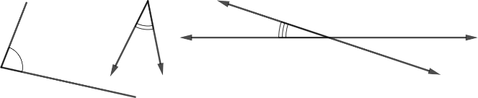
acute triangle | A triangle with all interior angles smaller than 90°. | 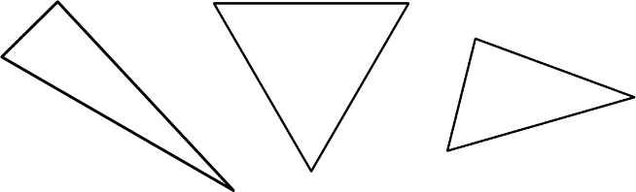
angle | Angles are formed wherever two lines, segments, or rays intersect. | 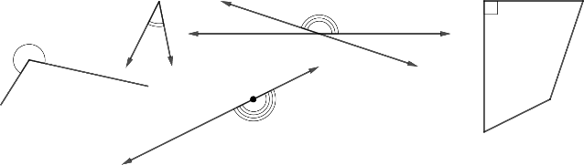
area model | A rectangular diagram that utilizes the decomposition of side lengths by place value to multiply numbers using the distributive property. | $32×12$ can be thought of as  $(30×10)+(30×2)+(2×10)+(2×2)$ which is equivalent to 384. This is demonstrated in the area model below.
   | 10 | 2
  30 | 300 | 60
  2 | 20 | 4
associative property of addition | Refer to Properties of Operations, Equality and Inequality (Appendix D). | $(5 + 6) + 9 = 5 + (6+9)$
associative property of multiplication | Refer to Properties of Operations, Equality and Inequality (Appendix D). | $(2 × 3) × 8 = 2 × (3 × 8)$
automaticity | In mathematical activities, the ability to act according to an automatic response or pattern which is easily retrieved from long-term memory. Usually results from repetition and practice.
bar graph | A visual display of categorical data values where each category is represented by a bar whose height represents the number in that category.
benchmark angles | Widely recognized angles that are used to classify and estimate angle measures, including 30º, 45º, 60º, 90º. | 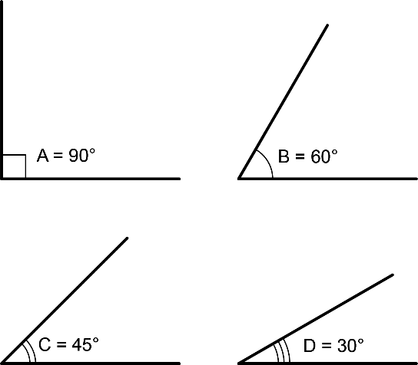
Cardinality Principle | The understanding that when the objects in a collection are being counted, the last count word in the counting sequence represents the total number of items in the collection.
categorical data | A type of data which is divided into groups. | Examples of categorical data are type of pet, hair color, favorite sport/game, etc.
circle | A perfectly round two-dimensional figure, where all points on the circle are equidistant from the center.
circle graph | A visual display of categorical data. The whole set of data is represented by the circle and its interior. The categories are represented by fractional parts of the circle. Also called a pie chart.
commutative property of addition | Refer to Properties of Operations, Equality and Inequality (Appendix D). | $2+3=5$ and $3+2=5$
commutative property of multiplication | Refer to Properties of Operations, Equality and Inequality (Appendix D). | $2×3=6$ and $3×2=6$
composite figure | A two- or three-dimensional figure that can be decomposed into smaller figures. | A rectangle can be decomposed into two right triangles.  The polygons below could be decomposed into the smaller figures represented by the dotted lines.  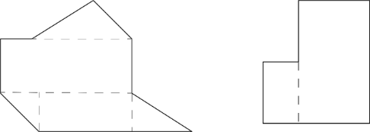  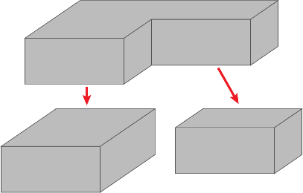
composite number | A whole number greater than 1 that has at least one whole-number divisor other than 1 and itself. | 4 is composite because it has three unique, whole-number divisors: 1, 2, 4  24 is composite because it has eight unique, whole-number divisors: 1, 2, 3, 4, 6, 8, 12, 24  23 is not composite because it only has two unique, whole-number divisors: 1, 23  1 is not composite because it only has one unique, whole-number divisor: 1
coordinate plane (first quadrant) | An infinite two-dimensional space bounded on two sides by two perpendicular scaled axes. The axes intersect at the origin. Each point in the coordinate plane is represented by a pair of coordinates that represent the distances from each axis. The origin is represented by the coordinate pair $(0,0)$. | 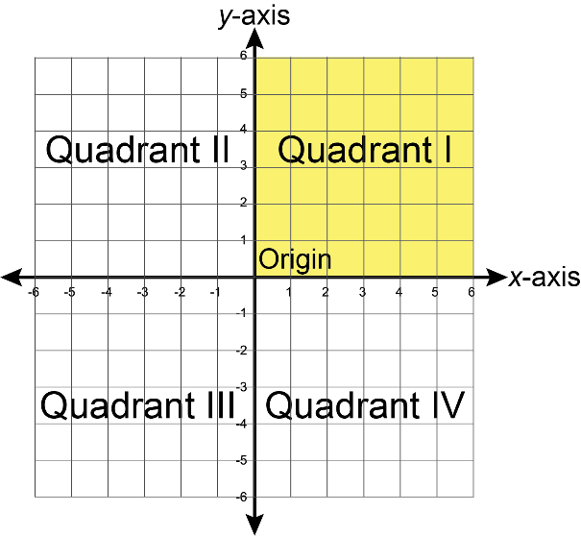
cube | A rectangular prism with six congruent square faces. | 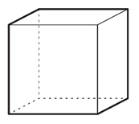
cylinder (right circular) | A figure containing two congruent, parallel, circular bases whose edges are connected by a perpendicular curved surface. | 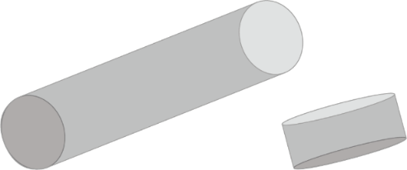
distributive property | Refer to Properties of Operations, Equality and Inequality (Appendix D). | $6\left(2+3\right)=(6×2)+(6×3)$
dividend | A quantity that is to be divided. | In the equation $6÷2=3$, 6 is the dividend.
divisor | The number by which another number is divided. | In the equation $6÷2=3$, 2 is the divisor.
edge | In a figure, the segment or curve where two faces intersect. | 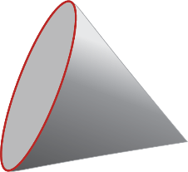
equal sign | The equal sign is placed between two quantities or expressions to indicate they have the same value or represent the same value. | $7=3+4$  $4×2=5+3$  $5+?=17$ is true if $?=12$.
equation | A mathematical relation statement where two equivalent expressions and values are separated by an equal sign. | $55÷5=24-13$
equilateral triangle | A triangle with three equal-length sides and three 60-degree interior angles. Also known as an equiangular triangle. | 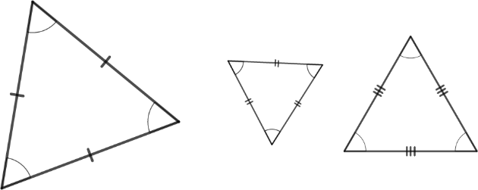
expression | A mathematical statement containing numerals, operators, grouping symbols and symbols or variables for unknown values. An expression does not contain an equal sign or inequality symbol. | $4×2$  $\frac{9}{5}-\frac{1}{3}$
factors (of positive whole numbers) | Whole numbers into which a positive whole number can be evenly divided. | 1, 3, 5, and 15 are factors of 15  One is a factor of every whole number.
hexagon | A polygon containing exactly six sides and six vertices. | 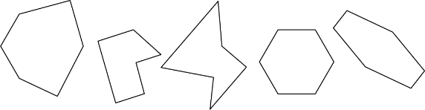
isosceles triangle | A triangle containing at least two equal length sides and two equal interior angle measures. Sub-class includes equilateral triangles. | 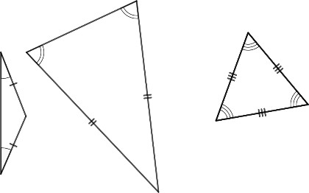
line | In geometry, a straight path that extends infinitely in both directions. Represented in diagrams as line with arrowheads at both ends.
line plot | A method of visually displaying a distribution of data values where each data value is shown as a dot or mark above a number line. Also known as a dot plot. | 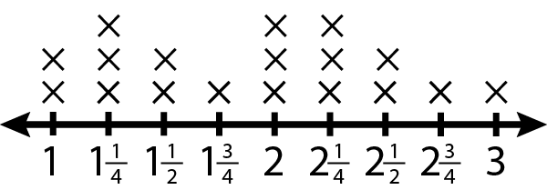
line of symmetry | A line that divides a figure into two parts with the same shape and size. When the figure is folded along the line of symmetry, the two parts match. | 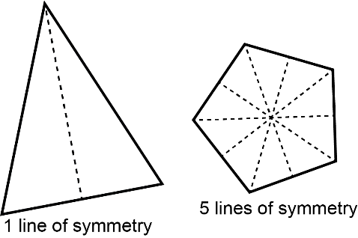
mean | The arithmetic average of a set of numbers found by dividing the sum of all values by the number of values. It is a measure of central tendency. | For the data set $\{2.3, 5.1, 9, 9, 11.5, 12, 17.1\}$, the mean is 9.4.  For the data set $\{8, 9, 27, 11, 5, 3\}$, the mean is 10.5.
median | The middle of an ordered list of values. If the list has an odd number of values, it is the middle value of that list. If the list has an even number of values, it is the mean of the two middle values. It is a measure of central tendency. | For the data set $\{23, 25, 26, 37, 40, 42, 44, 44, 48, 90\}$, the median is 41.  For the data set $\{4, 7, 8, 11, 14, 16, 20\}$, the median is 11.
mode | The value found most often in a set of numbers. There may be no mode, one mode, or more than one mode in a set of numbers. It is a measure of central tendency. | For the data set $\{3.3, 5, 13.7, 6.2, 9.3, 9\}$, there is no mode.  For the data set $\left\{\frac{2}{5}, \frac{1}{2}, \frac{7}{2}, \frac{2}{5}, \frac{1}{5}\right\}$, the mode is $\frac{2}{5}$.  For the data set $\{32, 73, 88, 35, 42, 73, 33, 88, 64\}$, the modes are 73 and 88.
natural number | The counting numbers {1, 2, 3, 4, 5…}.
number line | A straight line with evenly spaced marks labeled with successive numbers. Values are plotted as points on the line. | 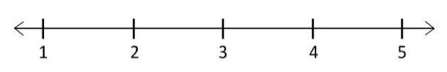
obtuse angle | An angle larger than 90º and smaller than 180º. | 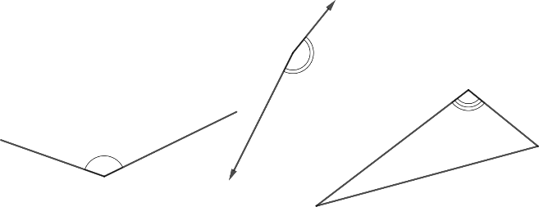
obtuse triangle | A triangle containing one interior angle larger than 90º. | 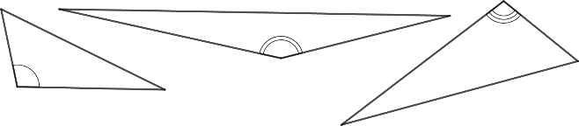
octagon | A polygon containing exactly eight sides and eight vertices. | 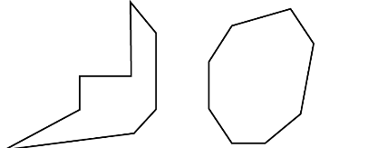
origin | In the coordinate place, the location where the x-axis and y-axis intersect. The coordinates of the origin are $(0,0)$. | 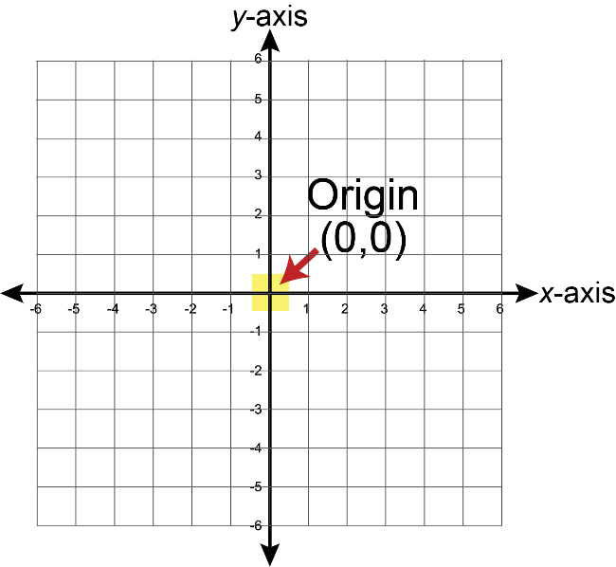
parallelogram | A quadrilateral containing two pairs of parallel sides. A member of the following shape classes: polygons, quadrilaterals, trapezoids. Sub-classes include rectangles, rhombi, and squares. | 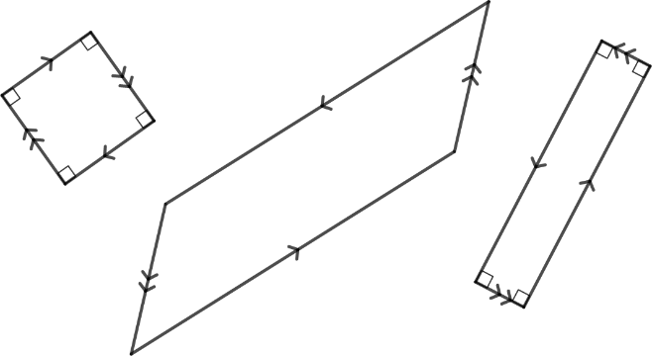
pentagon | A polygon containing exactly five sides and five vertices. | 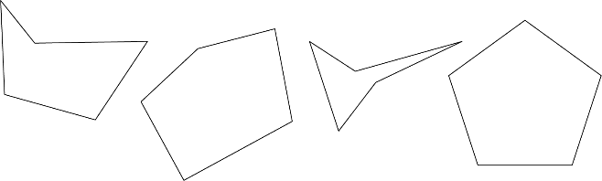
perimeter (of a polygon) | The sum of the side lengths of a polygon. | Rectangle: $P=l+l+w+w$  $P=2l+2w$  Square: $P=s+s+s+s$  $P=4s$
polygon | A closed two-dimensional figure composed of at least three straight sides and three vertices. | 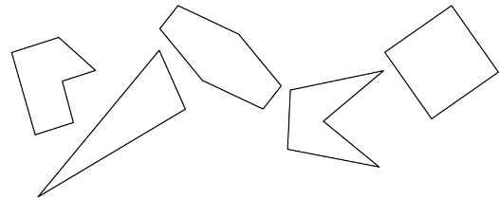
prime number | A whole number greater than 1 that is not divisible by any whole number other than 1 and itself. | 17 is a prime number.  16 is not a prime number.
prism (right) | A figure with two parallel bases that are the same shape and size. The bases are connected by rectangular faces that are perpendicular to the bases. A box with identical polygons on each end. | 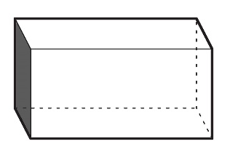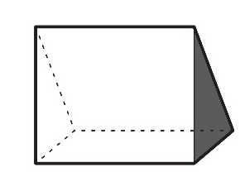
pyramid (regular) | A figure containing a polygonal base and triangular faces. The triangular faces have the same size and shape and they connect the sides of the base to a common point called the apex. | 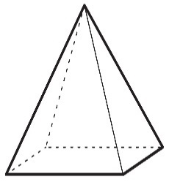
quadrilateral | A polygon with exactly four sides and four vertices. Sub-classes include trapezoids, parallelograms, rectangles, rhombi, and squares. | 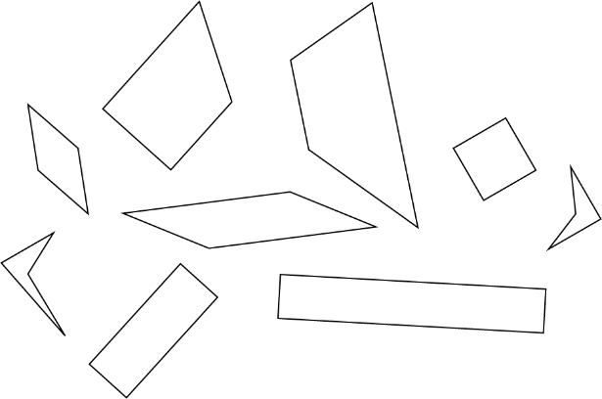
rectangle | A quadrilateral containing four right angles. Rectangles may be oblong or square. A member of the following shape classes: polygons, quadrilaterals, trapezoids, parallelograms. Squares form a sub-class. | 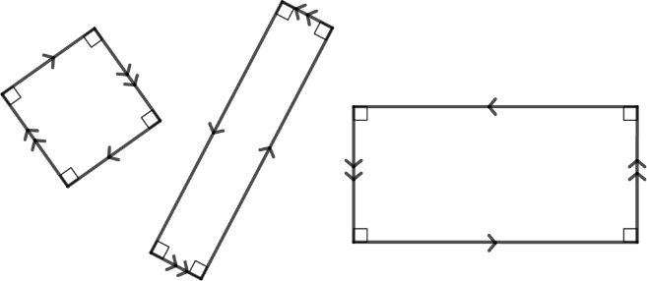
rectangular array | An arrangement of objects or symbols in rows and columns. All rows have an equal number and all columns have an equal number. | 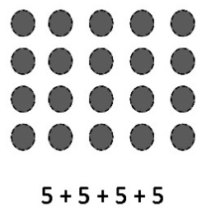
rectangular prism | A prism with rectangular bases. Cubes form a sub-class. | 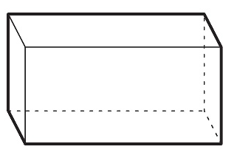
rectangular pyramid | A pyramid with a rectangular base. | 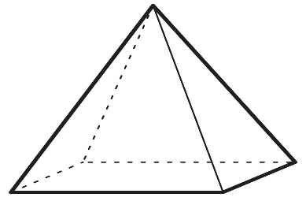
reflex angle | An angle larger than 180º and smaller than 360º. | 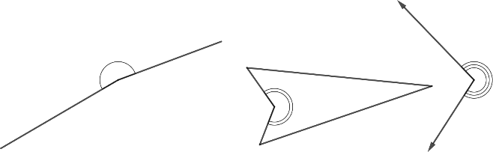
regular polygon | A polygon containing all equal-length sides and all equal-measure interior angles. | 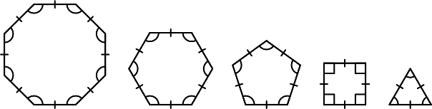
rhombus | A quadrilateral containing four equal-length sides. A member of the following shape classes: polygons, quadrilaterals, trapezoids, parallelograms. Squares form a sub-class. | 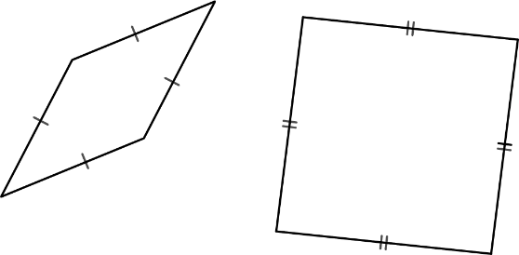
right angle | An angle measuring exactly 90º. | 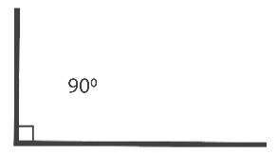
right triangle | A triangle containing an interior right angle. | 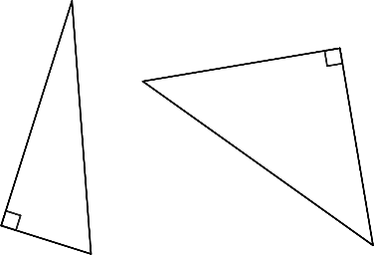
scalene triangle | A triangle containing three unequal side lengths and three unequal angle measures. | 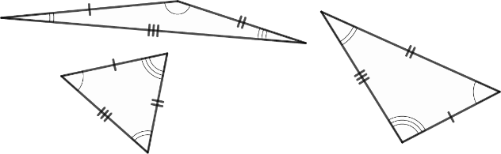
sphere | A three-dimensional figure with all points equidistant from a point called the center. | 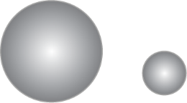
square | A quadrilateral with four right angles and four equal-length sides. A member of the following shape classes: polygons, quadrilaterals, trapezoids, parallelograms, rectangles, rhombuses.
stem-and-leaf plot | A table that organizes data by place value to compare data frequencies. | The data set {1, 4, 5, 8, 10, 11, 13, 27, 27, 28, 30, 31, 31, 40, 44, 63, 66} can be organized in a stem-and-leaf plot as shown below.
  stem | leaf
  0 | 1, 4, 5, 8
  1 | 0, 1, 3,
  2 | 7, 7, 8
  3 | 0, 1, 1,
  4 | 0, 4,
  5
  6 | 3, 6
straight angle | An angle measuring exactly 180º. | 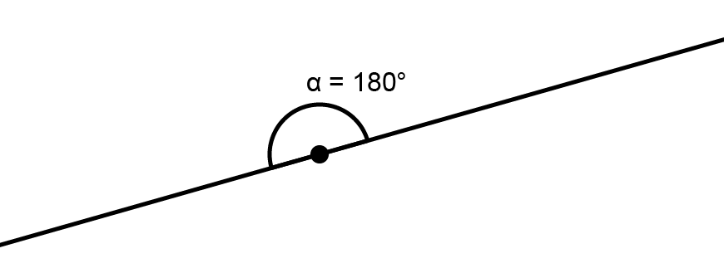
trapezoid | A quadrilateral with at least one pair of parallel sides. A member of the following shape classes: polygons, quadrilaterals. Sub-classes include parallelograms, rectangles, rhombuses, and squares. | 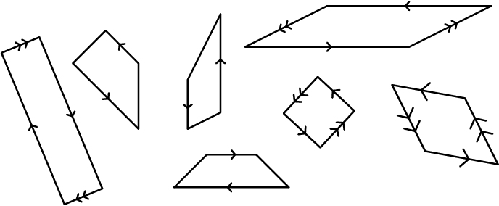
triangle | A polygon with exactly three sides and three vertices. | 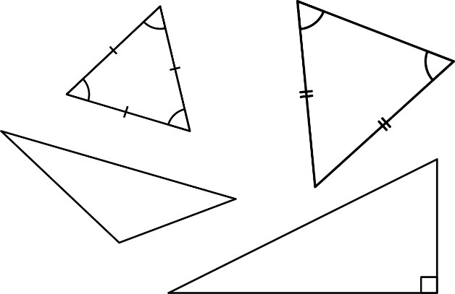
triangular prism | A prism with triangular bases. | 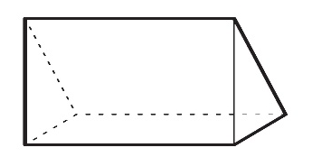
triangular pyramid | A pyramid with a triangular base. | 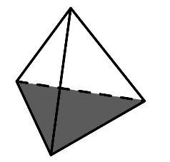
vertex (of a figure) | The point at which the rays or sides of an angle, the sides of a two-dimensional figure, or the edges of a three-dimensional figure meet. | 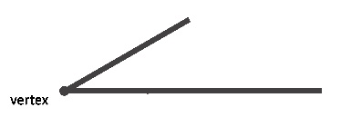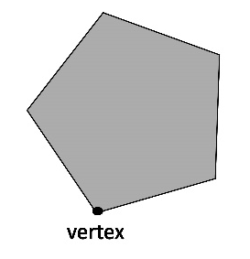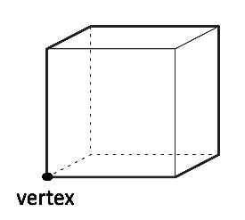
whole number | The natural numbers and zero. | {0, 1, 2, 3, 4, 5,…}.
$x$-axis | The horizontal axis in certain graphs, and in the coordinate system. In the coordinate system, the $x$-axis divides positive $y$-values from negative $y$-values, and the $y$-value of any point lying on the $x$-axis equals zero. | 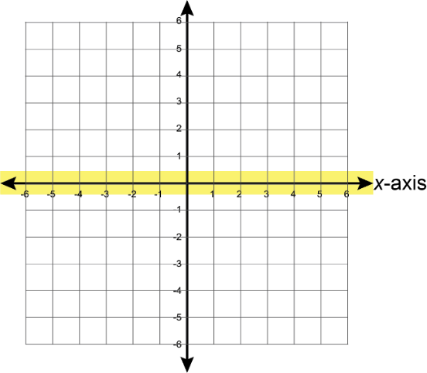
$y$-axis | The vertical axis in certain graphs, and in the coordinate system. In the coordinate system, the $y$-axis divides positive $x$-values from negative $x$-values, and the $x$-value of any point lying on the $y$-axis equals zero. | 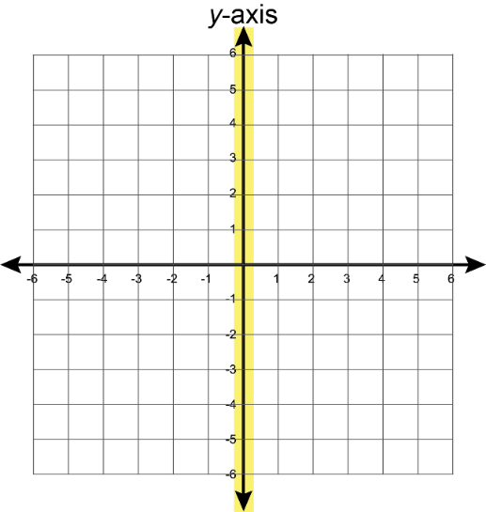

6-12 Mathematics Glossary
The following glossary is a reference list provided for teachers to support the expectations of the Florida’s B.E.S.T Standards for Mathematics for grades six to twelve. This glossary is not intended to comprise a comprehensive vocabulary list for teachers or students. The Florida Department of Education (FDOE) recognizes that there may be alternative definitions for some terms that are also mathematically correct, however, the intention here is to provide common language and shared understanding among all stakeholders in the state of Florida.
Vocabulary | Definition | Example
absolute value | A number’s distance from zero (0) on a number line. Distance is expressed as a positive value. | $\left|3\right|=3$ and $\left|-3\right|=3$
additive identity property | Refer to Properties of Operations, Equality and Inequality (Appendix D). | $5+0=5$
additive inverse property | Refer to Properties of Operations, Equality and Inequality (Appendix D). | In the equation $3+-3=0$, 3 and $-3$ are additive inverses of each other
addition property of equality | Refer to Properties of Operations, Equality and Inequality (Appendix D). | If $k-3=7$, then $k-3+3=7+3$.
addition property of inequality | Refer to Properties of Operations, Equality and Inequality (Appendix D). | If $k-3>7$, then $k-3+3>7+3$.
algorithm | A step-by-step way to solve a problem.
analytic geometry | The branch of mathematics that uses functions and relations to study geometric phenomena. | The description of ellipses and other conic sections in the coordinate plane by quadratic equations
angle $\left(∠\right)$ | Angles are formed wherever two lines, segments or rays intersect. Angles are measured in degrees. | 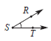  In the figure, the angle can be named $∠S, ∠RST, ∠TSR$.
area | The measure, in square units, of the inside region of a closed two-dimensional ﬁgure. | The area of a rectangle with dimensions 5 units by 8 units is 40 square units.
arithmetic sequence | A sequence of numbers in which each consecutive pair of numbers has a common difference. | The $n$th term of an arithmetic sequence with the first term $a_{1}$ and common difference $d$ is given by $a_{n}=a_{1}+\left(n-1\right)d$, where $n$ is a positive integer.
association | A way to describe the form, direction or strength of the relationship between the two variables in a bivariate data set. For numerical data, descriptions include linear or nonlinear; positive or negative; strong or weak. For categorical data, descriptions include strong or weak.
associative property | Refer to Properties of Operations, Equality and Inequality (Appendix D). | $\left(5+6\right)+9=5+(6+9)$  $\left(2×3\right)×8=2×(3×8)$
axes (of a graph) | The horizontal and vertical number lines used in a coordinate plane system. | 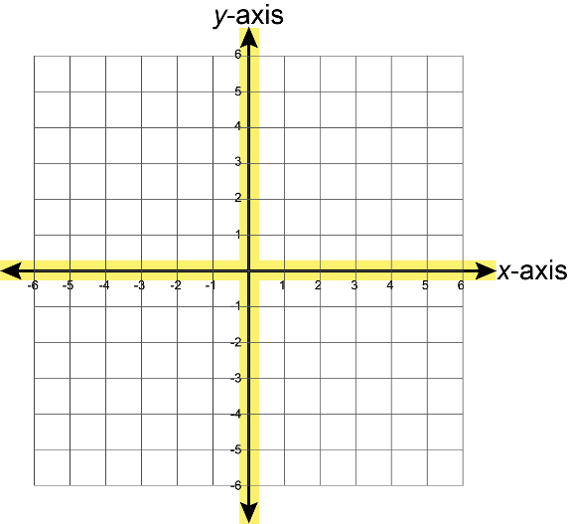
bar graph | A visual display of categorical data values where each category is represented by a bar whose height represents the number in that category. Bar graphs can be represented vertically or horizontally.
base (of an exponent) | The number used as a factor in exponential form. | $b^{3}$ is the exponential form of $b×b×b$. The variable $b$ is called the base, and the numeral 3 is called the exponent.
bivariate data | Data that measures two characteristics of a population. | hair color and eye color  height and weight
box plot | A plot displaying the spread or distribution of a data set using a five number summary, the minimum, lower quartile, median, upper quartile and maximum. It is also called a box-and-whisker plot. | 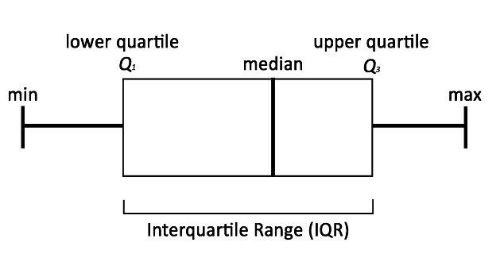
capacity | The amount of space that can be filled in a container. Both capacity and volume are used to measure three-dimensional spaces; however, capacity usually refers to ﬂuid measures, whereas volume is measured in cubic units.
categorical data | A type of data which is divided into groups. Categorical data are qualitative. | Examples of categorical data are type of pet, movie genre, favorite sport/game, etc.
central angle | An angle that has its vertex at the center of a circle with radii as its sides. | 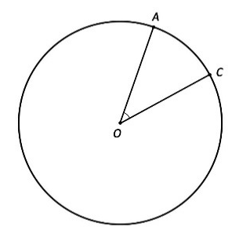
circle graph | A visual display of categorical data. The whole set of data is represented by the circle and its interior. The categories are represented by fractional parts of the circle. Also called a pie chart.
circumference | The distance around a circle. | A circle with radius 3 units has a circumference of $6π$ units.
circumscribed circle | The smallest circle that includes a plane figure. If the figure is a polygon, then the circle must contain all of the vertices of the polygon. Not every polygon has a circumscribed circle, but all triangles and all regular polygons have circumscribed circles. | 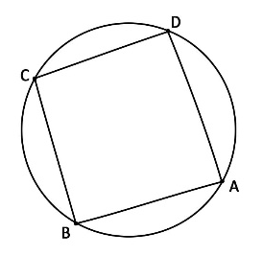
cluster (data) | Data that are in a close group on a scatter plot or univariate numerical data that have similar values.
coefficient | The number or constant that multiplies a variable in an algebraic expression. If no number is specified, the coefficient is 1. | Within the expression $4xy$, 4 is the coefficient.  Within the equation $y=mx+b$, $m$ is the coefficient of $x$.
commutative property (of addition or multiplication) | Refer to Properties of Operations, Equality and Inequality (Appendix D). | $2+3=3+2$  $4×7=7×4$
complementary angles | Two angles whose measures sum to 90°. | 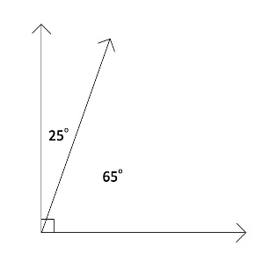
composite number | A whole number greater than 1 that has at least one whole-number factor other than one and itself. | 4 is composite because it has three unique, whole-number factors: 1, 2, 4  24 is composite because it has eight unique, whole-number factors: 1, 2, 3, 4, 6, 8, 12, 24  23 is not composite because it only has two unique, whole-number factors: 1, 23  1 is not composite because it only has one unique, whole-number factor: 1
compound inequality | A conjunction of two or more inequalities. | $$-4≤x≤\frac{3}{5}$$
concave polygon | A polygon with one or more diagonals that have points outside the polygon. See convex polygon. | 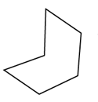
conditional relative frequency | The ratio of a joint relative frequency and a marginal relative frequency. Equivalently, the ratio of a relative frequency and a marginal frequency.
cone | A three-dimensional figure with a circular base and an apex that is connected to the base by a collection of line segments that form a curved surface. | 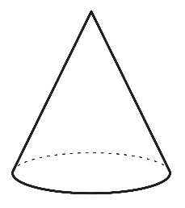
congruent | Having exactly the same shape and size. Equivalently, two figures are congruent if one can be mapped to the other using a rigid transformation.
constant of proportionality | The constant value of the ratio of two proportional quantities. | In the equation $y=kx$, $k$ is the constant of proportionality.
converse of Pythagorean Theorem | If the lengths $a$, $b$ and $c$ of the three sides of a triangle satisfy the relationship $a^{2}+b^{2}=c^{2}$, then the triangle is a right triangle.
convex polygon | A polygon with each interior angle measuring less than 180°. All diagonals of a convex polygon lie inside the polygon. See concave polygon.
coordinate plane | A plane determined by two perpendicular number lines called axes. The axes intersect at the origin. Each point in the coordinate plane is represented by a pair of coordinates that represent the direction and distance from each axis. The origin is represented by the coordinate pair $(0,0)$. | 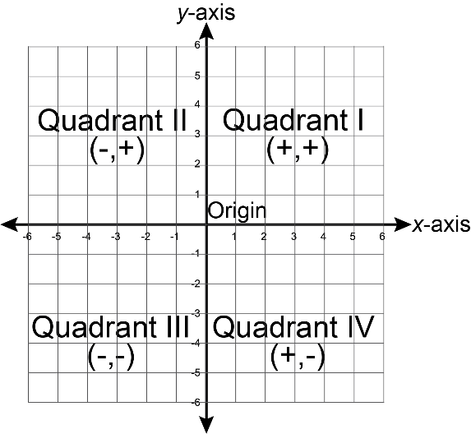
coordinate | A number used to locate a point on a number line. One of the numbers in an ordered pair, or triple, that locates a point on a coordinate plane or in coordinate space, respectively.
corresponding angles | Angles that are in the same position on two parallel lines in relation to a transversal. | 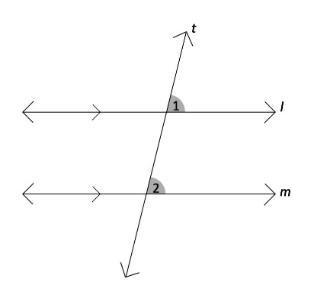
cube | A rectangular prism with six congruent square faces. | 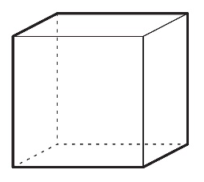
customary units | The units of measure used in the United States.  - Customary units for length include inches, feet, yards, and miles.  - Customary units for weight include ounces, pounds, and tons.  - Customary units for volume include cubic inches, cubic feet, and cubic yards.  - Customary units for capacity include ﬂuid ounces, cups, pints, quarts, and gallons.
cylinder (circular) | A figure containing two congruent, parallel, circular bases whose edges are connected by a curved surface. The net of the cylinder consists of a parallelogram and two circles. | 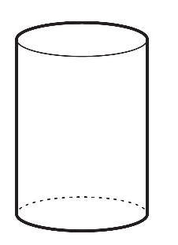
data | Values that are collected together for reference or analysis.
diameter | A line segment from any point on the circle passing through the center to another point on the circle. | 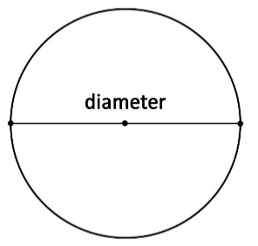
dilation | A proportional increase or decrease in size in all directions.
distributive property | Refer to Properties of Operations, Equality and Inequality (Appendix D). | $x\left(a + b\right)=ax+bx$
domain | The complete set of possible values of the input of a function or relation. The domain may vary depending on the context. See range (of a relation or function). | In the relation $\{\left(-6, 1\right), \left(-1, 2\right), \left(4, 6.1\right), \left(6,-3\right)\}$, the domain is the set of numbers $\{-6, -1, 4, 6\}$.
equilateral triangle | A triangle with three equal-length sides and three 60° interior angles. Also known as an equiangular triangle. | 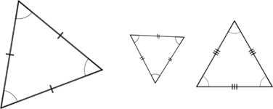
estimation | The use of methods to determine a reasonably accurate approximation, without calculating an exact answer.
event | A set of possible outcomes resulting from an experiment. In general, an event is any subset of a sample space. | In the experiment of rolling a single six-sided die, an example of an event is {5, 6}. That is, the roll could be a 5 or a 6.
exponent (exponential form) | The number of times the base occurs as a factor. | $b^{3}$ is the exponential form of $b×b×b$. The variable $b$ is called the base, and the numeral 3 is called the exponent.
exponential function | An exponential function is a function with a constant percent rate of change. | Exponential function can be written in the form$y=ab^{x}$, where $a≠0$and $b>0$.
experimental probability | The ratio of the number of times an event occurs to the total number of trials or times the activity is performed. Also called empirical probability.
frequency table | A table that shows how often each item, number, or range of numbers occurs in a set of data.
  Size | Tally Marks | Frequency
  2 | II | 2
  3 | IIII | 5
  4 | IIII | 4
  5 | IIII | 4
  6 | IIII I | 6
  7 | IIII II | 7
  Total |  | 28
function | A mathematical relation for which each element of the domain corresponds to exactly one element of the range.
function notation | A notation that describes a function. For a function $f$when $x$ is a member of the domain, the symbol$f\left(x\right)$ denotes the corresponding member of the range. | $f\left(x\right)=x+3$
geometric sequence | A sequence of numbers in which each consecutive pair of numbers has a common ratio. | The $n$th term an of a geometric sequence with first term $a_{1}$ and common ratio $r$ is given by  $a_{n}=a_{1}r^{(n-1)}$, where $n$ is any positive integer, $a_{1}≠0$ and $r≠0$.
greatest common factor (GCF) of two or more whole numbers | The largest whole number that evenly divides the given whole numbers. | 7 is the greatest common factor of 14, 28 and 49.
histogram | A visual display of numerical data using bars along a number line with no spaces between the bars. The height of each bar represents either the frequency or relative frequency of data within that interval.
hypotenuse | The longest side of a right triangle; the side opposite the right angle. | 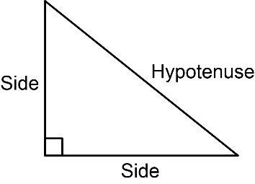
identity property of addition | Refer to Properties of Operations, Equality and Inequality (Appendix D). | $0+4.25=4.25$
identity property of multiplication | Refer to Properties of Operations, Equality and Inequality (Appendix D). | $\frac{11}{7}×1=\frac{11}{7}$
inscribed angle in a circle | An angle which is formed in the interior of a circle when two chords share an endpoint.
inscribed circle | The largest possible circle that can be contained in a plane figure. If the plane figure is a polygon, then the circle must be tangent to all of the sides of the polygon. Not every polygon has an inscribed circle, but all triangles and all regular polygons have inscribed circles. | 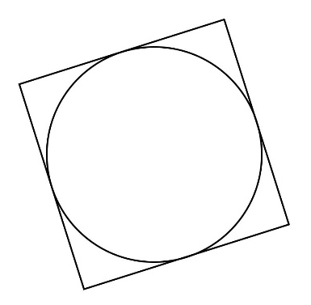
inscribed polygon in a circle | A polygon which has all of its vertices on a circle.
integers | Whole numbers and their opposites. | $\{. . . -4, -3, -2, -1, 0, 1, 2, 3, 4 . . .\}$
intercept | The value of a variable when all other variables in the equation equal 0. On a graph, the values where a function crosses an axis.
interquartile range (IQR) | A measure of variation in a set of numerical data, the interquartile range is the distance between the first and third quartiles of the data set. See quartile and box plot. | Example: For the data set $\{1, 3, 6, 7, 10, 12, 14, 15, 22, 120\}$, the interquartile range is $15-6=9$.
inverse functions | Two functions, $y=h\left(x\right)$ and  $x=g\left(y\right)$, are said to be inverses when $g\left(h\left(x\right)\right)=x$and $h\left(g\left(y\right)\right)=y$. The function inverse to $f(x)$ is denoted $f^{-1}(x)$.
irrational number | A real number that cannot be expressed as a ratio of two integers. | $\sqrt{2}$  $$π$$
joint frequency | In a two-way table, joint frequency is the number of times a combination of two conditions occurs.
joint relative frequency | Joint relative frequency is the ratio of the joint frequency and the total number of data points.
least common multiple (LCM) | The lowest number that is a multiple of two or more given numbers. | The least common multiple of 6 and 9 is 18.
line of fit | A line drawn on a scatter plot to estimate the relationship between two sets of data. Also known as a trend line. See scatter plot.
line graph | A graph that displays numerical data using connected line segments.
line plot | A visual display of data values where each data value is shown as a dot or mark above a number line. Also known as a dot plot.
linear expression (or linear equation) | A polynomial expression or equation that contains a term of degree 1, but no term of higher degree. | $7+6p$  $C=6.45g-78$
linear function | A function that has a constant rate of change. | A linear function can be written in the form  $y=mx+b$.
line of symmetry | A line that divides a figure into two congruent parts, so that the reflection of either part across the line maps precisely onto the other part.
matrix | A rectangular array of numbers or variables. | $\left(\begin{matrix}a & b & c\end{matrix}\right)$  $\left(\begin{matrix}1 & 0 \\ 0 & 1\end{matrix}\right)$
mean | The arithmetic average of a set of numbers. It is a measure of central tendency. | For the data set $\{1, 3, 6, 7, 10, 12, 14, 15, 22, 120\}$, the mean is $21$.
measures of center | A numerical value used to describe the overall clustering of data in a set, or the overall central value of a set of data. The three most common measures of central tendency are the mean, median, and mode.
measures of variability | A numerical value that measures how much a data set varies from a central value.
median | The middle of an ordered list of values. If the list has an odd number of values, it is the middle value of that list. If the list has an even number of values, it is the average of the two middle values. It is a measure of central tendency. | For the data set $\{23, 25, 26, 37, 40, 42, 44, 44, 48, 90\}$, the median is $41$.  For the data set $\{4, 7, 8, 11, 14, 16, 20\}$, the median is $11$.
metric units | The units of measure used in most of the world. Like the decimal system, the metric system uses the base 10.  - Metric units for length include millimeters, centimeters, meters, and kilometers.  - Metric units for mass include milligrams, grams, and kilograms.  - Metric units for volume include cubic millimeters, cubic centimeters, and cubic meters.  - Metric units for capacity include milliliters, centiliters, liters, and kiloliters.
mode | The value found most often in a set of numbers. There may be no mode, one mode, or more than one mode in a set of numbers. It is a measure of central tendency. | For the data set $\{3.3, 5, 13.7, 6.2, 9.3, 9\}$, there is no mode.  For the data set $\left\{\frac{2}{5}, \frac{1}{2}, \frac{7}{2}, \frac{2}{5}, \frac{1}{5}\right\}$, the mode is $\frac{2}{5}$.  For the data set $\{32, 73, 88, 35, 42, 73, 33, 88, 64\}$, the modes are $73$ and $88$.
monomial | A polynomial with one term. | $5x^{3}$, $8$, and $4xy$
multiplicative identity | Refer to Properties of Operations, Equality and Inequality (Appendix D). | $-9⋅1=-9$  $1\left(\frac{3}{2}\right)=\frac{3}{2}$
multiplicative inverse (reciprocal) | Refer to Properties of Operations, Equality and Inequality (Appendix D). | $4$ and $\frac{1}{4}$. Zero (0) has no multiplicative inverse.
net | A two-dimensional diagram that can be folded or made into a three-dimensional figure. | 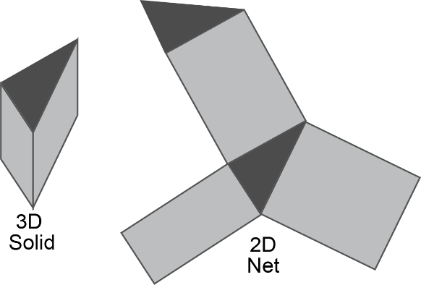
order of operations | The order of performing computations is to first work within grouping symbols using the order of operations. Then simplify terms with exponents. Next, while reading from left to right, perform multiplication and division in the order in which it appears. Finally, while reading from left to right, perform addition and subtraction in the order in which it appears. | $5^{2}+\left(12-2\right)÷2-3×2$  $5^{2}+(10)÷2-3×2$  $25+10÷2-3×2$  $25+5-6$  $30-6$  $24$
origin | The point of intersection of the $x$- and $y$-axes in a rectangular coordinate system, where the $x$-coordinate and $y$-coordinate are both $0$. | 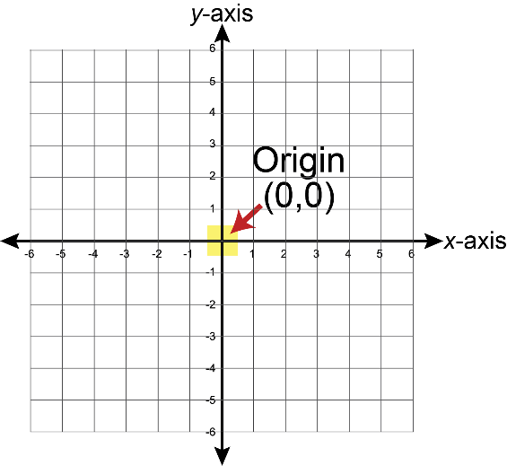
outlier | A value that is much higher or much lower than the other values in a set of data.
percent of change | The difference between a final value and an initial value, expressed as a percentage of the initial value.
percent error | The difference between the estimated number and the actual number as a percentage of the actual value. | If the estimate is $95$ and the actual is $89$, the percent error is $\frac{95-89}{89} ≈6.74\%$.
pi (π) | The symbol designating the ratio of the circumference of a circle to its diameter. It is an irrational number. Common approximations are $3.14$, $\frac{22}{7}$ or $\frac{355}{113}$.
piecewise function | A function defined by multiple sub functions, each of which applies to a certain interval of the main function’s domain. | An absolute value function, $y=\left|x\right|$, is an example of a piecewise function.
polynomials | The sum or difference of terms which have variables raised to non-negative integer powers and which have coefficients that may be real or complex. | $5x^{3}-2x^{2}+x-13$  $x^{2}y^{3}+ xy$  $\left(1+i\right)a^{2}+ib^{2}$
population (in data analysis) | The entire set of cases or individuals under consideration in a statistical analysis. | A poll given to a sample of voters is designed to measure the preferences of the population of all voters.
prime factorization | The expression of a number as the product of prime factors. | The prime factorization of 72 is  $2×2×2×3×3$.
prime number | A whole number greater than 1 that is not divisible by any whole number other than 1 and itself. | $17$ is a prime number.  $16$ is not a prime number.
principal square roots | The principal square root is the positive square root of a positive real number.
proportional relationships | A collection of pairs of numbers that are in equivalent ratios. | If $y=kx$, then $y$ is said to be directly proportional to $x$ and the constant of proportionality is $k$.
quadrant | Any of the four regions separated by the axes in a coordinate plane. | 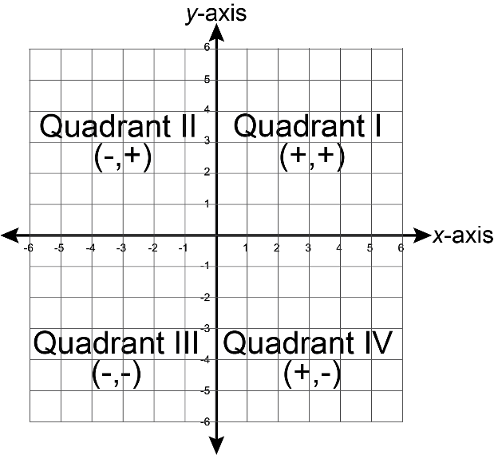
quadratic expression (or quadratic equation) | A polynomial expression or equation that contains a term of degree 2, but no term of higher degree. | $8-4x+9.2x^{2}$  $y-8.3=3{(x+2.1)}^{2}$
quadratic function | A polynomial function with degree of 2. | A quadratic function can be expressed in the form $y=ax^{2}+bx+c$.
quartiles | For a data set with median M, the first quartile is the median of the data values less than M and the third quartile is the median of the data values greater than M. The second quartile is the median M.
radius | A line segment extending from the center of a circle or sphere to a point on the circle or sphere. | 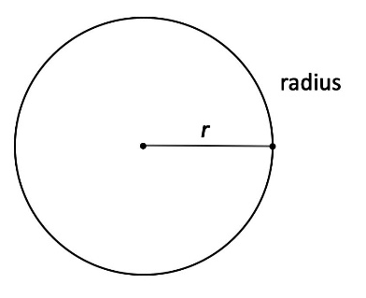
random sampling | A smaller group of people or objects chosen from a larger group or population by a process giving equal chance of selection to all possible people or objects, and all possible subsets of the same size.
random variable | An assignment of a numerical value to each outcome in a sample space.
range (of a data set) | The difference between the highest data value and the lowest data value. | For the data set $\{3.3, 5, 13.7, 6.2, 9.3, 9\}$, the range is $10.4$.
range (of a relation or function) | The complete set of possible values of the output of a relation or function. See domain. | In the relation $\{\left(-6, 1\right), \left(-1, 2\right), \left(4, 6.1\right), \left(6,-3\right)\}$, the range is the set of numbers $\{-3, 1, 2, 6.1\}$.
rate | A ratio that compares two quantities of different units. | feet per second
rate of change | The ratio of change in one quantity to the corresponding change in another quantity. | Given the order pairs $(7, 5)$ and $(0, 11)$, the rate of change is $\frac{5-11}{7-0}=-\frac{6}{7}$.
rational expression | A quotient of two polynomials with a non-zero denominator. | $\frac{x^{3}-5x+1}{x^{2}+9}$
rational number | A real number that can be expressed as the ratio of two integers.
real numbers | The set of all rational and irrational numbers.
reﬂection | A transformation that produces the mirror image of a geometric ﬁgure across a line of reﬂection. | 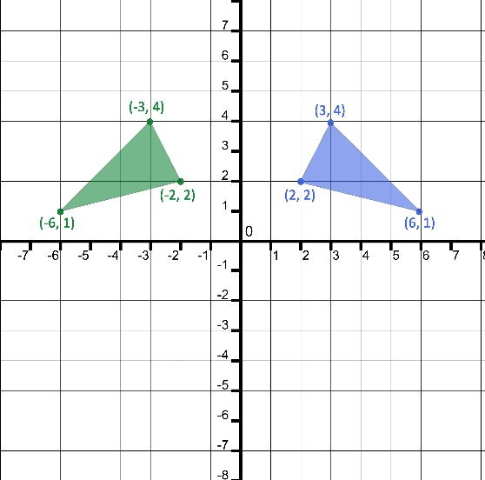
regular polygon | A polygon that is both equilateral (all sides congruent) and equiangular (all angles congruent). | 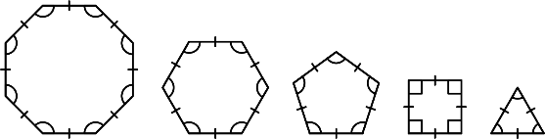
relation | A set of input-output pairs.
repeated experiment | A random experiment done with the same conditions and parameters as a previous one.
rigid transformation | A transformation of points in space consisting of a sequence of one or more translations, reflections, or rotations. Rigid transformations preserve distances and angle measures (congruency).
rotation | A transformation of a ﬁgure by turning it about a center point or axis. The amount of rotation can be expressed in the number of degrees. The direction of the rotation for two-dimensional figures can be expressed as clockwise or counterclockwise. | 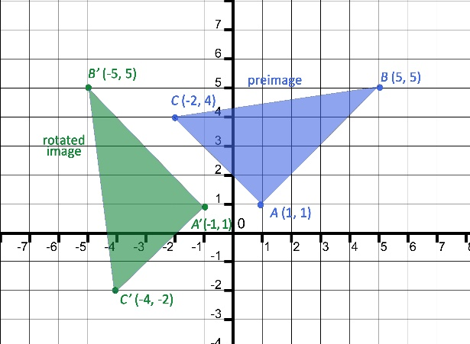
sample space | In a probability model for a random process, a list of the individual outcomes that are to be considered.
scale | The numeric values, set at fixed intervals, assigned to the axes of a graph.
scale factor | The constant that is multiplied by the length of each side of a ﬁgure to produce an image that is the same shape as the original ﬁgure.
scale model | A model or drawing based on a ratio of the dimensions for the model and the actual object it represents. | 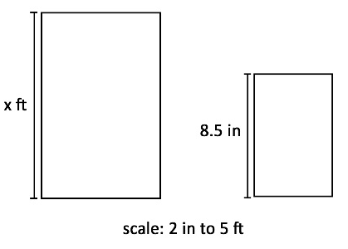
scatter plot | A graph in the coordinate plane representing a set of bivariate numerical data that is used to observe the relationship between two variables. See line of fit. | 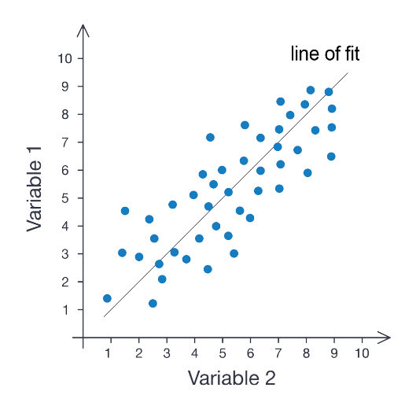
scientiﬁc notation | A method of writing very large or very small numbers using exponents in which a number is expressed as the product of a power of $10$ and a number that is at least 1 and less than 10. | $7.59×{10}^{5}=759,000$
set-builder notation | A shorthand used to write sets, often sets with an infinite number of elements. The set $\{x:x>0\}$ is read aloud, "the set of all $x$ such that $x$ is greater than $0$." It is read aloud exactly the same way when the colon $:$ is replaced by the vertical line $|$ as in $\{x|x>0\}$. | $\{x: x≠3$} - the set of all real numbers except $3$.  $\left\{x \right|x<5\}$ - the set of all real numbers less than $5$.  $\{2n+1: n$ is an integer$\}$ - the set of all odd integers (e.g. ..., $-3, -1, 1, 3, 5$...).
significant digits | The nonzero digits of a number and the zeros that are included between them or any trailing zeros that are considered to be precise.
similarity | Having exactly the same shape but not necessarily the same size. Equivalently, two figures are similar if one can be mapped to the other using a rigid transformation combined with a dilation, including cases with a scale factor of 1.
simple interest | A method of computing interest. Interest is computed from the (original) principal alone no matter how much money has accrued so far. | $A = P(1 + rt)$, where  $A=$ final amount  $P=$ principal, or original amount  $t=$ number of years  $r=$ rate of interest per year
simulation | A simulation is an approximate imitation of a statistical experiment, often done with a computer program to examine the statistics of a large quantity of trials.
slope | The ratio of the change in the vertical direction ($y$ direction) to change in the horizontal direction ($x$ direction), often expressed as $\frac{∆y}{∆x}$. | 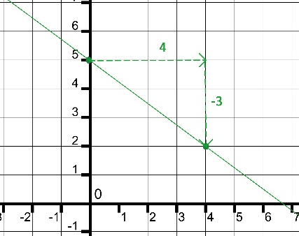
statistical question | A question that can be answered by collecting data. Often there will be variability in the data. | What time of the day do students get home from school?  What type of toppings do 7th graders like on their pizza?
stem-and-leaf plot | A table that organizes data by place value to compare data frequencies. | The data set {1, 4, 5, 8, 10, 11, 13, 27, 27, 28, 30, 31, 31, 40, 44, 63, 66} can be organized in a stem-and-leaf plot as shown below.
  stem | leaf
  0 | 1, 4, 5, 8
  1 | 0, 1, 3,
  2 | 7, 7, 8
  3 | 0, 1, 1,
  4 | 0, 4,
  5
  6 | 3, 6
supplementary angles | Two angles with measures the sum of which is exactly 180°. | 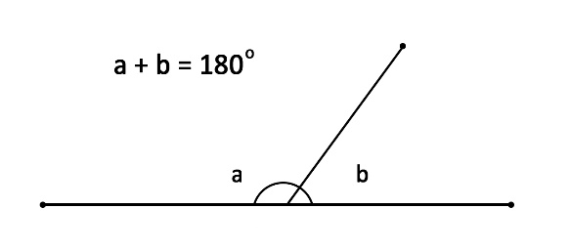
theoretical probability | A number between 0 and 1 representing the likelihood of an event in a theoretical model based on a sample space. If all outcomes in the sample space are equally likely, then theoretical probability of an event is the ratio of the number of outcomes in the event to the number of outcomes in the sample space.
translation | A transformation in which every point in a ﬁgure is moved in the same direction and by the same distance. | If the preimage has the coordinates $(2, 4)$, $(4, 2)$ and $(2, 1)$ and is translated to the left 6 units, its image will have the coordinates $(-4, 4)$, $(-2, 2)$ and $(-4, 1)$.
transversal | A line that intersects two or more lines in the same plane at different points.
trigonometric function | Any of the six functions (sine, cosine, tangent, cotangent, secant, cosecant) that, for an acute angle of a right triangle, may be expressed in terms of ratios of sides of the right triangle.
unit rates | A ratio comparing a number of units of one quantity to one unit of a second quantity.
vertical angles | The opposite angles formed when two lines intersect. | 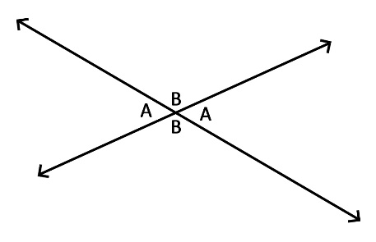
$x$-intercept | The value of $x$ at the point where a line or graph intersects the $x$-axis. The value of $y$ is $0$ at this point. | 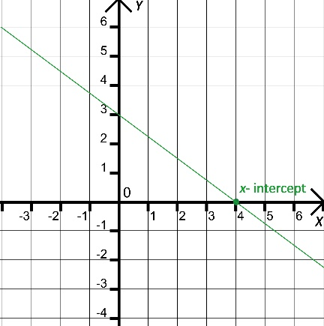
$y$-intercept | The value of $y$ at the point where a line or graph intersects the $y$-axis. The value of $x$ is $0$ at this point. | 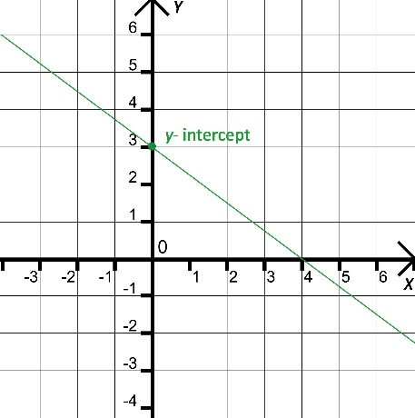

Appendix D: Properties of Operations,
Equality and Inequality

Properties of Operations
The table below illustrates the properties of operations. For each property, the variables $a$, $b$ and $c$ stand for arbitrary numbers in a given number system. The properties of operations apply to the rational number system, the real number system and the complex number system.

Property of Operation | Example
Associative property of addition | $\left(a+b\right)+c=a+(b+c)$
Commutative property of addition | $a+b=b+a$
Additive identity property of zero | $a+0=a$  $0+a=a$
Existence of additive inverses | For every $a$ there exists $-a$ so that $a+\left(-a\right)=0$ and $(-a)+a=0$.
Associative property of multiplication | $\left(a×b\right)×c=a×(b×c)$
Commutative property of multiplication | $a×b=b×a$
Multiplicative identity property of one | $a×1=a$  $1×a=a$
Existence of multiplicative inverses | For every $a≠0$ there exists $\frac{1}{a}$ so that $a×\frac{1}{a}=1$ and  $\frac{1}{a}×a=1$.
Distributive property of multiplication over addition | $a×\left(b+c\right)=(a×b)+(a×c)$

Properties of Equality
The table below illustrates the properties of equality. For each property, the variables $a$, $b$ and $c$ stand for arbitrary numbers in a given number system. The properties of equality apply to the rational number system, the real number system and the complex number system.

Property of Equality | Example
Reflexive property of equality | $a=a$
Symmetric property of equality | If $a=b$, then $b=a$.
Transitive property of equality | If $a=b$ and $b=c$, then $a=c$.
Addition property of equality | If $a=b$, then $a+c=b+c$.
Subtraction property of equality | If $a=b$, then $a-c=b-c$.
Multiplication property of equality | If $a=b$, then $a×c=b×c$.
Division property of equality | If $a=b$ and $c≠0$, then $a÷c=b÷c$.
Substitution property of equality | If $a=b$, then $b$ may be substituted for $a$ in any expression containing $a$.

Properties of Inequality
The table below illustrates the properties of inequality. For each property, the variables $a$, $b$ and $c$ stand for arbitrary numbers in a given number system. In addition, exactly one of the following is true: $a<b$, $a=b$ or $a>b$. The properties of inequality apply to the rational number system and the real number system.

Property of Inequality | Example
Asymmetric property of inequality | If $a>b$, then $b<a$.
Transitive property of inequality | If $a>b$ and $b>c$, then $a>c$.
Addition property of inequality | If $a>b$, then $a+c>b+c$.
Subtraction property of inequality | If $a>b$, then $a-c>b-c$.
Multiplication property of inequality | If $a>b$ and $c>0$, then $a×c>b×c$.  If $a>b$ and $c<0$, then $a×c<b×c$.
Division property of inequality | If $a>b$ and $c>0$, then $a÷c>b÷c$.  If $a>b$ and $c<0$, then $a÷c<b÷c$.

Appendix E: K-12 Formulas

K-12 Formulas
The following formulas are provided for teachers and are not intended to comprise a comprehensive formula list for students. The formulas defined in the table below pertain to the Florida’s B.E.S.T. Standards for Mathematics for Grades K-12.
Area of a two-dimensional figure
Rectangle | $A=lw$, where $l$ is the length and $w$ is the width  $A=bh$, where $b$ is the base and $h$ is the height
Square | $A=lw$, where $l$is the length and $w$ is the width  $A=bh$, where $b$ is the base and $h$ is the height  $A=s^{2}$, where $s$ is the side length
Triangle | $A=\frac{1}{2}bh$, where $b$ is the base and $h$ is the height
Trapezoid | $A=\frac{1}{2}\left(b_{1}+b_{2}\right)h$, where $b_{1}$ and $b_{2}$are the bases and $h$ is the height
Parallelogram | $A=bh$, where $b$ is the base and $h$ is the height
Rhombus | $A=bh$, where $b$ is the base and $h$ is the height  $A=\frac{1}{2}d_{1}d_{2}$, where $d_{1}$ and $d_{2}$ are the diagonals
Circle | $A=πr^{2}$, where $r$ is the radius
Equilateral triangle | $A=\frac{\sqrt{3}}{4}s^{2}$, where $s$ is the side length
Regular Polygon | $A=\frac{1}{2}Pa$, where $P$ is the perimeter and $a$ is the apothem

Surface Area of a three-dimensional figure
Cube | $SA=6s^{2}$, where $s$ is the side length
Prism | $SA=2B+Ph$, where $B$ is the area of the base, $P$ is the perimeter of the base and $h$ is the height
Cylinder | $SA=2B+Ph$, where $B$ is the area of the base, $P$ is the perimeter of the base and $h$ is the height
Cone | $SA=B+πrh_{s}$, where $B$ is the area of the base, $r$ is the radius and $h_{s}$ is the slant height
Pyramid | $SA=B+A(each face)$, where $B$ is the area of the base and $A$(each face) is the area of each face
Regular pyramid | $SA=B+\frac{1}{2}Ph_{s}$, where $B$ is the area of the base, $P$ is the perimeter of the base and $h_{s}$ is the slant height
Sphere | $SA=4πr^{2}$, where $r$ is the radius
Hemisphere | $SA=3πr^{2}$, where $r$ is the radius and the area of the flat side is included
Volume of a three-dimensional figure
Cube | $V=s^{3}$, where $s$ is the side length
Prism | $V=Bh$, where $B$ is the area of the base and $h$ is the height
Cylinder | $V=Bh$, where $B$ is the area of the base and $h$ is the height
Cone | $V=\frac{1}{3}Bh$, where $B$ is the area of the base and $h$ is the height
Pyramid | $V=\frac{1}{3}Bh$, where $B$ is the area of the base and $h$ is the height
Sphere | $V=\frac{4}{3}πr^{3}$, where $r$ is the radius

Laws of Exponents
(where $m$ and $n$ are integers and $a$ and $b$ are nonzero real numbers)
Product of powers | $a^{m}⋅a^{n}=a^{m+n}$ and conversely $a^{m+n}=a^{m}⋅a^{n}$
Quotient of powers | $\frac{a^{m}}{a^{n}}=a^{m-n}$ and conversely $a^{m-n}=\frac{a^{m}}{a^{n}}$
Power of a power | ${(a^{m})}^{n}=a^{m⋅n}$ and conversely $a^{m⋅n}={(a^{m})}^{n}$
Power of a product | ${(ab)}^{m}=a^{m}⋅b^{m}$ and conversely $a^{m}⋅b^{m}={(ab)}^{m}$
Power of a quotient | ${\left(\frac{a}{b}\right)}^{m}=\frac{a^{m}}{b^{m}}$ and conversely $\frac{a^{m}}{b^{m}}={\left(\frac{a}{b}\right)}^{m}$
Negative exponent | $a^{-1}=\frac{1}{a}$ and conversely $\frac{1}{a}{=a}^{-1}$  ${\left(\frac{a}{b}\right)}^{-1}=\frac{b}{a}$ and conversely $\frac{b}{a}={\left(\frac{a}{b}\right)}^{-1}$
Identity exponent | $a^{1}=a$
Zero exponent | $a^{0}=1$
Rational, Fractional exponent | $a^{\frac{m}{n}}={\left(\sqrt[n]{a}\right)}^{m}$ and conversely ${\left(\sqrt[n]{a}\right)}^{m}=a^{\frac{m}{n}}$, where $a>0$  $a^{\frac{m}{n}}=\sqrt[n]{\left(a^{m}\right)}$ and conversely $\sqrt[n]{\left(a^{m}\right)}=a^{\frac{m}{n}}$, where $a>0$

