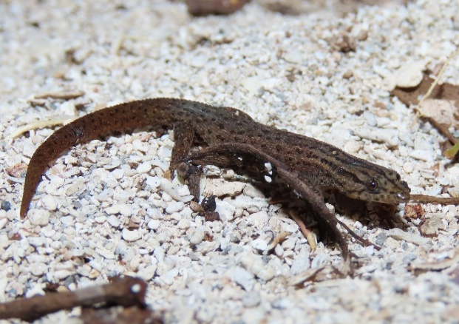
Executive Summary

Florida Reef Gecko

Sphaerodactylus notatus notatus
The Florida reef gecko is listed as State-designated Threatened on Florida’s Endangered and Threatened Species List. This document describes protections for the species and the biological background necessary to understand when a permit may be necessary for this species. The document also provides voluntary conservation measures in line with recommendations in the Species Action Plan, for which no permit is necessary. In circumstances where take may be unavoidable, permitting options including minimization and mitigation are described.
Florida reef gecko. Photo by Kevin Christman, FWC.
Florida reef geckos are closely tied to hardwood hammock habitats in South Florida. These diminutive geckos rely on fallen leaf litter that provides refugia and microhabitats and maintain humidity levels that are necessary for the species to maintain essential behavioral patterns. The primary threats to this species include their preferred habitats’ proximity to the coast, habitat degradation, and competition from nonnative species.
Rule 68A-27.003, Florida Administrative Code (F.A.C.), prohibits take of this species, which includes harm and harassment. Take can either be intentional or incidental to an otherwise lawful activity. Harm includes injury, mortality, or significant modification of habitat. Capturing, handling, marking, taking biological samples from, or collecting this species or its’ eggs are other forms of take. These guidelines allow for limited take of the species, in the form of collection and harassment, when this occurs in survey activities to determine if this gecko is present prior to habitat modification. Survey methodology is described, and an example Florida Reef Gecko Survey Authorization form is available in Appendix I. Surveyors must be in possession of the Authorization when searching for the species, and the completed Authorization and Data Sheet must be returned to FWC within five business days of a survey.
These guidelines include measures to avoid take, as well as circumstances under which take is authorized without a permit. If take is unavoidable during otherwise lawful activities, the Florida Fish and Wildlife Conservation Commission (FWC) may issue Incidental Take Permits, which must provide a conservation or scientific benefit to the species. Conservation benefit is typically achieved through a combination of minimization measures, which reduce the take that occurs, and mitigation measures, which counterbalance the take and provide an additional benefit. If Florida reef geckos are encountered on a site after it has been surveyed in accordance with these guidelines, it will be considered a cryptic species and incidental take is authorized for the duration of the activity without a permit, provided the individual submits information on the location and habitat characteristics of the observation to Imperiled@MyFWC.com. The FWC also issues Scientific Collecting permits for some forms of intentional take, typically for scientific collecting for research purposes.

Species Overview
Status: Listed as State-designated Threatened on Florida’s Endangered and Threatened Species List.

Current Protections
- 68A-27.003(2)(a), F.A.C. No person shall take, possess, or sell any threatened species included in this subsection or parts thereof or their nests or eggs except as authorized by Commission rule or by permit from the Commission or when such conduct is authorized in a management plan as defined in this chapter and approved by the Commission, or as authorized in Commission-approved guidelines.
- 68A-27.001(4), F.A.C. Take – to harass, harm, pursue, hunt, shoot, wound, kill, trap, capture, or collect, or to attempt to engage in such conduct. The term “harm” in the definition of take means an act which actually kills or injures fish or wildlife. Such an act may include significant habitat modification or degradation where it actually kills or injures wildlife by significantly impairing essential behavioral patterns, including breeding, feeding or sheltering. The term “harass” in the definition of take means an intentional or negligent act or omission which creates the likelihood of injury to wildlife by annoying it to such an extent as to significantly disrupt normal behavioral patterns which include, but are not limited to, breeding, feeding or sheltering.
- At the time of incorporation of these Guidelines into F.A.C., restrictions on possession are intended to only be applied to specimens clearly identified as Florida reef geckos, Sphaerodactylus notatus notatus. Other subspecies of reef geckos are not prohibited by rule.

Cryptic Species
Cryptic species are those that may be difficult to detect due to behavior, habitat, or physical features, even when using standardized survey techniques in occupied habitat. Interpretation of when harm or harassment may occur is difficult without a clear understanding of essential behavioral patterns of the species or habitat that may support those behavioral patterns. The documented difficulties in detecting cryptic species and the lack of a reliable detection methodology leads to different considerations for take due to harm, as described in FWC’s policy on permitting standards for incidental take of cryptic species in Florida’s Imperiled Species Management Plan (ISMP).
The Florida reef gecko may be considered a cryptic species in the following circumstance:
- A project is planned in an area with habitat characteristics suitable for Florida reef geckos to occur.
- A minimum of three surveys have been completed by trained observers in accordance with the recommended survey methodology in this document, and no Florida reef geckos were detected during survey activities.
If Florida reef geckos are not detected after implementing the recommended survey methodology, and thus considered a cryptic species, the following provisions shall apply:
- If Florida reef geckos are encountered during a project activity, incidental take (i.e., take incidental to otherwise lawful activities) is authorized for the duration of the activity without a permit, provided the project manager or delegate submits the information on the location of the detection, photographs of the species, and habitat characteristics to Imperiled@MyFWC.com, within 48 hours of the observation.
- FWC encourages, but does not require, minimization measures to reduce impacts to the Florida reef gecko.
If Florida reef geckos are detected during a survey, the site shall be deemed occupied by the species. Any habitat modification activities which may cause incidental take would therefore require mitigation. In this case, further coordination with the FWC is recommended (see contact information).

Biological Background
This section describes the biological background for this species and provides context for the following sections. It focuses on the habitat features that support essential behaviors for the Florida reef gecko, helping frame what constitutes take for this species. For more information about life history and conservation actions for the Florida reef gecko, please refer to the Species Action Plan for the Florida reef gecko (Sphaerodactylus notatus notatus; FWC 2026).
Florida reef geckos are small geckos found in four South Florida counties. Adults reach maximum lengths of 5.1 – 5.7 cm (2 – 2.4 in), snout-to-vent length (Krysko et al. 2019). These lizards are brown-to-tan overall and exhibit sexual dichromatism (Powell and Uy 2023). Male geckos have fully spotted heads while females have three light stripes on their head that extend through the neck and onto the body, although this patterning may be obscure or poorly defined in some individuals (Duellman and Schwartz 1958, Powell et al. 2016, Krysko et al. 2019). Older geckos may be nearly uniform brown in color, and immature geckos resemble females. Physical characteristics of Florida reef geckos include pointed, slightly flattened snouts, large, rounded toepads, vertical pupils, and large, overlapping, strongly keeled scales (Baird 1858, Cope 1900, Krysko and Daniels 2005, Powell et al. 2016).
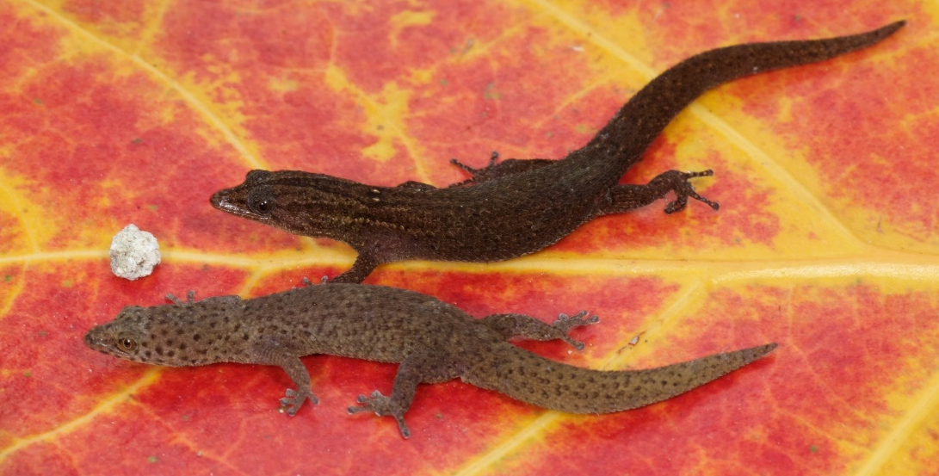
Figure 1. A female Florida reef gecko with light stripes on its head (top) and a male Florida reef gecko with a fully spotted head (bottom). FWC Photograph by Kevin Enge.
At least three species of nonnative Sphaerodactylidae occur in Florida, including the ashy gecko (S. elegans), ocellated gecko (S. a. argus), and yellow-headed gecko (Gonatodes albogularis albogularis; Bartlett and Bartlett 2011, Krysko et al. 2011, Krysko et al. 2019; Figure 2). The ashy gecko is the most widespread of these species and are light tan in overall coloration with darker tan markings. They have heavily striped heads, and heavily striped to dotted bodies. Young are yellowish overall with thick brownish crossbanding. Adult ocellated geckos are dark brown overall with white splotching or dotting on their bodies. The dots may resemble striping on their heads and necks. Young resemble adults, but are lighter in overall coloration. Adult male yellow-headed geckos have dark grey bodies with yellow heads. Young and females are overall tan, with light and dark splotching on their bodies (Bartlett and bartlett 2011, Krysko et al. 2019).
Little is known about the breeding behavior of this species. Based on other species, it is assumed that reproduction begins at about 18 months of age (Heagy and Frank 2008, Leclair and Leclair 2011). Females will lay eggs one-at-a-time, several times throughout the year. Florida reef geckos may nest communally with other species, including nonnative ashy and tropical house geckos (Hemidactylus mabouia; Krysko et al. 2003; Figure 2), usually under rotten logs, woody or leafy debris, driftwood or other logs, coconut husks, or at the base of palm fronds (Krysko et al. 2019). Incubation lasts 75-90 days (Krysko et al. 2003). Newly hatched geckos are less than 2.54 cm (1 inch; Krysko et al. 2019).
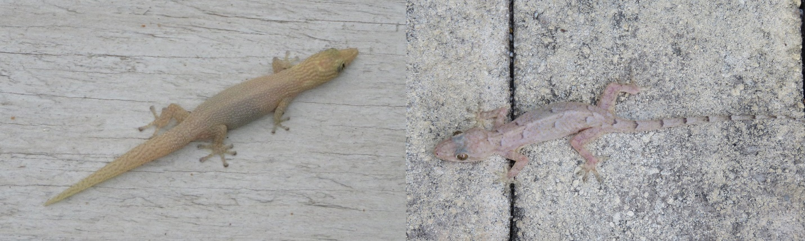
Figure 2. Nonnative species, like the ashy gecko (left) and tropical house gecko (right), may appear similar to Florida reef geckos and can occur in similar habitat. Any survey efforts for the Florida reef gecko should be performed by observers trained at identification and safe handling of the species. FWC Photographs by Kevin Christman.

Habitat Features that Support Essential Behavioral Patterns
Florida reef geckos are primarily found in tropical hardwood hammocks, including rockland hammock and maritime hammock. Within Florida, these geckos are apparently restricted to coastal areas and are typically found within 1.2 km (0.75 mi) of the coast (Clements et al. 2021). The species has been documented in pinelands, cypress heads, altered areas including vacant lots, and in structures (Duellman and Schwartz 1958, Schwartz 1970, Krysko et al. 2019, Clements et al. 2021). Due to their small size, Florida reef geckos have specific habitat needs to prevent desiccation (the process of extreme drying, potentially leading to mortality; Leclair 1978, Steinberg et al. 2007, Johnson et al. 2013). They shelter in cool, moist, shaded habitats created by fallen leaf litter (Steinberg et al. 2007). Described habitat includes habitats with an abundance of leaf litter and the presence of cabbage palm (Sabal palmetto), saw palmetto (Serenoa repens), seagrape (Coccoloba uvifera), and reef rocks (Figure 3). Krysko et al. (2003) reported the species using nonnative Australian pines (Casuarina spp.).
Florida reef geckos can persist in areas with light-to-moderate human use. For example, reef geckos can be found in fallen leaf litter next to outdoor dining areas, in parks, adjacent to trails, and within developed lots. Maintaining a layer of leaf litter in occupied or potentially suitable habitat is important in this species’ conservation.
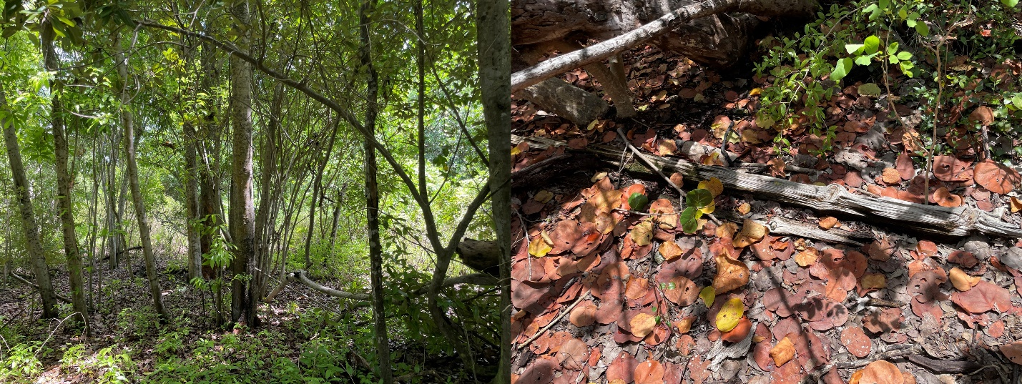
Figure 3. Tropical hardwood hammock (left), and fallen sea grape leaves (right), which serve as important habitat for Florida reef geckos. FWC Photographs by Ryan Hess.

Threats
The primary threats to Florida reef geckos include habitat loss and degradation, hurricanes, over wash and inundation from tropical storm systems, sea level rise, nonnative species, and reptile diseases. For an accounting of threats to the species, please refer to the Species Action Plan (FWC 2026).
Habitat loss includes the decline of suitable habitat either through direct loss, degradation, or fragmentation. The direct loss of habitat to conversion may be mitigated somewhat by the Monroe County Comprehensive Plan (Monroe County 2016a). More so, the removal of specific microhabitats may limit useable habitat, especially when combined with additional threats. For example, removing fallen leaves from unpaved paths, green spaces, and other common public areas may cause harm to the species as that action may reduce the capability of the gecko to perform its essential behavioral patterns.
Tropical storm systems, including hurricanes, have the potential to harm populations of Florida reef geckos. Storm surge events may impact the quality of suitable habitat or cause direct harm to the species. All but three currently known occupied sites are at risk of inundation from a category 3 hurricane (Clements et al. 2021). Changes in sea level, air temperature and sea temperature may cause complex challenges to populations of the Florida reef gecko.
Interactions and competition with nonnative species may impact Florida reef geckos through direct predation or behavioral modification that reduces available shelter and microhabitats (Pimentel et al. 2005, Langkilde 2009). Nonnative vegetation may reduce site quality and availability of shelter.
The impact of reptile diseases on Florida reef geckos is largely unknown; however, the impact of disease may be exacerbated by the combination of the threats above.

Potential to Significantly Disrupt or Impair Essential Behavioral Patterns
Florida reef geckos rely on specific microhabitat conditions driven by humidity requirements created by native plant species, including cabbage palm, saw palmetto, sea grape, and others. The loss of these microhabitats due to development or incompatible management may cause further declines in the species. Activities that eliminate, reduce, or degrade habitat for the species may cause either direct harm to the species or increase the rate of decline through incompatible habitat availability. Activities that may significantly modify Florida reef gecko habitat include, but are not limited to, clearing, grading, paving, bulldozing, and construction. Damaging or killing native vegetation may reduce the amount of available shelter and impact the ability of the gecko to persist at that location.

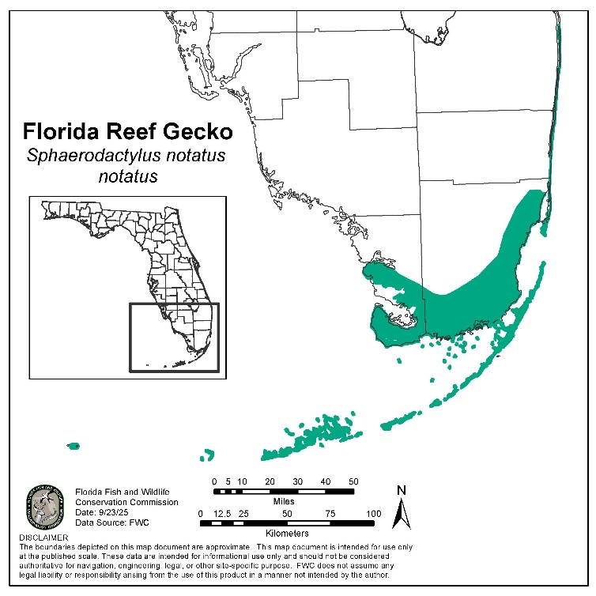
Distribution and Survey Methodology
The map (Figure 4) represents the geographic range of the Florida reef gecko, including intervening areas of unoccupied habitat. This map is for informational purposes only and not for regulatory use.
Counties: Broward, Miami-Dade, Monroe, Palm Beach

Recommended Survey Methodology
The FWC requires surveys for the Florida reef gecko prior to any activities that occur in suitable habitat for the species, and may cause incidental take for the gecko. Additionally, the FWC recommends contacting the agency for updates and consultation at ConservationPlanningServices@MyFWC.com, if projects are expected to impact hardwood hammocks or areas adjacent to those habitat types within the species’ range. If Florida reef geckos are known to be present at locations where habitat modification is planned, the FWC recommends coordination with the agency to determine strategies to avoid take and provide conservation benefit. If take is unavoidable, permitting options can be coordinated with the FWC (see FWC Permitting: Incidental Take).
Figure 4. Distribution of the Florida reef gecko in Florida, including areas of unoccupied habitat.

Survey methodology for this species is adopted from methods described in Clements et al. (2021), as that study represents the most comprehensive survey effort for this species to date. Florida reef geckos are a relatively fragile species, and excessive handling may cause harm to individuals, therefore, only people trained at safely handling this species should perform surveys. Additionally, Florida reef geckos are quick to flee when their cover is disrupted, which may create difficulties when performing survey efforts.

Targeted pedestrian surveys are the most effective way to document this species. Prior to commencing a survey, areas containing the highest quality potential habitat should be identified, including areas that have cabbage palm, saw palmetto, sea grape, an abundance of fallen vegetation, reef rocks, and other cover objects. Surveys should be performed in accordance with the methodology below. Prior to any survey activities, a Florida Reef Gecko Survey Authorization form must be obtained (an example form is provided in Appendix I).

Temporary authorization to handle this species, for the sole purpose of documenting occupancy prior to permit application, may be obtained by possessing the Florida Reef Gecko Survey Authorization form. Florida Reef Gecko Survey Authorization forms may be provided by the FWC Office of Conservation Planning Services (ConservationPlanningServices@MyFWC.com). Parties may reach out to the Office of Conservation Planning Services if they anticipate planned projects may impact Florida reef geckos to inform the potential for incidental take while developing an environmental narrative. Additionally, the office may provide survey forms as a part of project commenting activities if potential impacts to the species are anticipated.

Because Florida reef geckos are quick to scurry away when disturbed, it may be possible to photograph them within leaf litter without direct handling. This technique may be employed during surveys in addition to other methodologies, but should not be relied on as the sole survey methodology as Florida reef geckos and similar non-native species may not be able to be identified based on characteristics captured by photographs.

Survey Methodology Considerations:
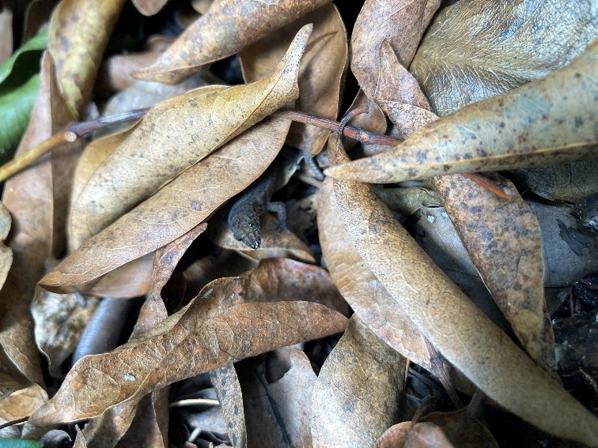
- Observers shall be trained at the identification and safe handling of Florida reef geckos, other native and nonnative lizard species, and other imperiled species that may occur in the area. The primary observer shall have an adequate background (e.g., a professional biologist, consultant, or other similar experience) that allows proper identification of species detected.
- Observers should slowly walk through suitable habitat and look for movement caused by the species.
Figure 5. Florida reef geckos frequently use fallen leaves as important habitat. Photograph courtesy of Stephanie Clements.

- When encountered, cover objects, such as large leaves, rocks, and logs should be gently lifted and the areas under the log should be examined.
- Florida reef geckos, or lizards suspected to be Florida reef geckos, should be gently captured, temporarily restrained in a tube, jar, or clear bag, and identified. Florida reef geckos should be clearly photographed, as well as any other imperiled species encountered. Sightings of these animals should be reported to Imperiled@MyFWC.com by submitting the completed Florida Reef Gecko Survey Authorization form (example in Appendix I) within 5 business days of a survey effort.
- It may be possible to photograph Florida reef geckos, and other lizard species, without direct handling, although this may make it difficult to determine a confident identification of the species.
- A survey shall consist of a single observer searching a project location for a minimum of two hours, or multiple observers searching a project location for a minimum of one hour each.
- Sites shall be surveyed a minimum of three times, separated minimally by 9 days, prior to determining that the species likely does not occur at a given location.
- Surveys may be completed year-round, during daylight hours, while temperatures are between 70˚ – 95˚ F.
- Surveys shall not occur during periods of heavy rain or periods of drought.
- Surveys shall not occur for a period of 21 days after the project location has experienced inundation from storm surge events.
- If small lizards are observed during a survey, but unable to be identified, the survey shall be repeated. Surveys may be extended in an effort to document lizards that evaded identification during the initial observation.
- The objective of a survey is to document the presence of Florida reef geckos; therefore, once a Florida reef gecko has been observed, the site will be deemed occupied by the species, and survey efforts must cease. Clear photographs of the specimen shall be submitted to the FWC.
- If any Florida reef geckos are detected with signs of clinical disease, surveys should be immediately halted, equipment disinfected, and the observer should coordinate future actions with the FWC. The surveyor may bring reef geckos with signs of clinical diseases to a licensed wildlife rehabber.

Recommended Conservation Practices
Recommended Conservation Practices are general measures that could benefit the Florida reef gecko by lessening the impact of activities to their populations, but are not required. No FWC permit is required to conduct these activities, but coordination with the FWC is recommended (see Contact information below). Additional actions that benefit Florida reef geckos can be found in the Species Action Plan (FWC 2026).
- Limiting lawn or open space management within public or private spaces so that fallen debris is allowed to accumulate.
- Maintaining accumulation of fallen leaf litter, such as leaves from sea grape and saw palmetto, which serve as important microhabitat for the species.
- Establishing conservation easements that maximize the conservation of hardwood hammocks, or other suitable Florida reef gecko habitats, either in known occupied areas, or areas that are otherwise suitable for species occurrence.
- Refraining from clearing or fragmenting key habitats (intact tropical hardwood hammocks and adjacent habitats).
- Reporting trespassing, illegal dumping, species releases, or species collection to the landowner or land manager, and the FWC.
- Detecting Florida reef geckos can be viewed as a Scientific Benefit when observations are reported to the FWC.
- Implementing nonnative and invasive plant and/or animal control methods in and around occupied and suitable habitat.
  - Treating fire ant mounds according to label instructions.
  - Prior to using herbicides or pesticides in or around known occupied or suitable habitat, review labels for potential effects to non-target organisms.
- Removing and controlling feral domestic animals (e.g., feral cats, hogs) that may directly or indirectly (i.e., species that cause vegetation restructuring) impact the Floria reef gecko or directly prey on the lizard.

Measures to Avoid Take

Avoidance Measures that Eliminate the Need for FWC Incidental Take Permitting
This section describes measures that would avoid the need for a project manager, agent, or other party to apply for an FWC Incidental Take Permit.
- Avoid impacts to tropical hardwood hammocks, adjacent habitats, and accumulations of leaf litter where Florida reef geckos occur.

Examples of Activities Not Expected to Cause Take
This is not an exhaustive list of exempt actions. Please contact the FWC if you are concerned that a project may potentially cause take.
- Activities that occur on land not consistent with Florida reef gecko habitat.
- Standard vehicular and pedestrian traffic on roads and sidewalks within or adjacent to potential or occupied habitat.
- Recreational viewing or photographing Florida reef geckos, provided a disance is maintained that does not alter Florida reef gecko behavior. Geckos should not be handeled or manipulated in any manner while viewing.

Florida Forestry Wildlife BMP’s and Florida Agricultural Wildlife BMP’s
- Due to its geographical distribution, this species is not included in the Florida Forestry Wildlife BMP’s or Florida Agricultural Wildlife BMP’s program, and this these practices do not apply.

Other Authorizations for Take
- In cases where there is an immediate danger to the public’s health and/or safety, including imminent or existing power outages that threaten public safety, or in direct response to an official declaration of a state of emergency by the Governor of Florida or a local government entity, power restoration activities, non-routine removal or trimming of vegetation within linear right of way in accordance with a vegetation management plan that meets applicable federal and state standards, or water management activities for flood control do not require an Incidental Take Permit from the state.
- As described in Rule 68A-27.007(2)(c), F.A.C., land management activities that benefit wildlife and are not inconsistent with FWC Management Plans are authorized and do not require a permit authorizing incidental take. Wildlife management activities include but are not limited to exotic species removal, prescribed burning, roller chopping, brush- and tree-cutting to improve wildlife habitat, and herbicide application.
- Mosquito control measures. The FWC recommends following guidelines described by the Florida Keys Mosquito Control District (2021) that limit direct and indirect effects on non-target vertebrates.
- In accordance with local, state, and federal regulations (including, but not limited to, Federal Electric Reliability Council (FERC) Electric Reliability Standard FAC-00303, National Electrical Safety Code (NESC) section 218, and Florida Public Service Commission (FPSC) mandates), routine vegetation maintenance activities within existing powerline right of ways do not require a permit authorizing incidental take.
  - While performing maintainence, following the recommended conservation practices, especially allowing fallen leaf litter to accumulate near the margins of right of ways, is encouraged.
  - Periodically, surveys for Florida reef geckos along right of ways should be performed to determine if the species is using this habitat, and if right of ways could be considered dispersal cooridors for Florida reef geckos. This activity should be coordinated with FWC as a Scientific Collecting permit may be required.
- Infrequently, Florida reef geckos may occur in anthropogenic environments, for example, within dwellings or storage areas. In these situations, reef geckos may be gently captured and relocated outside of the structure, and released within the property bounds of the structure, ideally within or adjacent to hardwood hammocks. Photos of animals relocated and coordinates for the release location should be emailed to Imperiled@MyFWC.com.
- General landscaping and maintenance activities (e.g., sweeping, raking, mowing) around dwellings or businesses that do not permanently modify areas consistent with Florida reef gecko habitat.
- Florida reef geckos that show visible signs of diseases or pathogens may be collected and brought to a wildlife rehabber. In instances where a wildlife disease is suspected, the FWC should be notified of the location where the individual was observed, and the rehabber where the individual was brought to for follow up.
- Pre habitat modification surveys may be completed if the surveyor possesses the Florida Reef Gecko Survey Authorization form (Appendix I).

Coordination with Other State and Federal Agencies
The FWC participates in other state and federal agency regulatory programs as a review agency. During review, the FWC identifies and recommends measures to address fish and wildlife resources to be incorporated into other agencies’ regulatory processes. The FWC coordinates with the Florida Department of Environmental Protection (FDEP) and the Florida Forest Service (FFS) to develop management plans suitable to species occurring in specific natural communities. The FWC coordinates with the U.S. Fish and Wildlife Service (USFWS) on species management occurring on federally protected or managed lands. The FWC assists with applying for grants and providing technical review, project guidance, equipment purchasing, and monitoring needs.
The FWC coordinates with local jurisdictions on the Monroe County Comprehensive Plan (2016a), Chapter 118 of the Land Development Code, and the Land Planning Regulations for the Florida Keys Area of Critical State Concern - Monroe County (Chapter 28-20, F.A.C.; State of Florida 2014). Chapter 380 of the Florida Statutes addresses the FWC’s interactions with counties. For example, the FWC commented on the Big Pine Key and No Name Key Habitat Conservation Plan (HCP), which notes the importance of tropical hardwood hammock for federally-listed species and restricts the loss of native habitat for species covered under the plan. The HCP assists in determining the location of potential new development and in prioritizing mitigation areas on those keys. The beneficial management of other imperiled Key’s species would likely benefit the Florida reef gecko.

The FWC provides recommendations for addressing potential impacts to state listed species in permits issued by other agencies. If permits issued by other agencies adequately address the requirements for issuing a state-Threatened species Incidental Take Permit, the FWC will consider those regulatory processes to fulfill the requirements of Chapter 68A-27, F.A.C., with a minimal additional application process. This may be accomplished by issuing a concurrent take permit from the FWC, by a memorandum of understanding with the cooperating agency, or by a programmatic permit issued by another agency. These permits would be issued based on the understanding that the implementation of project commitments will satisfy the requirements of Rules 68A-27.003 and 68A-27.007, F.A.C.

Review of Land and Water Conversion Projects with State-Listed Species Conditions for Avoidance, Minimization and Mitigation of Take
- The FWC, in coordination with other state agencies, provide comments to federal agencies (e.g., the USACE) on federal actions, such as projects initiated by a federal agency, or permits being approved by a federal agency.
- The FWC works with landowners, local jurisdictions, and state agencies such as the Department of Economic Opportunity on large-scale land use decisions, including long-term planning projects like sector plans, projects in Areas of Critical State Concern, and large-scale comprehensive plan amendments.
- The FWC coordinates with state agencies such as the FDEP and the five Water Management Districts in the Environmental Resource Permitting (ERP) program. The ERP program regulates activities such as dredging and filling in wetlands, flood protection, stormwater management, site grading, building dams and reservoirs, waste facilities, power plant development, power and natural gas transmission projects, oil and natural gas drilling projects, port facility expansion projects, some navigational dredging projects, some docking facilities, single-family developments for homes, boat ramps, and artificial reefs.

FWC Permitting: Incidental Take
Take of Florida reef geckos can either be incidental or intentional. Under Chapter 68A-27.001, F.A.C., incidental take is defined as take that is incidental to, and not the purpose of the carrying out of an otherwise lawful activity. This type of take is prohibited without an Incidental Take Permit of other authorization. Habitat modification activities within or adjacent to occupied habitats that cause accidental death, injury, or impair the species essential behavioral functions are examples of incidental take. Intentional take is not incidental to an otherwise lawful activity and requires a Scientific Collecting permit, unless authorized under certain circumstances that may involve risk to human health and safety (e.g., hurricane response), or as a part of authorized surveys as described above. Capturing and handling Florida reef geckos for research is an example of intentional take. Consult the sections Recommended Conservation Actions and Measures to Avoid Take for guidance on actions that would avoid needing an FWC permit.

For activities that could result in impacts to Florida reef geckos, an Incidental Take Permit from the FWC may be required (see above for actions that do not require a permit). Incidental Take Permits may be issued when there is a scientific or conservation benefit to the species and the applicant shows that the permitted activity will not have a negative impact on the survival potential of the species. Scientific benefit, conservation benefit, and negative impacts are evaluated by considering the factors listed in rule 68A-27.007(2)(b), F.A.C. These conditions are usually accomplished through a combination of avoiding take when practicable, minimizing any take that could occur, and mitigating for any permitted take.

This section describes the minimization measures and mitigation options available as part of the Incidental Take Permit process for take of Florida reef geckos. This list is not an exhaustive list of options. As more information is learned about this species mitigation options may change, and will be represented through revisions to this document, or presented to applicants during the permitting process.

Minimization Options
The options below are intended to address the evaluation factors the FWC considers when issuing an Incidental Take Permit. All the options below assume that adhering to avoidance measures that eliminate the need for FWC permitting described above is not possible, and that some level of take may occur. These options can lessen the impact of activities, and ultimately may reduce what is needed to achieve a conservation or scientific benefit. The FWC requires surveys to determine the presence of Florida reef geckos prior to considering provisions associated with the Cryptic Species policy.

Seasonal, Temporal, and Buffer Measures
- Seasonal activity patterns for the Florida reef gecko are unknown. Due to the size of the species and potential habitat specialization, it is unlikely that this species would be absent from occupied habitat during any portion of the year.

Design Modification
- Design projects to avoid tropical hardwood hammock habitats and adjacent habitats.
  - Consider provisions in the Monroe County Comprehensive Plan regarding protection of tropical hardwood hammocks and other native habitats (Monroe County 2016a).
  - Adhere to Land Planning Regulations for the Florida Keys Area of Critical State Concern – Monroe County (Chapter 28-20, F.A.C.) and Sections 118-7, 118-10(1), and 118-10(4) of the Monroe County Land Development Code regarding designing development away from natural areas and sensitive habitats, restrictions to developing tropical hardwood hammock, and maintenance of native trees (State of Florida 2014, Monroe County 2016b).
- Design projects to leave leaf litter and other naturally occurring ground debris intact, especially in areas within and adjacent to hardwood hammocks and areas that occur in spaces with light-to-moderate human use.
- Avoid placement of impermeable surfaces, such as roads or parking lots, in and adjacent to intact hardwood hammocks.

Method Modification
- Provide information to project personnel on identifying Florida reef geckos and encourage reporting observations to the FWC by emailing photographs and GPS coordinates of the observation to Imperiled@MyFWC.com.
- Post signs or provide information to project personnel encouraging keeping ground cover and debris intact around hardwood hammocks.
- Provide information to project personnel on identifying other imperiled Keys species that may co-occur in suitable Florida reef gecko habitat (for example: Florida Keys mole skink [Plestiodon egregius egregius], Key ringneck snake [Diadophis punctatus], Florida brown snake [Storeria victa], rim rock crowned snake [Tantilla oolitica]).

Mitigation Options
Mitigation is scalable depending on the impact, with mitigation options for significant impairment or disruption of essential behavioral patterns. Mitigation must provide either a scientific or conservation benefit. To achieve conservation benefit, mitigation must counterbalance the take that occurs and provide an additional benefit. When activities are expected to impact hardwood hammock, habitat options that place other areas containing hardwood hammock into perpetual conservation would be most beneficial for the Florida reef gecko, and other imperiled Keys species. Additional potential options for mitigation are described below. References to specific actions within the Species Action Plan are provided in parentheses.

Scientific Benefit
This section describes research and monitoring activities that provide a scientific benefit, per Rule 68A-27.007, F.A.C. Conducting or funding these activities can be the sole form of mitigation for a project, provided the FWC staff approve the objectives and methods submitted as part of the permit application. These projects must be conducted with input from the FWC to achieve results in concert with ongoing management actions. Since information on this species is limited, information available to completely define their essential behavioral patterns, the options provided below are subject to change as new information becomes available.
- Scientific studies may provide scientific benefit if they fill data gaps in the species’ life history, including reproduction, diet and refuge use, impact of habitat fragmentation, recolonization after storm surge events, patch size, population demographic parameters (i.e., productivity, survivorship, and mortality rates), and disease dynamics (SAP Actions 5,6,7).
- Surveys provide scientific benefit if they provide data on habitat requirements, dispersal distances, and demography of Florida reef geckos. Such surveys also provide scientific benefit if they explain how the species reacts to environmental changes, such as storm surge events or invasive species manipulations (SAP Action 8).

Habitat
- Acquire occupied or potential Florida reef gecko habitat (i.e., hardwood hammock and surrounding areas) that provides suitable areas for the species’ essential behavioral patterns (SAP Action 2).
    - Fee simple acquisition or conservation easements of occupied or potential habitat, with a commitment for long-term management with a habitat management plan. The amount of habitat placed in long-term conservation will be scalable based on impacts to Florida reef geckos, or hardwood hammock impacted by habitat modification activities.
    - Acquisition of parcels on mainland Florida that are resilient to sea level rise should be prioritized when this option is considered.
- Control, reduce and remove invasive plants encroaching on occupied and potentially suitable habitat within and adjacent to hardwood hammocks. (SAP Action 1).
- On-site preserve areas where sufficient hardwood hammock habitat is protected, with a commitment for long-term management with a habitat management plan, that preserves the accumulation of fallen leaf litter which provides essential microhabitats for the species (SAP Action 18).

Funding
  - Mitigation may take the form of a financial contribution to the Fish and Wildlife Foundation of Florida’s Imperiled Species Permitting Conservation Fund. Mitigation contributions will be used to fund priority actions included in or consistent with the objectives of the SAP. Funding options as part of mitigation will be considered on a case-by-case basis but must be sufficient to counterbalance the take that will occur and provide a benefit to the species. For example, applicants could consider the cost of habitat acquisition of a similar size to any hardwood hammock disturbed or destroyed by alteration and modification when developing proposals for financial contributions as part of a mitigation package.

Information
  - This form of mitigation can be part of a mitigation package but shall not be the sole form of mitigation. The information options include: live and dead observations reported to the FWC, and including latitude, longitude, habitat characteristics, and photographs (required for verification purposes) by email to Imperiled@MyFWC.com. Provide any dead specimens discovered to the FWC as vouchers that can fill in data gaps for new locations, disease screening, and future genetics work. Arrangements for the transport or shipping of vouchers may be arranged by contacting Imperiled@MyFWC.com.

Programmatic Options
- Multi-year or long-term permits are possible and will be considered on a case-by-case basis. Examples include, but are not limited to, large-scale ecological restoration projects or public works projects.

Multi-species Options
- No specific multi-species permitting options have been identified at this time, but multispecies options may be available for projects that impact other state-listed species in hardwood hammock or adjacent habitats on a case-by-case basis. It may also be possible to include state-Threatened species in Federal Habitat Conservation Plans developed in coordination with the U.S. Fish and Wildlife Service for federally listed species that occur within the same habitat types. Contact WildlifePermits@MyFWC.com for permitting options.
These options may be combined by the applicant when creating a mitigation package. None of the options above are mandatory components of any such package. Additional or alternative mitigation options may be considered by the FWC’s Protected Species Permitting Office, provided the applicant can provide sufficient justification of scientific or conservation benefit. Approved wildlife or habitat management plans may include these or alternative options.

FWC Permitting: Intentional Take
Intentional take is not incidental to otherwise lawful activities. In accordance with Rule 68A-27, F.A.C., intentional take is prohibited without a permit or other authorization. For state-Threatened species, intentional take permits may only be considered for scientific or conservation purposes (defined in the FWC’s ISMP as activities that further the conservation or survival of the species taken). Permits are issued for intentional take of state-Threatened species following the guidance in Rule 68A-27.007(2)(a), F.A.C.

Intentional Take for Human Safety
- There are no known circumstances for which Florida reef geckos may be intentionally taken for human safety.

Aversive Conditioning
- Not applicable for the Florida reef gecko.

Permits Issued for Harassment
- Not applicable for the Florida reef gecko.

Scientific Collecting and Conservation Permits
- Scientific collecting permits may be issued for the Florida reef gecko using guidance found in Rule 68A-27.007(2)(a), F.A.C. Activities requiring a permit include any research that involves capturing, handling, or marking wildlife; conducting biological sampling; other research that may cause take; or captive breeding for reintroduction efforts or population augmentation. Those possessing Florida reef geckos for education and outreach events must have a scientific collecting permit.
- Scientific collecting permits are generally not issued for the sole purpose of removing a species for education or exhibition purposes. Florida reef geckos used for education and outreach will require a scientific collecting permit and should be used for a minimum of 12 educational engagements equating to a minimum of 48 hours of contact time per year. When applying for an education and outreach permit, please include a description of how the animal will be housed, both permanently and when being used for outreach, and include any lesson plans or summaries of educational activities.
- If targeting other species as part of a scientific study, and there is the potential for the Florida reef gecko to be captured as bycatch, the Florida reef gecko should be included in the permit application along with a description of measures that will be used to minimize any harm to the gecko if incidentally captured.
- Other agencies may require concurrent permits or authorizations to access potential study locations. The FWC may be able to offer guidance on these additional requirements, however, the permit holder may ensure that any and all other permitting needs have been completed.
- For Florida reef geckos in personal possession prior to inclusion on Florida’s Endangered and Threatened Species List (68A-27.003, F.A.C.), a permit can be issued to possess the specimen for the life of the animal. Those with Florida reef geckos should contact WildlifePermits@MyFWC.com within 90 days of these guidelines being incorporated into F.A.C. to obtain a permit for the species.

Considerations for Issuing a Scientific Collecting Permit
- Is the purpose adequate to justify removing the species from the wild (if the project requires this)?
- Permits will be issued if the identified project is consistent with the goal of the SAP (i.e., improvement in status that leads to removal from Florida’s Endangered and Threatened Species List) or addresses an identified data gap important for the conservation of the species.
- Is there a direct or indirect effect of issuing the permit on the wild population?
- Applicants must include detailed methods, including measures taken to minimize take. Applications also must include proposed study duration, timeframe, sample size, and disposition of individuals, as appropriate.
- Applications proposing to trap, capture, or handle Florida reef geckos must include trapping and handling protocols. Trapping and handling protocols must identify measures to lessen stress for captured individuals and to lessen impacts to Florida reef gecko populations (e.g., measures to minimize disease transmission).
- Methodologies for any collection of tissues must be clearly spelled out, including measures taken to reduce stress/injury and disease transmission.
- Will the permit conflict with any program intended to enhance survival of species?
- Applications must include clear objectives to ensure that the project does not conflict with other conservation efforts for the species.
- Applications must identify the project location, such as where trapping or handling will occur (privately owned or public lands).
- Will the purpose of the permit reduce likelihood of extinction?
- Projects consistent with the goal of the SAP or that fill identified data gaps in species life history or management may reduce the likelihood of extinction.
- Applications must include clear project objectives and justification of why the proposed project has a scientific or conservation purpose, including how the project advances conservation of the species.
- Have the opinions or views of other scientists or other persons or organizations having expertise concerning the species been sought?
- Is applicant expertise sufficient?
- Applicants must have prior documented experience with this or similar species; applicants should have met all conditions of previously issued permits; and applicants may include a letter of reference that supports their ability to handle the species.
- The application must describe the qualifications (e.g., experience or training) of staff overseeing the work and the resources and facilities available to conduct the proposed work.
- Disposition involving captive possession for any period of time must include a full explanation of whether the facility has appropriate resources for accomplishing the project objectives and for maintaining the animals in a safe and humane manner.

Information Relevant to all Scientific Collecting Permits for Florida Reef Geckos
  - Permit amendment and renewal applications must be “stand alone” (i.e., include all relevant information on objectives and methods, even if previously submitted for a predecessor permit).
- Applications must include a proposal that contains the elements in the Considerations for Issuing a Scientific Collecting Permit section above.
- Applications must include detailed qualifications or training for all individuals who will be capturing or handling Florida reef geckos. For those likely to submit multiple applications over time, applicants are encouraged to upload minimum qualifications as part of an application for a Registered Agent permit in the online permitting site. The FWC also encourages applicants to include qualifications of sub-permittees in the Registered Agent permit. This will allow applicants to upload minimum qualifications only once rather than repeatedly uploading them in each scientific collecting permit application.
- Visual encounter surveys that do not involve handling animals do not require a permit.
- Any activity that requires trapping or handling a Florida reef gecko requires a permit. For example, these activities include collecting genetic material for taxonomic analyses.
- Permits may be issued to display a specimen if the specimen was obtained via rehabilitation facility or was encountered dead.
- Permits may be issued for captive possession (removal from the wild) if the individual is deemed non-releasable.
- Any mortality should be reported immediately to the FWC at the contact information below. The FWC will provide guidance on proper disposition of specimens.
- Geographical or visual data gathered must be provided to the FWC in the format specified in the permit conditions.
- A final report must be provided to the FWC in the format specified in the permit conditions.

Contact
For permitting questions or to report mortalities that occur during permitted activities, contact the FWC at (850) 921-5990 or WildlifePermits@MyFWC.com.
For regional information, visit the FWC contacts webpage.
To report a wildlife violation please visit the Wildlife Alert webpage or call 1-888-404-FWCC (3922).
Florida Reef Gecko Survey Authorization forms are available by contacting ConservationPlanningServices@MyFWC.com.
General questions and inquiries can be directed to Imperiled@MyFWC.com or by calling the Division of Habitat and Species Conservation at 850-488-3831.

Literature Cited
Baird, S.F. 1858. Description of new genera and species of North American lizards in the museum of the Smithsonian Institute. Proceedings of the Academy of Natural Sciences of Philadelphia 1858:253-256.
Bartlett R.D. and P.P. Bartlett. 2011. Florida’s Turtles, Lizards, and Crocodilians. University of Florida Press. Gainesville, FL. 258pp.
Clements, S.L., E.A. Powell, C.C. Mothes, and C.A. Searcy. 2021. Assessing the conservation risk of Sphaerodactylus notatus, the U.S. herpetofaunal species most vulnerable to sea level rise. Biodiversity and Conservation 30:107-121.
Cope, E.D. 1900. The crocodilians, lizards and snakes of North America. Pages 153-1270 in Report of the U.S. National Museum for the Year Ending June 30, 1898. Washington Printing Office. Washington, D.C. 1269pp.
Duellman, W.E. and Schwartz, A. 1958. Amphibians and reptiles of southern Florida. Bulletin of the Florida State Museum. Biological Sciences 3:181-324.
Florida Fish and Wildlife Conservation Commission. 2026. A species action plan for the Florida reef gecko. Florida Fish and Wildlife Conservation Commission, Tallahassee, Florida. 49pp.
Florida Keys Mosquito Control District. 2021. How we control mosquitos. https://keysmosquito.org/control-methods/. Assessed 4 September 2024.
Heagy, T. and P. Frank. 2008. The reef geckos of Florida. Iguana 15:37-41.
Johnson, S.K., J.S. Parmerlee Jr., D.A. Eifler, and R. Powell. 2013. Comparative water-loss rates of Hemidactylus mabouia and Sphaerodactylus notatus on Eleuthera Island, Commonwealth of the Bahamas. Herpetology Notes 6:471-475.
Krysko, K.L., C.M. Sheehy III, and A.N. Hooper. 2003. Interspecific communal oviposition and reproduction of four species of lizards (Sauria: Gekkonidae) in the Lower Florida Keys. Amphibia-Reptilia 24:390-396.
Krysko, K.L. and K.J. Daniels. 2005. A key to the geckos (Sauria: Gekkonidae) of Florida. Caribbean Journal of Science 41:28-36.
Krysko, K.L., J.P. Burgess, M.R. Rochford, C.R. Gillette, D. Cueva, K.M. Enge, L.A. Somma, J.L. Stabile, D.C. Smith, J.A. Wasilewski, G.N. Kieckhefer III, M.C. Granatosky, and S.V. Nielsen. 2011. Verified non-indigenous amphibians and reptiles in Florida from 1863 through 2010: outlining the invasion process and identifying invasion pathways and stages. Zootaxa 3028:1-64.
Krysko, K.L., K.M. Enge, and P.E. Moler. 2019. Amphibians and Reptiles of Florida. University of Florida Press, Gainesville. 706 pp.
Langkilde, T. 2009. Invasive fire ants alter behavior and morphology of native lizards. Ecology 118:858-866.
Leclair, R. Jr. 1978. Water loss and microhabitats in three sympatric species of lizards (Reptilia, Lacertilia) from Martinique, West Indies. Journal of Herpetology 12:177-182.
Leclair, R. Jr., and M.H. Leclair. 2011. Life-history traits in a population of the dwarf gecko, Sphaerodactylus vincenti ronaldi, from a xerophytic habitat in Martinique, West Indies. Copeia 2011:566-576.
Monroe County. 2016a. Monroe County year 2030 comprehensive plan. Policy Document as Adopted by the Board of County Commissioners. 379pp.
Monroe County. 2016b. Monroe County land development code. Monroe County. 640pp.
Pimentel, D. R. Zuniga, and D. Morrison. 2005. Update on the environmental and economic costs associated with alien-invasive species in the United States. Ecological Economics 52:273-288.
Powell, E.A. and J.A.C. Uy. 2023. Male color polymorphism in populations of reef geckos (Sphaerodactylus notatus) reduces the utility of visual signals in sex recognition. Behavioral Ecology and Sociobiology 77:2
Powell, R., R. Conant, and J.T. Collins. 2016. Peterson Field Guide to Reptiles and Amphibians. Houghton Mifflin Harcourt Publishing Company. New York, NY. 494pp.
Schwartz, A. 1970. Sphaerodactylus notatus. Catalogue of American Amphibians and Reptiles: 90.
State of Florida. 2014. Rule Chapter 28-20 land planning regulations for the Florida Keys area of critical state concern – Monroe County. Florida Administrative Code.
Steinberg, D.S., S.D. Powell, R. Powell, J.S. Parmerlee Jr., and R.W. Henderson. 2007. Population densities, water-loss rates, and diets of Sphaerodactylus vincenti on St Vincent, West Indies. Journal of Herpetology 41:330-336.

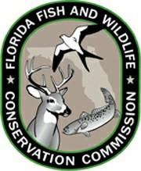
FLORIDA REEF GECKO SURVEY AUTHORIZATION
FLORIDA FISH AND WILDLIFE CONSERVATION COMMISSION
Division of Habitat and Species Conservation, Wildlife Diversity Conservation Section
620 South Meridian Street, Tallahassee, FL 32399-1600
Imperiled@MyFWC.com, (850) 488-3831

Date of survey: _____________________ Survey number: ________ of 3

Survey start time: ____________________ Survey end time: ___________

Primary observer name: _____________________________________________________

Observers’ affiliation: _____________________________________________________

Representing (if entity proposing habitat modification is different than observers’ affiliation):

__________________________________________________________________________

Performing surveys at (project location address):

__________________________________________________________________________

GPS coordinates (center of location): ___________________________________________

Additional observers:

__________________________________________________________________________

IS AUTHORIZED TO: Temporarily take Florida reef geckos in accordance with survey methodology in the Florida reef gecko (Sphaerodactylus notatus notatus) Species Conservation Measures and Permitting Guidelines, via pursuing, capture, and harassment, to determine potential occupancy at the project location above.

Primary Observer Signature:_______________________________ Date:_______________________
Not valid unless signed. By signature, confirms that all information provided on this Authorization is accurate and complete, and indicates acceptance and understanding of the provisions and conditions listed below. Any false statements or misrepresentations when using this Authorization may result in felony charges. This Authorization is only valid for the date indicated above, and only for the location indicated above.

PLEASE RETAIN THIS DOCUMENT FOR YOUR RECORDS

Pages 1 (Authorization) and 4 (Data Sheet) of this document must be submitted to Imperiled@MyFWC.com within 5 business days of a survey
AUTHORIZATION CONDITIONS AND PROVISIONS:
- This Authorization is only for Observers performing an activity to survey for Florida reef geckos on behalf of an entity which is proposing or planning on performing habitat modification in or adjacent to occupied or suitable habitat for the Florida reef gecko, for the purposes of documenting potential occupancy of Florida reef geckos.
- This Authorization, and attached data sheet, must be returned to the FWC, by emailing completed forms to Imperiled@MyFWC.com within 5 business days of completing a survey.
- This Authorization does not authorize possession of Florida reef geckos outside of the survey, nor does this Authorization authorize removing Florida reef geckos from the survey location, except to transport Florida reef geckos showing signs of clinical disease to a licensed wildlife rehabber.
- This Authorization is non-transferable and must be carried by the Primary Observer for inspection by all authorized officials (including but not limited to state, federal, local building and zoning, law enforcement) at all times while surveys are being performed, and must list all Observers participating in the survey.
- The activities authorized under this Authorization are the responsibility of the Primary Observer, their affiliation, and the entity that they are representing. The Primary Observer, their affiliation, and the entity that they are representing shall be fully responsible for any such activities to the same extent as if they had themselves carried out those activities under this Authorization.
- This Authorization does not authorize access to any public or private properties. The Primary Observer must secure permission from the appropriate landowner or land manager prior to conducting any activity authorized under this Authorization.
- This following survey methodology must be adhered to by all Observers:
- Observers shall be trained at the identification of Florida reef geckos, other native and nonnative lizard species, and other imperiled species that may occur in the area.
- Observers should slowly walk through suitable habitat and look for movement caused by the species.
- When encountered, cover objects, such as large leaves, rocks, and logs should be gently lifted and the areas under the log should be examined.
- Florida reef geckos, or lizards suspected to be Florida reef geckos, should be gently captured, temporarily restrained in a tube, jar, or clear bag, and identified. Florida reef geckos should be clearly photographed, as well as any other imperiled species encountered.
- A survey shall consist of a single observer searching a project location for a minimum of two hours, or multiple observers searching a project location for a minimum of one hour.
- Surveys may be completed year-round, during daylight hours, while temperatures are between 70˚ – 95˚ F.
- Surveys shall not occur during periods of heavy rain or periods of drought.
- Surveys shall not occur for a period of 21 days after the project location has experienced inundation from storm surge events.
- If small lizards are observed during a survey, but unable to be identified, the survey shall be repeated. Surveys may be extended in an effort to document lizards that evaded identification after initial observation.
- The objective of a survey is to document the presence of Florida reef geckos; therefore, once a Florida reef gecko has been observed, the site may be deemed occupied by the species, and survey efforts must cease. Clear photographs of the specimen shall be submitted to the FWC.
- If any Florida reef geckos are detected with signs of clinical disease, surveys should be immediately halted, equipment disinfected, and the observer should coordinate future actions with the FWC. The surveyor may bring reef geckos with signs of clinical diseases to a licensed wildlife rehabber.
The remainder of this page is intentionally blank, survey data sheet is on the next page
FLORIDA REEF GECKO SURVEY DATA SHEET
FLORIDA FISH AND WILDLIFE CONSERVATION COMMISSION
Division of Habitat and Species Conservation, Wildlife Diversity Conservation Section
620 South Meridian Street, Tallahassee, FL 32399-1600
Imperiled@MyFWC.com, (850) 488-3831

Were Florida reef geckos observed: Yes / No

GPS coordinates of Florida reef gecko observations:

_____________________________________________________________________________

File names of photos containing Florida reef geckos: _________________________________

_____________________________________________________________________________

Were other native reptiles or amphibians observed?

_____________________________________________________________________________

_____________________________________________________________________________

Were other nonnative reptiles or amphibians observed?

_____________________________________________________________________________

_____________________________________________________________________________

Additional survey notes (temperature, wind, cloud cover, other species observations, etc.):

_____________________________________________________________________________

_____________________________________________________________________________

_____________________________________________________________________________

_____________________________________________________________________________

PLEASE RETAIN THIS DOCUMENT FOR YOUR RECORDS

Pages 1 (Authorization) and 4 (Data Sheet) of this document must be submitted to Imperiled@MyFWC.com within 5 business days of a survey

