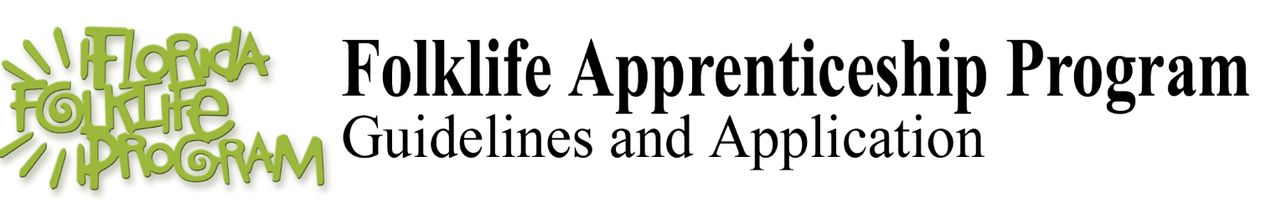
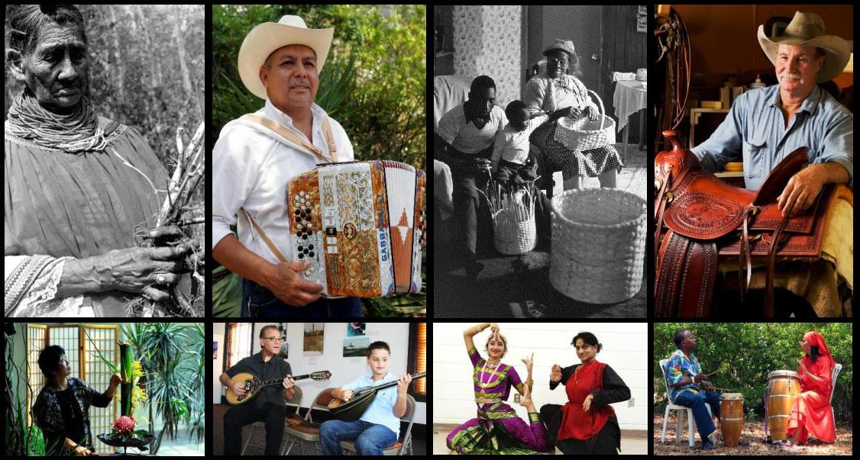
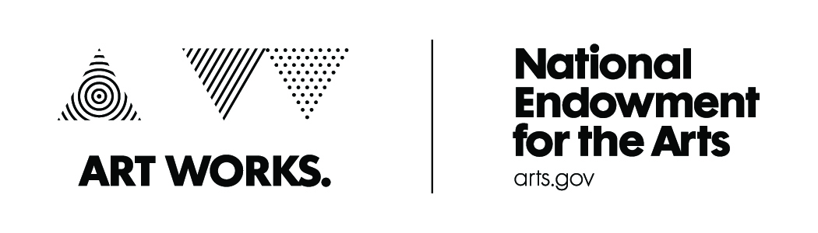
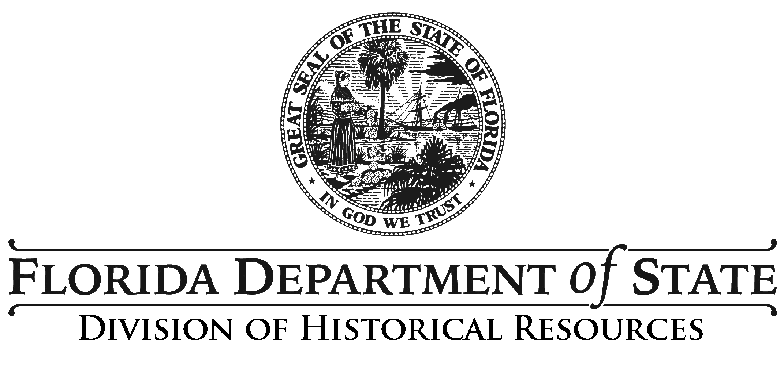
Top left to right: Susie Billie, Seminole herbalism; Tomás Granado, norteño accordion; Lucreaty Clark & Alphonso Jennings, basketry; Mike Wilder, saddlery. Bottom left to right: Mieko Kubota, ikebana; George Soffos & Georgios Makris, bouzouki; Shree Sundaresh & Geeta Raj Karkera, bharata natyam dance; Louinés Louinis & Karine Moron, Haitian drumming.
Annual Application Deadline: May 15
Contact: Florida Folklife Program, 850.245.6427

PROGRAM INFORMATION

The Folklife Apprenticeship Program provides an opportunity for master folk artists to share technical skills and cultural knowledge with apprentices to maintain their art as a vital part of their heritage. Master artists should be among the finest practitioners of the tradition in their communities. Apprentices must have experience in the tradition they wish to study, and must make a commitment to learn it thoroughly. The underlying purpose of the Folklife Apprenticeship Program is to reinforce traditions within folk groups; preference is therefore given to apprentices who study traditions within their own group.

The Florida Folklife Program welcomes applications for apprenticeships in all forms of Florida traditional culture. Since 1984, the program has supported apprenticeships for boat making, fly tying, fiddling, Afro-Caribbean percussion, African American gospel steel guitar, Greek bouzouki, Nicaraguan festival arts, Japanese dance, steel drum making, Seminole basketry, and much more.

The Folklife Apprenticeship Program is a component of the Florida Department of State’s Florida Folklife Program and is funded in part by the National Endowment for the Arts.

(Effective 05/16)
Rule 1P - 1.009, F.A.C.

WHAT IS FOLKLIFE

Folklife is traditional expressive culture that is shared within folk groups and learned informally by word of mouth, imitation, or observation. Folklife consists of the living traditions currently practiced and shared within communities. Traditional expressive culture includes a wide range of forms such as art, music, dance, handicraft, pageantry, oral tradition, custom, belief, and more.

Folk groups are communities that share knowledge, skills, aesthetics, and beliefs. Folk groups can be familial, ethnic, occupational, religious, or regional.

AWARD AMOUNTS

The following amounts are dependent on available funding and represent the maximum awards for three-, six-, or eight-month apprenticeships:
DURATION | MASTER | APPRENTICE
3 months | $750 | $150
6 months | $1,500 | $300
8 months | $2,000 | $400

When apprenticeships are awarded to immediate family members (parents, siblings, or children), only the master will be eligible for funding.

EXPECTATIONS

Awards are intended to cover program expenses and transportation. Participants receive payments at regular intervals based on the recommended funding level and completion of apprenticeship objectives including but not limited to:

- agreement to all terms and conditions
- submission of meeting logs showing work plan progress
- a site visit by a program representative
- demonstration at the Florida Folk Festival.

HOW TO APPLY

Eligibility
Interested master/apprentice teams must submit a joint application. Before completing the application, the master artist and apprentice should discuss their ideas for the apprenticeship. In this way, we hope you will come to a shared understanding of what will take place and why. Prospective teams should discuss the pre-requisite level of skill, frequency and location of meetings, the work plan, goals, and agree on training expectations. Apprentices must be permanent Florida residents, and it is preferred that masters and apprentices belong to the same folk group.

Completing the Forms
Part 1 is for the master, Part 2 is for the apprentice, and Part 3 is to be completed by both master and apprentice. Please answer all questions as thoroughly as possible and use additional pages as needed. Applications do not have to be typed, but should be legible. If you complete the forms by hand, please print and use black ink.

SUPPORT MATERIALS

Applications must include audio-visual and written support materials for both masters and apprentices. These materials form an important part of the application package and will be evaluated by the Florida Folklife Council. Professional recordings and videos are not necessary. Media materials of applicants chosen to participate in the program will be deposited in the Florida State Archives. Upon submission to the Florida Folklife Program, all materials become public information, and will not be returned to the applicant. Support materials should be appropriate for the cultural tradition. Please refer to the following guidelines:

Audio-Visual Work Samples
- Crafts and Occupational Folk Arts: Submit 6 to 10 digital images that are in focus and not too dark or too light. It is best to show whole objects and examples of detail.
- Music: A video and/or audio sample up to 10 minutes in length of your music is recommended. This sample can feature audio and/or video of a single work or selections from multiple works but cannot exceed 10 minutes in length. Links to YouTube clips of live performances or CD and/or DVD recordings are preferred. Include recordings of unaccompanied performances.
- Dance: A video sample up to 10 minutes in length is recommended. This sample can feature video of a single work or selections from multiple works but cannot exceed 10 minutes in length. A DVD recording or a link to a YouTube clip is preferred.
- Storytelling and Oral Traditions: A sample up to 10 minutes in length is recommended. This sample can feature audio and/or video of a single work or selections from multiple works but cannot exceed 10 minutes in length. CD and/or DVD recordings or links to YouTube clips are preferred.
Written Support Materials
- At least two letters of support are required attesting to the quality and authenticity of the master’s skills. Letters from community leaders, colleagues, peers, cultural specialists, or other individuals who can confirm the details of the application and attest to the master artist's qualifications may strengthen an application. Do not submit more than 5 letters of support for the master. A maximum of two letters of support for the apprentice are also encouraged.

- Press clippings about the master artist or apprentice and letters in support of prior performances, educational activities, and festival demonstrations will not serve as letters of support; they will be considered general support materials. Limit support materials, such as press clippings, performance programs, and festival flyers, to no more than ten 10 items.

APPLICATION DEADLINE

Applications must be submitted by email or postmarked by May 15.

Applicants are encouraged to submit applications before the deadline. If May 15 falls on a Saturday, Sunday, or legal holiday, the deadline date will be the next business day.

Please send completed applications to:

folklife@dos.myflorida.com

Florida Folklife Program
Division of Historical Resources
500 South Bronough Street
Tallahassee, FL 32399-0250

If you have questions about the application or need assistance call 850.245.6427 or 1.800.847.PAST.

REVIEW CRITERIA AND SELECTION

Eligible applications are reviewed by the Florida Folklife Council according to the following unranked criteria:

- Expertise of the master artist - work samples and letters of support will assist in determining the level of expertise.
- Level of commitment to the apprenticeship.
- Feasibility of the work plan and the overall coherence of the apprenticeship.
- Impact of the apprenticeship on the vitality of the tradition.
- Relevance of the tradition to the cultural history of Florida.
- Demonstrated association of master and apprentice within a shared folk group.

The Florida Folklife Council will rank applications and recommend funding levels and any appropriate special conditions. Recommendations will be submitted to the Secretary of State for review and approval. Final decisions will be made by August, and applicants will be notified thereafter.

PART 1: MASTER ARTIST
Name:
Date of Birth:
Email:

Phone:
Tradition you wish to teach:
FL resident:
If not, immigration status:
U.S. citizen:

Answer questions in the spaces provided or use additional pages if necessary. Type or print neatly.
- Provide a brief bio: ethnicity, birthplace, schooling, occupation(s), how many years in Florida, etc.
Address:

- Describe your background and experience in this tradition. How, when, where, and from whom did you learn this tradition? Have you taught this tradition to others? When and for whom do you do this tradition? Have you practiced it continually since you learned it? Have you received any fellowships, apprenticeships, or grants? Is there a website where samples of your work are available for review?

- Explain the significance and history of this tradition in your life and that of your family or community.

- Describe the proposed apprenticeship. How long have you known the apprentice? Have you worked together before in this tradition? How much does the apprentice already know about this tradition? Why do you wish to work with this particular apprentice? What techniques or forms will you teach? What do you hope to accomplish during the apprenticeship period?

I am willing to work with __________________________according to the plan outlined in this application. I will allow this apprenticeship to be documented for the purpose of preserving Florida folklife.

Master’s Signature: ________________________________________________ Date: ___________________
PART 2: APPRENTICE
Email:

Tradition you wish to learn:
FL resident:
If not, immigration status:
U.S. citizen:
Address:

Answer questions in the spaces provided or use additional pages if necessary. Type or print neatly.
Name:
Date of Birth:
Phone:
- Provide a brief bio: ethnicity, birthplace, schooling, occupation(s), how many years in Florida, etc.

- How, when, where, and from whom did you learn this tradition? What is the current level of your skill? How long have you known the master artist? Have you and the master artist worked together before? How did you become acquainted with him or her?

- Why do you wish to learn this tradition and participate in the Florida Folklife Apprenticeship Program?

- What do you hope to accomplish during the apprenticeship? What do you plan to do with the skills you learn? How do you plan to help preserve this tradition?

I am willing to work with __________________________according to the plan outlined in this application. I will allow this apprenticeship to be documented for the purpose of preserving Florida folklife.

Apprentice’s Signature: ___________________________________________ Date: __________________

PART 3: WORK PLAN

- List the skills and techniques that will be taught during the apprenticeship. What tunes or styles do you want the apprentice(s) to learn, or what objects do you want them to make? What will the apprentice(s) be expected to do between meetings? Please be specific.

- State the goals that you expect the apprentice to achieve. Examples might include: make six baskets; develop a repertory of twenty tunes; sew five pieces of clothing; learn two complete dances.

- How often will you meet, where, and for how long? A typical schedule might be: once a week, for four hours, at the master’s home.

- What length of apprenticeship do you prefer? (check one)

_______ 3 months _______6 months _______8 months

List the materials and supplies, including itemized costs, which the apprentice will need to complete the apprenticeship. If you do not know the exact cost, give your most accurate estimate. Funds are not available for the purchase of musical instruments, personal clothing, or costumes.

________________________________________ ________________________________________
Master Artist Date Apprentice Date

________________________________________ ________________________________________ Apprentice Date Apprentice Date

