Food Sorting Guidance and Model Consumer Commodity Salvage Code

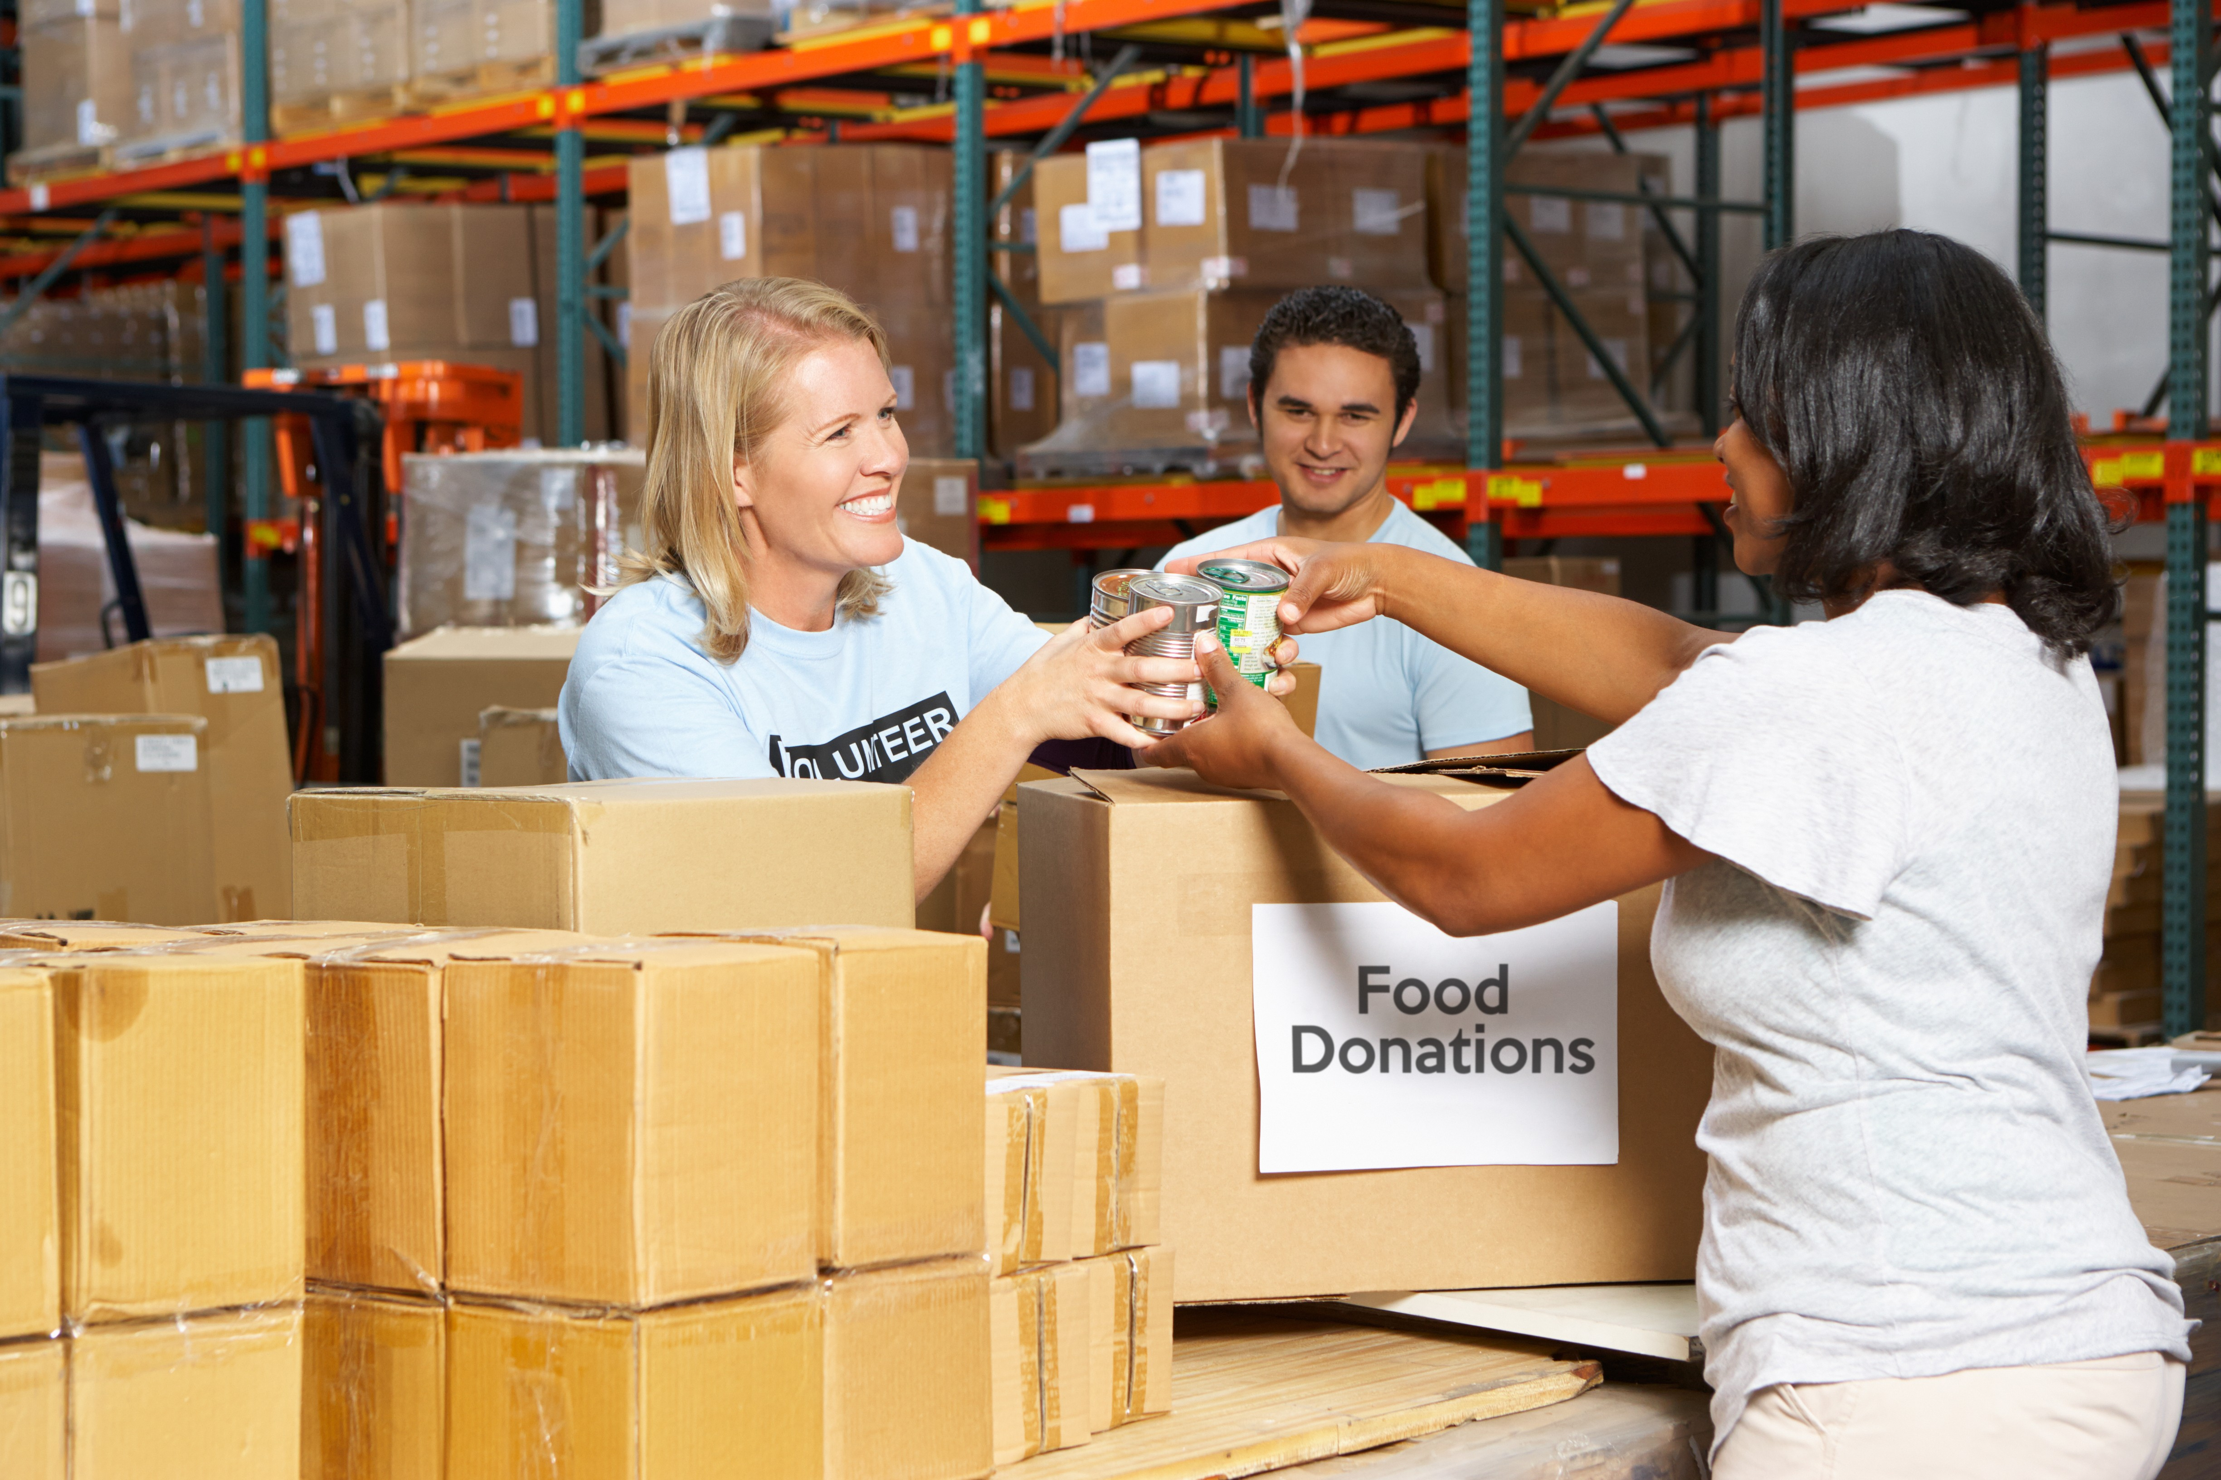




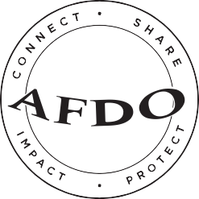
Association of Food and Drug Officials

September 2017

Table of Contents

INTRODUCTION 5
CONTRIBUTORS 7
FOOD SORTING GUIDANCE 8
General 8
Product Donation Sourcing & Handling Mission Statement 8
Purpose 9
Product Notices 9
General Food Protection 10
Evidence of Insects and Rodents 10
Food Storage 10
Sanitation 12
Allergen Management 13
Disposal of Unacceptable Items 14
Labeling 15
General 15
Date Indicators 15
Allergen Labeling Requirements 18
Appearance of Items 19
Tape Usage 20
Tamper-proof Seals 21
Food in Cans 24
General 24
Dents 24
Bulges 28
Rust (Corrosion) 28
Food in Glass or Plastic Containers 29
General 29
Jars with a Vacuum Seal 30
Jars or Bottles without A Vacuum Seal 32
Food Deterioration 32
Food in Other Containers 33
Non-food Items 34
Medical products 34
Plastic-wrapped Items 34
Liquid Products 35
Chemicals 35
Canning Supplies 35
Alcohol 36
Other Considerations 36
Food Requiring Refrigeration 36
Marked Items 36
Pet Supplies 36
AFDO MODEL CONSUMER COMMODITY SALVAGE CODE 37
Introduction 37
  - Intent and Scope 38
  - Definitions 39
Section Two: Salvager Personnel 44
  - Employee Health 44
  - Personal Cleanliness 44
  - Employee Training and Supervision 46
Section Three: Salvager Responsibilities for the Protection from Contamination of Salvageable and Salvaged Consumer Commodities 46
  - Contamination Protection 46
  - Segregation of Distressed Consumer Commodities 48
Section Four: Salvager Equipment and Utensils 49
4-101 Design and Fabrication 49
Section Five: Cleaning, Sanitization, and Storage of Salvager Equipment and Utensils 50
  - Salvager Equipment and Utensil Cleaning and Sanitizing ... 50
  - Salvager Equipment and Utensil Handling and Storage 50
  - Storage 51
Section Six: Salvager Sanitary Facilities and Controls 51
  - Water Supply 51
  - Sewage Disposal 52
  - Plumbing 52
  - Toilet Facilities 52
  - Handwashing Facilities 53
  - Garbage and Refuse 53
  - Insect and Rodent Control 54
Section Seven: Construction and Maintenance of Salvager Facilities 55
  - Separation of Reconditioning Activities 55
  - Floor Construction 55
  - Walls and Ceilings 56
  - Salvager Lighting 56
  - Heat Lamp Protective Shielding 57
  - Ventilation 57
  - Clothing and Personal Belongings 57
  - Housekeeping 57
  - Transportation 58
Section Eight: Handling and Movement of Distressed Consumer Commodities 58
8-101 Notice to Enforcement Agency 58

  - Transporting of Distressed Consumer Commodities 59
  - Handling of Distressed Consumer Commodities 60
  - Processing Animal Feed and Animal Food (Pet Food) 60
Section Nine: Reconditioning Distressed Consumer Commodities 60
9-01 General 60
9-102 Food and Other Consumer Commodity Containers 61
Section Ten: Salvaged Commodity Labeling 63
  - Label Removal 64
  - Relabeling 64
Section Eleven: Handling of Non-Salvageable Consumer Commodities 65
  - General 65
  - Distribution of Nonsalvageable Consumer Commodities ... 66
Section Twelve: Records 66
12-101 General 66
Section Thirteen: Salvager Permits 67
  - General 67
  - Issuance of Permits 68
  - Suspension of Permits 69
  - Reinstatement of Suspended Permits 70
  - Revocation of Permits 70
  - Serving of Notices 71
Section Fourteen: Salvager Inspections and Enforcement 71
  - General 71
  - Access to Salvager Facilities, Operations, and Vehicles 71
  - Hearings 72
  - Remedies 72
  - Injunctions 72
  - Salvagers and Sources of Distressed Consumer Commodities Outside the Jurisdiction of the Enforcement Agency. 72 14-107 Review of Plans 73
Section Fifteen: Food Recovery Programs 74
  - General 74
  - Food Safety Resources 74

INTRODUCTION

The Association of Food & Drug Officials (AFDO), in conjunction with Feeding America and Grocery Manufacturers Association (GMA), is pleased to provide this combination best-practices and model-code document for food sorting and food salvage operations.

Today, food banks are trusted community-based organizations that distribute safe and nutritious food to millions of individuals in need every month. Much of this food comes into food banks in the form of donated food from growers, processors, wholesalers, retailers, and food drives. The donated foods are sorted so unfit and out-of-condition products can be removed before they are provided to needy individuals or distributed to non-profit agencies, including shelters, pantries, soup kitchens, counseling centers, educational organizations, and community-based safety net organizations. The Food Sorting Guidance portion of this document provides best practice protocols for the proper evaluation of these products.

Food salvage operations, also referred to as food recovery operations, are establishments that evaluate distressed food merchandise for the purpose of determining if the products may be reconditioned for use. States may license these operations or provide guidance to assure the reconditioning is conducted in such a fashion that assures potential adulterated products are not marketed. The “AFDO Consumer Commodity Salvage Code” portion of this document provides best practices information for recovery
operations and a foundation for food protection regulatory agencies considering regulations for these types of establishments.
CONTRIBUTORS

 | 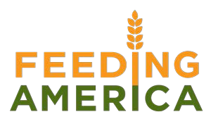
 | 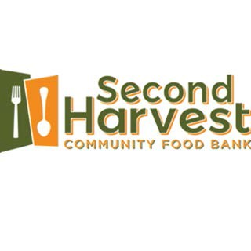

FOOD SORTING GUIDANCE

General

Product Donation Sourcing & Handling Mission Statement

The Feeding America network of food banks serves 46 million people each year. To successfully achieve this, they must be sure the food they feed to children, seniors, and families facing hunger is not only filling and healthy, but also safe.

To ensure that the billions of meals the network of food banks distribute are safe, they depend on a combination of food industry requirements and specially designed safeguards to:

    - Apply the same stringent requirements that govern
U.S. grocery retailers, food manufacturers, and restaurants.

    - Ensure that each food bank in the Feeding America network passes a specially designed, third-party audit based on a combination of food safety laws and industry best practices.

    - Implement a proprietary food safety training course for food bank employees, developed specifically to address the needs of food banks.

Purpose

Use of these guidelines will yield more consistent, high- quality food drive and salvaged products. These guidelines are based on the recommendation of the AFDO Model Commodity Salvage Code, Feeding America Donor Requirements, and the USDA Food Safety and Inspection Service Food Labeling Guidelines

Product Notices

The Warehouse Coordinator/Partner Agency Director posts notices identifying:

- Current cut-off dates for acceptable items (food, baby food, formula, etc.).

- Product defects or recalls.

- Health hazards.

- Unacceptable ingredients, such as Olestra (fat substitute) and Ephedra (stimulant).

- Other special instructions, such as handling of jars of baby food.

Product notices should be reviewed at the start of each shift.

General Food Protection

Evidence of Insects and Rodents

No pests, rodents, or other animals shall be allowed in any area where sorting or salvage is stored or processed. Before unloading a box of donated items, inspect for obnoxious odors, mouse droppings, and nibbled packaging. Discard the box and all food items in the box except for canned and jarred food. This protects people from becoming ill if they use the food.

Food Storage

All food, including canned and dry foods, should be kept at least 6 inches off the ground. When putting food away, remember that it should not be stored against the walls.

With all foods, you should use a first-in, first-out distribution model to ensure that your stock does not become outdated.
Keep non‐canned foods (flour, rice, etc. that are in permeable packaging) in rodent-proof bins, such as clean
plastic containers with tight lids. Do not overstock this type of food, as weevil infestation may occur after prolonged storage periods.

Access to storage should be limited to authorized staff and volunteers who have an awareness of food safety issues.

Dry storage areas should be clean, dry, and pest free.
- Clean storage areas regularly.
- Storage areas should be well ventilated.
- Keep the dry-storage environment between 50° and 70° F with humidity less than 60%.
- If there is a “musty” smell or condensation on the walls, install a dehumidifier.
- Keep records of pest inspections and document what steps were taken if evidence of pests was discovered.
  - If you do not have a contract with a pest- control service, create your own log that tracks inspections and treatments.
- Ensure that all access points for pests and vermin are sealed.
- Store cereals, grains, sugar, and flour in airtight containers to prevent infestations.
- Food should be stored at least 6 inches above the ground and (ideally) 2 inches away from the walls. This:
  - Prevents product from contamination, should there be minor flooding,
  - Reduces pest access, and
  - Allows for easier cleaning.
- To maximize storage, put non-food items on the floor or the lowest shelf.
  - Separate dry storage product from chemicals.
    - Store cleaning products and other chemicals in a separate room from food storage.
    - If this is not possible, store such items on a separate set of shelves.
    - Do not ever store cleaning products or chemicals above food items.
  - Avoid storing product:
    - Beneath water or sewer lines,
      - Near heat sources, such as ovens, forced air vents, or furnaces, and
      - Near windows that receive direct sunlight.
- Maintain cold-storage units properly.
  - Ensure that refrigerators are holding temperatures between 33° F and 40° F.
    - Below 32° F, product may freeze.
    - Colonies of bacteria that cause foodborne illness can double in 20 minutes if food is stored in the temperature danger zone (41° F - 135° F).
  - Ensure that freezers are holding temperatures between 10°F and 0°F.
    - Food stored below 30° F may appear to be frozen, but certain yeasts and bacteria can continue to grow at 15° F.
    - Record cold storage temperatures at least daily.
    - Clean and/or defrost all units at least quarterly.

Sanitation

- Employees and volunteers should wash their hands before and after handling food.
- Food should not be stored on the ground.
- Store chemicals away from and separate from food.
- An all-purpose kitchen cleaner should be used to wipe down surfaces that will come into contact with food, provided that it is rinsed with water afterwards.
  - These surfaces include:
    - Tables.
    - Counters.
    - Coolers.
    - Refrigerators.
    - Freezers.

- Keep your dry-food storage areas clean.
  - Small bits of paper, cardboard, and food attract rodents and insects. These are not just an inconvenience. They are a health hazard.
  - Sweep and mop regularly.
  - Empty trash regularly and keep garbage can covered.
  - Keep shelving clean.
  - Keep the area underneath the shelving clean.

Allergen Management

These eight foods have been identified as major food allergens:

- Milk.
- Eggs.
- Peanuts.
- Tree nuts (e.g., almonds, cashews, walnuts).
- Fish (e.g., bass, cod, flounder).
- Shellfish (e.g., crab, lobster, shrimp).
- Soy.
- Wheat.
When a food item containing an allergen comes in contact with another food item and their proteins mix, it is called cross-contact. This can be dangerous for individuals with food allergies, because even a tiny amount of food protein cross-contact has been shown to cause reactions in people with food allergies. The term “cross-contact” is often referred to as “cross-contamination.”
One of the most important ways to protect individuals with food allergies is by preventing cross-contact.

- Food should be stored and handled in a way that prevents cross-contact. This could include designated storage areas or compartments and designated handling times for food items containing an allergen.

- To effectively remove food protein from surfaces, wash the surfaces with soap and water. Simply wiping the crumbs from spatulas, cookie sheets, cutting boards, or other surfaces is not enough.

- Where possible, utilize a cutting board, plates, and kitchen utensils that will be used for allergy-free foods only.

Disposal of Unacceptable Items

Remove unacceptable food items from other consumable food items in an isolated and identified area.

Unacceptable discarded food and non-food items are collected in trash boxes and taken away by a trash hauler.

Labeling

General

The U.S. Fair Packaging and Labeling Act prohibits the distribution of any food item (except fresh fruit and vegetables) without a label. Labels shall contain:

- Common name of the product (for example, apple sauce).

- Name and address of manufacturer, packer, or distributor.

- Quantity of the contents (for example, 10 oz.).

- Common name of each ingredient ( for example, salt or sugar).

Products with torn labels are acceptable when all the above information is legible and complete.

Many people are on restricted or specialized diets, while others may be allergic to individual foods. The ingredients list helps them avoid products which may cause allergic reactions or which are life-threatening.

Date Indicators

The only foods that are required by federal law to have expiration dates are baby food, infant formula, and over-the- counter medications. Many canned and boxed products are safe to eat long after the date on the container. The shelf-life of refrigerated and frozen foods can be extended if they are handled properly. Once a perishable item is frozen, it doesn’t matter if the expiration date passes. Foods kept frozen
continuously are safe indefinitely, though the quality slowly deteriorates over time.

There are a few code dates you may see on food packages.

“Expiration Date” (Examples: “Expires 11/15/16” or “Do not use after 11/15/16.”)

  - Look for it on baby food and formula, medicines, vitamins, yeast, and baking powder.
  - What it means: Do not distribute infant formula, baby food, vitamins, or medicines after the expiration date! Yeast and baking powder do not work as well after expiration but are still safe to eat.

“Pack Date” (Examples: “Packed on 03/01/2016” or “22:5306416” or “KL064.”)

  - Look for it on canned food, crackers, cookies, and spices.

  - What it means: This is the date the food was packaged. A code is often used that cannot be understood by the general public, often numbering days sequentially. Examples include listing January 1 as 001 and December 31 as day 365 (366 in leap years). Usually, this food is of good quality and is safe to eat for a long time past the date. For your protection, you may call the food manufacturer.

“Sell By” Date (Example: “Sell by January 1, 2016”. Also called “Pull Date.”)
  - Look for it on refrigerated foods, such as milk, yogurt, cottage cheese, eggs, lunch meat, and packaged salad mixes.

  - What it means: The store must sell these foods before the code date listed. Stores often donate these foods when they are close to date. If the food has been handled properly, it is still safe to eat and the quality is good.

“Use By” or Quality Date (Examples: “Best if used by 1/1/16” or “Use Before 1/1/16.”)

  - Look for it on crackers, cookies, cold cereals, and other dry, shelf-stable food.

  - What it means: This date is the manufacturer’s recommendation for how long the food will be at peak quality. The food is still safe after the quality date, but it slowly begins to lose nutrients and the quality diminishes.

Some products bear a manufacturing code. Do not confuse these with date indicators. Ignore them. Examples:

  - Stop & Shop Beans can: 0282C 13:36 XPK XQ
  - Contadina Tomato Paste can: 0216HFT164:18
  - (In addition, some food donors make requests, place restrictions, or have special requirements on some or all of their donations. It is critical that all appropriate staff and volunteers be notified of these requests, requirements, or restrictions. Please reference the Feeding America Donor Requirements.)
For additional information, see “Product Code Date Labeling; Crucial Initiative to Reduce Consumer Confusion.”

Allergen Labeling Requirements

Food sorting operators should be aware of allergen labeling requirements and the Food Allergen Labeling and Consumer Protection Act (FALCPA), which requires food manufacturers to label food products that contain an ingredient that is or contains protein from a major food allergen in one of two ways.

One option provided for food manufacturers is to include the name of the food source in parenthesis following the common or usual name of the major food allergen in the list of ingredients in instances when the name of the food source of the major allergen does not appear elsewhere in the ingredient statement. For example:

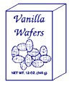
Ingredients: Enriched flour (wheat flour, malted barley, niacin, reduced iron, thiamin mononitrate, riboflavin, folic acid), sugar, partially hydrogenated soybean oil, and/or cottonseed oil, high fructose corn syrup, whey (milk), eggs,
vanilla, natural and artificial flavoring) salt, leavening (sodium acid pyrophosphate, monocalcium phosphate), lecithin (soy), mono-and diglycerides (emulsifier).

Another option is to place the word "contains" followed by the name of the food source from which the major food allergen is derived, immediately after or adjacent to the list of ingredients, in type-size that is no smaller than the type-size used for the list of ingredients. For example: (Contains Wheat, Milk, Egg, and Soy) Bulk Packaging.

Some items have several products fastened together, usually with cardboard or plastic shrink-wrap. For example, packs of drinks or pudding, cans of tuna fish and dried soup packets. Remove the wrapping and inspect each item for acceptability and proper labeling. If individual items do not contain the required labeling, cut the label from the bulk pack and place it in a plastic bag along with the individual items. If individual items are received and no original label can be found, items should be discarded.

Appearance of Items

All items should be clean. Dirt and other contamination must be removed by wiping with a dry paper towel or with a towel moistened with a special cleaner (10-to-1 water-to-bleach ratio).

Do not wash jars of food. Washing may drive contaminants under the edge of the lid. When the jar is opened, contaminants may go into the food.

Packages that show signs of spilled liquid (even if the packages are dry) should be discarded because the unknown liquid may
be toxic. Many cleaning products are poisonous.

Bulk-pack cartons containing hidden individual food items (such as Kool-Aid or fruit drinks) that show signs of leakage should be opened. The food items should be inspected and leaking items should be discarded.

Tape Usage

Use tape marked with Food Bank printing to repair usable products (such as torn cartons, loose labels and cartons with unsealed flaps). The Food Bank tape assures our customers the product has been checked and found acceptable. Do not use non-Food Bank tape. Using clear unmarked tape for repair fails to show the product has been checked.

Businesses donating items frequently use unmarked tape to make repairs. Remove this tape if possible, inspect the product and, if the product is acceptable, repair with Food Bank tape. Here again, this shows our customers that the product has been checked.

Tamper-proof Seals

Different types of seals protect the contents of many products against tampering. The container may have a paper, foil, or plastic sheet sealed to the edge under the lid. Remove the screw-on or snap-on lid and examine this seal. Discard the item if the seal is pierced, not adhered to the edge of the container, or if there is visual evidence of product contamination.

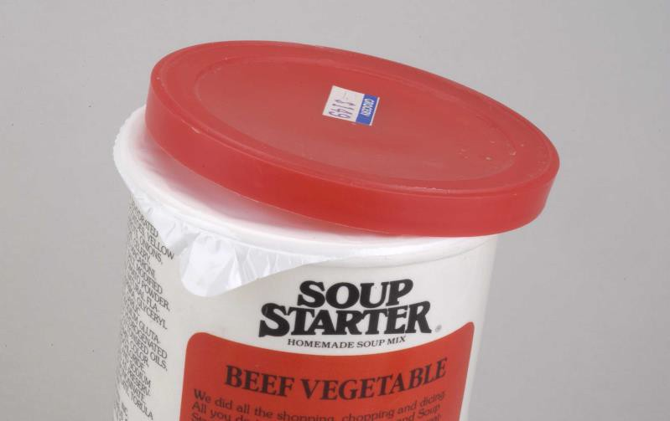

Seal
Some bottles may have a plastic or metal cap attached by small links to a ring fastened around the neck of the bottle. If these connecting links are broken, discard the item. Bottle cap or jar lid may have shrink-wrapped plastic around it. If this is completely broken, discard the item. If the seal is slightly damaged but shows no tampering was possible, retain the product.

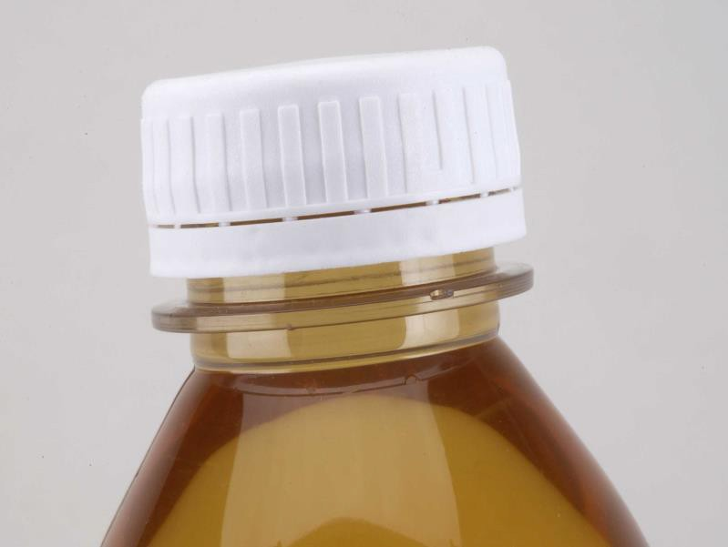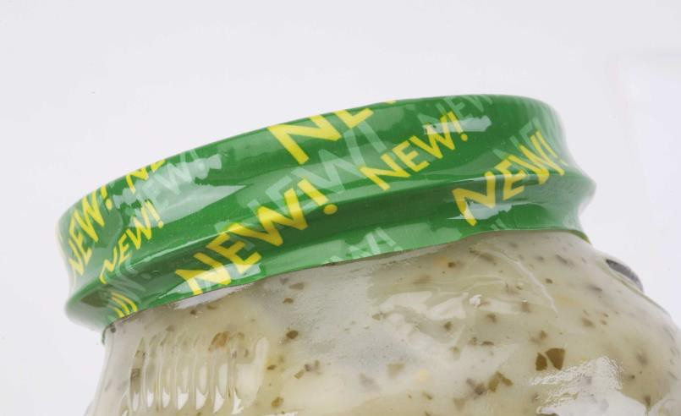

Link
Paper seal may be glued around the cap and neck of a bottle. If this paper is torn, discard the item.

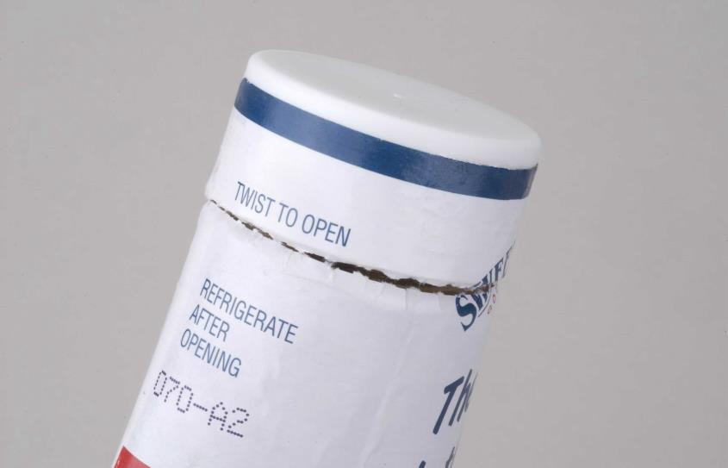
Torn Paper

Food in Cans

General

Sealing food in airtight cans protects it from contamination.
The inner surfaces of some metal cans are protected with a film coating that prevents the metal from contacting the food or causing an unpleasant taste.

Dents

Sharp dents on the double seamed ends (top or bottom of a 3-piece can or the top of a 2-piece can) are unacceptable because these offer the greatest possibility of allowing bacteria to enter. If the dent extends below the double seam and into the side of the can, discard the item. Accept cans with a long and flat dent on a double seam, unless the dent is tipped inward.

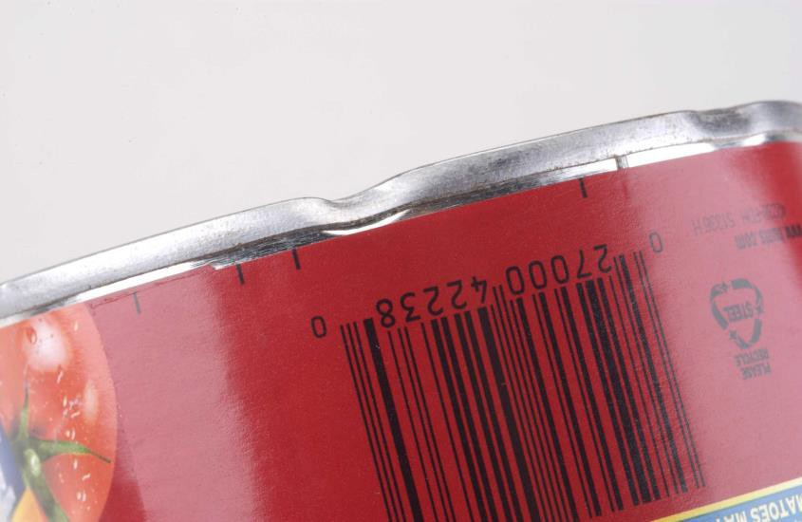
Squeezed Double Seam

Sharp Dent
Dents that peel back the top or bottom double seam are unacceptable.

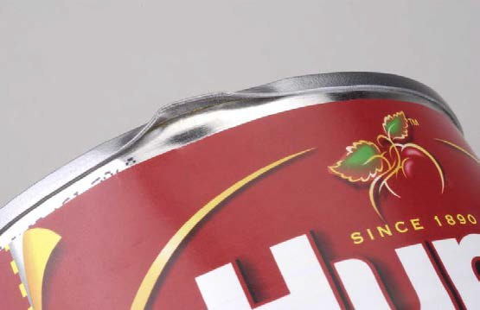
Peeled Double

Dents that cause sharp corners or sharp creases are unacceptable because the can’s inner protective coating may tear, exposing food to contamination by contact with the can’s metal.

25

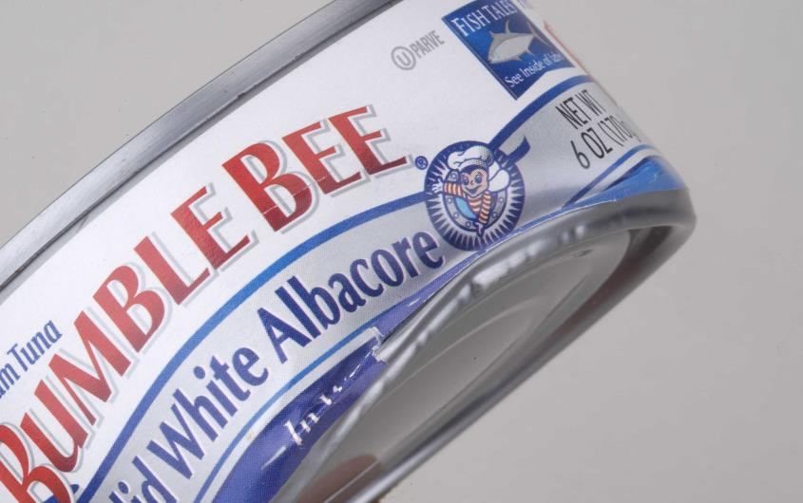
Sharp Crease
Although there is no seam on the bottom of a 2-piece can, a sharp crease might tear the inner coating. If a fingernail or a tool with a thin edge applied to the edge of the crease can suspend the can, discard the item.

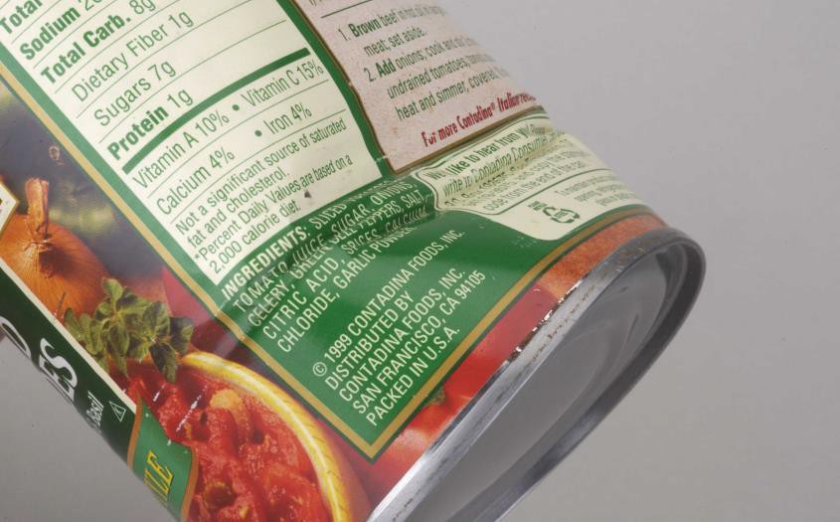
Deformed End
Pointed End of Crease
Cans with side dents causing points at the ends of the crease are not acceptable. When the crease is so deep that it also deforms an end of the can, causing it to wobble, discard it.

26

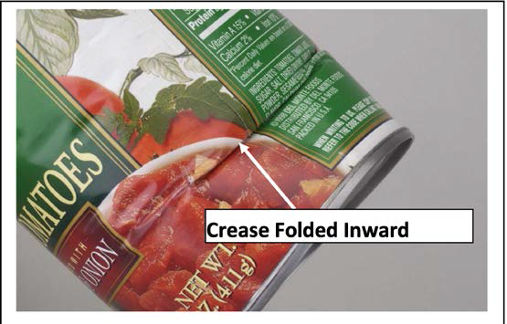
Severely crushed cans may have the sides folded in on themselves. Discard them.

Dents on pull-top can lids (used for drinks, soups, and some fruit) may cause unseen perforations (tears) in the very thin (score) area that rips when opening the can. These tears may allow bacteria to enter. In addition, the rip area may leak if struck by another item during packing.

No damage to the pull- top lid is allowed.

Exception: Severe dents are acceptable in all dried food containers, such as coffee, when there is no leakage.

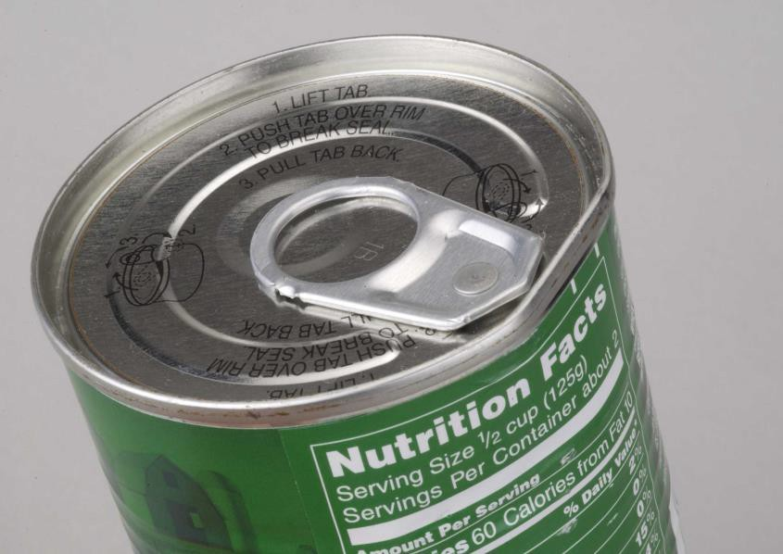
Dent

Bulges

Some bacteria release gas when they feed on canned food. Swollen cans are a sure sign that contamination may be present. Detect a slight amount of swelling by pressing on the end. If the end can be pushed in, contamination may be present. Discard the product. Even if the end springs back after it is released (known as “oil-canning”), discard the product.

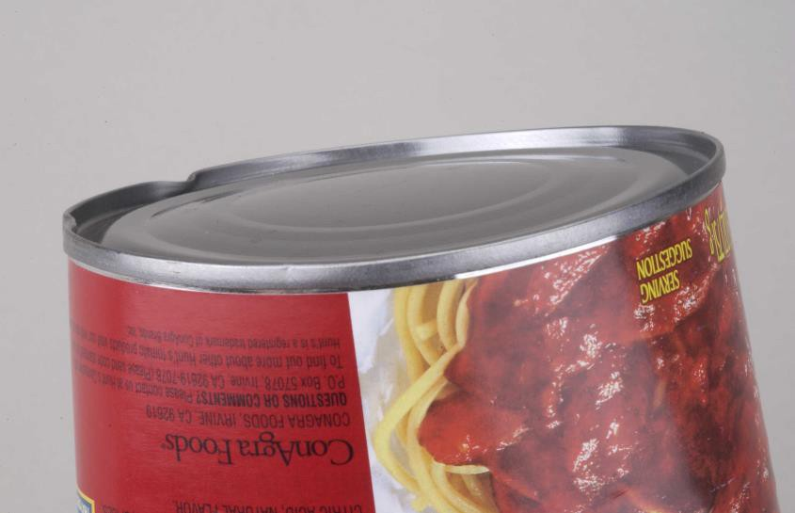
Bulged Outward

Rust (Corrosion)

Rust that remains after wiping may indicate pitting that is deep enough to cause the can to be compromised (perforated) and allow contamination of the contents. Discard the can.

Food in Glass or Plastic Containers

General

Glass jars with dents on the lids indicate glass chips may be in the food. Discard these jars.

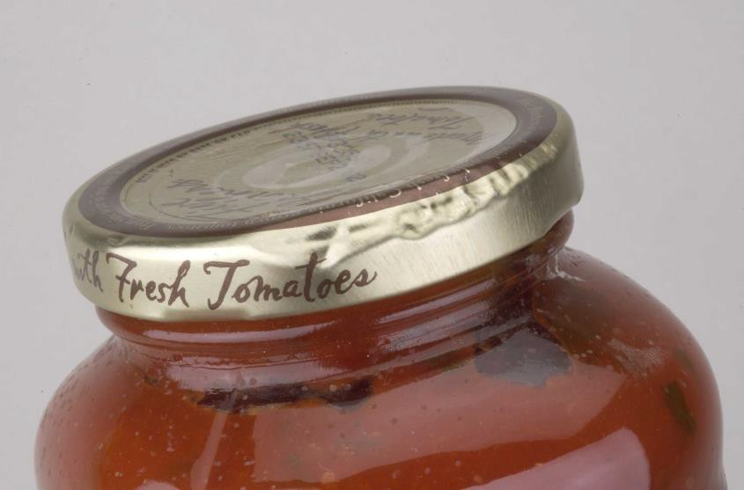
Dents

Jars with a Vacuum Seal

A jar with a good vacuum seal is airtight. An indicator of a good vacuum seal is an inward dished (un-popped button) usually marked with a printed pop-up indicator, which shows the jar has a good vacuum seal and is airtight.

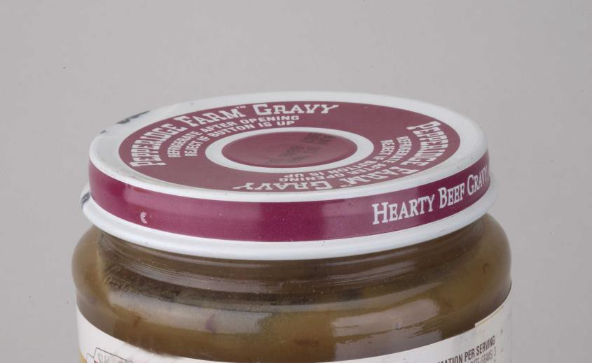
Un-Popped Button
A jar with a lid with a raised center that may or may not spring back after being depressed (“oil-canning”) is not airtight and must be discarded.

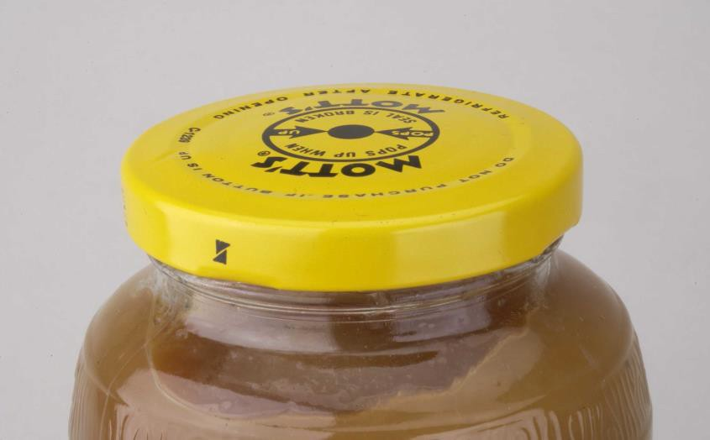
Popped Button

Jars or Bottles without A Vacuum Seal

Food that is very resistant to bacterial contamination (such as syrup and honey) may not be vacuum-sealed. A screw- cap and seal protect the contents from tampering and physical contamination. Discard the item if there is visual evidence of contamination or if the seal is broken.

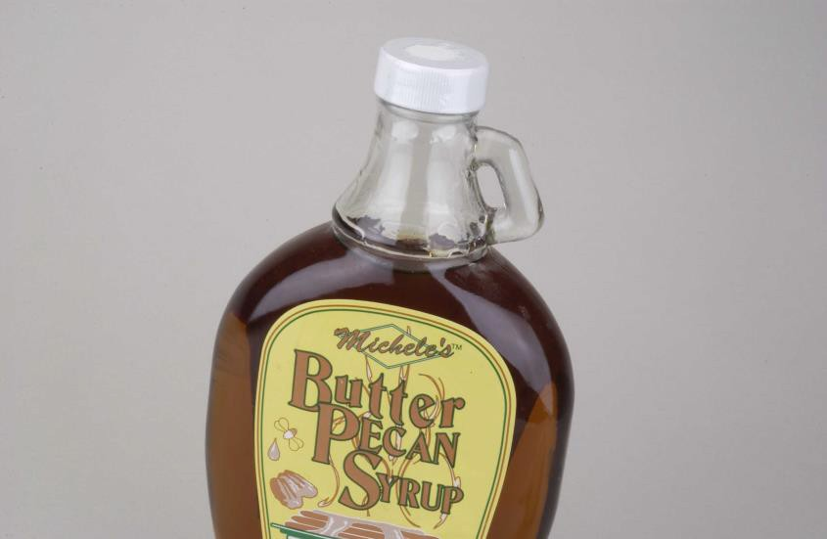
Plastic Seal
Screw Cap

Food Deterioration

Discard items that have visible abnormal food conditions or foreign material.

Food in Other Containers

When cardboard cartons with an inner sealed package (such as cereal, gelatin, rice, and cake mix) are damaged, shake the carton in several positions. If food comes out, discard the item. If no food comes out, remove the inner package and check for damage. If there is no damage, replace the package in the carton and use Food Bank tape to repair the carton damage.

When cardboard cartons have no inner sealed package (for example, most pasta, flour and pierced boil-in-the-bag food), and food comes out, do not repair it. Reject the item.
Styrofoam plastic containers (such as those used for dried soup mix) may have a paper or thin plastic seal adhered to the edge of the container. Reject the product if the container or seal is damaged.

Non-food Items

Medical products

Discard all prescription medicines.

For those intended for internal use (such as vitamins, non- prescription medicines, nasal sprays, ear drops, douches, and herbal supplements), follow the directions of the Warehouse Coordinator/Partner Agency Director.

Those for external use (such as Band-Aids, skin creams, Preparation H, and antiseptics) are acceptable.

Plastic-wrapped Items

These are typically paper or plastic products (such as table napkins, disposable dinnerware, toilet paper and towel rolls). Torn wrapping presents the possibility of contamination.

- Single item: retain it for use at the Food Bank or discard it because of contamination.
- Multi-pack item: remove items exposed by a small tear, and seal the tear with Food Bank tape.
- Feminine pads: individually wrapped products are acceptable. Seal the torn bulk wrapping with Food Bank tape.
- Discard all boxes of facial tissues with torn packaging.

Liquid Products

Tighten the cap and place a strip of Food Bank tape across the cap to show the cap is tight. This reduces the possibility of the cap becoming loose and leaking liquid after it is packed.

Place tape across flip-up lids to prevent them from being snagged and opened after being packed.

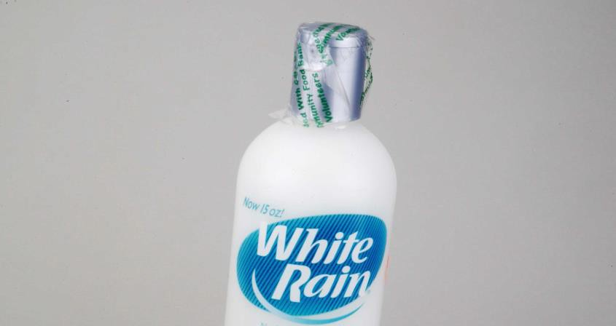
Tape Strip

Chemicals

Many chemicals are poisonous or can cause injury. Discard all pesticides, insect repellants and oven cleaners (unless they are “foam-free”).

Canning Supplies

Agencies do not want canning products. Discard lids, rings, pectin, etc., but accept canning jars, because they have other uses.

Alcohol

Discard all alcohol and alcohol-related products, such as pre- made mixes.

Other Considerations

When questions about the acceptability of an item arises, ask the Warehouse Coordinator or Food Acquisition Coordinator / Partner Agency Director or the designated knowledgeable person for guidance.

Food Requiring Refrigeration

Discard products so marked (such as some pickles, salad dressings and Jell-O products) because food deterioration has occurred or will occur shortly. Accept products marked for refrigeration after opening.

Marked Items

The donating company may mark some products. Discard those with markings that indicate a defect (such as NG, No Good, Damaged, or Rejected). Accept those marked with an “X”.
This mark usually identifies the product for removal from the store’s stock.

Pet Supplies

Use the same sorting rules as those for human use items.

AFDO MODEL CONSUMER COMMODITY SALVAGE CODE

Introduction
Exposure of food products, drugs and other consumer commodities to adverse environmental conditions or shipping and handling damage does not necessarily mean that the products could not be reconditioned for use by consumers. The salvage of distressed consumer commodities prevents unnecessary waste and expense. Consumer commodity salvaging should be done in a manner consistent with public health practices and eliminate products that pose an unacceptable health risk or misrepresent their history and quality. Consumer commodity salvaging requires knowledge, training, and regulatory oversight.

This Model Salvage Code is provided to assist state and local health agencies that regulate the salvage and reconditioning of distressed consumer commodities. If fully implemented, it can prevent many conditions and activities that could lead to unsafe, deceptive and quality- compromised products from being offered for sale. The Association of Food and Drug Officials (AFDO) recognizes that salvage of these products occurs on a routine basis and there is a need to regulate salvage to protect public health and maintain consumer trust. This Model Code is based upon the Federal Good Manufacturing Practice Regulations and the cumulative experience of AFDO's membership and with guidance from the U.S. Food and Drug Administration
(FDA) and the U.S. Department of Agriculture, Food Safety and Inspection Service (FSIS).

Section One: General Provisions

Intent and Scope

- The (insert appropriate authority) hereby finds and declares that a uniform statewide salvage code is needed to regulate all distressed consumer commodity processing facilities, distributors of salvaged or distressed consumer commodities and salvage dealers and processors conducting business within the State of , to provide for uniformity of inspections of such establishments and to protect the health of consumers by preventing the sale and/or distribution of distressed consumer commodities until such time that distressed consumer commodities can be reconditioned for sale and/or distribution as salvaged consumer commodities in a condition which satisfies all requirements of the (insert appropriate state law).

The requirements of this code are in addition to the current Good Manufacturing Practices for foods as set forth in Title 21, Code of Federal Regulations, Part
117 and all related regulations under this or other agency jurisdiction (e.g. USDA, EPA) and any appropriate state authority and law.

This code does not apply to USDA- and state- inspected plants that produce meat, poultry, and related USDA-inspected products. Distressed meat, poultry and processed egg products, governed by the Federal Meat Inspection Act, Poultry Product Inspection Act and Egg Product Inspection Act and
applicable FSIS regulations, may be reconditioned and/or relabeled only at official establishments under the supervision of an inspector. 1

This code does not apply to medical device and drug manufacturing facilities registered with the FDA.

- This code shall also apply to those situations wherein the courts have decided that detained or embargoed articles found to be adulterated or misbranded can be corrected by reconditioning or proper labeling.

Definitions

For the purpose of this ordinance:

- "Commodity-contact surface" means:

  - A surface of equipment or utensil with which a consumer commodity normally comes into contact; or

  - A surface of equipment, structure or a utensil which may drain, drip, or splash into consumer commodity or a surface normally in contact with a consumer commodity.

- "Consumer commodity" means any food, beverage (including beer, wine, and distilled spirits), dietary supplement, animal food (pet food), drug, device, cosmetic, single service food containers or utensils, soda straws, paper napkins, or any other product of a

1 Inquiries for these products should go to the closest FSIS District Office, which can be found on FSIS' Website or by calling USDA’s Intergovernmental Regulatory Information Line at 1-800- 233-3935.
similar nature. It also may include animal feed when handled by the safe person and at the same facility as other consumer commodities.2

- "Distressed consumer commodity" means any consumer commodity that has had its contents or container subjected to damage or contamination or its label removed or obliterated due to an accident, prolonged storage, fire, flood, adverse weather condition, chemical exposure or other natural or man- made disaster. "Distressed consumer commodity" shall not include consumer commodities that are rejected due to a failure to meet regulatory standards of manufacturer, packer, or customer specifications.

- "Employee" means any person employed by a salvage processing facility or distributor who handles or otherwise contacts distressed consumer commodities or salvaged consumer commodities in any manner including selling, sorting, reconditioning, packaging, storing, and transporting.

- "Enforcement Agency" means state and/or local authority or authorities having responsibility for enforcing this code.

- "Food" means any of the following:
  - Any article used or intended for use for food, drink, confection, condiment, or chewing gum for human consumption, animal food, or animal feed.

2 Definition changed to address salvage caused by disasters which could include drugs and medical devices (both prescription and OTC) and to address concerns with animal feeds which are handles differently then “animal food” which is destined for consumption by pets (e.g., cans of cat food, broken bags of dry dog food).
  - Any article used or intended for use as a component of any article designated in subdivision (1).

- “Food recovery” is the practice of taking edible food that would otherwise go to waste from places such as restaurants, grocery stores, produce markets, or dining facilities and distributing it to local emergency food programs.

- "Non-salvageable consumer commodity" means a "distressed consumer commodity" as defined in paragraph (B) of this section that has been damaged or contaminated to such a state that it cannot be safely or practically reconditioned by routine means of washing, sanitizing, sorting, labeling, or other types of reconditioning.

- "Perishable" means that there exists a significant risk of spoilage or unacceptable deterioration when the distressed consumer commodities have not been properly stored or handled.

- "Person" means any individual, or a firm, partnership, company, corporation, trustee, association, agency, or any public or private entity.

- “Potentially hazardous food (PHF) means any food which consists in whole or in part of milk or milk products, eggs, meat, poultry, rice, fish, shellfish, edible crustacean, raw-seed sprouts, heat-treated vegetables and vegetable products and other ingredients in a form capable of supporting rapid and progressive growth of microorganisms.

- "Reconditioning" means any appropriate process or procedure by which distressed consumer
commodities can be brought into compliance with all federal and Enforcement Agency requirements, making it suitable for consumption or use as human food or animal feed. It does not mean the dilution of a distressed consumer commodity with a like acceptable consumer commodity to meet a minimum acceptable level of safety or quality.

- "Salvageable consumer commodities" means any "distressed consumer commodities," defined in paragraph (a) of this section, which can be reconditioned to the satisfaction of the Enforcement Agency.

- "Salvage dealer" means a facility that stores or holds for sale salvaged consumer commodities.

- "Salvaged consumer commodities" means previously "distressed consumer commodities," as defined in paragraph (a) of Section 1 - 102 which, when reconditioned, meets all federal and Enforcement Agency requirements.

- "Salvage processing facility" means an establishment engaged in the business of reconditioning or by other means salvaging distressed consumer commodities for human or animal consumption or use.

- "Salvager" means any salvage processing facility or any facility operated by a salvage dealer, salvage distributor, or salvage processor where there are any distressed, salvageable, or salvaged consumer commodities.

- "Sanitize" or "sanitizing" means the application of cumulative heat or chemicals to the surface of consumer commodities packaging that, when
evaluated for efficacy, is sufficient to yield a reduction of 5 logs, which is equal to a 99.99% reduction, of representative disease microorganisms of public health importance.

- "Salvage distributor" means any person who is engaged in selling or distributing salvageable consumer commodities.

- "Salvage processor" means any person who prepares distressed food for sale or further distribution at a facility operated by another person.

- "Supplier" means any person who transfers distressed consumer commodities to a salvage processor.

- "Time-dated consumer commodities" means any food, drug, or device that has a "Use-by Date", "Sell-by Date", or "Expiration Date."

- "Vehicle" means any truck, car, bus, railcar, aircraft, boat, ship or other means by which distressed, salvageable, or salvaged consumer commodities is transported from one location to another.

Section Two: Salvager Personnel

Employee Health

The operator of a salvager shall exclude any employee whose duties require contact with distressed or salvaged consumer commodities or close proximity to commodity- contact surfaces, distressed or salvaged consumer commodities, or employees handling distressed or salvaged consumer commodities from a facility if the employee:

- Has been recently (last 90 days) diagnosed with, or lives in the same household with a person diagnosed with or exposed to Salmonella typhi, Shigella spp.,
Escherichia coli 0157:H7, or Hepatitis A Virus; or

- Suspected of causing or being exposed to a confirmed disease outbreak caused by Salmonella typhi, Shigella spp., Escherichia coli 0157:H7, or Hepatitis A Virus; or

- Has symptoms of illness such as diarrhea, fever, vomiting, sore throat with fever, or jaundice; or

- Has a lesion containing pus, such as a boil or infected wound that is open or draining, that may be exposed to distressed consumer commodities, salvaged consumer commodities, or commodity-contact surfaces unless it can be adequately protected and covered by an impermeable cover.

Personal Cleanliness

All consumer commodities-handling employees shall practice hygienic practices necessary to protect the
consumer commodities from contamination and cross- contamination.

- Employees, while working in direct contact with distressed consumer commodities, salvaged consumer commodities, or commodity-contact surfaces, shall maintain a high degree of personal cleanliness, wear clean outer garments, keep their fingernails trimmed and clean, and wear hair restraints such as hair nets, headbands, caps, or snoods.

- Employees shall wash their hands and exposed portion of their arms thoroughly in an adequate hand- washing facility utilizing warm running potable water, hand soap, and clean, single-use disposable towels before starting work, and as often as may be necessary to remove soil, and after any activity that may contaminate hands or gloves.

- Employees shall not resume work after visiting the toilet room without first washing their hands.

- No person shall eat food, drink beverages, or use tobacco in any form in areas where salvaged or salvageable consumer commodities are exposed or in areas used for washing equipment or utensils.

- When gloves are used in any activity where the consumer commodity or its immediate container is directly contacted, they shall be clean and of a non- contaminating design. They shall be single-use or durable enough to be adequately washed. They shall be replaced or washed anytime they contact an insanitary surface or develop holes or tears.

Employee Training and Supervision

- Personnel responsible for identifying sorting and reconditioning distressed consumer commodities should have a background of education or experience, or a combination thereof, to provide a level of competency necessary for production of clean and safe products.

  - Employees shall be given appropriate training in proper food handling techniques, food protection principles, and other procedures to adequately process consumer commodities to be salvaged.

  - Employees shall be informed of the danger of poor personal hygiene and insanitary practices.

- Responsibility for assuring compliance by all personnel with all requirements of this code shall be clearly assigned to competent supervisory personnel.

Section Three: Salvager Responsibilities for the Protection from Contamination of Salvageable and Salvaged Consumer Commodities

Contamination Protection

All salvageable and salvaged consumer commodities, while being stored, reconditioned, or transported, shall be protected from contamination.

- All potentially hazardous foods and any drug that requires refrigeration shall be held and handled such that the temperature of the product does not exceed
5oC (41oF) at any time or other temperature requirement as stated upon the label of the food or drug.

- Foods that are highly perishable, such as fresh produce, shall be refrigerated to prevent spoilage while being stored.

- Frozen food shall be maintained in a frozen state and held at a temperature of -18oC (0oF) or below.

- When separating intermingled distressed consumer commodities, reasonable care shall be taken at all times to prevent cross-contamination by removing any container suspected of leaking, isolating any container that may have been cross-contaminated and ensuring that unsalvageable or contaminated commodities are safely disposed.

- Poisonous and toxic materials shall be identified and handled in a manner to prevent contamination to any salvageable or salvaged consumer commodities and should be stored separately from any area where salvageable and salvaged consumer commodities are handled or stored.

- Toxic cleaning compounds, sanitizing agents, and pesticide chemicals shall be identified, held and stored in a manner that protects against contamination of commodities, commodity-contact surfaces, or commodity-packaging materials. All relevant regulations promulgated by other federal, state and local government agencies for the application, use, or holding of these products should be followed.

Segregation of Distressed Consumer Commodities

All distressed consumer commodities shall be segregated from salvaged consumer commodities until sorted and shall be sorted as soon as is practical to reduce the risk of cross- contamination.

- Pending consumer commodity sorting, care shall be taken to not increase the possibility of contamination of distressed consumer commodities by combining separate lots or loads.

- Non-salvageable consumer commodities and containers shall be removed and stored separately from other consumer commodities and in isolated and identified areas of the salvage facility.

- Pending destruction, stored non-salvageable consumer commodities shall be handled in such a manner that they do not attract or harbor pests or become a source of contamination by airborne particle cross-contamination, dripping, or direct contact with other commodities.

- After sorting, salvageable consumer commodities shall be removed from the sorting area and stored in separate area from the distressed consumer commodity area and non-salvageable consumer commodities.

Section Four: Salvager Equipment and Utensils

4-101 Design and Fabrication

(A) Commodity-contact surfaces of equipment and utensils contacting salvageable consumer commodities shall be made of non-toxic, non- corrosive materials and cleanable materials. Exceptions may be made to the above materials requirements if approved by the Enforcement Agency.

(B) | Equipment | shall | be designed, installed, and
 | maintained | to | ensure adequate cleaning.
Commodity-contact surfaces shall be durable such that they do not deteriorate after repeated cleaning and sanitizing.

- Equipment in use at the time when this code becomes effective and which does not fully meet the above requirements may be continued in use only if it is:

  - maintained in good repair,
  - capable of being maintained in a sanitary condition, and
  - designed so that surfaces that come in contact with salvageable or salvaged consumer commodities are non-toxic and non- contaminating.

Section Five: Cleaning, Sanitization, and Storage of Salvager Equipment and Utensils

Salvager Equipment and Utensil Cleaning and Sanitizing

- Utensils and commodity-contact surfaces shall be thoroughly cleaned and sanitized prior to use.

- Surfaces of equipment and utensils that contact non-food items shall be cleaned to prevent contamination of the salvageable consumer commodities, shall not cause loss of sterility if labeled as "sterile," and shall not chemically react with commodities contacted.

- All other surfaces or equipment shall be cleaned and sanitized after use.

Salvager Equipment and Utensil Handling and Storage

- During processing, commodity-contact and other salvageable commodity-contact surfaces shall not be exposed to contamination from other process lines via drift, dripping, splash, or other airborne methods of contamination.

- Due care shall be taken to not contaminate consumer commodity-contact surfaces and consumer commodities during the application of water, detergent, or sanitizing compound as part of any washing activity.
- Cleaned and sanitized food contact surfaces, equipment surfaces, and utensils shall be used to prevent contamination of commodities being salvaged.

- Employee personal items, including medications, food, cosmetics and tobacco products, shall not be utilized or stored where consumer commodities processing equipment is handled or stored.

- All single-service articles shall be used only once and shall not be cleaned or reconditioned for the purpose of being offered for sale for additional use.

Storage

- Cleaned and sanitized equipment and utensils shall be stored in a manner that protects them from contamination when not in use.

- Unused single-service articles used in processing distressed consumer commodities, such as cleaning cloths, paper cups and paper towels, shall be handled and stored in a manner that will protect them against contamination.

Section Six: Salvager Sanitary Facilities and Controls

Water Supply

The water supply shall be adequate, of a safe, sanitary quality, and from a source constructed and operated in accordance with specifications approved by the Enforcement Agency.
- Warm water [approximately 43oC (110oF)] shall be provided to all handwashing stations through a mixing valve or combination faucet.

- Water under pressure shall be provided to all fixtures, equipment, and nonfood equipment that are required to use water.

- No cross-connections shall exist between the water supply and any source of non-potable water, cleaning material, sewage plumbing or other source of contamination.

- If hoses or other equipment are attached directly to the water supply system, there shall also either be a suitable backflow prevention device or air gap installed to protect the water system.

Sewage Disposal

All sewage, including liquid waste shall be disposed through the plumbing system, which shall discharge into an approved sewage system or in a manner approved by the Enforcement Agency.

Plumbing

Plumbing shall be sized, installed, and maintained in compliance with applicable state and local plumbing codes.

Toilet Facilities

Each salvager shall provide its employees with properly installed and conveniently located toilet facilities in numbers and equipped as required by law.
- Toilet facilities, including rooms and fixtures, shall be kept in a clean condition and in good repair at all times.

- The doors of all toilet rooms shall be self-closing and shall not open directly into any room or area where consumer commodities are processed or unpackaged.

- Toilet tissue shall be provided. Easily cleanable receptacles shall be provided for waste materials. Waste receptacles in toilet rooms shall be covered.

Handwashing Facilities

Each salvager shall provide adequate handwashing facilities conveniently located to the processing area for its employees, including a lavatory or lavatories equipped with hand-cleansing soap or detergent dispensed from a suitable wall- or sink-mounted dispenser and suitable single-use sanitary towels or approved hand-drying devices.

- Such facilities shall be kept clean and in good repair.

- Signs shall be posted directing all employees to wash their hands immediately after using the toilet and before starting or resuming work.

Garbage and Refuse

- All organic or organic-containing refuse shall be kept in leak-proof, non-absorbent containers which shall be kept covered with tight-fitting lids when filled, stored, or not in continuous use. Such containers shall be covered when stored, and stored in either a vermin-proof room or enclosure or in a waste refrigerator. Paper, cardboard, unused equipment,
and non-organic refuse shall be stored in containers, rooms, or areas in such a manner to prevent it from becoming a source of contamination or pest harborage.

- Refuse shall be stored in suitable containers and each container and any room or area where refuse is stored shall be thoroughly cleaned after the emptying or removal of refuse.

- All refuse shall be disposed of with sufficient frequency and in a manner to prevent contamination of salvaged product and surrounding processing areas.

- A separate area with suitable sewage disposal sink with hot and cold running water under pressure shall be provided for cleaning garbage containers and mops and disposing of used mop water.

Insect and Rodent Control

No pests, rodents, birds or other animals shall be allowed in any area where consumer commodities are stored or processed. Patrol dogs accompanying security or police officers are permitted. Guide dogs accompanying blind persons shall be permitted in sales areas.

- Effective measures shall be taken to exclude pests, rodents, birds, or other animals from the processing and storage areas and to protect against the contamination of consumer commodities on the premises.

- The use of insecticides or rodenticides is permitted only under precautions and restrictions that will protect against the contamination of consumer
commodities, commodity-contacting surfaces, and packaging materials. Application of insecticides and rodenticides and the use of traps and other pest control devices shall either follow a written procedure that is appropriate and effective for its intended purpose or be directed and maintained by a professional pest control service.

Section Seven: Construction and Maintenance of Salvager Facilities

Separation of Reconditioning Activities

The area used for the purpose of reconditioning distressed consumer commodities shall be a separate and enclosed room that does not open directly to receiving or storage areas. This room shall be equipped with a handwash sink and a separate three-compartment cleaning sink with hot and cold running water under pressure for reconditioning distressed consumer commodities.

Floor Construction

- The floor surfaces in all rooms and areas in which salvageable or salvaged consumer commodities are stored or processed and in which utensils are washed, walk-in refrigerators, dressing or locker rooms and toilet rooms shall be constructed to be easily cleanable.

- All floors shall be kept clean and in good repair.

- Any floor that is exposed to water or liquids shall be constructed and maintained to be impermeable.

- Floor drains shall be provided in all rooms where floors are subjected to flooding-type cleaning or where normal operations release or discharge water or other liquid waste
onto the floor. Floors in these areas shall be graded to the floor drain.

Walls and Ceilings

Walls and ceilings of all rooms where consumer commodities are stored or processed shall be clean, smooth, and maintained in good repair.

- Where walls and floors are exposed to water or other liquids, the juncture between the wall and floor shall be coved and sealed.

- Where walls and floors are not exposed to water or other liquids, the juncture shall not exceed 1 mm (1/32 inch).

Salvager Lighting

Adequate lighting shall be provided in handwashing areas, dressing/ locker rooms and toilet rooms and in all areas where consumer commodities are examined, processed, or stored, and where equipment or utensils are cleaned.

- Where an employee is inspecting, sorting, or reconditioning distressed consumer commodities, at least 540 lux (50 foot candles) of light shall be provided at the work surface.

- At all other areas of the facility where light is required, at least 110 lux (10 foot candles) of light shall be provided when measured at 75 cm (30 inches) above the floor.

- Light bulbs, fixtures, skylights, or other glass suspended over exposed consumer commodities in
any step of preparation shall be designed to prevent contamination in case of glass breakage.

Heat Lamp Protective Shielding

Infrared or other heat lamps shall be protected against breakage by a shield surrounding and extending beyond the bulb, leaving only the face of the bulb exposed.

entilation

All consumer commodity storage rooms and processing areas in the salvage processing facility or distributor shall be well ventilated. Ventilation hoods and devices when used shall be designed to prevent condensation from dripping into exposed distressed consumer commodities. Filters, when used, shall be readily removable for cleaning or replacement. Ventilation systems shall comply with applicable federal, state, and local codes, as well as fire prevention and air pollution prevention requirements.

Clothing and Personal Belongings

Adequate facilities shall be provided by the salvager operator for the orderly storage of employee clothing and personal belongings.

Housekeeping

- All rooms, areas, and premises of a salvager shall be kept clean and free of litter and rubbish. Cleaning operations shall be conducted in such a manner as to prevent contamination of salvageable and salvaged consumer commodities.
- No area used to store or sort consumer commodities shall be utilized as an employee lounge, living area, or sleeping quarters. Soiled coats and aprons shall be kept in suitable containers until removed for laundering.

Transportation

Vehicles used to transport distressed, salvageable, or salvaged consumer commodities shall be maintained in a clean and sanitary condition to protect consumer commodities from contamination.

Section Eight: Handling and Movement of Distressed Consumer Commodities

Notice to Enforcement Agency

It shall be the duty of any salvager to keep the Enforcement Agency aware of what source, from where, and when distressed consumer commodities are provided for salvage processing, storage, and distribution.

- When the source of distressed consumer commodities is the result of a natural disaster, accident, power failure or other emergency, the salvage processing facility operator shall make personal contact with the Enforcement Agency within
24 hours after their initial awareness of the emergency and prior to any commodity’s removal from the place at which it was located when it became distressed.

- If emergency removal of distressed consumer commodities is required, notice to the Enforcement Agency shall be made as soon thereafter as possible.
It shall be the duty of the salvager operator to make contact with the Enforcement Agency within forty- eight (48) hours whenever distressed consumer commodities subject to the provisions of this section are obtained.

- When distressed consumer commodities are received as a periodic delivery from a warehouse, retailer, shipper, or manufacturer as a normal course of business, the salvager operator shall notify the Enforcement Agency of the nature of commodities received, source, and frequency of deliveries prior to receipt of the first delivery and annually thereafter.

Transporting of Distressed Consumer Commodities

Distressed consumer commodities shall be moved from the site where it became distressed to a suitable holding or processing facility as expeditiously as possible after notice complying with Section 8-101 has been given. All distressed and salvageable consumer commodities of a perishable nature shall, prior to reconditioning, be transported only in vehicles provided with sufficient refrigeration and freezing capabilities as necessary for product maintenance. No interstate movement of known distressed or salvaged consumer commodities shall be made without the prior approval of the Enforcement Agency and after notification of the responsible Enforcement Agency in the state to which distressed or salvaged consumer commodities shall be moved. Concurrence shall also be obtained from the FDA prior to interstate movement.

Handling of Distressed Consumer Commodities

When processing areas or equipment are to be used to recondition several types of distressed consumer commodities and there is a potential for cross-contamination, commodities shall be isolated from the source of contamination either by time or space. If isolated by time, the reconditioning equipment and area shall be cleaned and sanitized as necessary to prevent cross-contamination.

Processing Animal Feed and Animal Food (Pet Food)

Animal food shall be processed in separate areas on separate equipment from human food and other consumer commodities to prevent cross-contamination. Packaged animal feed and pet food can be stored in the same area as consumer commodities provided there is no spillage or leakage. Containers of animal food shall not be stacked on, in, with, or above containers of other consumer commodities.

Section Nine: Reconditioning Distressed Consumer Commodities

9-01 General

All distressed consumer commodities shall be reconditioned prior to sale or distribution except when sold to a salvager holding a valid salvage-processing permit for salvage processing.

9-102 Food and Other Consumer Commodity Containers

Distressed consumer commodities shall be sorted and/or reconditioned to ensure that they are fit for sale and meet the requirements of this code and all applicable laws and regulations. (Reference: AFDO “Guide to Can Defects & Basic components of Double Seam Containers”)

- All metal cans food and animal food shall be sorted to remove and destroy any cans that are of questionable safety. Cans salvaged for sale or distribution shall not leak or appear to be abnormal ("swells," "flippers," and "springers").

  - Salvaged cans shall not be offered for sale in a pitted or rusty condition. Cans shall be considered "pitted" if surface rust cannot easily and completely be removed by rubbing the can's surface with a cloth.

  - Salvaged cans shall have no severe, sharp dents that could fracture the can's interior coating or the container itself. Sharp dents to the side-seam or any end double-seam are not acceptable. Cans unable to be opened by a normal can opener are not salvageable.

- Containers, including metal, retort pouches and glass containers with press caps, screw caps, pull rings or other types of openings which have been in contact with water, liquid foam, or other deleterious substances, as a result of fire fighting efforts, flood, sewer backups or similar mishaps, shall be removed and destroyed.
  - Salvaged containers shall have lids, caps, and closures that are intact and appear to never have been opened.

  - Salvaged containers shall appear to have maintained their full contents.

  - Salvaged containers, if glass, shall be viewed with light ("candled") to view contents and detect, if possible, any glass fragments or foreign materials, such as mold.

- Alcoholic beverages (such as wine and liquors) that show evidence of container failure or lid contamination may be distilled if, after a risk analysis, distillation is approved by the Enforcement Agency.

- Salvageable metal containers (cans) of food that have been partially or totally submerged in water, liquid foam, or other container contaminating substance shall be thoroughly cleaned and then sanitized. The sanitizing solution shall either contain 100 ppm available chlorine and be applied for a minimum period of one minute or shall be sanitized by a method approved by the Enforcement Agency. After sanitizing, the metal containers shall then be treated to inhibit rust formation.

- When the distressed commodity is a non-potentially hazardous food (such as flour, rice, cereal, salt, pepper, or dry pet food) or it is a single-use product (such as straws, napkins, paper cups, or plastic silverware), it may be repackaged into clean containers.

  - Unpackaging and repackaging shall not contaminate the commodity being salvaged.
  - Packaging must be clean and suitable for the commodity to be packaged.

  - Different products or lots shall not be combined without the approval of the Enforcement Agency.

  - Repackaged salvage commodities shall be labeled per this code.

- When salvaging time-dated consumer commodities that are dated to ensure safety or nutrient accuracy (such as for over-the-counter drugs and devices, infant formula, meal replacement products, and dietary supplements), these products shall be inspected to see if the date has passed. If passed, the product container shall be removed by sorting and either destroyed or fully tested to verify safety and label accuracy of declared nutrients or active ingredients prior to sale or distribution.

- When prescription drugs and devices are obtained as distressed consumer commodities, they shall either be destroyed or, with permission of the Enforcement Agency, returned to an FDA-registered manufacturer or importer. With approval of the Enforcement Agency, some prescription devices may be sold as scrap.

Section Ten: Salvaged Commodity Labeling
Salvaged commodities shall be truthfully and accurately labeled and such labels shall comply with all applicable labeling requirements.

Label Removal

Labels for containers may be removed prior to cleaning if adequate precautions are taken to ensure that the same labels or same complete label information are reapplied to the containers. Pallets or other containers of unlabeled consumer commodity containers shall only be stored if traceability to the actual label is maintained. Each container of unlabeled consumer commodity shall only contain identical products from the same manufacture's lot or date code. Unlabeled containers of consumer commodities may not be sold or distributed without the advanced approval of the Enforcement Agency.

Relabeling

- All salvaged consumer commodities shall have added to any otherwise required original labeling on the principal display panel of each individual retail package a statement indicating that the container or product has been salvaged. The name and address of the salvager shall be printed legibly on the label in indelible ink or other permanent manner.

- All salvaged consumer commodities in containers are to be provided with labels meeting the requirements of (insert appropriate sections of state law, and the Federal Food, Drug, and Cosmetic Act, Fair Packaging and Labeling Act, and regulations promulgated under these acts for products in interstate commerce). Where original labels are removed from containers that are to be resold or redistributed, the replacement labels must show as the distributor the name and address of the salvage processing facility and the date of reconditioning for sale or distribution.
- Time-dated commodities shall not have their sell-by, use-by, expiration date, or other date removed, obliterated, altered, extended, or obscured.

- Salvaged human food, animal feed or animal food may contain prohibited animal proteins. Any salvaged food product intended for animal feed or animal food shall prominently and conspicuously notify on the principal display panel of each individual retail package or on a sign when sold from bulk notification that the container or product has been salvaged and may contain prohibited animal proteins. In addition to labeling which meets the requirements of (insert appropriate sections of state law, Federal Food, Drug and Cosmetic Act, Fair Packaging and Labeling Act and regulations promulgated under these acts), the name and address of the salvager, the word “salvage” and the warning statement, “Do not feed to cattle or other ruminants,” shall be prominently and legibly printed on the principle display panel in indelible ink or other permanent manner.

Section Eleven: Handling of Non- Salvageable Consumer Commodities

General

Consumer commodities distressed by deterioration, filth, insects, rodents, pesticides or other chemicals, potentially hazardous foods and temperature sensitive drugs which have been exposed to temperatures above 5oC (41oF) for a period exceeding 4 hours or which indicates spoilage by appearance or smell, frozen foods which have not been maintained at a temperature of 18 C (0 F), containers showing evidence of partial usage, unauthorized opening or
tampering, containers found unfit for salvage upon examination, and products packaged in paper or other porous materials which have been subject to contamination by absorption shall be deemed to be non-salvageable consumer commodities, as defined in Section 1-102(G) of this code.

Distribution of Nonsalvageable Consumer Commodities

Non-salvageable consumer commodities shall not be sold or distributed, and shall be disposed of in a manner approved by the Enforcement Agency.

Section Twelve: Records

12-101 General

A written record or receipt of distressed, salvageable, destroyed non-salvageable consumer commodities and salvaged consumer commodities shall be kept by the salvage processing facility for inspection by the Enforcement Agency. Records documenting relabeling, repackaging and distribution shall also be maintained such that traceability of lots, ingredients, and expiration dates are recorded and such records can be used to verify adequate handling and for purposes of recall should that become necessary.

- Records shall be available for review at the salvage processing facility during normal business hours.

- Records shall include the name of the product, the name and address of the manufacturer or distributor, the production code, container sizes, source of the distressed consumer commodities, the date received,
the type of damage, and the salvage process conducted.

- Records shall be kept on the premises of the salvage processing facility for a period of one year following the completion of transactions involving each lot of a consumer commodity.

Section Thirteen: Salvager Permits

General

It shall be unlawful for any person to operate a Salvage Processing Facility, Salvage Distributor, Salvage Processor, or Salvage Distributor within the State of who does not possess a valid permit issued by the Enforcement Agency. Only a person who complies with the requirements of this code shall be entitled to receive and retain such a permit. Permits shall be specific to the type of operation except that a Salvage Processing Facility may act as a Salvage Distributor or Salvage Dealer.

- A permit shall be issued only upon determination of compliance with this code by inspection and shall be good for one year upon issuance.

- Renewal permit shall be issued after determination of compliance with this code by inspection and shall be good for one year upon issuance.

- Each permit shall indicate the firm name, the operator, address of the salvager, permit number, and date of expiration.

- Permits shall not be transferable from one person to another person and are valid only for the location
indicated except that a Salvage Processor may operate a remote location with approval of the Enforcement Agency.

- The permit shall be posted at the Salvager facility where it can be publicly viewed and at any remote site utilized by a Salvage Processor. A facsimile may be posted in lieu of the original. Any vehicle used to convey distressed, salvageable, salvaged, and non- salvageable consumer commodities shall carry a copy of the valid permit when transporting consumer commodities.

- The name and address of the salvager and the permit number shall be conspicuously displayed on the outside of all vehicles being used for consumer commodity salvage operations.

Issuance of Permits

- Any person desiring to operate as a salvager shall make written application for a permit on forms provided by the Enforcement Agency. Such application shall include the applicant's full name and complete address, whether such applicant is an individual, firm, or corporation, and, if a partnership, the name of the partners together with their addresses, the location and type of the proposed business, and the signature of the applicant or applicants. All new salvagers operating within the State of _ after the Enforcement Agency has adopted this code shall be required to have permits before they commence operations. Salvagers already established shall apply for permits within thirty days. Pending permit receipt, their operations may continue unless the permit is denied. Should a permit
be denied, the Enforcement Agency shall cite the reasons for denial.

- Upon receipt of an application, the Enforcement Agency shall make such inspections of the salvager as is necessary to determine compliance with the provisions of this code. When any inspection reveals that the applicable requirements have been met, the enforcement agency shall issue the permit.

Suspension of Permits

- When the Enforcement Agency has reason to believe that the salvager has created or is responsible for an imminent public health hazard, the permit may be suspended or revoked and the concerned consumer commodities seized immediately upon notice to the permit-holder without a hearing. In such event, the permit holder may request a hearing, which shall be granted in accordance with applicable administrative procedures.

- In all other instances of violation of the provisions of this code, the Enforcement Agency shall serve upon the holder of the permit a written notice specifying the violation(s) in question and afford the holder a reasonable opportunity to correct same. Whenever a permit holder or operator has failed to comply with any written notice issued under the provisions of this code, the permit holder or operator shall be notified in writing that the permit shall be suspended at the end of 15 days following the serving of such notice, unless a written request for a hearing is filed with the Enforcement Agency by the permit holder within such 15-day period. If no request for a hearing is filed within such 15 days the suspension is sustained. If a written request for a hearing is received by the
Enforcement Agency, a hearing shall be conducted in accordance with applicable administrative procedures.

Reinstatement of Suspended Permits

Any person whose permit has been suspended may, at any time, within 15 days following receipt of a written request, make application for a reinspection for the purpose of reinstatement of the permit. The request shall include a statement signed by the applicant that in his or her opinion the conditions causing suspension of the permit have been corrected. The enforcement agency shall make a reinspection. If the applicant is in compliance with the requirements of this code, the permit shall be reinstated. Summaries of the findings of reinspection shall be provided to the facility at the conclusion of the inspection.

Revocation of Permits

For serious or repeated violations of any of the requirements of this code, or for interference with the Enforcement Agency in the performance of its duties, the permit may be revoked after an opportunity for hearing has been provided by the Enforcement Agency. Prior to such action, the Enforcement Agency shall notify the permit holder, in writing, stating the reasons for which the permit is subject to revocation and advising the permit holder that the permit shall be permanently revoked at the end of 15 days following servicing of such notice, unless a request for a hearing is filed with the Enforcement Agency by the permit holder within such 15-day period. If no written request for a hearing is filed within the 15-day period, the revocation of the permit becomes final. A permit may be suspended for cause pending its revocation or a hearing relative thereto.

Serving of Notices

A notice provided for in this code is properly served when it is delivered to the permit holder or when it is sent by registered or certified mail, return receipt requested, to the last known address of the permit holder. A copy of any such notice shall be filed in the records of the Enforcement Agency.

Section Fourteen: Salvager Inspections and Enforcement

General

The Enforcement Agency shall inspect each salvager at least once every 3 months and shall make as many additional inspections as necessary to insure compliance with this code.

Access to Salvager Facilities, Operations, and Vehicles

Authorized representatives of the Enforcement Agency, after proper identification, shall be permitted to enter at any reasonable time any salvager facility, any remote storage or processing facility being used by a salvage processor, or any salvager vehicle for the purpose of making inspections to determine compliance with this code. The Enforcement Agency's designated representatives shall be permitted to examine the records of the salvage processing facility or distributor to obtain information pertaining to distressed, salvageable, non-salvageable, and
salvaged consumer commodities purchased, received, used, sold, destroyed and/or distributed.

  - Hearings

After prior notice to a salvager permit holder suspected of a violation, the hearings provided for in this section shall be conducted by the Enforcement Agency at a time and place designated by it or as provided by the State administrative procedures act. Based upon the recorded evidence of such hearings, the Enforcement Agency shall make a finding and shall sustain, modify, or rescind any official notice or order considered in the hearing. A transcript of the hearing shall not be made unless the interested party assumes the costs thereof and a request is made therefor at the time a hearing is requested.

Remedies

In addition to the provisions herein for suspension or revocation

Of operating permits, the Enforcement Agency may, at its discretion, institute civil or criminal proceedings against any person who violates any provision of this code and the regulations thereunder.

Injunctions

The Enforcement Agency may seek to enjoin violators of this code.

Salvagers and Sources of Distressed Consumer Commodities Outside the Jurisdiction of the Enforcement Agency
Salvaged consumer commodities from salvagers and other sources located outside the jurisdiction of the State of _, may be sold or distributed within the State, if such facilities and distributors conform to the provisions of this code or substantially equivalent provisions and have a valid permit from the Enforcement Agency.

To determine the extent of compliance with such provisions, the Enforcement Agency may accept reports from responsible authorities in other jurisdictions where such facilities and distributor's operations are located.

Review of Plans

- When a salvager is hereafter constructed or extensively remodeled, or when an existing structure is converted for use as a salvager, properly prepared plans and specifications for such construction, remodeling, or alteration, showing layout, arrangements, and construction materials of work areas and the location, size, and type of fixed equipment and facilities, and a plumbing riser diagram shall be submitted to the Enforcement Agency for approval before such construction, remodeling, etc., is begun.

- The plans shall be approved or rejected within 10 working days after receipt by the Enforcing Agency and the applicant shall be notified in writing or electronically of the decision. This review period may be extended if the Enforcing Agency and applicant agree that additional time is warranted due to the need to complete a site inspection, review land-use or other permits, or complete other actions that are pending. If the plans are rejected, the Enforcing Agency shall advise the applicant the reason or reasons why the plans were not acceptable.

Section Fifteen: Food Recovery Programs

General

Recovering consumable food and moving it to hunger relief organizations has impacted the lives of millions of people of all ages across America. Numerous organizations, both governmental and private, are involved in this vital work.

The safety of food throughout this recovery process is of critical importance due, in part, to the high level of vulnerable individuals served by hunger relief organizations.
Compounding this concern is the diversity of organizations and agencies acting to insure food safety standards are consistently met.

Food Safety Resources

(A) The “Comprehensive Resource for Food Recovery Programs” was developed through the Conference for Food Protection (CFP) and is intended to assist all stakeholders, whether new or existing, involved in the recovery, distribution or service of food to people who live their lives insecure about from where their next nutritious meal will come.

- The Bill Emerson Good Samaritan Food Donation Act converts Title IV of the National and Community Service Act of 1990, known as the Model Good Samaritan Food Donation Act, into permanent law, within the Child Nutrition Act of 1966. Signed into law on October 1, 1996, the Act is designed to encourage the donation of food and grocery products to nonprofit
organizations such as homeless shelters, soup kitchens, and churches for distribution to individuals in need.

The Bill Emerson Good Samaritan Food Donation Act promotes food recovery by limiting the liability of donors to instances of gross negligence or intentional misconduct. The Act further states that, absent gross negligence or intentional misconduct, persons, gleaners, and nonprofit organizations shall not be subject to civil or criminal liability arising from the nature, age, packaging, or condition of wholesome food or fit grocery products received as donations. It also establishes basic nationwide uniform definitions pertaining to donation and distribution of nutritious foods and will help ensure that donated foods meet all quality and labeling standards of federal, state, and local laws and regulations.

Further details may be obtained by contacting the office of the attorney general for the appropriate state. In addition, the Emerson Act does not alter or interfere with state or local health regulations or workers’ compensation laws. Local organizations in each state should also be familiar with the impact upon food recovery projects of state or local health regulations and workers’ compensation laws.

- The FDA Food Code is an excellent reference for minimizing the occurrence of risk factors that contribute to foodborne illness. The standards expressed in the Food Code cover such subjects as:
  - Manager or person-in-charge knowledge requirements,
  - Monitoring the health of food handlers,
- Food handler training and supervision,
- Protecting food from pathogens and contaminants from hands and other sources which cause foodborne diseases,
- Time and temperature requirements, and
- Equipment design and construction and maintenance.
Procedures outlined in this section are based on well- established food safety principles and are set forth as guidance for planning and conducting a food recovery program.

For additional copies contact:

Association of Food and Drug Officials 155 West Market Street, 3rd Floor York, PA 17401

Tel.: +1 717-757-2888

