District Form 40C-41.063(4)
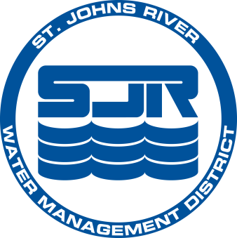
LOCAL GOVERNMENT NOTIFICATION

 |  |  |  |  |  | hereby provides notification that the
(name of local governmental entity)
development proposal, submitted to the St. Johns River Water Management District, known
as
 | (project name)
being proposed by
 |  |  | (applicant name)
which is located in Section |  |  |  |  | Township |  |  | Range |  | and which
Consists of |  |  | acres has been reviewed by the local government. After such
review, all necessary final action has been taken by the government entity to determine, and such determination has been made, that the proposed activity is consistent with the
local comprehensive plan and is in compliance with any local development regulation
in effect in the area where the development will take place.

Name and title of officer or employee of Local
Government authorized to execute notification

Signature of above officer or employee
Date

