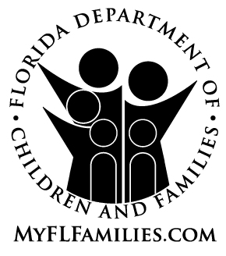
AUTHORIZATION FOR RELEASE OF HEALTH AND MEDICAL INFORMATION
FOR PROSPECTIVE FOSTER OR ADOPTIVE PARENTS

I. I hereby request and authorize the: Department of Children and Families

(Address)

II. To obtain from: ____________________________________________________________________
(Name of Person/Agency Holding the Information)
(Address)

III. The following Information:
All Medical Information & Reports Immunizations HIV Test Results
Prenatal Medical Record X-ray Report(s)
Physical Examination Report(s) Medical data for WIC Certification
Laboratory Report(s) Other (specify):__________________________________

IV. From the medical record of _____________________________________________________________
(Print/type name of client, birth date and file number if applicable)

V. For the purpose of assessing the health of the prospective caretaker as it relates to the applicant’s ability to provide long-term care of a child(ren).

VI. I understand that my signature authorizes full disclosure of my medical and health condition and, thereby, includes HIV test results.

VII. All information I hereby authorize to be obtained from this agency will be held strictly confidential and cannot be released by the recipient without my written consent, except for the purpose of judicial review in adoption proceedings. I understand that this authorization will remain in effect during the licensure as a foster home.

VIII. I understand that I may withdraw my consent at any time, but to do so will stop further consideration of myself as an adoptive or foster parent.

______________ ________________________________________________
Date Signature of Client or Legal Representative

______________ ________________________________________________
Date Legal Representative’s Relationship to Client

IX. USE THIS SPACE ONLY IF CLIENT WITHDRAWS CONSENT

____________________ ________________________________________________
Date Consent Revoked by Client Signature of Client

