






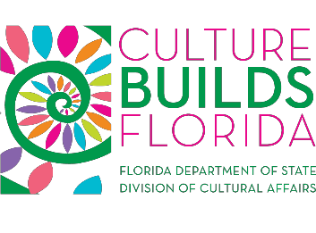
Division of Cultural Affairs Initiatives Partnership Program Application

Applicant Information
Organization Name:
FEIN: DUNS:
Mailing Address:
Contact: Phone:
Email:
Request amount: $ ($5,000-$50,000)
The purpose of these projects fulfills the following initiative related to the Division of Cultural Affairs’ strategic plan:
Economic and creative industry growth Arts education
Leadership and development
Healthy and vibrant community promotion Identity and sense of place
Area of concentration in relation to the above
Project Title:
Project Description (applicants should consider the review criteria when composing your project description):

Please attach detailed budget information regarding how the funds would be expended by your organization. Include a statement indicating the benefit to your organization and other support material.

