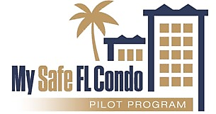
Condominium
Association
Guide
Dear Florida Condominium Associations,
Welcome to the Condominium Association Guide for the My Safe Florida Condominium Pilot Program (MSFCP Program). In 2024, tThe Florida Legislature created the MSFCP Program, in the 2024 Legislative Session. administered by tThe Florida Department of Financial Services is the state agency administering the MSFCP Program. The MSFCP Program This is a pilot program, meaning and future funding opportunities will depend on the results and feedback. The MSFCP Program aims to support eligible Condominium Associations by providing Mitigation Grants for Mitigation Projects to strengthen condominium properties against hurricane winds. Key elements of the MSFCP Program include:
- Free Initial Inspection: Eligible Condominium Associations will receive a free Initial Inspection to identify existing hurricane-resistant features of their properties and recommend, if any, potential recommendations for Improvements to strengthen the properties against hurricane winds and to reduce wind insurance premiums.
- Mitigation Grant Funding: In addition to the free Initial Inspection, Eeligible Condominium Associations may apply for a Mitigation Grant to perform Mitigation Projects consisting of implement Improvements recommended in the MSFCP Program Initial Inspection Report. These Improvements are designed to protect properties from hurricane damage, and to potentially reduce wind insurance premiums.
We encourage you to explore this opportunity and consider applying for the MSFCP Program. This comprehensive guide has been prepared to assist you through the application process.
Strengthening your condominium against hurricanes is an investment in the safety and security of condominium unit owners. We believe the My Safe Florida Condominium Pilot Program is an excellent step towards achieving this goal.

Sincerely,
The My Safe Florida Condominium Pilot Program Team

Table of Contents

Program Stages 3
Stage 1: Inspection Application 4
Stage 2: Initial Inspection 11
Stage 3: Grant Application 16
Stage 4: Final Inspection 25
Stage 5: Reimbursement Request 28
Important Reminders 31

Program Stages
The My Safe Florida Condominium Pilot Program (MSFCP Program) is organized into five distinct stages.
Stage 1: Inspection Application
Eligible Condominium Associations can apply for a free Initial Inspection through the MSFCP Program.
The Condominium Association must complete the application for an Initial Inspection through the online MSFCP Program Portal.

Stage 2: Initial Inspection
The Initial Inspection is provided at no cost to the Condominium Association. A Wind Certification Entity (WCE) will perform the Initial Inspection to evaluate the condominium property, recommend Improvements to enhance the condominium's property’s resilience against wind damage, and identify potential insurance premium discounts.

Stage 3: Grant Application
If the Initial Inspection recommends Improvements, the Condominium Association may return to the MSFCP Program Portal to submit a Grant Application.

The Condominium Association must NOT perform any Mitigation Projects until after the Grant Application is approved. Failure to follow this procedure will result in a denial of the Reimbursement Request.

Stage 4: Final Inspection
Once the recommended Mitigation Project is complete, the Condominium Association must return to the MSFCP Program Portal to request a Final Inspection. The Final Inspection is the final evaluation conducted by the WCE after the Mitigation Project is complete to ensure that recommended Improvements were successfully installed.

Stage 5: Reimbursement Request
After the Final Inspection, the Condominium Association must return to the MSFCP Program Portal and submit a Reimbursement Request. If the Reimbursement Request is approved, grant funds will be disbursed to the Condominium Association.

Stage 1: Inspection Application
Condominium Associations may begin the process by clicking the ‘Create an Account’ button on the MSFCP Program’s website: www.mysafeflcondo.com. After registering, Condominium Associations will be required to complete an application and provide supporting documentation required for eligibility review. All documentation submitted by the Condominium Association applicant must be valid at the time of submission. Case managers and call center agents will be available by phone and email to assist the Condominium Association applicant through the intake process and to answer questions as needed. The MSFCP Program can be contacted by dialing 1-877-891-0012.

Inspection Application Eligibility
Applications will be screened for eligibility to ensure compliance with the MSFCP Program requirements. Failure to disclose accurate and complete information may result in a denial if not corrected.

To be eligible, Condominium Associations:
- Must be located within 15 miles of the coastline;
- Must receive approval by a majority vote of the board of administration or a majority vote of the total voting interests of the Condominium Association;
NOTE: These votes must occur at the annual budget meeting of the Condominium Association or at a unit owner meeting called for the purpose of taking such vote.
- Must provide written notice, within 14 days after an affirmative vote to participate in the MSFCP Program, as required under section 718.112(2)(d), F.S., to all unit owners; and
- Must complete and submit the Inspection Application (Form DFS-O1-010) through the MSFCP Program Portal.

To apply for a free Initial Inspection, a each Condominium Association must submit an on the Inspection Application with the following information and documents for review:

- Condominium Association’s Name,
- Condominium Association’s Address,
- Condominium Association’s Authorized Representative’s Contact Information Completing Application (First and Last Name, Title, Phone Number and Email Address),
- Condominium Association’s Point of Contact (if different from the Authorized Representative),
- Condominium Property Details,
- Condominium Property Insurance Declaration Page, and
- Condominium Voting Results (either majority of board members or total voting interest).

Inspection Applications are reviewed in the order they are received and notifications regarding application status will be sent using the email address provided during MSFCP Program Portal registration. Funds are limited and application review is subject to funding availability. Applications will be screened for eligibility to ensure compliance with the MSFCP Program requirements. Failure to disclose accurate and complete information may result in a denial if not corrected.

NOTE: After reviewing your the Inspection Application, if the MSFCP Program finds that additional information is necessary, your the Inspection Application will be marked as "Needs More Information." Condominium Associations will have 60 days to submit the required documentation before the application is closed administratively as WITHDRAWN.

How to Apply for a Free Initial Inspection
Follow the instructions below to submit the Inspection Application.
Step 1: The Condominium Association’s Representative (Association President, Treasurer, or Designee) will be responsible for creating an account with the MSFCP My Safe Florida Condominium Pilot Program. The email address used to create the account will be used to send notices regarding the application. Please keep this in mind when creating a registration.
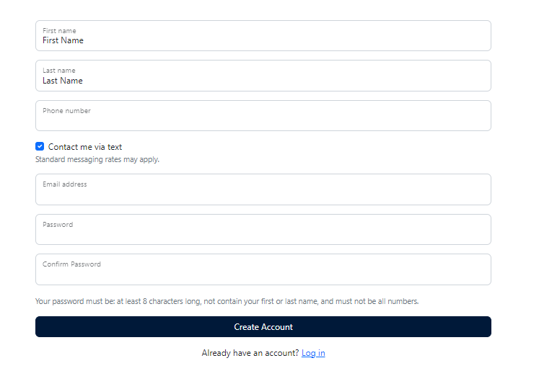
Step 2: Instructions and Overview – Please read the instructions and overview for the MSFCP Pprogram. It shares step-by-step guidance for completing the application process.
Step 3: Disclosures – Please read, select the checkbox, and sign accepting the data and privacy statement agreeing to the terms and conditions for use of the MSFCP Pprogram Pportal. Click save after signing.
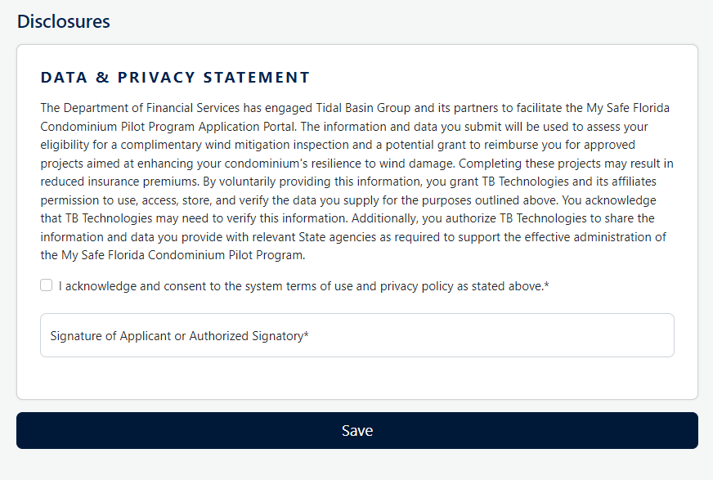
Step 4: Applicant Details – Enter the Name of your the Condominium Association as listed on your the State of Florida Corporation Filing and all pertinent information regarding the condominium property and Condominium Aassociation.
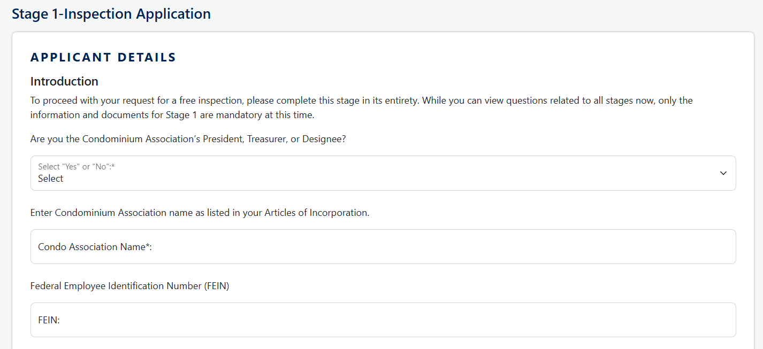
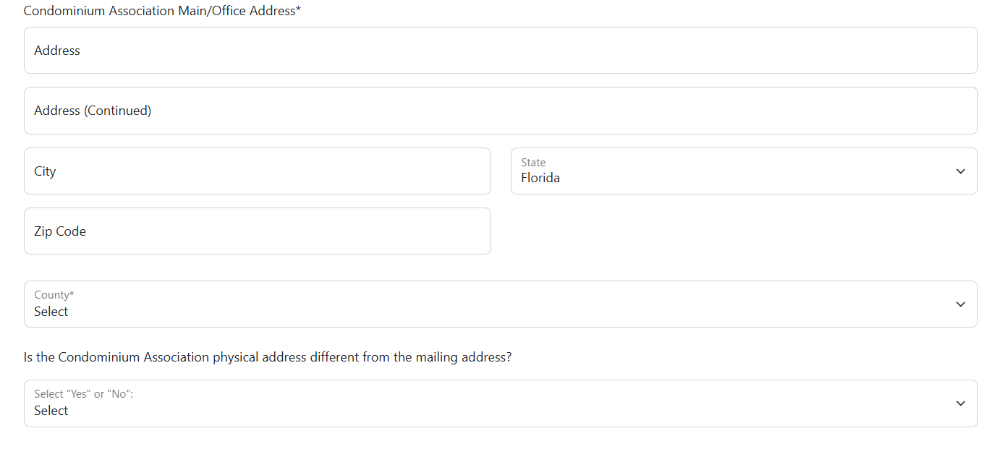
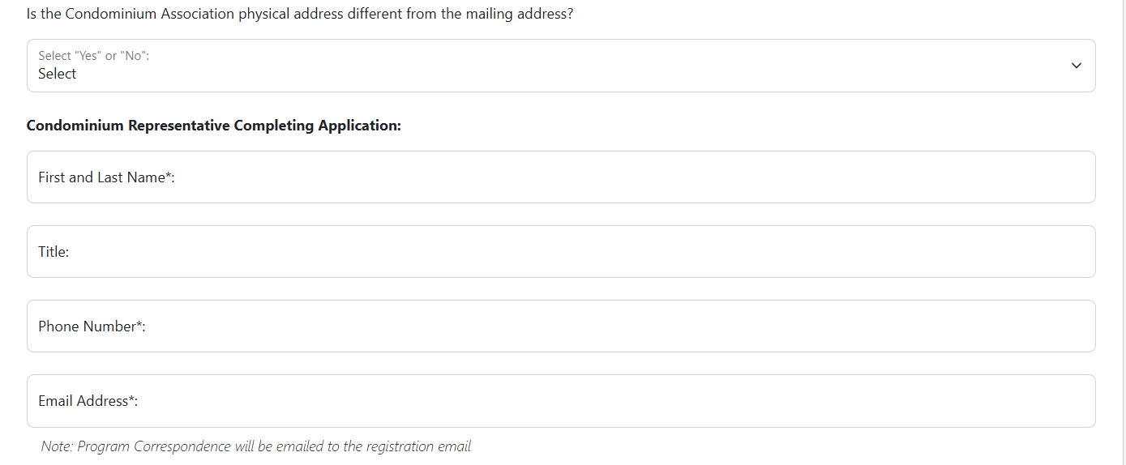
Step 5: Property Details – Enter details relative to your the condominium property. If you’re the condominium property has more than one building, you will need to provide the total number of buildings, stories, and units for each building. Understanding Aaccess to the building’s your attic or crawl space is necessary for an Initial Iinspection.
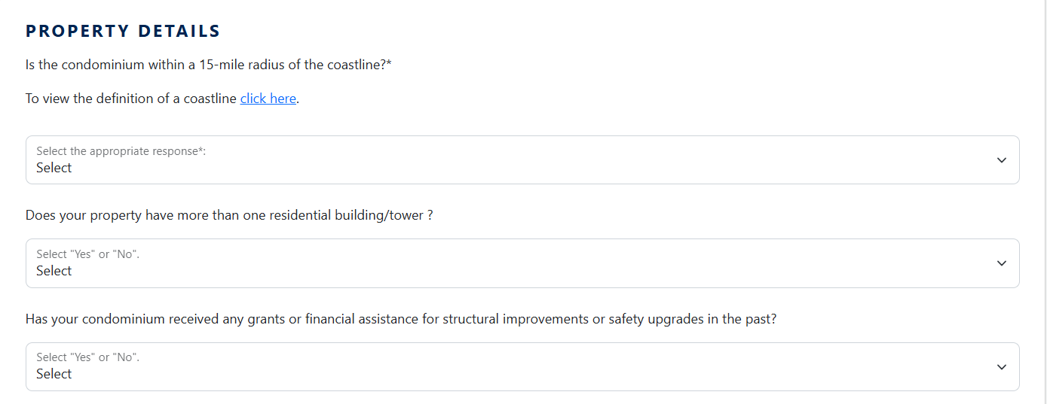
Step 6: Insurance Information: – Enter your the condominium property’s Insurance Provider’s Name, Policy Number, and Annual Insurance Premium.
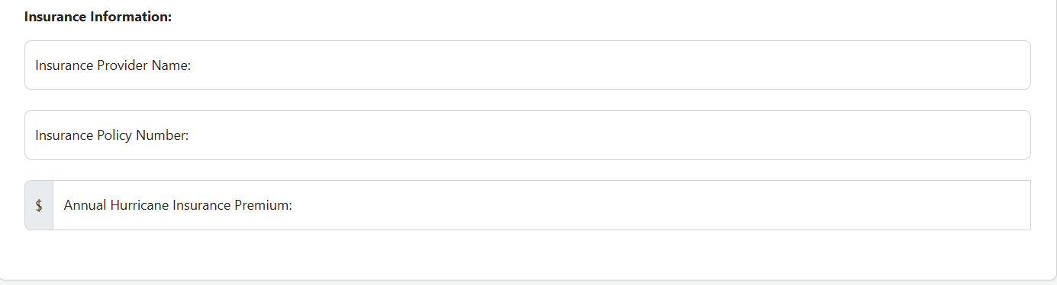
Step 7: Document Upload – Upload a copy of your the Condominium Association’s meeting minutes, to including include the voting results of your the Board Members to receive an free initial inspection.
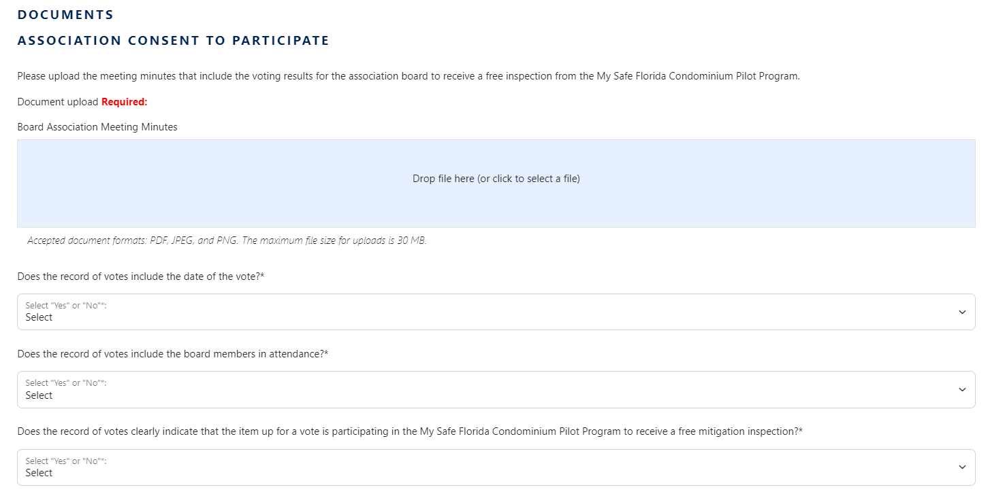
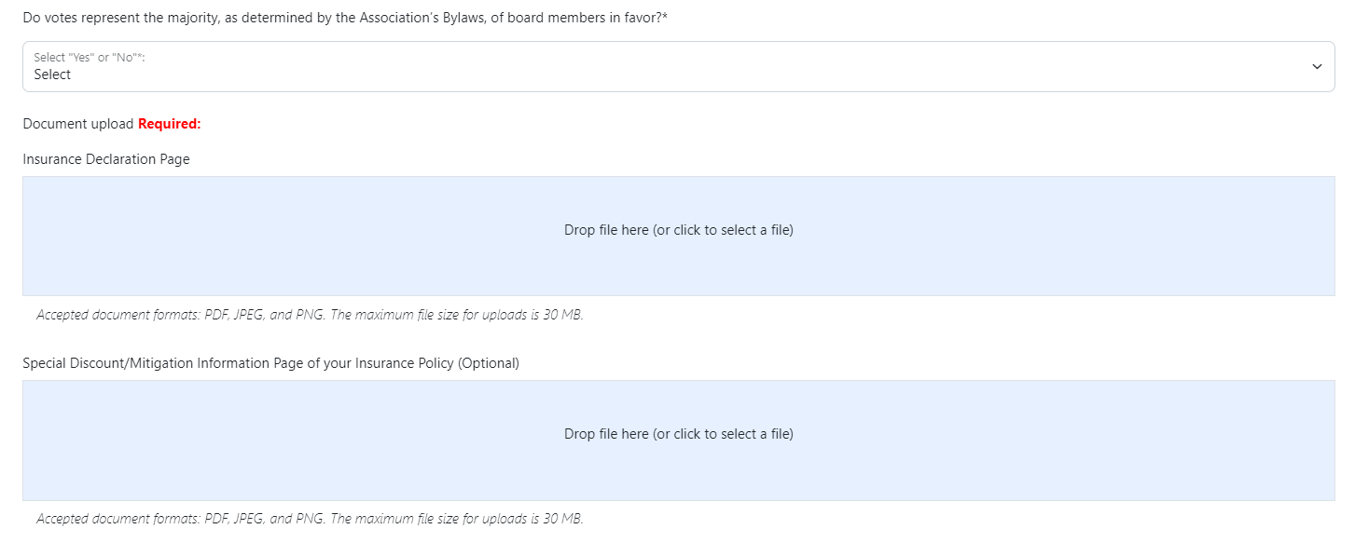

Step 8: Document Upload – Please Uupload a copy of your the condominium property’s Insurance Declaration Page. If the Insurance Declaration Page does not include current wind deductions credits, please upload a copy of the specific special discount or mitigation information page that includes this information.
Step 9: Complete the Attestations and & sSave.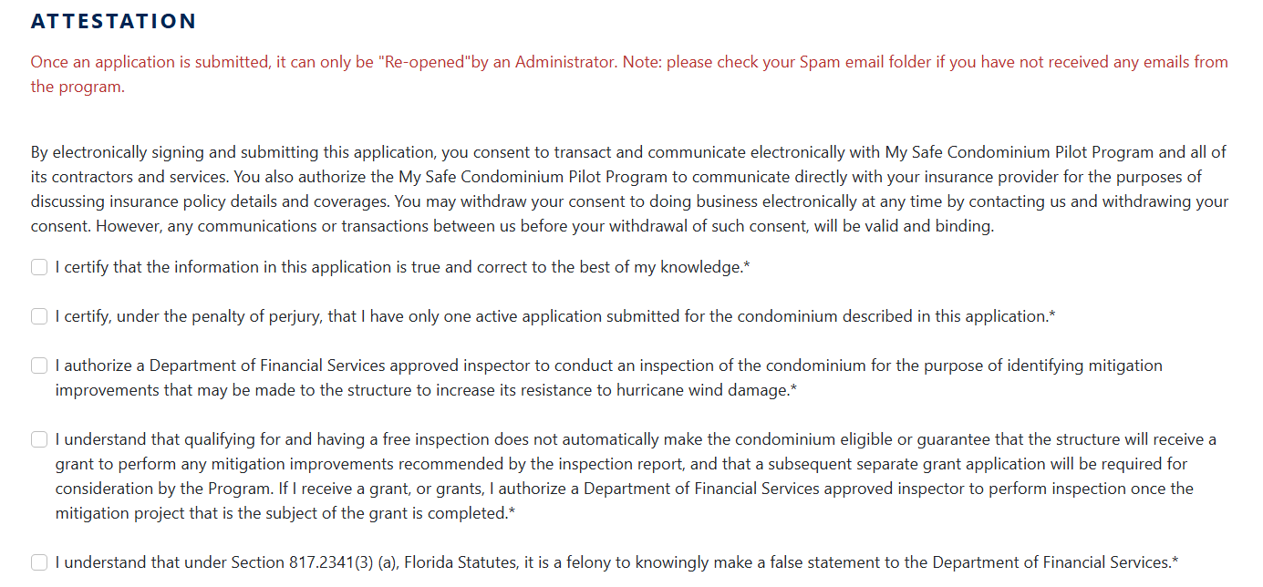
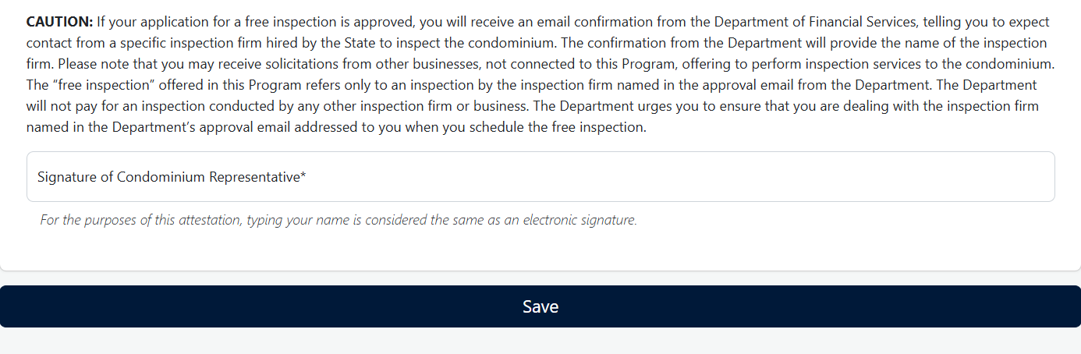

Step 10: Click Go to the Submit page, then click Validate and Submit.
Click Submit: On the Submit page, Validate and Submit. If there are incomplete items you have overlooked while completing your in the Condominium Association’s Inspection Application Stage 1, you will be prompted that items require your attention. Please go back to your the Condominium Association’s Inspection Application Stage 1 and make the necessary corrections. Remember to SAVE your work. Return You will then need to click the Submit page and click Validate and Submit once more to receive a confirmation of submission screen.
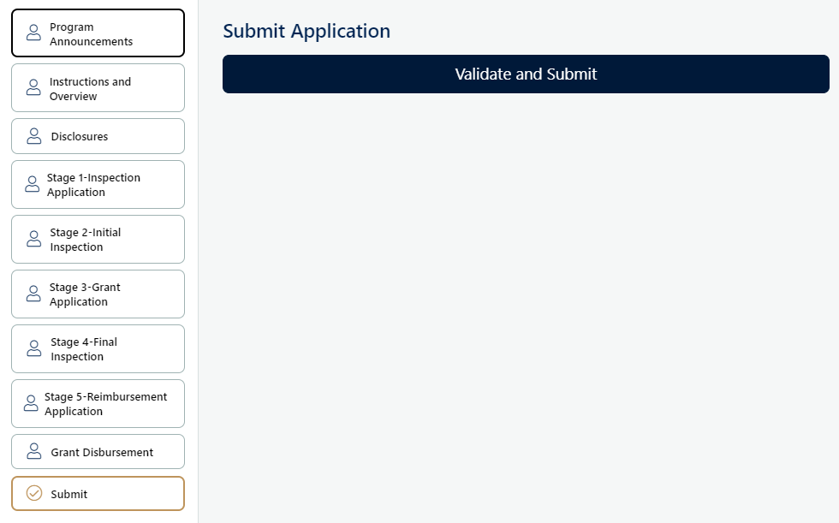
Upon approval of your Inspection Application, the MSFCP Program will notify you via electronic mail using your registration email address. approval determination letter will provide you with the name and contact information of the Wind Certification Entity (WCE) assigned to inspect your condominium.

An inspector will contact you to schedule free Initial Inspection. You should receive an email notification within two weeks after the Iinspection date with a copy of your Initial Inspection Report.

NOTE: Approval of your Inspection Application does not guarantee any grant funding.

Stage 2: Initial Inspection
Upon approval of your the Condominium Association’s Inspection Application, the MSFCP Program will notify you via electronic mail using your registration email address. The Condominium Association’s approval determination letter will provide you with the name and contact information of the Wind Certification Entity (WCE) assigned to inspect your the condominium property.

NOTE: Approval of the Inspection Application does not guarantee any Mitigation Ggrant funding.

After a the Condominium Association’s Inspection Application is approved, Aa representative of the WCE will contact the Condominium Association’s representative to complete schedule scheduling of the Initial Inspection. The WCE assigned to inspect the condominium property will provide the Condominium Association with the Initial Inspection Report. The purpose of the Initial Inspection Report is to recommend Improvements to enhance the condominium property’s resilience against wind damage and identify potential insurance premium discounts.

NOTE: The Inspection Application will be administratively closed, and no further action will be taken by the MSFCP Program, if the Condominium Association:
1. Declines an Initial Inspection;
2. Refuses to allow the WCE access to the condominium property;
3. Fails to schedule an Initial Inspection with the WCE;
4. Fails to appear for an Initial Inspection; or
5. Is non-responsive after the WCE makes three (3) attempts to schedule an Initial Inspection.

Condominium Associations unable to schedule an Initial Inspection with the WCE may contact the MSFCP Program, at 1-877-891-0012, to request assistance with scheduling an Initial Inspection.

Following your free Initial Inspection, the WCE assigned to inspect your property will provide the Condominium Association with the Initial Inspection Report. The purpose of your Initial Inspection Report is to recommend Improvements to enhance the property’s resilience against wind damage and identify potential insurance premium discounts.

How to Obtain Inspection Report(s) and Inspector Recommendations
Step 1: My Applications
You will be able to access The Condominium Association’s report(s) are accessible under My Safe Florida Condo-Inspections. In the case of multiple buildings, you will be able to access each building’s report is accessible under their assigned application ID.

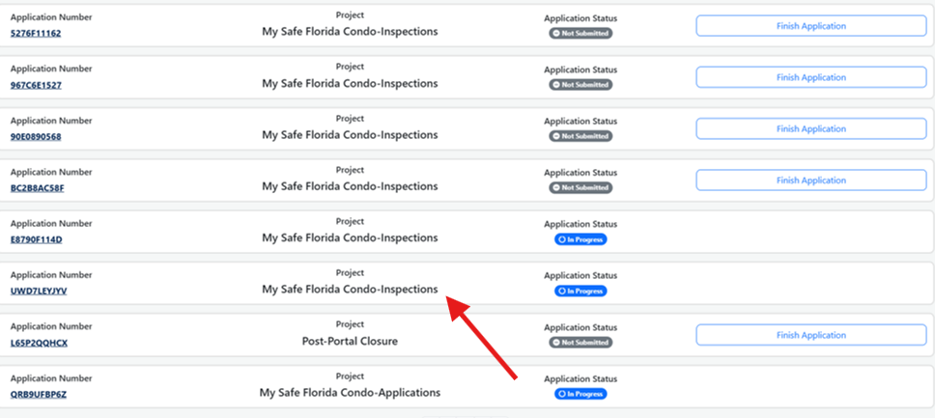

Step 2: My Safe FL Condo Application Details
Each Inspection Application will include the bBuilding aAddress for the condominium building inspected property Building Inspected.

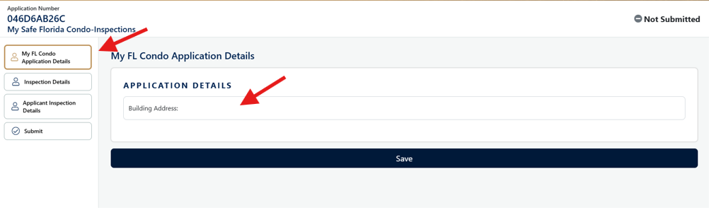

Step 3: Inspection Details
The Initial Inspection report is accessible uUnder Inspection Details, you will be able to obtain your the Condominium Association’s Initial Inspection Report and observe the Initial Inspection recommendations.

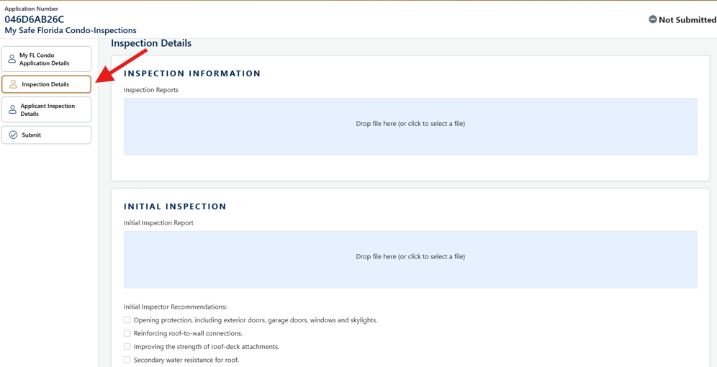

Step 4: Applicant Inspection Details
Based on your the Initial Inspection Report, the Condominium Association may select the recommended Improvements your the Condominium Association will complete. These will appear as selectable or clickable boxes.

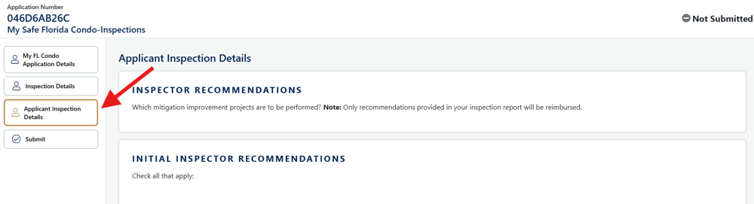

Step 54: Click Go to the Submit page, then click Validate and Submit.
Once you selects have chosen the recommended Improvements to be completed you must Validate and Submit.

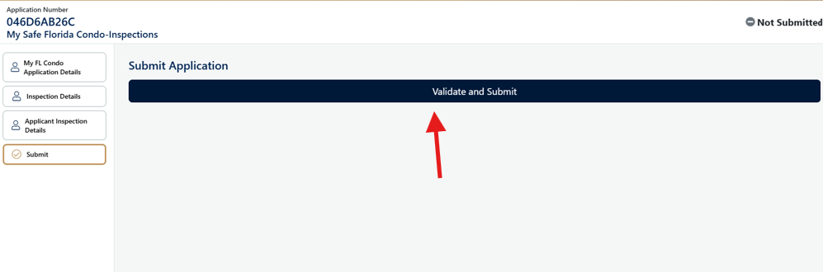

Initial Inspection Report
Each Initial Inspection Report includes:
- Cover Page
  - Includes an exterior photo of the inspected building, street address, the WCE who prepared the report, WCE contact info, application ID, and inspection date.
- Table of Contents & Introduction Pages
- Recommended Improvements
- Improvement Cost Estimates
- Potential Insurance Premium Savings
  - Current Wind Resistant Feature of Your Condominium
  - Current Potential Savings to Your Wind Insurance Premium
  - Missing Wind Resistant Features of Your Condominium
- Uniform Mitigation Verification Inspection Form
  - This form (Form OIR-B1-1802) is to be completed for three story condominium buildings up to three (3) stories.
- Building Type II and III Mitigation Inspection Form
  - This form is to be completed for condominium buildings that are four (4) stories and above.
- Inspection Photos
  - Interior and exterior images taken during the Initial Inspection of the building, along with any supporting documentation.
- Inspection Notes

Sample Table of Recommended Improvements
Please see Tthis section of the Initial Inspection Report identifies to see which Improvements are recommended by the WCE has recommended for that condominium building. If the WCE did not recommend an Improvement in the Initial Inspection Report, the MSFCP Program will not provide any Mitigation Ggrant fundingpayments towards the cost of that Improvement.

Improvement | Recommended | Potential Discount
Improvement 1.0 – Roof Deck Attachment |  | ______________%  (see note)
Improvement 2.0 – Roof to Wall Attachment |  | _____________%  (see note)
Improvement 3.0 – Secondary Water Resistance (SWR) |  | _____________%  (see note)
Improvement 4.0 – Opening Protection |  | _____________%  (see note)
Improvement 5.0 – Roof Covering |  | _____________%  (see note)

Initial Inspection Report Checklist and Reminders
The following checklist has been created to help you get the most out of your Initial Inspection Report.
- Review the Initial Inspection Report and familiarize yourself with the current and missing hurricane-resistant features of your the condominium property.
- Review the information on the Recommended Improvements pages and familiarize yourself with the recommended Improvements that are being recommended for your the condominium property and the potential discounts you the Condominium Association may receive on your the wind insurance premium from your the condominium property’s insurance provider.
- Review the information on the Upgrade Cost Estimates page and consider the estimated cost ranges for the recommended Improvements. NOTE: Actual costs will vary based on location, labor, and material costs.
- Discuss the Initial Inspection Report with the Condominium Association to decide whether to move forward with a Grant Application.

Stage 3: Grant Application
Condominium Aassociations that have received recommended Improvements from the WCE on the Initial Inspection Report may submit a Grant Application. If the Initial Inspection Report did not recommend any Improvements, the Condominium Association’s Grant Application will be denied.
Grant Application Eligibility Requirements
To be eligible, Condominium Associations:
- Must not have already begun actual construction of the performed a Mitigation Project;
- Must receive an MSFCP Program Initial Inspection and an MSFCP Program Initial Inspection Report with recommended Improvements;
- Must provide unit owners with the Disclosure Notice (Form DFS-O1-012);
- Must receive vote approval by at least 75 percent of unit owners within the structure or building that is the subject of the Mitigation Grant; and
- Must provide a completed and signed Intended Contractors List and Commitment to Complete (Form DFS-O1-011);.
- Must provide documentation showing that recommended Improvements will result in a mitigation credit, discount or other rate differential, such as;
  - Correspondence from the insurance carrier or agent acknowledging that the recommended improvements will qualify the structure for a mitigation credit or discount;
  - An insurer’s mitigation credit schedule showing how recommended improvements affect premium rates for the structure; or
  - A copy of the carrier’s underwriting or mitigation guidelines specifying the credit, discount, or rate differential for recommended improvements for the structure; and
- For opening protection Improvement(s), must provide the Condominium Association’s governing documents which demonstrate the windows of the condominium property are established as a common element.

NOTE: After reviewing your the Condominium Association’s Grant Application, if the MSFCP Program finds that additional information is necessary, your the Grant Application will be marked as "Needs More Information." Condominium Aassociations will have 60 days to submit the required documentation before the application is closed administratively as WITHDRAWN.

Please note: Not all Condominium Associations applicants who received an Initial Inspection through the MSFCP Program will be eligible for a Mitigation Grant.

How to Submit a Grant Application
Step 1: Confirm the receipt of your the Condominium Association’s Initial Inspection Report and that your the Condominium Association wishes to proceed with the MSFCP Pprogram by completing the recommended Improvements.
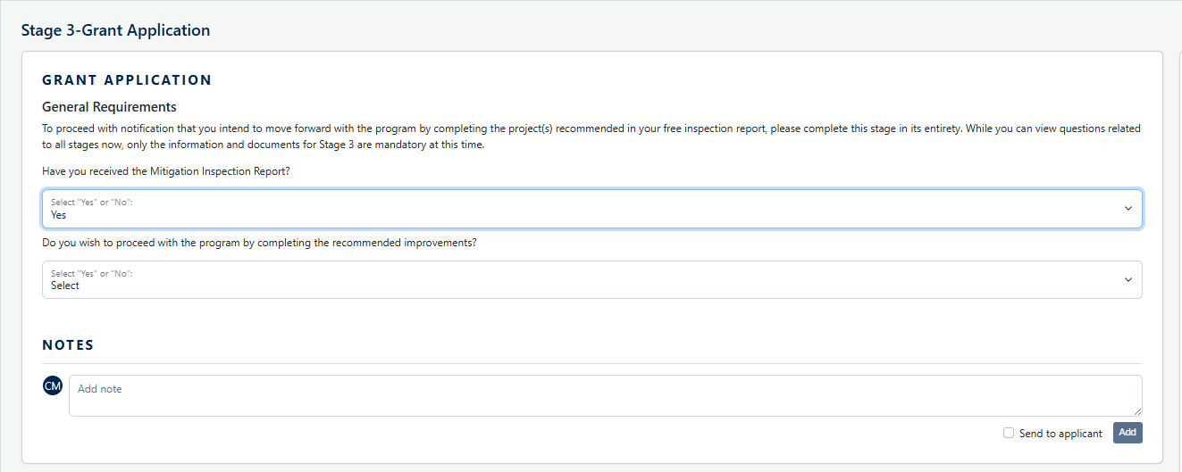
Step 2: Select the Improvement to be performed. Note: You will only be able to select from the Improvements projects recommended in your Iinitial Iinspection Rreport.
Step 3: Refer to your the Condominium Association’s Inspection Application(s) and select the Mitigation Project(s) to be completed in each building and “save” at the bottom of the page to save the your selection(s).

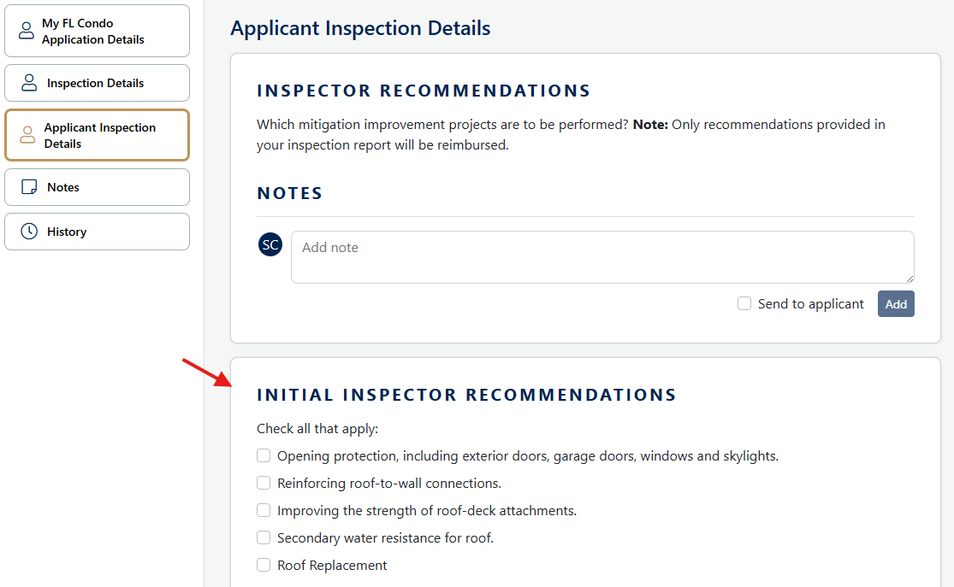

Step 4: Confirm your the Condominium Association has reserved funds to complete the selected Mitigation Project(s).
Step 5: Confirm your the Condominium Association has hired a state-licensed contractor, provide the Contractor’s name and license number, and estimated time frame to complete the Mitigation Projects. For the opening protection improvement(s), you must also confirm that the openings are established as common elements in the Ccondominium Association's declaration governing documents., Finally, confirm that the Mitigation Improvement(s) will result in an insurance credit, discount, or other rate differential.
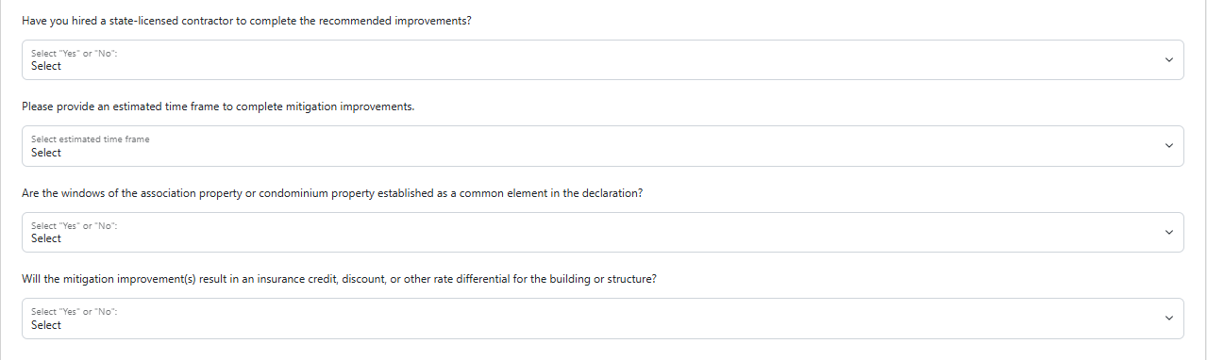

Step 6: Upload a copy of the Notarized Statement of your the Condominium Association’s Intended Contractor(s) and Commitment to Complete Mitigation Projects and your selected intended contractor’s cost estimate.
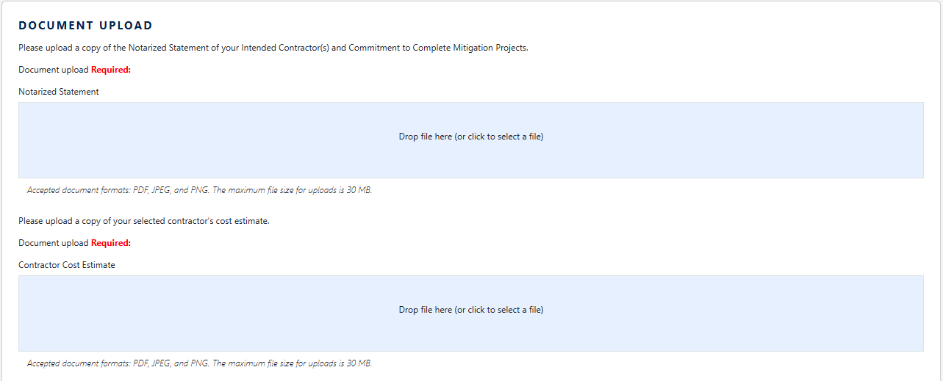

Step 7: Provide responses regarding unit owners' voting results.

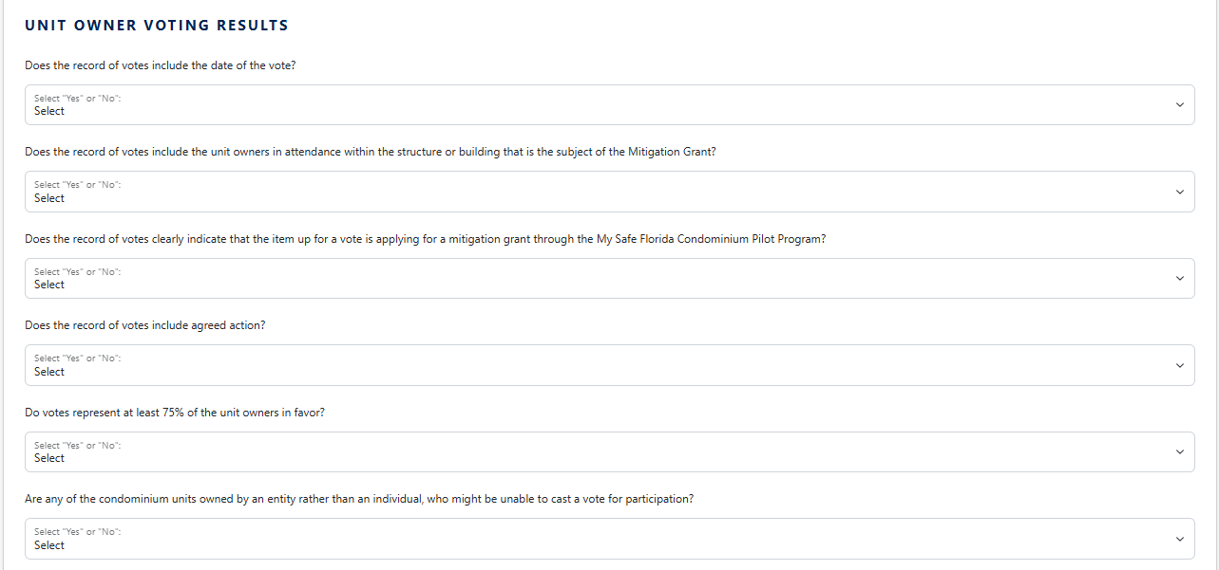
Step 8: Upload a copy of the Condominium Association’s mMeeting mMinutes or rRecord of uUnit oOwner vVoting rResults.
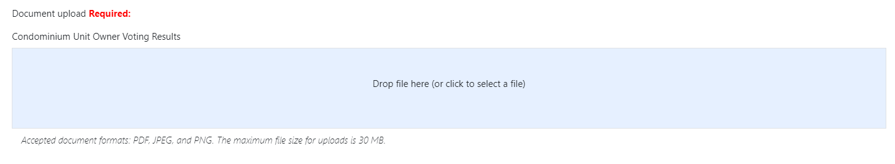
Step 9: Upload a cCopy of the Disclosure Notice Statement provided to unit owners.
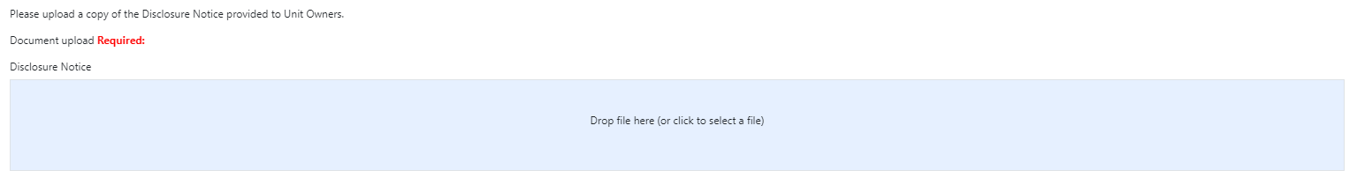

Step 10: Upload a cCopy of the Condominium Association’s Declaration(s) governing documents demonstrating validating openings are established as common elements (only required for opening protection Iimprovements).
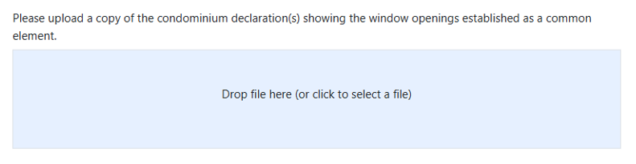

Step 11: Upload correspondence from the insurance carrier or agent, insurer’s mitigation credit schedule, or the carrier’s underwriting or mitigation guidelines showing the potential for a mitigation credit, discount, or other rate differential.
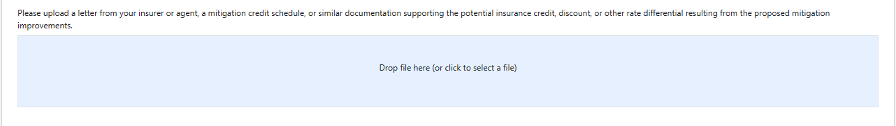
Step 12: Complete the Attestations and & sSave.
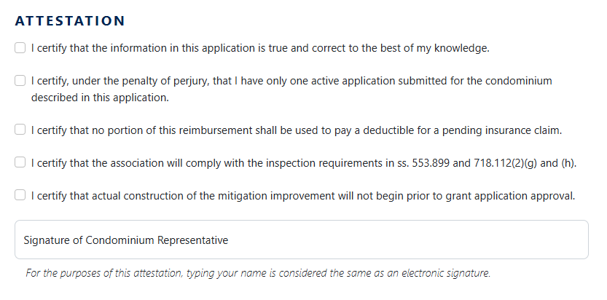
Step 13: Click Go to the Submit page, then click Validate and Submit.

Mitigation Project Checklist and Reminders
The following checklist has been created to help you get the most out of your Mitigation Project.
- It is recommended, but not required, that the Condominium Associations request up to three bids from Ccontractors of the Condominium Association’s choosing for the Mitigation Project.
- Review the bids carefully and select a state licensed Ccontractor.
- Before signing any contracts, confirm that the selected Ccontractor has a state license, will obtain all necessary permits, and is aware of all MSFCP Program requirements. As mentioned in section 215.55871, F.S., a Condominium Association may select its own Contractor(s) for the Mitigation Project, provided each Contractor meets all qualification, certification, or licensing requirements in general law. Before beginning work, the Condominium Association you must ensure the Ccontractor receives all applicable building permits from the local building inspector’s office. At the end of construction, the Condominium Association you must also ensure all the permits are closed out, and the local building inspector’s office has completed all required inspections.

Summary of Improvements

Please read this guide carefully. Only the Improvements recommended in your the Condominium Association’s Initial Inspection Report are eligible for Mitigation Grant funding reimbursement. Please see the summaries below for more information regarding the five potential Improvements that may be eligible for Mitigation Ggrant funding, when recommended in a MSFCP Program Initial Inspection Report, through the MSFCP Program.

Improvement 1 – Improving the strength of your roof deck attachment.
If your the condominium property’s roof consists of shingles nailed to plywood sheets, the Initial Inspection may reveal that the plywood sheets are not adequately nailed to your roof trusses, and additional nails or longer nails are needed to reduce the possibility of the plywood being blown off during high wind events.

Improvement 2 – Reinforcing roof-to-wall connections.
Completed by installing metal tie-down clips that attach roof rafters to walls to reduce the possibility that all or a portion of the roof will lift off your the condominium building structure during high wind events.

Improvement 3 – Creating a secondary water barrier to prevent water intrusion.
When adding a Secondary Water-Resistant Barrier (SWR), the Condominium Association may use program funds to replace your a condominium building’s roof if the final product result includes the SWR.

There are three (3) ways to install an SWR:
- At the time of reroofing the condominium building, a full-coverage self-adhered underlayment (commonly referred to as peel-and-stick) is directly added to the roof sheathing.
- At the time of reroofing the condominium building, a self-adhered product (commonly referred to as seam tape) is used on all joints and seams of the roof sheathing. A nailed-down underlayment, such as felt paper, is still required.
- If not replacing the roof, a closed-cell foam adhesive is installed on all the seams and joints from the attic side of the roof.

Costs relating to re-covering you’re the roof after adding the SWR are covered by the grant. Improving the survivability of your roof covering might include upgrading to stronger wind-resistant roof shingles, attached with properly sized and properly applied roofing nails, to reduce the susceptibility of your the roof shingles blowing off during high wind events. You The Condominium Association may replace your a condominium building’s roof with a different covering of your the Condominium Association’s choice, like tile, metal, or shingle. DO NOT upgrade your the roof covering without also adding SWR. You Costs relating to re-covering the roof when completing the SWR Improvement are included in the total Mitigation Project cost for a Condominium Association’s Reimbursement Request. The Condominium Association must replace all portions of a contiguous roof with SWR. MSFCP Program funds shall not be used for roof patching or other partial repairs of the roof.

Improvement 4 – Opening Protection
Completed by installing impact rated windows or impact rated hurricane shutters.
NOTE: If a condominium building currently has compliant hurricane shutters but requests Mitigation Ggrant funds for impact windows instead, the request will be denied. A condominium building with compliant shutters has already been mitigated against wind damage. The Mitigation Ggrant cannot be used to exchange one type of opening protection for another.

Improvement 5 – Roof Covering

Regardless of you’re a condominium building’s roof’s current condition, if it is of a certain age there are potentially insurance savings available when replaced. This is because many roofs were installed prior to current building codes. Once 100% of the your a condominium building has a newer, permitted roof, it should qualify as an “FBC” roof on a subsequent windstorm inspection.

In addition to replacing your the roof covering material, all mechanical equipment must be adequately tied to the roof deck to resist overturning and sliding during high winds. Any flat roof covering with flashing or coping must be mechanically attached to the structure with face fasteners (no clip/cleat systems).

Stage 4: Final Inspection
Condominium Associations must make their condominium property available for a Final Inspection after the Mitigation Project is complete. The Condominium Associations will receive only one (1) free MSFCP Program Final Inspection.
After you the Condominium Association have requests requested your the Final Inspection, the Program will alert your the assigned WCE who will contact you to schedule the Final Inspection.
NOTE: Construction must be completed, and the Condominium Association must request a Final Inspection, or request an extension of time, within one (1) year after receiving grant approval. If the Condominium Association fails to request a Final Inspection, or an extension, within one (1) year of grant approval, the Grant Application is deemed abandoned, and the Mitigation Ggrant funds shall revert back to the MSFCP Program.
NOTE: The Grant Application will be administratively closed, and no further action will be taken by the MSFCP Program, if the Condominium Association:
1. Declines a Final Inspection;
2. Refuses to allow the WCE access to the condominium property;
3. Fails to schedule a Final Inspection with the WCE;
4. Fails to appear for a Final Inspection; or
5. Is non-responsive after the WCE makes three (3) attempts to schedule a Final Inspection.

Condominium Associations unable to schedule a Final Inspection with the WCE may contact the MSFCP Program, at 1-877-891-0012, to request assistance with scheduling a Final Inspection.

NOTE: Do NOT request a Final Inspection until the entire Mitigation Project is completed on the condominium property. Applicants Condominium Associations have only one (1) opportunity to request a free Final Inspection.

Final Inspection Request Requirements
The Condominium Association must provide the following documentation:
- Contractor’s invoice;.
- Proof of full payment (canceled check, receipts, paid invoice);. and
- A copy of the final inspection from the local permit-issuing agency or /department.

How to Request a Final Inspection
Step 1: Enter the total amount of payment for Open Protection-Related Improvements, if applicable. Enter 0 if no Open Protection-Related improvements were performed.
Enter the total amount of payment for Roof-Related Improvements, if applicable. Enter 0 if no Roof Open Protection-Related improvements were performed.
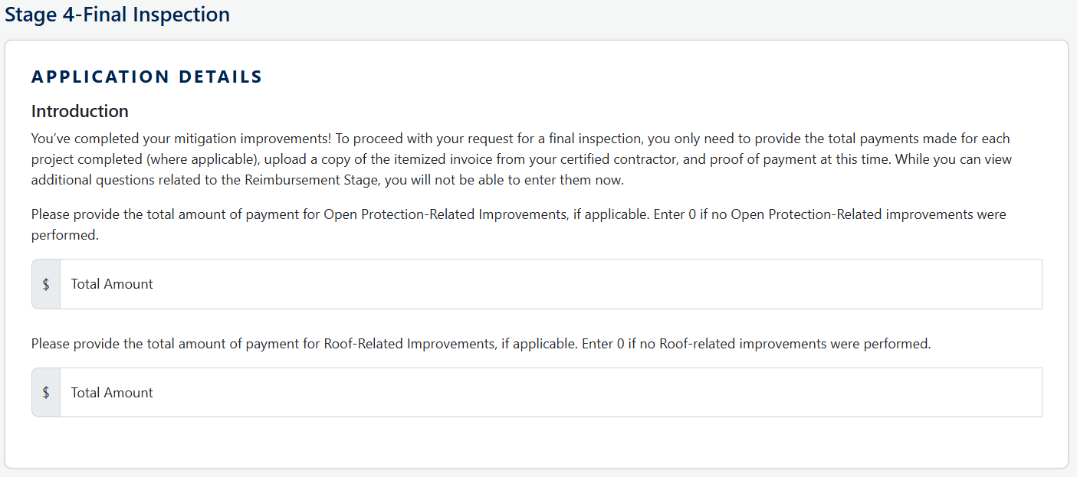
Step 2: Upload a copy of your the Final Contractor’s iItemized iInvoice and pProof of pPayment.
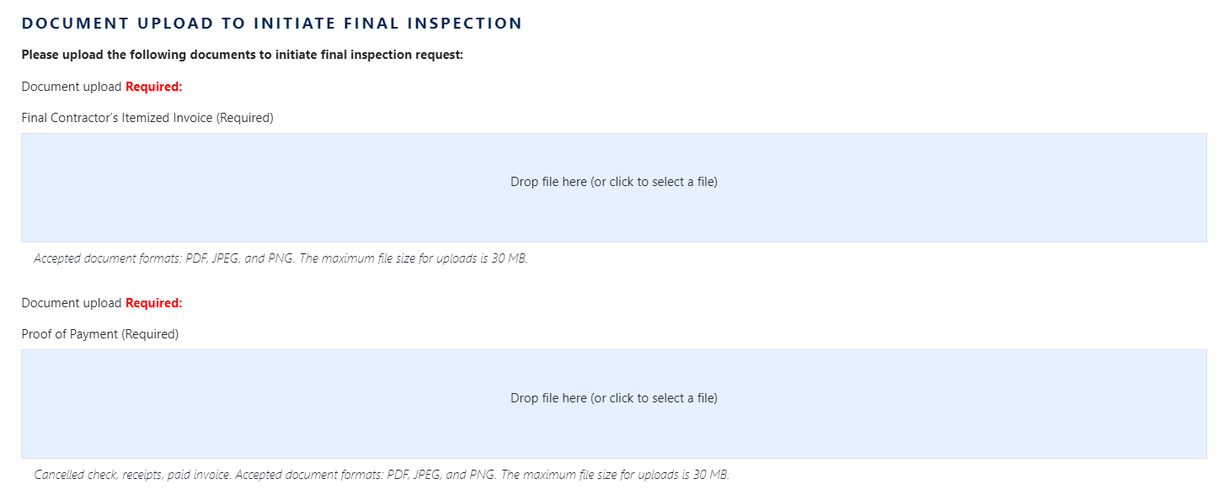

Step 3: Confirm all permits are have been closed out and the local building inspector’s office has completed all required inspections.
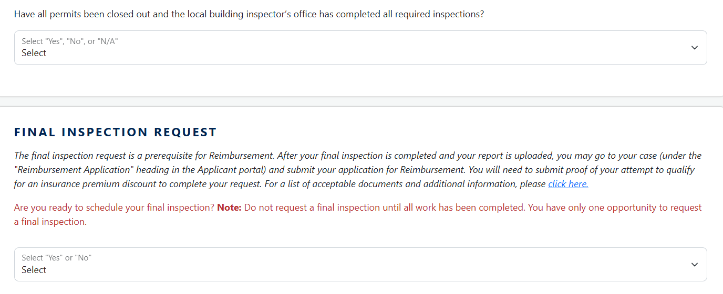
Step 4: Confirm your the Ccondominium Association property is ready for a Final Inspection. Note: Do not request a Final Inspection until all work is has been completed. The Condominium Association only has have one (1) opportunity to request a Final Inspection.
Step 5: Complete the Attestations and & sSave.
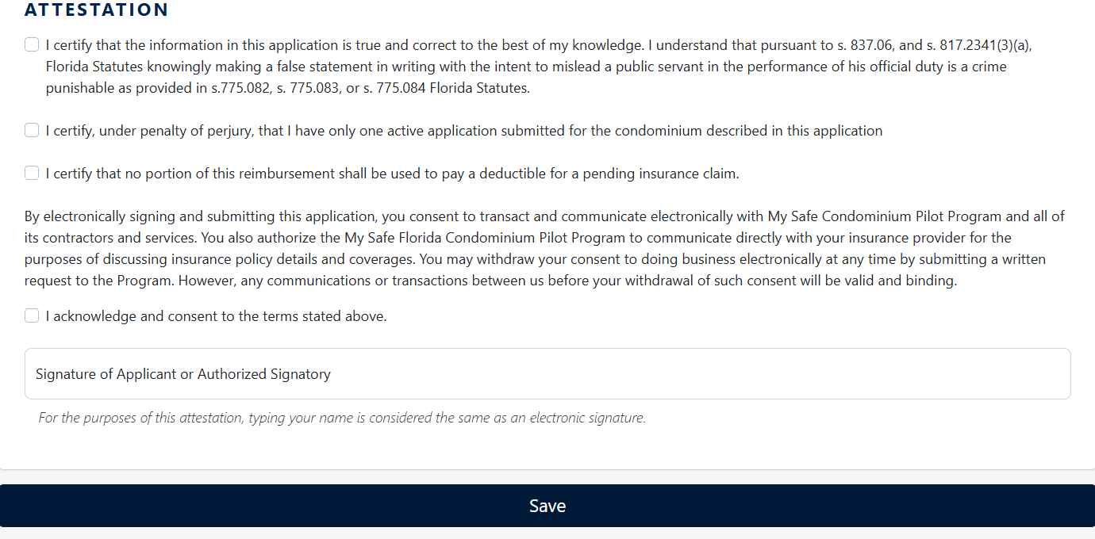

Step 6: Go to the Submit Page, then click Validate and Submit.

Stage 5: Reimbursement Request
After the Final Inspection is completed, the Condominium Association must return to the MSFCP Program Portal and submit all information required information for a Rreimbursement Request. A copy of the Final Inspection Report will be provided to you the Condominium Association by the WCE, and also available within the Stage 5 page to share with your the condominium property’s Insurance Provider.

Mitigation Projects shall be funded in accordance with section 215.55871, F.S.

NOTE: After reviewing your the Reimbursement Request, if the MSFCP Program finds that additional information is necessary, your the Reimbursement Request will be marked as "Needs More Information." Condominium Associations will have 60 days to submit the required documentation before the Reimbursement Request is closed administratively as WITHDRAWN.

Reimbursement Request Requirements
The Condominium Association must provide one of the following documents:
- Detailed insurance policy;
- Specific discount information page of insurance policy;
- Specific mitigation information page of insurance policy; or
- Correspondence from insurance provider detailing insurance discounts.

How to Submit a Reimbursement Request
Step 1: Upload a copy of one of the required documents listed above.
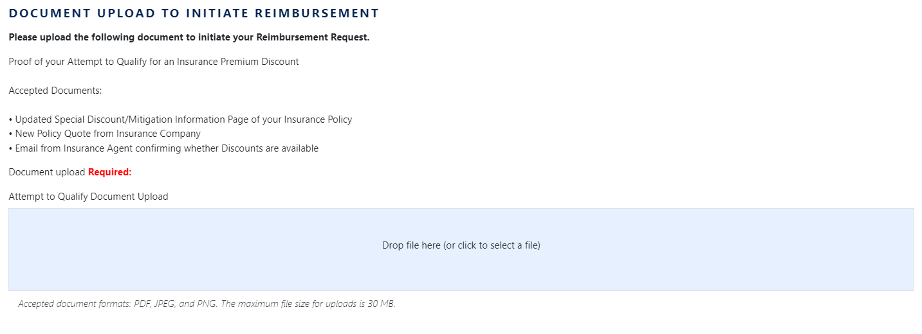
Step 2: Complete the Attestations and & sSave.
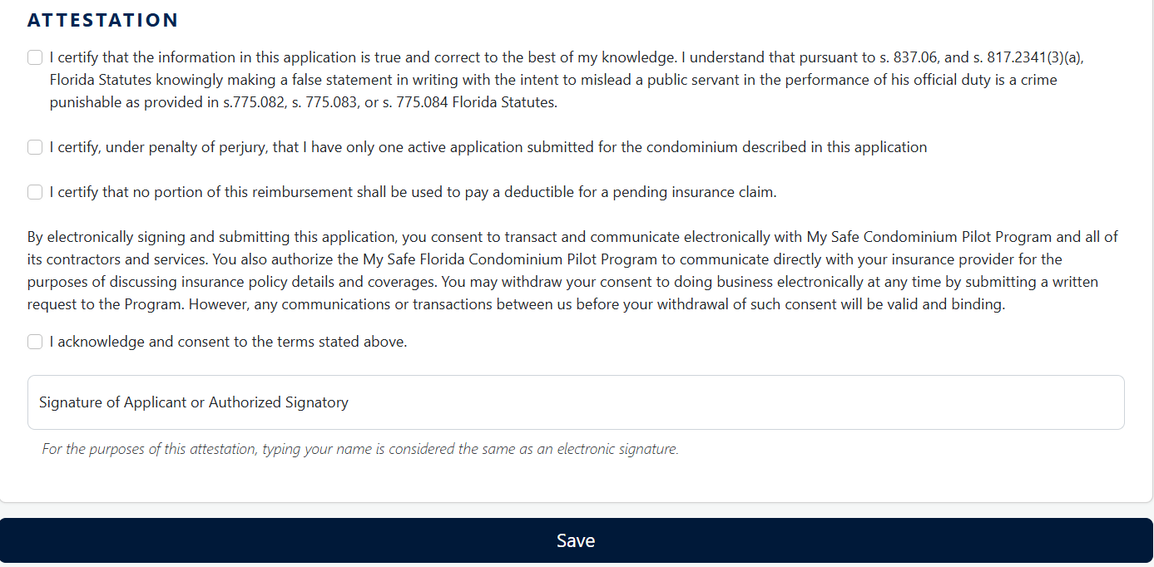

Step 3: Click Go to the Submit page, then click Validate and Submit.

Important Reminders
- Condominium Associations must follow the MSFCP Program steps outlined in this guide. Failure to follow the steps in order will result in a denial of the Condominium Association’s MSFCP Program Application.
- Any work performed on a condominium property that is not recommended in the Initial Inspection Report is not eligible for Mitigation Grant funding reimbursement and the Reimbursement Request will be denied.
- After selecting a Contractor, the Condominium Associations must will need to provide the Ccontractor's name and state license number through the MSFCP Program Portal. All applicants Condominium Associations must do this prior to beginning a Mitigation Project work.
- The MSFCP Program will deny not pay any Rreimbursements Request if the Condominium Association fails to use a certified Ccontractor to perform recommended Improvements or otherwise does not follow the MSFCP Program requirements.
- Prior to beginning a Mitigation Project work, you Condominium Associations must ensure the Ccontractor receives all applicable building permits from the local building inspector’s office. As mentioned in section 215.55871, F.S., a Condominium Association may select its own contractors for the Mitigation Project, provided each contractor meets all qualification, certification, or licensing requirements in general law.
- The Condominium Associations must provide the Ccontractor with the MSFCP Program Initial Inspection Report provided by the WCE. The Condominium Association must ensure that only recommended Improvements recommended by the WCE in the Initial Inspection Report are completed on the condominium property.
- If the Condominium Association has recommended improvements, they should contact an MSFCP pProgram representative by calling 1-877-891-0012.
- Upon completion of the Mitigation Project, the Condominium Associations must ensure all the permits are closed out, and the local building inspector’s office has completed all required inspections, if applicable. Afterward, the Condominium Association must request the Final Inspection from the MSFCP Program. Condominium Associations will receive only one (1) free MSFCP Program Final Inspection.

