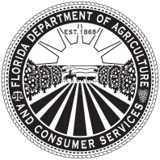
Florida Department of Agriculture and Consumer Services
Division of Plant Industry

HEMP SAMPLE SUBMISSION FORM
NICOLE “NIKKI” FRIED
commissioner
Section 581.217, F.S., 5E-4.016(2)(a)2., F.A.C
Post Office Box 147100, Gainesville, FL 32614-7100 / (352)395-4700

This form is to be submitted with each composite hemp sample collected for THC analysis. A separate form is required for each composite sample. Sampling must be done in accordance with Rule 5B-57.014(7), F.A.C. The licensee must require the laboratory to report the analysis results for Total delta-9 tetrahydrocannabinol concentration and send a copy of this form directly to the Department by email at DPIHemp@FDACS.gov within twenty-four (24) hours of test completion.

License Number: Date Sample Collected:

Collector: Date Sample Submitted to Lab:

Plot Planting Date: Anticipated Harvest Date:

Responsible Person Information:

Name:
First Middle Last

Address:
Street or PO Box City State Zip Code

Email Address: Phone:

Variety and Growing Location:

Plot designation: Variety:

Growing Address:
Street or Parcel Number or GPS City State Zip Code

Acreage or Square Footage Sampled:

Number of clippings included in this representative sample:

Remarks:

Responsible Person Signature: Lab Receiver Signature:

Date:

