Once the registration confirmation e-mail is received, Intermediate Care Facilities for the Developmentally Disabled shall submit monthly: net patient revenues and Medicaid patient days through the online data collection form found at: https://apps.ahca.myflorida.com/nfqa/. Login using the user name and password you created during registration. Then, click Login.

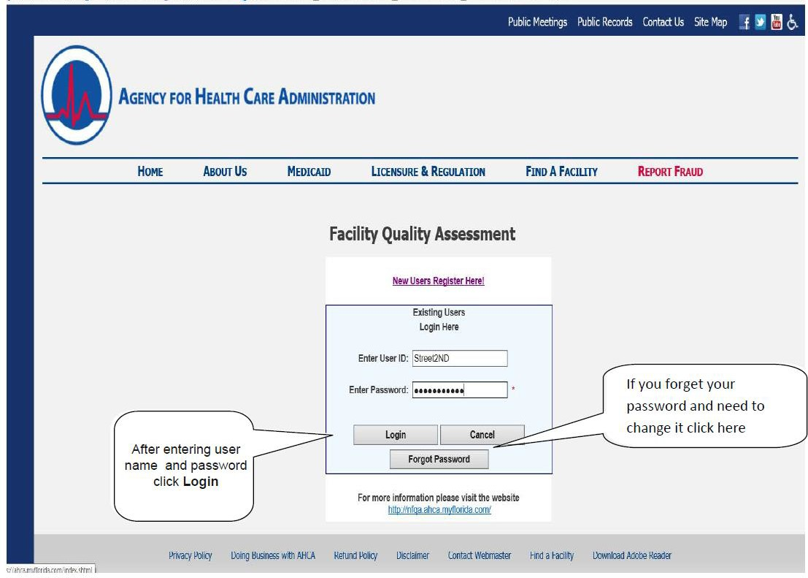

Choose the reporting month/year from the drop down box. Your facility’s information is already populated in the dark grayed boxes. Please review this information for any discrepancies. Then click Next.

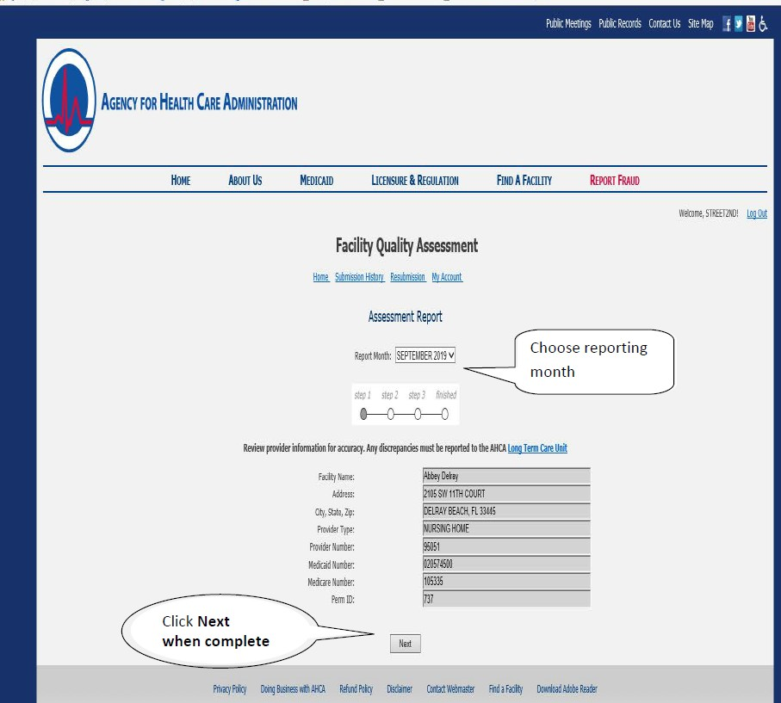

Quality Assessment Worksheet: Enter the following information.

Monthly net patient revenue: Monthly net patient revenue includes the total of all payer types (see statute for further definition of Net Patient Revenue). Enter this amount in the Monthly Net Patient Revenue box (NOTE: This field is optional).
Data entry A: Total Medicaid Patient Days: Enter the total number of Medicaid days for the current month based on dates of service paid or payable by Medicaid.

The following fields are available for input but are set to “Zero” by default. Private and Medicare patient days on the norm are not applicable to ICF/DD facilities:

Data entry B: Total Private/Other Non-Medicare Days: Enter the total number of Total Private/Other Non-Medicare Days for the current month based on dates of service paid or payable by any other source that is neither Medicaid nor Medicare.

Data entry F: Total Medicare Patient Days: Enter the number of Medicare patient days for the current month based on dates of service paid or payable by Medicare. Medicare resident days mean those patient days funded by the Medicare program or by a Medicare Advantage or special needs plan.
The system automatically calculates Total Non-Medicare Days (C), Provider Assessment Daily Rate (D), Total Amount Due (E), and Total Patient Days (G). When data entry is complete, click Next.

See following page for Screenshot.

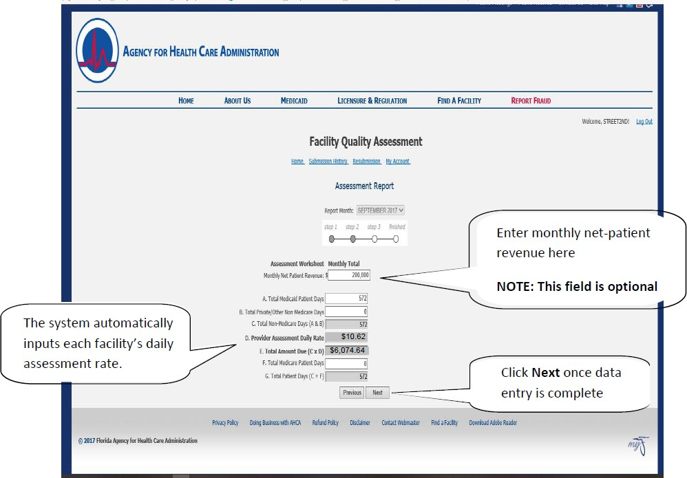

Verification Page:

Verify that the monthly data input for your facility is correct. If there is an error click Previous, which directs you back to the Assessment Worksheet. There you can correct any errors. Notice the Total Amount Due. This is the amount of your facility’s monthly assessment. If all the information is correct click Submit.

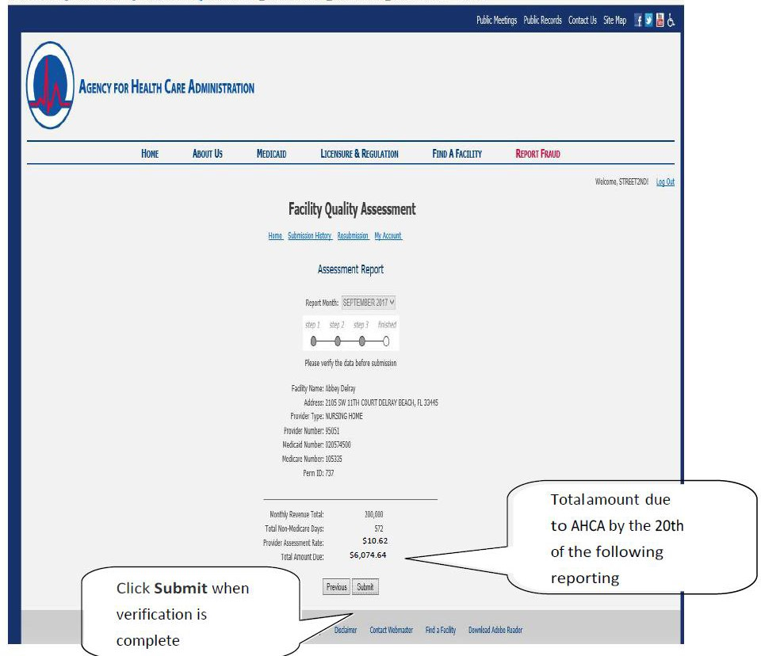

The remittance document is to be printed and submitted with payment. To go to the Remittance page, either click Print Invoice Image for pdf. format or click Print HTML Invoice for HTML format.

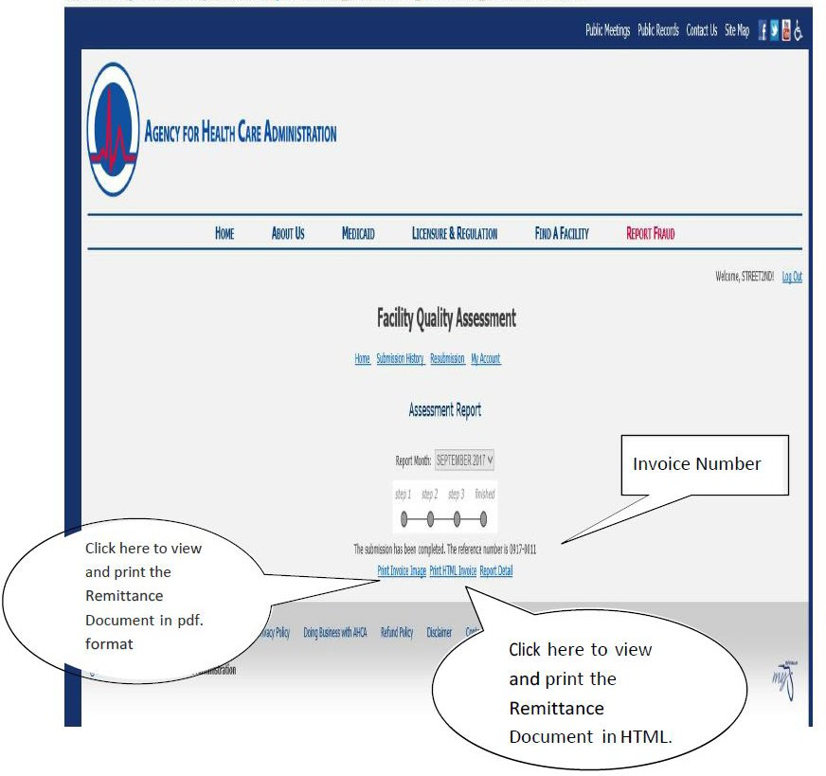

Remittance Document:
Print out and submit with payment to the address located on the document. Remember, payments are due by the 20th day of the following reporting month (e.g. October 2009 assessment shall be paid by November 20, 2009). Delinquent payments are subject to fines up to $1,000 per day, liens against medical assistance payment, and/or licensure action. If you have any questions, please contact the QAF staff at NFQA@ahca.myflorida.com.

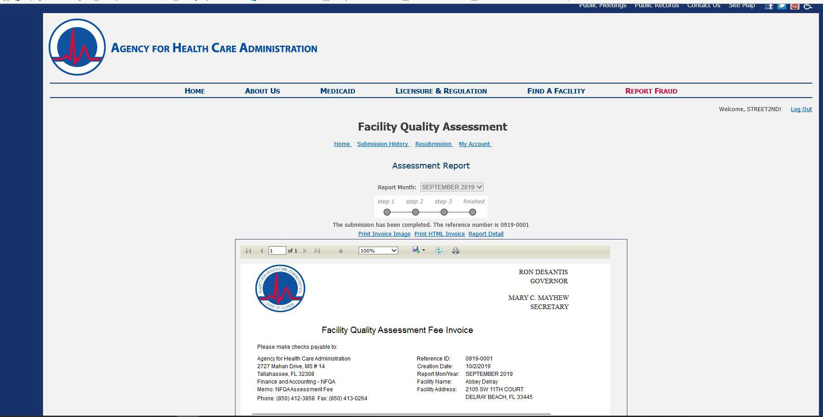
If you chose the Print
HTML Invoice option you must click on
File and then Print to
print the invoice
Click the printer icon to print. If you are unable to print please download the Microsoft Active X control software that pops up on
your screen.

Remittance Document Continued:

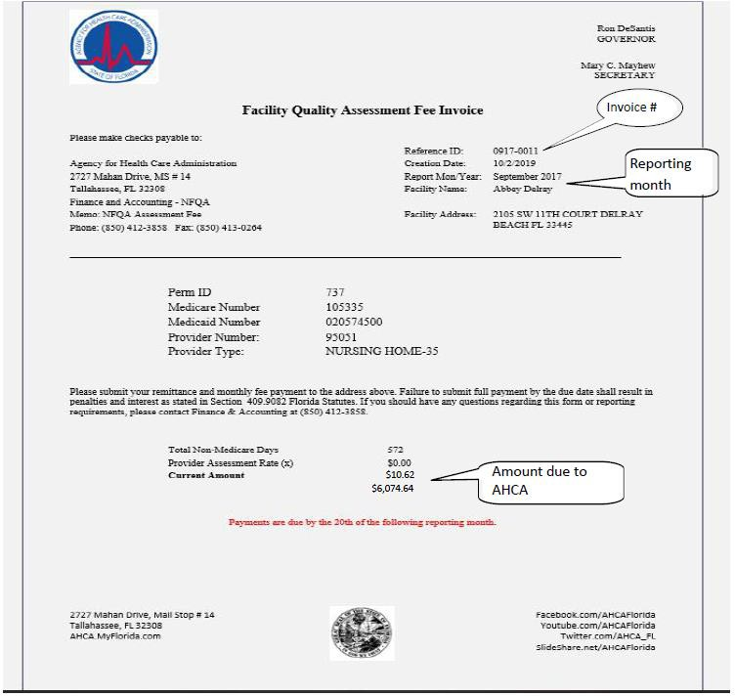

COMPLETE!

AHCA Form 5000-3548, October 2013 (Incorporated by reference in Rule 59G-6.045, F.A.C)

