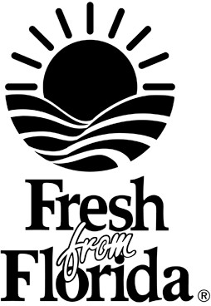
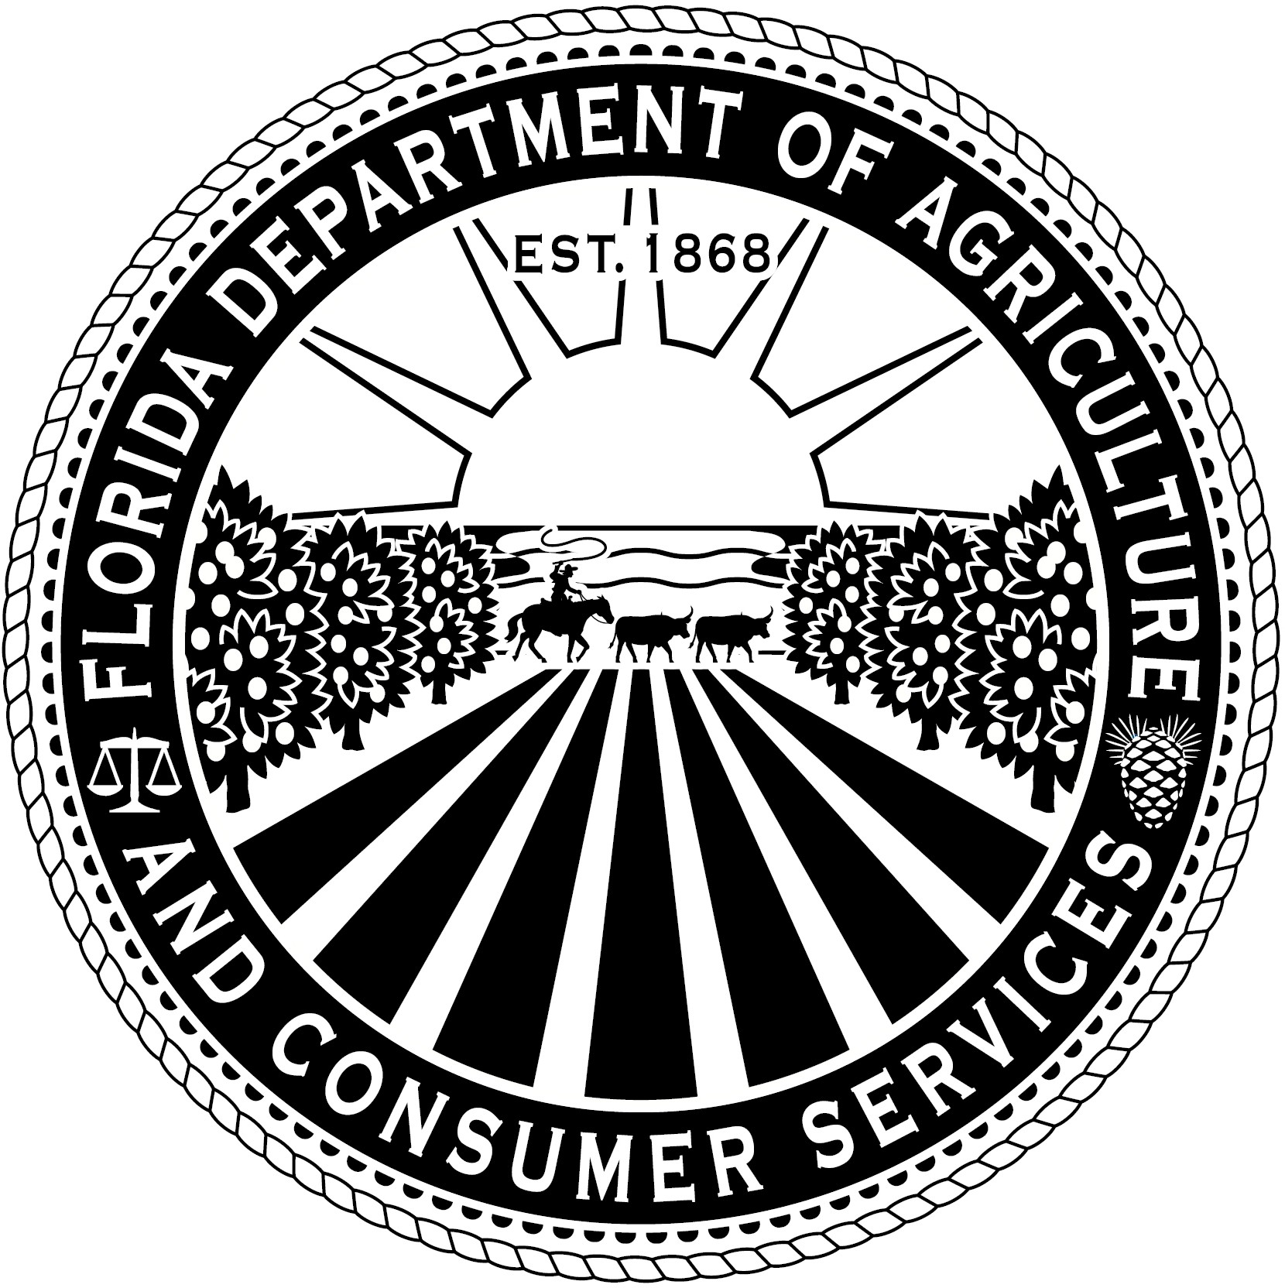
WILTON SIMPSON
COMMISSIONER
Florida Department of Agriculture and Consumer Services Division of Marketing and Development

“FRESH FROM FLORIDA” LOGO INCENTIVE PROGRAM APPLICATION
Section 571.24, Florida Statutes
Rule 5H-17.005, F.A.C.

Entrant Name:

Title:

Company:

FEID Number:

Street Address:

City: State: Zip:

Mailing Address:

City: State: Zip:

Phone: Email Address:

By signing this application for incentive awards, I confirm that I have followed the guidelines and rules governing the “Fresh From Florida” Logo Incentive Program, and certify that information included within the entry is correct.

Print Name:

Signature:

Date:

Email Send Entries and Proof of Payment to: IndustryMKT@FDACS.gov or mail to:
Florida Department of Agriculture and Consumer Services “Fresh From Florida” Logo Incentive Program
407 South Calhoun Street, M-9 Tallahassee, Florida 32399-0800

“Fresh From Florida” Logo Incentive Program
The purpose of this incentive program is to provide participating agricultural entities with the opportunity to offset a portion of their consumer packaging and carton printing costs while promoting the “Fresh From Florida” message.

To qualify for incentive monies, “Fresh From Florida” (FFF) members must work directly with Florida Department of Agriculture and Consumer Services (FDACS) representatives and provide a printer’s draft proof for final approval before applications are considered for reimbursement.

This program is not intended to provide full compensation for a company’s printing costs, and is not intended to provide profit under any circumstances.

Usage of logos is limited to those companies who establish FFF membership prior to participating in the incentive program. Pre-approval of all artwork is required before application submission.

Reimbursement Limitations

- Consumer packaging and cartons are eligible for half (50 percent) of actual printing cost up to $5,000.

- Reimbursements will be paid to qualified entries upon receipt for as long as budgeted monies are available. FFF members are eligible for incentive monies only once per product for each fiscal year the duration of the program. Multiple product entries are eligible but cannot exceed $5,000 per fiscal year.

Eligibility

- Participants must be active members of the “Fresh From Florida” Program to participate.
For more information on becoming a member, please contact FDACS the Florida Department of Agriculture and Consumer Services at (850) 617-7399.

2. Products must meet criteria set forth in Rule 5H-17.003, F.A.C. to use the “Fresh From Florida” logo. Products using the “Fresh From Florida Made With” logo or other identifiers are not eligible.

3. 2. State agencies and non-paying members are not eligible to participate.

4. 3. Media brokers and advertising third parties and co-packers are not eligible to participate and cannot use this program as a selling tool.

Requirements for Participation

- The “Fresh From Florida” Logo is Incentive Program participants may receive incentive dollars for placement of FFF logos that are printed on consumer packaging, cartons, labels or catalogs (horticulture and gift fruit shippers only). Photocopies of labels or logos inserted in or affixed to a label are not eligible. The “Fresh From Florida” logo should be clearly visible.
- Products must be Florida-grown horticulture products or agricultural products in its raw state and never been frozen or subject to any form or thermal processing or preservation and not combined with any other product. All products must include the “Fresh From Florida” logo. The “Fresh From Florida” logo must be large enough that it is clearly visible there is no degradation of the image.

2. 3. A minimum of 1,000 items must be printed produced in order to be eligible for incentive dollars.

4. Consumer packages and cartons must have logos printed directly on the label. Photocopies of labels or logos inserted in or affixed to a label are not eligible. “Clamshell” packaging for fruits and vegetables must have a logo that is large enough that is easily recognized.

Entry Application Guidelines

- Entries must include an application a FDACS entry form. If additional applications entry forms are needed, please contact the Florida Department of Agriculture and Consumer Services at (850) 617-7399.

- Reimbursements are paid after approved entries have been received and documented.

- Entries must be submitted under the company’s name and Tax ID/FEID number or applicant social security number.

- In order to qualify, you must submit a printer’s draft proof for approval by FDACS. Once approved, upon completion of printing, please provide one two sample samples of each finished product item along with copies of proof of payment for itemized invoices dated during the approved program period outlining eligible printing charges. Entries submitted without proper documentation will be considered incomplete and will not be eligible for incentive dollars.

- Entries become the property of FDACS and cannot be returned. By participating, you grant give FDACS your permission to use your entry for promotional publicity purposes.

- Freight charges, state and sales taxes are not eligible for reimbursement.

- To be eligible for payment, members must be registered vendors of the State of Florida in My Florida Marketplace and with the Florida Department of Financial Services.

Email Send Entries and Proof of Payment to: IndustryMKT@FDACS.gov or mail to:

Florida Department of Agriculture and Consumer Services "Fresh From Florida" Logo Incentive Program
Mayo Building, M9
407 South Calhoun Street Tallahassee, Florida 32399-0800

Contact
For more information about the Logo Incentive Program, contact:

The Division of Marketing and Development “Fresh From Florida” Programs and Industry Relations
Telephone: (850) 617-7399
Email: IndustryMKT@FDACS.gov

