
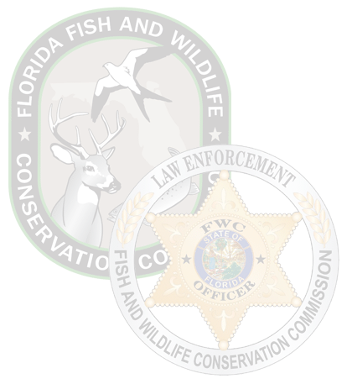

Livery Operator Permit
Florida Fish and Wildlife Conservation Commission
THIS PERMIT DOES NOT ASSURE QUALITY OF THE VESSELS OR EQUIPMENT PROVIDED. IT IS THE OWNER’S RESPONSIBILITY TO ENSURE COMPLIANCE WITH ALL APPLICABLE STATUTES, RULES AND REGULATIONS.
Business Name: Business Address:

Valid Until xx-xx-xxxx Florida Fish and Wildlife Conservation Commission
2024A00-0000000000 Division of Law Enforcement Boating and Waterways Section 620 South Meridian Street
Authorized Issuing Agent Signature Tallahassee, FL 32399-1600
FWCDLE_310 (11/22) – Rule 68D-34.006, F.A.C.

