Florida Fish and Wildlife Conservation Commission
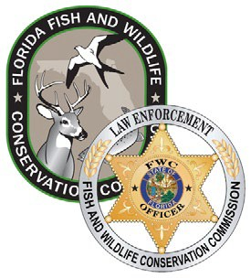

Florida Livery Permit Checklist

Name of livery business or individual applicant:

Name:

Business or individual operating as a livery mailing address (primary - if multiple):
Phone number: (
)
E-mail:
Applicant Date of Birth (permits will expire annually on this date):
Contact informationiX
Please initial next to each item you have submitted with this checklist.

Name:
Number and street:
City, State, Zip code:

1. List of all vessels offered by the livery for lease or rent
2. Proof of current insurance coverage (minimum $500,000 per person, $1 million per incident) as required by section 327.54, Fla. Stat. *Liveries only offering human-powered vessels are exempt from insurance requirement
For businesses:
- Business creation records (such as Articles of Incorporation, State Sunbiz records, etc.)
- Current local business license or business tax receipt, if applicable
For individuals:
5. A copy of government-issued photographic identification card
6. Completed and signed Livery Permit Certification form (FWCDLE_312 (9/2022)

i An applicant is not required by law to provide this contact information. Providing the information will help to expedite communications between the program and the individual requesting the permit. Under Florida law, e-mail addresses and phone numbers as well as most other portions of records provided to public agencies are public records. If you do not want your e-mail address or phone number released in response to a public records request, do not include this information. Instead, contact this office in writing.

FWCDLE_311 (11/2022) – Rule 68D-34.006, F.A.C.

