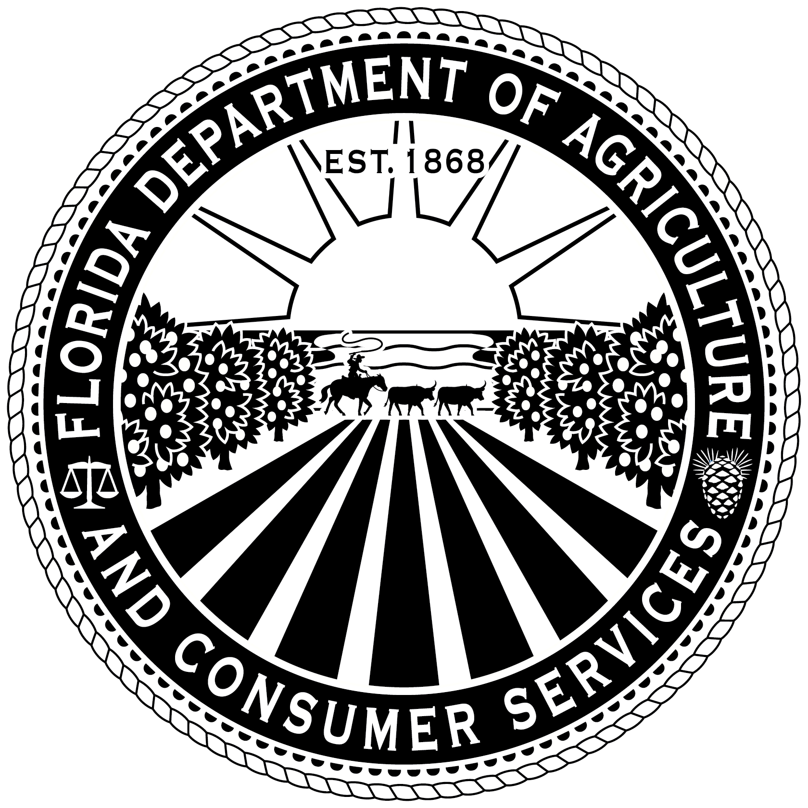
Florida Department of Agriculture and Consumer Services
Division of Marketing and Development
Remit Non-Refundable Fee Online at: www.FreshFromFlorida.com
- or -
Check or Money Order payable to FDACS and remit to:

Florida Department of Agriculture and Consumer Services
P.O. Box 6700
Tallahassee, Florida 32314-6700

“FRESH FROM FLORIDA”
MEMBER RENEWAL FORM
ADAM H. PUTNAM
COMMISSIONER

Rule 5H-17.005, F.A.C.
Phone (850) 617-7399 Fax (850) 617-7301

DATE:
□ The contact information provided is correct.
□ If the information below is not correct, please make the following corrections.
(Please cross through the incorrect information and write correct information below)
Name of Company:  Contact’s Name:  Address:  City, State, Zip Code: | Phone Number:  Fax Number:  Email:  Website:

Org Code: 42 06 13 01 000
EO: BF
Object: 001127 $50.00

Please return renewal form and $50 renewal payment (if applicable) to:

Florida Department of Agriculture and Consumer Services
P.O. Box 6700
Tallahassee, Florida 32314-6700

