Motorboat rental safety




Alcohol and many other drugs are dangerous when combined with boating. Do not operate any boat while impaired by alcohol or drugs.


It is easy to slip and fall into the water if sitting on the front (bow), sides (gunwales), rear (stern) or a swim platform and be severely injured by the boat propeller.
Operate at a safe speed and be cautious about proper loading of passengers and gear.

You and your passengers must know the location and proper use of life jackets and other safety equipment for the boat you are renting. It is always best to wear a life jacket when on the water, and children under the age specifed by law are required to wear one.
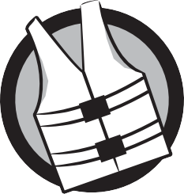




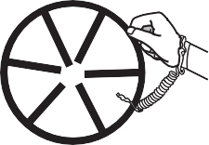

When boating after sunset and before sunrise, or when visibility is poor, your boat must display navigation lights. An anchor light must be displayed if you anchor for the night. Should a problem arise, you must know how to properly use the boat’s distress signals.

If the boat is equipped with an ignition kill switch, you should always use it when the boat is underway.

Most boating accidents involve collisions due to operator inattention or carelessness. Be aware of dangers approaching from any direction.

The rules for meeting, passing and crossing paths of other boats are important.

When you meet another boat head-on, you should steer to the right (starboard).



To overtake (pass) another boat, you should pass on the left (port) side, leave plenty of room and yield (give way) to that boat. If conditions require it, you may pass on the right (starboard) side.

Crossing the path of another boat requires that you yield (give way) to the boat on your right (starboard). Any time there is a threat of collision, you must slow down, stop or steer away.
Coming into contact with the boat’s propeller is likely to cause serious injury or death. Be careful of people in the water and minimize risk of falls overboard.



Do not let anyone jump, dive or swim from or near the boat unless the motor is turned off, the keys are removed, the propeller has stopped turning and you have checked the water depth.


The boat’s motor(s) and other equipment such as generators and appliances produce carbon monoxide, a colorless, odorless
gas that can cause death quickly. Keep everyone away from the boat’s exhaust at all times and keep the boat well ventilated.



If someone falls overboard or unexpectedly ends up in the water, you must have a plan. Be prepared to slow down quickly, throw the person a throwable fotation device (unless the person is wearing a life jacket) and approach from downwind or into the current. Help the person into the boat once the motor is turned off.

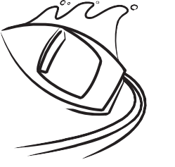

The boat operator is responsible for damage or injuries caused by the boat’s wake if he or she is negligent and fails to operate in a reasonable and prudent
manner. You are responsible for the boat’s wake.


The rental company has rules aimed at protecting you and your passengers.
Understand and follow the rental company’s rules and the boating laws that apply to the type of boat you are renting.




Make sure your rental company has explained any specifc local boating hazards and regulations so you can avoid problems on the water.

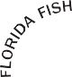



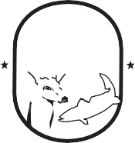
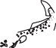

Florida Fish and Wildlife Conservation Commission
MyFWC.com

FWCDLE_315 (11/22) - Rule 68D-34.004, F.A.C.

