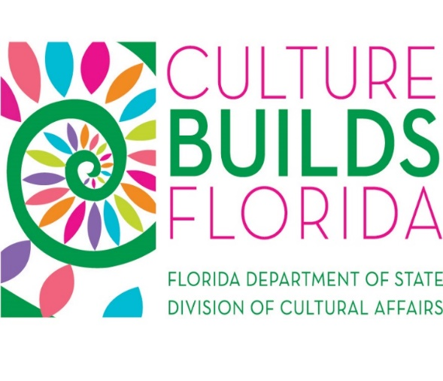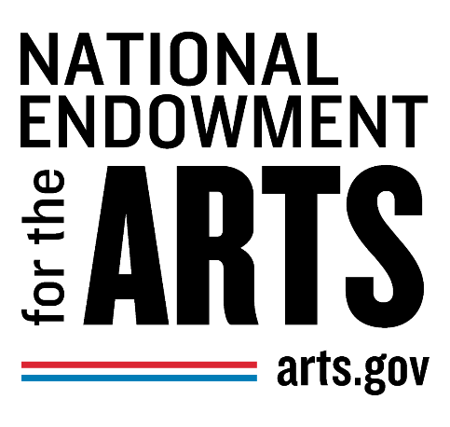

FLORIDA DIVISION OF CULTURAL AFFAIRS
AND
NATIONAL ENDOWMENT FOR THE ARTS DIVISION INITIATIVES PARTNERSHIP PROGRAM GUIDELINES

Grant Period: July 1– June 30

Florida Department of State
Division of Cultural Affairs
329 North Meridian Street
Tallahassee, Florida 32301

Contents
Application Submission
Introduction
Program Description

Review and Selection of Partner Organizations
Eligibility
Application Requirements

Grant Period

Accessibility and Non-Discrimination

Grant Request Amount

Grant Proposal Budget

Allowable Expenses

Non-Allowable Expenses
Scoring

Division Panel Review

Florida Council on Arts and Culture Review
After the Division panel meeting, the Division will report the recommendations to the Florida Council on Arts and Culture.
Funding
Funds are subject to availability.
Legal References and Resources

Application Submission
Applications must be submitted to the program manager on or before the deadline. Applicants may only receive one grant per fiscal year from this program.
For Assistance and Information
Program | Contact
- Division Initiatives Partnership Program | Teri Abstein  850.245.6299  Teri.Abstein@dos.myflorida.com

These Guidelines are also available electronically at:
https://dos.myflorida.com/cultural/grants/grant-programs/florida-division-of-cultural-affairs-and-the-national-endowment-for-the-arts-division-initiative-partnership-program/ and can be made available in an alternative format.

Introduction
The Division of Cultural Affairs will annually solicit applications that further the goals of the Division and the Division’s strategic plan.
These guidelines are supported under the Division of Cultural Affairs State Partnership Agreement with the National Endowment for the Arts, the federally approved application and our State Arts Agency Strategic Plan. The National Endowment for the Arts (NEA) is an independent federal agency that funds and promotes artistic excellence, creativity, and innovation for the benefit of individuals and communities. As Florida's official State Arts Agency, the Division of Cultural Affairs receives an annual state partnership grant.

Program Description
The Division Initiatives Partnership Program is designed to provide access to funds for arts and cultural projects that support specific Division of Cultural Affairs and National Endowment for the Arts initiatives as outlined in the Divisions’ Strategic Plan. The Division will direct funds toward proposals that best demonstrate these goals:
- Building the economy and creative industries;
- Enhancing education through arts and culture;
- Advancing leadership in arts and culture in the state and nation;
- Promoting healthy, vibrant and thriving communities; and
- Advancing a sense of place and identity.
This grant program is a competitive grant program. Applications will be reviewed and scored by an appointed panel. This program does not fund general programming activities of an organization.
Examples of projects that may be funded include: accessibility in underserved populations, arts in healthcare, arts in the military, arts education activities for specific populations, and leadership development within organizations with a demonstrable statewide impact.

Review and Selection of Partner Organizations
Division staff will identify and recommend partner organizations to submit applications for the Division Initiatives Partnership Program. The proposals must meet and further the goals of the strategic plan. Not all proposals will be funded.

Eligibility
All applicants must meet the following eligibility requirements at the time of application submission.
- Have the required legal status;
  - Applicant organizations must be either a public entity or a Florida nonprofit, tax-exempt corporation as of the application deadline.
    - Public Entity:
      - A Florida local government, entity of state government, school district, community college, college, or university. Private schools, private community colleges, private colleges, and private universities are not public entities and must be nonprofit and tax exempt to meet the legal status requirement.
    - Nonprofit, Tax Exempt: A Florida Organization that is both:
      - Nonprofit: incorporated as an active nonprofit Florida corporation, in accordance with Chapter 617 or Chapter 623, Florida Statutes. We do not fund foreign nonprofits. A foreign nonprofit is an existing corporation that is registered to do business in a state or jurisdiction other than where it was originally incorporated.
      - Tax exempt: designated as tax exempt as defined in section 501(c)(3) or 501(c)(4) of the Internal Revenue Code of 1954, as amended. Staff will verify status in Guidestar at https://www.guidestar.org/
      - For more information about tax exempt status, see Exemption Requirements-Section 501(c)(3) Organizations on the Internal Revenue Service website (http://www.irs.gov).
- Must be in compliance with all of Florida Department of State Divisions:
- Agree to comply with all grant requirements:
  - Complete all proposal activities within the grant period;
  - Make programming and activities open and accessible to all members of the public (see accessibility and non-discrimination).
  - Include only allowable expenses in the proposal budget (see allowable and non-allowable expenses);
  - Provide all information needed for the Grant Award Agreement;
  - Sign and return the Grant Award Agreement within thirty (30) days;
  - Submit timely and accurate reports;
  - Maintain complete and accurate grant records for a period of five (5) years;
  - Comply with the requirements of the Florida Single Audit Act;
  - Comply with the certification on debarment, suspension, ineligibility and voluntary exclusion-lower tier federally funded transactions;
  - Comply with the General Terms and Conditions for Sub awards under the Division’s NEA Partnership Agreement and 2 CFR Part 200 (https://www.ecfr.gov/cgi-bin/text-idx?SID=ba5e47a033fae83d6e8014ae88f2082f&mc=true&node=pt2.1.200&rgn=div5)
  - Credit the State of Florida, the Division of Cultural Affairs, and the National Endowment for the Arts for funding.
- Must have active registration in Florida Division of Corporations as of the submission.

For more information on corporate status, visit Sunbiz.org or call the Division of Corporations, profit and nonprofit information line at (850) 245-6052. To verify corporate status, you can review your corporate record online through the Sunbiz document search tool.

Application Requirements
Organizations who wish to apply must contact the Division and request an application. In addition to this, all applications must provide the following:
- All applicants must provide a DUNS number. You can request a DUNS number at https://www.dandb.com.
- All applicants must provide a copy of the Substitute W-9 with the application form. This can be found at https://flvendor.myfloridacfo.com.

Grant Period
All proposed activity must take place within the grant period July 1 - June 30.

Accessibility and Non-Discrimination
The Division of Cultural Affairs is committed to making the arts and culture accessible to everyone, including:
- persons with disabilities;
- elder adults;
- culturally and economically underserved populations; and
- minorities.
Organizations seeking support for activities that will not be open and accessible to all members of the public, regardless of sex, race, color, national origin, religion, disability, age, or marital status are not eligible for this publicly funded grant.
The Americans with Disabilities Act (ADA) prohibits discrimination against individuals with disabilities in employment, state and local government services, public accommodations, transportation and telecommunication. The ADA extends the requirements under Section 504 of the Rehabilitation Act of 1973, as amended, to all activities of state and local governments and places of public accommodations operated by private entities, including places of public display. The 504 Self Evaluation Workbook which can be used as a reference, and downloadable Disability Symbols can be found at http://dos.myflorida.com/cultural/info-and-opportunities/resources-by-topic/accessibility/. While the workbook is not required, failure to complete the workbook can affect the applicant’s Impact score.

Grant Request Amount
Request amounts will be determined by the panel and are subject to the availability of funds. No match is required, but it is encouraged.

Grant Proposal Budget
The Division Initiatives Partnership Program form requires a proposal budget. This budget must be accurate and reflect cost effective, reasonable, and allowable expenditures.

Allowable Expenses
Allowable expenses must be:
- directly related to the proposal;
- specifically, and clearly detailed in the proposal budget; and
- incurred and paid within the grant period.
Only allowable expenses may be included in the proposal budget. The Grantee may be asked to provide documentation such as canceled checks, paid invoices, or other financial documents verifying grant related expenses.
Spending grant funds on expenses that have not been approved by the Division, even if directly related to the project, will be disallowed and could result in a legal demand for the return of grant funds.

Non-Allowable Expenses
The Grantee agrees to expend all grant funds received under this agreement solely for the purposes for which they were authorized and appropriated. Expenditures shall be in compliance with the state and federal guidelines for allowable project costs as outlined in the Department of Financial Services' Reference Guide for State Expenditures (revised 11/2019), which are incorporated by reference and are available online at https://www.myfloridacfo.com/Division/AA/Manuals/documents/ReferenceGuideforStateExpenditures.pdf. The following are non-allowable expenses for grant funds.
- General programming activities;
- Expenses incurred or obligated before or after the grant period;
- Lobbying or attempting to influence federal, state, or local legislation;
- Building, renovation, or remodeling of facilities;
- Capital expenditures;
- Costs associated with bad debts, contingencies (money set aside for possible expenses), fines and penalties, interest, taxes (does not include payroll taxes), depreciation, and other financial costs including bank fees and charges and credit card fees;
- Private entertainment;
- Food, and beverages;
- Plaques, awards, and scholarships;
- Activities that are restricted to private or exclusive participation, which shall include restricting access to programs on the basis of sex, race, color, national origin, religion, disability, age, or marital status;
- Re-granting;
- Contributions and donations;
- Mortgage payments; and
- Payments to current Department of State employees.
- Phone;
- Utilities;
- Office supplies;
- Equipment costing over $1,000;
- Property improvements;
- Fixtures;
- Building maintenance; and
- Travel.

Scoring
The maximum number of points an application can earn is 100. Applications must earn a minimum average score of 90 to be eligible to be recommended for funding by the Division panel.
The Division panel members will individually score each organization application. Proposals will be ranked by score and funding will be considered top down and allocated based on available funds.
- Align with and furthers the goals of the Division’s strategic plan (Up to 40 points);
- Project impact (Up to 15 points);
- Benefits an underserved population and/or promotes arts education (Up to 15 points);
- Contributes to artistic excellence and merit (Up to 10 points);
- Has financial and management stability (Up to 10 points); and
- Budgets are reasonable and well defined (Up to 10 points).

Division Panel Review
Division staff member(s) and Florida Council on Arts and Culture member(s) serve as the panel for this program. They independently evaluate each application based on the review criteria in these guidelines. After each panel member has evaluated the applications, they will meet to review, discuss, and score the applications. During discussion, the panel may make a motion to adjust an applicant’s request amount or proposed budget.

Florida Council on Arts and Culture Review
After the Division panel meeting, the Division will report the recommendations to the Florida Council on Arts and Culture.

Funding
Funds are subject to availability.

Legal References and Resources
Florida Statute 265.284 (1) (a, b &c) and 265.828 http://www.leg.state.fl.us/Statutes/index.cfm?App_mode=Display_Statute&Search_String=&URL=0200-0299/0265/Sections/0265.284.html and
http://www.leg.state.fl.us/Statutes/index.cfm?App_mode=Display_Statute&Search_String=&URL=0200-0299/0265/Sections/0265.285.html
DCA Strategic Plan
http://dos.myflorida.com/cultural/about-us/strategic-plan/
20 U.S. Code § 954 - National Endowment for the Arts https://www.gpo.gov/fdsys/granule/USCODE-2011-title20/USCODE-2011-title20-chap26-subchapI-sec954
NEA General Terms and Conditions In particular section 22, 23 and 24
https://www.arts.gov/sites/default/files/2015-general-terms-and-conditions-for-orgs.pdf

2 CFR Part 200
https://www.ecfr.gov/cgi-bin/text-idx?SID=90c31fce014b83b065c6d1fe9f20037a&mc-true&tpl=/ecfrbrowse/Title02/2cfr200_main_02.tpl

