DIVISION OF MEDICAL QUALITY ASSURANCE
BOARD OF NURSING HOME ADMINISTRATORS
4052 BALD CYPRESS WAY, BIN #C-07
TALLAHASSEE, FLORIDA 32399-3257
(850) 245-4355

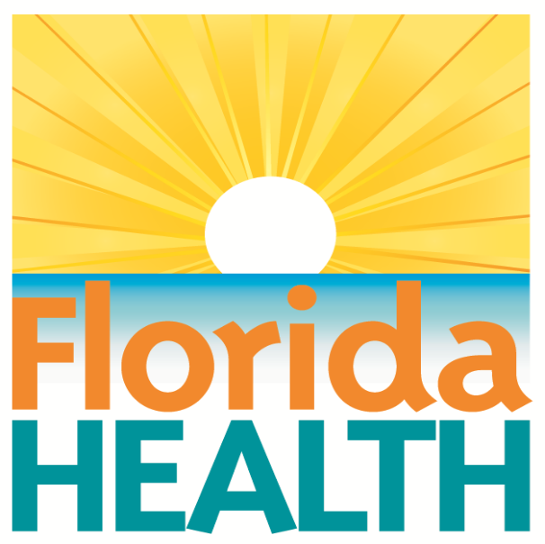

PRECEPTOR CERTIFICATION
SEPTEMBER 2016

CONFIDENTIAL AND EXEMPT FROM PUBLIC RECORDS DISCLOSURE

Florida Department of Health
Board of Nursing Home Administrators
Name: Last First Middle

Social Security Number:

This page is exempt from public records disclosure. The Department of Health is required and authorized to collect Social Security Numbers relating to applications for professional licensure pursuant to Title 42 USCA § 666 (a)(13). For all professions regulated under Chapter 456, Florida Statutes, the collection of Social Security Numbers is required by section 456.013 (1)(a), Florida Statutes.

4052 Bald Cypress Way, Bin # C07
Tallahassee, Florida 32399-3257

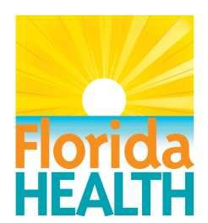

PRECEPTOR CERTIFICATION
(Client 801)

PLEASE PRINT OR TYPE IN BLACK INK OR APPLICATION WILL BE RETURNED Mail To: Board of Nursing Home Administrators
Post Office Box 6330
Tallahassee, FL 32314-6330
http://floridasnursinghomeadmin.gov/resources/
(850) 245-4355

REQUIRED FEES: (Certified Check or Money Order)
Initial Certification Fee: (3010) $100.00
Total: $100.00

PROFILE DATA (Please print or type or the application will be returned):

1. NAME:

(Last) (First) (Middle)

2. MAILING ADDRESS:

(Street and Number) (Apt. #) (City) (State) (Zip)

PRIMARY LOCATION:
(Street and Number) (Apt. #) (City) (State) (Zip)

3. TELEPHONE: ( ) ( )
Home: Area Code/Phone Number Work: Area Code/Phone Number

4. LICENSE NUMBER:

5. E-MAIL ADDRESS:
(Email Notification: If you want to notified of the status of your application by email please check the “YES” box and write your email address on the line provided above. If you choose this form of notification you will receive information regarding your application file through email. You will be responsible for checking your email regularly and updating your email address with the board office MQA.NursingHomeAdmin@flhealth.gov. Under Florida law, email addresses are public records. If you do not want your e-mail address released in response to a public records request, do not provide an email address or send electronic mail to our office. Instead contact the office by phone or in writing. [ ] YES [ ] NO

6. SKILLED NURSING FACILITIES IN WHICH YOU HAVE WORKED FOR THE LAST FIVE (5) YEARS:

Beginning/Ending Dates Facility Name, Address, County Facility Rating

Beginning/Ending Dates Facility Name, Address, County Facility Rating

Beginning/Ending Dates Facility Name, Address, County Facility Rating

7. Have you been convicted of, or entered a plea of guilty or nolo contendere to, regardless of adjudication, a felony under Chapter 409, F.S. (relating to social and economic assistance), Chapter 817, F.S. (relating to fraudulent practices), Chapter 893, F.S. (relating to drug abuse prevention and control) or a similar felony offense(s) in another state or jurisdiction? (If no, do not answer 7 a-d.)
Yes No
7a. If “yes” to 7, for the felonies of the first or second degree, has it been more than 15 years from the date of the plea, sentence and completion of any subsequent probation?
Yes No
7b. If “yes” to 7, for the felonies of the third degree, has it been more than 10 years from the date of the plea, sentence and completion of any subsequent probation? (This question does not apply to felonies of the third degree under Section 893.13(6) (a), Florida Statutes).
Yes ________ No ________
7c. If “yes” to 7, for the felonies of the third degree under Section 893.13(6)(a), Florida Statutes, has it been more than 5 years from the date of the plea, sentence and completion of any subsequent probation?
Yes _______ No ________
7d. If “yes” to 7, have you successfully completed a drug court program that resulted in the plea for the felony offense being withdrawn or the charges dismissed? (If “yes”, please provide supporting documentation).
Yes _______ No ________
8. Have you been convicted of, or entered a plea of guilty or nolo contendere to, regardless of adjudication, a felony under 21 U.S.C. ss. 801-970 (relating to controlled substances) or 42 U.S.C. ss. 1395-1396 (relating to public health, welfare, Medicare and Medicaid issues)? (If no, do not answer 8a.)
Yes _______ No_______
8a. If “yes” to 8, has it been more than 15 years before the date of application since the sentence and any subsequent period of probation for such conviction or plea ended?
Yes_______ No_______
9. Have you ever been terminated for cause from the Florida Medicaid Program pursuant to Section 409.913, Florida Statutes? (If no, do not answer 9a.)
Yes_______ No_______
9a. If you have been terminated but reinstated, have you been in good standing with the Florida Medicaid Program for the most recent five years?
Yes_______ No_______
10. Have you ever been terminated for cause, pursuant to the appeals procedures established by the state or federal government, from any other state Medicaid program or the federal Medicare program? (If no, do not answer 10a and 10b.)
Yes_______ No_______
10a. Have you been in good standing with a state Medicaid program or the federal Medicare program for the most recent five years?
Yes_______ No_______
10b. Did the termination occur at least 20 years prior to the date of this application?
Yes_______ No_______

11. APPLICANT SIGNATURE:

I, the undersigned, state that I am the person referred to in this application for licensure in the State of Florida.

I state that these statements are true and correct and recognize that providing false information may result in disciplinary action against my license or criminal penalties pursuant to Sections 456.067, 456.072, 468.1745, 468.1755, Florida Statutes.

I hereby authorize all hospitals, institutions or organizations, my references, personal physicians, employers (past and present), and all governmental agencies and instruments (local, state, federal or foreign) to release to the Department of Health, any information, files and/or records requested by the Department in connection with the processing of this application. I further authorize the Department to release to the organization, individuals, and groups listed above, any information which is material to my application.

I understand that Florida law requires me, as an applicant for licensure, to supplement my application after it has been submitted if and when any material change in circumstances or conditions occur which might affect the Board of Nursing Home Administrators decision concerning my eligibility for licensure. (Section 456.013, Florida Statutes) Failure to do so may result in action by the Board including denial of licensure.

I further state that I have carefully read the questions in the foregoing application and have answered them completely without reservations of any kind and I declare that my answers and all statements made by me herein are true and correct. Should I furnish any false information in this application, I understand that such action shall constitute cause for denial, suspension, or revocation of any license to practice in the State of Florida in the profession for which I am applying.

I also state that I will comply with all requirements for licensure renewal in effect at the time of license renewal, including submission of appropriate renewal fees and completion of required continuing education credits.

As a reminder to all applicants, please understand that Section 456.013(1)(a), Florida Statutes, provides that an incomplete application shall expire one year after initial filing with the Department.

(Signature of Applicant) (Date)

PRECEPTOR TRAINING COURSE

TO: Florida Board of Nursing Home Administrators
4052 Bald Cypress Way, Bin #C07
Tallahassee, FL 32399-3257

FROM: _ (Please type or print)

_ _ _ _

I have completed the six (6) hour preceptor training course in compliance with Rule 64B10-16.0025, Florida Administrative
Code. Attached is a copy of the certificate of completion.

Course Completion Date:

Instructor: _ _ Sponsored by: _
Have you previously been approved as a Florida preceptor? No Yes

I declare that these statements are true and correct and recognize that providing false information may result in a fine, suspension or revocation of my license as provided in Florida Statutes 456.067, 456.072, 468.1745, 468.1755.

Signature (Required)

Date (of signature)

