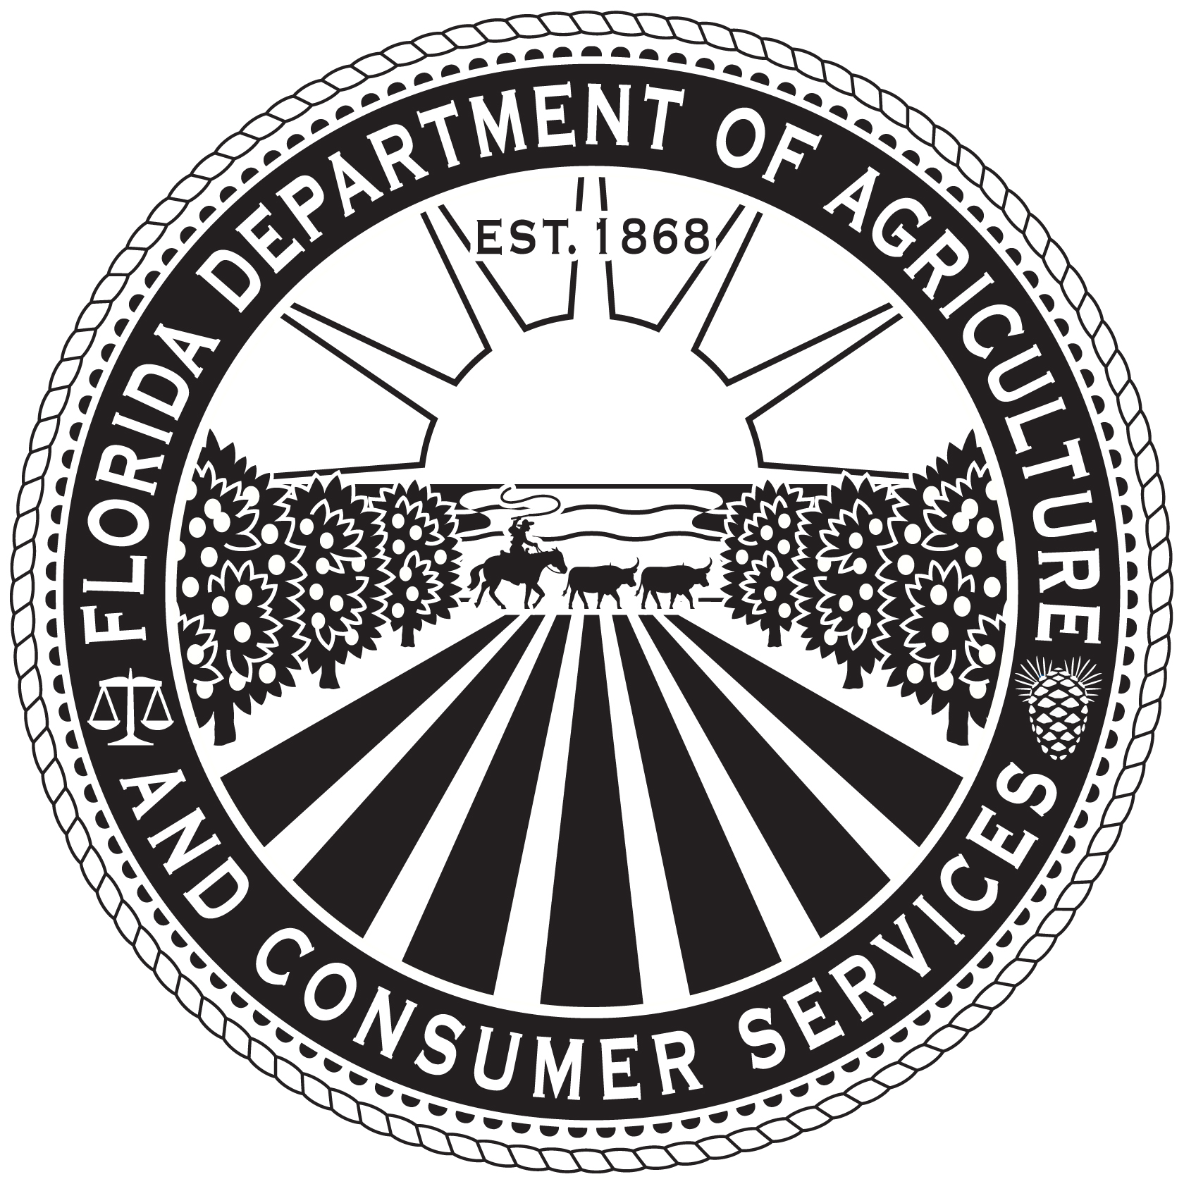
Florida Department of Agriculture and Consumer Services
Florida Forest Service

BEST MANAGEMENT PRACTICES FOR SILVICULTURE
AND NOTICE OF INTENT TO IMPLEMENT
ADAM H. PUTNAM
COMMISSIONER

NOTICE OF INTENT TO IMPLEMENT

In accordance with sections 403.067(7)(c)2., 570.07(23), F.S., and Rule 5I-6.004, F.A.C. The following information is hereby submitted as verification of my intent to implement Silviculture Best Management Practices.

Property Owner |  |  |  |  |  |  | Acres
Property Tax ID# (s)
Location of Property
County(s)
Authorized Local Contact
Landowner or Representative Address:
Phone

Complete the attached Silviculture Best Management Practices Checklist and submit it along with this Notice of Intent to the Department of Agriculture and Consumer Services, Florida Forest Service at the address listed below. Keep the completed Checklist in your files along with a copy of your completed Notice(s) of Intent.

Signature of Property Owner or Authorized Representative  Mail this notice and the attached Checklist to:  FDACS – Florida Forest Service  Attn: Silviculture BMP Program  3125 Conner Boulevard  Tallahassee, FL 32399-1650 |  | Date

SILVICULTURE BEST MANAGEMENT PRACTICES CHECKLIST

Instructions: Place a check beside each sub-category of Best Management Practices (BMP) that are currently being implemented. For those BMPs that are not currently being implemented but planned for the future, enter the year that you expect BMP implementation to occur beside each category and/or sub-category. Use the Silviculture BMP Manual for details on individual practices within each sub-category.

Special Management Zones
Primary Zone
Secondary Zone
Stringer
Wetlands
Drainage and Conversion
Roads
Harvesting
Skidding
Canals
General
Maintenance
Sinkholes
General
Forest Roads
Planning
Construction
Drainage
Maintenance
Stream Crossings
General
Culverts
Hard Surface Crossings
Timber Harvesting
Skid Trails
Slash Disposal

Site Preparation and Planting
General
Fireline Construction
General
Pesticide and Fertilizer Use
Pesticides
Fertilizer
Waste Disposal
Waste Oil
Solid Waste
Wet Weather Operations
General
Emergency Operations
Wildfire
Insect and Disease
Primary Zone Exceptions
Exception #1
Exception #2
Exception #3a
Exception #3b

