PART I
INTRODUCTION, ORGANIZATION, DEFINITIONS AND APPLICABILITY

- Introduction

This is Volume II of a two-volume Applicant’s Handbook that is designed to assist persons in understanding the rules, procedures, standards and criteria of the environmental resource permit (ERP) program under part IV of chapter 373 of the Florida Statutes (F.S.). Within the St. Johns River Water Management District, the ERP program is governed by chapters 373, 403 and 120, F.S. and chapters 62-330, 40C-1, 40C-4, 40C-41, 40C-42, and 40C-44, F.A.C. This handbook volume accompanies Applicant’s Handbook – Volume I (General and Environmental). Volume II and portions of Volume I are incorporated by reference in chapter 62-330, F.A.C., and are, therefore rules of the Department of Environmental Protection (DEP). In accordance with paragraph 373.4131(2)(a), F.S. (2012), they are also rules of the District.

This Volume includes:

- Design and performance standards and criteria for water quality and quantity for stormwater management systems, including alternative criteria for those systems
- Explanations of standards and criteria pertaining to water flows and levels, flood protection and the design of dams
- Design and performance standards for agricultural surface water management (Chapter 40C-44, F.A.C.)
- Descriptions of drainage basins and regional watersheds
- Explanations of basin criteria (Chapter 40C-41, F.A.C.)
- Descriptions of District-specific thresholds and exemptions referenced in chapter 62-330, F.A.C.

This Volume should be used in conjunction with Volume I, which provides general background information on the ERP program including points of contact, a summary of the statutes and rules used to authorize and implement the ERP program, and forms used to notice or apply to the District for an ERP authorization, except those forms related to agricultural systems which are incorporated by reference in rules 40C-44.061 and 40C-44.101, F.A.C. Volume I also provides discussion of:

  - Activities that are regulated by the ERP program
  - Types of permits, permit thresholds, and exemptions
  - Procedures used in the review of ERPs
  - Conditions for issuance of an ERP, including a detailed discussion of the environmental criteria that are used for activities located in wetlands and other surface waters
  - Erosion and sediment control practices to prevent water quality violations
  - Operation and maintenance requirements and copies of maps used in implementing the provisions of the ERP program
The term “District” or “SJRWMD” where used in this Volume shall apply to the Department of Environmental Protection, the St. Johns River Water Management District or a delegated local government as applicable in accordance with the division of responsibility specified by the operating agreement incorporated by reference in subsection 62-330.010(3), F.A.C., except where a specific agency is otherwise identified. In cases where conflicting or ambiguous interpretations of the information in this Volume result in uncertainty, the final determination of appropriate procedures to be followed will be made by reference to chapters 120 and 373, and chapters 40C-1, 40C-4, 40C-41, 40C- 42, 40C-44 and 62-330, F.A.C.

References to a section or subsection shall include all parts of the section or subsection unless otherwise specified.

1.1 Organization

This Volume is divided into eight parts:

Part I – Introduction, Organization, Definitions and Applicability
Part II – General Criteria
Part III – Stormwater Quantity/Flood Control
Part IV – Stormwater Quality
Part V – Best Management Practices and Special Basin Criteria
Part VI – Basin Criteria
Part VII - Agricultural Surface Water Management Systems
Part VIII – Appendices

1.2 District-Specific Thresholds

1.2.1 Background
Rule 62-330.020 sets forth the thresholds for when an environmental resource permit must be obtained under part IV of chapter 373. Subsection (2) of this
Rule requires a person to obtain an environmental resource permit before
constructing, altering, operating, maintaining, removing, or abandoning any new
project that, by itself or in combination with an activity conducted after October
1, 2013, cumulatively results in “[a]ny project exceeding the thresholds in
section 1.2 (District-specific thresholds) of the applicable Volume II” unless the
proposed project is governed by subsection 62-330.020(1), F.A.C. [62-
330.020(2)(i), F.A.C.]

Subsections 1.2.2 and 1.2.3 of this Volume set forth the District-specific thresholds for activities within the St. Johns River Water Management District.

The District encourages applicants to consult section 2.0 of Volume I which contains definitions of important terms such as “project” and “activity”.

1.2.2 Activities in the Wekiva Riparian Habitat Protection Zone

A permit under chapter 62-330 is required for any activity that is located wholly or partially within the Wekiva River Hydrologic Basin’s Riparian Habitat Protection Zone (RHPZ) described in paragraph 40C-41.063(3)(e), F.A.C. When an activity requires a permit pursuant to this subsection, the review for determining compliance with all relevant permitting requirements will be conducted in accordance with rule 62-330.054.

1.2.3 Agricultural Surface Water Management Systems

A permit under chapter 62-330, F.A.C., is required for the alteration, maintenance and operation of certain existing agricultural surface water management systems and for the construction, maintenance and operation of certain new agricultural surface water management systems, in accordance with chapter 40C-44, F.A.C. (Environmental Resource Permits: Regulation of Agricultural Surface Water Management Systems). These systems are described in rule 40C-44.041, but are also described in this subsection and in Part VII of this Volume.

Agricultural operations that are required to obtain a permit shall satisfy the requirements of the District in terms of the quality of water discharged from the system, by implementing the performance standards and water quality practices described in Part VII of this Volume.

A permit for an agricultural system is required under this subsection and chapter
40C-44, F.A.C., if the activity exceeds any of the following thresholds:

(a) The activity incorporates pumped discharges from an existing agricultural surface water management system, when:

(1) the pumps are stationary or portable facilities, and

(2) the pump(s) have a capacity, either individually or cumulatively, of 10,000 GPM or greater. [40C-44.041(1)(a), F.A.C.]

(b) The activity causes or contributes to a violation of state water quality standards in waters of the state, when:

(1) the discharge is pumped or gravity drained, and

(2) the District has considered the following information on a case-by-case basis:

a. water quality monitoring data collected by the District or other agency,

b. the size of the agricultural operation and the amount of stormwater and associated wastewater reaching waters of the state, relative to the size and nature of the immediate drainage basin,

c. the means of conveyance of stormwater and associated wastewater to waters of the state,

d. characteristics of the site including the slope, vegetation, rainfall and other factors related to the likelihood or frequency of discharge of stormwater and associated wastewater to waters of the state,

e. the status, results and recommendations of available basin-specific studies, including those conducted as part of a Surface Water Improvement and Management Plan or pursuant to chapter 62-40, F.A.C., and

f. the existence of mixing zones, variances or site specific alternative criteria granted by DEP pursuant to chapters 62-4 and 62-302, F.A.C. [40C-44.041(1)(b), F.A.C.]

(c) An applicant proposes construction, maintenance and operation of new agricultural surface water management systems, or alteration of existing systems, which:

(1) drain an agricultural area greater than 2 acres;

(2) are not located in, on, or over existing wetlands or other surface waters;

(3) serve a project with a total land area less than 40 acres; and

(4) do not provide for the placement of 12 or more acres of impervious surface which constitutes 40 or more percent of the total land area. [40C-44.041(2), F.A.C.]

When an activity that requires a permit pursuant to this subsection also requires a permit because it exceeds one or more thresholds listed in paragraphs 62-330.020(2)(a),(b), (c),(d),(e),(f),(g),(h), or (j), F.A.C., or in subsection 1.2.2 of this Volume, the review for determining compliance with all relevant permitting requirements will be conducted in accordance with rule 62-330.054.

When an activity requires a permit solely pursuant to this subsection the permit application for such activity shall be filed, and shall be reviewed and acted upon, in accordance with chapter 40C-44, F.A.C., and Part VII of this Volume. The District encourages applicants to contact the District’s Agricultural Assistance Team to assist them in completing such permit applications.

1.3 District-Specific Exemptions

1.3.1 Background

Rule 62-330.051(1) exempts from permitting under chapter 62-330, F.A.C.,
activities that are conducted in conformance with the District-specific exemptions
in Section 1.3 of Volume II applicable to the location of the activity. However, if
an activity is not exempt and requires an individual ERP under chapter 62-330,
F.A.C., rule 62-330.054 requires the application for the individual ERP to be
prepared, submitted, reviewed and acted upon in accordance with subparagraphs 62-
330.054(2)(a), (b) and (c), F.A.C., except as otherwise provided by the ERP rules.

Consistent with these rules, the District has established one District-specific exemption from permitting and one District-specific exemption from certain provisions of chapter 62-330, F.A.C. More specifically, subsection 1.3.2 of this Volume sets forth a District-specific exemption from permitting within the St. Johns River Water Management District while subsection 1.3.3 exempts certain agricultural systems from certain requirements in chapter 62-330, F.A.C.

1.3.2 Existing Systems

The District’s rules in chapters 40C-4, 40C-40, and 40C-41, F.A.C. became effective on December 7, 1983. Before December 7, 1983, rules authorized under part IV, chapter 373, F.S. were implemented in the Upper St. Johns River and the Ocklawaha River basins as shown in Figure 1.3-1. The rules adopted on December 7, 1983 superseded all previous rules. The date of implementation is important in determining whether a permit is required and the effective dates for the District’s permitting programs are described in rule 40C-4.031. Certain systems are not required to be permitted until they are to be altered, removed, or abandoned. These systems are identified in the paragraph below.

Specifically exempted from permitting under chapter 62-330 for the purpose of construction, operation, and maintenance are:

(a) Each system or phase of a phased system which is located in the areas described in the Upper St. Johns River Basin or the Ocklawaha River Basin as depicted in Figure 1.3-1, except agricultural operations, which:

(1) Was constructed and operating under the provisions of a valid District permit on December 7, 1983; or

(2) Was not required to obtain a permit prior to December 7, 1983, and was:

a. Constructed and operating prior to December 7, 1983; or

b. Being constructed on December 7, 1983, and was completed and operating by June 7, 1984; or

c. Under construction on December 7, 1983, and which had complied with the regulations of the Florida Department of Environmental Regulation and the appropriate local governmental agency.

(3) Was constructed and operating as of March 2, 1974 for the Upper St. Johns River Basin as described in Figure 1.3-1; or

(4) Was constructed and operating as of January 1, 1975 for the portion of the Oklawaha River Basin as described in Figure 1.3-1.

(b) Each system or phase of a phased system which is located in the Lower St. Johns River Basin as described in Figure 1.3-1 and section 373.069(2)(c), F.S. (Supp. 1976), except agricultural operations, and which was:

(1) Constructed and operating prior to December 7, 1983; or

(2) Being constructed on December 7, 1983, and was completed and operating on June 7, 1984; or

(3) Under construction on December 7, 1983, and which had complied with the regulations of the Florida Department of Environmental Regulation and the appropriate local governmental agency and was completed December 7, 1984.

(c) The exemptions listed in paragraphs (a) and (b) above apply only to those systems or phases of a phased system as such systems are set forth in its plans, specifications and performance criteria prepared and existing as of December 7, 1983 and to the extent:

(1) Construction of such system is completed, within the applicable time frames, in accordance with such plans, specifications and performance criteria; and

(2) Such system is maintained and operated in a manner consistent with such plans, specifications and performance criteria.

(d) The exemptions listed in paragraphs (a), (b) and (c) above shall not apply to those systems or phases of a phased system which on December 7, 1983 have been abandoned or removed or have ceased to operate as set forth in such system’s plans, specifications and performance criteria.

(e) Those systems or phases of a phased system exempted by paragraphs (a), (b) and (c) above shall not be required to obtain a permit for construction, operation or maintenance.

(1) Any alteration of such system, or a portion thereof (including the rebuilding of such system if it has ceased to operate as set forth in such system’s plans, specifications and performance criteria), shall require that a permit be obtained for such alteration, which permit shall include an authorization to alter as well as an authorization to operate and maintain such alteration. For purposes of this subsection, the following are not considered to be alterations, and consequently are not required to be permitted:

a. The relocation of pumps, provided that the pump is not moved out of the immediate vicinity of its existing location, not to another drainage basin or subbasin, and operation of the pump at the new location will not result in increased adverse impacts to the water resource.

b. The installation of driveway and road inlets and pipes with a diameter of less than 60 inches or equivalent size within an existing surface water management system, provided that the pipe or inlet will not increase the volume of water discharged, and causes no upstream or downstream flooding.

c. The change of the location of a drainage system’s secondary or tertiary drainage ditches provided that the total linear length and cross-sectional dimensions of the ditches are not changed.

d. Roadways not located in wetlands may be widened provided that fill material is not obtained by excavating ditches next to the roadway, and provided that the roadway is otherwise constructed in accordance with accepted engineering practices. Roadways not located in wetlands may be increased in height provided that the elevation of the existing centerline road grade is above the 10-year flood elevation, and provided that no increase in upstream flooding is caused.

(2) Any abandonment or removal of such system or portion thereof, shall require that a permit be obtained for such abandonment or removal.

(3) The activities in subparagraphs (e)(1)a. through d. are also exempt from permitting when conducted by agricultural operations.

(f) The amendments to subsections 10.7.2, 10.7.4, 10.7.5., 16.1.3 and 16.1.5, Applicant’s Handbook: Management and Storage of Surface Waters, effective September 25, 1991, shall not apply to each system for which the District has issued an individual or general permit pursuant to Chapter 40C-4 or 40C-40, F.A.C., prior to September 25, 1991. This subsection applies only to the project area and plan approved in the referenced permit; however, where the referenced permit authorizes construction of a master system for drainage and flood control, this subsection shall apply to the project area served by the master system and to the plan approved in the referenced permit.

(g) The amendments to subsections 10.7.2, 10.7.4, 10.7.5, 16.1.3 and 16.1.5, Applicant’s Handbook: Management and Storage of Surface Waters, effective September 25, 1991 shall not apply to each system for which the District has issued, pursuant to Chapter 40C-4, F.A.C., and prior to September 25, 1991, both a conceptual approval permit and at least one permit authorizing construction consistent with the conceptual approval permit. This subsection applies only to the project area and plan approved in the referenced conceptual approval permit.

(h) The permitting threshold set forth in subparagraph 40C- 4.041(2)(b)8., F.A.C., as it existed on September 25, 1991,
incorporated by reference in 40C-4.091(1)(a), F.A.C., and
contained in Appendix D of this Volume, regarding isolated
wetlands and the amendments to subsections 10.7.2, 10.7.4, 10.7.5,
16.1.3 and 16.1.5, Applicant’s Handbook: Management and
Storage of Surface Waters, effective September 25, 1991 shall not
apply to each system for which the District has issued a permit
pursuant to Chapter 40C-42, F.A.C., prior to September 25, 1991.
This subsection applies only to a system which did not require a
permit pursuant to Chapter 40C-4 or 40C-40, F.A.C., prior to
September 25, 1991 and only to the project area and the plan
approved in the referenced permit.

(i) The amendments to section 10.3.2 of the Applicant’s Handbook: Management and Storage of Surface Waters effective February 27, 1994, shall not apply to any general or individual permit application pursuant to Chapter 40C-4 or 40C-40, F.A.C., which is complete prior to February 27, 1994.

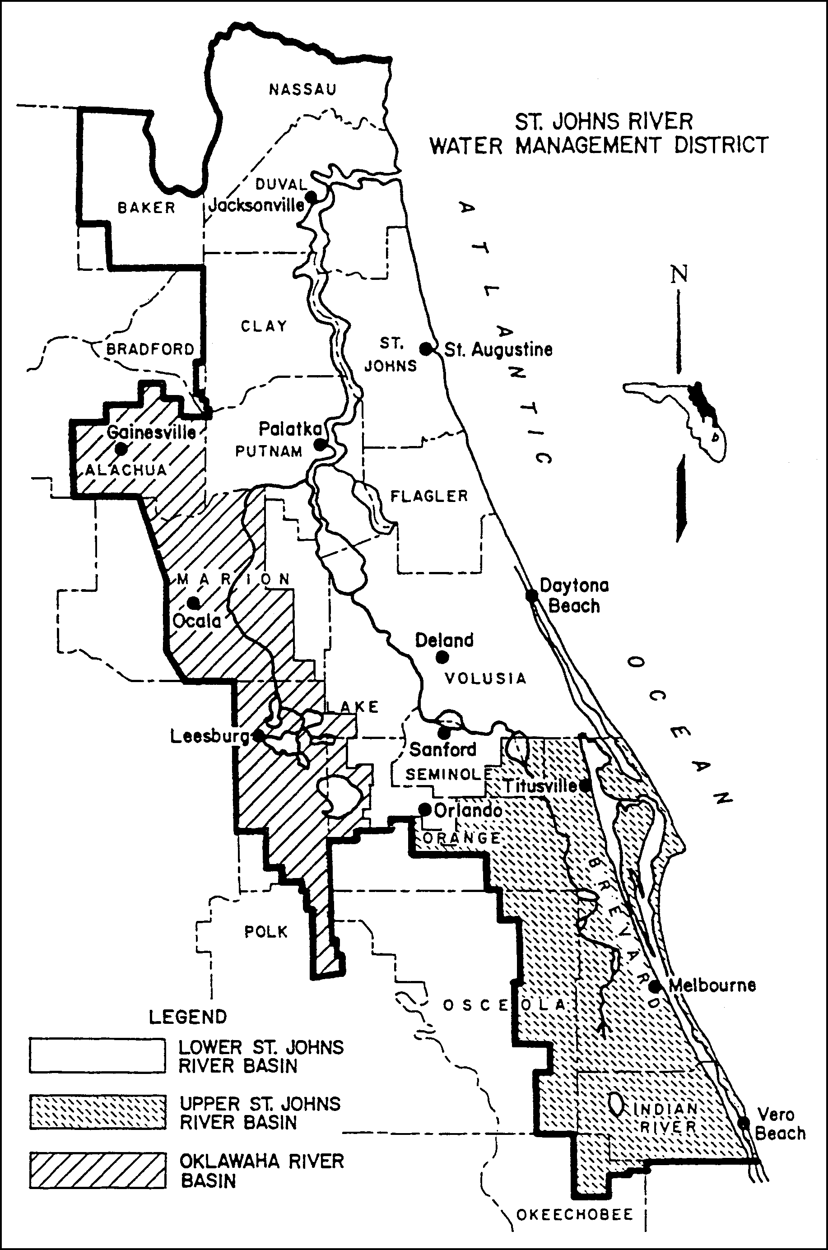

Figure 1.3-1 Areas within the District Having Differing Effective Dates for Implementation of Management and Storage of Surface Water Rules

1.3.3 Agricultural Surface Water Management Systems

Each system that requires an individual permit solely pursuant to section 1.2.3 of this Volume shall be exempt from the requirements in rules 62-330.060, 62-330.062, 62-330.090(1),(4) and (6), 62-330.301, 62-330.302, 62-330.310, 62-330.311, 62-330.315, 62-330.320, 62-330.340, and 62-330.350. Permit applications for such systems shall be filed, reviewed and acted upon in accordance with chapter 40C-44, F.A.C., and Part VII of this Volume. Once authorized, such systems shall be constructed, operated and maintained in accordance with 40C-44, F.A.C., and Part VII of this Volume.

