PART II – GENERAL CRITERIA

2.0 Criteria for Evaluation – Reasonable Assurance

Except as provided in section 1.2.3 of this Volume, an applicant for an individual permit must provide reasonable assurance that the proposed activities will meet the criteria in rules 62-330.301 and 62-330.302, F.A.C. More specifically, under 62-330.301, F.A.C., an applicant must provide reasonable assurance that the construction, alteration, operation, maintenance, removal or abandonment of a project within SJRWMD:

(a) Will not cause adverse water quantity impacts to receiving waters and adjacent lands (62-330.301(1)(a), F.A.C.);

(b) Will not cause adverse flooding to on-site or off-site property (62- 330.301(1)(b), F.A.C.);

(c) Will not cause adverse impacts to existing surface water storage and conveyance capabilities (62-330.301(1)(c), F.A.C.);

(d) Will not adversely impact the value of functions provided to fish and wildlife and listed species by wetlands and other surface waters (62- 330.301(1)(d), F.A.C.);

(e) Will not adversely affect the quality of receiving waters such that the water quality standards set forth in Chapters 62-4, 62-302, 62-520, and 62-550, F.A.C.,
(incorporated by reference in 40C-4.091(1)(c)) including the antidegradation provisions of paragraphs 62- 4.242(1)(a) and (b), F.A.C., subsections 62-4.242(2)
and (3), F.A.C., and Rule 62-302.300, F.A.C., and any special standards for Outstanding Florida Waters and Outstanding National Resource Waters set forth in subsections 62-4.242(2) and (3), F.A.C., will be violated (62-330.301(1)(e), F.A.C.);

(f) Will not cause adverse secondary impacts to the water resources (62- 330.301(1)(f), F.A.C.;

(g) Will not adversely impact the maintenance of surface or ground water levels or surface water flows established in Chapter 40C-8, F.A.C., (10-1-13) (62-330.301(1)(g), F.A.C.);

(h) Will not cause adverse impacts to a Work of the District established pursuant to Section 373.086, F.S. (62-330.301(1)(h), F.A.C.);

(i) Will be capable, based on generally accepted engineering and scientific principles, of being performed and of functioning as proposed (62- 330.301(1)(i), F.A.C.);

(j) Will be conducted by a person with the financial, legal and administrative capability of ensuring that the activity will be undertaken in accordance with the terms and conditions of the permit, if issued (62-330.301(1)(j), F.A.C.); and

(k) Will comply with the applicable special basin or geographic area criteria in Chapter 40C-41, F.A.C. (62-330.301(1)(k), F.A.C.);

The provisions in this Volume and in Volume I explain how applicants may provide the requisite reasonable assurance to demonstrate compliance with these criteria within SJRWMD. In certain instances, an applicant for an individual permit that involves an agricultural surface water management system will be governed solely by Chapter 40C- 44, F.A.C. and Part VII of this Volume. (See subsection 62-330.054(2), F.A.C. and subsections 1.2.3 and 1.3.3 of this Volume) Therefore, the District recommends that applicants whose projects involve an agricultural surface water management system that only exceeds the thresholds set forth in section 1.2.3 of this Volume initially consult Part VII of this handbook.

2.1 Definitions

The following definitions are used by the District to clarify its intent in implementing its permitting programs pursuant to part IV, chapter 373, F.S.

(a) “Compensating treatment” means treatment for water quality in an offsite location when physical conditions do not allow for treatment on-site equivalent to that otherwise required by Chapter 62-330, F.A.C., and Environmental Resource Permit Applicant’s Handbook Volume II: For Use Within the Geographic Limits of the St. Johns River Water Management District.”

(b) "Control Device" or "Bleed-down Device" means that element of a discharge structure which allows the gradual release of water under controlled conditions.

(c) "Control Elevation" means the lowest elevation at which water can be released through the control device or withdrawn by a stormwater harvesting system.

(d) "Detention with filtration" or "Filtration" means the selective removal of pollutants from stormwater by the collection and temporary storage of stormwater and the subsequent gradual release of the stormwater into surface waters in the state through at least 2 feet of suitable fine textured granular media such as porous soil, uniformly graded sand, or other natural or artificial fine aggregate, which may be used in conjunction with filter fabric and/or perforated pipe.

(e) "Detention" or "To Detain" means the collection and temporary storage of stormwater with subsequent gradual release of the stormwater.

(f) "Direct Discharge" means, for purposes of this Volume, either a point or nonpoint discharge which enters Class I, Class II, Outstanding Florida Waters, or Class III waters which are approved, conditionally approved, restricted, or conditionally restricted for shellfish harvesting without an adequate opportunity for mixing and dilution to prevent significant degradation. Examples of direct discharge include the following:

(1) Discharge without entering any other water body or conveyance prior to release to the Class I, Class II, Outstanding Florida Water, or Class III waters which are approved, conditionally approved, restricted, or conditionally restricted for shellfish harvesting.

(2) Discharge into an intermittent watercourse which is a tributary of a Class I, Class II, Outstanding Florida Water, or Class III waters which are approved, conditionally approved, restricted, or conditionally restricted for shellfish harvesting.

(3) Discharge into a perennial watercourse which is a tributary of a Class I, Class II, Outstanding Florida Water, or Class III waters which are approved, conditionally approved, restricted, or conditionally restricted for shellfish harvesting when there is not an adequate opportunity for mixing and dilution to prevent significant degradation.

(g) "Dry Detention" means a system designed to collect and temporarily store stormwater in a normally dry basin with subsequent gradual release of the stormwater.

(h) "Effective Grain Size" means the diameter of filter sand or other aggregate that corresponds to the 10 percentile finer by dry weight on the grain size distribution curve.

(i) Floodway - The permanent channel of a stream or other watercourse, plus any adjacent floodplain areas that must be kept free of any encroachment in order to discharge the 100 year flood without cumulatively increasing the water surface elevation more than a designated amount (not to exceed one foot except as otherwise established by the District or established by a Flood Insurance Rate Study conducted by the Federal Emergency Management Agency (FEMA) ).

(j) Hydrologically Sensitive Area - Wetlands and those geographical areas which are specifically designated as hydrologically sensitive areas by the Board because of the importance of the hydrology and hydraulics of the area in meeting the Legislative policy contained in section 373.016, F.S.

(k) "Intermittent Watercourse" means a stream or waterway that flows only at certain times of the year, flows in a direct response to rainfall, and is normally an influent stream except when the ground water table rises above the normal wet season level.

(l) Littoral Zone - In reference to stormwater management systems, this phrase shall mean that portion of a wet detention pond which is designed to contain rooted aquatic plants.

(m) "Off-line" means the storage of a specified portion of the stormwater in such a manner so that subsequent runoff in excess of the specified volume of stormwater does not flow into the area storing the initial stormwater.

(n) "Perennial Watercourse" means a stream or waterway which is not an intermittent watercourse.

(o) Permanent Pool - That portion of a wet detention pond which normally holds water (e.g., between the normal water level and the pond bottom).

(p) "Reconstruction" means rebuilding or construction in an area upon which construction has previously occurred.

(q) "Retention" means a system designed to prevent the discharge of a given volume of stormwater runoff into surface waters in the state by complete on-site storage. Examples may include excavated or natural depression storage areas, pervious pavement with subgrade, or above ground storage areas.

(r) "Seasonal high ground water table elevation" means the highest level of the saturated zone in the soil in a year with normal rainfall.

(s) "Stormwater Discharge Facility" means a stormwater management system which discharges stormwater into surface waters of the state.

(t) "Stormwater Harvesting" means to prevent the discharge of a given volume of stormwater into surface waters of the state by deliberate application of stormwater for irrigation (such as irrigation of golf courses, cemeteries, highway medians, parks, playgrounds, school yards, retail nurseries, agricultural lands, and residential and commercial properties) or industrial uses (such as cooling water, process water, and wash water).

(u) "Swale" means a manmade trench which:

(1) Has a top width to depth ratio of the cross-section equal to or greater than 6:1, or side slopes equal to or greater than 3 feet horizontal to 1 foot vertical.

(2) Contains contiguous areas of standing or flowing water only following a rainfall event.

(3) Is planted with or has stabilized vegetation suitable for soil stabilization, stormwater treatment, and nutrient uptake.

(4) Is designed to take into account the soil erodibility, soil percolation, slope, slope length, and drainage area so as to prevent erosion and reduce pollutant concentration of any discharge.

(v) Traversing Work - Any artificial structure or construction that is placed in or across a stream, or other watercourse, or an impoundment

(w) "Underdrain" means a drainage system installed beneath a stormwater holding area to improve the infiltration and percolation characteristics of the natural soil when permeability is restricted due to periodic high water table conditions or the presence of layers of fine textured soil below the bottom of the holding area. These systems usually consist of a system of interconnected below-ground conduits such as perforated pipe, which simultaneously limit the water table elevation and intercept, collect, and convey stormwater which has percolated through the soil.

(x) "Underground Exfiltration Trench" or "Exfiltration Trench" means a below-ground system consisting of a conduit such as perforated pipe surrounded by natural or artificial aggregate which is utilized to percolate stormwater into the ground.

(y) "Uniformity Coefficient" means the number representing the degree of homogeneity in the distribution of particle sizes of filter sand or other granular material. The coefficient is calculated by determining the D60/D10 ratio where D10 and D60 refer to the particle diameter corresponding to the 10 and 60 percentile of the material which is finer by dry weight.

(z) Wet Detention - means the collection and temporary storage of stormwater in a permanently wet impoundment in such a manner as to provide for treatment through physical, chemical, and biological processes with subsequent gradual release of the stormwater.

(aa) "Wetlands Stormwater Management System" means a stormwater management system which incorporates those wetlands described in section 10.2 of this Volume II, into the stormwater management system to provide stormwater treatment.

2.2 Existing Ambient Water Quality

In instances where an applicant is unable to meet water quality standards because existing ambient water quality does not meet standards and the system will contribute to this existing condition, mitigation for water quality impacts can consist of water quality enhancement. In these cases, the applicant must implement mitigation measures that will cause net improvement of the water quality in the receiving waters for those parameters which do not meet standards. (see paragraph 373.414(1)(b), F.S. and section 8.2.3 of Volume I)

2.3 Professional Certification

All construction plans and supporting calculations submitted to the District must be signed, sealed, and dated by the appropriate registered professional (e.g., engineer, geologist, or landscape architect) as required by the relevant statutory provisions (i.e., chapters 471, 472, 481, or 492, F.S.) when the design of the project requires the services of a registered professional.

2.4 Maintenance Access

Regular maintenance is crucial to the long term effectiveness of stormwater management systems. The systems must be designed to permit personnel and equipment access and to accommodate regular maintenance activities. For example, high maintenance features such as inlets, outlets, and pumps should be easily accessible to maintenance equipment and personnel.

Legal authorization, such as an easement, deed restrictions, or other instrument must be provided establishing a right-of-way or access for maintenance of the stormwater management system unless the operation and maintenance entity wholly owns or retains ownership of the property. The following are requirements for specific types of maintenance access easements:

(a) Easements must cover at least the primary and high maintenance components of the system (i.e., inlets, outlets, littoral zones, filters, pumps, etc.).

(b) Easements for waterbodies, open conveyance systems, stormwater basins and storage areas must meet the following requirements:

1. Include the area of the water surface measured at the control elevation

2. Be a minimum of 20 feet from the edge of water at the control elevation or top of bank and include side slopes no steeper than 4H:1V

(c) Easements adjacent to water control structures must be 20 feet wide.

(d) Easements for piped stormwater conveyance must be a minimum of the width of the pipe plus 4 times the depth of the pipe invert.

(e) Access easements must be 20 feet wide from a public road or public right-of-way to the stormwater management system.

(f) As an alternative, the applicant may propose other authorization for maintenance access provided the applicant affirmatively demonstrates that equipment can enter and perform the necessary maintenance on the system.

A copy of the legal authorization must be submitted with the permit application.

2.5 Legal Authorization

Applicants which propose to utilize offsite areas not under their control to satisfy the
criteria for evaluation listed in section 2.0 must obtain sufficient legal authorization prior to permit issuance to use the area. For example, an applicant who proposes to locate the outfall pipe from the stormwater basin to the receiving water on an adjacent property owner's land must obtain a drainage easement or other appropriate legal authorization from the adjacent owner. A copy of the legal authorization must be submitted with the permit application.

2.6 Public Safety

2.6.1 Basin Side Slopes

Normally dry basins designed to impound more than two feet of water or permanently wet basins must contain side slopes that are no steeper than 4H:1V out to a depth of two feet below the control elevation. As an alternative, the basins can be fenced or otherwise restricted from public access if the slopes must be steeper due to space or other constraints.

2.6.2 Basin Side Slope Stabilization

All stormwater basin side slopes shall be stabilized by either vegetation or other material to minimize erosion of the basin.

Stabilization of side slopes is necessary in order to prevent erosion due to flow velocity and runoff from the banks. Good engineering practices, taking into consideration soil characteristics, flow and drainage characteristics, shall be employed. Again, the retardation of overland runoff and soil stabilization using naturally occurring vegetation coverage shall be considered before paving, riprap, lining, energy dissipation and other structural measures are employed.

2.6.3 Control Structures

Control structures that are designed to contain more than two feet of water within the
structure under the design storm and have openings of greater than one foot minimum dimension must be restricted from public access.

2.7 Tailwater Considerations

"Tailwater" refers to the water elevation (or pressure) at the final discharge part of the stormwater management system. Tailwater is an important component of the design and operation of nearly all stormwater management systems and can affect any of the following management objectives of the system:

(a) Peak discharge from the stormwater management system

(b) Peak stage in the stormwater management system

(c) Level of flood protection in the project

(d) Recovery of peak attenuation and stormwater treatment volumes

(e) Control elevations, normal water elevation regulation schedules, and ground water management

2.7.1 Tailwater for Water Quality Design

For recovery of the stormwater treatment volume, stormwater management systems
(except retention and exfiltration systems) must provide a gravity or pumped discharge that effectively operates (i.e., meets applicable criteria) under one of the following tailwater conditions:

(a) Maximum stage in the receiving water resulting from the mean annual 24-hour storm. This storm depth is shown on the isopluvial map in Figure 2.7.1-1 Generally, applicants utilizing this option would model the receiving waters utilizing standard hydrologic and hydraulic methods for the mean annual 24-hour storm to determine peak stages at various points of interest. Lower stages may be utilized if the applicant demonstrates that flow from the project will reach the receiving water prior to the time of maximum stage in the receiving water.

(b) Mean annual high tide for tidal areas. This elevation is the average of all the high tides for each year. This elevation may be determined from tide charts or other similar information.

(c) Mean annual seasonal high water elevation. This elevation may be determined by water lines on vegetation or structures, historical data, adventitious roots or other hydrological or biological indicators, design of man-made systems, or estimated by a registered professional using standard hydrological methods based on the site and receiving water characteristics.

(d) The applicant may propose applicable criteria established by a local government, state agency, or stormwater utility with jurisdiction over the project. However, the District must approve the use of alternative criteria. In this case, the applicant is encouraged to consult with District staff prior to submitting an application.

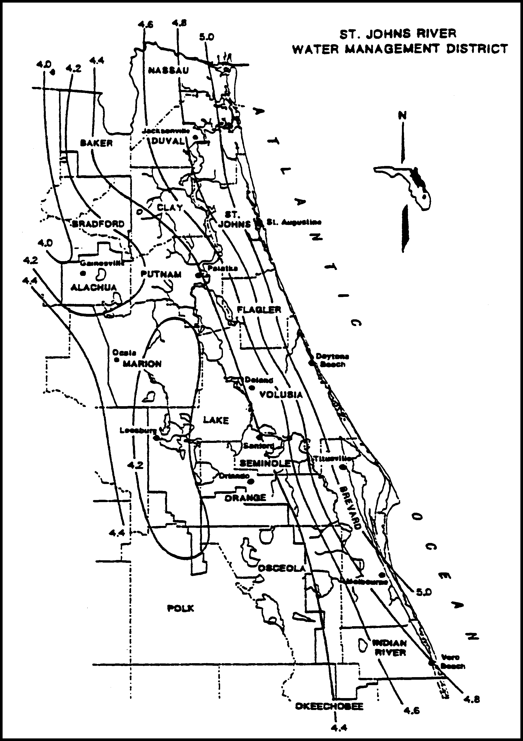

Figure 2.7.1-1 Mean Annual 24-Hour Maximum Rainfall, inches (Source: Rao, 1991)

2.7.2 Tailwater for Water Quantity Design

Receiving water stage can affect the amount of flow which will discharge from the project to the receiving water. This stage may be such that tailwater exists in portions of the project system, reducing the effective flow or storage area. Typical examples of this are illustrated in Figures 2.7.2-1 (gravity) and 2.7.2-2 (pumped).

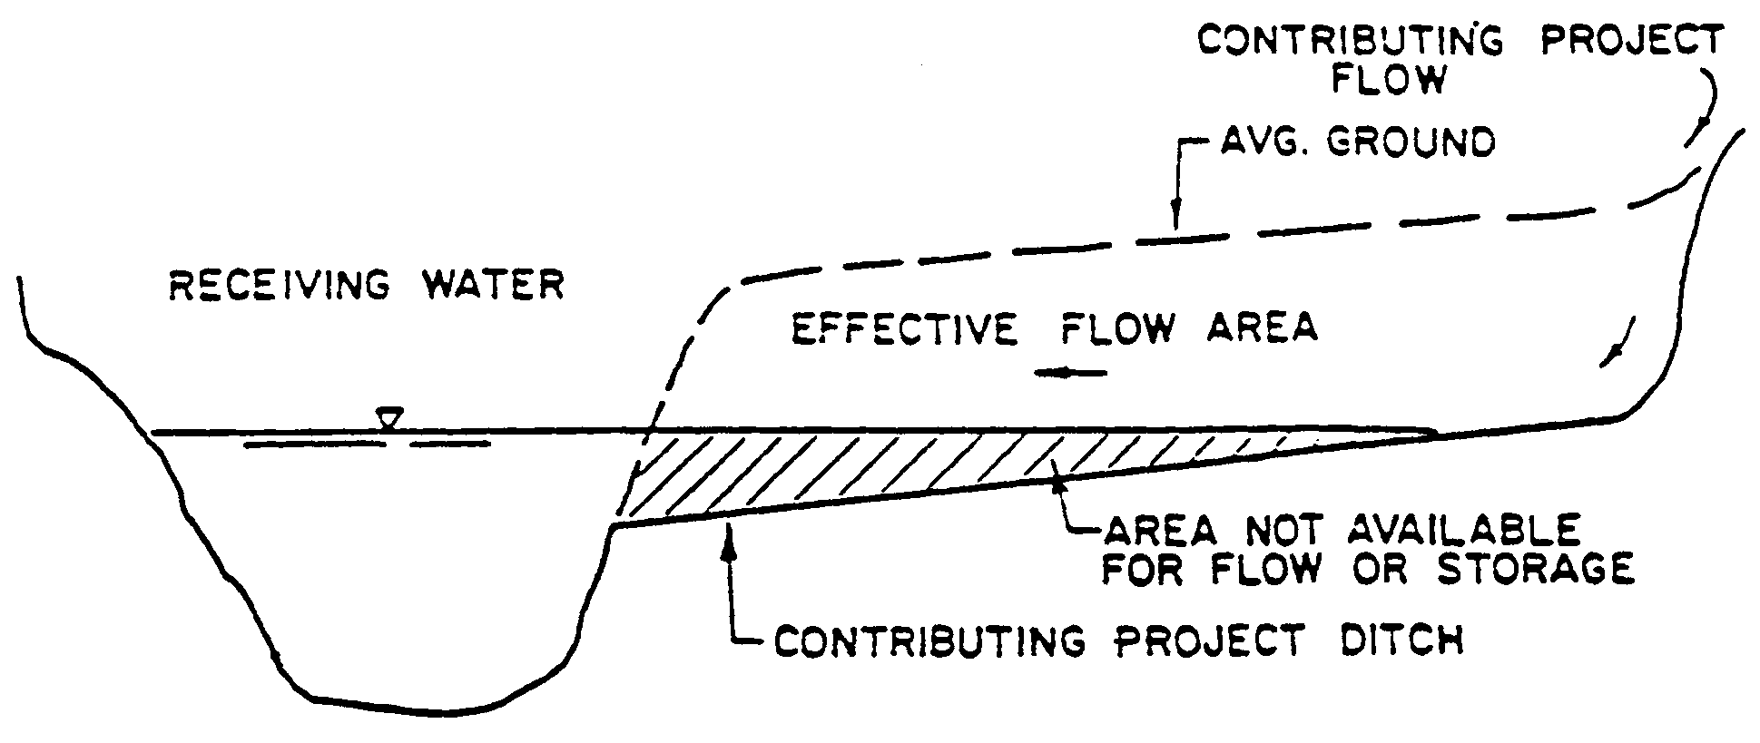
Figure 2.7.2-1

The stage in the receiving water should be considered to be the maximum stage which would exist in the receiving water from a storm equal to the project design storm. Lower stages may be used if the applicant can show that the flow from his project will reach the receiving water prior to the time of maximum stage in the receiving water.

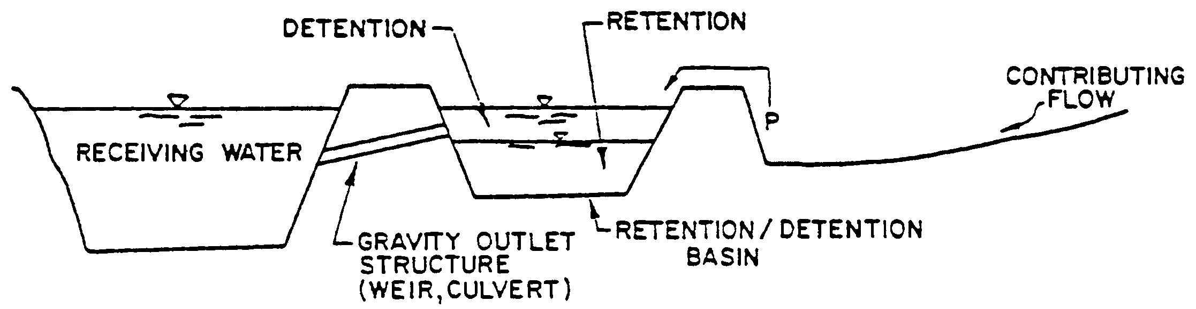

Figure 2.7.2-2

2.8 Applicant Responsibility

Except as provided in Part VII of this Volume, the applicant:

(a) must provide for an operation and maintenance entity as required in Part V of Applicant’s Handbook Volume I.

(b) is responsible for converting the permit from the construction phase to the operation and maintenance phase, as required in Rule 62-330.310 and section 6.1.4 of Applicant’s Handbook Volume I.

(c) is responsible for notifying the Agency of any transfer of permit,
ownership, or sale, including applying to the Agency for transfer of ownership using Form 62-330.340(1) within 30 days of such transfer (Rule 62-330.340, F.A.C.)

2.9 Operation and Maintenance

Except as provided in Part VII of this Volume, all systems under this Volume must be transferred to an operation and maintenance entity as provided in Rule 62-330.340, F.A.C. and Part V of Applicant’s Volume I.

2.10 Retrofits of Existing Surface Water Management Systems

(a) A stormwater retrofit project is typically proposed by a county, municipality, state agency, or water management district to provide new or additional treatment or attenuation capacity, or improved flood control to an existing stormwater management system or systems. Stormwater retrofit projects shall not be proposed or implemented for the purpose of providing the water quality treatment or flood control needed to serve new development or redevelopment.

Example components of stormwater retrofit projects are:

1. Construction or alteration that will add additional treatment or attenuation capacity and capability to an existing stormwater management system;

2. Modification, reconstruction, or relocation of an existing stormwater management system or stormwater discharge facility;

3. Stabilization of eroding banks through measures such as adding attenuation capacity to reduce flow velocities, planting of sod or other vegetation, and installation of rip rap boulders;

4. Excavation or dredging of sediments or other pollutants that have accumulated as a result of stormwater runoff and stormwater discharges.

(b) Stormwater Quality Retrofits

1. The applicant for a stormwater quality retrofit project must provide reasonable assurance that the retrofit project itself will, at a minimum provide additional water quality treatment such that there is a net reduction of the stormwater pollutant loading into receiving waters. Examples are:

(a) Addition of treatment capacity to an existing stormwater management system such that it reduces stormwater pollutant loadings to receiving waters;

(b) Adding treatment or attenuation capability to an existing developed area when either the existing stormwater management system or the developed area has substandard stormwater treatment and attenuation capabilities, compared to what would be required for a new system requiring a permit under Part IV of Chapter 373, F.S.; or

(c) Removing pollutants generated by, or resulting from, previous stormwater discharges.

2. If the applicant has conducted, and the Agency has approved, an analysis that provides reasonable assurance that the proposed stormwater quality retrofit will provide the intended pollutant load reduction from the existing system or systems, the project will be presumed to comply with the requirements in sections 4.0 through 4.5 of this Volume.

3. The pollutants of concern will be determined on a case-by-case basis during the permit application review based upon factors such as the type and intensity of land use, existing water quality data within the area subject to the retrofit, and the degree of impairment or water quality violations in the receiving waters.

(c) Stormwater Quantity (Flood Control) Retrofits

The applicant for a stormwater quantity retrofit project must provide reasonable assurance that the retrofit project will reduce existing flooding problems in such a way that it does not cause any of the following:

1. A net reduction in water quality treatment provided by the existing stormwater management system or systems;

2. Increased discharges of untreated stormwater entering adjacent or receiving waters;

If the applicant has conducted, and the Agency has approved, an analysis that provides reasonable assurance that the stormwater quantity retrofit project will comply with the above, the project will be presumed to comply with the requirements in sections 3.1 through 3.3 of this Volume.

(d) The applicant for any stormwater retrofit project must design, implement, and operate the project so that it:

1. Will not cause or contribute to a water quality violation;

2. Does not reduce stormwater treatment capacity or increase discharges of untreated stormwater. Where existing ambient water quality does not meet water quality standards the applicant must demonstrate that the proposed activities will not cause or contribute to a water quality violation. If the proposed activities will contribute to the existing violation, measures shall be proposed that will provide a net improvement of the water quality in the receiving waters for those parameters that do not meet standards.

3. Does not cause any adverse water quality impacts in receiving waters; or

4. Will not cause or contribute to increased flooding of adjacent lands or cause new adverse water quantity impacts to receiving waters.

2.11 Flexibility for State Transportation Projects and Facilities

With regard to state linear transportation projects and facilities, the District shall be governed by subsection 373.413(6), F.S. (2012).

