PART IV – STORMWATER QUALITY

4.0 Criterion

Under 62-330.301, F.A.C., an applicant must provide reasonable assurance that the construction, alteration, operation, maintenance, removal or abandonment of a project will not adversely affect the quality of receiving waters such that the water quality standards set forth in Chapters 62-4, 62-302, 62-520, and 62-550, F.A.C., will be violated.

4.1 State Water Quality Standards

State water quality standards are established by DEP and are set forth in chapters 62-4, 62-302, 62-520 and 62-550, F.A.C. Surface and ground water discharges from stormwater management systems, works, and other projects may not cause or contribute to a violation of state water quality standards.

4.1.1 Surface Water Quality Standards

State water quality standards for surface waters are contained in chapters 62-4 and 62-302, F.A.C. The standards apply at the point of mixing of discharge from the system with waters of the state.

4.1.2 Ground Water Quality Standards

State water quality standards for ground water are set forth in chapter 62-520, F.A.C. In addition to the minimum criteria, Class G-I and G-II ground water must meet primary and secondary drinking water quality standards for public water systems established pursuant to the Florida Safe Drinking Water Act, which are listed in sections 62-550.310 and 62-550.320, F.A.C., (incorporated by reference in 40C-
4.091(1)(c)).

Only the minimum criteria apply within a zone of discharge, as determined in section 62-520.400, F.A.C., (incorporated by reference in 40C-4.091(1)(c)). A zone of discharge is defined as a volume underlying or surrounding the site and extending to the base of a specifically designated aquifer or aquifers, within which an opportunity for the treatment, mixture or dispersion of wastes into receiving ground water is afforded. Generally, stormwater systems have a zone of discharge 100 feet from the system boundary or to the project's property boundary, whichever is less.
4.1.3 How Standards May be Met
A showing by the applicant that a project complies with the applicable criteria in Parts II, IV, V and subsection 13.3.1 and sections 13.6 through 13.7 of this Volume and in Part IV of Volume I shall create a rebuttable presumption that the applicant has provided reasonable assurance that the proposed project meets the requirements in subsection 2.0(e) and 62-330.301(1)(e), F.A.C.

4.2 Erosion and Sediment Control Criteria for Stormwater Management Systems,
Works and other Projects

Land clearing actions, including the construction of stormwater management systems or works, shall be designed, constructed, and maintained at all times so that erosion and sedimentation from the system, including the areas served by the system, do not cause or contribute to violations of applicable water quality standards in receiving waters. Further, because sedimentation of off-site lands can lead to public safety concerns, erosion and sediment controls shall be designed and implemented to retain sediment on-site. In particular, the erosion and sediment control requirements described in Part IV of Applicant’s Handbook Volume I shall be followed during construction of the system.

4.3 Oil and Grease Control

Systems which receive stormwater from areas with a greater than 50 percent impervious area (excluding water bodies) or which are a potential source of oil and grease (e.g., gasoline station) must include a baffle, skimmer, grease trap or other mechanism suitable for preventing oil and grease from leaving the stormwater system in concentrations that would cause a violation of water quality standards. A typical illustration of a skimmer on an outlet structure is shown in Figure 4-1.

Figure 4-1. Oil skimmer detail for a typical outfall structure (N.T.S.)
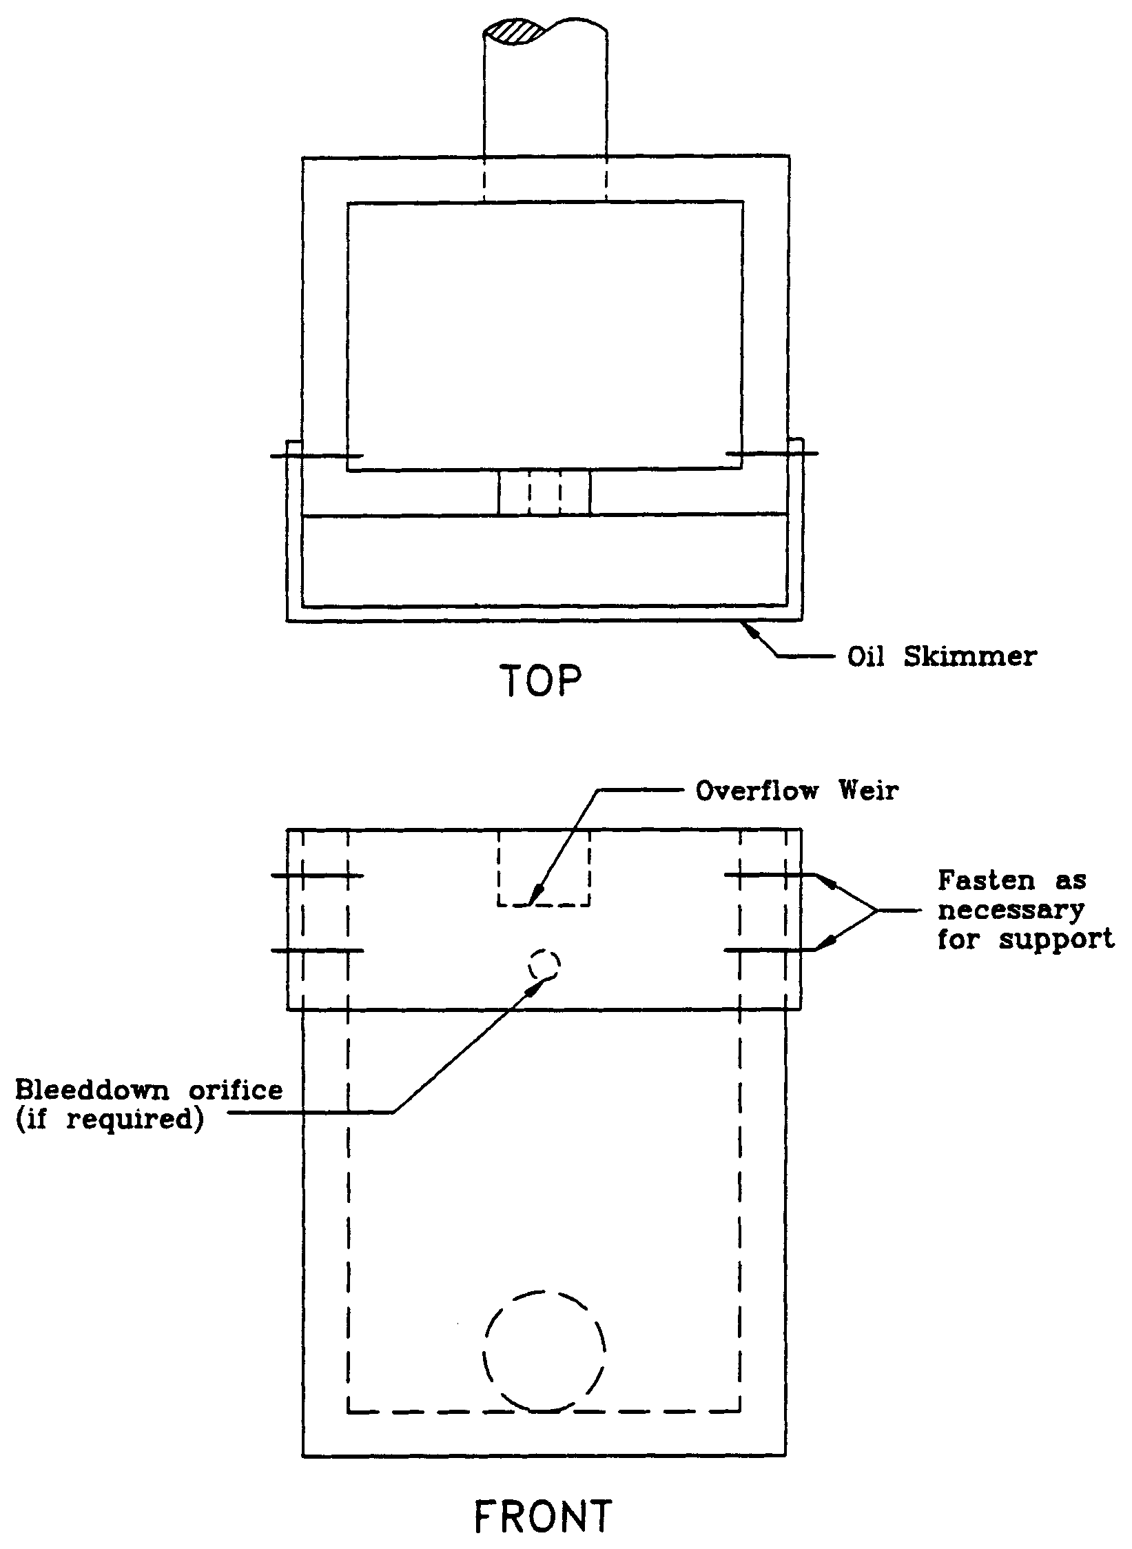

4.4 On-Line and Off-line Stormwater Systems

Pollutants in stormwater runoff from urbanized areas generally exhibit the "first flush" effect. This is the phenomenon where the concentrations of pollutants in stormwater runoff are highest during the early part of the storm with concentrations declining as the runoff continues. Substantial reductions in pollutant loads will occur when this first flush is captured and treated. Therefore, each Best Management Practice (BMP) specifies a required volume of stormwater runoff to be captured and treated (i.e., treatment volume) prior to release to surface or ground water.

There are two basic types of configurations for capturing the treatment volume: on-line and off-line systems. On-line systems (Figure 4-2) consist of a storage area which provides storage of the required treatment volume for smaller storm events and, if required, temporary detention storage for peak discharge control during larger storm events. Runoff volumes in excess of the treatment volume mix with the treatment volume in the basin and transport a portion of the pollutant mass load over the basin control structure.

Off-line treatment systems (Figure 4-3) divert the treatment volume into a basin which is designed for storage and treatment of the applicable treatment volume. Runoff volumes in excess of the treatment volume by-pass the off-line basin and are discharged to the receiving water or routed to a detention basin if peak discharge attenuation is required. A diversion box (Figure 4-4) may be utilized to divert the treatment volume to the off-line basin and route subsequent flows away from the off-line basin.

Off-line systems are generally more effective at removing pollutants than on-line systems because accumulated pollutants cannot be "flushed out" during storm events that produce runoff volumes exceeding the treatment storage volume. Consequently, on-line systems must treat a greater volume of runoff than off-line systems to reduce the likelihood of flushing accumulated pollutants out of the system and achieve the pollutant removal goals required by the Water Resource Implementation Rule (chapter 62-40, F.A.C.). Treatment volumes for each of the stormwater treatment practices described in this Volume are discussed in sections 5.0 through 12.9 of Part V of this Volume.

The treatment storage provided in an off-line system can be considered in the stage/storage calculations for peak discharge attenuation. Off-line systems should be designed to bypass essentially all additional stormwater runoff volumes greater than the treatment volume to a discharge point or other detention storage area. Of course, there will be some incremental additional storage in the off-line system associated with the hydraulic grade line at the weir structure in the typical diversion structure. This will depend on the size of the weir, but the weir should be sized to pass the design flow with minimal headwater.

Proposed off-line systems which will also serve to provide significant detention storage above the off-line treatment volume storage will be considered to function as on-line systems. These systems should either be designed to meet on-line treatment volume requirements or the designer should discuss the merits of the particular system (in terms of potential of flushing accumulated pollutants) with District staff in a pre-application conference.

4.5 Hazardous or Toxic Substances

Systems serving a use that produces or stores hazardous or toxic substances shall be designed to have no stormwater discharge that contains such substances.

Figure 4-2. On-line treatment system

Figure 4-3. Off-line treatment system

Figure 4-4. Diversion box (N.T.S.)

