PART V – BEST MANAGEMENT PRACTICES

5.0 Retention System Design and Performance Criteria

5.1 Description

Retention system is defined as a storage area designed to store a defined quantity of runoff, allowing it to percolate through permeable soils into the shallow ground water aquifer. Stormwater retention works best using a variety of retention systems throughout the project site. Examples of retention systems include:

- Man-made or natural depressional areas where the floor is graded as flat as possible and turf is established to promote infiltration and stabilize the basin slopes (see Figure 5-1)

- Shallow landscaped areas designed to store stormwater

- Vegetated swales with swale blocks or raised inlets

- Pervious concrete with continuous curb

Soil permeability and water table conditions must be such that the retention system can percolate the desired runoff volume within a specified time following a storm event. After drawdown has been completed, the basin does not hold any water, thus the system is normally "dry." Unlike detention basins, the treatment volume for retention systems is not discharged to surface waters.

Retention systems should not be located in close proximity to drinking water supply wells. Chapter 62-555, F.A.C., requires stormwater treatment facilities to be at least 100 feet from any public supply well. Chapter 40C-41, F.A.C., provides additional design features for systems constructed in Sensitive Karst Areas of the District where the drinking water aquifer is close to the land surface (see section 13.6).

Besides pollution control, retention systems can be utilized to promote the recharge of ground water to prevent saltwater intrusion in coastal areas or to maintain groundwater levels in aquifer recharge areas. Chapter 40C-41, F.A.C., contains recharge criteria for the Wekiva Recharge Protection Basin and the Tomoka River and Spruce Creek Hydrologic Basins (see sections 13.3.1 and 13.5.1). Retention systems can also be used to meet the runoff volume criteria for projects which discharge to land-locked lakes (see section 3.2 of this Volume).

There are several design and performance criteria specific to retention systems which are described below.

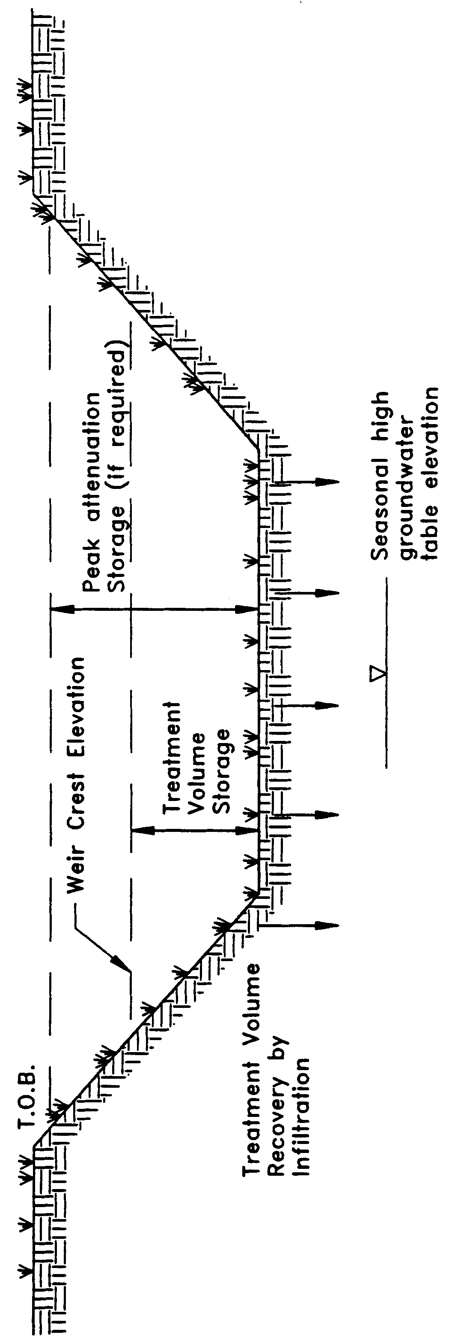

Figure 5-1. Retention (N.T.S.)

5.2 Treatment Volume

The first flush of runoff should be routed to the retention basin and percolated into the ground. Retention systems that discharge to Class III receiving water bodies shall provide for one of the following:

(a) Off-line retention of the first one-half inch of runoff or 1.25 inches of runoff from the impervious area, whichever is greater.

(b) On-line retention of an additional one half inch of runoff from the drainage area over that volume specified for off-line treatment.

(c) On-line retention that provides for percolation of the runoff from the three year, one-hour storm.

(d) On-line retention of the runoff from one inch of rainfall or 1.25 inches of runoff from the impervious area, whichever is greater, for systems which serve an area with less than 40 percent impervious surface and that contain only U.S. Department of Agriculture Natural Resources Conservation Service (SCS) hydrologic group "A" soils.

For direct discharges to Class I, Class II, OFWs, or Class III waters which are approved, conditionally approved, restricted, or conditionally restricted for shellfish harvesting the applicant shall provide retention for one of the following:

(a) At least an additional fifty percent of the applicable treatment volume specified for off-line retention in (a), above. Off-line retention must be provided for at least the first one-half inch of runoff or 1.25 inches of runoff from the impervious area, whichever is greater, of the total amount of runoff required to be treated.

(b) On-line retention of an additional fifty percent of the treatment volume specified in (b), above.

(c) On-line retention of the runoff from the three-year, one-hour storm.

(d) On-line retention that provides at least an additional 50 percent of the runoff volume specified in (d), above, for systems which serve an area with less that 40 percent impervious surface and that contain only U.S. Department of Agriculture Natural Resources Conservation Service (SCS) hydrologic group "A" soils.

5.3 Recovery Time

The retention system must provide the capacity for the appropriate treatment volume of stormwater specified in section 5.2 within 72 hours following a storm event assuming average antecedent moisture conditions. In retention systems, the stormwater is drawn down by natural soil infiltration and dissipation into the ground water table, evaporation, or evapotranspiration, as opposed to underdrain systems which rely on artificial methods like drainage pipes.

Antecedent moisture condition (AMC) refers to the amount of moisture and storage in the soil profile prior to a storm event. Antecedent soil moisture is an indicator of wetness and availability of soil to infiltrate water. The AMC can vary from dry to saturated depending on the amount of rainfall received prior to a given point in time. Therefore, "average AMC" means the soil is neither dry or saturated, but at an average moisture condition at the beginning of a storm event when calculating recovery time for retention systems.

The antecedent condition has a significant effect on runoff rate, runoff volume, infiltration rate, and infiltration volume. The infiltration volume is also known as the upper soil zone storage. Both the infiltration rate and upper soil zone storage are used to calculate the recovery time of retention systems and should be estimated using any generally accepted and well documented method with appropriate parameters to reflect drainage practices, seasonal high water table elevation, the AMC, and any underlying soil characteristics which would limit or prevent percolation of storm water into the soil column.

5.4 Basin Stabilization

The retention basin should be stabilized with pervious material or permanent vegetative cover. To provide proper treatment of the runoff in very permeable soils, permanent vegetative cover must be utilized when U.S. Department of Agriculture Natural Resources Conservation Service (SCS) hydrologic group "A" soils underlie the retention basin, except for pervious pavement systems.

5.5 Retention Basin Construction

5.5.1 Overview

Retention basin construction procedures and the overall sequence of site construction are two key factors that can control the effectiveness of retention basins. Sub-standard construction methods or construction sequence can render the basin inoperable prior to completion of site development.

5.5.2 Construction Requirements

The following construction procedures are recommended to avoid degradation of retention basin infiltration capacity due to construction practices (Andreyev and Wiseman 1989):

(a) Initially construct the retention basin to rough grade by under-excavating the basin bottom and sides by approximately 12 inches.

(b) After the drainage area contributing to the basin has been fully stabilized, the interior side slopes and basin bottom should be excavated to final design specifications. The excess soil and undesirable material should be carefully excavated and removed from the pond so that all accumulated silts, clays, organics, and other fine sediment material has been removed from the pond area. The excavated material should be disposed of beyond the limits of the drainage area of the basin.

(c) Once the basin has been excavated to final grade, the entire basin bottom should be deep raked and loosened for optimal infiltration.

(d) Finally, the basin should be stabilized according the section 5.4, above.

5.6 References

Andreyev, N.E., and L.P. Wiseman. 1989. Stormwater Retention Pond Infiltration Analysis in Unconfined Aquifers. Prepared for Southwest Florida Water Management District, Brooksville, Florida.
6.0 Underdrain Design and Performance Criteria

6.1 Description

Stormwater underdrain systems consist of a dry basin underlain with perforated drainage pipe which collects and conveys stormwater following percolation from the basin through suitable soil. Underdrain systems are generally used where high water table conditions dictate that recovery of the stormwater treatment volume cannot be achieved by natural percolation (i.e, retention systems) and suitable outfall conditions exist to convey flows from the underdrain system to receiving waters. Schematics of a typical underdrain system are shown in Figures 6-1 and 6-2.

Underdrain systems are intended to control both the water table elevation over the entire area of the treatment basin and provide for the drawdown of the treatment volume. Underdrains are utilized where the soil permeability is adequate to recover the treatment volume since the on-site soils overlay the perforated drainage pipes.

There are several design and performance criteria which must be met in order for a underdrain system to meet the rule requirements. The underdrain rule criteria are described below.

6.2 Treatment Volume

The first flush of runoff should be detained in a dry detention basin and percolated through the soil. Dry detention systems that discharge to Class III receiving water bodies, shall provide for either of the following treatment volumes:

(a) Off-line retention of the first one-half inch of runoff or 1.25 inches of runoff from the impervious area, whichever is greater, or

(b) On-line retention of an additional one half inch of runoff from the drainage area over that volume specified for off-line treatment.

For direct discharges to Class I, Class II, OFWs, or Class III waters which are approved, conditionally approved, restricted, or conditionally restricted for shellfish harvesting the applicant shall provide retention for either of the following:

(a) At least an additional fifty percent of the applicable treatment volume specified for off-line retention in (a), above. Off-line retention must be provided for at least the first one-half inch of runoff or 1.25 inches of runoff from the impervious area, whichever is greater, of the total amount of runoff required to be treated.

(b) On-line retention of the runoff from the three-year, one-hour storm or an additional fifty percent of the treatment volume specified in (b), above, whichever is greater.

6.3 Recovery Time

The system should be designed to provide for the drawdown of the appropriate treatment volume specified in section 6.2 within 72 hours following a storm event. The treatment volume is recovered by percolation through the soil with subsequent transport through the underdrain pipes. The system should only contain standing water within 72 hours of a storm event.

The pipe system configuration (e.g., pipe size, depth, pipe spacing, and pipe inflow capacity) of the underdrain system must be designed to achieve the recovery time requirement.

6.4 Safety Factor

The underdrain system must be designed with a safety factor of at least two unless the applicant affirmatively demonstrates based on plans, test results, calculations or other information that a lower safety factor is appropriate for the specific site conditions. Examples of how to apply this factor include but are not limited to the following:

(a) Reducing the design percolation rate by half

(b) Designing for the required drawdown within 36 hours instead of 72 hours.

6.5 Underdrain Media

To provide proper treatment of the runoff, at least two feet of indigenous soil must be between the bottom of the basin storing the treatment volume and the outside of the underdrain pipes (or gravel envelope as applicable).

6.6 Filter Fabric

Underdrain systems shall utilize filter fabric or other means to prevent the soil from moving into and clogging perforated pipe.

6.7 Inspection and Cleanout Ports

To facilitate maintenance of the underdrain system, capped and sealed inspection and cleanout ports which extend to the surface of the ground should be provided, at a minimum, at the following locations for each drainage pipe:

(a) The terminus

(b) At every 400 feet or every bend of 45 or more degrees, whichever is shorter.

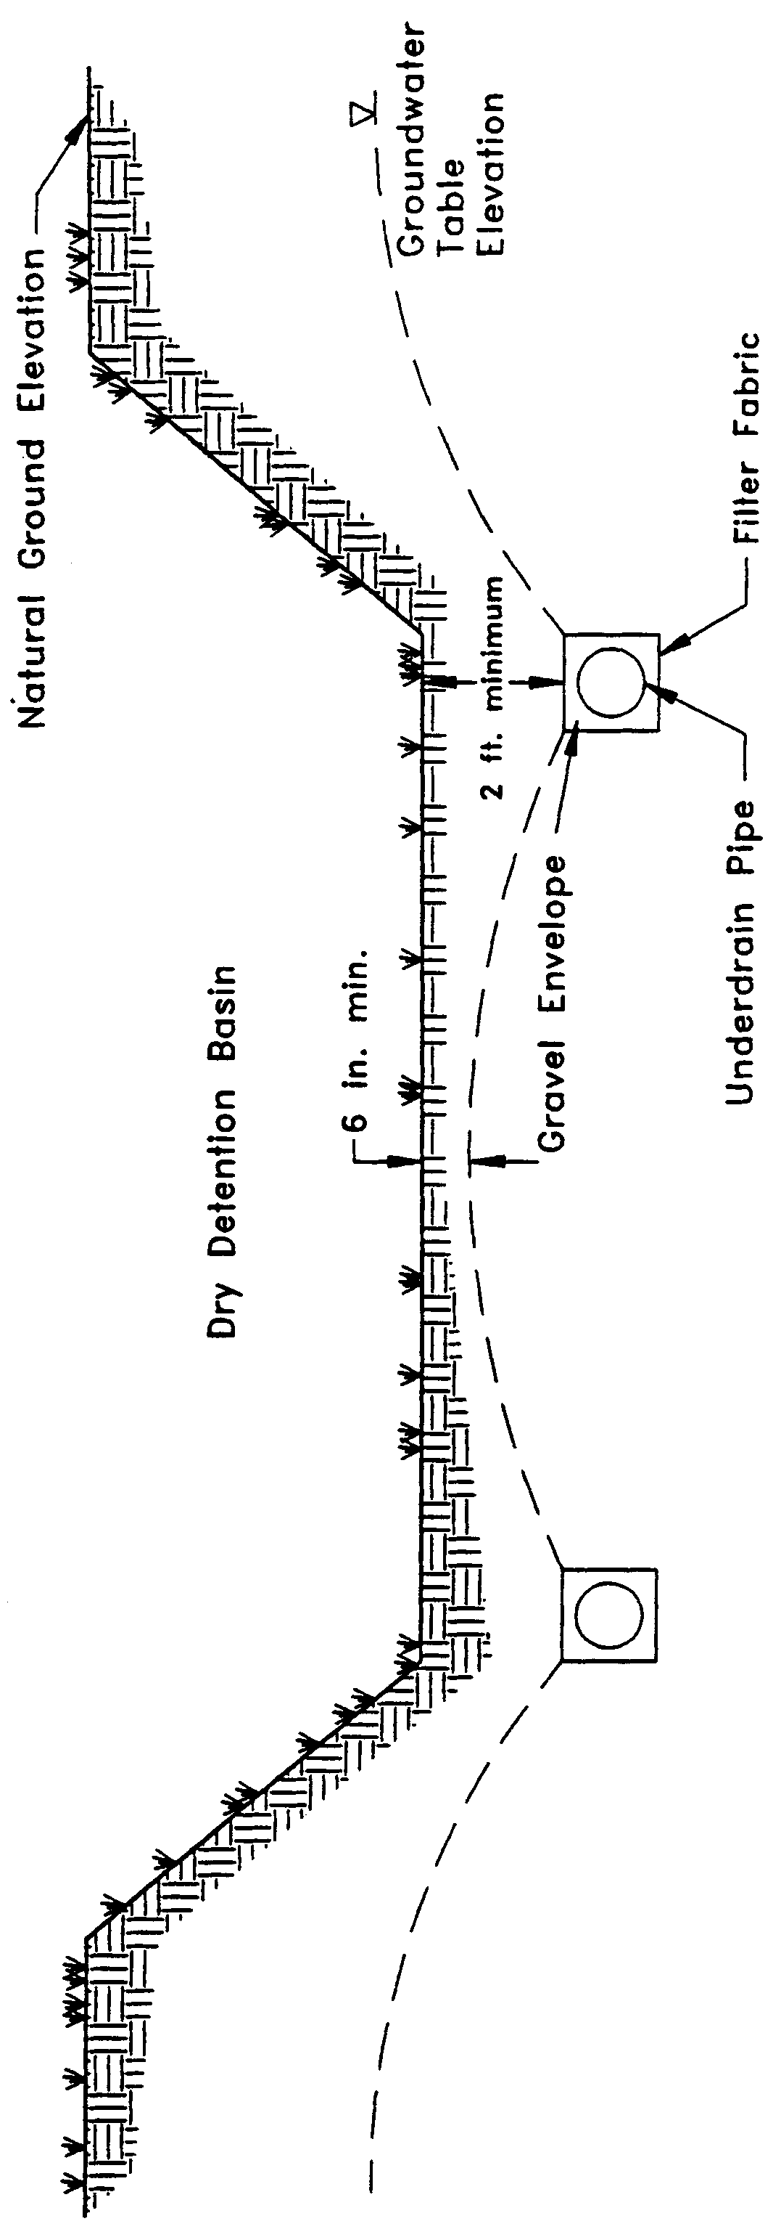

Figure 6-1. Cross-section of underdrain system (N.T.S.)

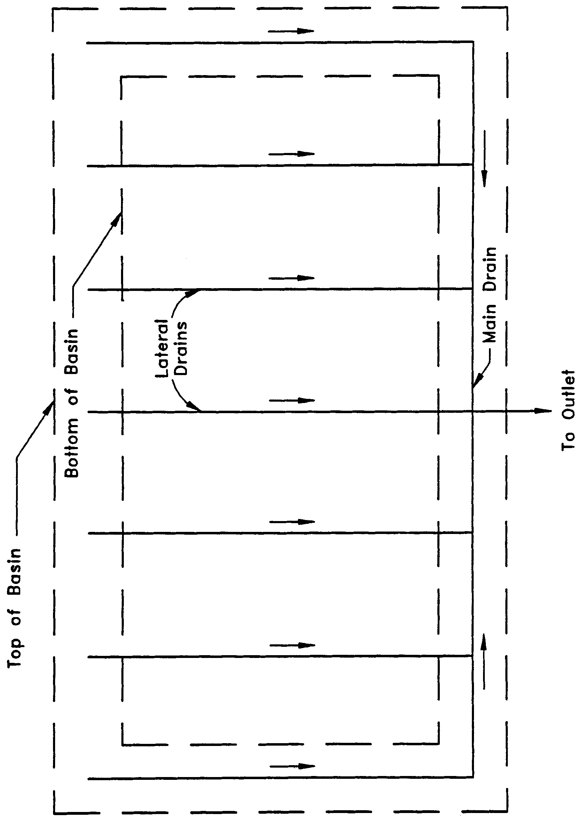

Figure 6-2. Top view of underdrain system (N.T.S.)

6.8 Basin Stabilization

The underdrain basin shall be stabilized with permanent vegetative cover and should contain standing water only immediately following a rainfall event.

6.9 References

Livingston, E.H., E. McCarron, J. Cox, P. Sanzone. 1988. The Florida Land Development Manual: A Guide to Sound Land and Water Management. Florida Department of Environmental Regulation, Nonpoint Source Management Section, Tallahassee, Florida.
7.0 Exfiltration Trench Design and Performance Criteria

7.1 Description

Exfiltration trench is a subsurface system consisting of a conduit such as perforated pipe surrounded by natural or artificial aggregate which temporarily stores and infiltrates stormwater runoff (Figure 7-1). Stormwater passes through the perforated pipe and infiltrates through the trench walls and bottom into the shallow groundwater aquifer. The perforated pipe increases the storage available in the trench and helps promote infiltration by making delivery of the runoff more effective and evenly distributed over the length of the system (Livingston et al. 1988). Generally, exfiltration trench systems are utilized where space is limited and/or land costs are high (i.e., downtown urban areas).

Soil permeability and water table conditions must be such that the trench system can percolate the required stormwater runoff treatment volume within a specified time following a storm event. The trench system is returned to a normally "dry" condition when drawdown of the treatment volume is completed. Like retention basins, the treatment volume in exfiltration trench systems is not discharged to surface waters. Thus, exfiltration is considered a type of retention system.

Exfiltration trench systems should not be located in close proximity to drinking water supply wells. Chapter 62-555, F.A.C., requires stormwater treatment systems to be at least 100 feet from any public supply well. Chapter 40C-41, F.A.C., provides additional design features for systems constructed in Sensitive Karst Areas of the District where the drinking water aquifer is close to the land surface (see section 13.6).

Besides pollution control, exfiltration trench systems can be utilized to promote the recharge of ground water and to prevent saltwater intrusion in coastal areas, or to maintain groundwater levels in aquifer recharge areas. Chapter 40C-41, F.A.C., contains recharge criteria for the Wekiva Recharge Protection Basin and the Tomoka River and Spruce Creek Hydrologic Basins (see sections 13.3.1 and 13.5.1). Exfiltration trench systems can also be used to meet the runoff volume criteria for projects which discharge to land-locked lakes (see section 3.2.1 of this Volume).

The operational life of an exfiltration trench is believed to be short (possibly 5 to 10 years) for most exfiltration systems. Sediment accumulation and clogging by fines can reduce the life of an exfiltration trench (Wanielista et al. 1991). Total replacement of the trench may be the only possible means of restoring the treatment capacity and recovery of the system. Periodic replacement of the trench should be considered routine operational maintenance when selecting this management practice.

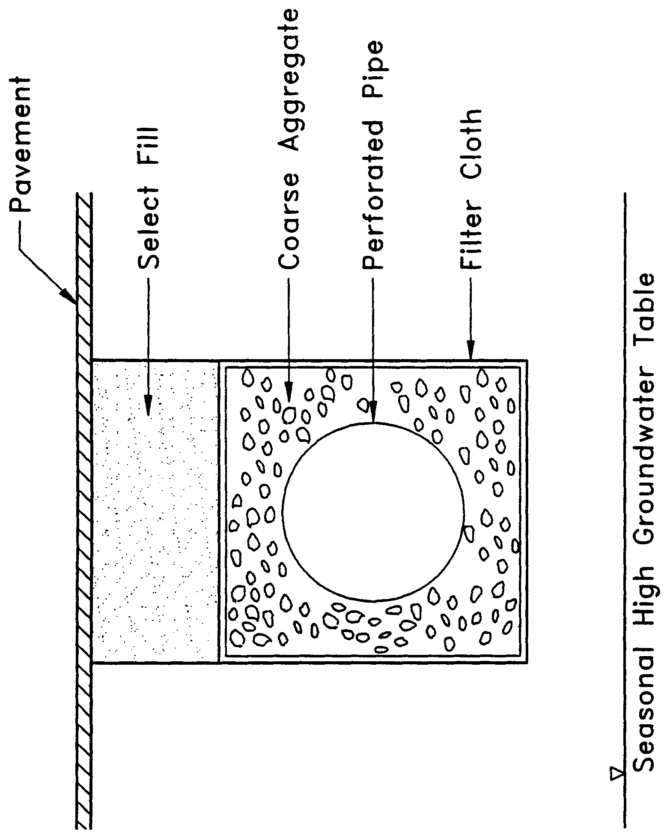

Figure 7-1. Cross-section of typical underground exfiltration trench (N.T.S.)

There are several design and performance criteria which must be met in order for an exfiltration trench system to meet the District’s requirements. A description of each criterion is presented below.

7.2 Treatment Volume

The first flush of runoff should be collected in the exfiltration trench and infiltrated into the surrounding soil. For systems which discharge to Class III receiving water bodies, the exfiltration trench shall provide either of the following:

(a) Off-line storage of the first one-half inch of runoff or 1.25 inches of runoff from the impervious area, whichever is greater.

(b) On-line storage of an additional one-half inch of runoff from the drainage area over that volume specified for off-line treatment.

For direct discharges to Class I, Class II, OFWs, or Class III waters which are approved, conditionally approved, restricted, or conditionally restricted for shellfish harvesting the applicant shall provide storage for either of the following:

(a) At least an additional fifty percent of the applicable treatment volume specified for off-line storage in (a), above. Off-line storage must be provided for at least the first one-half inch of runoff or 1.25 inches of runoff from the impervious area, whichever is greater, of the total amount of runoff required to be treated.

(b) On-line storage of the runoff from the three-year, one-hour storm or an additional fifty percent of the treatment volume specified in (b), above, whichever is greater.

Exfiltration trench systems must be designed to have the capacity to retain the required treatment volume without considering discharges to ground or surface waters.

7.3 Recovery Time

The system must be designed to provide for the appropriate treatment volume of stormwater runoff specified in section 7.2 within 72 hours following a storm event assuming average antecedent moisture conditions. The stormwater is drawn down by infiltration into the soil.

Antecedent moisture condition (AMC) refers to the amount of moisture and storage in the soil profile prior to a storm event. Antecedent soil moisture is an indicator of wetness and availability of soil to infiltrate water. The AMC can vary from dry to saturated depending on the amount of rainfall received prior to a given point in time. Therefore, "average AMC" means the soil is neither dry or saturated, but at an average moisture condition at the beginning of a storm event when calculating recovery time for exfiltration systems.

The antecedent condition has a significant effect on runoff rate, runoff volume, infiltration rate, and infiltration volume. The infiltration volume is also known as the upper soil zone storage. Both the infiltration rate and upper soil zone storage are used to calculate the recovery time of retention systems and should be estimated using any generally accepted and well documented method with appropriate parameters to reflect drainage practices, seasonal high water table elevation, the AMC, and any underlying soil characteristics which would limit or prevent percolation of storm water into the soil column.

7.4 Safety Factor

The exfiltration trench system must be designed with a safety factor of at least two unless the applicant affirmatively demonstrates based on plans, test results, calculations or other information that a lower safety factor is appropriate for the specific site conditions. For example, two possible ways to apply this factor are:

(a) Reducing the design percolation rate by half

(b) Designing for the required drawdown within 36 hours instead of 72 hours

7.5 Minimum Dimensions

The perforated pipe shall be designed with a 12-inch minimum pipe diameter and a three (3)-foot minimum trench width. The perforated pipe should be located within the trench section to minimize the accumulation of sediment in the aggregate void storage and maximize the preservation of this storage for stormwater treatment. To meet this goal, it is recommended that the perforated pipe be located at or within 6 inches of the trench bottom. The maximum trench width will be limited by the rate at which stormwater can effectively fill the void storage within the trench.

7.6 Filter Fabric

Exfiltration trench systems shall be designed so that aggregate in the trench is enclosed in filter fabric. This serves to prevent migration of fine materials from the surrounding soil that could result in clogging of the trench. Wanielista et al. (1991) reports that woven fabric (Mirafi 700XG) performed better in mixed sand and silty soil than non-woven fabric (Mirafi 140N). On the other hand, the 140N had higher exfiltration rates in sandy soils than the woven fabric.

Filter fabric may also be utilized directly surrounding the perforated pipe. In this instance, sedimentation of particulates will occur in the perforated pipe. Consequently, the pipe is more prone to clogging and reductions in capacity will occur more often than usual. Livingston et al. (1988) points out that while this may seem unacceptable, the pipe may be cleaned relatively easy using high pressure hoses, vacuum systems, etc. On the other hand, designs without the fabric directly surrounding the perforated pipe require complete replacement when clogging occurs.

7.7 Inspection and Cleanout Structures

Inspection and cleanout structures which extend to the surface of the ground must be provided, at a minimum, at the inlet and terminus of each exfiltration pipe. Inlet structures should include sediment sumps. These inspection and cleanout structures provide three primary functions:

(a) Observation of how quickly the trench recovers following a storm

(b) Observation of how quickly the trench fills with sediment

(c) Maintenance access to the perforated pipe

(d) Sediment control (sumps)

Standard precast concrete inlets and manholes are widely used to furnish the inspection and cleanout access.

7.8 Ground Water Table

The exfiltration trench system must be designed so that the invert elevation of the trench is at least two feet above the seasonal high ground water table elevation unless the applicant affirmatively demonstrates based on plans, test results, calculations or other information that an alternative design is appropriate for the specific site conditions.

7.9 Construction

During construction, measures should be implemented to limit the parent soil and debris from entering the trench. Wanielista (1991) reports complete failure (no exfiltration) when a 1" to 2" thickness of parent soil and stormwater solids were added to an exfiltration trench. Applicants and system designers should consult Part IV of Volume I for information on erosion and sediment control. Any method used to reduce the amount of fines entering the exfiltration trench during construction will extend the life of the system (Wanielista et al. 1991). The use of an aggregate with minimal fines is also recommended (Wanielista et al. 1991).

7.10 Alternative Designs

Wanielista et al. (1991) describes an alternative procedure for designing exfiltration trenches based on long term mass balance of an exfiltration system utilizing local rainfall conditions. Fifteen years of hourly precipitation data from six regions in Florida were used as input for the mass balance. From these simulations, design curves for exfiltration systems were developed. These curves relate the rate at which stored runoff is removed from the trench to the volume of storage within the trench. These curves can be used to design an exfiltration trench based on diversion efficiencies of 50%, 60%, 70%, 80%, 85%, 90%, and 95%. In lieu of the requirements of section 7.2, the District accepts this methodology for those areas of the District (i.e., Jacksonville and Orlando) for which the curves have been developed. Applicants designing systems which discharge to Class III receiving waters shall use the 80% curve and those that direct discharge to Class I, Class II, and Outstanding Florida Waters shall utilize the 95% curve.

7.11 References

Livingston, E.H., E. McCarron, J. Cox, and P. Sanzone. 1988. The Florida Land Development Manual: A Guide to Sound Land and Water Management. Florida Department of Environmental Regulation, Nonpoint Source Management Section, Tallahassee, Florida.

Wanielista, M.P., M.J. Gauthier, and D.L. Evans. 1991. Design and Performance of Exfiltration Systems. Department of Civil and Environmental Engineering, University of Central Florida, Orlando, Florida.
8.0 Wet Detention Design and Performance Criteria

8.1 Description

These systems are permanently wet ponds which are designed to slowly release collected stormwater runoff through an outlet structure. A schematic of a typical wet detention system is shown in Figure 8-1.

There are several components in a wet detention system which must be properly designed to achieve the required level of stormwater treatment. A description of each design feature and its importance to the treatment process is presented below. The design and performance criteria for wet detention systems are discussed below.

8.2 Treatment Volume

For wet detention systems, the design treatment volume is the greater of the following:

(a) one inch of runoff over the drainage area

(b) 2.5 inches times the impervious area (excluding water bodies)

Additional treatment volume is required for systems which discharge directly to Class I, Class II, Outstanding Florida Waters, or Class III waters which are approved, conditionally approved, restricted, or conditionally restricted for shellfish harvesting (see section 8.13 of this Volume).

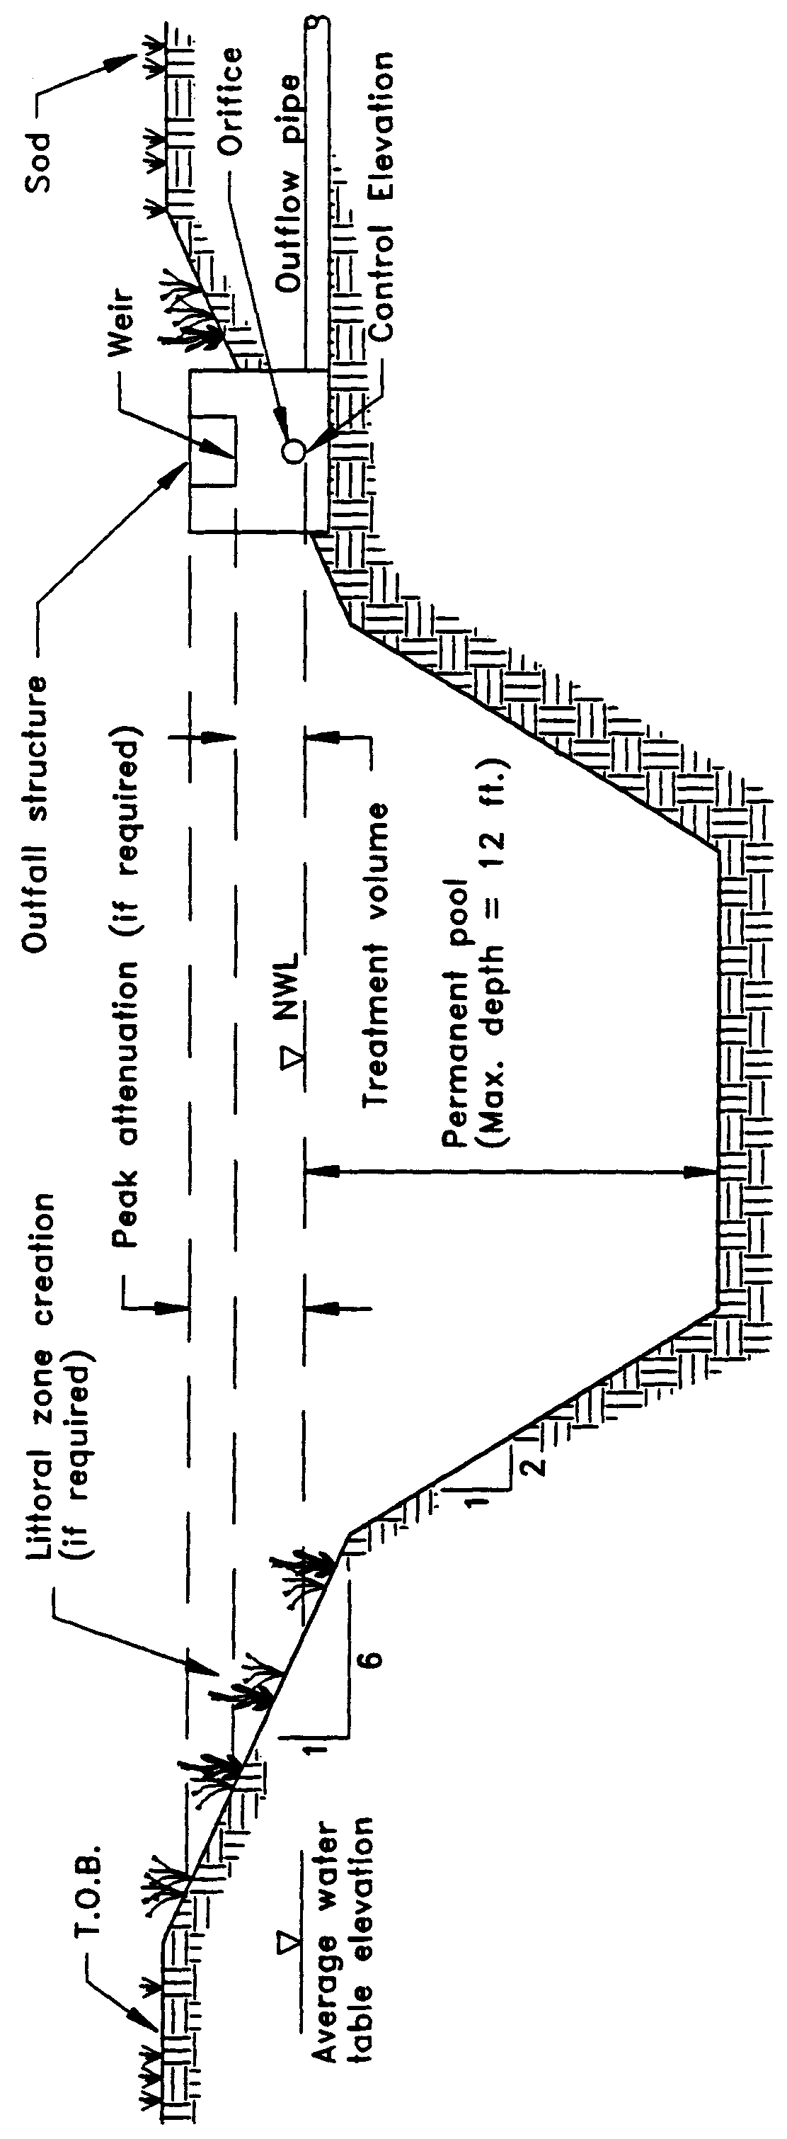

Figure 8-1. Wet detention (N.T.S.)

8.3 Recovery Time

The outfall structure shall be designed to drawdown one-half the required treatment volume within 24 and 30 hours following a storm event, but no more than one-half of this volume will be discharged within the first 24 hours.

8.4 Outlet Structure

The outlet structure generally includes a drawdown device (such as an orifice, "V" or square notch weir) set to establish a normal water control elevation and slowly release the treatment volume (see Figures 8-2 and 8-3 for schematics). The design of the outfall structure must also accommodate the passage of ground water baseflows and flows from upstream stormwater management systems (see Figure 8-4).

The control elevation shall be set at or above the design tailwater elevation so the pond can effectively recover the treatment storage. Also, drawdown devices smaller than 6 square inches of cross-section area that is 2 inches wide or less than 20 degrees for "V" notches shall include a device to eliminate clogging. Examples of such devices include baffles, grates, screens, and pipe elbows.

8.5 Permanent Pool

The permanent pool shall be sized to provide at least a 14-day average residence time during the wet season (June - October).

Additional permanent pool volume may be required for wet detention systems which directly discharge to Class I, Class II, or Outstanding Florida Waters (see section 8.13 of this Volume).

Figure 8-1. Wet detention (N.T.S.)

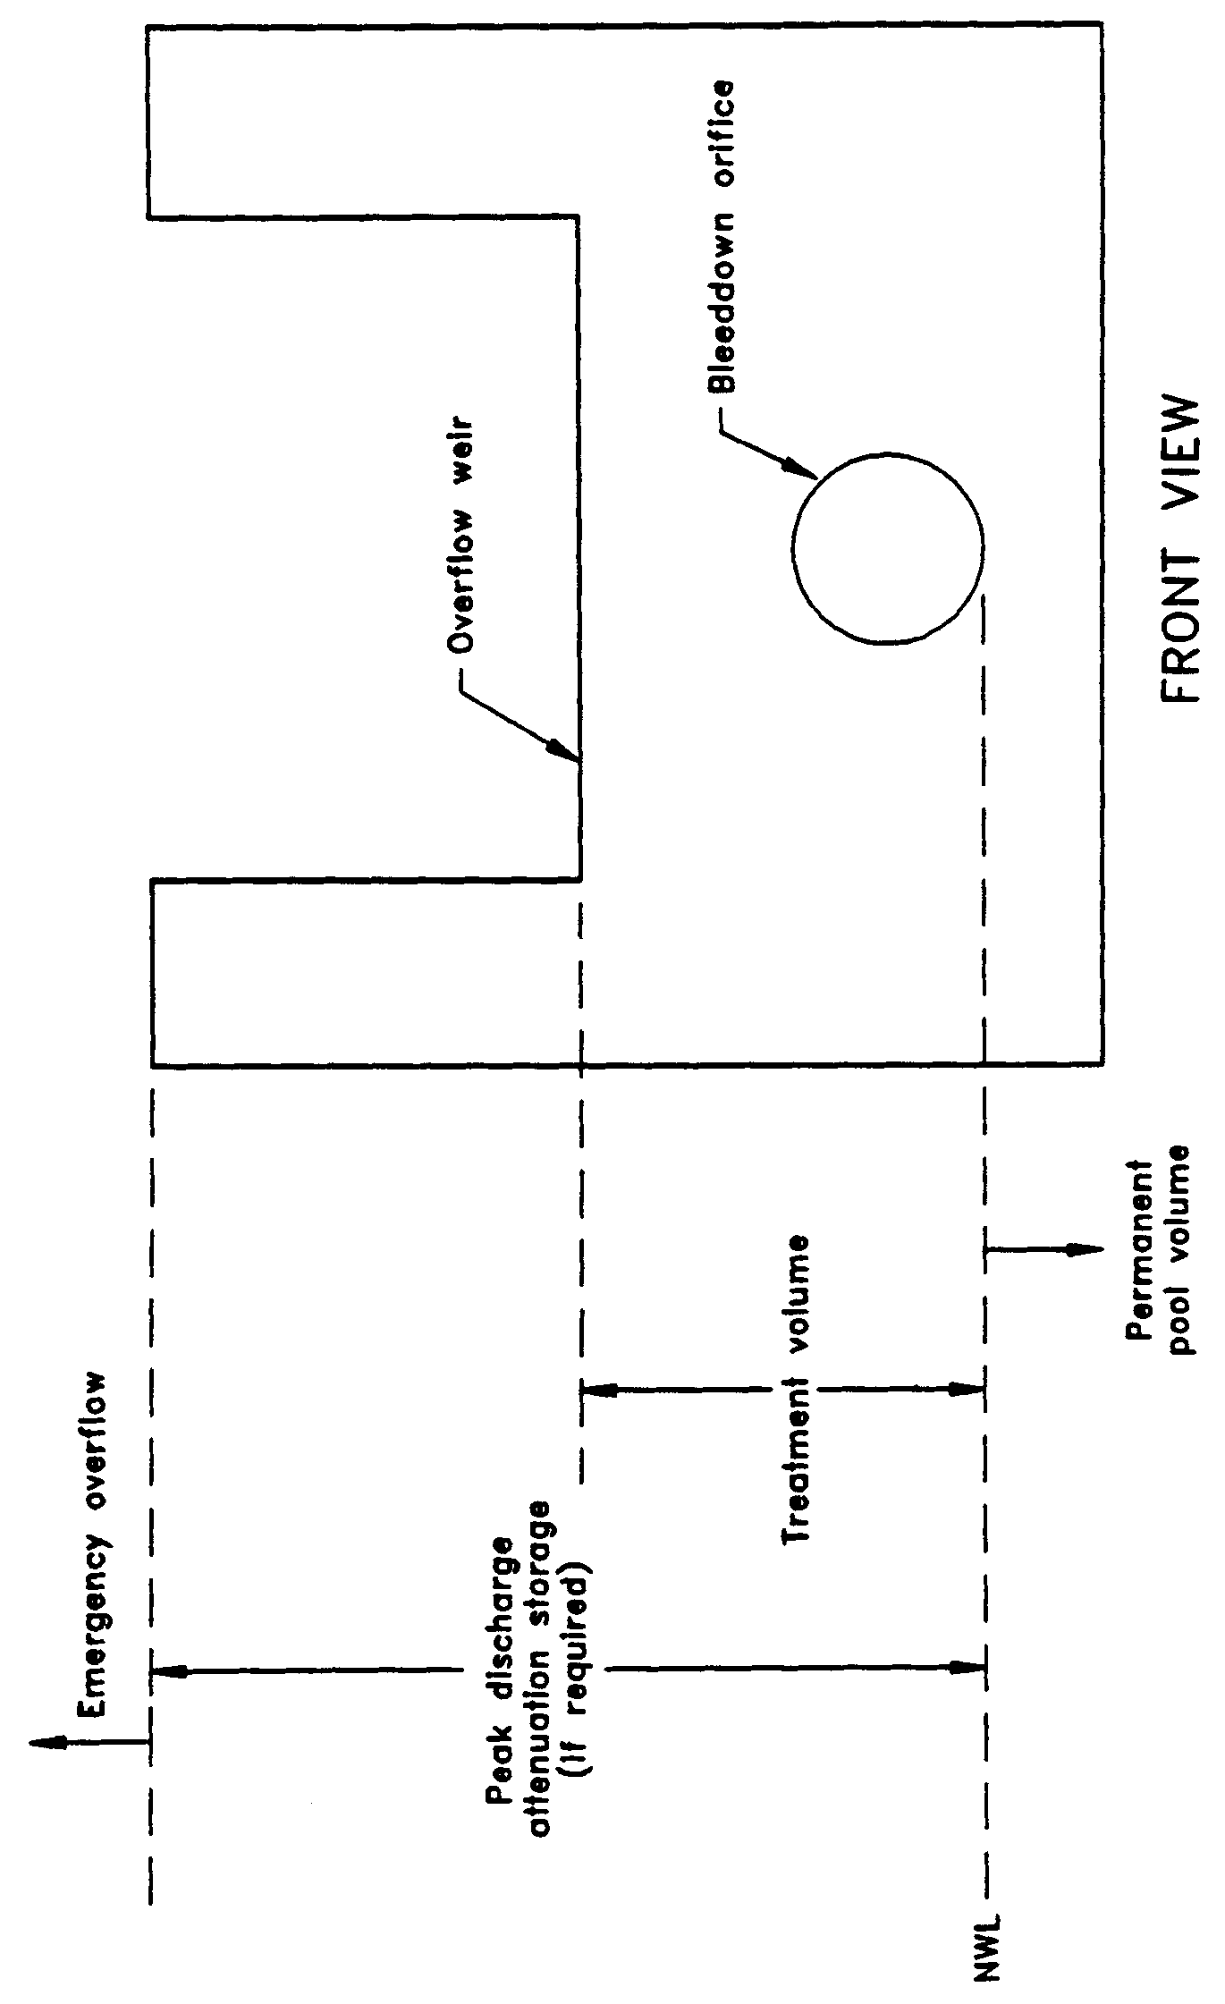

Figure 8-2. Typical wet detention outfall structure (N.T.S.)

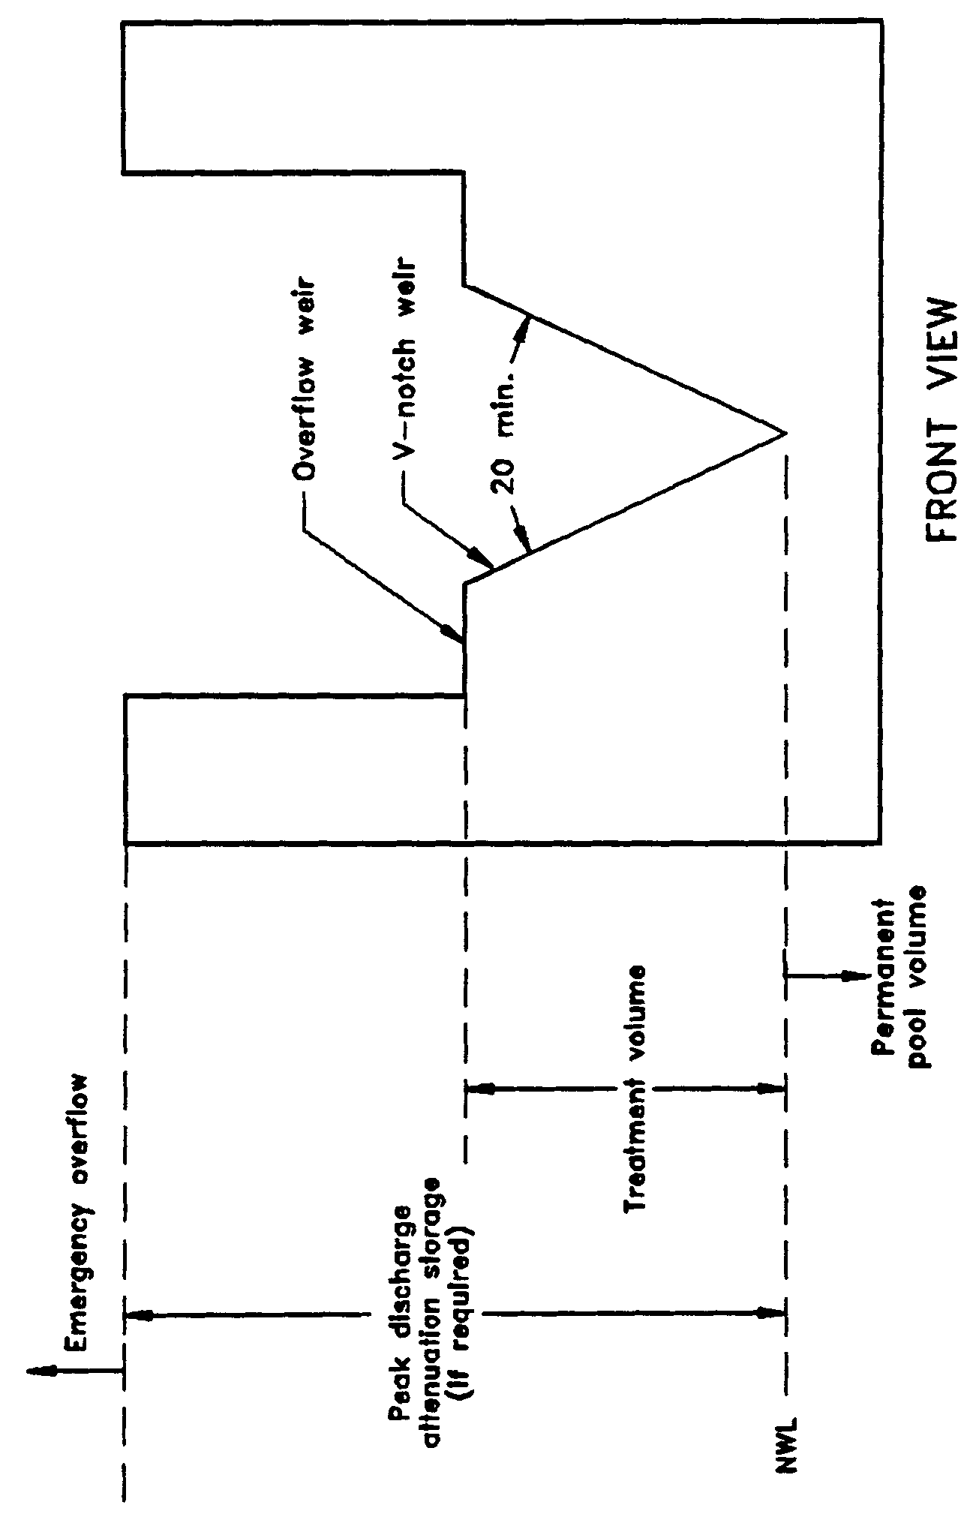

Figure 8-3. Typical wet detention outfall structure with "V"-notch weir (N.T.S.)

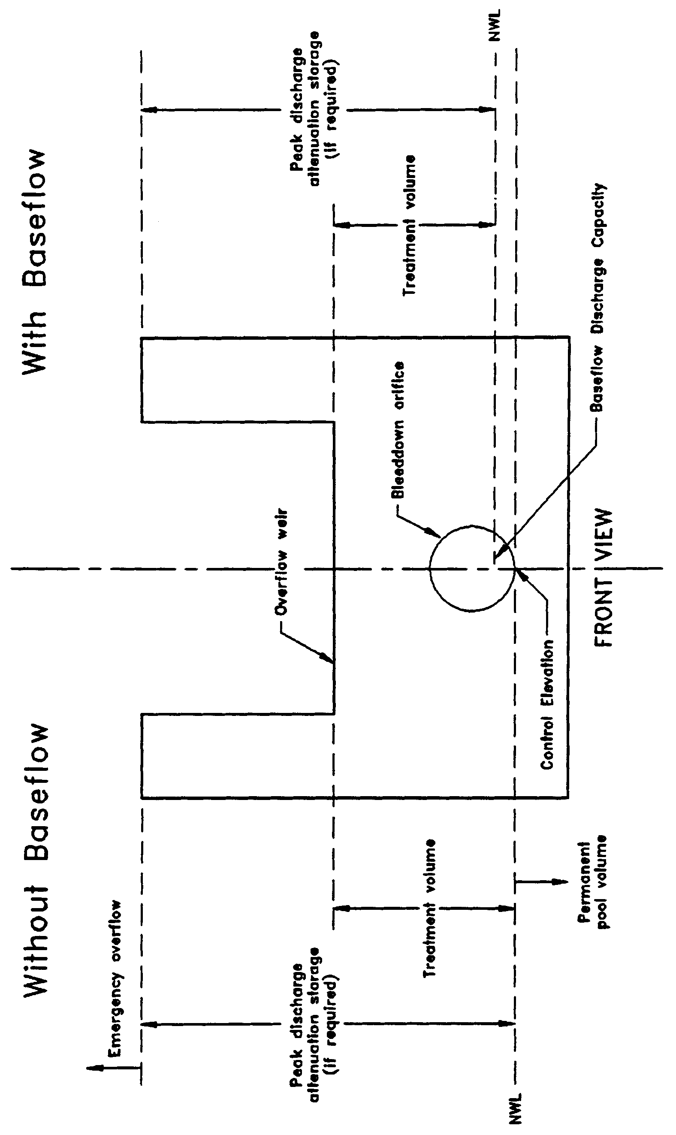
Figure 8-4. Typical wet detention outfall structure with and without baseflow conditions (N.T.S.)

8.6 Littoral Zone

The littoral zone is that portion of a wet detention pond which is designed to contain rooted aquatic plants. The littoral area is usually provided by extending and gently sloping the sides of the pond down to a depth of 2-3 feet below the normal water level or control elevation. Also, the littoral zone can be provided in other areas of the pond that have suitable depths (i.e., a shallow shelf in the middle of the lake).

The littoral zone is established with native aquatic plants by planting and/or the placement of wetland soils containing seeds of native aquatic plants. A specific vegetation establishment plan must be prepared for the littoral zone. The plan must consider the hydroperiod of the pond and the type of plants to be established. Livingston et al. (1988) has published a list of recommended native plant species suitable for littoral zone planting. In addition, a layer of muck can be incorporated into the littoral area to promote the establishment of the wetland vegetation. When placing muck, special precautions must be taken to prevent erosion and turbidity problems in the pond and at its discharge point while vegetation is becoming established in the littoral zone.

The following is a list of the design criteria for wet detention littoral zones:

(a) The littoral zone shall be gently sloped (6H:1V or flatter). At least 30 percent of the wet detention pond surface area shall consist of a littoral zone. The percentage of littoral zone is based on the ratio of vegetated littoral zone to surface area of the pond at the control elevation.

(b) The treatment volume should not cause the pond level to rise more than 18 inches above the control elevation unless the applicant affirmatively demonstrates that the littoral zone vegetation can survive at greater depths.

(c) Within 24 months of completion of the system or as specified by permit condition, 80 percent coverage of the littoral zone by suitable aquatic plants is required.

(d) Planting of the littoral zone is recommended to meet the 80% coverage requirement. As an alternative to planting, portions of the littoral zone may be established by placement of wetland top soils (at least a four inch depth) containing a seed source of desirable native plants. When utilizing this alternative, the littoral zone must be stabilized by mulching or other means and at least the portion of the littoral zone within 25 feet of the inlet and outlet structures must be planted.

8.7 Littoral Zone Alternatives

As an option to establishing and maintaining vegetative littoral zones as described in section 8.6, the applicant can provide either:

(a) An additional 50% of the appropriate permanent pool volume as required in section 8.5 or 8.13, or

(b) Pre-treatment of the stormwater prior to the stormwater entering the wet detention pond. The level of pre-treatment must be at least that required for retention, underdrain, exfiltration, or swale systems. See section 8.11 of this Volume for additional information on pre-treatment.

8.8 Pond Depth

Wet detention systems shall provide for a maximum pond depth of 12 feet and a mean depth (pond volume divided by the pond area at the control elevation) between 2 and 8 feet.

8.9 Pond Configuration

The average length to width ratio of the pond must be at least 2:1.

If short flow paths are unavoidable, the effective flow path can be increased by adding diversion barriers such as islands, peninsulas, or baffles to the pond. Inlet structures should be designed to dissipate the energy of water entering the pond. Examples of good and poor pond configurations are given in Figure 8-5.

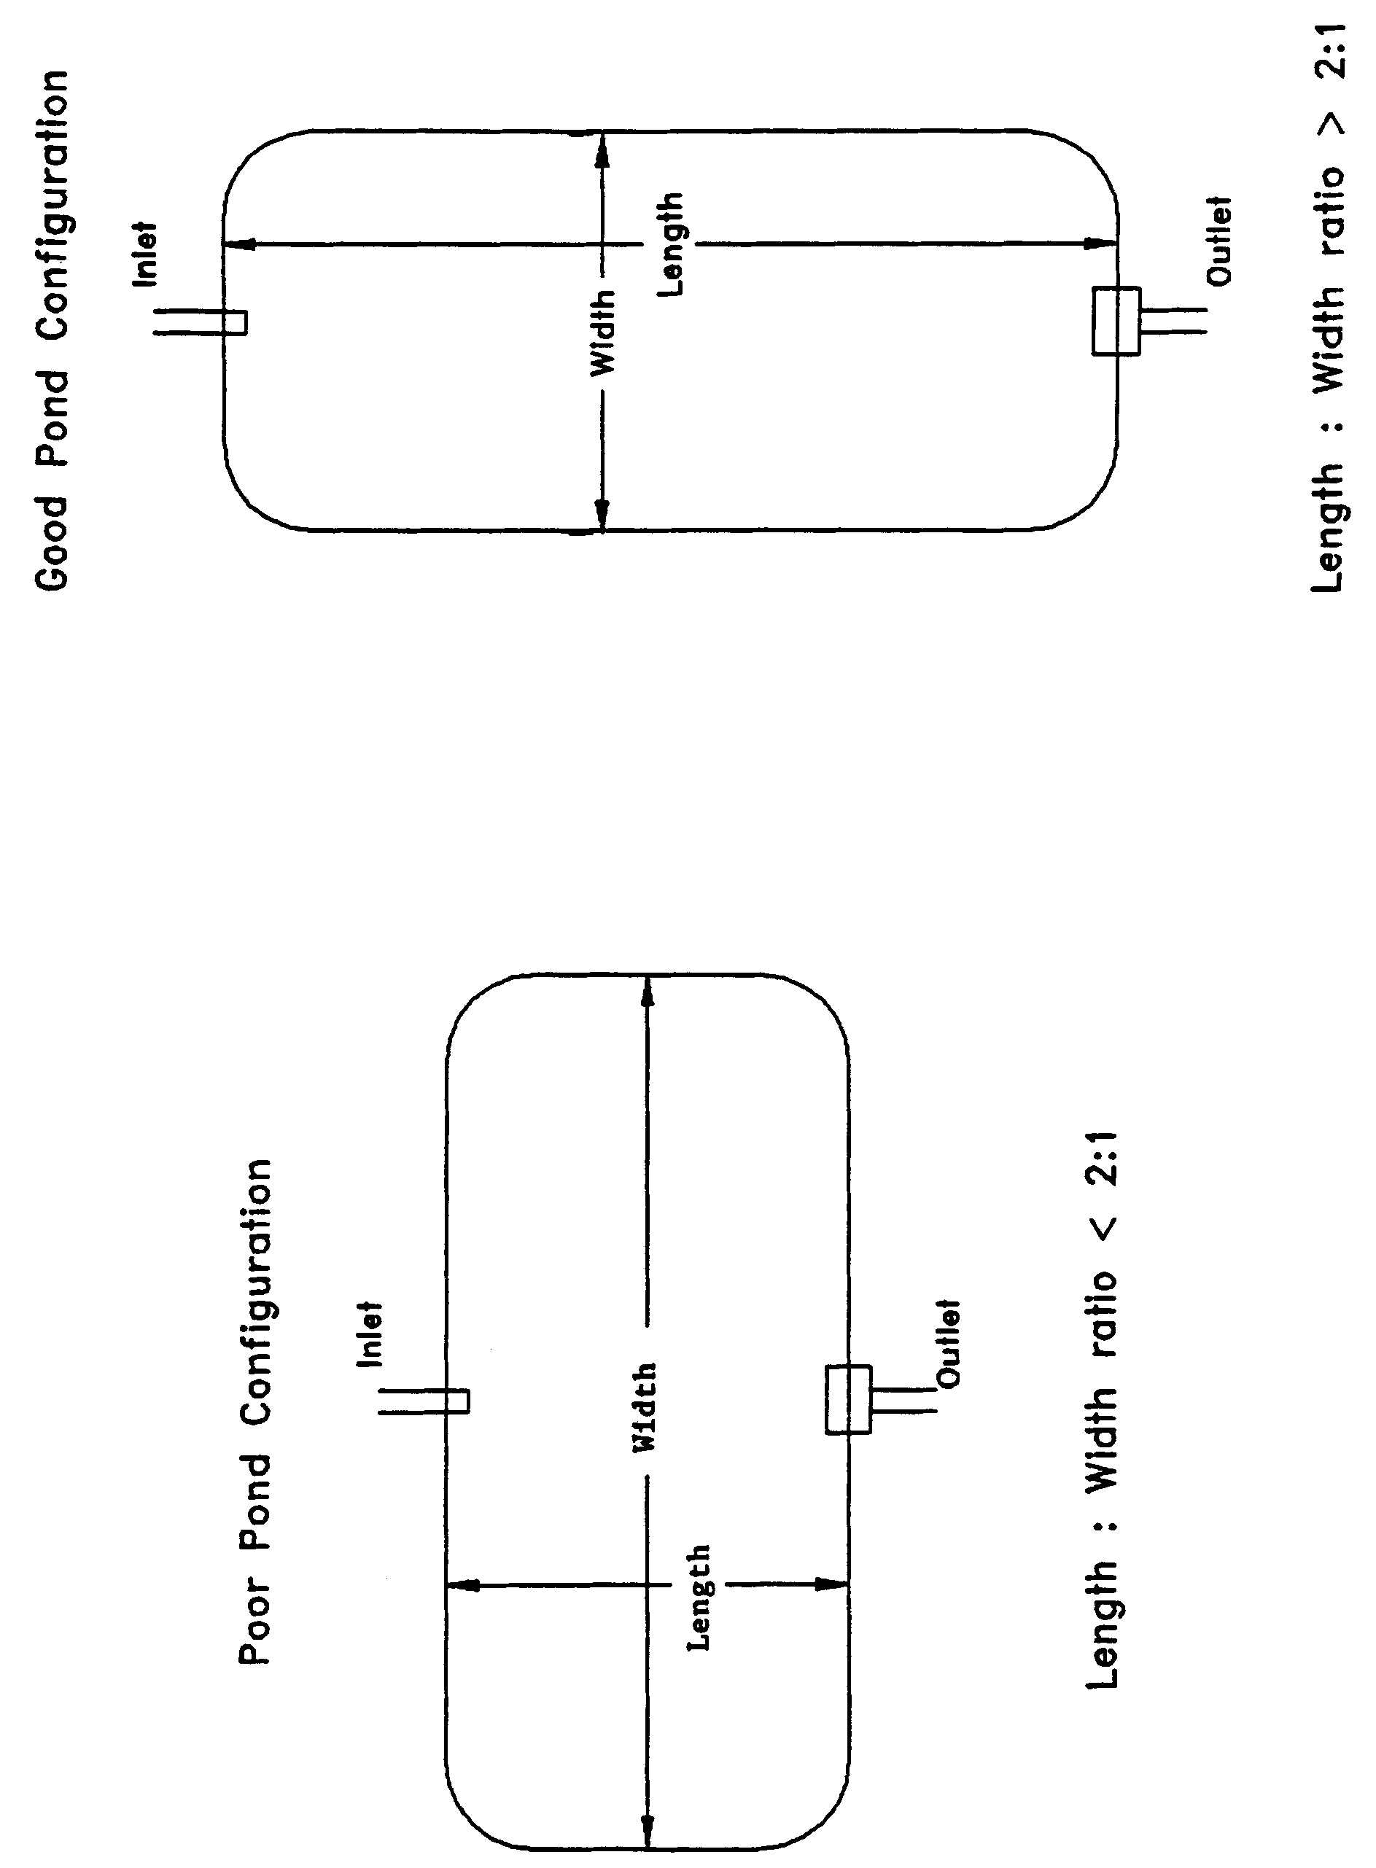

Figure 8-5. Examples of good and poor wet detention pond configurations (N.T.S.)

8.10 Ground Water Table

To minimize ground water contributions which may lower treatment efficiencies, the control elevation shall be set at or above the normal on-site ground water table elevation (Yousef et al. 1990). This elevation may be determined by calculating the average of the seasonal high and seasonal low ground water table elevations.

Ground water inflow (baseflow) must be considered when the control elevation is set below the normal ground water table elevation or the project utilizes underdrains (i.e., road underdrains) to control ground water conditions on-site. The design of the outfall structure must provide for the discharge of baseflow at the design normal water level in the pond. Baseflow rates must be included in the drawdown calculations for the outfall structure. Baseflow shall also be considered in the permanent pool residence time design. Establishment of the normal water level in the pond will also be influenced by baseflow conditions (see Figure 8-4).

8.11 Pre-treatment

"Pre-treatment" is defined as the treatment of a portion of the runoff prior to its entering the wet detention pond. Pre-treatment increases the pollutant removal efficiency of the overall stormwater system by reducing the pollutant loading to the wet detention pond. Pre-treatment may be used to enhance the appearance of the wet detention pond or meet the additional treatment criteria for discharges to receiving water which are classified as Class I, Class II, Outstanding Florida Waters (OFWs), or Class III waters which are approved, conditionally approved, restricted, or conditionally restricted for shellfish harvesting.

For developments where the appearance of the lake is important, pre-treatment can reduce the chances of algal blooms and slow the eutrophication process. Some types of pre-treatment practices include utilizing vegetative swales for conveyance instead of curb and gutter, perimeter swales or berms around the lake, oil and grease skimmers on inlet structures, retention storage in swales with raised inlets, or shallow landscaped retention areas (when soils and water table conditions will allow for adequate percolation).

For systems in which pre-treatment is utilized to meet the additional design criteria requirements for systems which direct discharge to Class I, Class II, OFWs, or Class III waters which are approved, conditionally approved, restricted, or conditionally restricted for shellfish harvesting, pre-treatment practices must meet the appropriate design and performance criteria for that BMP. Acceptable types of pre-treatment include the following:

(a) Retention systems which meet the design and performance criteria in section 5,

(b) Underdrain systems which meet the design and performance criteria in section 6,

(c) Exfiltration trench section 7, or

(d) Swales systems which meet the design and performance criteria in section 9.

Alternative pre-treatment methods will be evaluated on a case-by-case basis by the District. Applicants or system designers are encouraged to meet with District staff in a pre-application conference if alternative methods are proposed.

8.12 Pond Side Slopes

The pond must be designed so that the average pond side slope measured between the control elevation and two feet below the control elevation is no steeper than 3:1 (horizontal:vertical).

8.13 Direct Discharges to Class I, Class II, OFWs, or Shellfishing Waters

Wet detention systems which discharge to Class I, Class II, OFWs, or Class III waters which are approved, conditionally approved, restricted, or conditionally restricted for shellfish harvesting, must provide either:

(a) An additional fifty percent of both the required treatment and permanent
pool volumes

(b) Pre-treatment of the stormwater prior to the stormwater entering the wet
detention pond. The level of pre-treatment must be at least that required for
retention, underdrain, exfiltration, or swale systems (see section 8.11 of this
Volume).

8.14 References

Camp Dresser & McKee Inc (CDM). 1985. An Assessment of Stormwater Management Programs. Prepared for Florida Department of Environmental Regulation, Tallahassee, Florida.

Livingston, E.H., E. McCarron, J. Cox, P. Sanzone. 1988. The Florida Land Development Manual: A Guide to Sound Land and Water Management. Florida Department of Environmental Regulation, Nonpoint Source Management Section, Tallahassee, Florida.

Yousef, Y.A., M.P. Wanielista, L.Y. Lin, and M. Brabham. 1990. Efficiency Optimization of Wet Detention Ponds for Urban Stormwater Management (Phase I and II). University of Central Florida, Orlando, Florida
9.0 Swale Systems Design and Performance Criteria

9.1 Description

Swales are a man-made or natural system shaped or graded to required dimensions and designed for the conveyance and rapid infiltration of stormwater runoff. Swales are designed to infiltrate a defined quantity of runoff through the permeable soils of the swale floor and side slopes into the shallow ground water aquifer (Figure 9-1). Turf is established to promote infiltration and stabilize the side slopes. Soil permeability and water table conditions must be such that the swale can percolate the desired runoff volume from the 3-year, 1-hour storm event. The swale holds water only during and immediately after a storm event, thus the system is normally "dry." Unlike retention basins, swales are "open" conveyance systems. This means there are no physical barriers such as berms or check-dams to impound the runoff in the swale prior to discharge to the receiving water.

Swale systems should not be located in close proximity to drinking water supply wells. As required by chapter 62-555, F.A.C., stormwater treatment facilities must be at least 100 feet from any public supply well. Additional design criteria are established for swale systems constructed in Karst Sensitive Areas of the District where the drinking water aquifer is close to the land surface (see section 13.6).

Besides pollution control, swale systems can be utilized to promote the recharge of groundwater to prevent saltwater intrusion in coastal areas, and to maintain ground water levels in aquifer recharge areas. Swales can be incorporated into the design of a stormwater management system to meet the recharge criteria for the Wekiva Recharge Protection Basin and the Tomoka River and Spruce Creek Hydrologic Basins.

Swales can also be utilized to provide pre-treatment of runoff prior to its release to another treatment BMP such as wet detention (see section 8.11) or wetlands stormwater management systems (see section 10.4). Pre-treatment reduces the pollutant loading to the downstream treatment system, increases the pollutant efficiency of the overall stormwater management system, and reduces maintenance. In some cases, pre-treatment may be used to meet the additional treatment criteria for discharges to sensitive receiving waters (Class I, Class II, and OFWs). For developments where the appearance of the downstream system (i.e, wet detention lake) is important, pre-treatment can reduce the probability of algal blooms occurring and slows the eutrophication process.

The design and performance criteria specific to swale systems are described in the following sections.

Figure 9-1. Cross-section of swale system (N.T.S.)
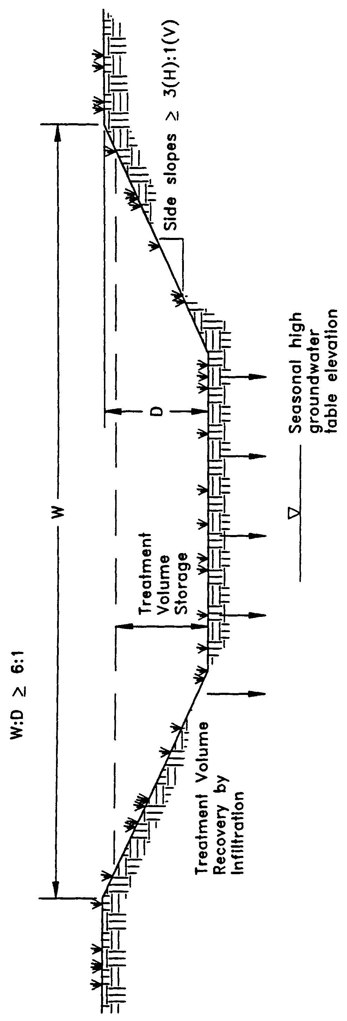

9.2 Treatment Volume

The runoff from the site should be routed to the swale system for conveyance and percolation into the ground. For systems which discharge to Class III receiving water bodies, the swales shall be designed to percolate 80% of the runoff from the 3-year, 1- hour storm. The remaining 20% of the runoff from the 3-year, 1-hour storm event may be discharged offsite by the swale system.

Swale systems which directly discharge to Class I, Class II, OFWs, or Class III waters which are approved, conditionally approved, restricted, or conditionally restricted for shellfish harvesting, shall be designed to percolate all of the runoff from the 3-year, 1-hour storm.

9.3 Recovery Time

Swale systems must provide the capacity for the specified treatment volume of stormwater and contain no contiguous areas of standing or flowing water within 72 hours following the storm event referenced in section 9.2 assuming average antecedent moisture conditions. The treatment volume must be provided by percolation through the soil, evaporation, or evapotranspiration.

Antecedent moisture condition (AMC) refers to the amount of moisture and storage in the soil profile prior to a storm event. Antecedent soil moisture is an indicator of wetness and availability of soil to infiltrate water. The AMC can vary from dry to saturated depending on the amount of rainfall received prior to a given point in time. Therefore, "average AMC" means the soil is neither dry or saturated, but at an average moisture condition at the beginning of a storm event when calculating recovery time for swale systems.

The antecedent condition has a significant effect on runoff rate, runoff volume, infiltration rate, and infiltration volume. The infiltration volume is also known as the upper soil zone storage. Both the infiltration rate and upper soil zone storage are used to calculate the recovery time of retention systems and should be estimated using any generally accepted and well documented method with appropriate parameters to reflect drainage practices, seasonal high water table elevation, the AMC, and any underlying soil characteristics which would limit or prevent percolation of storm water into the soil column.

9.4 Dimensional Requirements

Swales must have a top width to depth ratio of the cross-section equal to or greater than 6:1 or side slopes equal to or greater than 3:1 (horizontal to vertical).

9.5 Stabilization

Swales should be stabilized with vegetative cover suitable for soil stabilization, stormwater treatment, and nutrient uptake. Also, the swale should be designed to take into account the soil errodibility, soil percolation, slope, slope length, and drainage area so as to prevent erosion and reduce pollutant concentrations.
10.0 Wetlands Stormwater Management Systems Design and Performance Criteria

10.1 Description

For wetlands stormwater management systems the District must ensure that a proposed wetlands stormwater management system is compatible with the existing ecological characteristics of the wetlands proposed to be utilized for stormwater treatment. The District must also ensure that water quality standards will not be violated by discharges from wetlands stormwater management system. To achieve these goals, specific performance criteria are set forth and described below for systems which incorporate wetlands for stormwater treatment.

10.2 Types of Wetlands that may be Utilized for Stormwater Treatment

The only wetlands which may be considered for use to provide stormwater treatment are those which are:

(a) Isolated wetlands; and

(b) Those which would be isolated wetlands, but for a hydrologic connection to other wetlands or surface waters via another watercourse that was excavated through uplands.

10.3 Treatment Volume

The system shall be part of a comprehensive stormwater management system that utilizes wetlands in combination with other best management practices to provide treatment of the runoff from the project. For systems discharging to Class III waters, treatment of the runoff from the greater of the following shall be provided:

(a) First one inch of runoff, or

(b) 2.5 inches times the impervious area.

Those systems which directly discharge to Class I, Class II, OFWs, or Class III waters which are approved, conditionally approved, restricted, or conditionally restricted for shellfish harvesting, shall provide an additional fifty percent of the applicable treatment volume specified above.

If the wetland alone cannot provide the treatment volume, then other best management practices shall be incorporated upstream and outside of the wetland to store the proper level of runoff. Utilization of other BMPs must not adversely affect the ability of the wetlands stormwater management system from meeting the requirements of this section.

10.4 Recovery Time

The system shall be designed to bleed down one-half the applicable treatment volume specified above between 60 and 72 hours following a storm event.

10.5 Inlet Structures

Inlet structures shall be designed to dissipate the energy of runoff entering the wetland and minimize the channelized flow of stormwater. Methods include, but are not limited to, sprinklers, pipe energy dissipators, overland flow or spreader swales.

10.6 Wetland Function

The use of wetlands for stormwater treatment must meet the criteria in section 10.0, Environmental Considerations, of the Environmental Resource Permit Applicant’s Handbook, Volume I. Pre-treatment can reduce the impact of untreated stormwater upon the wetland. In addition, pre-treatment can be utilized to attenuate stormwater volumes and peak discharge rates so that the wetland's hydroperiod is not adversely altered (Livingston 1989). Swale conveyances and lakes adjacent to the wetland are typical pre-treatment practices.

10.8 Residence Time

The design features of the system should maximize residence time of the stormwater within the wetland to enhance the opportunity for the stormwater to come into contact with the wetland sediment, vegetation, and micro-organisms (Livingston 1989). This can be accomplished by several means. The inlets and outlets should be located to maximize the flow path through the wetland. Energy dissipators and spreader swales can promote overland flow and reduce the possibility of channelized flow occurring. In some instances, berms in wetlands can act as baffles to increase the flow path of surface flow through the wetland.

10.8 Monitoring

In order to establish a reliable, scientifically valid data base upon which to evaluate the performance criteria and the performance of the wetlands stormwater management system, a monitoring program may be required. Monitoring programs shall provide the District with comparable data for different types of wetlands and drainage designs. Data to be collected may include but not be limited to:

(a) Sedimentation rate

(b) Sediment trace metal concentrations

(c) Sediment nitrogen and phosphorus concentrations

(d) Changes in the frequency, abundance and distribution of vegetation

(e) Inflow and outflow water quality for nutrients, metals, turbidity, oils and greases, bacteria and other parameters related to the specific site conditions

Inflow and outflow water quality parameters will be monitored on such storm event occurrences as established by the District based on a site specific basis. The District shall eliminate the requirement to continue the monitoring program upon its determination that no further data is necessary to evaluate the performance criteria or ensure compliance with the performance criteria and applicable water quality standards.

10.9 Dredge and Fill

If the applicant proposes to dredge or fill in the wetlands used for stormwater treatment, the District in its review of the permit application shall evaluate the adverse effects of the dredging or filling on the treatment capability of the wetland.

10.10 Alternative Criteria

If the applicant is unable to show compliance with the performance criteria sections 10.3 – 10.9, above, the applicant may qualify for an environmental resource stormwater permit to use a wetlands stormwater management system permit using alternative design and performance criteria if the applicant affirmatively demonstrates that the use of the wetlands meets the criteria in section 10.0, Environmental Resource Permit Applicant’s Handbook, Volume I (General and Environmental) and the applicant complies with the requirements for issuance in section 2.0.

10.11 References

Livingston, E.H. 1989. The Use of Wetlands for Urban Stormwater Management. In Design of Urban Runoff Quality Controls, ed. L.A. Roesner, B. Urbonas, and M.B. Sonnen, pages 467-490. American Society of Civil Engineers. New York.

11.0 [Reserved]
12.0 Dry Detention Design and Performance Criteria

12.1 Description

Dry detention systems are normally dry storage areas which are designed to store a defined quantity of runoff and slowly release the collected runoff through an outlet structure to adjacent surface waters. After drawdown of the stored runoff is completed, the storage basin does not hold any water, thus the system is normally "dry." A schematic of a typical dry detention system is presented in Figure 12-1.

Dry detention basins are similar to retention systems in that the basins are normally dry. However, the main difference between the two systems is that retention systems are designed to percolate the stored runoff into the ground while dry detention systems are designed to discharge the runoff through an outlet structure to adjacent surface waters.

Sedimentation is the primary pollutant removal process which occurs in dry detention systems. Unfortunately, only pollutants which are primarily in particulate form are removed by sedimentation. Therefore, the pollutant removal efficiency of dry detention systems is not as great as systems such as retention and wet detention which remove both dissolved and particulate pollutants. Because of the limited pollutant removal efficiency of dry detention, this BMP must only be utilized where no other general permit BMP is feasible. For example, use of dry detention must be restricted to the following situations:

(a) Where high ground water table or soil conditions limit the feasibility of other BMPs such as retention, and

(b) Small drainage basins (less than 5 acres). For larger projects (greater than 5
acres) other BMPs like wet detention shall be utilized instead of dry
detention.

There are several design and performance criteria which must be met in order for a dry detention system to meet the District’s requirements. A description of each design criterion is presented below.

12.2 Treatment Volume

For discharges to Class III receiving water bodies, the dry detention system shall provide off-line detention of the first one inch of runoff or 2.5 inches of runoff from the impervious area, whichever is greater.

For direct discharges to Class I, Class II, OFWs, or Class III waters which are approved, conditionally approved, restricted, or conditionally restricted for shellfish harvesting, the applicant shall provide dry detention for at least an additional fifty percent of the applicable treatment volume specified for off-line dry detention in (a), above. Off-line detention must be provided for at least the first one inch of runoff or 2.5 inches of runoff from the impervious area, whichever is greater, of the total amount of runoff required to be treated.

Dry detention removes less pollutants on a per unit basis than other traditional best management practices. Therefore, dry detention systems must treat a greater volume of stormwater than the other treatment practices specified in the rule to achieve an equivalent level of pollutant removal.

12.3 Recovery Time

The outfall structure shall be designed to drawdown one-half the required treatment volume specified above between 24 and 30 hours following a storm event.

12.4 Outlet Structure

The outlet structure shall include a drawdown device (such as an orifice, "V" or square notch weir) set to slowly release the treatment volume (see Figures 12-2 and 12-3 for conceptual schematics). In addition, the structure must include a device to prevent the discharge of accumulated sediment, minimize exit velocities, and prevent clogging. Examples of such devices include perforated riser enclosed in a gravel jacket and perforated pipes enclosed in sand or gravel (see Figure 12-5).

In addition, the control elevation shall be set at or above the design tailwater elevation so the basin can effectively recover the treatment storage.

12.5 Ground Water Table, Basin Floor, and Control Elevation

To minimize ground water contributions and ensure the basin floor is normally dry, the control elevation and basin floor shall be set at least one foot above the seasonal high ground water table elevation. Sumps may be placed up to one foot below the control elevation. The basin floor shall be level or uniformly sloped toward the control structure. The system may only contain standing water within 3 days of a storm event. Continuous standing water in the basin may also reduce the aesthetic value of the system and may promote mosquito production.

12.6 Basin Stabilization

The dry detention basin shall be stabilized with permanent vegetative cover.

12.7 Basin Configuration

The average length to width ratio of the dry detention basin must be at least 2:1. Under these design conditions, short circuiting is minimized and pollutant removal efficiency is maximized.

If short flow paths are unavoidable, the effective flow path can be increased by adding diversion barriers such as peninsulas or baffles to the basin. Examples of good and poor basin configurations are given in Figure 12-4.

12.8 Inlet Structures

Inlet structures shall be designed to dissipate the energy of water entering the basin.

12.9 Maintenance

Dry detention systems must include provisions for removal of sediment and debris from the basin and mowing and removal of grass clippings.

Figure 12-1 Dry detention (N.T.S.)

Figure 12-2. Typical dry detention outfall structure with orifice (N.T.S.)

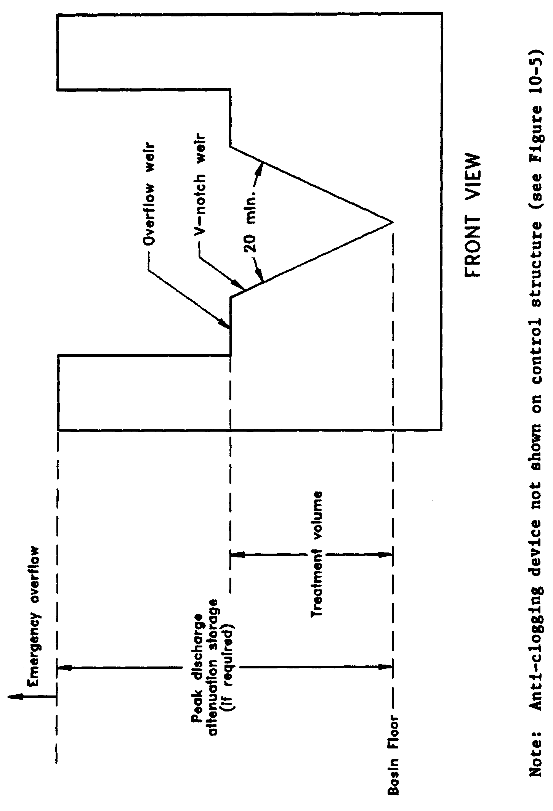

Figure 12-3. Typical dry detention outfall structure with “V”-notch weir (N.T.S.)

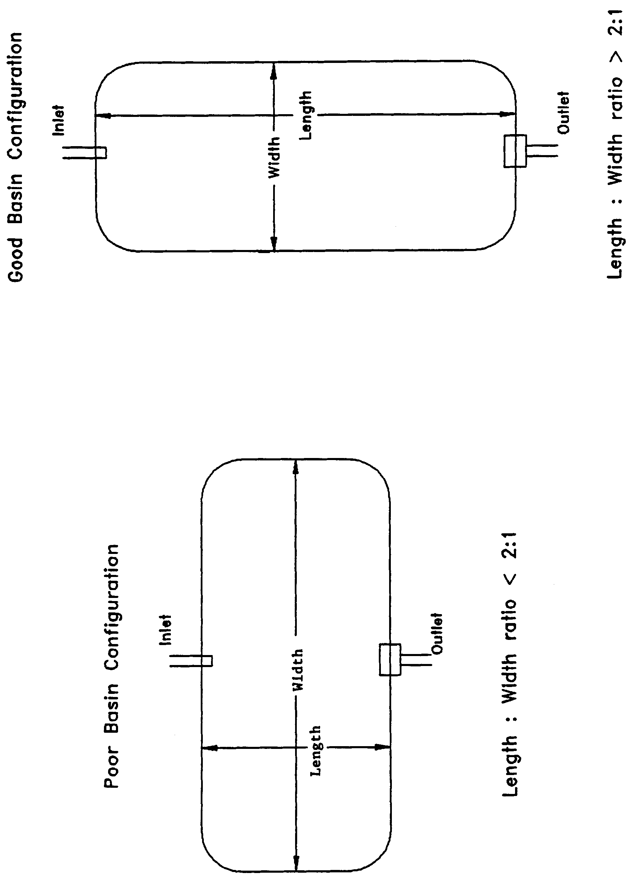

Figure 12-4. Examples of good and poor dry detention pond configurations (N.T.S.)

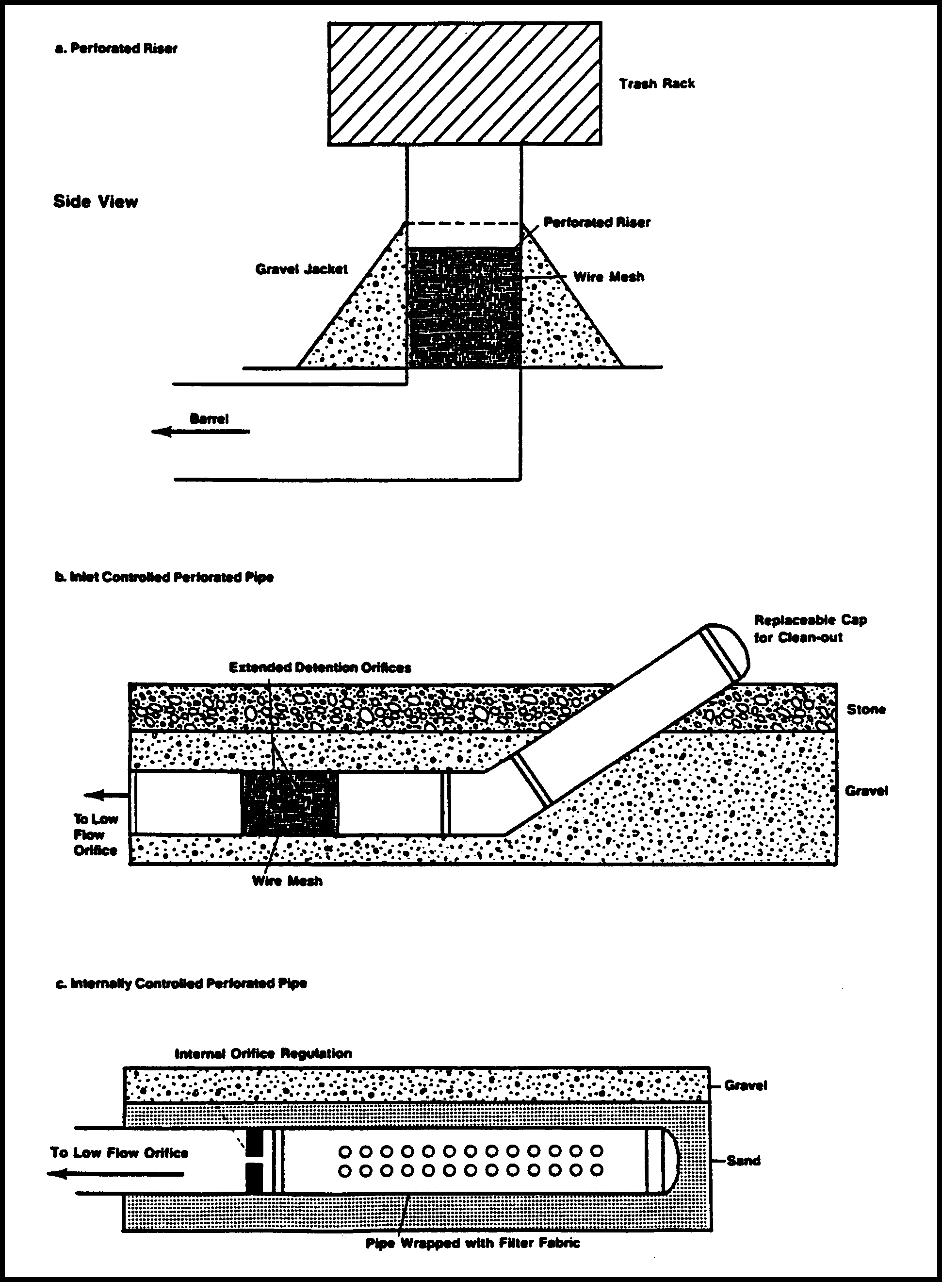
Figure 12-5. Devices to prevent clogging in dry detention control structures (Source: Schueler, T.R. 1987. Controlling Urban Runoff: A Practical Manual for Planning and Designing Urban BMP’s. Metropolitan Washington Council of Governments, Washington, D.C.)

