Personal watercraft/jet boat rental safety




Alcohol and many other drugs are dangerous when combined with any form of boating. Do not operate any boat while impaired by alcohol or drugs.

It is very important to get in the habit of wearing a life jacket while boating. Not only is life jacket wear mandatory for personal watercraft riders, but it is also highly recommended that appropriate protective clothing and footwear are worn.
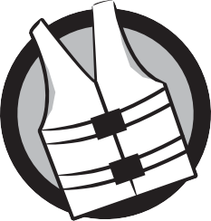

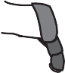




Securely attach the engine shut-off cord (lanyard) to your wrist or life jacket and wear it at all times. This will ensure the engine stops should you fall overboard.


Starting and stopping the engine(s) usually requires the push of a button. Stopping the engine will not stop forward motion and will result in the loss of steering.


The throttle controls your speed and the steering wheel or handlebars move the jet thrust nozzle in different directions to steer the boat. Do not decrease throttle when trying to steer, and always remember that boats don’t have brakes.


Items such as long hair, loose clothing or life jacket straps can become entangled in moving parts within the water intake grate and cause severe injury or drowning. Stay away from the intake grate.



Do not apply throttle when anyone is at the rear of the boat. Water forced from the jet thrust nozzle can cause serious bodily injury.



Most boating injuries and many deaths are the result of collisions. Learning to avoid collisions will keep your boating experience safe and more enjoyable.

Most boating accidents are due to operator inattention or carelessness. Be aware of dangers approaching from any direction.
Operate at a safe speed while keeping more than enough distance between you and other boats. Remember, the faster you are going the more distance you will travel when trying to react to danger, thus increasing the likelihood of collision and serious bodily injury or death.





It is unsafe and against the law to follow closely behind another boat, to spray another boat or a person, to jump boat wakes close to a boat and to make sharp turns or maneuvers which make it diffcult for others to avoid colliding with you.


Personal watercraft and jet boats are not toys. It is important that you avoid
aggressive maneuvers, sharp turns or jump waves or wakes. These activities increase the risk of back/spinal injuries (paralysis), facial injuries and broken bones.


For personal watercraft operators, it is important that you follow the proper instructions for righting the boat in the event you capsize in open water. Discuss this with your rental company before going out.

The rental company has rules aimed at protecting you and your passengers.

Understand and follow the rental company’s rules and the boating laws that apply to the type of boat you are renting.





Make sure your rental company has explained any specifc local boating hazards and regulations so you can avoid problems on the water.


There are specifc warnings and instructions that apply to the boat you are going to operate. Become familiar with all product labels on the boat and follow the directions.

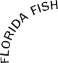



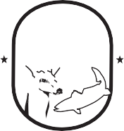
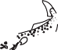

Florida Fish and Wildlife Conservation Commission
MyFWC.com

FWCDLE_314 (11/22) - Rule 68D-34.004 F.A.C.

