Paddlecraft rental safety




Alcohol and many other drugs are especially dangerous when combined with any form of boating. Do not operate any boat, even one without a motor, while impaired by alcohol or drugs.



Boating in any manually propelled boat (such as canoes, kayaks, rafts and rowboats) can be physically challenging. Be careful not to overestimate your physical capabilities or those of the boat you will be using.



Paddlecraft and other nonmotorized boats have a tendency to be less stable than larger boats. It is important not to overload the boat, to keep at least three points
of contact and to stay low in the boat to improve balance.


Most boating deaths are the result of someone drowning after falling overboard from a small boat. You and your passengers must know the location and proper use of life jackets and other safety equipment for the boat you are renting. It is always best to wear a life jacket when on the water, and children under the age specifed by law are required to wear one.

Most boating accidents involve collisions due to operator inattention or carelessness. Be aware of dangers approaching from any direction.


To avoid collision with another boat, stay visible so others can see you and alert so you are ready to move out of the way of danger

Florida IntraCoastal Waterway (ICW); Paddlecraft may only operate if there is not another navigable area due to vessel congestion or water obstructions and must proceed with diligence to a location outside of the marked channel When crossing the marked channel of the ICW, paddlecraft must cross in the most direct, continuous and expeditious manner possible and not interfere with other vessel traffic.
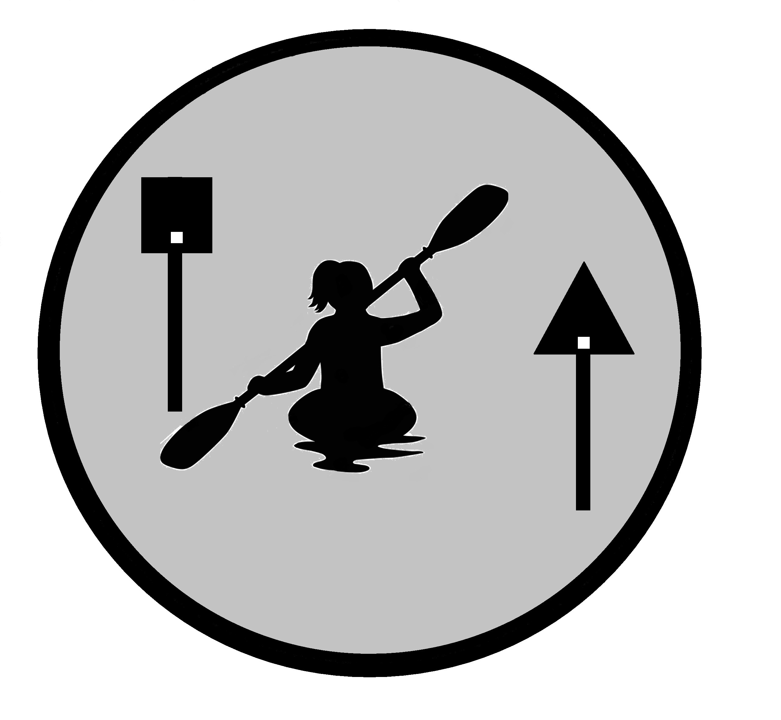

When boating after sunset and before sunrise, or when visibility is poor, you must be prepared to shine a white light (such as a fashlight) in time to avoid a collision with another boat. Should a problem arise, you must know how to properly use distress signals.






Stay aware of hazards such as wind, water currents and tidal fow that can make
it very diffcult to reach your intended destination. Pay extra attention to weather, since storms bring lightning and high waves. Avoid boating in poor weather conditions.



Always wear your life jacket and know what to do if you unexpectedly end up in the water. Stay calm and stay with the boat if possible. If you fall out in a swift current, keep your feet on or near the surface and swim to shore. There you can dump the water out of the boat, re-enter and be on your way.


The rental company has rules aimed at protecting you and your passengers.
Understand and follow the rental company’s rules and the boating laws that apply to the type of boat you are renting.




Make sure your rental company has explained any specifc local boating hazards and regulations so you can avoid problems on the water.

Hydration and sun protection are important issues. Take drinking water, wear sunblock, polarized sunglasses and a hat.






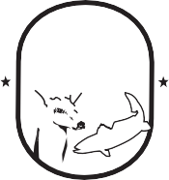


Small boats are not good platforms for diving or swimming. Pull the boat to shore before going into the water and be careful to check the water depth.

Florida Fish and Wildlife Conservation Commission
MyFWC.com

FWCDLE_318 (11/22) - 68D-36.004, F.A.C.

