A. ENVIRONMENTAL RESOURCE PERMIT

APPLICANT’S HANDBOOK, VOLUME II:

FOR USE WITHIN THE GEOGRAPHIC LIMITS

OF THE ST. JOHNS RIVER WATER MANAGEMENT DISTRICT



June 28, 2024

ST. JOHNS RIVER WATER MANAGEMENT DISTRICT
4049 Reid Street
Palatka, FL 32177-2529
(386) 329-4500

PART I
INTRODUCTION, ORGANIZATION, DEFINITIONS AND APPLICABILITY

- Introduction Revised 6/1/18

This is Volume II of a two-volume Applicant’s Handbook that is designed to assist persons in understanding the rules, procedures, standards and criteria of the environmental resource permit (ERP) program under part IV of chapter 373 of the Florida Statutes (F.S.). Within the St. Johns River Water Management District, the ERP program is governed by chapters 373, 403 and 120, F.S. and chapters 62-330, 40C-1, 40C-4, 40C-41, and 40C-44, F.A.C. This handbook volume accompanies Applicant’s Handbook – Volume I (General and Environmental). Volume II and portions of Volume I are incorporated by reference in chapter 62-330, F.A.C., and are, therefore rules of the Department of Environmental Protection (DEP). In accordance with paragraph 373.4131(2)(a), F.S. (2012), they are also rules of the District.

This Volume includes:

- Design and performance standards and criteria for water quality and quantity for stormwater management systems, including alternative criteria for those systems
- Explanations of standards and criteria pertaining to water flows and levels, flood protection and the design of dams
- Design and performance standards for agricultural surface water management (Chapter 40C-44, F.A.C.)
- Descriptions of drainage basins and regional watersheds
- Explanations of basin criteria (Chapter 40C-41, F.A.C.)
- Descriptions of District-specific thresholds and exemptions referenced in chapter 62-330, F.A.C.

This Volume should be used in conjunction with Volume I, which provides general background information on the ERP program including points of contact, a summary of the statutes and rules used to authorize and implement the ERP program, and forms used to notice or apply to the District for an ERP authorization, except those forms related to agricultural systems which are incorporated by reference in rules 40C-44.061 and 40C-44.101, F.A.C. Volume I also provides discussion of:

  - Activities that are regulated by the ERP program
  - Types of permits, permit thresholds, and exemptions
  - Procedures used in the review of ERPs
  - Conditions for issuance of an ERP, including a detailed discussion of the environmental criteria that are used for activities located in wetlands and other surface waters
  - Erosion and sediment control practices to prevent water quality violations
  - Operation and maintenance requirements and copies of maps used in implementing the provisions of the ERP program
The term “District” or “SJRWMD” where used in this Volume shall apply to the Department of Environmental Protection, the St. Johns River Water Management District or a delegated local government as applicable in accordance with the division of responsibility specified by the operating agreement incorporated by reference in subsection 62-330.010(3), F.A.C., except where a specific agency is otherwise identified. In cases where conflicting or ambiguous interpretations of the information in this Volume result in uncertainty, the final determination of appropriate procedures to be followed will be made by reference to chapters 120 and 373, and chapters 40C-1, 40C-4, 40C-41, 40C- 44 and 62-330, F.A.C.

References to a section or subsection shall include all parts of the section or subsection unless otherwise specified.

1.1 Organization Revised 6/1/18

This Volume is divided into eight parts:

Part I – Introduction, Organization, Definitions and Applicability
Part II – General Criteria
Part III – Stormwater Quantity/Flood Control
Part IV – Stormwater Quality
Part V – Best Management Practices
Part VI – Basin Criteria
Part VII - Agricultural Surface Water Management Systems
Part VIII – Appendices

1.2 District-Specific Thresholds

1.2.1 Background
Rule 62-330.020 sets forth the thresholds for when an environmental resource permit must be obtained under part IV of chapter 373. Subsection (2) of this Rule requires a person to obtain an environmental resource permit before constructing, altering, operating, maintaining, removing, or abandoning any new project that, by itself or in combination with an activity conducted after October 1, 2013, cumulatively results in “[a]ny project exceeding the thresholds in section 1.2 (District-specific thresholds) of the applicable Volume II” unless the proposed project is governed by subsection 62-330.020(1), F.A.C. [62-330.020(2)(i), F.A.C.]

Subsections 1.2.2 and 1.2.3 of this Volume set forth the District-specific thresholds for activities within the St. Johns River Water Management District.

The District encourages applicants to consult section 2.0 of Volume I which contains definitions of important terms such as “project” and “activity”.

1.2.2 Activities in the Wekiva Riparian Habitat Protection Zone

A permit under chapter 62-330 is required for any activity that is located wholly or partially within the Wekiva River Hydrologic Basin’s Riparian Habitat Protection Zone (RHPZ) described in paragraph 40C-41.063(3)(e), F.A.C. When an activity requires a permit pursuant to this subsection, the review for determining compliance with all relevant permitting requirements will be conducted in accordance with rule 62-330.054.

1.2.3 Agricultural Surface Water Management Systems Revised 6/1/18

A permit under chapter 62-330, F.A.C., is required for the alteration, maintenance and operation of certain existing agricultural surface water management systems and for the construction, maintenance and operation of certain new agricultural surface water management systems, in accordance with chapter 40C-44, F.A.C. (Environmental Resource Permits: Regulation of Agricultural Surface Water Management Systems). These systems are described in rule 40C-44.041, but are also described in this subsection and in Part VII of this Volume.

Agricultural operations that are required to obtain a permit shall satisfy the requirements of the District in terms of the quality of water discharged from the system, by implementing the performance standards and water quality practices described in Part VII of this Volume.

A permit for an agricultural system is required under this subsection and chapter 40C-44, F.A.C., if the activity exceeds any of the following thresholds:

(a) The activity incorporates pumped discharges from an existing agricultural surface water management system, when:

(1) the pumps are stationary or portable facilities, and

(2) the pump(s) have a capacity, either individually or cumulatively, of 10,000 GPM or greater. [40C-44.041(1)(a), F.A.C.]

(b) The activity causes or contributes to a violation of state water quality standards in waters of the state, when:

(1) the discharge is pumped or gravity drained, and

(2) the District has considered the following information on a case-by-case basis:

a. water quality monitoring data collected by the District or other agency,

b. the size of the agricultural operation and the amount of stormwater and associated wastewater reaching waters of the state, relative to the size and nature of the immediate drainage basin,

c. the means of conveyance of stormwater and associated wastewater to waters of the state,

d. characteristics of the site including the slope, vegetation, rainfall and other factors related to the likelihood or frequency of discharge of stormwater and associated wastewater to waters of the state,

e. the status, results and recommendations of available basin-specific studies, including those conducted as part of a Surface Water Improvement and Management Plan or pursuant to chapter 62-40, F.A.C., and

f. the existence of mixing zones, variances or site specific alternative criteria granted by DEP pursuant to chapters 62-4 and 62-302, F.A.C. [40C-44.041(1)(b), F.A.C.]

(c) An applicant proposes construction, maintenance and operation of new agricultural surface water management systems, or alteration of existing systems, which:

(1) drain an agricultural area greater than 2 acres;

(2) are below thresholds described in paragraphs 62-330.020(2)(a) and (e), F.A.C.;

(3) serve a project with a total land area less than 40 acres; and

(4) do not provide for the placement of 12 or more acres of impervious surface which constitutes 40 or more percent of the total land area. [40C-44.041(2), F.A.C.]

When construction or alteration of an agricultural surface water management system that requires a permit pursuant to this subsection also requires a permit because it exceeds one or more thresholds listed in paragraphs 62-330.020(2)(a),(b), (c), (e),(f),(g),(h), or (j), F.A.C., or in subsection 1.2.2 of this Volume, the review for determining compliance with all relevant permitting requirements will be conducted in accordance with rule 62-330.054.

When construction or alteration of an agricultural surface water management system requires a permit solely pursuant to this subsection or paragraph 62-330.020(2)(d), F.A.C., the permit application for such activity shall be filed, and shall be reviewed and acted upon, in accordance with chapter 40C-44, F.A.C., and Part VII of this Volume. The District encourages applicants to contact the District’s Agricultural Assistance Team to assist them in completing such permit applications.

1.3 District-Specific Exemptions

1.3.1 Background

Rule 62-330.051(1) exempts from permitting under chapter 62-330, F.A.C., activities that are conducted in conformance with the District-specific exemptions in Section 1.3 of Volume II applicable to the location of the activity. However, if an activity is not exempt and requires an individual ERP under chapter 62-330, F.A.C., rule 62-330.054 requires the application for the individual ERP to be prepared, submitted, reviewed and acted upon in accordance with subparagraphs 62- 330.054(2)(a), (b) and (c), F.A.C., except as otherwise provided by the ERP rules.

Consistent with these rules, the District has established one District-specific exemption from permitting and one District-specific exemption from certain provisions of chapter 62-330, F.A.C. More specifically, subsection 1.3.2 of this Volume sets forth a District-specific exemption from permitting within the St. Johns River Water Management District while subsection 1.3.3 exempts certain agricultural systems from certain requirements in chapter 62-330, F.A.C.

1.3.2 Existing Systems

The District’s rules in chapters 40C-4, 40C-40, and 40C-41, F.A.C., became effective on December 7, 1983. Before December 7, 1983, rules authorized under part IV, chapter 373, F.S., were implemented in the Upper St. Johns River and the Ocklawaha River basins as shown in Figure 1.3-1. The rules adopted on December 7, 1983 superseded all previous rules. The date of implementation is important in determining whether a permit is required and the effective dates for the District’s permitting programs are described in rule 40C-4.031. Certain systems are not required to be permitted until they are to be altered, removed, or abandoned. These systems are identified in the paragraph below.

Specifically exempted from permitting under chapter 62-330 for the purpose of construction, operation, and maintenance are:

(a) Each system or phase of a phased system which is located in the areas described in the Upper St. Johns River Basin or the Ocklawaha River Basin as depicted in Figure 1.3-1, except agricultural operations, which:

(1) Was constructed and operating under the provisions of a valid District permit on December 7, 1983; or

(2) Was not required to obtain a permit prior to December 7, 1983,
and was:

a. Constructed and operating prior to December 7, 1983; or

b. Being constructed on December 7, 1983, and was completed and operating by June 7, 1984; or

c. Under construction on December 7, 1983, and which had complied with the regulations of the Florida Department of Environmental Regulation and the appropriate local governmental agency.

(3) Was constructed and operating as of March 2, 1974 for the Upper St. Johns River Basin as described in Figure 1.3-1; or

(4) Was constructed and operating as of January 1, 1975 for the portion of the Oklawaha River Basin as described in Figure 1.3-1.

(b) Each system or phase of a phased system which is located in the Lower St. Johns River Basin as described in Figure 1.3-1 and section 373.069(2)(c), F.S. (Supp. 1976), except agricultural operations, and which was:

(1) Constructed and operating prior to December 7, 1983; or

(2) Being constructed on December 7, 1983, and was completed and operating on June 7, 1984; or

(3) Under construction on December 7, 1983, and which had complied with the regulations of the Florida Department of Environmental Regulation and the appropriate local governmental agency and was completed December 7, 1984.

(c) The exemptions listed in paragraphs (a) and (b) above apply only to those systems or phases of a phased system as such systems are set forth in its plans, specifications and performance criteria prepared and existing as of December 7, 1983 and to the extent:

(1) Construction of such system is completed, within the applicable time frames, in accordance with such plans, specifications and performance criteria; and

(2) Such system is maintained and operated in a manner consistent with such plans, specifications and performance criteria.

(d) The exemptions listed in paragraphs (a), (b) and (c) above shall not apply to those systems or phases of a phased system which on December 7, 1983 have been abandoned or removed or have ceased to operate as set forth in such system’s plans, specifications and performance criteria.

(e) Those systems or phases of a phased system exempted by paragraphs (a), (b) and (c) above shall not be required to obtain a permit for construction, operation or maintenance.

(1) Any alteration of such system, or a portion thereof (including the rebuilding of such system if it has ceased to operate as set forth in such system’s plans, specifications and performance criteria), shall require that a permit be obtained for such alteration, which permit shall include an authorization to alter as well as an authorization to operate and maintain such alteration. For purposes of this subsection, the following are not considered to be alterations, and consequently are not required to be permitted:

a. The relocation of pumps, provided that the pump is not moved out of the immediate vicinity of its existing location, not to another drainage basin or subbasin, and operation of the pump at the new location will not result in increased adverse impacts to the water resource.

b. The installation of driveway and road inlets and pipes with a diameter of less than 60 inches or equivalent size within an existing surface water management system, provided that the pipe or inlet will not increase the volume of water discharged, and causes no upstream or downstream flooding.

c. The change of the location of a drainage system’s secondary or tertiary drainage ditches provided that the total linear length and cross-sectional dimensions of the ditches are not changed.

d. Roadways not located in wetlands may be widened provided that fill material is not obtained by excavating ditches next to the roadway, and provided that the roadway is otherwise constructed in accordance with accepted engineering practices. Roadways not located in wetlands may be increased in height provided that the elevation of the existing centerline road grade is above the 10-year flood elevation, and provided that no increase in upstream flooding is caused.

(2) Any abandonment or removal of such system or portion thereof, shall require that a permit be obtained for such abandonment or removal.

(3) The activities in subparagraphs (e)(1)a. through d. are also exempt from permitting when conducted by agricultural operations.

(f) The amendments to subsections 10.7.2, 10.7.4, 10.7.5., 16.1.3 and 16.1.5, Applicant’s Handbook: Management and Storage of Surface Waters, effective September 25, 1991, shall not apply to each system for which the District has issued an individual or general permit pursuant to Chapter 40C-4 or 40C-40, F.A.C., prior to September 25, 1991. This subsection applies only to the project area and plan approved in the referenced permit; however, where the referenced permit authorizes construction of a master system for drainage and flood control, this subsection shall apply to the project area served by the master system and to the plan approved in the referenced permit.

(g) The amendments to subsections 10.7.2, 10.7.4, 10.7.5, 16.1.3 and 16.1.5, Applicant’s Handbook: Management and Storage of Surface Waters, effective September 25, 1991 shall not apply to each system for which the District has issued, pursuant to Chapter 40C-4, F.A.C., and prior to September 25, 1991, both a conceptual approval permit and at least one permit authorizing construction consistent with the conceptual approval permit. This subsection applies only to the project area and plan approved in the referenced conceptual approval permit.

(h) The permitting threshold set forth in subparagraph 40C- 4.041(2)(b)8., F.A.C., as it existed on September 25, 1991,
incorporated by reference in 40C-4.091(1)(a), F.A.C., and
contained in Appendix D of this Volume, regarding isolated
wetlands and the amendments to subsections 10.7.2, 10.7.4, 10.7.5,
16.1.3 and 16.1.5, Applicant’s Handbook: Management and
Storage of Surface Waters, effective September 25, 1991 shall not
apply to each system for which the District has issued a permit
pursuant to Chapter 40C-42, F.A.C., prior to September 25, 1991.
This subsection applies only to a system which did not require a
permit pursuant to Chapter 40C-4 or 40C-40, F.A.C., prior to
September 25, 1991 and only to the project area and the plan
approved in the referenced permit.

(i) The amendments to section 10.3.2 of the Applicant’s Handbook: Management and Storage of Surface Waters effective February 27, 1994, shall not apply to any general or individual permit application pursuant to Chapter 40C-4 or 40C-40, F.A.C., which is complete prior to February 27, 1994.

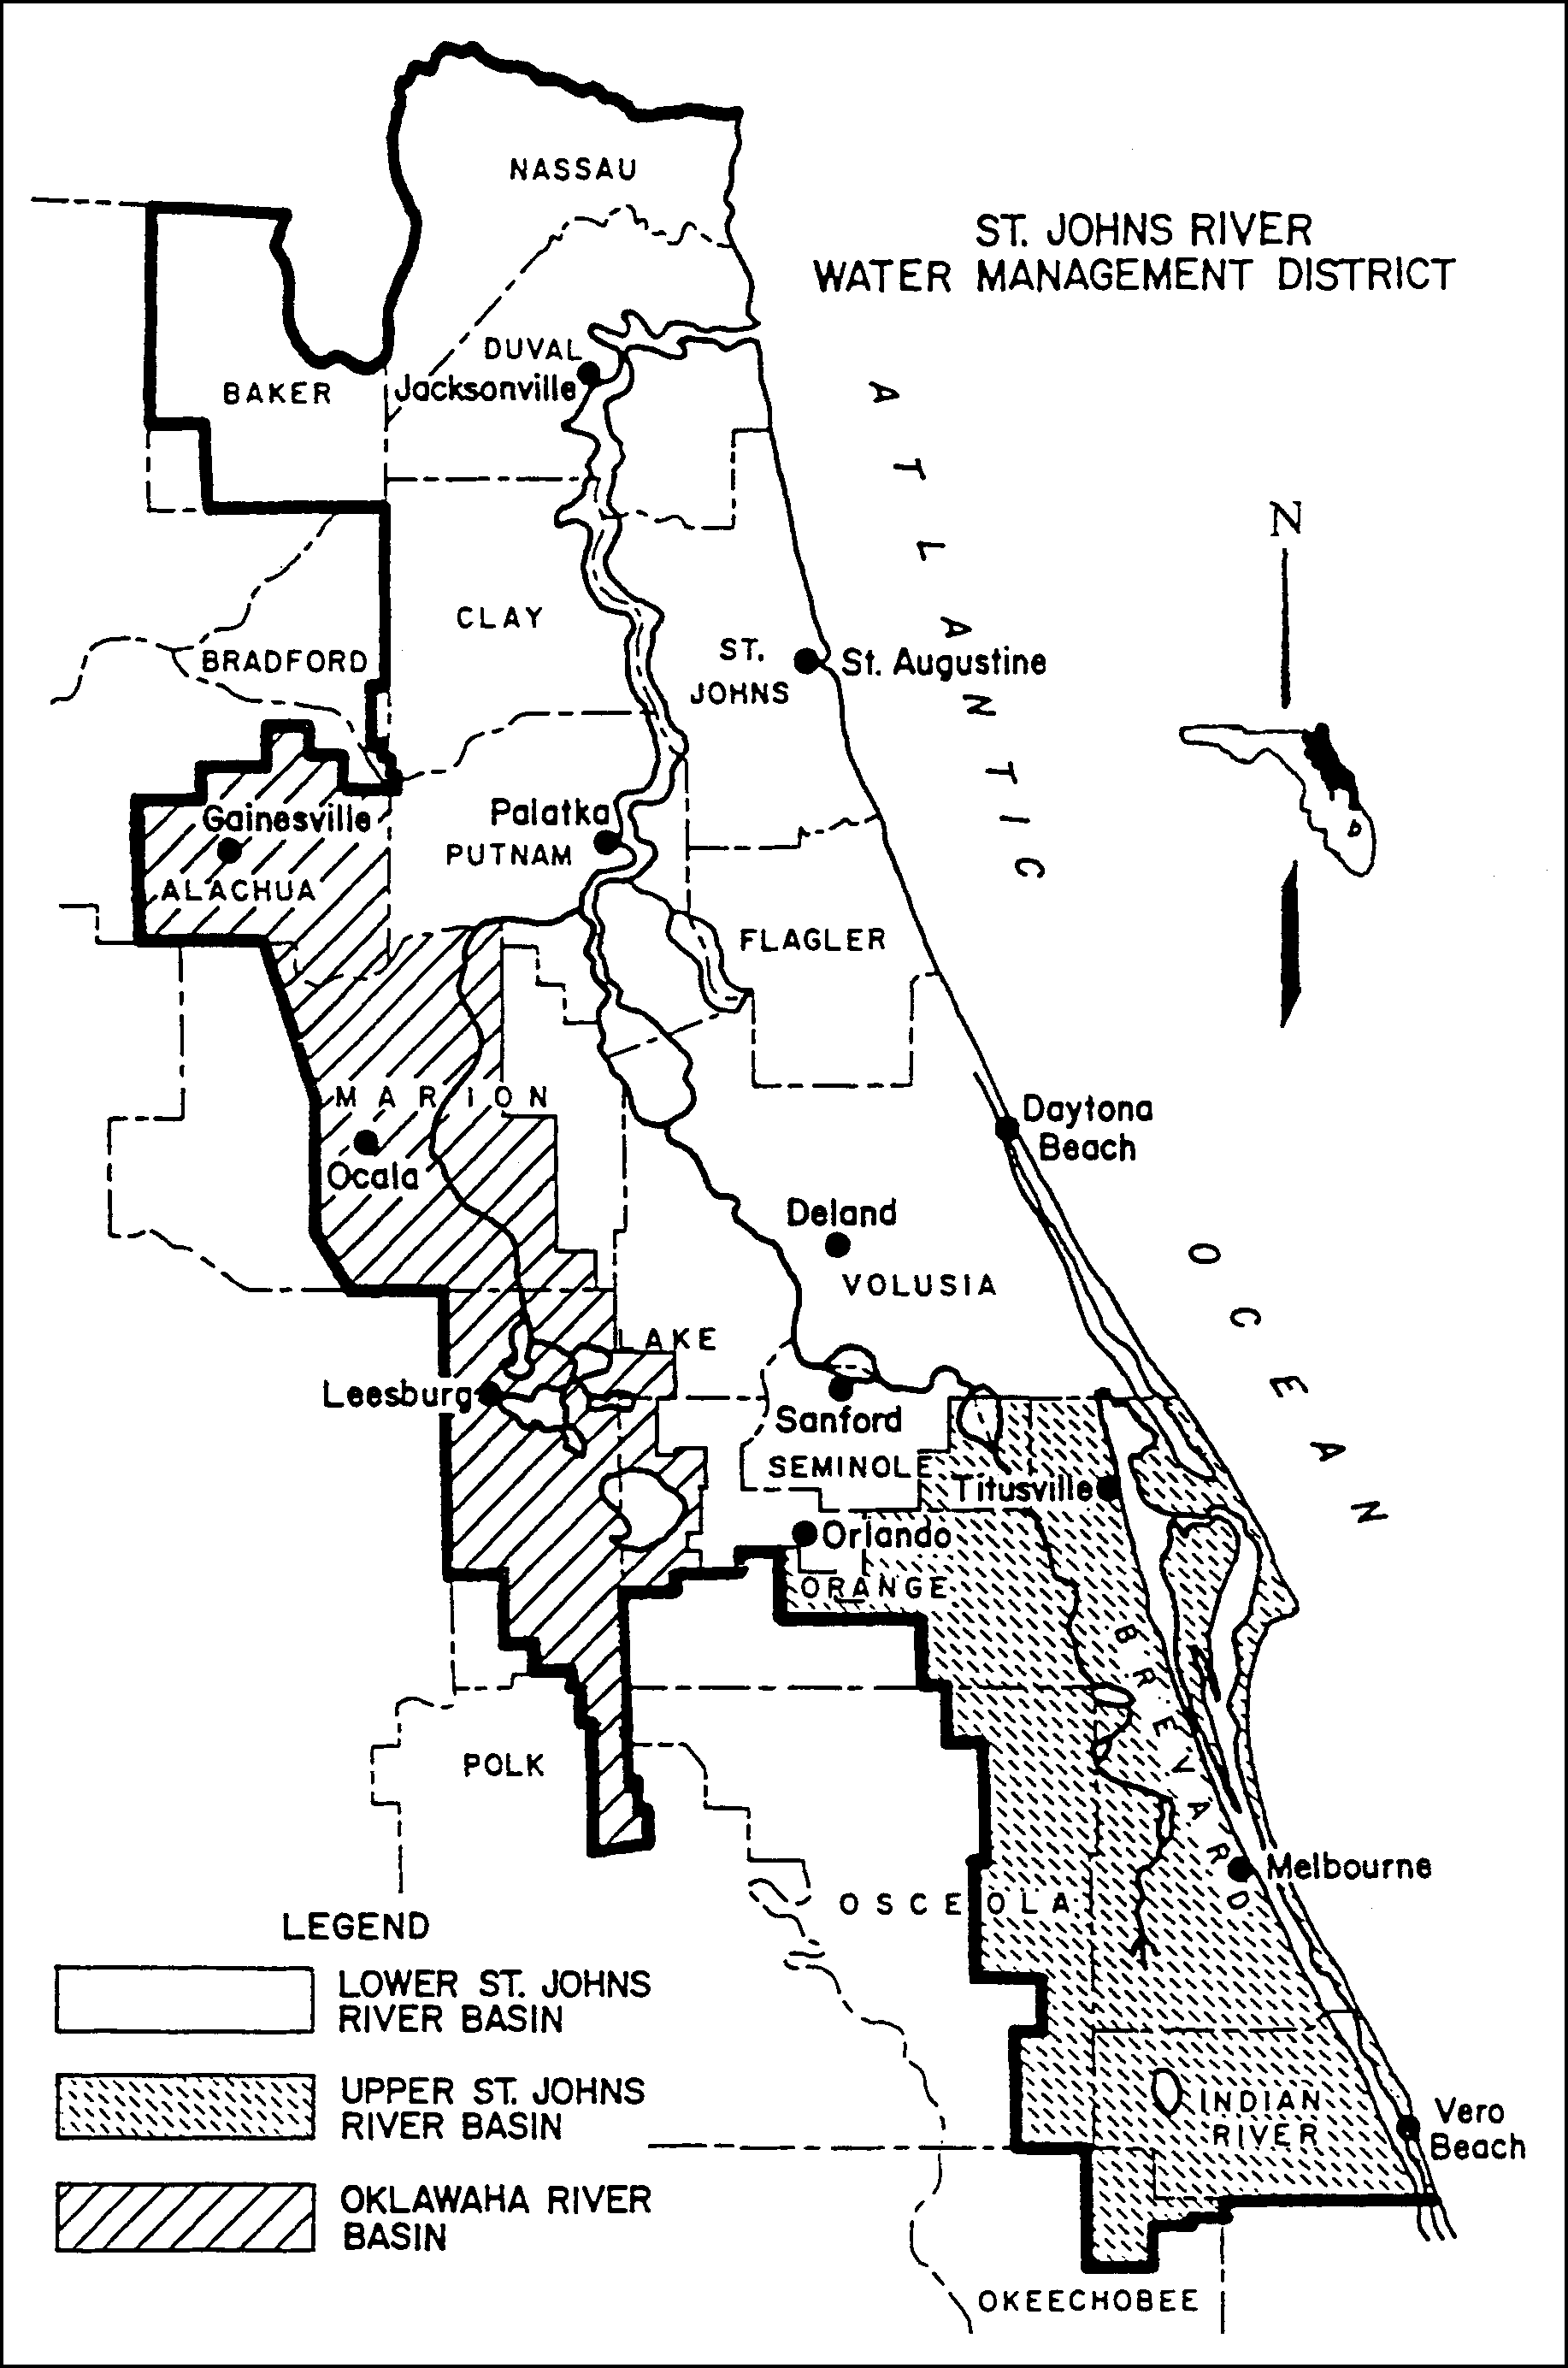

Figure 1.3-1 Areas within the District Having Differing Effective Dates for Implementation of Management and Storage of Surface Water Rules

1.3.3 Agricultural Surface Water Management Systems Revised 6/1/18

Each system that requires an individual permit solely pursuant to section 1.2.3 of this Volume or paragraph 62-330.020(2)(d), F.A.C., shall be exempt from the requirements in rules 62-330.060, 62-330.062, 62-330.090(1),(4) and (6), 62-330.301, 62-330.302, 62-330.310, 62-330.311, 62-330.315, 62-330.320, 62-330.340, and 62-330.350. Permit applications for such systems shall be filed, reviewed and acted upon in accordance with chapter 40C-44, F.A.C., and Part VII of this Volume. Once authorized, such systems shall be constructed, operated and maintained in accordance with 40C-44, F.A.C., and Part VII of this Volume.

PART II – GENERAL CRITERIA

2.0 Criteria for Evaluation – Reasonable Assurance Revised 6/1/18

Except as provided in section 1.2.3 of this Volume, an applicant for an individual permit must provide reasonable assurance that the proposed activities will meet the criteria in rules 62-330.301 and 62-330.302, F.A.C. More specifically, under 62-330.301, F.A.C., an applicant must provide reasonable assurance that the construction, alteration, operation, maintenance, removal or abandonment of a project within SJRWMD:

(a) Will not cause adverse water quantity impacts to receiving waters and adjacent lands (62-330.301(1)(a), F.A.C.);

(b) Will not cause adverse flooding to on-site or off-site property (62- 330.301(1)(b), F.A.C.);

(c) Will not cause adverse impacts to existing surface water storage and conveyance capabilities (62-330.301(1)(c), F.A.C.);

(d) Will not adversely impact the value of functions provided to fish and wildlife and listed species by wetlands and other surface waters (62- 330.301(1)(d), F.A.C.);

(e) Will not adversely affect the quality of receiving waters such that the water quality standards set forth in Chapters 62-4, 62-302, 62-520, and 62-550, F.A.C.,
(incorporated by reference in 40C-4.091(1)(c)) including the antidegradation provisions of paragraphs 62-4.242(1)(a) and (b), F.A.C., subsections 62-4.242(2)
and (3), F.A.C., and Rule 62-302.300, F.A.C., and any special standards for Outstanding Florida Waters and Outstanding National Resource Waters set forth in subsections 62-4.242(2) and (3), F.A.C., will be violated (62-330.301(1)(e), F.A.C.);

(f) Will not cause adverse secondary impacts to the water resources (62- 330.301(1)(f), F.A.C.);

(g) Will not adversely impact the maintenance of surface or ground water levels or surface water flows established pursuant to section 373.042, F.S., (62-330.301(1)(g), F.A.C.);

(h) Will not cause adverse impacts to a Work of the District established pursuant to Section 373.086, F.S. (62-330.301(1)(h), F.A.C.);

(i) Will be capable, based on generally accepted engineering and scientific principles, of being performed and of functioning as proposed (62- 330.301(1)(i), F.A.C.);

(j) Will be conducted by a person with the financial, legal and administrative capability of ensuring that the activity will be undertaken in accordance with the terms and conditions of the permit, if issued (62-330.301(1)(j), F.A.C.); and

(k) Will comply with the applicable special basin or geographic area criteria in Chapter 40C-41, F.A.C. (62-330.301(1)(k), F.A.C.);

The provisions in this Volume and in Volume I explain how applicants may provide the requisite reasonable assurance to demonstrate compliance with these criteria within SJRWMD. In certain instances, an applicant for an individual permit that involves an agricultural surface water management system will be governed solely by Chapter 40C- 44, F.A.C., and Part VII of this Volume. (See subsection 62-330.054(2), F.A.C., and subsections 1.2.3 and 1.3.3 of this Volume.) Therefore, the District recommends that applicants whose projects involve an agricultural surface water management system that only exceeds the thresholds set forth in section 1.2.3 of this Volume initially consult Part VII of this handbook.

2.1 Definitions Revised 6/1/18, 6/28/24

The following definitions are used by the District to clarify its intent in implementing its permitting programs pursuant to part IV, chapter 373, F.S.

(a) “Compensating treatment” means treatment for water quality in an offsite location when physical conditions do not allow for treatment on-site equivalent to that otherwise required by Chapter 62-330, F.A.C., this Volume, or Volume I.

(b) "Control Device" or "Bleed-down Device" means that element of a discharge structure which allows the gradual release of water under controlled conditions.

(c) "Control Elevation" means the lowest elevation at which water can be released through the control device or withdrawn by a stormwater harvesting system.

(d) "Detention with filtration" or "Filtration" means the selective removal of pollutants from stormwater by the collection and temporary storage of stormwater and the subsequent gradual release of the stormwater into surface waters in the state through at least 2 feet of suitable fine textured granular media such as porous soil, uniformly graded sand, or other natural or artificial fine aggregate, which may be used in conjunction with filter fabric and/or perforated pipe.

(e) "Detention" or "To Detain" means the collection and temporary storage of stormwater with subsequent gradual release of the stormwater.

(f) "Effective Grain Size" means the diameter of filter sand or other aggregate that corresponds to the 10 percentile finer by dry weight on the grain size distribution curve.

(g) “Floodway” means the permanent channel of a stream or other watercourse, plus any adjacent floodplain areas that must be kept free of any encroachment in order to discharge the 100-year flood without cumulatively increasing the water surface elevation more than a designated amount (not to exceed one foot except as otherwise established by the District or established by a Flood Insurance Rate Study conducted by the Federal Emergency Management Agency (FEMA) ).

(h) “Hydrologically Sensitive Area” means wetlands and those geographical areas which are specifically designated as hydrologically sensitive areas by the Board because of the importance of the hydrology and hydraulics of the area in meeting the Legislative policy contained in section 373.016, F.S.

(i) "Intermittent Watercourse" means a stream or waterway that flows only at certain times of the year, flows in a direct response to rainfall, and is normally an influent stream except when the ground water table rises above the normal wet season level.

(j) “Littoral Zone” means in reference to stormwater management systems that portion of a wet detention pond which is designed to contain rooted aquatic plants.

(k) "Off-line" means the storage of a specified portion of the stormwater in such a manner so that subsequent runoff in excess of the specified volume of stormwater does not flow into the area storing the initial stormwater.

(l) "Perennial Watercourse" means a stream or waterway which is not an intermittent watercourse.

(m) “Permanent Pool” means that portion of a wet detention pond which normally holds water (e.g., between the normal water level and the pond bottom).

(n) "Reconstruction" means rebuilding or construction in an area upon which construction has previously occurred.

(o) "Retention" means a system designed to prevent the discharge of a given volume of stormwater runoff into surface waters in the state by complete on-site storage. Examples may include excavated or natural depression storage areas, pervious pavement with subgrade, or above ground storage areas.

(p) "Seasonal high ground water table elevation" means the highest level of the saturated zone in the soil in a year with normal rainfall.

(q) "Stormwater Discharge Facility" means a stormwater management system which discharges stormwater into surface waters of the state.

(r) "Stormwater Harvesting" means to prevent the discharge of a given volume of stormwater into surface waters of the state by deliberate application of stormwater for irrigation (such as irrigation of golf courses, cemeteries, highway medians, parks, playgrounds, school yards, retail nurseries, agricultural lands, and residential and commercial properties) or industrial uses (such as cooling water, process water, and wash water).

(s) "Swale" means a manmade trench which:

(1) Has a top width to depth ratio of the cross-section equal to or greater than 6:1, or side slopes equal to or greater than 3 feet horizontal to 1 foot vertical.

(2) Contains contiguous areas of standing or flowing water only following a rainfall event.

(3) Is planted with or has stabilized vegetation suitable for soil stabilization, stormwater treatment, and nutrient uptake.

(4) Is designed to take into account the soil erodibility, soil percolation, slope, slope length, and drainage area so as to prevent erosion and reduce pollutant concentration of any discharge.

(t) “Traversing Work” means any artificial structure or construction that is placed in or across a stream, or other watercourse, or an impoundment.

(u) "Underdrain" means a drainage system installed beneath a stormwater holding area to improve the infiltration and percolation characteristics of the natural soil when permeability is restricted due to periodic high water table conditions or the presence of layers of fine textured soil below the bottom of the holding area. These systems usually consist of a system of interconnected below-ground conduits such as perforated pipe, which simultaneously limit the water table elevation and intercept, collect, and convey stormwater which has percolated through the soil.

(v) "Underground Exfiltration Trench" or "Exfiltration Trench" means a below-ground system consisting of a conduit such as perforated pipe surrounded by natural or artificial aggregate which is utilized to percolate stormwater into the ground.

(w) "Uniformity Coefficient" means the number representing the degree of homogeneity in the distribution of particle sizes of filter sand or other granular material. The coefficient is calculated by determining the D60/D10 ratio where D10 and D60 refer to the particle diameter corresponding to the 10 and 60 percentile of the material which is finer by dry weight.

(x) “Wet Detention” means the collection and temporary storage of stormwater in a permanently wet impoundment in such a manner as to provide for treatment through physical, chemical, and biological processes with subsequent gradual release of the stormwater.

(y) "Wetlands Stormwater Management System" means a stormwater management system which incorporates those wetlands described in section 10.2 of this Volume, into the stormwater management system to provide stormwater treatment.

2.2 Existing Ambient Water Quality

In instances where an applicant is unable to meet water quality standards because existing ambient water quality does not meet standards and the system will contribute to this existing condition, mitigation for water quality impacts can consist of water quality enhancement. In these cases, the applicant must implement mitigation measures that will cause net improvement of the water quality in the receiving waters for those parameters which do not meet standards. (see paragraph 373.414(1)(b), F.S. and section 8.2.3 of Volume I)

2.3 Professional Certification

All construction plans and supporting calculations submitted to the District must be signed, sealed, and dated by the appropriate registered professional (e.g., engineer, geologist, or landscape architect) as required by the relevant statutory provisions (i.e., chapters 471, 472, 481, or 492, F.S.) when the design of the project requires the services of a registered professional.

2.4 Maintenance Access

Regular maintenance is crucial to the long term effectiveness of stormwater management systems. The systems must be designed to permit personnel and equipment access and to accommodate regular maintenance activities. For example, high maintenance features such as inlets, outlets, and pumps should be easily accessible to maintenance equipment and personnel.

Legal authorization, such as an easement, deed restrictions, or other instrument must be provided establishing a right-of-way or access for maintenance of the stormwater management system unless the operation and maintenance entity wholly owns or retains ownership of the property. The following are requirements for specific types of maintenance access easements:

(a) Easements must cover at least the primary and high maintenance components of the system (i.e., inlets, outlets, littoral zones, filters, pumps, etc.).

(b) Easements for waterbodies, open conveyance systems, stormwater basins and storage areas must meet the following requirements:

1. Include the area of the water surface measured at the control elevation

2. Be a minimum of 20 feet from the edge of water at the control elevation or top of bank and include side slopes no steeper than 4H:1V

(c) Easements adjacent to water control structures must be 20 feet wide.

(d) Easements for piped stormwater conveyance must be a minimum of the width of the pipe plus 4 times the depth of the pipe invert.

(e) Access easements must be 20 feet wide from a public road or public right-of-way to the stormwater management system.

(f) As an alternative, the applicant may propose other authorization for maintenance access provided the applicant affirmatively demonstrates that equipment can enter and perform the necessary maintenance on the system.

A copy of the legal authorization must be submitted with the permit application.

2.5 Legal Authorization

Applicants which propose to utilize offsite areas not under their control to satisfy the
criteria for evaluation listed in section 2.0 must obtain sufficient legal authorization prior to permit issuance to use the area. For example, an applicant who proposes to locate the outfall pipe from the stormwater basin to the receiving water on an adjacent property owner's land must obtain a drainage easement or other appropriate legal authorization from the adjacent owner. A copy of the legal authorization must be submitted with the permit application.

2.6 Public Safety

2.6.1 Side Slopes Revised 6/28/24

Normally dry basins designed to impound more than two feet of water or permanently wet basins and ponds must contain side slopes that are no steeper than 4H:1V from design high water out to a depth of two feet below the control elevation. As an alternative, the basins or ponds can be fenced or otherwise protected or restricted from public access if the slopes will be steeper. In determining the sufficiency of other protection or restriction measures, consideration shall be given to the depth and morphometry of the detention or retention area, surrounding land uses, degree of public access, and likelihood of accidental incursion.

Unless restricted from public access, constructed side slopes steeper than 3.5:1 (horizontal:vertical) shall be considered a substantial deviation from the permitted design.

2.6.2 Side Slope Stabilization Revised 6/28/24

All stormwater basin and pond side slopes shall be stabilized by either vegetation or other material to minimize erosion of the basin or pond.

Stabilization of side slopes is necessary in order to prevent erosion due to flow velocity and runoff from the banks. Good engineering practices, taking into consideration soil characteristics, flow and drainage characteristics, shall be employed. Again, the retardation of overland runoff and soil stabilization using naturally occurring vegetation coverage shall be considered before paving, riprap, lining, energy dissipation and other structural measures are employed.

2.6.3 Control Structures

Control structures that are designed to contain more than two feet of water within the
structure under the design storm and have openings of greater than one foot minimum dimension must be restricted from public access.

2.7 Tailwater Considerations

"Tailwater" refers to the water elevation (or pressure) at the final discharge part of the stormwater management system. Tailwater is an important component of the design and operation of nearly all stormwater management systems and can affect any of the following management objectives of the system:

(a) Peak discharge from the stormwater management system

(b) Peak stage in the stormwater management system

(c) Level of flood protection in the project

(d) Recovery of peak attenuation and stormwater treatment volumes

(e) Control elevations, normal water elevation regulation schedules, and ground water management

2.7.1 Tailwater for Water Quality Design Revised 6/1/18

For recovery of the stormwater treatment volume, stormwater management systems
(except retention and exfiltration systems) must provide a gravity or pumped discharge that effectively operates (i.e., meets applicable criteria) under one of the following tailwater conditions:

(a) Maximum stage in the receiving water resulting from the mean annual 24-hour storm. This storm depth is shown on the isopluvial map in Figure 2.7.1-1. Generally, applicants utilizing this option would model the receiving waters utilizing standard hydrologic and hydraulic methods for the mean annual 24-hour storm to determine peak stages at various points of interest. Lower stages may be utilized if the applicant demonstrates that flow from the project will reach the receiving water prior to the time of maximum stage in the receiving water.

(b) Mean annual high tide for tidal areas. This elevation is the average of all the high tides for each year. This elevation may be determined from tide charts or other similar information.

(c) Mean annual seasonal high water elevation. This elevation may be determined by water lines on vegetation or structures, historical data, adventitious roots or other hydrological or biological indicators, design of man-made systems, or estimated by a registered professional using standard hydrological methods based on the site and receiving water characteristics.

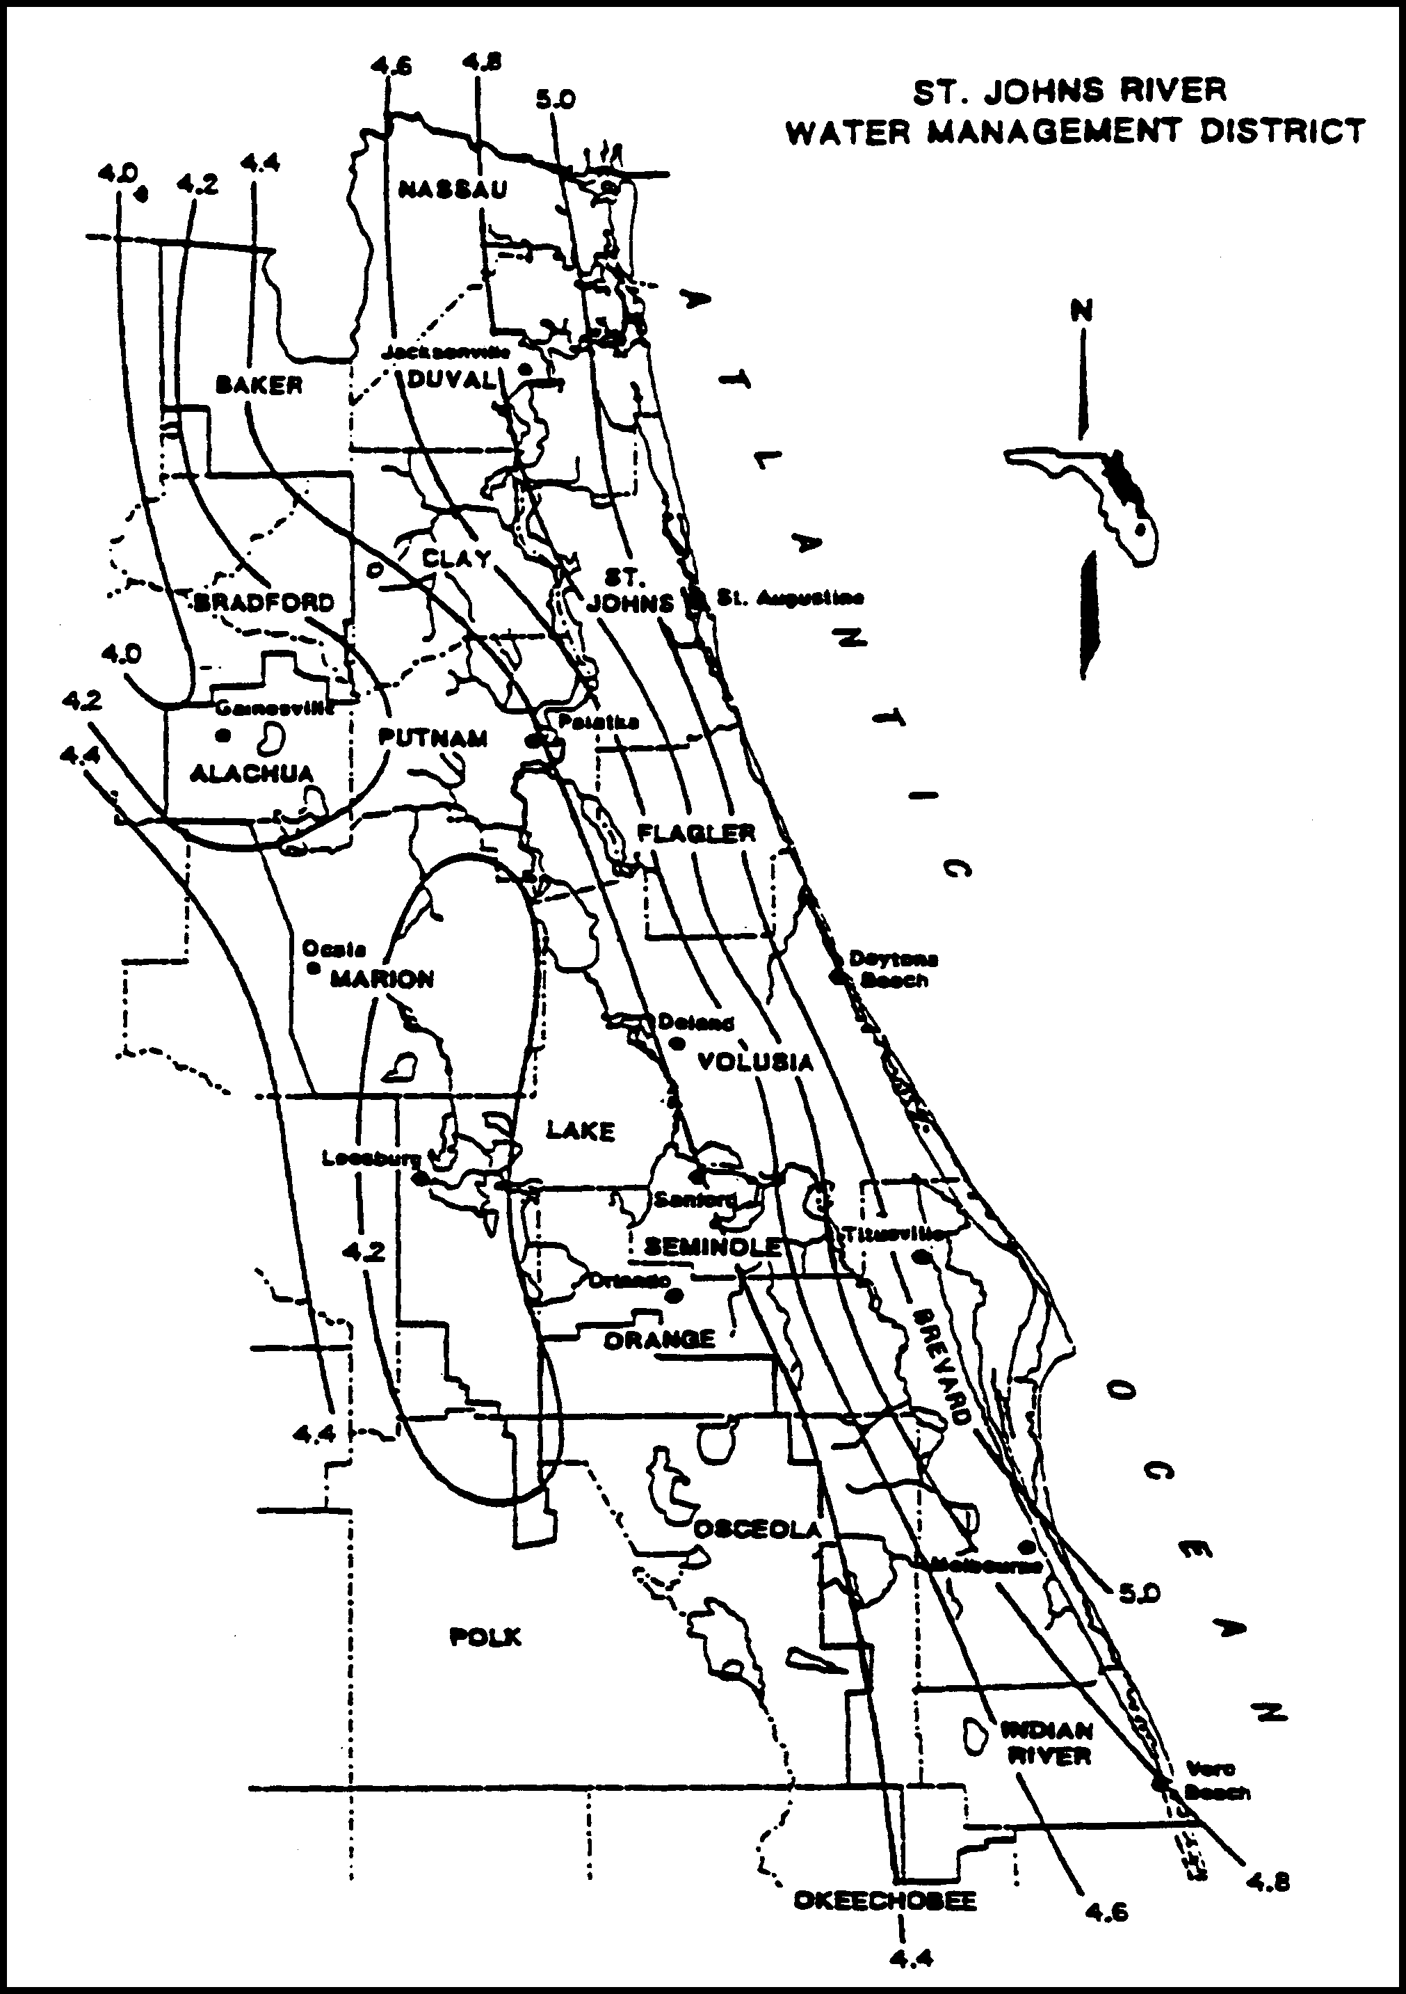

Figure 2.7.1-1 Mean Annual 24-Hour Maximum Rainfall, inches (Source: Rao, 1991)

2.7.2 Tailwater for Water Quantity Design

Receiving water stage can affect the amount of flow which will discharge from the project to the receiving water. This stage may be such that tailwater exists in portions of the project system, reducing the effective flow or storage area. Typical examples of this are illustrated in Figures 2.7.2-1 (gravity) and 2.7.2-2 (pumped).

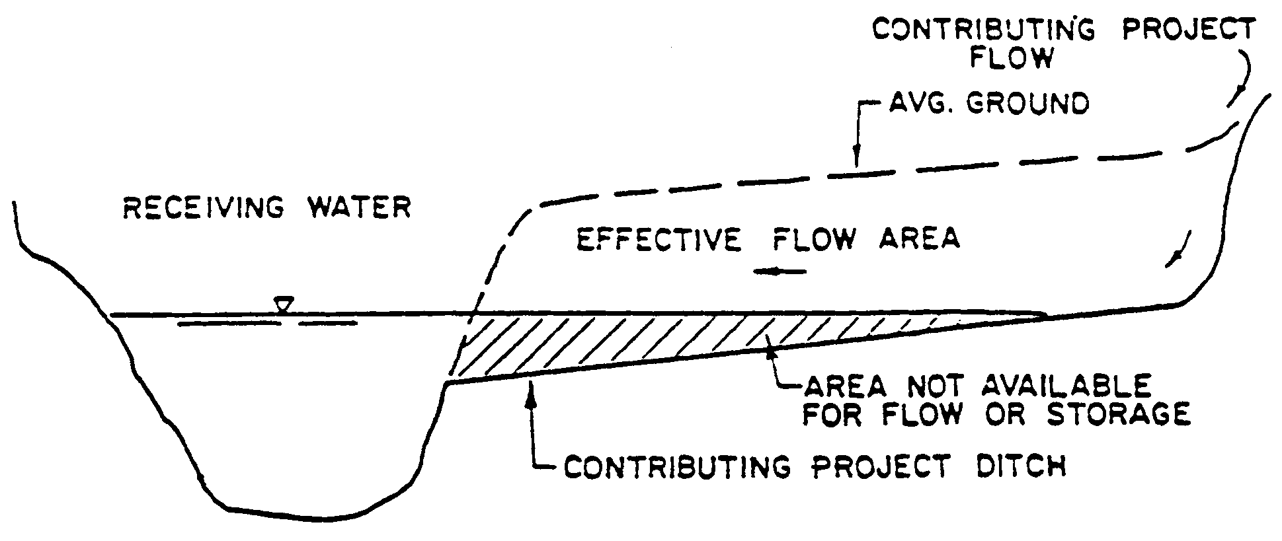
Figure 2.7.2-1

The stage in the receiving water should be considered to be the maximum stage which would exist in the receiving water from a storm equal to the project design storm. Lower stages may be used if the applicant can show that the flow from his project will reach the receiving water prior to the time of maximum stage in the receiving water.

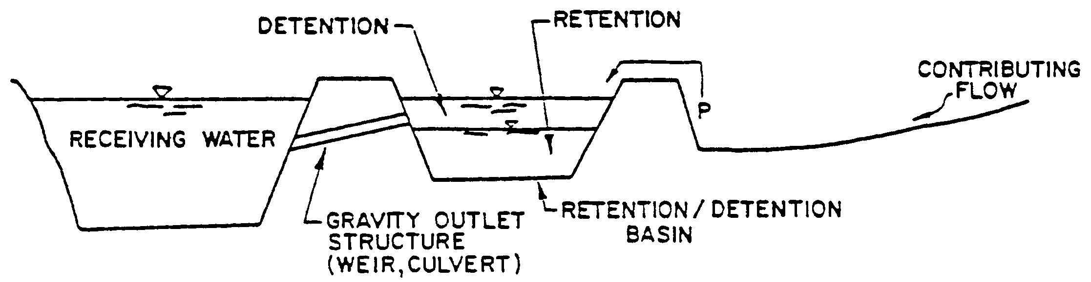

Figure 2.7.2-2

2.8 Applicant Responsibility

Except as provided in Part VII of this Volume, the applicant:

(a) must provide for an operation and maintenance entity as required in Part V of Applicant’s Handbook Volume I.

(b) is responsible for converting the permit from the construction phase to the operation and maintenance phase, as required in Rule 62-330.310 and section 6.1.4 of Applicant’s Handbook Volume I.

(c) is responsible for notifying the Agency of any transfer of permit,
ownership, or sale, including applying to the Agency for transfer of ownership using Form 62-330.340(1) within 30 days of such transfer (Rule 62-330.340, F.A.C.)

2.9 Operation and Maintenance

Except as provided in Part VII of this Volume, all systems under this Volume must be transferred to an operation and maintenance entity as provided in Rule 62-330.340, F.A.C., and Part V of Applicant’s Volume I.

2.10 Retrofits of Existing Surface Water Management Systems

(a) A stormwater retrofit project is typically proposed by a county, municipality, state agency, or water management district to provide new or additional treatment or attenuation capacity, or improved flood control to an existing stormwater management system or systems. Stormwater retrofit projects shall not be proposed or implemented for the purpose of providing the water quality treatment or flood control needed to serve new development or redevelopment.

Example components of stormwater retrofit projects are:

(1) Construction or alteration that will add additional treatment or attenuation capacity and capability to an existing stormwater management system;

(2) Modification, reconstruction, or relocation of an existing stormwater management system or stormwater discharge facility;

(3) Stabilization of eroding banks through measures such as adding attenuation capacity to reduce flow velocities, planting of sod or other vegetation, and installation of rip rap boulders;

(4) Excavation or dredging of sediments or other pollutants that have accumulated as a result of stormwater runoff and stormwater discharges.

(b) Stormwater Quality Retrofits

(1) The applicant for a stormwater quality retrofit project must provide reasonable assurance that the retrofit project itself will, at a minimum provide additional water quality treatment such that there is a net reduction of the stormwater pollutant loading into receiving waters. Examples are:

a. Addition of treatment capacity to an existing stormwater management system such that it reduces stormwater pollutant loadings to receiving waters;

b. Adding treatment or attenuation capability to an existing developed area when either the existing stormwater management system or the developed area has substandard stormwater treatment and attenuation capabilities, compared to what would be required for a new system requiring a permit under Part IV of Chapter 373, F.S.; or

c. Removing pollutants generated by, or resulting from, previous stormwater discharges.

(2) If the applicant has conducted, and the Agency has approved, an analysis that provides reasonable assurance that the proposed stormwater quality retrofit will provide the intended pollutant load reduction from the existing system or systems, the project will be presumed to comply with the requirements in sections 4.0 through 4.5 of this Volume.

(3) The pollutants of concern will be determined on a case-by-case basis during the permit application review based upon factors such as the type and intensity of land use, existing water quality data within the area subject to the retrofit, and the degree of impairment or water quality violations in the receiving waters.

(c) Stormwater Quantity (Flood Control) Retrofits

The applicant for a stormwater quantity retrofit project must provide reasonable assurance that the retrofit project will reduce existing flooding problems in such a way that it does not cause any of the following:

(1) A net reduction in water quality treatment provided by the existing stormwater management system or systems;

(2) Increased discharges of untreated stormwater entering adjacent or receiving waters;

If the applicant has conducted, and the Agency has approved, an analysis that provides reasonable assurance that the stormwater quantity retrofit project will comply with the above, the project will be presumed to comply with the requirements in sections 3.1 through 3.3 of this Volume.

(d) The applicant for any stormwater retrofit project must design, implement, and operate the project so that it:

(1) Will not cause or contribute to a water quality violation;

(2) Does not reduce stormwater treatment capacity or increase discharges of untreated stormwater. Where existing ambient water quality does not meet water quality standards the applicant must demonstrate that the proposed activities will not cause or contribute to a water quality violation. If the proposed activities will contribute to the existing violation, measures shall be proposed that will provide a net improvement of the water quality in the receiving waters for those parameters that do not meet standards.

(3) Does not cause any adverse water quality impacts in receiving waters; or

(4) Will not cause or contribute to increased flooding of adjacent lands or cause new adverse water quantity impacts to receiving waters.

2.11 Above Ground Berms New 6/28/24

Above grade berms greater than three feet high (as measured from the highest berm elevation to the lowest elevation on the downstream slope) on permanently wet ponds must:

a) Contain an emergency overflow spillway designed to prevent overtopping of earthen portions of the berm, and

b) Be designed with a berm stability analysis consistent with generally accepted engineering practices as applied to local conditions, considering such factors as: the type of material used to construct the berm, the type of soils and degree of compaction, pond water level, and construction techniques.

2.12 Flexibility for State Transportation Projects and Facilities

With regard to state linear transportation projects and facilities, the District shall be governed by subsection 373.413(6), F.S. (2012).
PART III – STORMWATER QUANTITY/FLOOD CONTROL

3.0 General Flood Control Performance Criteria

Urbanization increases total runoff volume, peak discharge rates, and the
magnitude and frequency of flood events. With an increase in the number of flood events a stream is subjected to, the potential for accelerated erosion of both the stream banks and channel bottom is enhanced. Proper design of detention systems to limit post-development peak discharge rates to predevelopment rates can minimize some of the stormwater effects of urbanization.

3.1 Projects That Must Meet Water Quantity Criteria

Projects that do not exceed the thresholds listed in paragraphs 3.1 (a)–(h) below shall have a rebuttable presumption that they meet the criteria for issuance in paragraphs 2.0 (a)–(c) if they are designed to meet the standards listed in subsections 3.2.1 (a) and 3.3.1. Projects that exceed any of the thresholds listed in paragraphs 3.1 (a)–(h) shall have a rebuttable presumption that they meet the criteria for issuance in paragraphs 2.0 (a)–(c) if they are designed to meet the standards in subsections 3.2.1, 3.3.1, 3.3.2, 3.4.1, 3.5.1 and 3.5.2.

(a) Is capable of impounding a volume of water of 40 or more acre- feet;

(b) Serves a project with a total land area equal to, or exceeding 40 acres;

(c) Provides for the placement of 12 or more acres of impervious surface which constitutes 40 or more percent of the total land area;

(d) Is wholly or partially located in, on, or over any wetland or other surface water.

(e) Serves a project with a total land area equal to or exceeding ten acres, when any part of the project is located within the Wekiva River Hydrologic Basin north of State Road 436, within the Econlockhatchee River Hydrologic Basin, within the Tomoka River Hydrologic Basin, or within the Spruce Creek Hydrologic Basin;

(f) Provides for the placement of one-half acre or more of impervious surface, when any of the impervious surface is located within the Wekiva River Hydrologic Basin north of State Road 436;

(g) Provides for the placement of two acres or more of impervious surface, when any of the impervious surface is located within the Econlockhatchee River Hydrologic Basin, within the Tomoka River Hydrologic Basin, or within the Spruce Creek Hydrologic Basin; or

(h) Is wholly or partially located within the Wekiva River Hydrologic Basin's Riparian Habitat Protection Zone as described in Paragraph 40C-41.063(3)(e).

3.2 Design Standards for Flood Protection

3.2.1 Water Quantity Revised 6/1/18

(a) The post-development peak discharge rate must not exceed the pre-development peak rate of discharge for the mean annual 24- hour storm for systems serving both of the following:
(1) New construction area greater than 50% impervious (excluding waterbodies)

(2) Projects for the construction of new developments that exceed the thresholds in paragraphs 62-330.020(2)(b) or (c), F.A.C.
Note: Both of these conditions must be met before a project is required to comply
with the peak discharge criterion. Also, projects which modify existing systems are exempt from this criterion pursuant to condition 2., above. Pervious concrete and turf blocks are not considered impervious surface for this purpose, however,
compacted soils and limerock are considered impervious for purposes of this subsection.

(b) The post-development peak rate of discharge must not exceed the pre-development peak rate of discharge for the 25-year frequency, 24-hour duration storm for all areas of the District except:
(1) For those systems which discharge directly into the St. Johns River north of Lake George, the man-made portions of the Intracoastal Waterway, the Intracoastal Waterway north of the Matanzas Inlet, or the Atlantic Ocean.

(2) Where separate basin criteria have been adopted (see section 13.0 of this Volume). Projects located in areas for which
separate basin criteria have been developed must meet the flood protection design standards specified by the basin criteria.
(c) The post-development volume of direct runoff must not exceed the pre-development volume of direct runoff for the 25-year frequency, 96-hour duration storm for systems discharging to land- locked lakes which are adjacent to properties of more than one ownership. These systems shall not cause an increase in the total pre-development flood stage. This can be accomplished through retention with percolation or, if the soil conditions are not sufficient for percolation, then through detention for a duration sufficient to mitigate adverse impacts on flood stages.
(d) Systems which are within areas for which separate basin criteria have been adopted pursuant to Chapter 40C-41, F.A.C., must meet the applicable volume and rate requirements found in section 13.0 of this
Volume.

3.2.2 Alternative Peak Discharge Criteria

The applicant has two options for providing reasonable assurances that the standards referenced in subsection 3.2.1 (a) and (b) are met. The applicant may make such demonstration through compliance with the criteria specified in subsection 3.2.1 (a) and (b) or applicants may propose to utilize the applicable storm event duration, or criteria specified by a local government, state agency (including FDOT), or stormwater utility with jurisdiction over the project or by use of alternative methods as may be appropriate for the specific system. However, the District must review and approve the use of the alternative criteria. Applicants proposing to use alternative criteria are encouraged to have a preapplication conference with District staff.

3.2.3 Methodologies

(a) A peak discharge analysis typically consists of generating pre- development and post-development runoff hydrographs, routing the post-development hydrograph through a detention basin, and sizing an overflow structure to control post-development discharges at or below predevelopment rates.

Peak discharge computations should consider the duration, frequency, and intensity of rainfall, the antecedent moisture conditions, upper soil zone and surface storage, time of concentration, tailwater conditions, changes in land use or land cover, and any other changes in topographic and hydrologic characteristics. Large systems should be divided into subbasins according to artificial or natural drainage divides to allow for more accurate hydrologic simulations.

The Natural Resources Conservation Service (NRCS) Curve Number Method is an example of an accepted methodology (see SJ No. 85-5: A Guide to SCS Runoff Procedures (1985) and incorporated by reference in 40C-4.091(1)(e)).

(b) The modified rational method (see Appendix C of this Volume, incorporated
by reference in 40C-4.091(1)(a)) is a popular method for estimating peak
runoff rates for small urban areas. The rational method gives peak discharge
rates rather than a runoff hydrograph. The modified rational formula can be
modified to generate a runoff hydrograph by utilizing the rainfall intensity
for various increments of a design storm. Similar to the rational method, use
of the modified rational hydrograph method should be limited to small
drainage basins with short times of concentration. Therefore, the modified
rational method shall only be used for systems meeting the following
criteria:

(1) The drainage area is less than 40 acres.

(2) The predevelopment time of concentration for the system is less than 60 minutes.

(3) The post-development time of concentration for the system is less than 30 minutes.

The modified rational hydrograph method shall only be utilized for the mean annual return frequency, 24-hour duration storm.

3.2.4 Computer Programs Accepted by the District

Numerous computer programs have been written to solve the runoff hydrograph and detention basin routing calculations required in a peak discharge analysis. If the model is sound from a theoretical standpoint and the results compare favorably with those of a benchmark standard model (such as HEC-1), the program is accepted for use.

3.2.5 Aggregate Discharge

Depending on the location and design of large systems where multiple off-site
discharges are designed to occur, the District may allow the total post-development
peak discharge not to exceed the pre-development peak discharge for the combined
discharges rather than for each individual discharge. Such a consideration shall be
made only if the combined discharges meet all other requirements of chapter 62-
330, F.A.C., and discharge to the same receiving water body.

3.2.6 Rainfall Intensity Revised 6/28/24

In determining peak discharge rates, intensity of rainfall values shall be obtained
through a statistical analysis of historical long term rainfall data or from sources or
methods generally accepted as good engineering practice.

(a) Examples of acceptable sources include:

(1) U.S. Weather Bureau Technical Paper No. 40.

(2) St. Johns River Water Management District, “Rainfall Analysis for Northeast Florida,” Technical Publication No. 88-3, Palatka, Florida.

(b) For a drainage basin greater than 10 square miles, the areal rainfall can be calculated from point rainfall using a method that has been well documented. The converting factor as described in U.S. Weather Bureau Technical Paper No. 49 may be used.

3.2.7 System Recovery

Where basins are designed for reducing post-development peak rate discharge and volume, the outlet and regulation schedule should be designed to provide necessary design detention and retention storage within 14 days following any storm event.

3.2.8 Upper Soil Zone Storage and Surface Storage

In most instances, the upper soil zone storage and surface storage capacities will have an effect on the pre-development and post-development peak discharges and should be considered in these computations. Any generally accepted and well documented method may be used to develop the upper soil zone storage and surface storage values.

(a) The soil zone storage at the beginning of a storm should be estimated by
using reasonable and appropriate parameters to reflect drainage practices,
average wet season water table elevation, the antecedent moisture condition
(AMC II) and any underlying soil characteristics which would limit or
prevent percolation of storm water into the entire soil column. In no case
should the soil storage used in the computation exceed the difference
between the maximum soil water capacity and the field capacity (i.e.,
gravitational water) for the soil columns above any impervious layer or
seasonal ground water table.

(b) Surface storage, including that available in wetlands and low lying areas,
shall be considered as depression storage. Depression storage shall be
analyzed for its effect on peak discharge and the time of concentration.
Depression storage can also be considered in post-development storage
routing which would require development of stage-storage relationships;
if depression storage is considered, then both pre-development and post-
development storage routing must be considered.

3.3 Storage and Conveyance

3.3.1 Conveyance Revised 6/1/18

Projects which alter existing conveyance systems (e.g., rerouting an existing ditch) must not adversely affect existing conveyance capabilities. It is presumed a system will meet this criterion if one of the following are met:

(a) The existing hydraulic capacity is maintained in the new system. This can be accomplished by maintaining existing headwater and tailwater conditions.

(b) The applicant demonstrates that changes in flood elevation and velocities will not adversely impact upstream or downstream off- site property. For example, this criterion may be satisfied by demonstrating that there is no increase in damages to existing off- site property (e.g., roads, buildings) resulting from changes in the existing flood elevations. Also, the applicant should demonstrate that proposed velocities are non-erosive or that erosion control measures (e.g., rip-rap, concrete lined channels, etc.) are sufficient to safely convey the flow.

(c) The criterion in paragraph 3.3.2(b) is met.

3.3.2 Floodways and Floodplain Storage

Floodways and floodplains, and levels of flood flows or velocities of adjacent streams, impoundments or other water courses must not be altered so as to adversely impact the off-site storage and conveyance capabilities of the water resource. It is presumed a system will meet this criterion if the following are met:

(a) A system may not cause a net reduction in flood storage within a 10-year floodplain except for structures elevated on pilings or traversing works. Traversing works, works or other structures shall cause no more than a one-foot increase in the 100-year flood elevation immediately upstream and no more than one tenth of a foot increase in the 100-year flood elevation 500 feet upstream. A system will not cause a net reduction in flood storage within a 10-year floodplain if compensating storage is provided outside the 10-year floodplain.

(b) A system may not cause a reduction in the flood conveyance capabilities provided by a floodway except for structure elevated on pilings or traversing works. Such works, or other structures shall cause no more than a one-foot increase in the 100-year flood elevation immediately upstream and no more than one-tenth of a foot increase in the 100-year flood elevation 500 feet upstream.

(c) An applicant may only be permitted to contravene the requirements of (a) or (b) if the applicant gives reasonable assurance that were all other persons who could impact the surface water of any impoundment, stream, or other watercourse by floodplain encroachment to exceed (a) and (b) above to the same degree as the applicant proposes, the cumulative impacts would not contravene subparagraphs 62-330.301(1)(a)-(c), F.A.C.

3.3.3 Level of Service Revised 6/1/18, 6/28/24

As part of providing reasonable assurance that the criteria in paragraphs 2.0(a)-(c) will be met, the applicant must demonstrate that the elevation of any proposed streets and roadways and the first floor of any proposed building will be set at or above the elevation associated with the peak stage of the applicable design storm pursuant to section 3.2.1 of this Volume.

3.3.4 Floodway and Floodplain Elevation Determination

(a) The floodway and floodplain criteria contained in subsection 3.3.2 are applicable only to locations downstream of the point on a stream or watercourse where the drainage area is five square miles.

(b) The District has detailed information regarding floodplain and floodway
elevations for many of the streams and water courses in its jurisdiction. The
applicant is encouraged to consult with the District prior to making
calculations. Other sources of information include the most recently
published data from flood insurance rate studies or relevant engineering
reports. If data are not available from the District, the flood insurance rate
studies, or published reports, the applicant will be responsible for making
determination of floodplain elevations or floodway limits using the
procedure of "Normal Depth Analysis", extrapolation of existing data, or any
other acceptable technique.

3.3.5 Flow Velocity

Good engineering practices shall be employed to minimize the flow velocity to avoid transport of soil particles and other suspended solids from one location and deposition in another location. Many different measures, structural or non- structural, may be used to reduce erosion from the bottom and side slopes of a conveyance system or around the control structures. However, velocity reduction measures and re-vegetation with naturally occurring species of the area should be considered before using other methods of bottom and side slope consolidation.

3.4 Dams and Impoundments Revised 6/28/24

3.4.1 Dams greater than six feet in height or which have a storage capacity of greater than 15 acre-feet of water which could be released in the event of dam failure shall have a spillway system with a capacity to pass the flow resulting from the design storm indicated in Table 3.4.1-1, without overtopping the dam unless the applicant provides analyses to show that the design flood can be stored, passed through, or passed over the dam without failure occurring.

TABLE 3.4.1-1

Downstream  Hazard Potential  Classification |  |  | Design  Storm  (24-hour)
Low |  |  | 100-yr.
Significant
 |  |  | 1/2 PMP
High
 |  |  | PMP

See Appendix L of Volume I to determine the Downstream Hazard Potential classifications. “PMP” means Probable Maximum Precipitation.

3.4.2 Dams greater than six feet in height or which have a storage capacity of greater than 15 acre-feet of water which could be released in the event of dam failure shall have a spillway system capable of removing from the reservoir at least 80% of the water detained in the reservoir above the principal spillway within ten days after passage of the design storm.

3.5 Low Flow and Base Flow Maintenance

Flows of adjacent streams, impoundments or other water courses must not be decreased so as to cause adverse impacts.

3.5.1 Low Flow

(a) Only systems with both of the following conditions meet the low flow
performance criteria in (b) and (c).

(1) Systems which impound water for purposes in addition to temporary
detention storage. Water impounded longer than a 14-day bleed
down period is considered conservation storage for benefits other
than detention storage (i.e., recreation, irrigation, etc.).

(2) Systems that impound a stream or other water course which, under
pre-development conditions, discharged surface water off-site to
receiving water during 5-year, 30-day drought frequency conditions.

(b) Any system meeting the conditions of (a) above shall be designed with an outlet structure to maintain a low flow discharge of available conservation storage. When the conservation storage is at the average dry season design stage, the low flow discharge should equal the average pre-development surface water discharge which occurred from the project site to receiving waters during the 5-year, 30-day drought.

(c) The system shall be operated to provide a low flow discharge whenever water is impounded. However, discharge may be discontinued, if desired, during the wet season (considered as June through October) unless a water shortage condition is declared by the District. The actual discharge will vary according to the water stage in the impoundment. When conservation storage is at the average dry season design stage, the discharge will be the average 5 year, 30-day low flow. When storage is below the average dry season design stage, the discharge may be less than the average 5-year, 30-day low flow.

3.5.2 Base Flow Revised 6/1/18

It is presumed that an adverse impact will result if the system causes the ground water table to be lowered:

(a) more than an average three feet lower over the project area than the average dry season low water table; or

(b) at any location, more than five feet lower than the average dry season low water table; or

(c) to a level that would decrease flows or levels below any minimum level or flow established pursuant to section 373.042, F.S.

PART IV – STORMWATER QUALITY

4.0 Criterion

Under 62-330.301, F.A.C., an applicant must provide reasonable assurance that the construction, alteration, operation, maintenance, removal or abandonment of a project will not adversely affect the quality of receiving waters such that the water quality standards set forth in Chapters 62-4, 62-302, 62-520, and 62-550, F.A.C., will be violated.

4.1 State Water Quality Standards

State water quality standards are established by DEP and are set forth in chapters 62-4, 62-302, 62-520 and 62-550, F.A.C. Surface and ground water discharges from stormwater management systems, works, and other projects may not cause or contribute to a violation of state water quality standards.

4.1.1 Surface Water Quality Standards

State water quality standards for surface waters are contained in chapters 62-4 and 62-302, F.A.C. The standards apply at the point of mixing of discharge from the system with waters of the state.

4.1.2 Ground Water Quality Standards

State water quality standards for ground water are set forth in chapter 62-520, F.A.C. In addition to the minimum criteria, Class G-I and G-II ground water must meet primary and secondary drinking water quality standards for public water systems established pursuant to the Florida Safe Drinking Water Act, which are listed in sections 62-550.310 and 62-550.320, F.A.C., (incorporated by reference in 40C-
4.091(1)(c)).

Only the minimum criteria apply within a zone of discharge, as determined in section 62-520.400, F.A.C., (incorporated by reference in 40C-4.091(1)(c)). A zone of discharge is defined as a volume underlying or surrounding the site and extending to the base of a specifically designated aquifer or aquifers, within which an opportunity for the treatment, mixture or dispersion of wastes into receiving ground water is afforded. Generally, stormwater systems have a zone of discharge 100 feet from the system boundary or to the project's property boundary, whichever is less.
4.1.3 How Standards May be Met Revised 6/28/24
A showing by the applicant that a project complies with the applicable criteria in Part II and subsections 13.3.1, 13.3.3, and 13.5.3 and sections 13.6 through 13.7 of this Volume and in Parts II and IV of Volume I shall create a rebuttable presumption that the applicant has provided reasonable assurance that the proposed project meets the requirements in subsection 2.0(e) and rule 62-330.301(1)(e), F.A.C.

4.2 Erosion and Sediment Control Criteria for Stormwater Management Systems,
Works and other Projects

Land clearing actions, including the construction of stormwater management systems or works, shall be designed, constructed, and maintained at all times so that erosion and sedimentation from the system, including the areas served by the system, do not cause or contribute to violations of applicable water quality standards in receiving waters. Further, because sedimentation of off-site lands can lead to public safety concerns, erosion and sediment controls shall be designed and implemented to retain sediment on-site. In particular, the erosion and sediment control requirements described in Part IV of Applicant’s Handbook Volume I shall be followed during construction of the system.

4.3 Oil and Grease Control Repealed 6/28/24

4.4 On-Line and Off-line Stormwater Systems Revised 6/1/18, Repealed 6/28/24

4.5 Hazardous or Toxic Substances Repealed 6/28/24

PART V – BEST MANAGEMENT PRACTICES (BMPs)

5.0 Retention System Design and Performance Criteria

5.1 Description Revised 6/1/18, 6/28/24

Retention system is defined as a storage area designed to store a defined quantity of runoff, allowing it to percolate through permeable soils into the shallow ground water aquifer. Stormwater retention works best using a variety of retention systems throughout the project site. Examples of retention systems include:

- Man-made or natural depressional areas where the floor is graded as flat as possible and turf is established to promote infiltration and stabilize the basin slopes (see Figure 5-1)

- Shallow landscaped areas designed to store stormwater

- Vegetated swales with swale blocks or raised inlets

- Pervious concrete with continuous curb

Soil permeability and water table conditions must be such that the retention system can percolate the desired runoff volume within a specified time following a storm event. After drawdown has been completed, the basin does not hold any water, thus the system is normally "dry." Unlike detention basins, the treatment volume for retention systems is not discharged to surface waters.

Retention systems should not be located in close proximity to drinking water supply wells. See section 8.5.2 of Volume I for additional permitting requirements to protect groundwater. Chapter 40C-41, F.A.C., provides additional design features for systems constructed in Sensitive Karst Areas of the District where the drinking water aquifer is close to the land surface (see section 13.6).

Besides pollution control, retention systems can be utilized to promote the recharge of ground water to prevent saltwater intrusion in coastal areas or to maintain groundwater levels in aquifer recharge areas. Chapter 40C-41, F.A.C., contains recharge criteria for the Wekiva Recharge Protection Basin and the Tomoka River and Spruce Creek Hydrologic Basins (see sections 13.3.1 and 13.5.1). Retention systems can also be used to meet the runoff volume criteria for projects which discharge to land-locked lakes (see section 3.2 of this Volume).

There are several design and performance criteria specific to retention systems which are described below.

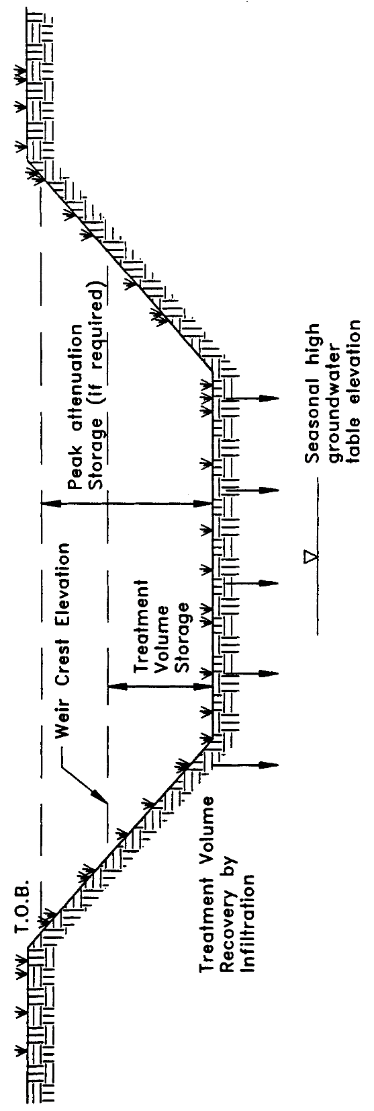

Figure 5-1. Retention (N.T.S.)

5.2 Treatment Volume Revised 6/28/24

The first portion of runoff should be routed to the retention basin and percolated into the ground to meet the treatment criteria in sections 8.3 and 9.0 of Volume I.
5.3 Recovery Time

The retention system must provide the capacity for the appropriate treatment volume of stormwater specified in section 5.2 within 72 hours following a storm event assuming average antecedent moisture conditions. In retention systems, the stormwater is drawn down by natural soil infiltration and dissipation into the ground water table, evaporation, or evapotranspiration, as opposed to underdrain systems which rely on artificial methods like drainage pipes.

Antecedent moisture condition (AMC) refers to the amount of moisture and storage in the soil profile prior to a storm event. Antecedent soil moisture is an indicator of wetness and availability of soil to infiltrate water. The AMC can vary from dry to saturated depending on the amount of rainfall received prior to a given point in time. Therefore, "average AMC" means the soil is neither dry or saturated, but at an average moisture condition at the beginning of a storm event when calculating recovery time for retention systems.

The antecedent condition has a significant effect on runoff rate, runoff volume, infiltration rate, and infiltration volume. The infiltration volume is also known as the upper soil zone storage. Both the infiltration rate and upper soil zone storage are used to calculate the recovery time of retention systems and should be estimated using any generally accepted and well documented method with appropriate parameters to reflect drainage practices, seasonal high water table elevation, the AMC, and any underlying soil characteristics which would limit or prevent percolation of storm water into the soil column.

5.4 Safety Factor New 6/28/24

The retention system must be designed with a safety factor of at least two unless the applicant affirmatively demonstrates based on plans, test results, calculations or other information that a lower safety factor is appropriate for the specific site conditions. Examples of how to apply this factor include but are not limited to the following:

(a) Reducing the design percolation rate by half

(b) Designing for the required drawdown within 36 hours instead of 72 hours.

5.5 Basin Stabilization

The retention basin should be stabilized with pervious material or permanent vegetative cover. To provide proper treatment of the runoff in very permeable soils, permanent vegetative cover must be utilized when U.S. Department of Agriculture Natural Resources Conservation Service (SCS) hydrologic group "A" soils underlie the retention basin, except for pervious pavement systems.

5.6 Retention Basin Construction

5.6.1 Overview

Retention basin construction procedures and the overall sequence of site construction are two key factors that can control the effectiveness of retention basins. Sub-standard construction methods or construction sequence can render the basin inoperable prior to completion of site development.

5.6.2 Construction Requirements Revised 6/28/24

The following construction procedures are recommended to avoid degradation of retention basin infiltration capacity due to construction practices (Andreyev and Wiseman 1989):

(a) Initially construct the retention basin to rough grade by under-excavating the basin bottom and sides by approximately 12 inches.

(b) After the drainage area contributing to the basin has been fully stabilized, the interior side slopes and basin bottom should be excavated to final design specifications. The excess soil and undesirable material should be carefully excavated and removed from the pond so that all accumulated silts, clays, organics, and other fine sediment material has been removed from the pond area. The excavated material should be disposed of beyond the limits of the drainage area of the basin.

(c) Once the basin has been excavated to final grade, the entire basin bottom should be deep raked and loosened for optimal infiltration.

(d) Finally, the basin should be stabilized according to section 5.5, above.

5.7 References

Andreyev, N.E., and L.P. Wiseman. 1989. Stormwater Retention Pond Infiltration Analysis in Unconfined Aquifers. Prepared for Southwest Florida Water Management District, Brooksville, Florida.
6.0 Underdrain Design and Performance Criteria

6.1 Description

Stormwater underdrain systems consist of a dry basin underlain with perforated drainage pipe which collects and conveys stormwater following percolation from the basin through suitable soil. Underdrain systems are generally used where high water table conditions dictate that recovery of the stormwater treatment volume cannot be achieved by natural percolation (i.e., retention systems) and suitable outfall conditions exist to convey flows from the underdrain system to receiving waters. Schematics of a typical underdrain system are shown in Figures 6-1 and 6-2.

Underdrain systems are intended to control both the water table elevation over the entire area of the treatment basin and provide for the drawdown of the treatment volume. Underdrains are utilized where the soil permeability is adequate to recover the treatment volume since the on-site soils overlay the perforated drainage pipes.

There are several design and performance criteria which must be met in order for a underdrain system to meet the rule requirements. The underdrain rule criteria are described below.

6.2 Treatment Volume Revised 6/28/24

The first portion of runoff should be detained in a dry detention basin and percolated through the soil to meet the treatment criteria in sections 8.3 and 9.0 of Volume I. Nutrient loads from groundwater that enter and are discharged from the underdrain system must be accounted for when designing underdrains systems to meet the stormwater nutrient permitting requirements of Volume I.

6.3 Recovery Time

The system should be designed to provide for the drawdown of the appropriate treatment volume specified in section 6.2 within 72 hours following a storm event. The treatment volume is recovered by percolation through the soil with subsequent transport through the underdrain pipes. The system should only contain standing water within 72 hours of a storm event.

The pipe system configuration (e.g., pipe size, depth, pipe spacing, and pipe inflow capacity) of the underdrain system must be designed to achieve the recovery time requirement.

6.4 Safety Factor

The underdrain system must be designed with a safety factor of at least two unless the applicant affirmatively demonstrates based on plans, test results, calculations or other information that a lower safety factor is appropriate for the specific site conditions. Examples of how to apply this factor include but are not limited to the following:

(a) Reducing the design percolation rate by half

(b) Designing for the required drawdown within 36 hours instead of 72 hours.

6.5 Underdrain Media

To provide proper treatment of the runoff, at least two feet of indigenous soil must be between the bottom of the basin storing the treatment volume and the outside of the underdrain pipes (or gravel envelope as applicable).

6.6 Filter Fabric

Underdrain systems shall utilize filter fabric or other means to prevent the soil from moving into and clogging perforated pipe.

6.7 Inspection and Cleanout Ports

To facilitate maintenance of the underdrain system, capped and sealed inspection and cleanout ports which extend to the surface of the ground should be provided, at a minimum, at the following locations for each drainage pipe:

(a) The terminus

(b) At every 400 feet or every bend of 45 or more degrees, whichever is shorter.

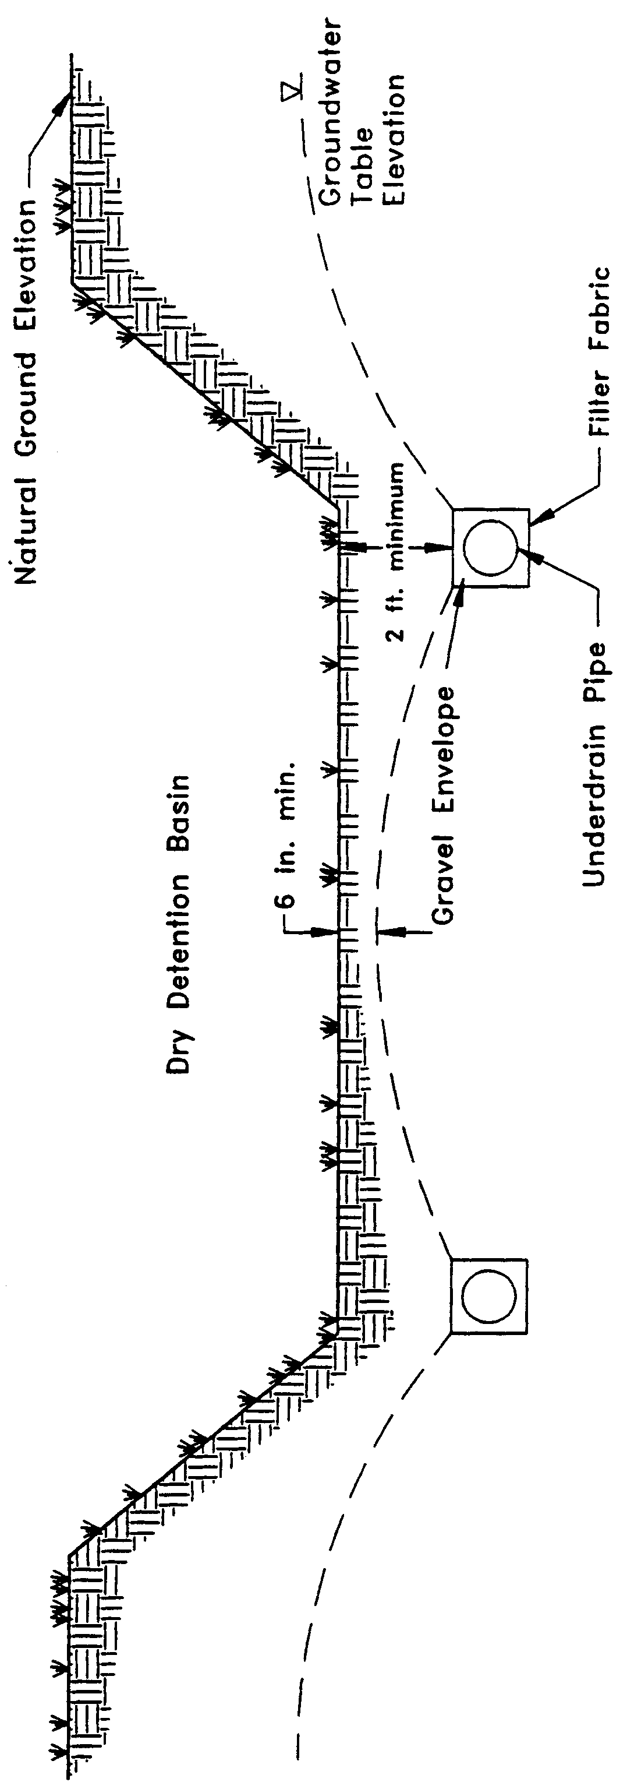

Figure 6-1. Cross-section of underdrain system (N.T.S.)

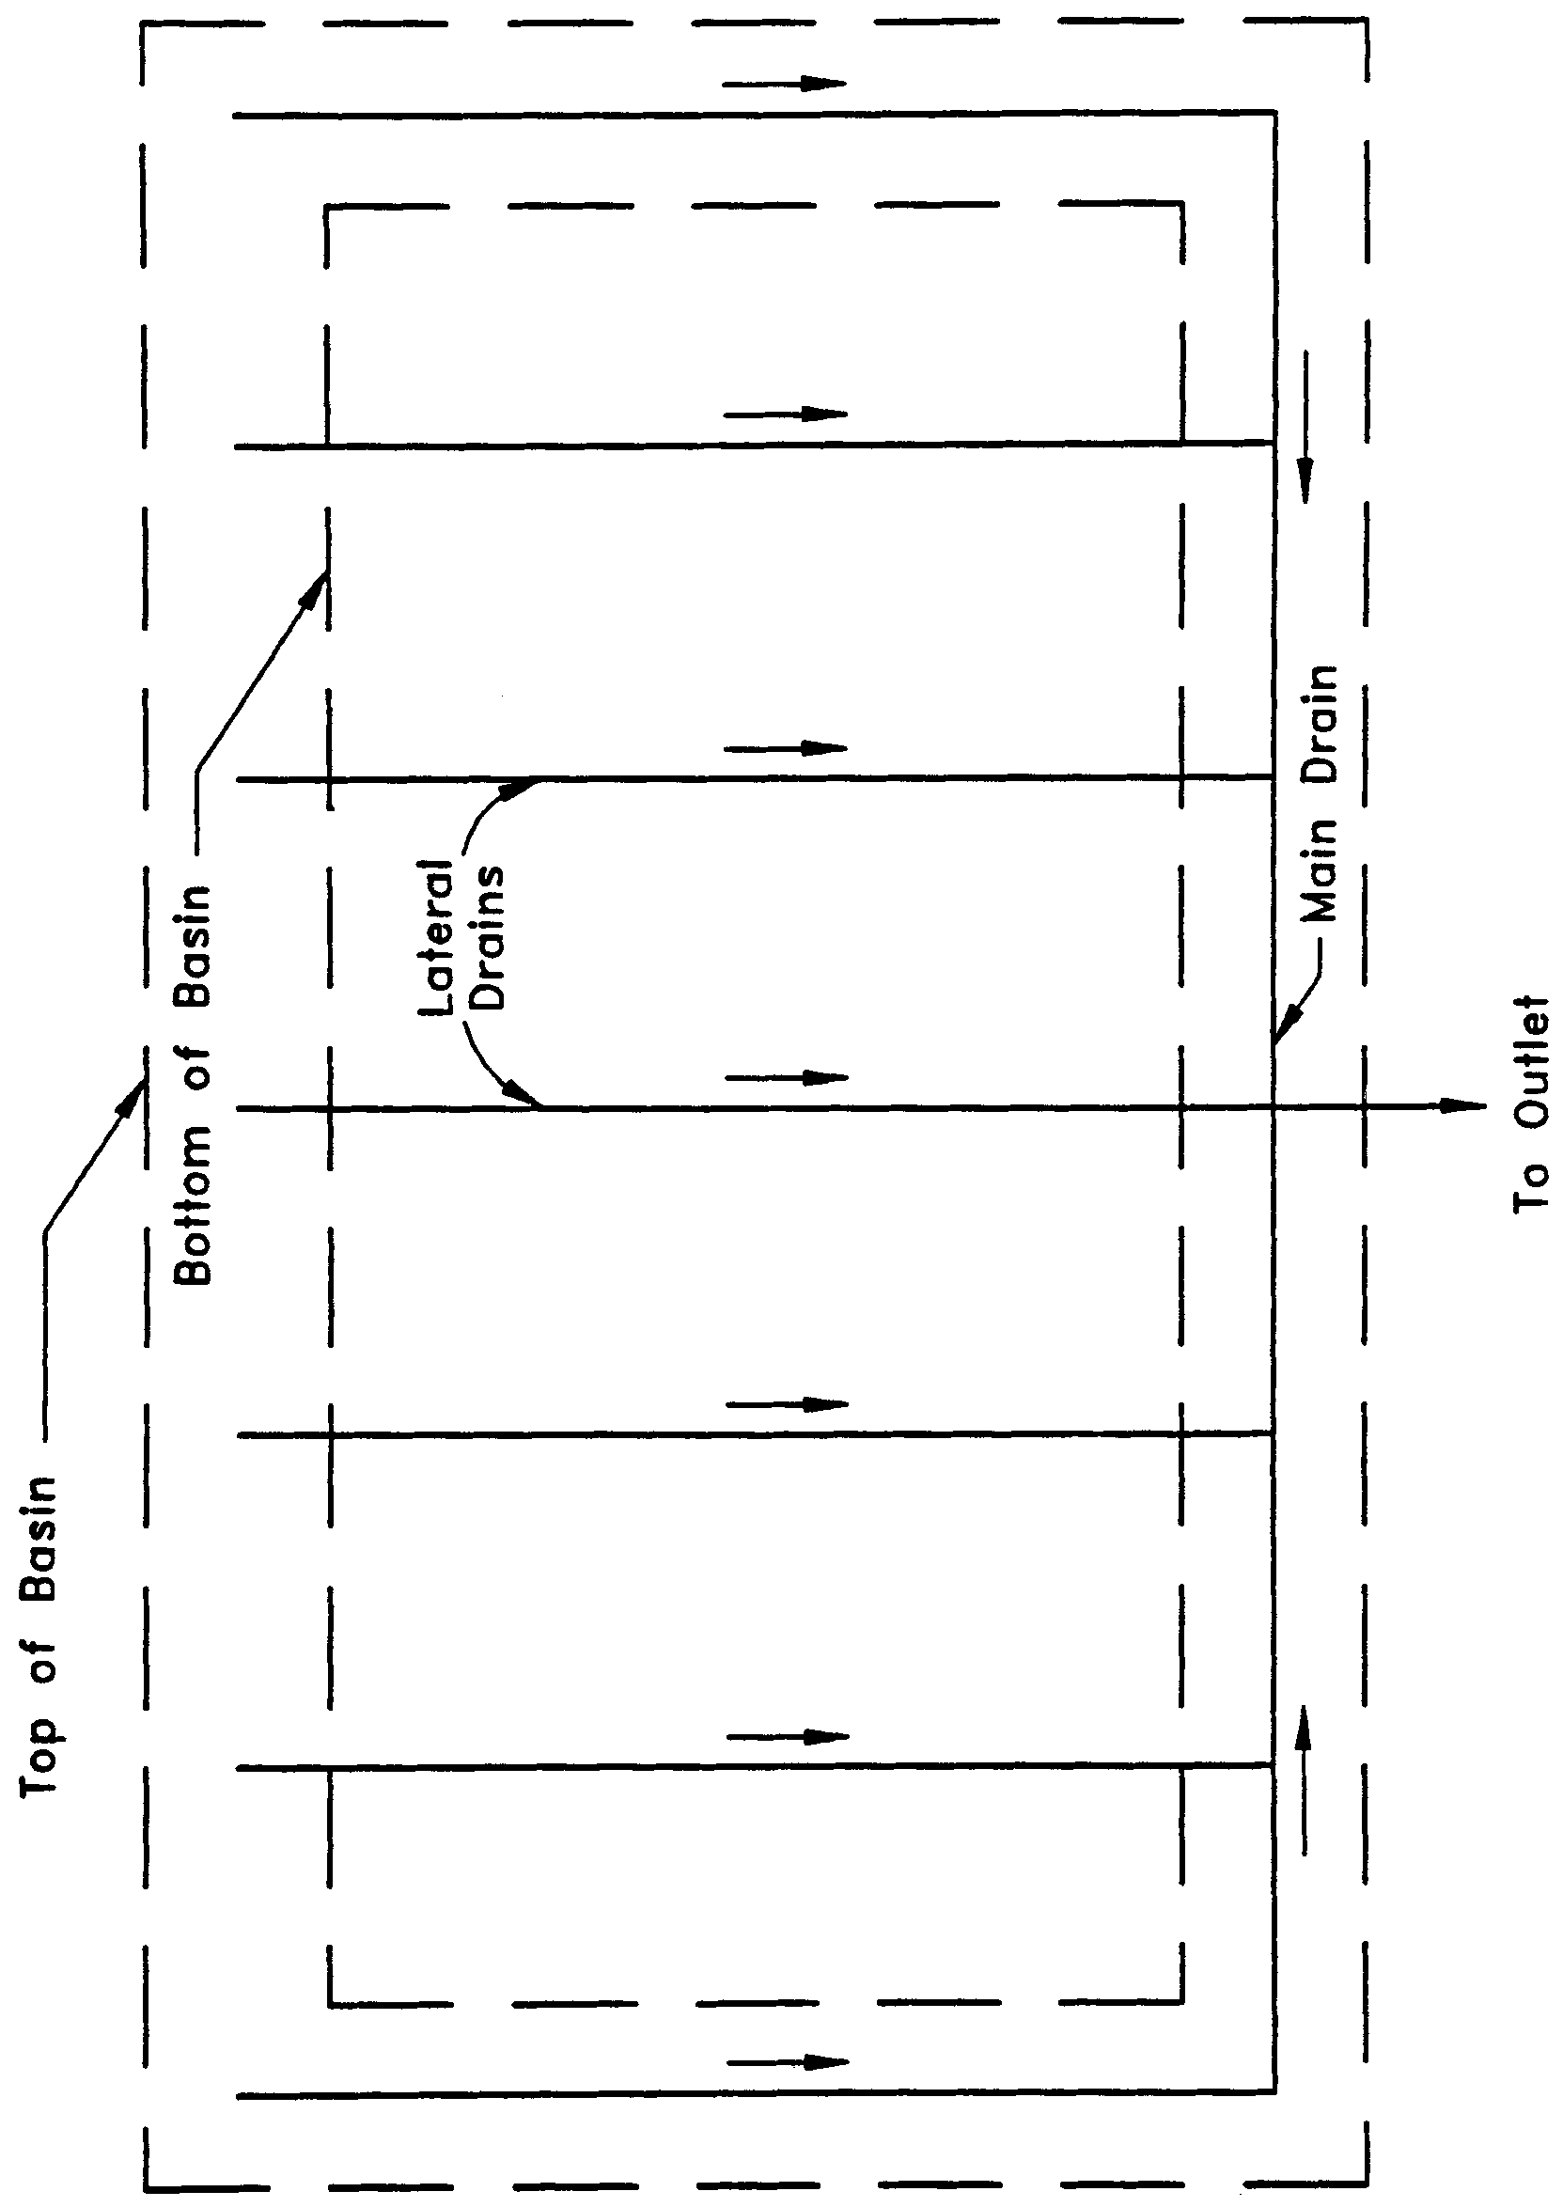

Figure 6-2. Top view of underdrain system (N.T.S.)

6.8 Basin Stabilization

The underdrain basin shall be stabilized with permanent vegetative cover and should contain standing water only immediately following a rainfall event.

6.9 References Revised 6/28/24

Livingston, E.H., E. McCarron, J. Cox, P. Sanzone. 1988. The Florida Land Development Manual: A Guide to Sound Land and Water Management. Florida Department of Environmental Regulation, Nonpoint Source Management Section, Tallahassee, Florida.

Harper, H.H. 2007. Evaluation of Current Stormwater Design Criteria within the State of Florida, Final Report for Florida Department of Environmental Protection under FDEP Contract No. SO108.

7.0 Exfiltration Trench Design and Performance Criteria

7.1 Description Revised 6/1/18, 6/28/24

Exfiltration trench is a subsurface system consisting of a conduit such as perforated pipe surrounded by natural or artificial aggregate which temporarily stores and infiltrates stormwater runoff (Figure 7-1). Stormwater passes through the perforated pipe and infiltrates through the trench walls and bottom into the shallow groundwater aquifer. The perforated pipe increases the storage available in the trench and helps promote infiltration by making delivery of the runoff more effective and evenly distributed over the length of the system (Livingston et al. 1988). Generally, exfiltration trench systems are utilized where space is limited and/or land costs are high (i.e., downtown urban areas).

Soil permeability and water table conditions must be such that the trench system can percolate the required stormwater runoff treatment volume within a specified time following a storm event. The trench system is returned to a normally "dry" condition when drawdown of the treatment volume is completed. Like retention basins, the treatment volume in exfiltration trench systems is not discharged to surface waters. Thus, exfiltration is considered a type of retention system.

Exfiltration trench systems should not be located in close proximity to drinking water supply wells. See section 8.5.2 of Volume I for additional permitting requirements to protect groundwater. Chapter 40C-41, F.A.C., provides additional design features for systems constructed in Sensitive Karst Areas of the District where the drinking water aquifer is close to the land surface (see section 13.6).

Besides pollution control, exfiltration trench systems can be utilized to promote the recharge of ground water and to prevent saltwater intrusion in coastal areas, or to maintain groundwater levels in aquifer recharge areas. Chapter 40C-41, F.A.C., contains recharge criteria for the Wekiva Recharge Protection Basin and the Tomoka River and Spruce Creek Hydrologic Basins (see sections 13.3.1 and 13.5.1). Exfiltration trench systems can also be used to meet the runoff volume criteria for projects which discharge to land-locked lakes (see section 3.2.1 of this Volume).

The operational life of an exfiltration trench is believed to be short (possibly 5 to 10 years) for most exfiltration systems. Sediment accumulation and clogging by fines can reduce the life of an exfiltration trench (Wanielista et al. 1991). Total replacement of the trench may be the only possible means of restoring the treatment capacity and recovery of the system. Periodic replacement of the trench should be considered routine operational maintenance when selecting this management practice.

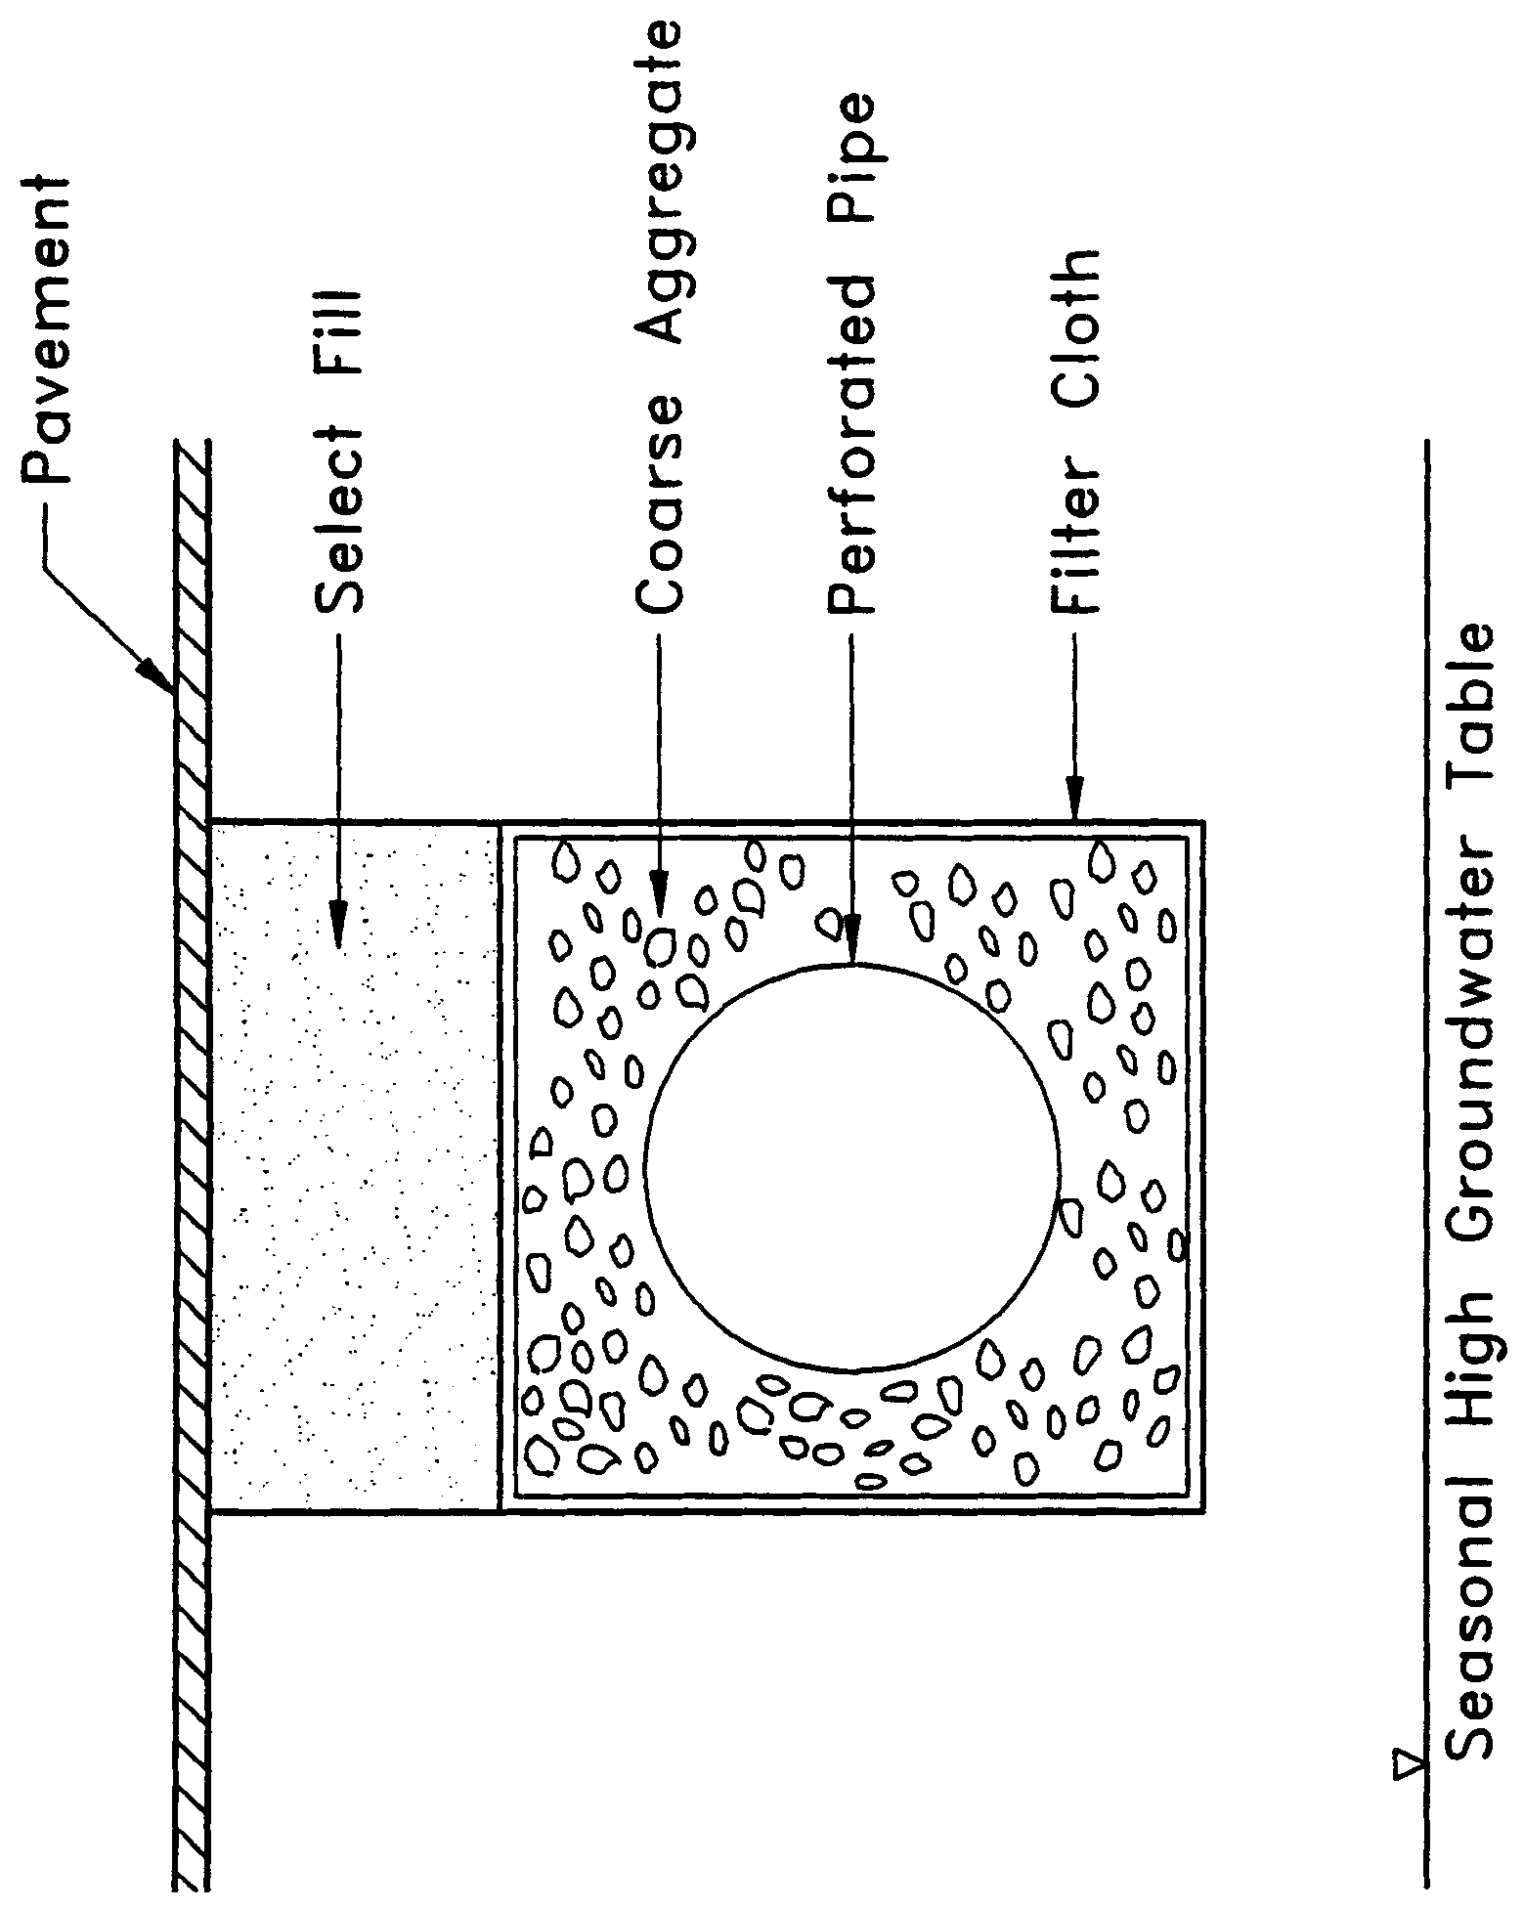

Figure 7-1. Cross-section of typical underground exfiltration trench (N.T.S.)

There are several design and performance criteria which must be met in order for an exfiltration trench system to meet the District’s requirements. A description of each criterion is presented below.

7.2 Treatment Volume Revised 6/28/24

The first portion of runoff should be collected in the exfiltration trench and infiltrated into the surrounding soil to meet the treatment criteria in sections 8.3 and 9.0 of Volume I.

Exfiltration trench systems must be designed to have the capacity to retain the required treatment volume without considering discharges to ground or surface waters.

7.3 Recovery Time

The system must be designed to provide for the appropriate treatment volume of stormwater runoff specified in section 7.2 within 72 hours following a storm event assuming average antecedent moisture conditions. The stormwater is drawn down by infiltration into the soil.

Antecedent moisture condition (AMC) refers to the amount of moisture and storage in the soil profile prior to a storm event. Antecedent soil moisture is an indicator of wetness and availability of soil to infiltrate water. The AMC can vary from dry to saturated depending on the amount of rainfall received prior to a given point in time. Therefore, "average AMC" means the soil is neither dry or saturated, but at an average moisture condition at the beginning of a storm event when calculating recovery time for exfiltration systems.

The antecedent condition has a significant effect on runoff rate, runoff volume, infiltration rate, and infiltration volume. The infiltration volume is also known as the upper soil zone storage. Both the infiltration rate and upper soil zone storage are used to calculate the recovery time of retention systems and should be estimated using any generally accepted and well documented method with appropriate parameters to reflect drainage practices, seasonal high water table elevation, the AMC, and any underlying soil characteristics which would limit or prevent percolation of storm water into the soil column.

7.4 Safety Factor

The exfiltration trench system must be designed with a safety factor of at least two unless the applicant affirmatively demonstrates based on plans, test results, calculations or other information that a lower safety factor is appropriate for the specific site conditions. For example, two possible ways to apply this factor are:

(a) Reducing the design percolation rate by half

(b) Designing for the required drawdown within 36 hours instead of 72 hours

7.5 Minimum Dimensions

The perforated pipe shall be designed with a 12-inch minimum pipe diameter and a three (3)-foot minimum trench width. The perforated pipe should be located within the trench section to minimize the accumulation of sediment in the aggregate void storage and maximize the preservation of this storage for stormwater treatment. To meet this goal, it is recommended that the perforated pipe be located at or within 6 inches of the trench bottom. The maximum trench width will be limited by the rate at which stormwater can effectively fill the void storage within the trench.

7.6 Filter Fabric

Exfiltration trench systems shall be designed so that aggregate in the trench is enclosed in filter fabric. This serves to prevent migration of fine materials from the surrounding soil that could result in clogging of the trench. Wanielista et al. (1991) reports that woven fabric (Mirafi 700XG) performed better in mixed sand and silty soil than non-woven fabric (Mirafi 140N). On the other hand, the 140N had higher exfiltration rates in sandy soils than the woven fabric.

Filter fabric may also be utilized directly surrounding the perforated pipe. In this instance, sedimentation of particulates will occur in the perforated pipe. Consequently, the pipe is more prone to clogging and reductions in capacity will occur more often than usual. Livingston et al. (1988) points out that while this may seem unacceptable, the pipe may be cleaned relatively easily using high pressure hoses, vacuum systems, etc. On the other hand, designs without the fabric directly surrounding the perforated pipe require complete replacement when clogging occurs.

7.7 Inspection and Cleanout Structures

Inspection and cleanout structures which extend to the surface of the ground must be provided, at a minimum, at the inlet and terminus of each exfiltration pipe. Inlet structures should include sediment sumps. These inspection and cleanout structures provide three primary functions:

(a) Observation of how quickly the trench recovers following a storm

(b) Observation of how quickly the trench fills with sediment

(c) Maintenance access to the perforated pipe

(d) Sediment control (sumps)

Standard precast concrete inlets and manholes are widely used to furnish the inspection and cleanout access.

7.8 Ground Water Table

The exfiltration trench system must be designed so that the invert elevation of the trench is at least two feet above the seasonal high ground water table elevation unless the applicant affirmatively demonstrates based on plans, test results, calculations or other information that an alternative design is appropriate for the specific site conditions.

7.9 Construction

During construction, measures should be implemented to limit the parent soil and debris from entering the trench. Wanielista (1991) reports complete failure (no exfiltration) when a 1" to 2" thickness of parent soil and stormwater solids were added to an exfiltration trench. Applicants and system designers should consult Part IV of Volume I for information on erosion and sediment control. Any method used to reduce the amount of fines entering the exfiltration trench during construction will extend the life of the system (Wanielista et al. 1991). The use of an aggregate with minimal fines is also recommended (Wanielista et al. 1991).

7.10 Alternative Designs Repealed 6/28/24

7.11 References

Livingston, E.H., E. McCarron, J. Cox, and P. Sanzone. 1988. The Florida Land Development Manual: A Guide to Sound Land and Water Management. Florida Department of Environmental Regulation, Nonpoint Source Management Section, Tallahassee, Florida.

Wanielista, M.P., M.J. Gauthier, and D.L. Evans. 1991. Design and Performance of Exfiltration Systems. Department of Civil and Environmental Engineering, University of Central Florida, Orlando, Florida.
8.0 Wet Detention Design and Performance Criteria

8.1 Description Revised 6/28/24

These systems are permanently wet ponds which are designed to slowly release collected stormwater runoff through an outlet structure.

There are several components in a wet detention system which must be properly designed to achieve the required level of stormwater treatment. A description of each design feature and its importance to the treatment process is presented below. The design and performance criteria for wet detention systems are discussed below.

8.2 Treatment Volume Repealed 6/28/24

8.3 Recovery Time Revised 6/28/24

The outfall structure shall be designed to drawdown the volume above the permanent pool storage and recover within 14 days following any storm event pursuant to section 3.2.7 of this volume.

8.4 Outlet Structure Revised 6/1/18, 6/28/24

The outlet structure generally includes a drawdown device (such as an orifice, "V", rectangular, or square notch weir) set to establish a normal water control elevation and slowly release the above the permanent pool volume. The design of the outfall structure must also accommodate the passage of ground water baseflows and flows from upstream stormwater management systems.

The control elevation shall be set at or above the design tailwater elevation so the pond can effectively recover the treatment storage. Drawdown devices shall have a cross-sectional area of at least six (6) square inches and be at least two (2) inches wide. If the device is a “V” notch, the notch shall be at least twenty (20) degrees. Drawdown devices less than 6 inches wide or less than 45 degrees for "V" notches shall include a device to minimize clogging. Examples of such devices include baffles, grates, screens, and pipe elbows.

8.5 Permanent Pool Revised 6/28/24

The permanent pool shall be sized to provide at least a minimum 14-day average residence time during the wet season (June - October). The required nutrient load reduction for the wet pond and, if necessary, associated BMPs in the BMP treatment train will be determined by the applicable performance standard as set forth in Section 8.3. of Volume I and methodology described in Section 9 of Volume I. Permanent pool volume shall be determined by the treatment efficiency.

8.6 Littoral Zone Revised 6/28/24

The littoral zone is that portion of a wet detention pond which is designed to contain rooted aquatic plants. The littoral area is usually provided by extending and gently sloping the sides of the pond down to a depth of 2-3 feet below the normal water level or control elevation. Also, the littoral zone can be provided in other areas of the pond that have suitable depths (i.e., a shallow shelf in the middle of the lake). Littoral Zones are not required but can be used to increase the treatment efficiency of the wet detention system.

The littoral zone is established with native aquatic plants by planting and/or the placement of wetland soils containing seeds of native aquatic plants. A specific vegetation establishment plan must be prepared for the littoral zone. The plan must consider the hydroperiod of the pond and the type of plants to be established. Livingston et al. (1988) has published a list of recommended native plant species suitable for littoral zone planting. In addition, a layer of muck can be incorporated into the littoral area to promote the establishment of the wetland vegetation. When placing muck, special precautions must be taken to prevent erosion and turbidity problems in the pond and at its discharge point while vegetation is becoming established in the littoral zone.

The following is a list of the design criteria for wet detention littoral zones:

(a) The littoral zone shall be gently sloped (6H:1V or flatter). At least 30 percent of the wet detention pond surface area shall consist of a littoral zone. The percentage of littoral zone is based on the ratio of vegetated littoral zone to surface area of the pond at the control elevation.

(b) The treatment volume should not cause the pond level to rise more than 18 inches above the control elevation unless the applicant affirmatively demonstrates that the littoral zone vegetation can survive at greater depths.

(c) Within 24 months of completion of the system or as specified by permit condition, 80 percent coverage of the littoral zone by suitable aquatic plants is required.

(d) Planting of the littoral zone is recommended to meet the 80% coverage requirement. As an alternative to planting, portions of the littoral zone may be established by placement of wetland top soils (at least a four inch depth) containing a seed source of desirable native plants. When utilizing this alternative, the littoral zone must be stabilized by mulching or other means and at least the portion of the littoral zone within 25 feet of the inlet and outlet structures must be planted.

8.7 Littoral Zone Alternatives Repealed 6/28/24

8.8 Pond Depth Revised 6/28/24

Wet detention systems shall provide for a maximum pond depth of 12 feet and a mean depth (pond volume divided by the pond area at the control elevation) of at least 2 feet. Deeper ponds are allowable, provided the registered professional affirmatively demonstrates that any design for deeper pond depths will not cause stratification within the water column and will prevent resultant anoxic bottom waters and sediments. Many of the nutrients and metals removed from the water column accumulate in the top few inches of the pond bottom sediments. If a pond is deep enough, it will have a tendency to stratify, creating the potential for anoxic conditions developing at the bottom of the pond. An aerobic environment should be maintained throughout the water column in wet detention ponds in order to minimize the release of nutrients and metals from the bottom sediments. The maximum depth criteria minimizes the potential for significant thermal stratification, which will help maintain aerobic conditions in the water column that should maximize sediment uptake and minimize sediment release of pollutants.

On the other hand, the minimum mean depth criteria minimizes aquatic plant growth, which may be excessive if the pond is too shallow.

8.9 Pond Configuration

The average length to width ratio of the pond must be at least 2:1.

If short flow paths are unavoidable, the effective flow path can be increased by adding diversion barriers such as islands, peninsulas, or baffles to the pond. Inlet structures should be designed to dissipate the energy of water entering the pond. Examples of good and poor pond configurations are given in Figure 8-5.

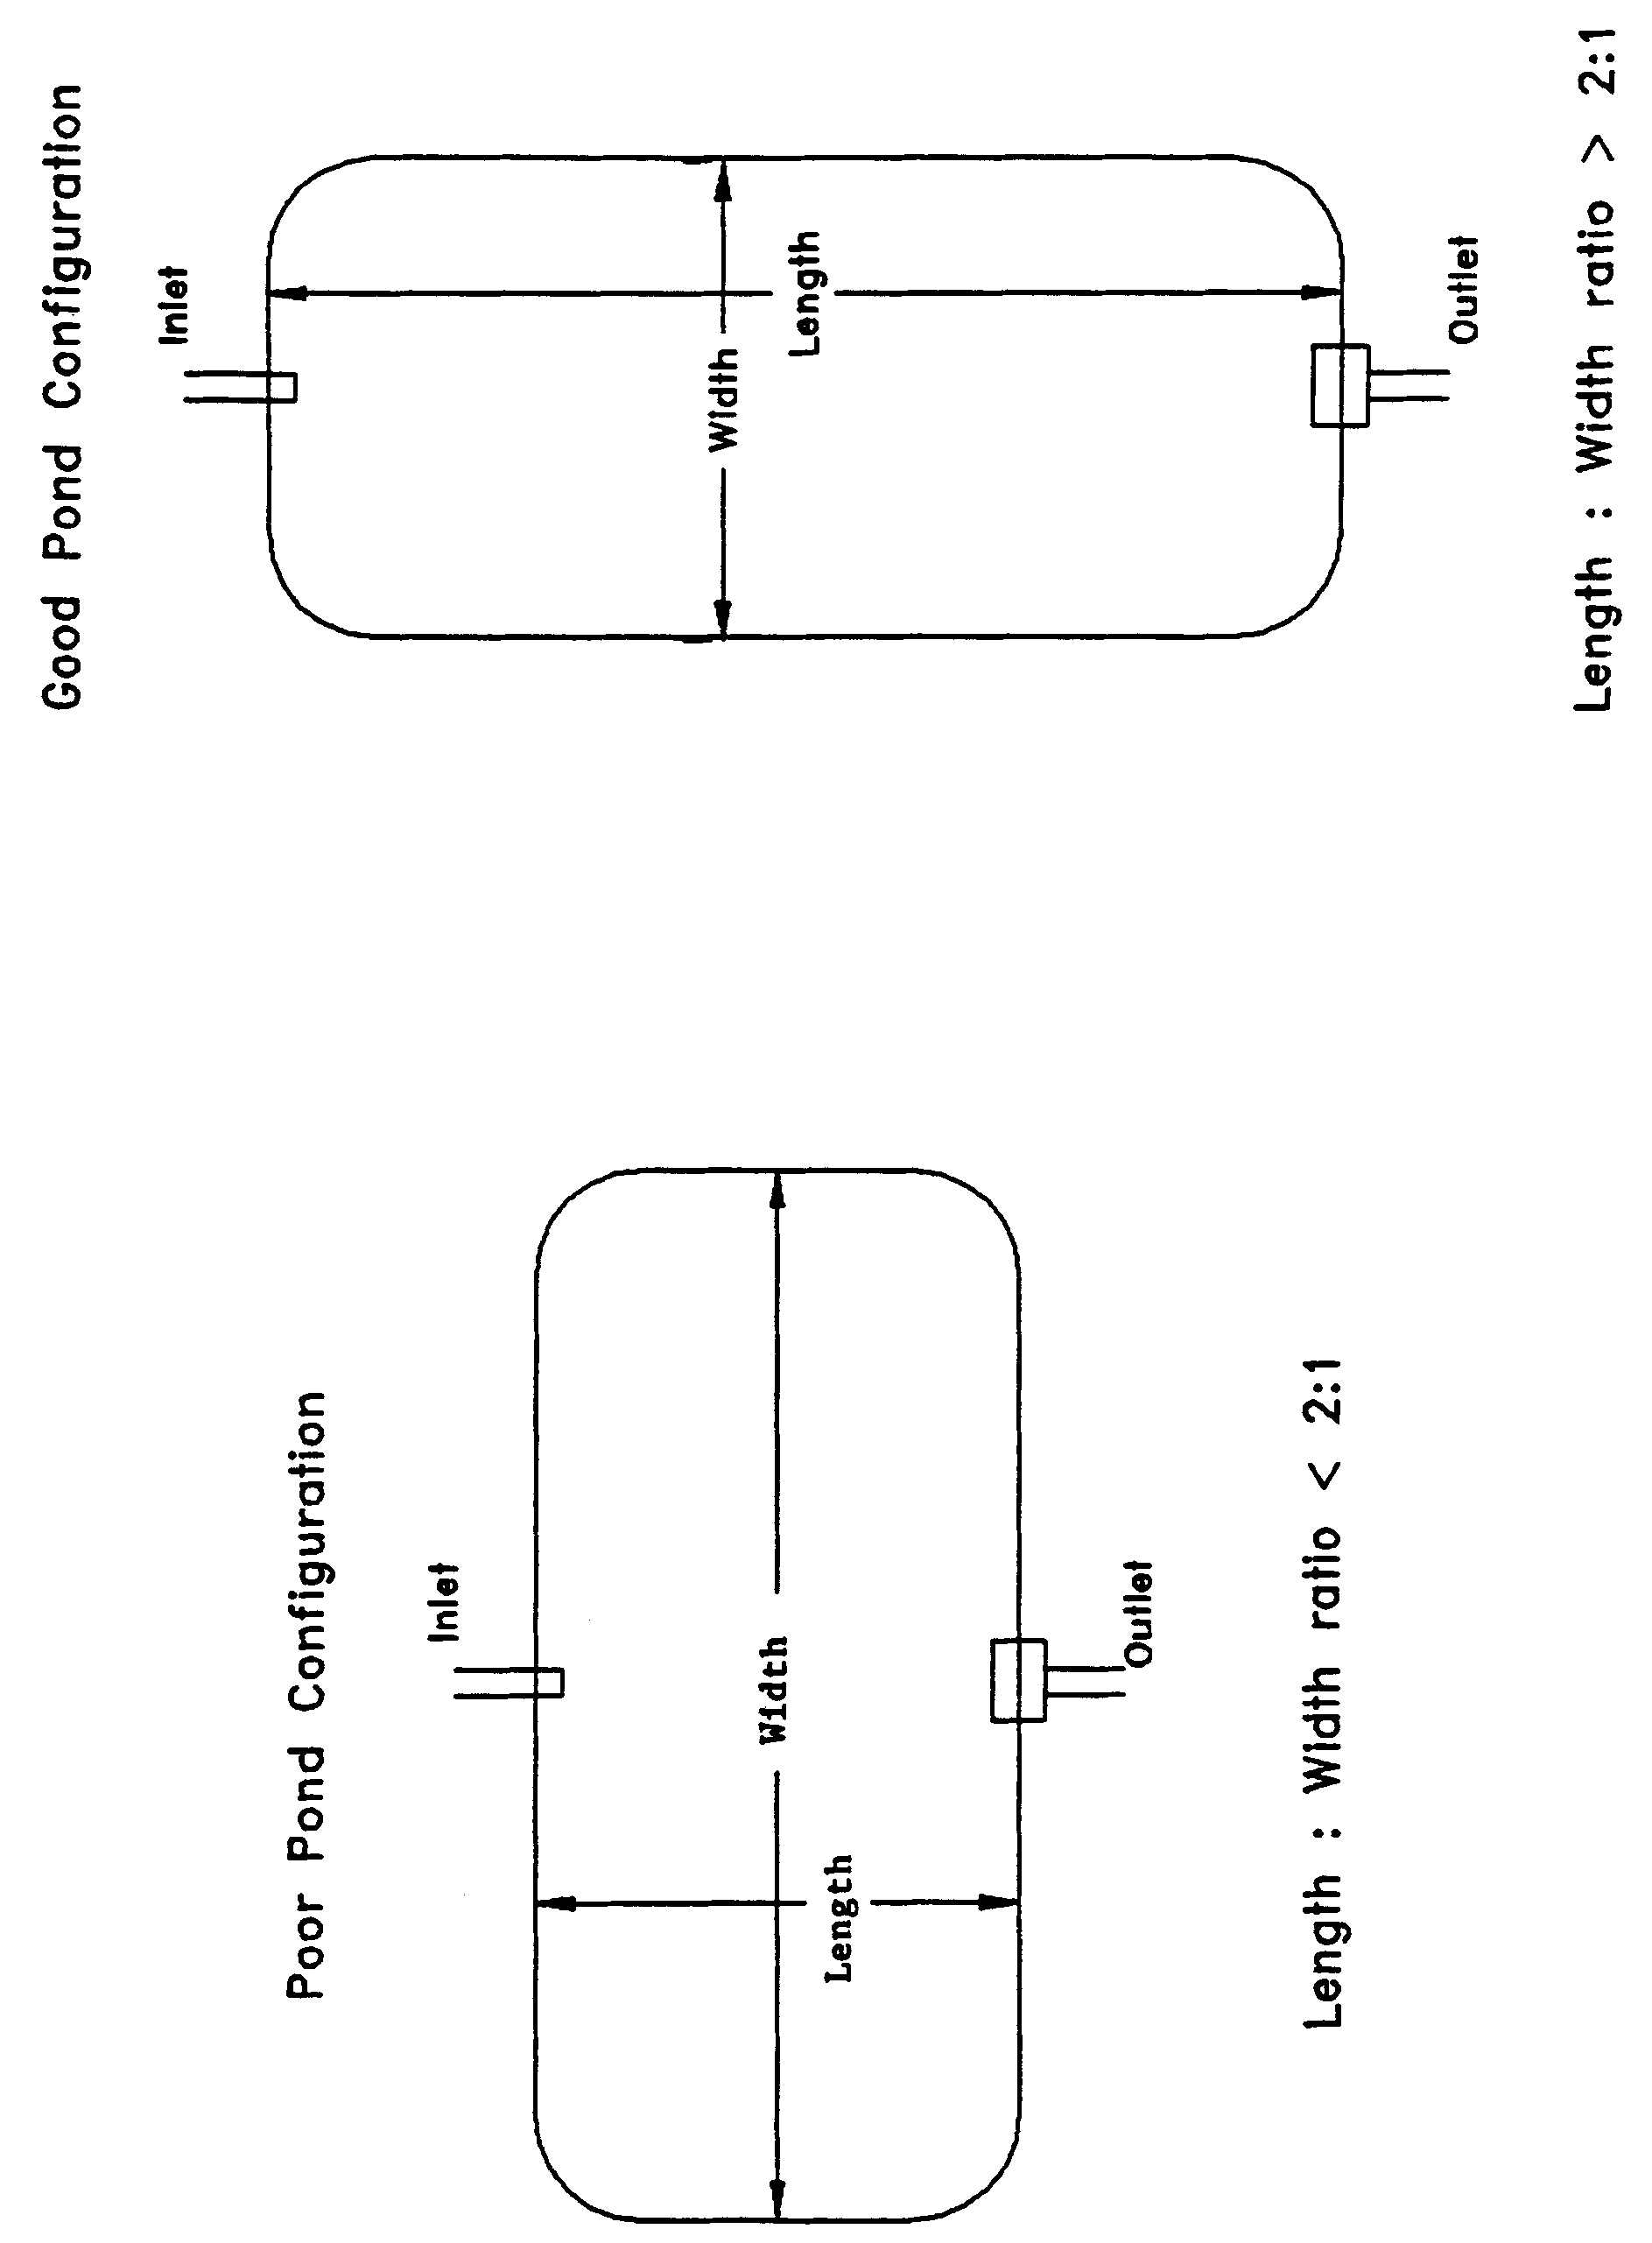

Figure 8-5. Examples of good and poor wet detention pond configurations (N.T.S.)

8.10 Ground Water Table Revised 6/28/24

To minimize ground water contributions which may lower treatment efficiencies, the control elevation shall be set at or above the normal on-site ground water table elevation (Yousef et al. 1990). This elevation may be determined by calculating the average of the seasonal high and seasonal low ground water table elevations.

Ground water inflow (baseflow) must be considered when the control elevation is set below the normal ground water table elevation or the project utilizes underdrains (i.e., road underdrains) to control ground water conditions on-site. The design of the outfall structure must provide for the discharge of baseflow at the design normal water level in the pond. Baseflow rates must be included in the drawdown calculations for the outfall structure. Baseflow shall also be considered in the permanent pool residence time design. Establishment of the normal water level in the pond will also be influenced by baseflow conditions.

8.11 Pre-treatment Repealed 6/28/24

8.12 Pond Side Slopes Revised 6/28/24

The pond must be designed so that the average pond side slope measured between the control elevation and two feet below the control elevation is no steeper than 3:1 (horizontal:vertical). Section 2.6.1 also applies to wet detention systems.

8.13 Direct Discharges to Class I, Class II, OFWs, or Shellfishing Waters Repealed 6/28/24

8.14 References

Camp Dresser & McKee Inc (CDM). 1985. An Assessment of Stormwater Management Programs. Prepared for Florida Department of Environmental Regulation, Tallahassee, Florida.

Livingston, E.H., E. McCarron, J. Cox, P. Sanzone. 1988. The Florida Land Development Manual: A Guide to Sound Land and Water Management. Florida Department of Environmental Regulation, Nonpoint Source Management Section, Tallahassee, Florida.

Yousef, Y.A., M.P. Wanielista, L.Y. Lin, and M. Brabham. 1990. Efficiency Optimization of Wet Detention Ponds for Urban Stormwater Management (Phase I and II). University of Central Florida, Orlando, Florida
9.0 Swale Systems Design and Performance Criteria

9.1 Description Revised 6/1/18, 6/28/24

Swales are a man-made or natural system shaped or graded to required dimensions and designed for the conveyance and rapid infiltration of stormwater runoff. Swales are designed to infiltrate a defined quantity of runoff through the permeable soils of the swale floor and side slopes into the shallow ground water aquifer (Figure 9-1). Turf is established to promote infiltration and stabilize the side slopes. Soil permeability and water table conditions must be such that the swale can percolate the desired runoff volume from the 3-year, 1-hour storm event. The swale holds water only during and immediately after a storm event, thus the system is normally "dry." Unlike retention basins, swales are "open" conveyance systems. This means there are no physical barriers such as berms or check-dams to impound the runoff in the swale prior to discharge to the receiving water.

Swale systems should not be located in close proximity to drinking water supply wells. See section 8.5.2 of Volume I for additional permitting requirements to protect groundwater. Additional design criteria are established for swale systems constructed in Karst Sensitive Areas of the District where the drinking water aquifer is close to the land surface (see section 13.6).

Besides pollution control, swale systems can be utilized to promote the recharge of groundwater to prevent saltwater intrusion in coastal areas, and to maintain ground water levels in aquifer recharge areas. Swales can be incorporated into the design of a stormwater management system to meet the recharge criteria for the Wekiva Recharge Protection Basin and the Tomoka River and Spruce Creek Hydrologic Basins.

Swales can also be utilized as part of a treatment train to provide treatment of runoff prior to its release to another treatment BMP such as wet detention or wetlands stormwater management systems. Incorporating swales as part of a treatment train reduces the pollutant loading to the downstream treatment system, increases the pollutant efficiency of the overall stormwater management system, and reduces maintenance. For developments where the appearance of the downstream system (i.e., wet detention lake) is important, swales can reduce the probability of algal blooms occurring and slows the eutrophication process.

The design and performance criteria specific to swale systems are described in the following sections.

Figure 9-1. Cross-section of swale system (N.T.S.)
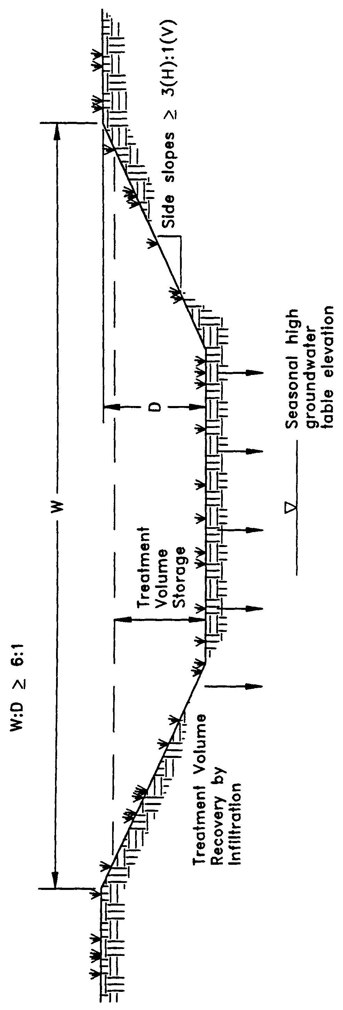

9.2 Treatment Volume Revised 6/28/24

The Required Treatment Volume necessary to achieve the treatment efficiency shall be routed to the swale and percolated into the ground. The required nutrient load reduction for the swale and, if necessary, associated BMPs in the BMP treatment train will be determined by the applicable performance standard as set forth in Section 8.3. of Volume I and methodology described in Section 9 of Volume I. Treatment volume shall be determined by the treatment efficiency.

9.3 Recovery Time

Swale systems must provide the capacity for the specified treatment volume of stormwater and contain no contiguous areas of standing or flowing water within 72 hours following the storm event referenced in section 9.2 assuming average antecedent moisture conditions. The treatment volume must be provided by percolation through the soil, evaporation, or evapotranspiration.

Antecedent moisture condition (AMC) refers to the amount of moisture and storage in the soil profile prior to a storm event. Antecedent soil moisture is an indicator of wetness and availability of soil to infiltrate water. The AMC can vary from dry to saturated depending on the amount of rainfall received prior to a given point in time. Therefore, "average AMC" means the soil is neither dry or saturated, but at an average moisture condition at the beginning of a storm event when calculating recovery time for swale systems.

The antecedent condition has a significant effect on runoff rate, runoff volume, infiltration rate, and infiltration volume. The infiltration volume is also known as the upper soil zone storage. Both the infiltration rate and upper soil zone storage are used to calculate the recovery time of retention systems and should be estimated using any generally accepted and well documented method with appropriate parameters to reflect drainage practices, seasonal high water table elevation, the AMC, and any underlying soil characteristics which would limit or prevent percolation of storm water into the soil column.

9.4 Dimensional Requirements

Swales must have a top width to depth ratio of the cross-section equal to or greater than 6:1 or side slopes equal to or greater than 3:1 (horizontal to vertical).

9.5 Stabilization

Swales should be stabilized with vegetative cover suitable for soil stabilization, stormwater treatment, and nutrient uptake. Also, the swale should be designed to take into account the soil erodibility, soil percolation, slope, slope length, and drainage area so as to prevent erosion and reduce pollutant concentrations.
10.0 Wetlands Stormwater Management Systems Design and Performance Criteria

10.1 Description

For wetlands stormwater management systems the District must ensure that a proposed wetlands stormwater management system is compatible with the existing ecological characteristics of the wetlands proposed to be utilized for stormwater treatment. The District must also ensure that water quality standards will not be violated by discharges from wetlands stormwater management system. To achieve these goals, specific performance criteria are set forth and described below for systems which incorporate wetlands for stormwater treatment.

10.2 Types of Wetlands that may be Utilized for Stormwater Treatment

The only wetlands which may be considered for use to provide stormwater treatment are those which are:

(a) Isolated wetlands; and

(b) Those which would be isolated wetlands, but for a hydrologic connection to other wetlands or surface waters via another watercourse that was excavated through uplands.

10.3 Treatment Volume Revised 6/28/24

The system shall be part of a comprehensive stormwater management system that utilizes wetlands in combination with other best management practices to provide treatment of the runoff from the project, pursuant to sections 8.3 and 9.0 of Volume I.

10.4 Recovery Time

The system shall be designed to bleed down one-half the applicable treatment volume specified above between 60 and 72 hours following a storm event.

10.5 Inlet Structures

Inlet structures shall be designed to dissipate the energy of runoff entering the wetland and minimize the channelized flow of stormwater. Methods include, but are not limited to, sprinklers, pipe energy dissipators, overland flow or spreader swales.

10.6 Wetland Function Revised 6/28/24

The use of wetlands for stormwater treatment must meet the criteria in section 10.0, Environmental Considerations, of the Environmental Resource Permit Applicant’s Handbook, Volume I. Pre-treatment can reduce the impact of untreated stormwater upon the wetland. Additional best management practices can be utilized to attenuate stormwater volumes and peak discharge rates so that the wetland's hydroperiod is not adversely altered (Livingston 1989). Swale conveyances and lakes adjacent to the wetland are typical pre-treatment practices.

10.7 Residence Time

The design features of the system should maximize residence time of the stormwater within the wetland to enhance the opportunity for the stormwater to come into contact with the wetland sediment, vegetation, and micro-organisms (Livingston 1989). This can be accomplished by several means. The inlets and outlets should be located to maximize the flow path through the wetland. Energy dissipators and spreader swales can promote overland flow and reduce the possibility of channelized flow occurring. In some instances, berms in wetlands can act as baffles to increase the flow path of surface flow through the wetland.

10.8 Monitoring

In order to establish a reliable, scientifically valid data base upon which to evaluate the performance criteria and the performance of the wetlands stormwater management system, a monitoring program may be required. Monitoring programs shall provide the District with comparable data for different types of wetlands and drainage designs. Data to be collected may include but not be limited to:

(a) Sedimentation rate

(b) Sediment trace metal concentrations

(c) Sediment nitrogen and phosphorus concentrations

(d) Changes in the frequency, abundance and distribution of vegetation

(e) Inflow and outflow water quality for nutrients, metals, turbidity, oils and greases, bacteria and other parameters related to the specific site conditions

Inflow and outflow water quality parameters will be monitored on such storm event occurrences as established by the District based on a site specific basis. The District shall eliminate the requirement to continue the monitoring program upon its determination that no further data is necessary to evaluate the performance criteria or ensure compliance with the performance criteria and applicable water quality standards.

10.9 Dredge and Fill

If the applicant proposes to dredge or fill in the wetlands used for stormwater treatment, the District in its review of the permit application shall evaluate the adverse effects of the dredging or filling on the treatment capability of the wetland.

10.10 Alternative Criteria Revised 6/1/18

If the applicant is unable to show compliance with the performance criteria sections 10.3 – 10.9, above, the applicant may qualify for an environmental resource permit to use a wetlands stormwater management system using alternative design and performance criteria if the applicant affirmatively demonstrates that the use of the wetlands meets the criteria in section 10.0, Environmental Resource Permit Applicant’s Handbook, Volume I (General and Environmental) and the applicant complies with the requirements for issuance in section 2.0.

10.11 References

Livingston, E.H. 1989. The Use of Wetlands for Urban Stormwater Management. In Design of Urban Runoff Quality Controls, ed. L.A. Roesner, B. Urbonas, and M.B. Sonnen, pages 467-490. American Society of Civil Engineers. New York.

11.0 [Reserved]
12.0 Dry Detention Design and Performance Criteria Repealed 6/28/24

