PART VI – BASIN CRITERIA

13.0 Basin Criteria Revised 6/1/18

Chapter 40C-41, F.A.C., and this section establish additional criteria which are to be used in reviewing applications for permits in certain hydrologic basins. These basins are:

(a) Upper St. Johns River Hydrologic Basin

(b) Ocklawaha River Hydrologic Basin

(c) Wekiva River Hydrologic Basin
(d) Wekiva Recharge Protection Basin
(e) Econlockhatchee River Hydrologic Basin

(f) Tomoka River Hydrologic Basin

(g) Spruce Creek Hydrologic Basin

(h) Sensitive Karst Areas Basin

(i) Lake Apopka Hydrologic Basin

See Figure 13.0-1 for a description of the areas contained within the Upper St. Johns River Hydrologic Basin, the Ocklawaha River Hydrologic Basin, the Wekiva River Hydrologic Basin, the Econlockhatchee River Hydrologic Basin, the Tomoka River Hydrologic Basin and the Spruce Creek Hydrologic Basin. See Figures 13.0-2, 13.0-3, and 13.0-4 for a description of the areas contained within the Sensitive Karst Areas Basin. See Figure 13.0-5 for a description of the areas contained within the Lake Apopka Hydrologic Basin. A legal description of the Hydrologic Basin boundaries is available in Appendix B.

Figure 13.0-1 Basin Criteria Map

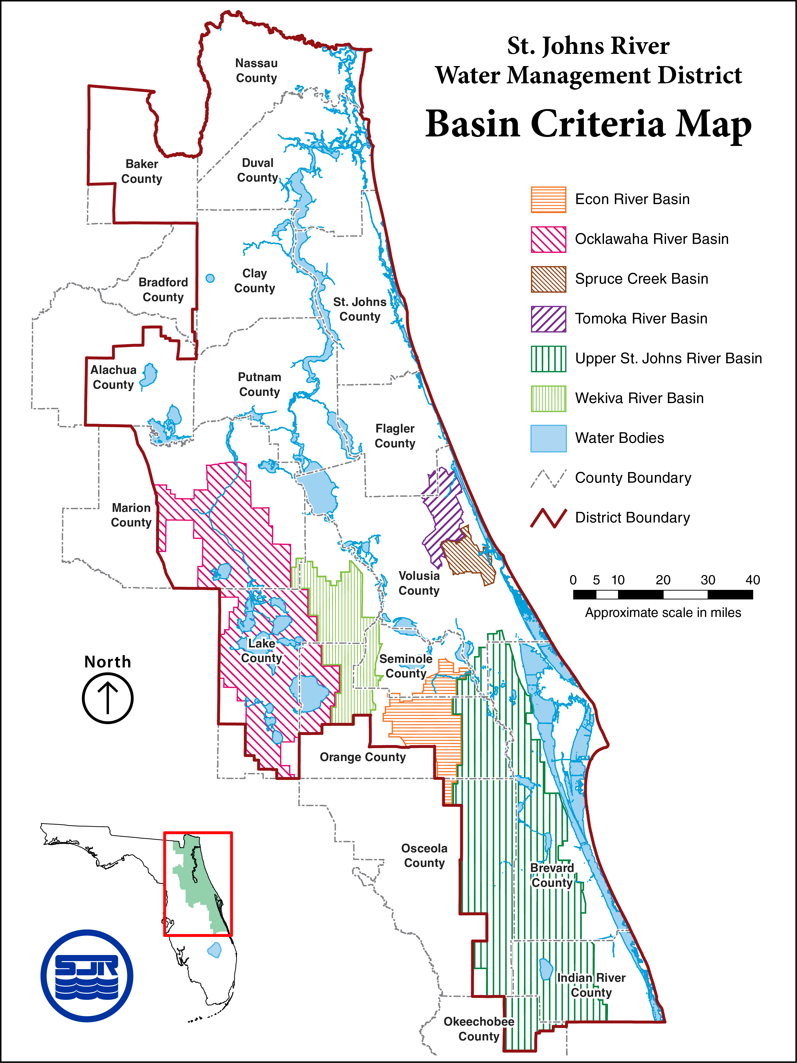
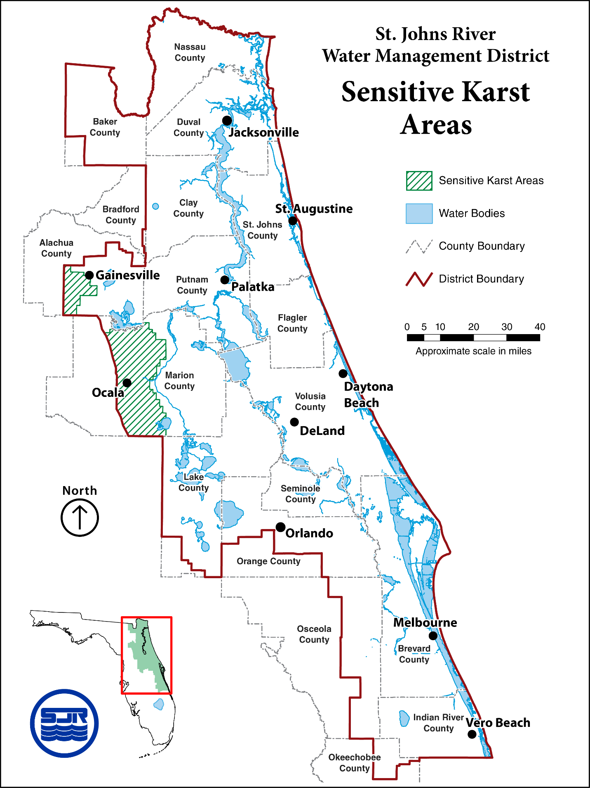
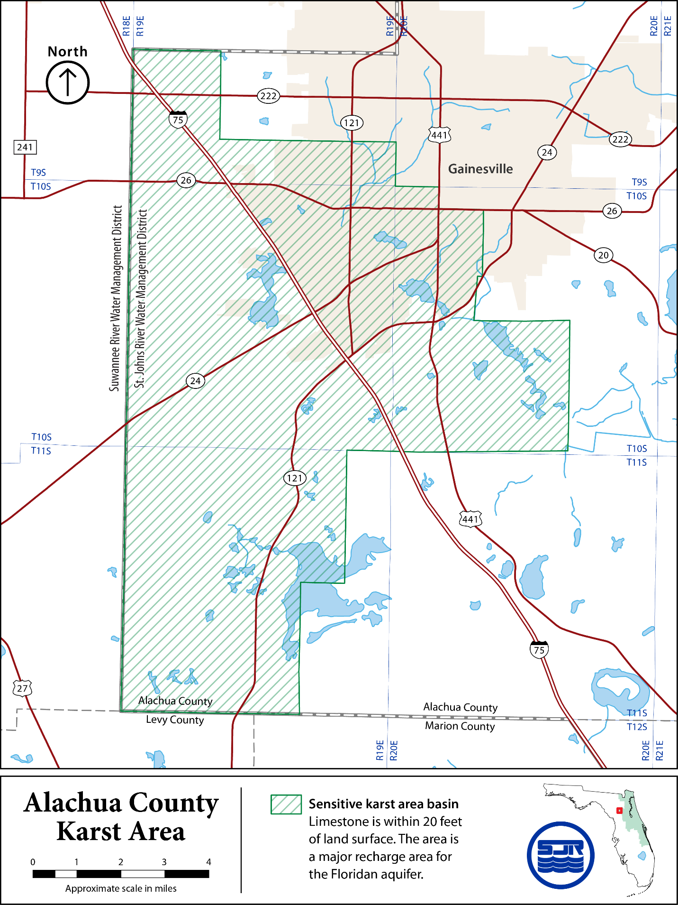
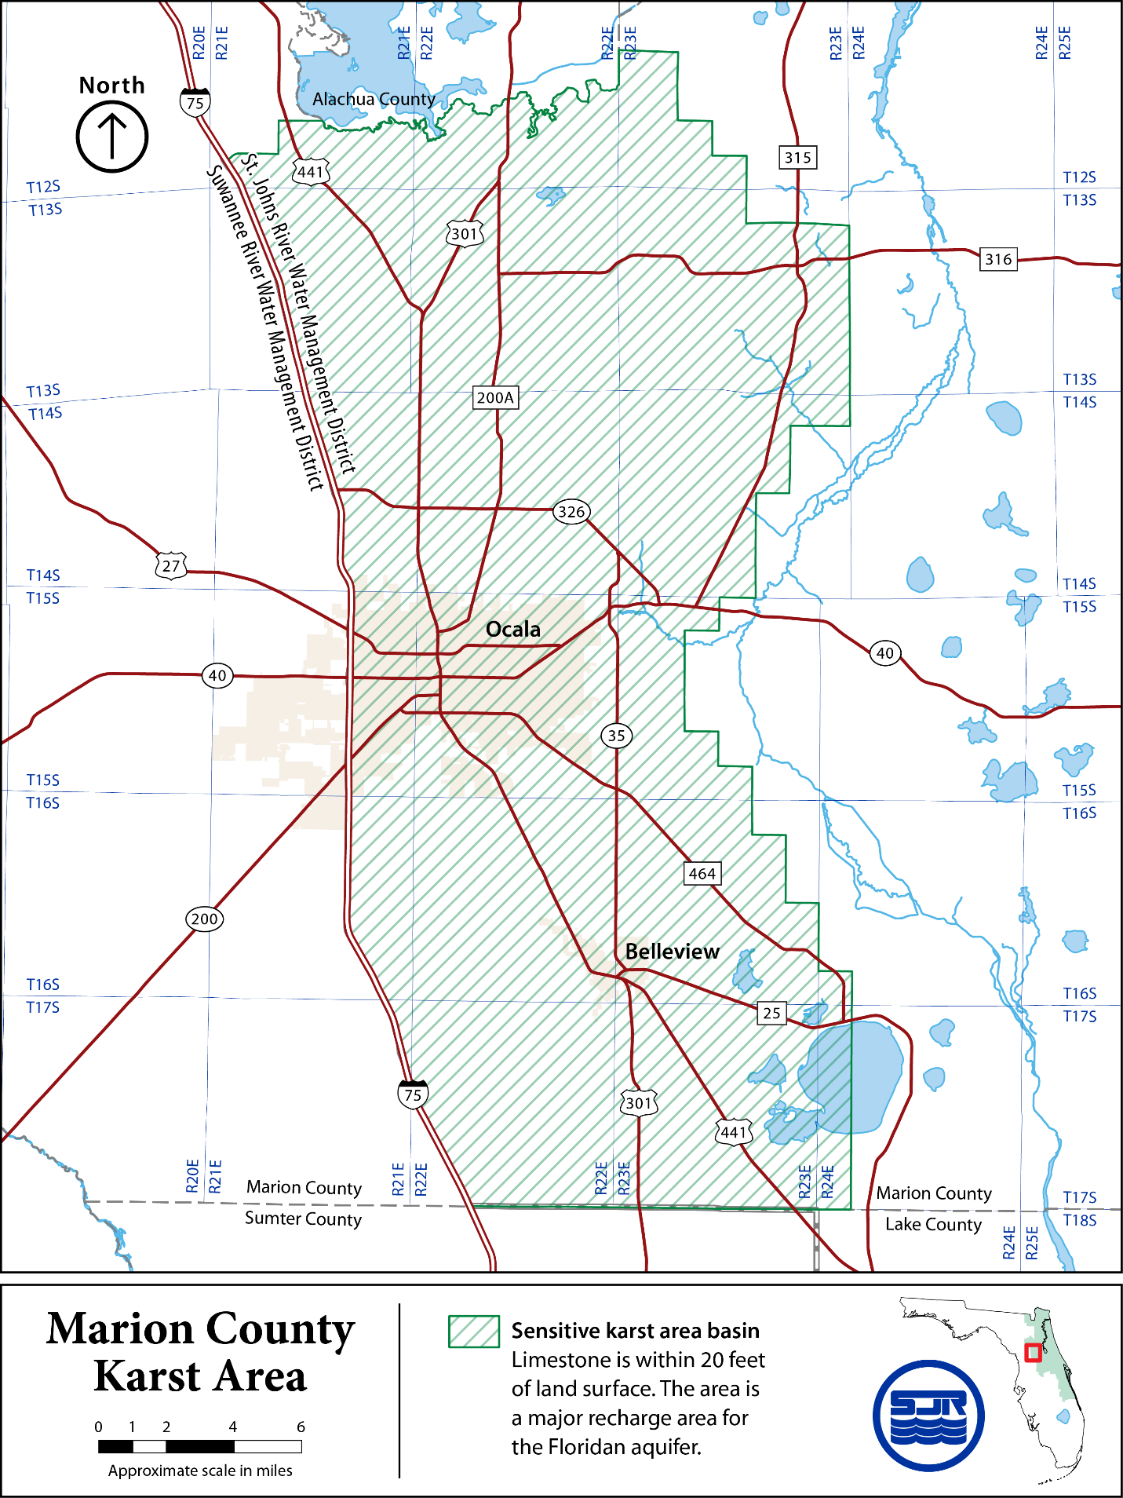
Figure 13.0-2 Sensitive Karst Areas in the St. Johns River Water Management District
Figure 13.0-3 Alachua County Karst Area
Figure 13.0-4 Marion County Karst Area
Figure 11.0-2 Sensitive Karst Areas in the St. Johns River Water Management District
Figure 13.0-5 Lake Apopka Drainage Basin
Figure 11.0-3 Alachua County Karst Area
13.1 Upper St. Johns River Hydrologic Basin

As part of the design criteria described in sections 62-330.301 and 62-330.302, F.A.C., above, systems in the Upper St. Johns River Basin must meet the following criteria:

13.1.1 Storm Frequency

The system shall meet applicable discharge criteria for 10-year and 25-year frequency storms. On-site storage and outlet capacity should be designed for the 25-year storm. Outlet capacity design should be checked and further refined, if necessary, for the 10-year storm.

13.1.2 Runoff Volume

For systems utilizing pumped discharges, the post-development discharge volume during the four-day period beginning the third day of the four-day duration storm may not exceed the pre-development discharge during the same period.

13.1.3 Interbasin Diversion

(a) A system may not result in an increase in the amount of water being diverted from the Upper St. Johns River Hydrologic Basin into coastal receiving waters.

(b) It is an objective of the District to, where practical, curtail diversions of water from the Upper St. Johns River Hydrologic Basin into coastal receiving waters.

13.2 Ocklawaha River Hydrologic Basin

As part of the design criteria described in sections 62-330.301 and 62-330.302, F.A.C., above, systems in the Ocklawaha River Hydrologic Basin must meet the following criteria:

13.2.1 Storm Frequency

The system shall meet applicable discharge criteria for 10-year and 25-year frequency storms. On-site storage and outlet capacity should be designed for the 25-year storm. Outlet capacity design should be checked and further refined, if necessary, for the 10-year storm.

13.2.2 Runoff Volume

For systems utilizing pumped discharges, the post-development discharge volume during the four-day period beginning the third day of the four-day duration storm may not exceed the pre-development discharge during the same period.

13.3 Wekiva River Hydrologic Basin and Wekiva Recharge Protection Basin

As part of the standards and design criteria described in sections 62-330.301 and 62-330.302, F.A.C., above, systems in the Wekiva River Hydrologic Basin or the Wekiva Recharge Protection Basin (which are both shown in Figure 13.3-2) must meet the following standards and criteria as described below:

13.3.1 Recharge Standard

Applicants required to obtain a permit pursuant to Chapters 62-330 or 40C-44, F.A.C., for a surface water management system located within the Wekiva Recharge Protection Basin shall demonstrate that the system provides for retention storage of three inches of runoff from all impervious areas proposed to be constructed on soils defined as a Type “A” Soils as defined by the Natural Resources Conservation Service (NRCS) Soil Survey in the following NRCS publications: Soil Survey of Lake County Area, Florida (1975); Soil Survey of Orange County Area, Florida (1989); and Soil Survey of Seminole County Area, Florida (1990), which are incorporated by reference in rule 40C-4.091(1)(d), F.A.C. For purposes of this rule, areas with Type “A” Soils shall be considered “Most Effective Recharge Areas.” The system shall be capable of infiltrating this storage volume through natural percolation into the surrounding soils within 72 hours. Off-site areas or regional systems may be utilized to satisfy this requirement. As an alternative, applicants may demonstrate that the post-development recharge capacity is equal to or greater than the pre-development recharge capacity. Pre-development recharge shall be based upon the land uses in place as of 12-3-06. Applicants may utilize existing permitted municipal master stormwater systems, in lieu of onsite retention, to demonstrate that post-development recharge is equal to or greater than pre-development recharge. Also, applicants may submit additional geotechnical information to establish whether or not a site contains Type “A” soils.

13.3.2 Storage Standard

Within the Wekiva River Hydrologic Basin, a system may not cause a net reduction in flood storage within the 100-year floodplain of a stream or other watercourse which has a drainage area upstream of more than one square mile and which has a direct hydrologic connection to the Wekiva or Little Wekiva Rivers or Black Water Creek.

Figure 13.3-2 Wekiva River Hydrologic Basin and Wekiva Recharge Protection Basin
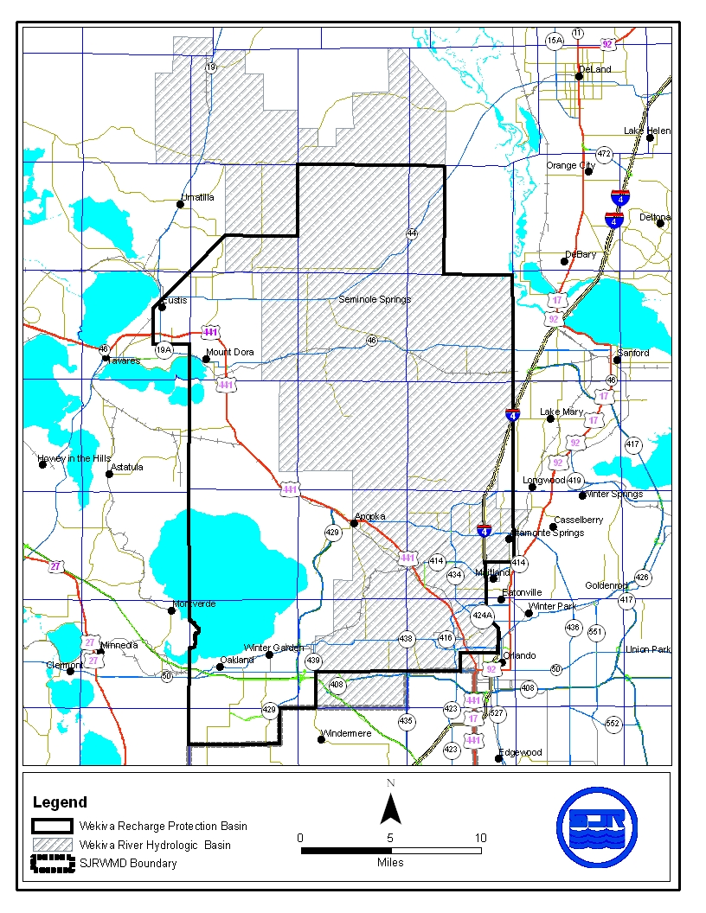

13.3.3 Standards for Erosion and Sediment Control and Water Quality Revised 6/1/18

Construction and alteration of systems can result in erosion and downstream turbidity and sedimentation of waters. Erosion is the process by which the land surface is worn away by action of wind, water, and gravity. During construction and alteration, the potential for erosion increases dramatically. The result of erosion is discharges of turbid water and subsequent sedimentation (settling out) of soil particles in downstream receiving waters. Turbidity, suspended solids, and sedimentation result in adverse biological effects in aquatic and wetland environments, water quality degradation, and loss of flood storage and conveyance. The potential for erosion can be severe in the Wekiva River Hydrologic Basin as a result of steep slopes and erosive soils.

(a) Although erosion and sediment control measures are required throughout the St. Johns River Water Management District (see section 11.0 of Volume I), the District has determined that the problems associated with erosion in the Wekiva River Hydrologic Basin are sufficiently serious to warrant requiring those applicants proposing certain systems to provide detailed plans when permit applications are submitted.

A Water Quality Protection Zone shall extend one half mile from the Wekiva River, Little Wekiva River north of State Road 436, Black Water Creek, Rock Springs Run, Seminole Creek, and Sulphur Run, and shall also extend one quarter mile from any wetland abutting an Outstanding Florida Water.

An erosion and sediment control plan must be submitted as part of the surface water management permit application for a surface water management system which:

1. Serves a project which is located wholly or partially within this zone; or

2. Serves a project with a total land area equal to or exceeding 120 acres.

The applicant proposing such a system must give reasonable assurance in the erosion and sediment control plan that during construction or alteration of the system (including revegetation and stabilization), erosion will be minimized and sediment will be retained on-site. The plan must be in conformance with the erosion and sediment control principles set forth in section 13.8.2, and must contain the information set forth in section 13.8.3.

(b) For a project which will be located wholly or partially within 100 feet of an Outstanding Florida Water or within 100 feet of any wetland abutting such a water, an applicant must provide reasonable assurance that the construction or alteration of the system will not cause sedimentation within these wetlands or waters and that filtration of runoff will occur prior to discharge into these wetlands and waters.

It is presumed that this standard will be met if, in addition to implementation of the plan required in paragraph (a), any one of the following criteria is met:

1. A minimum 100-foot width of undisturbed vegetation must be retained landward of the Outstanding Florida Water or the abutting wetland, whichever is more landward. During construction or alteration, runoff (including turbid discharges from dewatering activities) must be allowed to sheetflow across this undisturbed vegetation as the natural topography allows. Concentrated or channelized runoff from construction or alteration areas must be dispersed before flowing across this undisturbed vegetation. Construction or alteration of limited scope necessary for outfall structures may occur within this area of undisturbed vegetation.

2. Construction of the following perimeter controls at all outfall points to the Outstanding Florida Water or its abutting wetlands must be completed prior to the start of any construction or alteration of the remainder of the system:

a. Stormwater discharge facility meeting the requirements of Part V of this Volume;

b. Sedimentation trap or basin located immediately upstream of the stormwater discharge facility referred to above; and

c. Spreader swale to reduce the velocity of discharge from the stormwater facility to non-erosive rates before discharge to wetlands abutting the Outstanding Florida Water.

These perimeter controls must be maintained routinely and operated throughout construction or alteration of the entire system. A minimum 25-foot width of undisturbed vegetation must be retained landward of the Outstanding Florida Water or the abutting wetland, whichever is more landward. Construction or alteration of limited scope necessary for outfall structures may occur within this area of undisturbed vegetation.

3. During construction or alteration, no direct discharge to the Outstanding Florida Water or its abutting wetland may occur during the 10-year 24-hour storm event or due to discharge from dewatering activities. Any on-site storage required to satisfy this criteria must be available (recovered) within 14 days following the rainfall event. A minimum 25-foot width of undisturbed vegetation must be retained landward of the Outstanding Florida Water or the abutting wetland, whichever is more landward. Construction or alteration of limited scope necessary for outfall structures may occur within this area of undisturbed vegetation.

In determining whether construction or alteration is of "limited scope necessary", pursuant to any of the three presumptive criteria above, the District shall require that the area of disturbance be minimized and that the length of time between initial disturbance and stabilization of the area also be minimized.

13.3.4 Standard for Limiting Drawdown

Lowering the ground water table adjacent to wetlands can change the wetland hydroperiod such that the functions provided by the wetland are adversely affected.

Within the Wekiva River Hydrologic Basin, a Water Quantity Protection Zone shall extend 300 feet landward of the landward extent of Black Water Swamp and the wetlands abutting the Wekiva River, Little Wekiva River, Rock Springs Run, Black Water Creek, Sulphur Run, Seminole Creek, Lake Norris, and Lake Dorr. As part of providing reasonable assurance that the standard set forth in paragraph 62-330.301(1)(d) is met, where any part of a system located within this zone will cause a drawdown, the applicant must provide reasonable assurance that construction, alteration, operation, or maintenance of the system will not cause ground water table drawdowns which would adversely affect the functions provided by the referenced wetlands.

The applicant shall provide an analysis which includes a determination of the magnitude and areal extent of any drawdowns, based on site-specific hydrogeologic data collected by the applicant, as well as a description of the referenced wetlands, the functions provided by these wetlands, and the predicted impacts to these functions.

It is presumed that the part of this standard regarding drawdown effects will be met if the following criteria is met:

A ground water table drawdown must not occur within the Water Quantity Protection Zone.

13.3.5 Standard for Riparian Wildlife Habitat

Within the Wekiva River Hydrologic Basin, the wetlands abutting the Wekiva River, Little Wekiva River downstream of Maitland Boulevard, Rock Springs Run, Black Water Creek, Sulphur Run and Seminole Creek support an abundance and diversity of aquatic and wetland dependent wildlife. Uplands abutting these wetlands protect the wetlands from climatic extremes and also provide important habitat for some aquatic and wetland dependent species. Construction and alteration of surface water management systems within these wetlands and uplands can result in adverse changes in the habitat, abundance, and food sources of aquatic and wetland dependent species.

(a) The applicant must provide reasonable assurance that the construction or alteration of a system will not adversely affect the abundance, food sources, or habitat (including its use to satisfy nesting, breeding and resting needs) of aquatic or wetland dependent species provided by the following designated Riparian Habitat Protection Zone:

1. The wetlands abutting the Wekiva River, Little Wekiva River downstream of Maitland Boulevard, Rock Springs Run, Black Water Creek, Sulphur Run, or Seminole Creek;

2. The uplands which are within 50 feet landward of the landward extent of the wetlands above.

3. The uplands which are within 550 feet landward of the stream's edge as defined, for the purpose of this subsection, as the waterward extent of the forested wetlands abutting the Wekiva River, Little Wekiva River downstream of the northernmost crossing of the Little Wekiva River with S.R. 434, Rock Springs Run, Black Water Creek, Sulphur Run or Seminole Creek. In the absence of forested wetlands abutting these streams, the stream's edge shall be defined, for the purpose of this subsection, as the mean annual surface water elevation of the stream; however, if hydrologic records are unavailable, the landward extent of the herbaceous emergent wetland vegetation growing in these streams shall be considered to be the stream's edge.

(b) Any of the following activities within the Riparian Habitat Protection Zone is presumed to adversely affect the abundance, food sources, or habitat of aquatic or wetland dependent species provided by the zone: construction of buildings, golf courses, impoundments, roads, canals, ditches, swales, and any land clearing which results in the creation of any system. (Activities not listed above do not receive a presumption of no adverse effect.)

(c) The presumption in paragraph (b) shall not apply to any activity which promotes a more endemic state, where the land in the zone has been changed by man. An example of such an activity would be construction undertaken to return lands managed for agriculture or silviculture to a vegetative community that is more compatible with the endemic land cover.

13.3.6 Local Government Notification for Wekiva River Protection Area
Revised 6/1/18

The District shall not issue a conceptual approval or individual permit for a proposed surface water management system located wholly or partially within the Wekiva River Protection Area, as defined in Section 369.303(9), F.S., until the appropriate local government has provided written notification that the proposed activity is consistent with the local comprehensive plan and is in compliance with land development regulations in effect in the area where development will take place. The applicant proposing such a system must submit to the District form no. 40C-41.063(4), entitled "Local Government Notification", (incorporated by reference in 40C-41.063(4)), after it has been completed and executed by the local government. This form is available upon request from the St. Johns River Water Management District, 4049 Reid Street, Palatka, Florida 32177-2529. Permit applications for systems within the Wekiva River Protection Area shall be processed by the District staff pursuant to the time frames established in Section 120.60, F.S., and any District rule regarding permit processing, except that any agency action to approve or approve with conditions shall not occur until the Local Government Notification has been received by the District.

13.4 Econlockhatchee River Hydrologic Basin

As part of the standards and design criteria described in 62-330.301 and 62-330.302, F.A.C., above, systems in the Econlockhatchee River Hydrologic Basin must meet the following standards and criteria:

13.4.1 Design Storm Criteria

Systems must meet the peak discharge requirement for the following 24-hour duration design storm events:

(a) Mean annual storm (2.3-year return period) with a total 24-hour rainfall depth of 4.5 inches.

(b) 25-year return period.

System outlet control structures can be designed to meet the control peak discharge rates for both design storms by use of a two-stage weir, v-notch weir, multiple orifices, or other similar structures.

13.4.2 Floodplain Storage Criteria Revised 6/1/18

A system must not cause a net reduction in flood storage within the 100-year floodplain of the Econlockhatchee River or any of its tributaries, at a location with an upstream drainage area of 1 square mile or greater, except for structures elevated on pilings or traversing works that comply with the conveyance requirements in subsection 3.3.2.

13.4.3 Riparian Wildlife Habitat Standard

The wetlands abutting the Econlockhatchee River and its tributaries support an abundance and diversity of aquatic and wetland dependent wildlife. Uplands abutting these wetlands protect the wetlands and provide important habitat for aquatic and wetland dependent species. Construction, alteration, operation, maintenance, removal or abandonment of surface water management systems within these wetlands and uplands can result in adverse changes in the habitat, diversity, abundance and food sources of aquatic and wetland dependent species. Implementation of these regulations should be done in a manner which encourages development of functional resource protection plans.

(a) The applicant must provide reasonable assurance that the construction, alteration, operation, maintenance, removal or abandonment of a system within the following designated Riparian Habitat Protection Zone will not adversely affect the abundance, diversity, food sources or habitat (including its use to satisfy nesting, breeding and resting needs) of aquatic or wetland dependent species:

1. The wetlands contiguous with the Econlockhatchee River and the following tributaries: Little Econlockhatchee River north of University Boulevard, Mills Creek, Silcox Branch (branch of Mills Creek), Mills Branch (branch of Mills Creek), Long Branch, Hart Branch, Cowpen Branch, Green Branch, Turkey Creek, Little Creek, and Fourmile Creek;

2. The uplands which are within 50 feet landward of the landward extent of the wetlands above; and

3. The uplands which are within 550 feet landward of the stream's edge as defined, for the purpose of this subsection, as the waterward extent of the forested wetlands abutting the Econlockhatchee River and the above named tributaries. In the absence of forested wetlands abutting these streams, the stream's edge shall be defined, for the purpose of this subsection, as the mean annual surface water elevation of the stream; however, if hydrologic records are unavailable, the landward extent of the herbaceous emergent wetland vegetation growing in these streams shall be considered to be the stream's edge.

4. The following portions of streams typically lack a defined water's edge, and subparagraph 3. shall not apply:

a. Mills Creek upstream of the intersection of the creek with the Fort Christmas Road in Section 2, Township 22 South, Range 32 East;

b. Long Branch upstream of the intersections of the creek with SR 520;

c. Hart Branch upstream of the intersection of the creek and the Old Railroad Grade in Section 18, Township 23 South, Range 32 East;

d. Cowpen Branch upstream of the southernmost bifurcation of the creek in Section 20, Township 23 South, Range 32 East;

e. Green Branch upstream of the intersection of the creek with the north-south section line between Section 29 and 30, Township 23 South, Range 32 East;

f. Turkey Creek including Turkey Creek Bay upstream of the intersection of the creek with the Weewahootee Road in Section 5, Township 24 South, Range 32 East;

g. Little Creek upstream of the intersection of the creek with the north-south section line between Sections 22 and 23, Township 24 South, Range 32 East;

h. Fourmile Creek including Bee Tree Swamp upstream of a point along the creek exactly halfway between section lines at the south end of Section 21 and the north end of Section 33 within Section 28, Township 24 South, Range 32 East; and

i. All of the Econlockhatchee River Swamp (a portion of the Econlockhatchee River).

(b) Any of the following activities within the Riparian Habitat Protection Zone are presumed to adversely affect the abundance, food sources, or habitat of aquatic or wetland dependent species provided by the zone: construction of buildings, golf courses, impoundments, roads, canals, ditches, swales, and any land clearing which results in the creation of any system. (Activities not listed above do not receive a presumption of no adverse effect.)

(c) The presumption in paragraph (b) shall not apply to any activity which promotes a more endemic state, where the land in the zone has been changed by man. An example of such an activity would be construction undertaken to return lands managed for agriculture or silviculture to a vegetative community that is more compatible with endemic land cover.

(d) Applicants seeking to develop within the Riparian Habitat Protection Zone shall be given the opportunity to demonstrate that the particular development for which permitting is being sought will not have an adverse effect on the functions provided by the zone to aquatic or wetland dependent species. The functions provided by the zone are dependent on many factors. When assessing the value of the zone to aquatic and wetland dependent species, factors which the District will consider include: vegetative land cover, hydrologic regime, topography, soils, and land uses, existing within and adjacent to the zone; and range, habitat, and food source needs of aquatic and wetland dependent species, as well as sightings, tracks, or other such empirical evidence of use.

(e) The standard of paragraph 13.4.3(a) may be met by demonstrating that the overall merits of the proposed plan of development, including the preservation, creation or enhancement of viable wildlife habitat, provide a degree of resource protection to these types of fish and wildlife which offsets adverse effects that the system may have on the abundance, diversity, food sources, or habitat of aquatic or wetland dependent species provided by the zone. Mitigation plans will be considered on a case-by-case basis upon detailed site specific analyses. The goal of this analysis shall be the determination of the value of the proposed mitigation plan to aquatic and wetland dependent species with particular attention to threatened or endangered species. Mitigation plans should include: the information set forth in section 10.3.3 Applicant’s Handbook Volume I for the uplands and wetlands within the zone and within other areas to be preserved, created or enhanced as mitigation for impacts within the zone; as well as other pertinent information, including land use, and the proximity of the site to publicly owned land dedicated to conservation. Implementation of this section contemplates that the proximity of development to the river and tributaries named herein and activities permitted in the zone may vary from place to place in support of a functional resource protection plan. Furthermore, some reasonable use of the land within the protection zone can be allowed under subsection 13.4.4.

(f) Roads or other traversing works which cross the zone have the potential to fragment the zone and adversely affect the habitat value of the zone to aquatic and wetland dependent species. To minimize adverse effects to the zone, applicants for permits to construct traversing works in the zone must first demonstrate the need for the traversing works to provide for regional transportation, regional utility services, or reasonable property access, in addition to meeting the requirement of paragraph 13.4.3(a), above. Traversing works must also be designed to meet all requirements of the district rules related to water quality and quantity. Permittees responsible for traversing works shall be required to be responsible for maintaining the traversing works clean and free from trash and debris to the greatest extent practical.

13.4.4 Off-site Land Preservation as Mitigation in the Econlockhatchee River Hydrologic Basin. Revised 6/1/18

Mitigation in the Econlockhatchee River Hydrologic Basin must offset any adverse impacts of the system to the functions provided by the Econlockhatchee River Riparian Habitat Protection Zone and wetlands outside this zone, to aquatic and wetland dependent species. The lands proposed for preservation must be regionally significant or provide unique fish and wildlife habitat. For the purposes of this section the land to be preserved must be located entirely within the Econlockhatchee River Basin as designated in section 40C-41.023, F.A.C., and the applicant must propose to convey the land in fee simple to the St. Johns River Water Management District or a mutually acceptable designee. Alternatively, a perpetual conservation easement or other acceptable legal instrument may be conveyed to the District or a mutually acceptable designee in accordance with section 704.06, F.S. All of the following requirements will apply to off-site land preservation proposals within the Econlockhatchee River Basin:

(a) Prior to proposing off-site land preservation, the applicant must demonstrate that alternatives for avoiding adverse impacts to the functions provided by the Riparian Habitat Protection Zone and wetlands outside the zone have been evaluated, and that to the maximum extent practicable, adverse impacts to these functions have been avoided.

(b) As a part of an off-site land preservation proposal, the applicant must demonstrate that the proposal meets the standard described in paragraph 13.4.3(a) by providing a functional analysis, as described in paragraph 13.4.3(c), of the proposed impacts within the Riparian Habitat Protection Zone and the benefits of the proposed preservation area. If adverse impacts occur to wetlands, then as part of an off-site land preservation proposal, the applicant must demonstrate that the proposal meets the criteria described in section 10.3.3, Applicant’s Handbook Volume I.

(c) The functional gain afforded by the preservation will depend upon the functional analysis of impacts and benefits. The suitability of this mitigation option will be determined on a case-by-case basis based on site-specific information.
13.5 Tomoka River and Spruce Creek Hydrologic Basins

As part of the standards and design criteria described in 62-330.301 and 62-330.302, F.A.C., systems within the Tomoka River Hydrologic Basin or the Spruce Creek Hydrologic Basin must meet the following standards and criteria:

13.5.1 Recharge Standard

Projects, or portions of projects, in the Most Effective Recharge Areas must retain three (3) inches of runoff from the directly connected impervious area within the Most Effective Recharge Area of the project area. As an alternative, applicants may demonstrate that the post-development recharge capacity will be equal to or greater than the pre-development recharge capacity.

Most Effective Recharge Areas, as used in this section, are areas which have 10-20 inches of recharge per year. Most Effective Recharge Areas can be more accurately defined by soils types. Those areas with Type “A” Hydrologic Soil Group shall be considered to be Most Effective Recharge Areas. Figures 13.5-1 and Figure 13.5-2 show the approximate location of the Most Effective Recharge Area in the Tomoka River and Spruce Creek Hydrologic Basins.

Section 13.8.1 contains a list of Type “A” soils for Flagler and Volusia counties. This list will be used to determine whether a proposed project, or portion of a project, is in the Most Effective Recharge Area. Also, applicants may submit additional geotechnical information to establish whether or not a site contains Type “A” soils and is within the Most Effective Recharge Area.

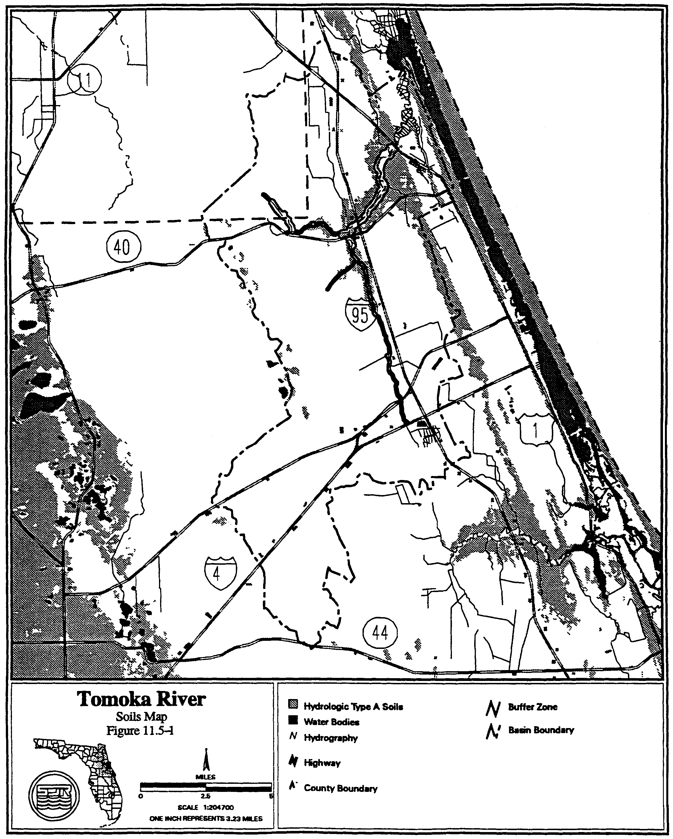
Figure 13.5-1 Tomoka River Soils Map
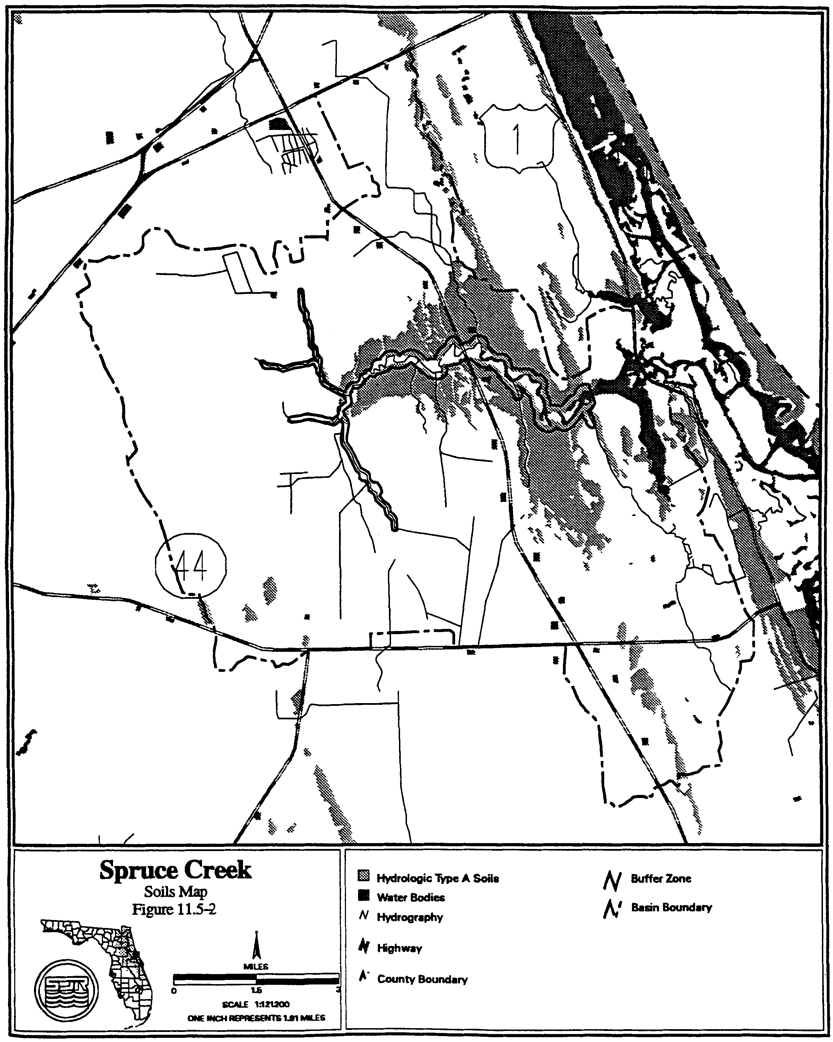
Figure 13.5-2 Spruce Creek Soils Map

Directly connected impervious areas are those impervious areas, which are connected to the surface water management system by a drainage improvement, such as a ditch, storm sewer, paved channel, or other man-made conveyance. Stormwater that is retained must be infiltrated into the soil or evaporated such that the storage volume is recovered within 14 days following the storm event.

13.5.2 Floodplain Storage Criteria

Systems constructed in the 100-year floodplain have the potential to increase flood stages on adjacent property. A system must not cause a net reduction in flood storage within the 100-year floodplain of the Tomoka River or Spruce Creek or any of their tributaries except for structures elevated on pilings or traversing works that comply with conveyance requirements in subsection 3.3.2.

13.5.3 Stormwater Management Standard Revised 6/28/24

Construction of new stormwater management systems must be in accordance with the applicable criteria of Part V of this Volume and Parts II and IV of Volume I. However, systems which serve drainage areas in excess of 10 acres cannot use detention with filtration treatment as the sole stormwater treatment methodology.

13.5.4 Riparian Wildlife Habitat Standard

The wetlands abutting the Tomoka River and Spruce Creek and their tributaries support an abundance and diversity of aquatic and wetland dependent wildlife. Uplands abutting these wetlands protect the wetlands and provide important habitat for aquatic and wetland dependent species. Construction, alteration, operation, maintenance, removal or abandonment of surface water management systems within these wetlands and uplands can result in adverse changes in the habitat, diversity, abundance and food sources of aquatic and wetland dependent species. Implementation of these regulations should be done in a manner which encourages development of functional resource protection plans.

(a) The applicant must provide reasonable assurance that the construction, alteration, operation, maintenance, removal or abandonment of a system within the following designated Riparian Habitat Protection Zone will not adversely affect the abundance, diversity, food sources or habitat (including its use to satisfy nesting, breeding and resting needs) of aquatic or wetland dependent species:

1. The wetlands and uplands which are within 50 feet landward of the landward extent of the wetlands which abut Spruce Creek north of Pioneer Trail to the FEC railroad, and the Tomoka River north of I-4 to US 1 and the following tributaries:

a. Spruce Creek east of the western section line of Section 35, Township 16 South, Range 32 East, Volusia County, Florida.

b. Spruce Creek east of the power line easement in Section 27, Township 16 South, Range 32 East, Volusia County, Florida.

c. Spruce Creek west of SR 415 and south of the northern section line of Section 23, Township 16 South, Range 32 East, Volusia County, Florida.

d. The Little Tomoka River north of SR 40 in Volusia County and south of the western section line of Section 22, Range 31 East, Township 14 South, Flagler County.

e. Priest Branch east of the power line easement in Section 6, Township 15 South, Range 32 East, Volusia County, Florida.

2. The uplands which are within 550 feet landward of the stream's edge of the following portions of the streams. The stream’s edge is defined, for the purpose of this subsection, as the waterward extent of the wetlands abutting the stream:

a. Spruce Creek north of the southern section line of Section 25, Range 32 East, Township 16 South, Volusia County, Florida;

b. Tomoka River north of the confluence of the Tomoka River and Priest Branch; and

3. The uplands which are within 320 feet landward of the stream’s edge of the following stream. The stream’s edge is defined, for the purpose of this subsection, as the waterward extent of the wetlands abutting the stream:

a. Spruce Creek east of I-95 and west of the FEC railroad; and

4. The uplands that are within 275 feet landward of the edge of the following streams:

a. Spruce Creek south of the southern section line of Section 25, Range 32 East, Township 16 South, Volusia County, Florida;

b. Spruce Creek east of the western section line of Section 35, Township 16 South, Range 32 East, Volusia County, Florida.

c. Spruce Creek east of the power line easement in Section 27, Township 16 South, Range 32 East, Volusia County, Florida.

d. Spruce Creek west of SR 415 and south of the northern section line of Section 23, Township 16 South, Range 32 East, Volusia County, Florida.

e. The Tomoka River south of the confluence of the Tomoka River and Priest Branch in section 36, Range 31 East, Township 14 South, Volusia County, Florida;

f. The Little Tomoka River north of SR 40, Volusia County, and south of the western section line of Section 22, Range 31 East, Township 14 South, Flagler County, Florida.

g. Priest Branch east of the power line easement in Section 6, Township 15 South, Range 32 East, Volusia County, Florida.

(b) Any of the following activities within the Riparian Habitat Protection Zone are presumed to adversely affect the abundance, food sources, or habitat of aquatic or wetland dependent species provided by the Zone: construction of buildings, golf courses, impoundments, roads, canals, ditches, swales, and any land clearing which results in the creation of any system (activities not listed above do not receive a presumption of no adverse effect.)

(c) The presumption in paragraph (b) shall not apply to any activity which promotes a more endemic state, where the land in the Zone has been changed by man. An example of such an activity would be construction undertaken to return lands managed for agriculture or silviculture to a vegetative community that is more compatible with endemic land cover.

(d) The standard of subsection 13.5.4(a) may be met by demonstrating that the overall merits of the proposed plan of development, including mitigation as described in section 10.3, Applicant's Handbook Volume I provide a degree of resource protection to these types of fish and wildlife which offsets adverse effects of the proposed system on the uplands and wetlands within the Zone. Some reasonable use of the land within the Zone can be allowed under subsection 13.5.4.

(e) Roads or other traversing works which cross the Zone have the potential to fragment the Zone and adversely affect the habitat value of the Zone to aquatic and wetland dependent species. To minimize adverse effects to the Zone, applicants for permits to construct traversing works in the Zone must first demonstrate the need for the traversing works to provide for regional transportation, regional utility services, or reasonable property access, in addition to meeting the requirement of subsection 13.5.4(a), above. Traversing works must also be designed to meet all requirements of the district rules related to water quality and quantity.

13.6 Sensitive Karst Areas Basin Design Criteria

Chapter 40C-41, F.A.C., establishes additional surface water management criteria which are used in reviewing applications for permits in designated hydrologic basins. The Sensitive Karst Areas Basin covers those portions of western Alachua and western Marion counties within the District’s boundaries (Figures 13.0-3 and 13.0-4). The design criteria for the Sensitive Karst Areas Basin are found in subsection 40C-41.063(6), F.A.C., and are discussed below.

13.6.1 Background of the Sensitive Karst Areas Design Criteria

The Floridan aquifer is the drinking water source for most of the population in the District. In parts of Alachua and Marion counties, the limestones that make up or comprise this aquifer are at or very near the land surface and potential sources of pollution. Potential contamination of the Floridan aquifer from surface pollutant sources in these areas is greater than within the rest of the District due to the hydrogeology and geology of these "sensitive karst areas." "Karst" is a geologic term used to describe areas where sinkhole formation is common and landscapes are formed by the solution of limestone.

13.6.2 Hydrogeology of the Sensitive Karst Areas Basin Revised 6/28/24

Throughout the majority of the District the highly porous limestone which contains the Floridan aquifer is overlain by tens to hundreds of feet of sands, clays, and other material. This material acts as a buffer, isolating the Floridan aquifer from surface pollutants. Surface water seeps through this material slowly which allows for filtration, adsorption, and biological removal of contaminants.

However, in the Sensitive Karst Areas (SKA) the limestone which contains the Floridan aquifer exists at, or virtually at, land surface (Figure 13.6-1). The absence of cover material allows rapid movement of surface water into the aquifer with little treatment. The SKA are areas of high recharge for the Floridan aquifer. Floridan aquifer ground water levels vary from land surface to approximately 60 feet below land surface in the SKA.

A factor which makes the SKA particularly prone to stormwater contamination is the formation of solution pipe sinkholes. Solution pipe sinkholes are common in these areas and form due to the collapse of surficial material into vertical cavities that have been dissolved in the upper portion of the limestone (Figure 13.6-1). They are also formed by the movement of surface material into the porous limestone of the SKA. In most cases, the solution pipes are capped by a natural plug of sands and clays (Figures 13.6-1 and 13.6-2). If the cap is washed out, the resulting solution pipe sinkhole (Figure 13.6-3) can act as a direct avenue for the movement of inadequately treated stormwater into the Floridan aquifer.

Solution pipe sinkholes often form in the bottom of stormwater retention basins. The capping plug may be reduced by excavation of the pond. Stormwater in the basin may increase the hydraulic head on the remaining plug. Both of these factors can wash the plug down the solution pipe. Solution pipes act as natural drainage wells and can drain stormwater basins.

The irregular weathering of the limestone surface in the SKA causes uncertainty and errors in determining the depth from land surface to limestone. For example, in Figure 13.6-1, boring A would show limestone much deeper than it would actually be encountered during excavation, shown at boring B. This potential for error must be considered for site investigations when evaluating site borings.

The SKA has been delineated within the District using two criteria:

(a) The area is a major recharge area, defined by the United States Geological Survey (USGS) as 10 to 20 inches annual recharge, for the Floridan aquifer.

(b) The porous limestone of the Floridan aquifer occurs within 20 feet of the land surface.

Delineations were made using the best available data, including boring and geologic data from the District, the Florida Geologic Survey, and the USGS. As additional data becomes available, the delineation of these areas can be further refined if needed. A generalized map of the SKA is shown in Figure 13.0-2; detailed maps are provided in Figures 13.0-3 and 13.0-4.

13.6.3 Design Criteria for Sensitive Karst Areas Revised 6/1/18

The stormwater system should be designed to assure adequate treatment of the water before it enters the Floridan aquifer. The system design should prevent the formation of solution pipe sinkholes in the basins. To protect the Floridan aquifer, the District requires the following minimum design features for all projects in the SKA:

(a) A minimum of three feet of unconsolidated soil material between the surface of the limestone bedrock and the bottom and sides of the stormwater basin. Excavation and backfill of suitable material may be made to meet this criteria. This provides reasonable assurance of adequate treatment of stormwater before it enters the Floridan aquifer.

(b) Stormwater storage areas should be as shallow as possible with a horizontal bottom (no deep spots). In general, the size of a stormwater storage basin can be minimized by providing retention throughout the project site by using shallow landscaped areas and swales.

(c) Maximum basin depth of 10 feet. (Items (b) and (c) reduce the potential for solution pipe sinkhole formation caused by a large hydraulic head.)

Figure 13.6-1 Generalized geologic section in karst sensitive area

Figure 13.6-2 Generalized geologic section in karst sensitive area with excavated retention basin

Figure 13.6-3. Generalized geologic section in karst sensitive area with excavated retention basin

(d) Fully vegetated basin side slopes and bottom. Vegetation plays a critical role in the removal of contaminants from stormwater and stabilization of side slopes. In the SKA, droughty, highly alkaline soils are common and prevent successful establishment of commonly used grasses such as bahia. Typically poor survival of vegetation in stormwater basins in the SKA has demonstrated the need for mat-forming vegetation which can tolerate these conditions.

Two species of grasses are best suited for use in retention basins in the SKA. These grasses are discussed below:

St. Augustine: This grass can tolerate high alkalinity and brief inundation.
However, irrigation is required to foster a healthy cover during dry periods.

Bermuda: This grass can grow in alkaline conditions, is drought resistant, and can
Figure 9-8. Generalized Geologic Section in Karst Sensitive Area with Excavated Retention Basin
Figure 9-9. Generalized Geologic Section in Karst Sensitive Area with Excavated Retention Basin
stand brief inundation. It is also a low maintenance species which provides excellent
cover and soil stabilization. Bermuda grass grows in a thick mat, eventually
covering all exposed soil. It recovers quickly after even extended drought.
Mowing is rarely required because Bermuda creeps laterally rather than growing
vertically. Seed is available commercially and is inexpensive.

The above conditions represent the minimum design requirements for systems in the
SKA. Depending on the potential for contamination to the Floridan aquifer, more
stringent criteria may apply. Industrial and some commercial sites will normally
require more stringent design features. Some of the more stringent site-specific
design requirements which may be necessary include:

(a) More than 3 feet of material between the limestone bedrock surface and the
bottoms and sides of retention basins

(b) Basin liners (Clay or geotextile)

(c) Sediment trapping structures at stormwater inlets

(d) Off-line treatment

(e) Special stormwater system design

(f) Ground water monitoring

(g) Paint/solvent and water separators

If the design of the proposed stormwater management systems does not include the minimum design criteria discussed in this section, an analysis must be submitted to the District that provides reasonable assurance that the ground water quality standards as set forth in chapter 62-520, F.A.C., (incorporated by reference in 40C-4.091(1)(c), F.A.C.) are met.

13.7 Lake Apopka Hydrologic Basin Revised 6/1/18, 6/28/24

(a) Pursuant to section 373.461(3)(a), F.S., the total phosphorus criterion for Lake Apopka is 55 parts per billion. To meet this total phosphorus criterion, the applicant must provide reasonable assurance of compliance with the following total phosphorus discharge limitations and comply with the relevant monitoring requirements in section 13.7(b) and relevant inspection requirements of section]=- 13.7(c):

(1) Sites Within Lake Apopka Hydrologic Basin

Applicants required to obtain a permit pursuant to chapters 62-330 or 40C-44, F.A.C., for a surface water management system located within the Lake Apopka Hydrologic Basin shall demonstrate: (i) that the system provides stormwater treatment equivalent to or greater than any of the applicable stormwater treatment options contained in Table 13.7-1 for the removal of total phosphorus; (ii) that the post-development total phosphorus load discharged from the project area will not exceed the pre-development total phosphorus load discharged from the project area utilizing the applicable performance standards and methodology in sections 8.3 and 9.0 of Volume I; or (iii) that the system, under the soil moisture conditions described in section 3.2.8(a), will not discharge water to Lake Apopka or its tributaries for the 100-year, 24-hour storm event. Systems described under section 13.7(a)(1)(iii) shall be considered to discharge to a land-locked lake that must meet the criteria in section 3.2. Any alteration of a system originally permitted pursuant to section 13.7(a)(1)(iii) which results in an increase in discharge of water to Lake Apopka or its tributaries shall be considered an interbasin diversion that must meet the criteria in sections 13.7(a)(2) and 13.7(b)(4).

(2) Interbasin Diversion of Water to Lake Apopka Hydrologic Basin

Applicants required to obtain a permit pursuant to chapters 62-330 or 40C-44, F.A.C., for a surface water management system that will cause the importation of water from another hydrologic basin into the Lake Apopka Hydrologic Basin shall not discharge any phosphorus from the project area to Lake Apopka or its tributaries, unless the applicant implements measures to reduce the existing total phosphorus load to Lake Apopka or its tributaries from another existing source by at least an equivalent amount of total phosphorus. The imported water shall consist only of stormwater runoff. The imported water shall not be discharged to Lake Apopka or its tributaries when the water level of Lake Apopka is in Zone A of the Lake Apopka Regulation Schedule set forth in Figure 13.7-2. All measures to reduce existing phosphorous loads to Lake Apopka or its tributaries must be constructed and operating in compliance with the environmental resource permit prior to any importation of water into the Lake Apopka Hydrologic Basin. Measures that reduce existing phosphorous loads to Lake Apopka or its tributaries shall not include those measures taken on the District’s land.

(3) Methodology for Determining Total Phosphorus Loads.

Determination of Pre-Development Total Phosphorus Loads.

Pre-development total phosphorus loads shall be based upon the land uses in place as of March 7, 2003. For systems which have been constructed in accordance with a permit issued pursuant to chapters 62-330 or 40C-44, F.A.C., at the permit applicant’s option, the pre-development total phosphorus loads shall be based upon the land uses in place at the time the prior permit was issued. Pre-development total phosphorus loads shall be determined by: monitoring the total phosphorus loads from the project area for a period of one year prior to construction, alteration, abandonment, or removal of the proposed or existing system; calculating total phosphorus loads using the applicable performance standards and methodology in sections 8.3 and 9.0 of Volume I . When the pre-development total phosphorus loads are determined by monitoring, the calculation of pre-development total phosphorus loads shall be adjusted by interpolation or extrapolation to reflect mean annual rainfall conditions.

Determination of Post-Development Total Phosphorus Loads.

Post-development total phosphorus loads shall be based upon the land uses proposed in the permit application and shall be determined by utilizing the applicable performance standards and methodology in sections 8.3 and 9.0 of Volume I.

(b) Monitoring

(1) Monitoring for Retention Systems.

A surface water management system to be permitted under section 13.7(a)(1)(i) which utilizes only retention, shall be monitored as set forth in this paragraph. Water elevations in such a system shall be monitored from the date that construction of the system is completed or any part of the system is used for its intended purpose, whichever is sooner. The monitoring shall continue for three years following completion of construction of the entire system, including all associated residential, commercial, transportation, or agricultural improvements. If the results of the monitoring indicate that the system is not recovering the treatment volume in accordance with the permitted design, then the permittee shall either perform maintenance on the system, or obtain a modification to the permit and implement measures, to bring the system into compliance, and in either event the monitoring shall continue for three years after the date the system is brought into compliance. If the system is determined to be in compliance after three years of monitoring, the system shall thereafter be inspected in accordance with Section 12 of Volume I.

(2) Monitoring for Systems Permitted Under Section 13.7(a)(1)(iii).

A surface water management system to be permitted under section 13.7(a)(1)(iii), shall be monitored as set forth in this paragraph. Water elevations in such a system shall be monitored from the date that construction of the system is completed or any part of the system is used for its intended purpose, whichever is sooner. The monitoring in such a system shall continue for ten years following completion of construction of the entire system, including all associated residential, commercial, transportation, or agricultural improvements. If the results of the monitoring indicate that either the system is not recovering storage in accordance with the permitted design or causes water to be discharged to Lake Apopka or its tributaries for events less than the 100-year, 24-hour storm event, then the permittee shall either perform maintenance that brings the system into compliance or obtain a modification to the permit and implement measures to bring the system into compliance, and in either event the monitoring shall continue for three years after the date the system is brought into compliance. If the system is determined to be in compliance after ten years of monitoring, the system shall thereafter be inspected in accordance with Section 12 of Volume I.

(3) Monitoring for Other Systems

A surface water management system to be permitted, other than a system described in sections 13.7(b)(1), 13.7(b)(2) or 13.7(b)(4), shall be monitored as set forth in this paragraph. Except as provided below, the total phosphorus load from the project area shall be monitored from the date that construction of such a system is completed or any part of the system is used for its intended purpose, whichever is sooner. The monitoring shall continue for three years following completion of construction of the entire system, including all associated residential, commercial, transportation, or agricultural improvements. If the results of the monitoring indicate that post-development total phosphorus loads exceed pre-development total phosphorus loads, then the permittee shall either perform maintenance on the system, or obtain a modification to the permit and implement measures, to reduce the total phosphorus loads to no more than pre-development levels, and, in either event, the monitoring shall continue for three years after the date the system is maintained or modified as described herein. If the system is determined to be in compliance after three years of monitoring, the system shall thereafter be inspected in accordance with Section 12 of Volume I.

No monitoring shall be required under section 13.7(b)(3) when an applicant demonstrates that the system provides stormwater treatment equivalent to or greater than any of the applicable stormwater treatment options contained in Table 13.7-1 for the removal of total phosphorus. Alternatively, no monitoring shall be required under section 13.7(b)(3) when an applicant demonstrates that the post-development total phosphorus load discharged from the project area will not exceed the pre-development total phosphorus load discharged from the project area when determined using the applicable performance standards and methodology in sections 8.3 and 9.0 of Volume I.

(4) Monitoring for Interbasin Diversion of Water to Lake Apopka Hydrologic Basin

A surface water management system to be permitted under section 13.7(a)(2) shall be monitored as set forth in this paragraph. The total phosphorus load shall be monitored from: (i) any system designed to reduce the existing total phosphorus load to Lake Apopka or its tributaries, and (ii) the system that is importing water to the Lake Apopka Hydrologic Basin. Monitoring of the system that is importing water to the Lake Apopka Hydrologic Basin shall commence from the date that construction of such system is completed or any part of the system is used for its intended purpose, whichever is sooner. Monitoring of systems designed to reduce the existing total phosphorus load to Lake Apopka or its tributaries shall commence from the date that construction of such system is completed. Monitoring shall continue for as long as water is imported from the system to the Lake Apopka Hydrologic Basin. If monitoring results indicate that the reductions in total phosphorus load are less than that in the imported water, then the permittee shall either perform maintenance or obtain a permit modification to bring the system(s) into compliance.

(c) Inspecting Systems

Systems subject to the inspection requirements in section 62-330.311, F.A.C., and which are also subject to the phosphorus discharge limitations in section 13.7(a), shall be inspected by the operation and maintenance entity within one year after completion of construction and thereafter in accordance with Section 12 of Volume I.

TABLE 13.7-1
STORMWATER TREATMENT CRITERIA TO ACHIEVE NO NET INCREASE IN POST- DEVELOPMENT LOADINGS WITHIN THE LAKE APOPKA HYDROLOGIC BASIN
LAND USE  CATEGORY | HYDROLOGIC  SOIL GROUP | RETENTION¹  ONLY² | RETENTION¹/  WET  DETENTION  OPTION³
Low-Density  Residential  (max. 15% impervious) | A  B  C  D | 2.75"  1.75"  1.25"  1.00" | 1.00"/14 days  0.50"/14 days  0.50"/14 days  0.25"/14 days
Single-Family  Residential (max. 25% impervious) | A  B  C  D | 2.75"  2.00"  1.75"  1.50" | 1.00"/14 days  0.75"/14 days  0.75"/14 days  0.50"/14 days
Single-Family Residential (max. 40% impervious) | A  B  C  D | 3.75”  3.00"  2.00"  1.50" | 1.25"/14 days  1.00"/14 days  0.75"/14 days  0.50"/14 days
Multi-  Family  Residential (max. 65% impervious) | A  B  C  D | 4.00”  3.75"  3.25"  2.75" | 2.50"/14 days  2.00"/14 days  1.75"/14 days  1.50"/14 days
Commercial  (max. 80%impervious) | A  B  C  D | 4.00”  3.75"  2.75"  2.25" | 2.75"/14 days  2.25"/14 days  1.50"/14 days  1.25"/14 days
Highway  (max. 50%  impervious) | A  B  C  D | 4.00"  3.00"  2.50"  2.25" | 2.00"/14 days  1.50"/14 days  1.25"/14 days  1.00"/14 days
Highway  (max. 75%  impervious) | A  B  C  D | 4.00”  3.75"  2.75"  2.25" | 2.75"/14 days  2.25"/14 days  1.75"/14 days  1.25"/14 days
1. For purposes of this Table, the term “retention” includes stormwater harvesting and underdrain and underground exfiltration trench systems as those terms are defined in section 2.1 of this Volume .

2. Required dry retention volume (inches of runoff over project area)

3. Required dry retention volume (inches of runoff over project area) followed by wet detention with listed minimum residence time.

Zone B

Zone A
Figure 13.7-2

13.8 Additional Basin Criteria

13.8.1 Soil Types Revised 6/1/18

Type “A” Soils as defined by the Natural Resources Conservation Service (NRCS) Soil Survey in the following NRCS publications: Soil Survey of Flagler County Area, Florida (1997); Soil Survey of Lake County Area, Florida (1975); Soil Survey of Orange County Area, Florida (1989); Soil Survey of Seminole County Area, Florida (1990); and Soil Survey of Volusia County Area, Florida (1980), (incorporated by reference in 40C-4.091(1)(d), F.A.C).

Flagler County
Orsino
Astatula
Tavares
Palm Beach Sand
Welaka
Cocoa
Bulow
Paola

Lake County
Apopka
Apopka Urban Land
Astaula
Chandler
Chandler Urban Land
Kendrick
Lake
Lake Urban Land
Orlando
Orsino
Paola
Paola Urban Land
St. Lucie
St. Lucie Urban Land
Tavares
Tavares Urban Land

Orange County
Archbold
Apopka
Candler
Candler Urban Land
Florahome
Florahome Urban Land
Lake
Millhopper
Millhopper Urban Land
St. Lucie
St. Lucie Urban Land
Tavares
Tavares Urban Land

Seminole County
Apopka
Astatula
Millhopper
Paola
St. Lucie
Tavares

Volusia County
Apopka
Arents
Astatula
Astatula Urban Land
Bulow
Cocoa
Cocoa Urban
Deland
Orsino
Palm Beach
Palm Beach Urban Land
Paola
Paola Urban Land
St. Lucie
Tavares

13.8.2 Erosion and Sediment Control Principles

Factors which influence erosion potential include soil characteristics, vegetative cover, topography, and climatic conditions. The following principles must be considered in planning and undertaking construction and alteration of surface water management systems:

(a) Plan the development to fit topography, soils, and drainage patterns;

(b) Minimize the extent of area exposed at one time and the duration of exposure;

(c) Schedule areas with greatest erosion potential for dry, rather than wet, season exposure;

(d) Apply erosion control practices to minimize erosion from disturbed areas;

(e) Apply perimeter controls to protect disturbed area from off-site runoff and to trap eroded material on-site to prevent sedimentation in downstream areas;

(f) Keep runoff velocities low and retain runoff on-site;

(g) Stabilize disturbed areas immediately after final grade has been attained or during interim periods of inactivity resulting from construction delays; and

(h) Implement a thorough maintenance and follow-up program.

13.8.3 Erosion and Sediment Control Plan

A plan must be prepared prior to construction and alteration for certain systems and submitted with the permit application to minimize erosion and retain sediment on-site. The details and scope of the plan will depend on the potential for erosion. Projects with larger exposed areas, long duration of construction, steep slopes, erosive soils, or close proximity to streams and other watercourses will require more detailed and comprehensive plans. The plan must include consideration of the site specific erosion potential, including slopes, soil erodibility, vegetative cover, and runoff characteristics. The following is a listing of the minimum information, which must be included in the plan, to be shown on construction or alteration plans, detail sheets, or other appropriate documents:

(a) The existing and proposed topography;

(b) A general description of the predominant soil types on the site, and the corresponding erodibility potential as described by the appropriate soil survey information or on-site investigation;

(c) Schedule and general description of each construction phase of the project. At a minimum, the following applicable phases must be addressed: clearing, excavation earthwork, embankment earthwork, site utilities, roads, site grading and stabilization. The schedule must include estimated starting date and duration. Description must include limits of area impacted by each phase; and

(d) For each construction phase, a description of the following:

1. Storm drainage characteristics, including flow patterns and the peak velocity and discharge from the 1-in-2 year 24 hour storm, at all locations where control measures are proposed and at points of off-site discharge; and

2. Individual control measures (to be shown on construction plans or detail sheets):

a. Estimated date of installation and removal,

b. Location,

c. Purpose of measure and area served,

d. Detailed construction drawings and specifications,

e. Operation and maintenance schedule, and

f. All supporting calculations and documentation including referenced design standards and specifications.

