STANDARD 2 TRAINED REGULATORY STAFF

Table of Contents
REQUIREMENT SUMMARY 2
DESCRIPTION OF REQUIREMENT 2
Step 1: Pre-Inspection Curriculum 3
Step 2: Initial Field Training and Experience 4
Step 3: Independent Inspections and Completion of ALL Curriculum Elements 6
Step 4: Food Safety Inspection Officer – Field Standardization 7
Step 5: Continuing Education and Training 8
OUTCOME 9
DOCUMENTATION 9

STANDARD 2 TRAINED REGULATORY STAFF

This Standard applies to the essential elements of a training program for regulatory staff.

Requirement Summary

The regulatory retail food program inspection staff (Food Safety Inspection Officers - FSIO) shall have the knowledge, skills, and ability to adequately perform their required duties. The following is a schematic of a 5-step training and standardization process to achieve the required level of competency.

STEP 1
Completion of curriculum courses designated as “Pre” in Appendix B-1 prior to conducting and independent routine inspections.

STEP 2
Completion of the following:
- A minimum of 25 joint field training inspections (or a sufficient number of joint inspections determined by the trainer and verified through written documentation that the FSIO has demonstrated all performance elements and competencies to conduct independent inspections of retail food establishments); and
- Successful completion of the jurisdiction’s FSIO Field Training Plan similar to the process outlined in Appendix B-2: Conference for Food Protection (CFP) Field Training Manual.

STEP 3
Completion of the following:
- A minimum of 25 independent inspections; and
- Remaining course curriculum (designated as “post” courses) outlined in Appendix B-1: Curriculum for Retail Food Safety Inspection Officers.

STEP 4
Completion of a standardization process similar to the FDA standardization procedures.

STEP 5
Completion of 20 contact hours of continuing food safety education every 36 months after the initial training is completed.

Description of Requirement

Ninety percent (90 %) of the regulatory retail food program inspection staff (Food Safety Inspection Officers - FSIO) shall have successfully completed the required elements of the 5-step training and standardization process:
- Steps 1 through 4 within 18 months of hire or assignment to the retail food regulatory program.
- Step 5 every 36 months after the initial 18 months of training.

Step 1: Pre-Inspection Curriculum
Prior to conducting any type of independent field inspections in retail food establishments, the FSIO must satisfactorily complete training in pre-requisite courses designated with a “Pre” in Appendix B-1, for the following curriculum areas:
  - Prevailing statutes, regulations, ordinances (specific laws and regulations to be addressed by each jurisdiction);
  - Public Health Principles;
  - Food Microbiology; and
  - Communication Skills.

There are two options for demonstrating successful completion of the pre-inspection curriculum.

OPTION 1: Completion of the pre-inspection curriculum may be demonstrated by successful completion of the following:
    - FDA ORA U pre-requisite courses identified as “Pre” in Appendix B-1; and
    - Training on the jurisdiction’s prevailing statutes, regulations, and/or ordinances.

Note: The estimated contact time for completion of the FDA ORA U pre-requisite (“Pre”) courses is 42 hours.

OPTION 2: Completion of the pre-inspection curriculum may be demonstrated by successful completion of the following:
    - Successful completion of courses deemed by the regulatory jurisdiction’s food program supervisor or training officer to be equivalent to the FDA ORA U pre- requisite (Pre”) courses; and
    - Training on the jurisdiction’s prevailing statutes, regulations, and/or ordinances; and
    - Successful passing of one of the four written examination options (described later in this Standard) for determining if a FSIO has a basic level of food safety knowledge.

A course is deemed equivalent if it can be demonstrated that it covers at least 80% of the learning objectives of the comparable ORA U course AND verification of successful completion is provided. The learning objectives for each of the listed ORA U courses are available from the web.

Note: While certificates issued by course sponsors are the ideal proof of attendance, other official documentation can serve as satisfactory verification of attendance. The key to a document’s acceptability is that someone with responsibility, such as a trainer/food program manager who has first-hand knowledge of employee attendance at the session, keeps the records according to an established protocol. An established protocol can include such items as:
      - Logs/records that are completed based on sign-in sheets; or
      - Information validated from the certificate at the time-of-issuance; or
      - A college transcript with a passing grade or other indication of successful completion of the course; or
      - Automated attendance records, such as those currently kept by some professional associations and state agencies, or

      - Other accurate verification of actual attendance.

Regulatory retail food inspection staff submitting documentation of courses equivalent to the FDA ORA U courses – OPTION 2 – must also demonstrate a basic level of food safety knowledge by successfully passing one examination from the four written examination categories specified herein.

- The Certified Food Safety Professional examination offered by the National Environmental Health Association; or

- A state sponsored food safety examination that is based on the current version of the FDA Food Code (and supplement) and is developed using methods that are psychometrically valid and reliable; or

- A food manager certification examination provided by an ANSI/CFP accredited certification organization; or

- A Registered Environmental Health Specialist or Registered Sanitarian examination offered by the National Environmental Health Association or a State Registration Board.

Note: Written examinations are part of a training process, not a standardization/certification process. The examinations listed are not to be considered equivalent to each other. They are to be considered as training tools and have been incorporated as part of the Standard because each instrument will provide a method of assessing whether a FSIO has attained a basic level of food safety knowledge. Any jurisdiction has the option and latitude to mandate a particular examination based on the laws and rules of that jurisdiction.

Step 2: Initial Field Training and Experience
The regulatory staff conducting inspections of retail food establishments must conduct a minimum of 25 joint field inspections with a trainer who has successfully completed all training elements (Steps 1 – 3)
of this Standard. The 25 joint field inspections are to be comprised of both “demonstration” (trainer led) and “training” (trainee led) inspections and include a variety of retail food establishment types available within the jurisdiction.

If the trainer determines that the FSIO has successfully demonstrated the required performance elements and competencies, a lower minimum number of joint field training inspections can be established for that FSIO provided there is written documentation, such as the completion of the CFP Field Training Plan in Appendix B-2, to support the exception.

Demonstration inspections are those in which the jurisdiction’s trainer takes the lead and the candidate observes the inspection process. Training inspections are those in which the candidate takes the lead and their inspection performance is assessed and critiqued by the trainer. The jurisdiction’s trainer is

responsible for determining the appropriate combination of demonstration and training inspections based on the candidate’s food safety knowledge and performance during the joint field inspections.

The joint field inspections must be conducted using a field training process and forms similar to ones presented in the CFP Field Training Manual included as Appendix B-2. The CFP Field Training Manual consists of a training plan and log, trainer’s worksheets, and procedures that may be incorporated into any jurisdiction’s retail food training program. It is a national model upon which jurisdictions can design basic field training and provides a method for FSIOs to demonstrate competencies needed to conduct independent inspections of retail food, restaurant and institutional foodservice establishments.

Jurisdictions are not required to use the forms or worksheets provided in the CFP Field Training Manual. Equivalent forms or training processes can be developed. To meet the intent of the Standard, documentation must be maintained that confirms FSIOs are trained on, and have demonstrated, the performance element competencies needed to conduct independent inspections of retail food and/or foodservice establishments.

Note: The CFP Field Training Manual is designed as a training approach providing a structure for continuous feedback between the FSIO and trainer on specific knowledge, skills, and abilities that are important elements of effective retail food, restaurant, and institutional foodservice inspections.
  - The CFP Field Training Manual is NOT intended to be used for certification or licensure purposes.
  - The CFP Field Training Manual is NOT intended to be used by regulatory jurisdictions for administrative purposes such as job classifications, promotions, or disciplinary actions.

FSIOs must successfully complete a joint field training process, similar to that presented in the CFP Field Training Manual, prior to conducting independent inspections and re-inspections of retail food establishments in risk categories 2, 3, and 4 as presented in Appendix B-3 (taken from Annex 5, Table 1 of the 2013 FDA Food Code). The jurisdiction’s trainer/food program manager can determine if the FSIO is ready to conduct independent inspections of risk category 1 establishments (as defined in Appendix B-3) at any time during the training process.

Note: The criterion for conducting a minimum of 25 joint field training inspections is intended for new employees or employees new to the food safety program. In order to accommodate an experienced FSIO, the supervisor/training officer can in lieu of the 25 joint field inspections:
  - Include a signed statement or affidavit in the employee’s training file explaining the background or experience that justifies a waiver of this requirement; and
  - The supervisor/training officer must observe experienced FSIOs conduct inspections to determine any areas in need of improvement. An individual corrective action plan should be developed outlining how any training deficiencies will be corrected and the date when correction will be achieved.

Step 3: Independent Inspections and Completion of ALL Curriculum Elements
Within 18 months of hire or assignment to the regulatory retail food program, Food Safety Inspection Officers must complete a minimum of 25 independent inspections of retail food, restaurant, and/or institutional foodservice establishments.
- If the jurisdiction’s establishment inventory contains a sufficient number of facilities, the FSIO must complete 25 independent inspections of food establishments in risk categories 3 and 4 as described in Appendix B-3.
- For those jurisdictions that have a limited number of establishments which would meet the risk category 3 and/or 4 criteria, the FSIO must complete 25 independent inspections in food establishments that are representative of the highest risk categories within their assigned geographic region or training area.

In addition, all coursework identified in Appendix B-1, for the following six curricula areas, must be completed within this 18 month time frame.

- Prevailing statutes, regulations, ordinances (all courses for this element are part of the pre- requisite curriculum outlined in Step 1);
- Public health principles (all courses for this element are part of the pre-requisite curriculum outlined in Step 1);
- Communication skills (Step 1);
- Food microbiology (some of the courses for this element are part of the pre-requisite curriculum outlined in Step 1);
- Epidemiology;
- Hazard Analysis Critical Control Points (HACCP);
- Allergen Management
- Emergency Management

All courses for each of the curriculum areas must be successfully completed within 18 months of hire or assignment to the regulatory retail food program in order for FSIOs to be eligible for the Field Standardization Assessment.

Note: The estimated contact time for completion of the FDA ORA U “post” courses is 26 hours. The term “post” refers to those courses in Appendix B-1 that were not included as part of the pre-requisite coursework. This includes all the courses in Appendix B-1 that do not have the designation “Pre” associated with them. All courses in Appendix B-1 must be successfully completed prior to conducting field standardizations.

As with the pre-requisite inspection courses, the coursework pertaining to the above six curriculum areas can be successfully achieved by completing the ORA U courses listed under each curriculum area OR by completing courses, deemed by the regulatory jurisdiction’s food program supervisor or training officer to be equivalent to the comparable FDA ORA U courses.

A course is deemed equivalent if it can be demonstrated that it covers at least 80% of the learning objectives of the comparable ORA U course AND verification of successful completion can be provided. The learning objectives for each of the listed ORA U courses are available from the FDA website.

Step 4: Food Safety Inspection Officer – Field Standardization
Within 18 months of employment or assignment to the retail food program, staff conducting inspections of retail food establishments must satisfactorily complete four joint inspections with a “training standard” using a process similar to the “FDA Standardization Procedures.” The jurisdiction’s “training standard” must have met all the requirements for conducting field standardizations as presented in the definition section of these Standards. The standardization procedures shall determine the inspector’s ability to apply the knowledge and skills obtained from the training curriculum, and address the five following performance areas:

- Risk-based inspections focusing on the factors that contribute to foodborne illness;
- Good Retail Practices;
- Application of HACCP;
- Inspection equipment; and
- Communication.

Continuing standardization (re-standardization) shall be maintained by performing four joint inspections with the "training standard" every three years.

Note: The field standardization and continuing standardization (re-standardization) criteria described in Step 4 is intended to provide a jurisdiction the flexibility to use their own regulation or ordinance. In addition, the reference to using standardization procedures similar to the FDA Procedures for Standardization of Retail Food Inspection Training Officers, is intended to allow the jurisdiction the option to develop its own written protocol to ensure that personnel are trained and prepared to competently conduct inspections. Any written standardization protocol must include the five performance areas outlined above in Step 4.

It is highly beneficial to use the FDA Food Code, standardization forms and procedures even when a jurisdiction has adopted modifications to the Food Code. Usually regulatory differences can be noted and discussed during the exercises, thereby enhancing the knowledge and understanding of the candidate. The scoring and assessment tools presented in the FDA standardization procedures can be used without modification regardless of the Food Code enforced in a jurisdiction. The scoring and assessment tools are, however, specifically tied to the standardization inspection form and other assessment forms that are a part of the FDA procedures for standardizations.

FDA’s standardization procedures are based on a minimum of 8 inspections. However to meet Standard 2, a minimum of 4 standardization inspections must be conducted.

Jurisdictions that modify the limits of the standardization process by reducing the minimum number of inspections from 8 to 4 are cautioned that a redesign of the scoring assessment of the candidate’s performance on the field inspections is required. This sometimes proves to be a very difficult task. A jurisdiction must consider both the food safety expertise of its staff, as well as the availability of personnel versed in statistical analysis before it decides to modify the minimum number of standardization inspections. The jurisdiction’s standardization procedures need to reflect a credible process and the scoring assessment should facilitate

consistent evaluation of all candidates.

The five performance areas target the behavioral elements of an inspection. The behavioral elements of an inspection are defined as the manner, approach and focus which targets the most important public health risk factors, and communicates vital information about the inspection in a way that can be received, understood and acted upon by retail food management. The goal of standardization is to assess not only technical knowledge but also an inspector’s ability to apply his or her knowledge in a way that ensures the time and resources spent within a facility offer maximum benefit to both the regulatory agency and the consuming public. Any customized standardization procedure must continue to meet these stated targets and goals.

Should a jurisdiction fall short of having 90% of its retail food program inspection staff successfully complete the Program Standard 2 criteria within the 18 month time frame, a written protocol must be established to provide a remedy so that the Standard can be met. This protocol would include a corrective action plan outlining how the situation will be corrected and the date when the correction will be achieved.

Step 5: Continuing Education and Training
A FSIO must accumulate 20 contact hours of continuing education in food safety every 36 months after the initial training (18 months) is completed. Within the scope of this standard, the goal of continuing education and training is to enhance the FSIO’s knowledge, skills, and ability to perform retail food and foodservice inspections. The objective is to build upon the FSIO’s knowledge base. Repeated coursework should be avoided unless justification is provided to, and approved by, the food program manager and/or training officer.

Training on any changes in the regulatory agency’s prevailing statutes, laws and/or ordinances must be included as part of the continuing education (CE) hours within six months of the regulatory change.
Documentation of the regulatory change date and date of training must be included as part of the individual’s training record.

The candidate qualifies for one contact hour of continuing education for each clock hour of participation in any of the following nine activities that are related specifically to food safety or food inspectional work:

- Attendance at FDA Regional seminars / technical conferences;
- Professional symposiums / college courses;
- Food-related training provided by government agencies (e.g., USDA, State, local);
- Food safety related conferences and workshops; and
- Distance learning opportunities that pertain to food safety, such as:
  - Web based or online training courses (e.g., additional food safety courses offered though ORA U, industry associations, universities); and
  - Satellite Broadcasts.

A maximum of ten (10) contact hours may be accrued from the following activities:

- Delivering presentations at professional conferences;
- Providing classroom and/or field training to newly hired FSIOs, or being a course instructor in food safety; or
- Publishing an original article in a peer-reviewed professional or trade association journal/periodical.

Contact hours for a specified presentation, course, or training activity will be recognized only one time within a 3-year continuing education period1.

Note: Time needed to prepare an original presentation, course, or article may be included as part of the continuing education hours. If the FSIO delivers a presentation or course that has been previously prepared, only the actual time of the presentation may be considered for continuing education credit.

A maximum of four (4) contact hours may be accrued for:
- Reading technical publications related to food safety.

Documentation must accompany each activity submitted for continuing education credit. Examples of acceptable documentation include:
- certificates of completion indicating the course date(s) and number of hours attended or CE credits granted;
- transcripts from a college or university;
- a letter from the administrator of the continuing education program attended;
- a copy of the peer-reviewed article or presentation made at a professional conference; or
- documentation to verify technical publications related to food safety have been read including completion of self-assessment quizzes that accompany journal articles, written summaries of key points/findings presented in technical publications, and/or written book reports.

Note: The key to a document’s acceptability is that someone with responsibility, such as a training officer or supervisor, who has first-hand knowledge of employee’s continuing education activities, maintains the training records according to an established protocol similar to that presented in Step 1 for assessing equivalent courses.

Outcome

The desired outcome of this Standard is a trained regulatory staff with the skills and knowledge necessary to conduct quality inspections.

Documentation

The quality records needed for this standard include:
- Certificates or proof of attendance from the successful completion of all the course elements identified in the Program Standard curriculum (Steps 1 and 3);

- Documentation of field inspection reports for twenty-five each joint and independent inspections (Steps 2 and 3);
- Certificates or other documentation of successful completion of a field training process similar to that presented in Appendix B-2. NOTE: The CFP Field Training Manual is available for the Conference for Food Protection web site. and is located under the icon titled “Conference Developed Guides and Documents.”
- Certificates or other records showing proof of satisfactory standardization (Step 4);
- Contact hour certificates or other records for continuing education (Step 5);
- Signed documentation from the regulatory jurisdiction’s food program supervisor or training officer that food inspection personnel attended and successful completed the training and education steps outlined in this Standard.
- Date of hire records or assignment to the retail food program; and
- Summary record of employees’ compliance with the Standard.

The Standard 2: Program Self-Assessment and Verification Audit Form is designed to document the findings from the self-assessment and the verification audit process for Standard 2.

Program Standard #2
APPENDIX B-1: Curriculum for Retail Food Safety Inspection Officers For state, local & tribal regulators to register on-line for free access to web courses:

Pre-requisite (“Pre”) curriculum courses
(to be completed during the 25 joint inspection period AND prior to conducting any independent inspections)

PUBLIC HEALTH PRINCIPLES
1. Public Health Principles (90) FDA36

MICROBIOLOGY
Food Microbiological Control (series):
- Overview of Microbiology (60) MIC01
- Gram-Negative Rods (60) MIC02
- Gram-Positive Rods & Cocci (90) MIC03
- Foodborne Viruses (60) MIC04
- Foodborne Parasites (90) MIC05
- Mid-Series Exam (30) MIC16
- Controlling Growth Factors (90) MIC06
- Control by Refrigeration & Freezing (60) MIC07
- Control by Thermal Processing (90) MIC08
- Control by Pasteurization (90) MIC09
- Aseptic Sampling (90) MIC13
- Cleaning & Sanitizing (90) MIC15

PREVAILING STATUTES, REGULATIONS, ORDINANCES
- Basic Food Law for State Regulators (60) FDA35
- Basics of Inspection: Beginning an Inspection (90) FDA38
- Basics of Inspection: Issues & Observations (90) FDA39
- An Introduction to Food Security Awareness (60) FD251 (ORA U internet site)
- FDA Food Code
NOTE: Specific state/local laws & regulations to be addressed by each jurisdiction

COMMUNICATION SKILLS
  - Communication Skills for Regulators (Course can be accessed through http://class.ucanr.org/)

Curriculum (“Post”) courses
(to be completed any time prior to Food Code Standardization AND within 18 months of hire or assignment to the regulatory retail food program)

MICROBIOLOGY
Food Microbiological Control (series):
- Control by Retorting (90) MIC10
- Technology-Based Food Processes (120) MIC11
- Natural Toxins (90) MIC12

HACCP
Basics of HACCP (series):
- Overview of HACCP (60) FDA16
- Prerequisite Programs & Preliminary Steps (60) FDA17
- The Principles (60) FDA18
ALLERGEN MANAGEMENT
1. Food Allergens (60) FD252

EPIDEMIOLOGY
Foodborne Illness Investigations (series):
- Collecting Surveillance Data (90) FI01
- Beginning the Investigation (90) FI02
- Expanding the Investigation (90) FI03
- Conducting a Food Hazard Review (90) FI04

- Epidemiological Statistics (90) FI05
- Final Report (30) FI06

EMERGENCY MANAGEMENT
FEMA – Incident Command System and National Incident Management System: Course available from FEMA web link. – http://training.fema.gov/IS/NIMS.asp
- IS-100.a, Introduction to Incident Command System,
(180) ICS-100 or IS-100 for FDA
- IS-200.a, ICS for Single Resources and Initial Action Incidents, (180) ICS-200
- IS-700.a, NIMS an Introduction, (180) ICS 700

( ) Average time in minutes required to take the course, 60 minutes equals .1 CEU, 90-120 minutes equals .2 CEUs Estimated total hours for “Pre” courses are 42 hours.
Estimated total hours for “Post” courses are 26 hours.
Estimated total hours for completion of all Program Standard #2 coursework are 68 hours

Program Standard #2
APPENDIX B-1: Curriculum for Retail Food Safety Inspection Officers

“Application” Courses and “Hands-On” Training

To provide application and transfer of web instruction to the FSIO’s work environment, a jurisdiction’s training program (inclusive of both classroom instruction and field training inspections) for staff newly hired or newly assigned to the retail food protection program must include a minimum of eighty percent (80%) of the learning objectives contained in the ORA U course FD170: Application of Inspection and Investigation Techniques. A jurisdiction may use any one of the following options to address learning objectives not covered in their existing training programs.

  - FD170: Application of Inspection and Investigation Techniques .
  - Courses and/or field training exercises developed by regulatory jurisdictions or other entities that contain learning objectives and exercises equivalent to Option 1 above.
  - Discussions, questions and exercises (conducted in the office or during the 25 joint inspections) that contain learning objectives and exercises equivalent to Option 1 above.

The learning objectives for the ORA U course FD170: Application of Inspection and Investigation Techniques are included below:

FD170: Application of Inspection and Investigation Techniques

Applying Knowledge and Principles to the Real World of Inspection and Investigation of Food Establishments

Learning Objectives: Upon completion of this course, participants will be able to:

    - Explain prerequisite knowledge, skills, and abilities required for inspection and investigation.

    - Apply laws, codes, and guidance documents.

    - Select and use inspection and investigation equipment and tools.

    - Identify the potential hazards present in an establishment.

    - Identify the steps of a focused food safety inspection.

    - Explain different types of investigations.

    - Write descriptive, accurate, and unbiased reports.

CONFERENCE FOR FOOD PROTECTION

FIELD TRAINING MANUAL

REGULATORY RETAIL FOOD SAFETY INSPECTION OFFICERS

UPDATED: May 31, 2013

TABLE OF CONTENTS
Page
 | Glossary of Terms ………………………………………………………………....... | iv
 | I. Introduction | 1
 | Background………………………………………………………………………....... | 1
 | Overview – CFP Field Training Manual…………………………………………… | 2
 | II. Pre-Requisite Curriculum | 3
 | Pre-Requisite Courses……………………………………………………………….. | 3
 | OPTION 1 – FDA ORA U Web-base Training……………………………………... | 3
 | OPTION 2 – Equivalent Coursework and Recognized Examination……………….. | 3
 | III. The CFP Training Plan and Log | 5
 | CFP Training Plan and Log…………………………………………………………. | 5
 | Description of Header Information………………………………………………….. | 6
 | Jurisdiction’s Training Methods……………………………………………………... | 7
 | Inspection Training Areas…………………………………………………………… | 7
 | Performance Elements……………………………………………………………….. | 7
 | IV. Creating Your Training Plan | 9
 | STEP 1 – Determine Performance Elements to be Included in Your Training Plan | 9
 | STEP 2 – Determine Competencies for Each Selected Performance Element……… | 10
 | STEP 3 – Determine Need for Additional Performance Elements and Competencies | 11
 | STEP 4 – Determine Appropriate Training Method for Each Competency……........ | 12
 | V. Preparing for Joint Field Training Inspections | 16
 | STEP 1 – Identify Source Documents for Orientation……………………………… | 16
 | STEP 2 – Review List of Pre-Requisite Curriculum with Trainee…………………. | 16
 | STEP 3 – Review Training Plan with Trainee...…………………………………….. | 17

TABLE OF CONTENTS
Page
 | VI. Conducting Field Training Inspections | 18
 | STEP 1 – Selecting Appropriate Trainers…………………………………………… | 18
 | STEP 2 – Conducting Demonstration (Trainer-Led) Inspections…………………… | 18
 | STEP 3 – Preparing for Inspections Led by Trainee………………………………… | 19
 | Trainer’s Role……………………………………………………………...... | 19
 | Trainee’s Role……………………………………………………………..... | 20
 | STEP 4 – Selecting Establishments for Inspections Led by Trainee….…………… | 20
 | STEP 5 – Determining the Number of Inspections Led by Trainee…………………. | 20
 | STEP 6 – Observing Trainees Demonstrate Competencies…………………………. | 21
 | VII. Documenting Training Progress and Accomplishments | 23
 | CFP Training Plan and Log used as a Single Source Document…………………… | 23
 | Optional Training Logs……………………………………………………………… | 25
 | FSIO Training Log………………………………………………………….. | 25
 | Joint Field Training Inspections – Establishment Log……………………… | 26
 | Supplemental Field Training Worksheet for Trainers……………………………….. | 26
 | Field Training Worksheet…………………………………………………… | 27
 | Abbreviated Field Training Worksheet……………………………………… | 31
 | Using a Supplemental Field Training Worksheet…………………………………… | 33
 | Approach #1 – During Every Inspection led by a Trainee…………………... | 34
 | Approach #2 – At Set Interval Points………………………………………... | 34
 | Reviewing Field Training……………………………..……………………………... | 36
 | Documentation of Completion………………………………………………………. | 36
 | VIII. Continuing Training | 38
 | Additional Food Safety Courses……………………………………………………... | 38
 | Standardization………………………………………………………………………. | 39

ATTACHMENTS
Page
 | Attachment A | CFP Training Plan and Log ................................................................... | 40
 | Attachment B | Field Training Worksheet ....................................................................... | 62
 | Attachment C | Abbreviated Field Training Worksheet ................................................... | 78

GLOSSARY OF TERMS

Competency: is the state or quality of being adequately or well qualified; having the ability to perform a specific duty, task or role as measured by comparison against a standard of performance.

As used in the context of this Field Training Manual, “competency” means:

      - The demonstration of one or more skills (job tasks) based on knowledge derived from educational programs and experience;
      - The ability to perform a task with expected outcomes under the varied circumstances of the real world; and
      - The effective application of knowledge and skill in the work setting.

Moreover, “competencies” also refers to a specific list of job tasks appropriate for each performance element.

Conference for Food Protection (CFP): is a biennial forum comprised of representatives from the food industry, government (local, state, federal), academia, and consumer organizations to identify and address emerging problems of food safety and to formulate consensus recommendations through a balanced and deliberative process.
Although the Conference has no formal regulatory authority, it is an organization that profoundly influences model food safety laws and regulations among all government agencies and minimizes different interpretations and implementation.

Consistent pattern of behavior: is a recurring pattern of action or performance that is recognizable and distinctive. As used in the context of this Field Training Manual, a “consistent pattern of behavior” means:

        - The trainee can explain the purpose/objective of a job task and the steps necessary to carry it out effectively;
        - The demonstration of a clear understanding of a given competency; and
        - A collective set of trainer observations which indicate that the trainee can successfully demonstrate the competency correctly and repeatedly.

Demonstration inspection: is a method used by an experienced trainer or designated staff member to physically illustrate and explain to a trainee the processes and procedures used to conduct a regulatory retail food safety inspection.

Establishment risk categories: are a defined grouping of types of food establishments for risk based inspections; Standard 3 of the FDA Program Standards requires that regulatory jurisdictions use a process that groups food establishments into categories based on potential and inherent food safety risks. Annex 5, Table 1 of the FDA Food Code provides an illustration for using risk categorization of food establishments with

four categories. Jurisdictions can use their own system for grouping establishments into categories based on potential food safety risks.

FDA Voluntary National Retail Food Regulatory Program Standards: are a voluntary set of standards developed through the CFP process and offered by the US Food and Drug Administration to promote continuous improvement and uniformity among regulatory retail food protection programs. The Program Standards serve as a model foundation and are designed to assist managers of regulatory retail food protection programs in their ability to enhance the services they provide to the public. When applied in the intended manner, the Program Standards should:

- Identify program areas where an agency can have the greatest impact on retail food safety;
- Promote wider application of effective risk-factor intervention strategies;
- Assist in identifying program areas most in need of additional attention;
- Provide information needed to justify maintenance or increase program budgets;
- Lead to innovations in program implementation and administration; and
- Improve industry and consumer confidence in retail food protection programs by enhancing uniformity within and between regulatory agencies.

This Field Training Manual was developed using the FDA Draft Voluntary National Retail Food Regulatory Program Standards, Standard 2 – Trained Regulatory Staff as the basis for required elements. Standard 2 – Trained Regulatory Staff applies to the essential elements of a training program for regulatory staff and requires that staff have the knowledge, skills and abilities to adequately perform their required duties.

Field Training Worksheet: is an optional form that can be used by a trainer to record their observations while a trainee is demonstrating the various competencies essential to conducting effective food safety inspections. The minimum performance element competencies (specific job related skills and tasks) a Food Safety Inspection Officer is expected to perform in the work setting are identified in the jurisdiction’s Training Plan and included on the Field Training Worksheet.

Food Safety Inspection Officer (FSIO): is a regulatory employee responsible for conducting food safety inspections of one or more of the following types of establishments:

- Institutional foodservice;
- Restaurants and other facilities involved in retail foodservice; and
- Grocery stores or other retail food facilities.

Inspection Training Area: is a generalized grouping of like or similar performance elements combined together under a single category. As used in the context of this Field Training Manual, there are six (6) Inspection Training Areas:

- Pre-Inspection;
- Inspection Observations and Performance;
- Oral Communication;
- Written Communication;
- Professionalism; and
- Additional Inspection Areas (jurisdiction specific).

Performance Element: is a general description of a group of competencies (job tasks) to be performed by an employee in a particular area of work. Performance Element descriptions are highlighted in the gray shaded boxes of the CFP Training Plan and Log and the Field Training Worksheets included with this Field Training Manual.

Pre-Requisite Curriculum: is a specified food safety training curriculum designed to provide Food Safety Inspection Officers (FSIO) with an understanding of the essential food safety and public health principles needed to effectively conduct food safety inspections. Areas of study include:

- Public health principles;
- Prevailing statutes, regulations, and ordinances;
- Communication skills; and
- Microbiology.

FSIOs newly hired or newly assigned to the regulatory retail food protection program should successfully complete the pre-requisite curriculum prior to conducting independent food safety inspections. Specific web-based courses and learning objectives for the pre-requisite curriculum are available on the FDA ORA-U website.

Trainee: is an individual newly hired or newly assigned to the regulatory retail food protection program. These individuals (regardless of their previous inspection experience) are in the process of learning and successfully demonstrating the competencies identified in the jurisdiction’s training plan as essential for conducting effective food safety inspections.

Trainee-Led Inspections: is a joint field-training inspection that includes both the jurisdiction’s designated trainer and the trainee: where the trainee takes the lead and is responsible for conducting the inspection per the jurisdiction’s administrative procedures and policies. The trainee’s inspectional approach, communication techniques, and food safety priorities should reflect those followed as if he/she were conducting an independent inspection.

Trainee-led inspections provide an opportunity for the jurisdiction’s trainer to observe the trainee as he/she demonstrates competencies, and to identify those competencies that
have yet to be learned or were not properly demonstrated.

Trainer: is an individual recognized by the regulatory jurisdiction’s food safety program manager as having the field experience and communication skills necessary to train other Food Safety Inspection Officers, and who has been assigned this training responsibility.

The trainer is responsible for observing the trainee as he/she demonstrates competencies identified in the jurisdiction’s training plan, and providing feedback to the trainee throughout the course of the training process on their ability to demonstrate these competencies.

For jurisdictions enrolled in the FDA Draft Voluntary National Retail Food Regulatory Program Standards, the trainer or designated staff member responsible for documenting the FSIOs demonstration of a competency must have completed all the training elements in Steps 1-3 of Standard 2 – Trained Regulatory Staff. It is highly recommended that the trainer be standardized in a process similar to the ‘FDA Standardization Procedures’.

Training Plan and Log: is a structured approach for a regulatory retail food protection program to identify and document training content, determine training methods, and track a Food Safety Inspection Officer’s progress in demonstrating competencies specific to their job responsibilities and essential for conducting independent food safety
inspections.

An example of a training plan and log is offered as an attachment to this Field Training Manual.

  - Introduction

BACKGROUND
The Conference for Food Protection (CFP) has progressed through multiple stages in the development of a nationally recognized model for training and standardizing regulatory Food Safety Inspection Officers (FSIO) responsible for conducting food safety inspections. Research conducted by CFP revealed that existing training and standardization programs were nearly as varied as the number of regulatory jurisdictions throughout the country. In response, a model multi-tiered approach for training and standardizing FSIOs was developed using the FDA Voluntary National Retail Food Regulatory Program Standards, Standard 2 – Trained Regulatory Staff.

This Field Training Manual focuses on two components of this multi-tiered approach contained in Standard 2 – the pre-requisite coursework and the field training model for preparing newly hired FSIOs or individuals newly assigned to the regulatory retail food protection program to conduct independent food safety inspections. The instructions and worksheets provided in this manual constitute a training process, not a certification or audit process.

The model developed through the CFP process, consists of a training plan, trainer’s worksheets, and procedures that may be used by any regulatory retail food protection program. Jurisdictions do not have to be enrolled in the FDA Voluntary National Retail Food Regulatory Program Standards to use, and benefit from, this training structure for preparing FSIOs to conduct independent food safety inspections. This manual was developed to assist jurisdictions that do not have the available staff resources and funding necessary to develop a comprehensive training process. The training model presented in this manual can be readily integrated into existing regulatory retail food protection programs.

The work within this document represents the culmination of years of research and
review by subject matter experts comprised of psychometricians and representatives from state and local regulatory retail food protection programs; industry trade associations; retail food and foodservice operations; academia; and the FDA’s Office of Regulatory Affairs University (ORA U). The coursework and training process are the basis for much of the criteria that is contained in Steps 1 and 2 of Standard 2 – Trained Regulatory Staff, FDA Voluntary National Retail Food Regulatory Program Standards. This manual is a working document and improvements will be made through the CFP Committee process.

With the availability of this document, state, local, and tribal regulatory retail food protection programs now have a nationally recognized model upon which to design basic training programs for FSIOs. Moreover, ongoing use of this model will both enhance the effectiveness of regulatory retail food safety inspections across the country and increase uniformity among regulatory professionals.

OVERVIEW – FIELD TRAINING MANUAL
All new employees or individuals new to the regulatory retail food protection program should complete pre-requisite coursework and a field training process similar to that presented in this document. The national research conducted by CFP has been used to identify the minimum performance element competencies needed to conduct effective regulatory retail food safety inspections. The CFP Training Plan and Log along with the Field Training Worksheets provided in this manual are based on these minimum performance element competencies.

Flexibility has been built into the process to allow regulatory jurisdictions the opportunity to customize training content and methods to represent a jurisdiction’s own
administrative policies, procedures, and inspection protocol. As you read through this manual, it is important to keep in mind that jurisdictions are not obligated to use the forms; equivalent forms or training processes can be developed. The ultimate objective is to ensure FSIOs are trained on, and provided an opportunity to successfully demonstrate, the performance element competencies that are a vital part of their job responsibilities.

Pre-Requisite Curriculum

PRE-REQUISITE COURSES
The CFP has worked with the FDA to identify a pre-requisite curriculum designed to provide a FSIO with a solid understanding of essential food safety and public health principles needed to conduct effective retail food safety inspections. The FSIO should complete the pre-requisite coursework prior to conducting independent inspections. A trainer can, however, conduct joint field training inspections with the newly-hired FSIO while they are in the process of completing the pre-requisite coursework.

The pre-requisite curriculum, as available on the FDA ORA U web site, is reprinted below with the estimated amount of time (in minutes) to complete each module indicated in parenthesis followed by the course number.

PUBLIC HEALTH PRINCIPLES PREVAILING STATUTES, REGULATIONS,
Public Health Principles (90) FDA36 ORDINANCES
Basic Food Law for State Regulators (60) FDA35
MICROBIOLOGY Basics of Inspection
Food Microbiological Control (series): Beginning an Inspection (90) FDA38
1. Overview of Microbiology (60) MIC01 Issues & Observations (90) FDA39
2A. Gram-Negative Rods (60) MIC02 An Introduction to Food Security Awareness (60) FD251 2B. Gram-Positive Rods & Cocci (90) MIC03 (ORA U internet site)
- Foodborne Viruses (60) MIC04
- Foodborne Parasites (90) MIC05 2009 Food Code
Mid-Series Exam (30) MIC16 NOTE: Specific state/local laws & regulations to be
- Controlling Growth Factors (90) MIC06 addressed by each jurisdiction
- Control by Refrigeration & Freezing (60) MIC07 7A. Control by Thermal Processing (90) MIC08
7B. Control by Pasteurization (90) MIC09 COMMUNICATION SKILLS
10. Aseptic Sampling (90) MIC13 Communication Skills for Regulators
- Cleaning & Sanitizing (90) MIC15

Two options are available for FSIOs to complete the pre-requisite coursework: OPTION 1 – FDA ORA U Web-base Training
All pre-requisite courses can be completed via web-base training and are available from FDA’s ORA University.

Employees of regulatory agencies can obtain free access to these course offerings; access passwords can be obtained on line. The time needed to complete the pre- requisite courses will vary from one trainee to another. FDA ORA U has estimated the total time needed to complete the pre-requisite coursework to be 42 hours.

OPTION 2 – Equivalent Coursework and Recognized Examination
A jurisdiction’s trainer or food protection program manager can allow credit for coursework that a FSIO has completed from sources other than FDA ORA U. A course is deemed equivalent if it can be demonstrated to cover at least 80% of the learning objectives of the comparable ORA U course and documentation of

successful completion is provided. The learning objectives for each of the ORA U courses are available from the FDA web site link listed under Option 1 above.

FSIOs submitting documentation of equivalent coursework should also demonstrate a basic level of food safety knowledge by successfully passing a written examination from one of the following four (4) categories:

  - The Certified Food Safety Professional (CFSP) examination offered by the National Environmental Health Association (NEHA); or

  - A state sponsored food safety examination that is based on the current version of the FDA Food Code (and supplement) and developed using methods that are psychometrically valid and reliable; or

  - A food manager certification examination provided by an ANSI/CFP accredited certification organization; or

  - A Registered Environmental Health Specialist (REHS) or Registered Sanitarian (RS) examination offered by NEHA or a State Registration Board.

NOTE: Within the context of this manual, the written examinations are part of a training process… not a standardization or certification process. The examinations listed above are not to be considered equivalent to each other; they are to be considered only as training tools and have been incorporated as part of this Field Training Manual because each provide a method for determining whether a FSIO has attained a basic level of food safety knowledge. Any jurisdiction has the option and latitude to mandate a particular examination based on the laws and rules of that jurisdiction.

The CFP Training Plan and Log

CFP TRAINING PLAN AND LOG

The CFP Training Plan and Log (see Attachment A) provides a structured approach for identifying the training content, determining the training methods, and tracking the FSIO’s progress in successfully demonstrating performance elements and competencies specific to their job responsibilities.

The CFP Training Plan and Log provides areas for documenting:
- Trainee and Trainer information;
- A jurisdiction’s method of training for each of the competencies;
- Completion of performance elements and/or competencies for each training area;

and optional areas for:
- Maintaining a weekly training log for tracking accomplishments and identifying future training goals; and
- Tracking the number and type of retail food and/or foodservice establishments included as part of the field training inspections.

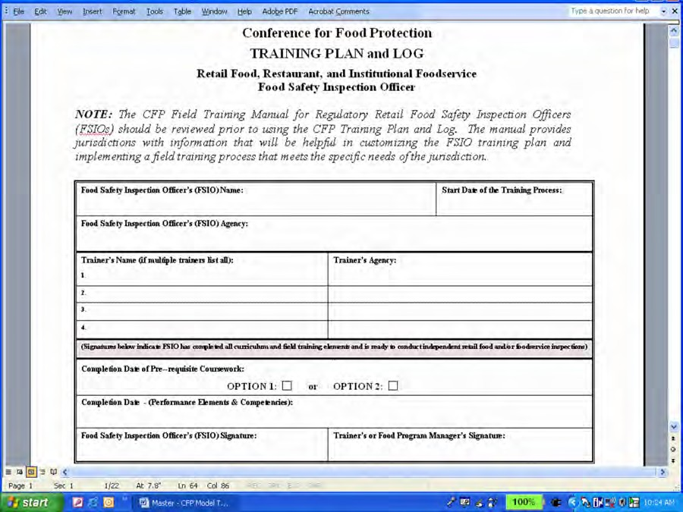

DESCRIPTION OF HEADER INFORMATION
Food Safety Inspection Officer’s (FSIO) Name – The name of the individual who will receive the training.
Food Safety Inspection Officer’s (FSIO) Agency – The name of the regulatory retail food protection program where the FSIO receiving training is employed.
Start Date of the Training Process – The date any part of the FSIO’s training for conducting independent food safety inspections is initiated; this includes review of the jurisdiction’s procedures, rules, manuals; classroom or web-based coursework; joint field training inspections; or other training methods identified in the jurisdiction’s training plan.
Trainer’s Name (if multiple trainers, list all) – The name(s) of the individual(s) delivering or overseeing the training of the FSIO.
Trainer’s Agency – The name of the regulatory retail food protection program or agency where the trainer is employed.
Completion Date of Pre-requisite Coursework – The date the trainee completes all pre- requisite coursework identified by the Conference for Food Protection as essential for conducting independent food safety inspections. Two options are available for completing the pre-requisite course work:
OPTION 1 – Box is checked to indicate the FSIO has completed the FDA ORA U pre-requisite (“Pre”) courses/examinations/exercises, and
has completed training on the jurisdiction’s prevailing statutes, regulations, and or ordinances.

OR
OPTION 2 – Box is checked to indicate the FSIO has submitted documentation of completing coursework equivalent to the FDA ORA U pre-requisite (“Pre”) curriculum, and
has completed training on the jurisdiction’s prevailing statutes, regulations, and/or ordinances, and
has certification or other documentation of successfully passing one of the written examination options in Standard 2 – Trained Regulatory Staff, FDA Voluntary National Retail Food Regulatory Program Standards.
Completion Date – (Performance Elements & Competencies) – The date the FSIO has successfully demonstrated all performance element competencies identified in the jurisdiction’s training plan. At this point, the jurisdiction’s trainer and/or retail food protection program manager has determined that the FSIO is now ready to conduct independent food safety inspections of retail food and/or foodservice establishments.
Food Safety Inspection Officer’s (FSIO) Signature – Signature of the FSIO is applied when all performance element competencies have been successfully demonstrated.
Trainer’s or Food Program Manager’s Signature – Signature of the individual responsible for making the determination that the trainee has completed all the training

areas and successfully demonstrated all the performance element competencies.

JURISDICTION’S TRAINING METHODS
The CFP Training Plan and Log is designed to incorporate a variety of training methods appropriate for each of the performance element competencies. Jurisdictions are free to select the training method most appropriate for their individual situation and needs. A table (see example below) is included in the CFP Training Plan and Log to document
and summarize the various training methods a jurisdiction may use. Examples of training methods include, but are not limited to, classroom presentations or exercises, laboratory workshops, office demonstrations, and joint field training inspections.

JURISDICTION’S TRAINING METHODS
Code | Training Method
CE | Classroom Exercise
OD | Office Demonstration
LE | Laboratory Exercise
JFT | Joint Field Training Inspection
O | Other (described in Training Plan)

The column with the heading ‘Code’ can be used to record an abbreviation that describes the training method. For example, the abbreviation ‘LE’ in the above table is used to describe ‘Laboratory Exercise’. The abbreviation ‘JFT’ is used to describe ‘Joint Field Training Inspections’.

INSPECTION TRAINING AREAS
The CFP Training Plan and Log is divided into six (6) inspection training areas:
- Pre-Inspection
- Inspection Observations and Performance
- Oral Communication
- Written Communication
- Professionalism
- Additional Inspection Areas (jurisdictions can add performance elements and competencies not contained in the CFP Training Plan and Log)

PERFORMANCE ELEMENTS
The CFP Training Plan and Log contains a total of 23 “performance elements” within the six (6) inspection training areas.

- Pre-Inspection – (2 Performance Elements)
  - Has the required equipment and forms to conduct the inspection.
  - Reviews establishment file for the previous inspection report, complaints on file, and if applicable, required HACCP Plans or documents supporting the issuance of a variance.

- Inspection Observations and Performance – (7 Performance Elements)
  - Provides identification as a regulatory official to the person in charge, confirming agency authority for the inspection, and stating the purpose of the visit.
  - Has knowledge of the jurisdiction’s laws, rules, and regulations required for conducting retail food/foodservice inspections.
  - Uses a risk-based inspection methodology to assess regulations related to employee practices and management procedures essential to the safe storage, preparation, and service of food.
  - Obtains immediate corrective action for out of compliance employee practices and management procedures essential to the safe storage, preparation and service of food.
  - Correctly assesses the compliance status of other regulations (Good Retail Practices) that are included in the jurisdiction’s prevailing statutes, regulations, and/or ordinances.
  - Verifies correction of out of compliance observations identified during the previous inspection.
  - Correctly uses inspection equipment during the joint inspection.

- Oral Communication – (6 Performance Elements)
  - Asks questions and engages in a dialogue with the person in charge/employees to obtain information relevant to the inspection.
  - Provides the person in charge/employees with accurate answers to inspection-related questions or admits not knowing the answer.
  - Uses available means (e.g., interpreter, drawings, demonstrations, diagrams, international food safety icons) to overcome language or communication barriers.
  - Follows the jurisdiction’s policy with regard to disclosure of confidential information.
  - Uses effective communication and conflict resolution techniques to overcome inspection barriers.
  - Conducts the exit interview explaining out of compliance observations and identifying corrective actions and timelines for all noted violations.

- Written Communication – (3 Performance Elements)
  - Completes inspection form per the jurisdiction’s administrative procedures (e.g., observations, corrective actions, public health reasons, applicable code references, compliance dates).
  - Includes with the inspection report any compliance or regulatory documents identified or cross- referenced in written statements (e.g., exhibits, attachments, sample forms, embargo forms, destruction forms, suspension notices).
  - Presents the inspection report, and when necessary cross referenced documents, to the person in charge.

- Professionalism – (3 Performance Elements)
  - Maintains a professional appearance consistent with the jurisdiction’s policy (e.g., clean outer clothing, hair restraint).
  - Demonstrates proper sanitary practices as expected from a food service employee.
  - Only reports substantiated findings as violations.

- Additional Performance Elements – (Jurisdiction Specific)
  - Uses an aseptic food sample collection method consistent with criteria established by laboratory serving the jurisdiction.
  - Uses an aseptic water sample collection method consistent with criteria established by the laboratory serving the jurisdiction.
  - Other performance elements identified by the jurisdiction.

NOTE: The CFP Training Plan lists 2 Performance Elements (aseptic food and water sample collection) under additional performance elements. The responsibility for aseptic sampling of food and water varies greatly from one jurisdiction to another. If FSIOs will be expected to collect aseptic samples of food and/or water, even if it is to be done on a limited basis, these performance elements should be included in the jurisdiction’s training plan.

Creating Your Training Plan
This section presents four (4) basic steps jurisdictions should consider when developing a training plan for your regulatory retail food protection program:
STEP 1 – Determine Performance Elements to be Included in Your Training Plan
STEP 2 – Determine Competencies for Each Selected Performance Element
STEP 3 – Determine Need for Additional Performance Elements and Competencies
STEP 4 – Determine Appropriate Training Method for Each Competency

STEP 1 – Determine Performance Elements to be Included in Your Training Plan
Performance elements appear in the shaded areas of the CFP Training Plan and Log. The jurisdiction’s trainer should review the performance elements contained in the CFP Training Plan and Log and determine those that are part of the job responsibility of a FISO in their jurisdiction. If a performance element is conducted by a FSIO, it is to be included in the training plan. An ‘X’ is to be placed in the box adjacent to each performance element included in your jurisdiction’s training plan.

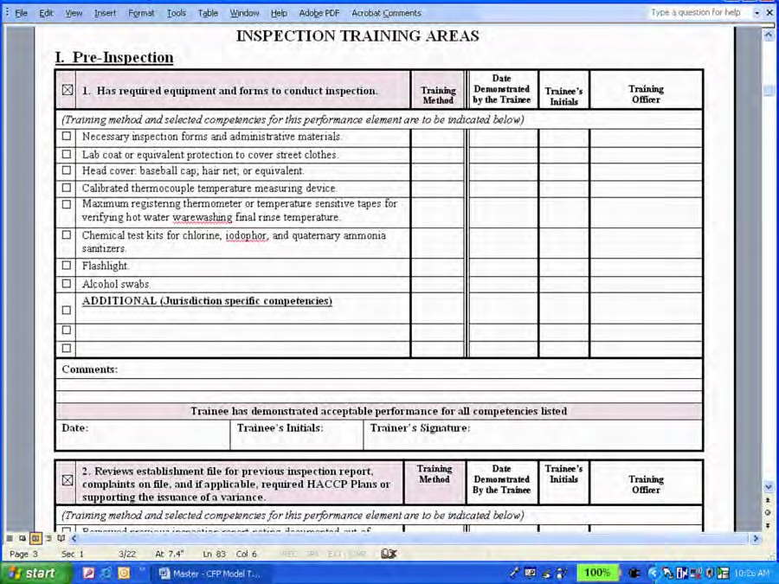

Using the graphic above as an example, an ‘X’ appears in the box for included performance elements within the ‘Pre-Inspection’ training area. The trainer has determined that both of these performance elements are part of the FSIO’s job responsibility in their jurisdiction.

STEP 2 – Determine Competencies for Each Selected Performance Element
The CFP Training Plan and Log provides a list of competencies (job tasks) under each performance element. These competencies are intended to serve as examples of job related tasks a FSIO will be expected to successfully demonstrate during field training inspections.

The jurisdiction’s trainer should review competencies listed under the selected performance elements and place an ‘X’ in the box for each of the competencies that are part of the FSIO’s job responsibility in their jurisdication.

Some of the competencies listed for a performance element may not be applicable to a FSIO within a given jurisdiction. In the graphic below, the use of infrared thermometers and cameras are not part of the standard issued equipment for inspection staff. The FSIO would not, therefore, be responsible for using this type of equipment. If this is the case, the boxes adjacent to these competencies are to be left blank as they would not be included in that jurisdiction’s training plan.

Competencies that are applicable to the FSIO’s job should not be arbitrarily removed or deleted from the Field Training Worksheet.

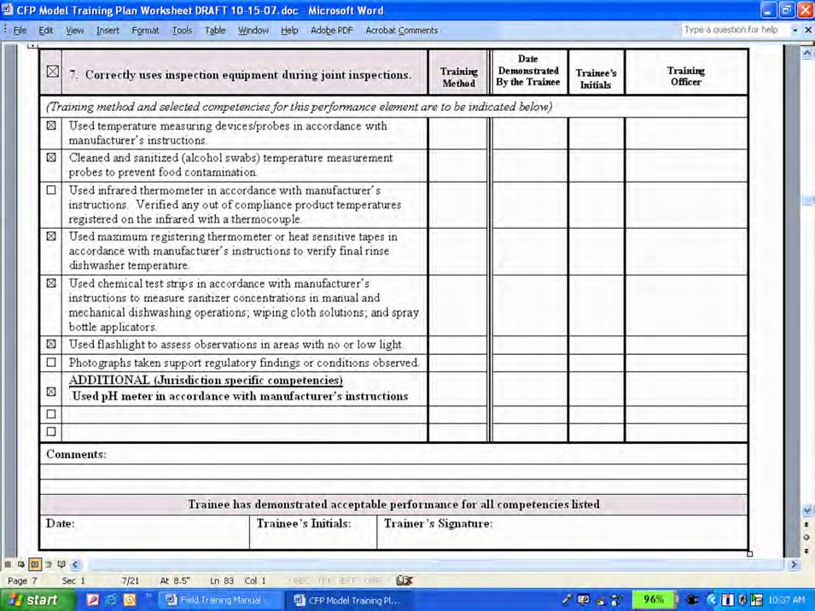

Conversely, there may be competencies not listed under a performance element that are important for a jurisdiction to include in a FSIO’s training. The CFP Training Plan and Log has been designed to accommodate ‘Additional’ jurisdiction specific competencies. In the example from the previous graphic, the jurisdiction issues pH test kits to all FSIOs for product assessments during inspections. If this is the case, the FSIO will need to successfully demonstrate the use of the pH test kit during their training and it is to be included as part of the training plan.

STEP 3 – Determine Need for Additional Performance Elements and Competencies
The performance element competencies that comprise the CFP Training Plan and Log represent a national model and the overwhelming majority of these apply to every jurisdiction. There will be instances, however, where a jurisdiction may need to add performance elements and competencies that are not listed on the CFP Training Plan and Log.

Section VI – Additional Performance Elements includes blank templates which a jurisdiction can use to further customize their training plan. Additional Performance Elements are placed in the shaded boxes circled in the graphic below. Any competencies that a FSIO will need to successfully demonstrate during the training process for this performance element need to be identified and listed in the spaces indicated with the arrows.

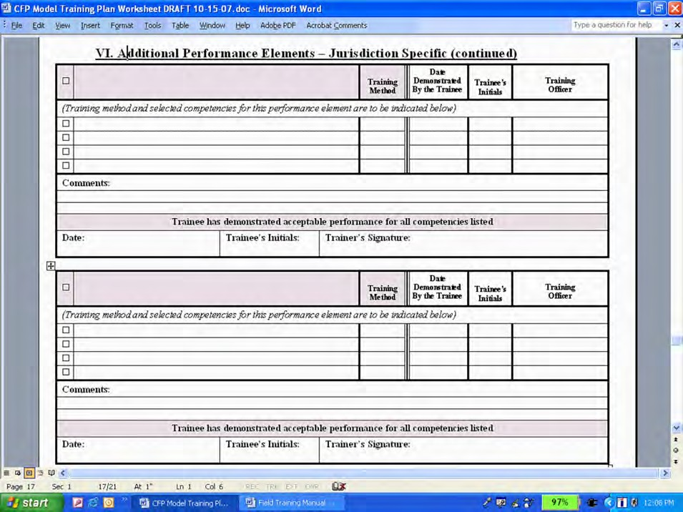

Feedback received from some jurisdictions that field tested the CFP training process suggested inclusion of the following additional performance element competencies in a training plan:
    - Applies HACCP principles in the assessment of food processes and/or preparation procedures to determine if food safety hazards are controlled.
    - Conducts menu-based reviews to determine inspection priorities based on potential food safety hazards.
    - Demonstrates a thorough understanding of how the Food Code is organized and proper application of Food Code conventions.
    - Develops risk control plans or other intervention strategies in accordance with the jurisdiction’s administrative procedures to obtain long term control of contributing factors to foodborne illnesses.

STEP 4 – Determine Appropriate Training Method for Each Competency
Once the FSIO competencies have been identified in the training plan, consideration needs to be given as to how the training will be delivered. Training methods vary from jurisdiction to jurisdiction, and resources available to a jurisdiction (time, money, personnel, etc.) may have a significant impact on determining the type of training that can be provided. Whatever training methods are selected, it is important to ensure that the process will cover all the competencies (job tasks) FSIOs will be expected to successfully demonstrate during food safety inspections.

Training is most effective when it is delivered within the context or environment in which an individual would be expected to apply the knowledge and skills. For FSIOs, the appropriate training environment is one that mirrors the actual experience of inspecting retail food, restaurant, and/or institutional foodservice establishments. When developing the training plan, every effort should be made to provide the FSIO with opportunities to demonstrate a competency during actual field training inspections.

In an ideal training environment, the selection of establishments used for training will provide adequate opportunity to demonstrate all competencies. However, for a variety of reasons, it may not always be possible for the trainee to demonstrate all competencies during joint field training inspections. Should this occur, other training options will need to be considered and implemented.

Some of the performance elements that comprise the CFP Training Plan and Log include competencies that frequently occur as part of the inspection process giving multiple opportunities for the trainer to observe the trainee demonstrating these job tasks during joint field training inspections. These performance elements include:
- Has the required equipment and forms to conduct the inspection;
- Reviews establishment file for previous inspection report, complaints on file, and, if applicable, required HACCP Plans or documents supporting the issuance of a variance;
- Provides identification as a regulatory official to the person in charge; confirming agency authority for the inspection and stating the purpose of the visit;

- Uses inspection equipment correctly during the inspection;
- Conducts the exit interview explaining out of compliance observations and identifying corrective actions and timelines for all noted violations;
- Presents the inspection report and, when necessary, cross-referenced documents, to the person in charge; and
- Maintains a professional appearance that is consistent with jurisdiction’s policy (e.g., clean outer clothing, hair restraints).

Some of the performance elements, though they frequently occur during field inspections, will have competencies that the FSIO will need to successfully demonstrate throughout the course of the joint field training process. These performance elements represent competencies for which the trainer will observe a trainee’s continued development and improvement with each subsequent training inspection. Most of the performance elements fall into this category and include:
- Has knowledge of the jurisdiction’s laws, rules, and regulations required for conducting retail food/foodservice inspections;
- Uses a risk-based inspection methodology to assess regulations related to employee practices and management procedures essential to the safe storage, preparation, and service of food;
- Obtains immediate corrective actions for out of compliance employee practices and management procedures essential to the safe storage, preparation, and service of food;
- Verifies correction of out of compliance observations identified during the previous inspection;
- Asks questions and engages in a dialogue with the person in charge/employees to obtain information relevant to the inspection;
- Provides the operator with accurate answers to inspection-related questions or admits not knowing the answer;
- Uses available means (e.g. interpreter, drawings, demonstrations, diagrams, international food safety icons) to overcome language or communication barriers;
- Completes inspection form per the jurisdiction’s administrative procedures (e.g., observations, corrective actions, public health reasons, applicable code reference, compliance dates);
- Includes with the inspection report any compliance or regulatory documents identified or cross-referenced in written statements (e.g., exhibits, attachments, sample forms, embargo forms, destruction forms, suspension notices);
- Demonstrates proper sanitary practices as expected from a food service employee; and
- Only reports substantiated findings as violations.

There are, however, some performance elements that are important inspection responsibilities but may seldom or rarely occur during the FSIO field training process. Due to the variable nature of inspections, the trainee may not be presented with an opportunity to demonstrate these competencies as part of the joint field training process. Although less frequently encountered, these performance elements include

knowledge and skills integral to enhancing the effectiveness of the inspection process and include:
- Follows the jurisdiction’s policy in regard to disclosure of confidential information;
- Uses effective communication and conflict resolution techniques to overcome inspection barriers; and
- Uses an aseptic food or water sample collection method consistent with criteria established by laboratory serving jurisdiction.

Whenever possible, competencies are to be assessed in the field inspection environment. If this is not feasible laboratory, classroom, or office exercises may be used to assess performance elements difficult to observe in the field. Examples of such training exercises may include:
• Trainee photographing a specific object in the office, field, or laboratory;
• Trainee explaining to the trainer the jurisdiction’s policy in regard to disclosure of confidential information;
• Trainee explaining to the trainer the jurisdiction’s policy in regard to conflict resolution (the trainer may develop scenarios for the trainee to review and discuss appropriate conflict resolution techniques); or
• Trainee demonstrating aseptic food and/or water sampling in the office, laboratory, or during a designated field training inspection.

The graphic below provides an illustration to document alternative training methods.

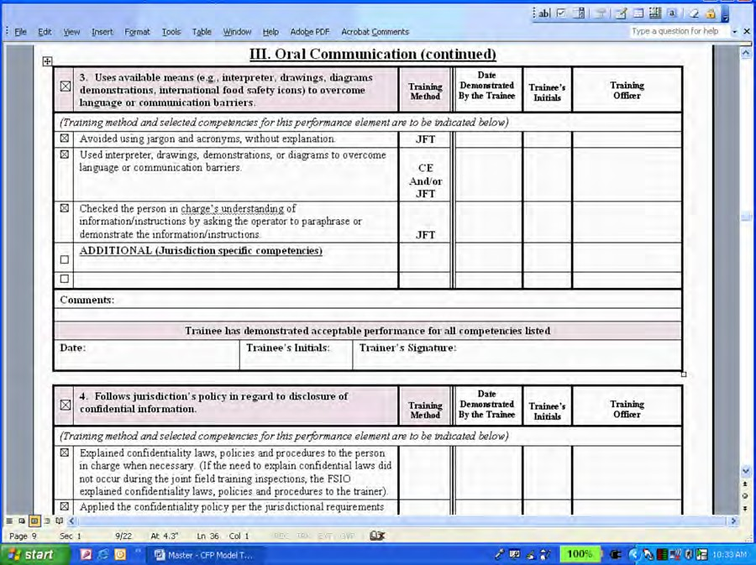

In this example, the types of establishments selected for the joint training process did not present an inspection environment that required the trainee to overcome language
barriers. An opportunity for the trainee to demonstrate these competencies was addressed by incorporating a classroom exercise as an alternative training method.

Preparing for Joint Field Training Inspections

STEP 1 – IDENTIFY SOURCE DOCUMENTS FOR ORIENTATION
Information that a regulatory jurisdiction should review as part of the FSIO’s orientation to the retail food protection program includes but is not limited to:
- The jurisdiction’s retail food training plan that identifies the specific performance element competencies a FSIO will need to successfully demonstrate during joint field training inspections;
- The jurisdiction’s current regulations, code, or ordinances governing foodservice and/or retail food under its inspection authority;
- Any written policies or interpretations implemented by the jurisdiction that carry the same weight as their prevailing rules and regulations;
- The jurisdiction’s current retail food protection program inspection form;
- Any marking instructions the jurisdiction may have developed to assist staff with documenting inspection findings;
- The pre-requisite curriculum posted on FDA’s ORA U web site and the web address for obtaining an access password; and
- Other documents specific to the jurisdiction that the trainer has determined are integral to the retail food protection training program.

The inclusion of the above list of source documents is not meant to imply that all material must be reviewed during a single dedicated FSIO orientation session. These documents are included here to provide a starting point for a checklist of materials a trainer will likely need to review with the FSIO over the first weeks of employment or assignment to the retail food protection program.

STEP 2 – REVIEW LIST OF PRE-REQUISITE CURRICULUM WITH TRAINEE
The courses listed as part of the pre-requisite curriculum (see page 3) should be reviewed with the FSIO. The trainer or food program manager is to make a determination whether a candidate has met any or all of the pre-requisite curriculum requirements and has documentation indicating successful completion. If the FSIO needs to complete coursework, the trainer should assist him/her with obtaining an access password to the FDA ORA U web site, or make a determination as to whether equivalent courses are a more viable option.

Reserving designated blocks of time each week for the FSIO to devote to this curriculum often facilitates timely completion of the pre-requisite coursework. Keep in mind that the FSIO can participate and even take the lead in conducting joint field training inspections while they are in the process of completing the pre-requisite coursework.

NOTE: The pre-requisite coursework includes a listing for the FDA 2005 Food Code. While most jurisdictions use the FDA Food Code as the foundation for their own rules and regulations, there will be some differences unless the jurisdiction has adopted the entire FDA Food Code by reference. Jurisdictions should use their own Food Code as the pre-requisite course for training FSIOs. State, local, and tribal jurisdictions are

strongly encouraged to conduct a frequent review of their existing Food Code provisions against the current version of the FDA Food Code to ensure that it provides a scientifically sound technical and legal basis for regulating the retail food segment of the industry.

STEP 3 – REVIEW TRAINING PLAN WITH TRAINEE
A review of the jurisdiction’s retail food protection training plan should include a discussion of:
- The performance elements, how they were determined, and their impact on conducting effective food safety inspections;
- The specific competencies that comprise each performance element so the trainee has a clear understanding of what job tasks they will be expected to successfully demonstrate during the course of the field training process;
- Training methods and approaches that will be offered to facilitate a trainee’s demonstration of the competencies;
- How field training objectives will be determined and communicated to the trainee;
- How the trainer will observe the trainee perform competencies during field training inspections and share feedback on their observations;
- How progress and accomplishments will be documented on the training plan; and
- The jurisdiction’s criteria for determining a trainee’s readiness to conduct independent inspections of retail food and/or foodservice facilities.

Conducting Field Training Inspections
Field training inspections are a core component for preparing a FSIO to perform their job responsibilities independently. There are two types of field training inspections: demonstration (trainer-led) and those where the trainee takes the lead (trainee-led).

Field training will initially be comprised of demonstration (trainer-led) inspections. Providing an opportunity for the FSIO to observe experienced staff conducting food safety inspections is an essential step in preparing a trainee for taking the lead during field training inspections.

Trainee-led inspections provide the opportunity for the jurisdiction’s trainer to observe the trainee build their skills and successfully demonstrate competencies. Inspections led by a trainee are not part of an examination or audit process. They are intended to be part of a structured training process where learning is still occurring, where trainers are providing feedback, and where correct demonstration of competencies is continually being re-enforced.

A sufficient number of field training inspections led by the trainee are to be conducted to allow the demonstration of all competencies identified in the jurisdiction’s training plan. Upon completion of the field training process, the trainee should have successfully demonstrated all competencies in the training plan and be ready to conduct independent inspections of retail food and/or foodservice facilities.

STEP 1 – SELECTING APPROPRIATE TRAINERS
The manager of the regulatory retail food protection program has the discretion of deciding who will serve as trainers. In making this decision, available training resources (e.g., personnel, time, funding) and overall program objectives will need to be considered when selecting staff to oversee and conduct the FSIO field training.

A trainee can garner important knowledge and perspective from observing different inspection approaches from experienced staff. During the course of these joint inspections, it is expected that a trainee will observe experienced staff demonstrate all performance element competencies that are part of the jurisdiction’s training plan.

STEP 2 – CONDUCTING DEMONSTRATION (TRAINER-LED) INSPECTIONS
When selecting staff for trainer-led inspections, management should consider experienced staff with a solid command of all the competencies the FSIO will be expected to demonstrate in the training process. These experienced staff members will lay the foundation for the trainee’s assimilation of the knowledge and skills needed to conduct food safety inspections as they will be initially demonstrating how to correctly perform specific job tasks.

If possible, management should consider pairing the trainee with several different FSIOs during demonstration inspections to allow exposure to different inspection approaches and techniques. Moreover, these trainer-led inspections should be conducted in a variety

of establishments that cover the spectrum of retail food and foodservice operations that the FSIO will eventually be inspecting on their own.

The level of preparedness and time needed to assimilate knowledge from observations made during demonstration inspections will vary with each trainee. When a determination has been made that the trainee is ready to take the lead during an inspection, it is important to keep in mind that training has not stopped. Trainees will still need trainers to demonstrate competencies and provide feedback. The CFP training process is designed to facilitate a continuous improvement learning experience.

STEP 3 – PREPARING FOR INSPECTIONS LED BY THE TRAINEE
Inspections led by the trainee consist of two inter-related but separate activities: one is specific to the role of the jurisdiction’s trainer, the other relates to the role and responsibilities of the trainee.

- The trainer is responsible for observing the trainee as he/she demonstrates competencies identified in the jurisdiction’s training plan.
- The trainee is responsible for conducting the inspection in the presence of the trainer, per the jurisdiction’s administrative procedures and policies.

Even though there is a relationship between these activities, it is important to recognize the need to view them separately.

Trainer’s Role
During trainee-led inspections, the trainer observes the trainee conducting the inspection and demonstrating the competencies. The trainer participates only when the inspection process dictates their assistance or intervention.

No single field training inspection will provide an opportunity for the trainee to demonstrate all the competencies listed in the training plan. The trainer should allow the inspection process to unfold as it normally would; in other words, the jurisdiction’s training plan should not be used as a checklist for structuring the inspection to accommodate observations of a trainee demonstrating competencies. Requesting that a trainee demonstrate a competency that is not integral to the inspection that is occurring may be disruptive and create unwanted confusion and stress for the trainee.

As the field training process progresses, the trainer may note that the selection of establishments has not provided the trainee an opportunity to demonstrate some competencies. The trainer can try to remedy this situation by selecting establishments that may provide appropriate environments where the trainee can demonstrate the job tasks. If this is not feasible, the trainer can set up field exercises during inspections led by the trainee; however, the exercise should be conducted at a time that will not disrupt the flow of the inspection and the trainer should discuss these exercises with the trainee prior to the inspection so expectations are clear.

Trainee’s Role
Since the trainee will be taking the lead during these field training inspections, their focus should be on observations of food safety practices and procedures within the establishment. During these inspections the trainee is responsible for:
- Initiating contact with the person in charge;
- Explaining the purpose of the inspection;
- Directing the inspection process;
- Establishing a dialogue with management and employees;
- Making the observations of food safety practices;
- Obtaining corrective actions for out of compliance foodborne illness contributing factors;
- Preparing the inspection report; and
- Facilitating and conducting the exit discussion of the report.

The trainee’s inspection approach, communication techniques, and food safety priorities should be reflective of those they would implement if inspecting independently. The inspection should not be structured solely around the demonstration of competencies.
The trainee should concentrate on conducting an effective food safety inspection. Providing an appropriate variety of establishments will help ensure the competencies listed on the jurisdiction’s training plan do not drive the inspection approach.

STEP 4 – SELECTING ESTABLISHMENTS FOR INSPECTIONS LED BY TRAINEE
The ideal establishment for conducting a food safety inspection led by the trainee is one that will provide an opportunity for the trainee to successfully demonstrate the greatest number of competencies. The majority of these inspections should be completed in establishments that are representative of the highest risk categories within the jurisdiction or the FSIO’s assigned training area.

Jurisdictions can use their own system for grouping establishments into categories based on potential or inherent food safety risks. Annex 5, Table 1 of the 2005 FDA Food Code can also be used as a reference for assigning risk categories.

STEP 5 – DETERMINING THE NUMBER OF INSPECTIONS LED BY TRAINEE
There is no definitive number of inspections led by the trainee that can be used as a standard for all newly hired employees. The number of inspections necessary is one that provides adequate opportunity for all competencies to be demonstrated. Some of the competencies, such as those related to conducting a risk-based inspection, must be continually demonstrated throughout the course of the field training process.

NOTE: For jurisdictions enrolled in the FDA Voluntary National Retail Food Regulatory Program Standards, staff conducting food safety inspections must conduct a minimum of 25 joint field inspections comprised of both “demonstration” (trainer-led) and trainee-led inspections, and include a variety of establishment types available within

the jurisdiction.

The CFP field training process is not intended to be part of an audit or evaluation process, therefore a ‘scoring system’ has not been included. The primary objective of this process is to ensure that the FSIO has received training for all the competencies that are part of the job responsibilities within that jurisdiction. As part of this training, the FSIO is to successfully demonstrate their ability to perform each of these competencies. No single inspection or observation should be used by the trainer(s) as the standard of measurement; the jurisdiction’s trainer(s) need to evaluate the trainee’s ability to demonstrate competencies throughout the entire process.

NOTE: FSIOs should successfully complete the field training process prior to conducting independent inspections and re-inspections of retail food establishments equivalent to Risk Categories 2, 3, and 4 as noted in Annex 5, Table 1 of the 2005 FDA Food Code. However a jurisdiction’s trainer or food program manager can make a determination as to the FSIO’s readiness to conduct independent inspections of Risk Category 1 establishments at any time during the training process.

STEP 6 – OBSERVING TRAINEES DEMONSTRATE COMPETENCIES
NOTE: For jurisdictions enrolled in the FDA Voluntary National Retail Food Regulatory Program Standards, the trainer or designated staff member responsible for documenting the FSIOs demonstration of a competency must have completed all the training elements in Steps 1-3 required in Standard 2 – Trained Regulatory Staff. It is highly recommended that this trainer be standardized in a process similar to the ‘FDA Standardization Procedures’.

There is no single ‘correct’ method for making a determination as to when a trainee has successfully demonstrated a competency during field training inspections. Throughout the series of training inspections, the trainer will observe the trainee demonstrate many competencies. For some competencies, the trainer will be able to ascertain relatively quickly whether a trainee has demonstrated the job task correctly. For example, once a trainee successfully demonstrates the proper use of inspection equipment, he/she generally will maintain that skill throughout the training process.

Almost all of the competencies listed, however, should be demonstrated by the trainee several times. The trainer should observe the trainee successfully demonstrate a consistent pattern of behavior for each competency. As defined in this document, a ‘consistent pattern of behavior’ means:

- The trainee can explain the purpose/objective of the job task and the steps necessary to carry it out effectively;
- The demonstration of a clear understanding of a given competency; and
• A collective set of trainer observations which predominately indicate that the trainee can successfully demonstrate the competency correctly and repeatedly.

Trainees will be on a continuous learning curve throughout the training process; inconsistencies in their inspection approach from one facility to another should be

expected. Trainers will need to determine whether these inconsistencies are due to a lack of understanding, an inability to successfully demonstrate a competency, or simply inexperience.

In some cases a trainee may be capable of successfully demonstrating a competency but fails to do so during an inspection. For example, he/she may not address an important food safety risk (such as employee health) with the person in charge. The trainee may understand and can demonstrate the proper approach to assessing an employee health policy within an establishment, but forgets to do so because they may have become distracted by other risk related observations and the need to work with management to obtain corrective actions. This is an example of a trainee who is still in the process of developing his/her own organized risk-based inspection approach.

It is important for trainers to recognize that during the training process, trainees are not only learning competencies but are also becoming acclimated to their working environment. Trainer’s decisions regarding a trainee demonstrating a competency should be based on a collective set of observations which predominately indicate the job task is being performed correctly.

When the trainee successfully demonstrates a competency, the jurisdiction’s trainer or designated staff person documents the completion of the skill on the training plan. Some options and forms for tracking the trainee’s progress and accomplishments are presented in Section VII of this document.

Documenting Training Progress and Accomplishments
Each regulatory retail food protection program will need to develop a system to track a FSIO’s training progress and accomplishments. A jurisdiction can customize the forms provided in this manual or develop their own. Any system for documenting training should provide a method for:
• Recording competencies that have been demonstrated by a FSIO;
• Determining competencies a FSIO has not yet demonstrated;
• Identifying the trainer(s) responsible for observing a FSIO demonstrating a competency;
• Providing feedback to the FSIO on training objectives; and
• Obtaining confirmation from both the FSIO and trainer that competencies have been demonstrated correctly.

CFP TRAINING PLAN AND LOG USED AS A SINGLE SOURCE DOCUMENT
The CFP Training Plan and Log (Attachment A) can be used as a single source document for recording a FSIO’s training progress and accomplishments.

The graphic below provides an illustration of how a FSIO’s training status can be tracked with documentation entered for the four competencies listed under this performance element.

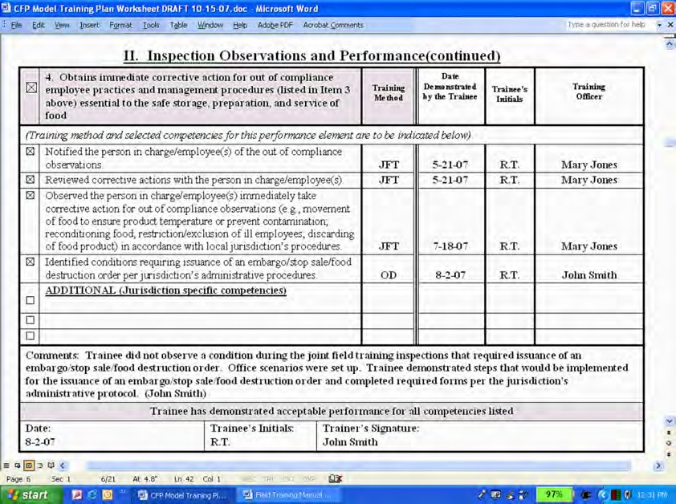

For each of the competencies, the trainer records the date a determination was made that the trainee successfully demonstrated the competency. The trainee’s initials (represented by ‘R.T.’ in the graphic on the previous page), indicate his/her agreement with the date recorded (represented as 5-21-07). The training officer’s name or signature indicates confirmation that the trainee successfully demonstrated the competency. When the trainee has demonstrated all the competencies for a performance element, the bottom row is completed as indicated with the arrow in the graphic.

Documentation on the CFP Training Plan and Log does not have to follow this format exactly. For example, a jurisdiction that has only one trainer may find it redundant to record the trainee’s initials and trainer’s name for all competencies within each performance element. In scenarios like this, a trainer may choose to simply record the date when each competency was demonstrated under the ‘Date Demonstrated by the Trainee’ column. Then, when the trainee has demonstrated all the performance element competencies, he/she places their initials in the bottom row (indicated with the arrow in the graphic), and the trainer signs confirming completion.

However, if multiple trainers are used, competencies demonstrated by the trainee may be confirmed by different individuals. In a case like this, in order to ensure open communication between the training staff and the trainee throughout the field training process, it may be important to know which trainer actually observed that the trainee demonstrated a specific competency.

A ‘comment’ section is provided at the bottom of each of the performance element tables. This area can be used to describe future training objectives or to provide a method of communicating training observations among multiple trainers. It can also be used to describe changes to the training plan to ensure opportunity to demonstrate a competency that may be difficult to observe during field training inspections.

From the example presented on the previous page, the comment section includes the following note:

Trainee did not observe a condition during the joint field training inspections that required issuance of an embargo/stop sale/food destruction order. Office scenarios were set up. Trainee demonstrated steps that would be implemented for the issuance of an embargo/stop sale/food destruction order and completed the required forms per the jurisdiction’s administrative protocol. (John Smith)

In this example, the scheduled field training inspections were coming to an end. The field inspections had not provided an opportunity for the trainee to demonstrate the jurisdiction’s procedure for issuance of an embargo/stop sale/food destruction order. The trainer set up an office exercise for the trainee to demonstrate this competency and the ’OD’ designation under training method in the graphic indicates ‘Office Demonstration’.

OPTIONAL TRAINING LOGS
Two optional training logs are included at the end of the CFP Training Plan and Log that can be used to track a FSIO’s progress and achievements.

- FSIO Training Log; and
- Joint Field Training Inspections – Establishment Log

A determination on whether to use these optional training logs should be made by the manager of the regulatory retail food protection program before initiating field training so their intended use and purpose can be communicated to FSIOs in training and staff who will serve as trainers.

FSIO Training Log
The optional FSIO Training Log provides a method for tracking a FSIO’s progress and accomplishments from one week to another by noting competencies demonstrated each week. Training objectives for the upcoming week can be established and communicated with the trainee to clarify expectations and assist in focusing on specific competencies. This weekly training log can also be an important means of sharing information in situations where multiple trainers are working with a FSIO.

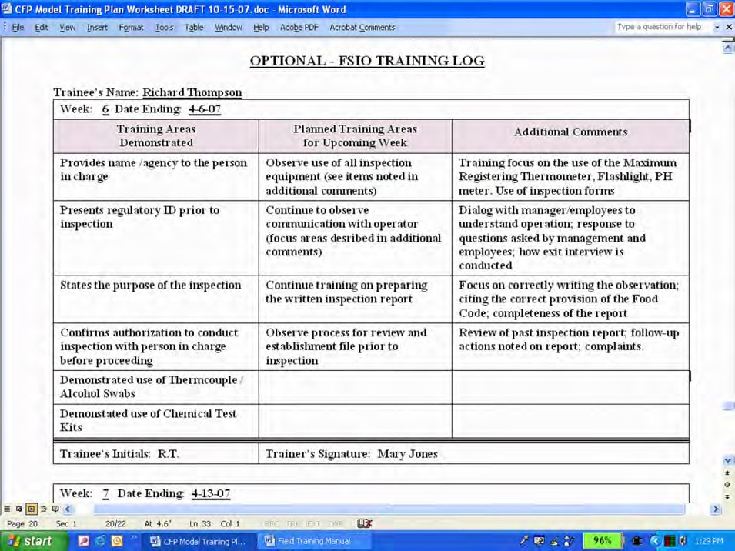

Joint Field Training Inspections – Establishment Log
The optional Joint Field Training Inspections – Establishment Log provides a method of tracking the number and type of establishments within which training has been conducted. A ‘Risk Category’ column provides a quick reference as to the complexity of food preparation processes that have been included in the FSIO’s training and assists in determining what types of establishments to include in future field training inspections.

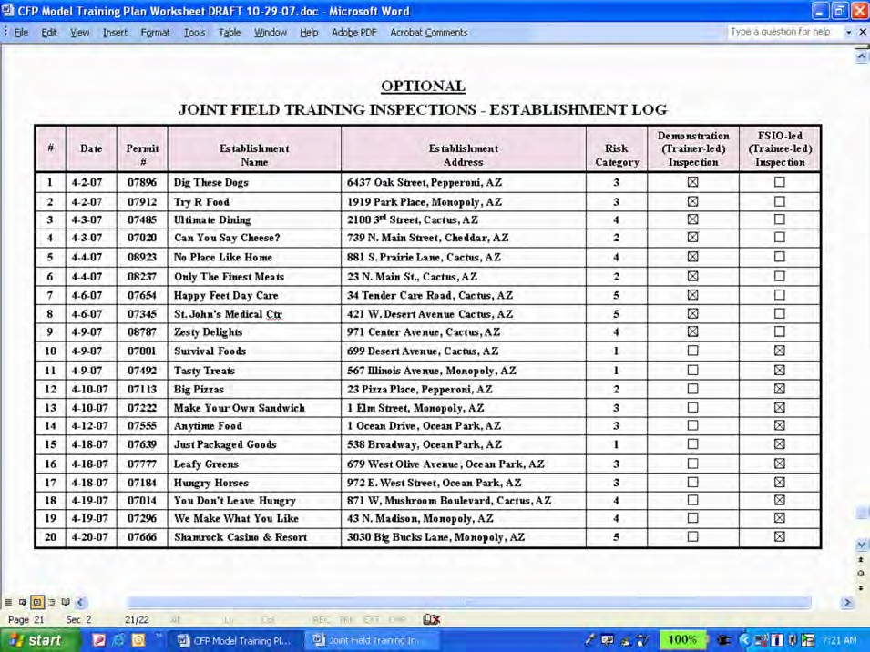

In addition, the establishment log provides a quick method for distinguishing trainer-led (demonstration) inspections from those which were trainee-led. An “X” is placed in the appropriate column to denote the type of field training inspection conducted. In the above graphic, the first 9 inspections were trainer-led, and the trainee first took the lead during joint field training inspections when establishment #10 was visited.

SUPPLEMENTAL FIELD TRAINING WORKSHEET FOR TRAINERS
Some jurisdictions who field tested the CFP training process requested optional Field Training Worksheets that trainers could use during trainee-led inspections to record observations that will aid in determining when a competency has been consistently demonstrated. The Field Training Worksheet also provides a means for identifying competencies that the trainee has not had the opportunity to successfully demonstrate.

Two versions of such as worksheet have been developed:

- Field Training Worksheet: a distilled version of the CFP Training Plan and Log.
- Abbreviated Field Training Worksheet: listing only the performance elements.

Either version can be used in conjunction with the CFP Training Plan and Log to track a FSIO’s progress and accomplishments. The manager of the regulatory retail food protection program has the discretion of determining whether to use a Field Training Worksheet as part of their training process.

Field Training Worksheet
The Field Training Worksheet, included as Attachment B, is a distilled version of the
CFP Training Plan and Log.

In this worksheet, all performance element competencies for which the most appropriate training method is ‘Joint Field Training Inspections – JFT’ have been included.

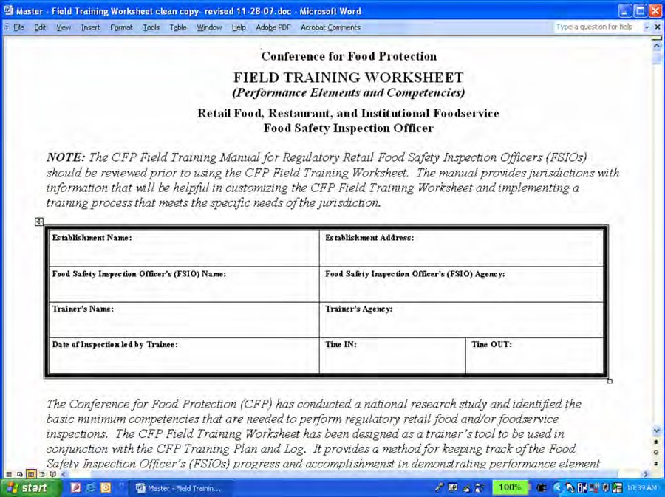

For each of the competencies included in the jurisdiction’s Field Training Worksheet, the trainer:

- Determines whether or not there was an opportunity to demonstrate a competency; and

  - Determines when a FSIO consistently demonstrates a competency correctly.

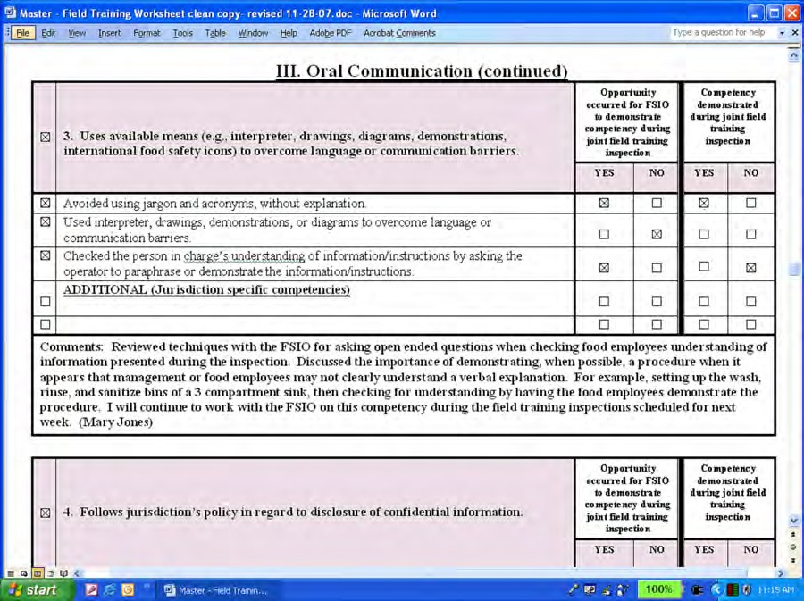

The Field Training Worksheet contains two major columns for recording observations:

  - Opportunity occurred for FSIO to demonstrate competency during field training inspection.
YES – An “X” is placed in this box if the trainee had an opportunity to successfully demonstrate the listed competency during the inspection. In the graphic above, the trainee had opportunity to demonstrate competencies pertaining to ‘avoiding the use of acronyms/jargon’ and ‘checking the person in charge’s understanding of information.’
NO – An “X” is placed in this box if the inspection environment did not require or present an opportunity for the trainee to successfully demonstrate the competency. Using the graphic above, an opportunity did not occur during the field training for the trainee to demonstrate ‘the use of interpreters/drawings/demonstrations, etc., to overcome language or communication barriers.’ If this pattern continues throughout the field
training inspections an alternative training method may need to be considered.

  - Competency demonstrated during field training inspections.
YES – An “X” is placed in this box if the trainee successfully demonstrates the competency during the inspection. When possible, a trainer should observe a

trainee demonstrating a competency several times. In the graphic displayed on the previous page, the trainer has indicated that the trainee has successfully demonstrated the ability to avoid acronyms/jargon when providing explanations to food employees during inspections.
NO – An “X” is placed in this box if the trainee has an opportunity to demonstrate a competency during the inspection but does not do so correctly or does not act correctly on the inspectional situation. It is important to emphasize that a ‘NO’ determination for the competency does not in any way denote or indicate that the trainee has failed. It is simply part of the continuous learning process and is intended to identify areas where additional training is needed. When a ‘NO’ determination is made regarding a specific competency, the trainer should take immediate steps to review or demonstrate the correct procedure or protocol with the trainee. In the graphic on the previous page, the trainer has indicated that the trainee needs additional training related to communication techniques for determining the person in charge’s level of understanding for the information presented during the inspection.

Comments – The trainer can provide detailed descriptions of observations made during joint training inspections in the ‘comments’ section at the bottom of each performance element table, as well as additional training provided and future training objectives. In the example used for this discussion, the trainer has provided the following statements in the comment section:

Reviewed techniques with the FSIO for asking open-ended questions when checking food employees understanding of information presented during the inspection. Discussed the importance of demonstrating, when possible, a specific procedure when it appears that management or food employees may not clearly understand a verbal explanation. For example, setting up the wash, rinse, and sanitize bins of a 3 compartment sink, then checking for understanding by having the food employees demonstrate the procedure. I will continue to work with the FSIO on this competency during the field training inspections scheduled for next week. (Mary Jones)

The Field Training Worksheet is a method for trainers to organize and record their notes from observations made of the trainee demonstrating competencies during training inspections.

As indicated in the graphic at the top of the next page, information from the Field Training Worksheet can be transferred to the CFP Training Plan and Log when a trainee has demonstrated a competency.

In this example, the trainee has demonstrated the first 3 competencies during ‘Joint Field Training Inspections – JFT’. The trainer, ‘Mary Jones’ has recorded the date the trainee demonstrated each of the competencies in the CFP Training Plan and Log.

Abbreviated Field Training Worksheet
The Abbreviated Field Training Worksheet, included as Attachment C, lists only the performance elements and is an even shorter version of the worksheet just discussed.

The use of this worksheet is intended for experienced trainers with a strong working knowledge of the competencies that FSIOs are expected to successfully demonstrate during field training inspections.

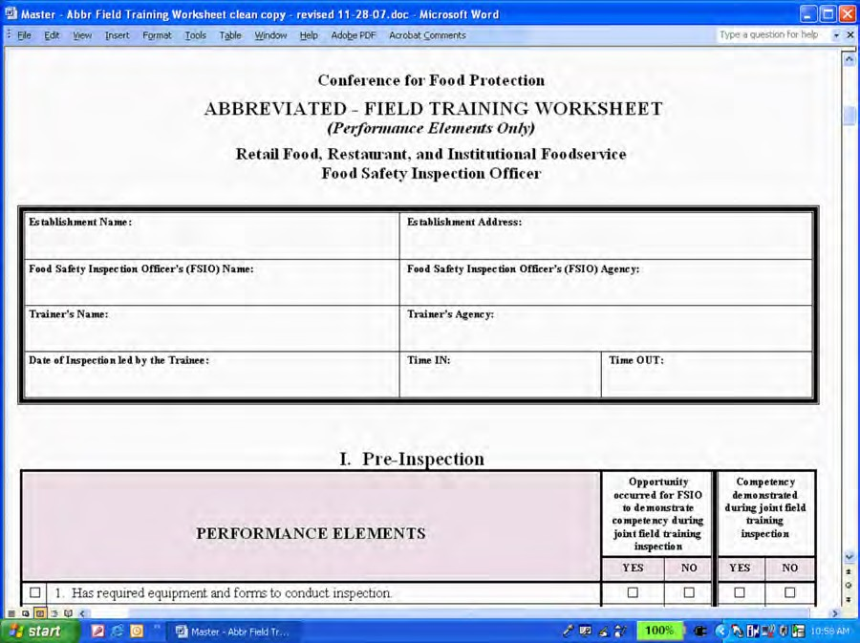

As an example, the abbreviated worksheet segment that lists the performance elements pertaining to oral communication is displayed in the graphic below. All six (6) of the performance elements for the ‘Oral Communication’ inspection area are included. Noe of the competencies (job tasks), however, are listed for these performance elements. The two column format and comment section for documenting training observations is the same as for the longer Field Training Worksheet.

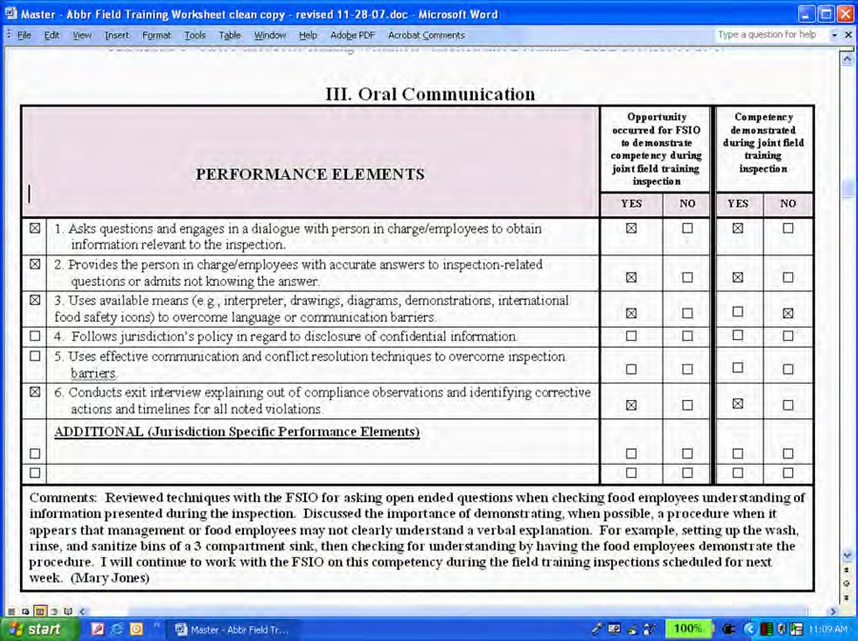

A reference list of example competencies for each performance element is provided at the end of the Abbreviated Field Training Worksheet for trainers to use during trainee-led inspections. The graphic that appears at the top of the next page displays competencies for some of the oral communication performance elements used as examples throughout this discussion.

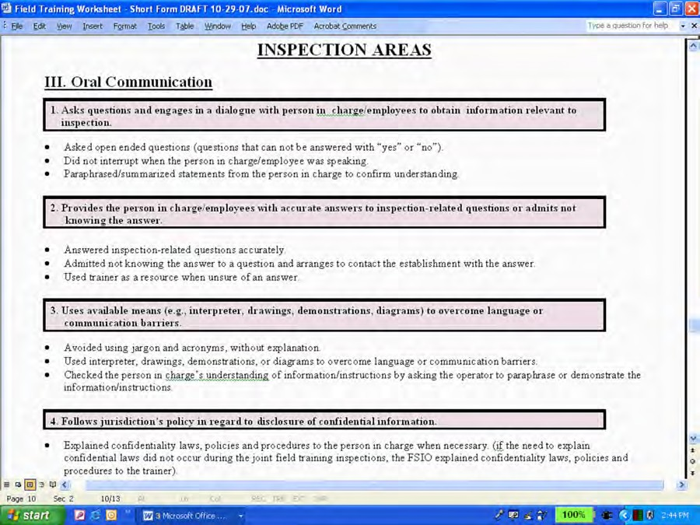

It is important to keep in mind that using either of the worksheets is a determination to be made by the regulatory jurisdiction’s management. These documents have been included with this manual to support a jurisdiction’s effort to ensure a FSIO has received training and demonstrated all competencies needed to conduct effective independent food safety inspections.

USING A SUPPLEMENTAL FIELD TRAINING WORKSHEET
In determining how to integrate a supplemental Field Training Worksheet into the training process, two approaches are generally considered:
- Using a worksheet during every trainee-led inspection; or
- Using a worksheet at set interval points during the trainee-led field training process.

These two approaches are only examples and are not intended to restrict the use of other formats by a jurisdiction. The following summary of strengths and challenges for each approach provides some guidance to regulatory retail food protection programs on ways to integrate a Field Training Worksheet into their training process.

Approach #1: During every inspection led by a trainee
Strengths: This approach provides continual feedback to the trainee on the competencies they have demonstrated and those for which more focused training is still needed. In the early stages of the training process, the Field Training Worksheet can be an important tool in determining whether more demonstration (trainer-led) inspections need to be performed. In later stages, the worksheet will help focus training on competencies the trainee is having difficulty with.

In addition, using the Field Training Worksheet with every inspection will
provide important feedback on the jurisdiction’s training and orientation program. The Field Training Worksheet can assist trainers with identifying potential gaps in the orientation/training program, coursework requirements, or administrative materials used to prepare staff to take the lead during field training inspections.

Challenges: Using the Field Training Worksheet during every inspection may cause trainers to focus too much on completing the form rather than on the training of the FSIO. The Field Training Worksheet is simply a tool to assist the trainer to track competencies as demonstrated during inspections led by a trainee.

Competing program priorities and limited resources may impede a jurisdiction’s ability to use a Field Training Worksheet during every trainee-led inspection.
Jurisdictions will need to balance the need to track the training process and communicate results effectively with the time commitment associated with completing forms used to support the training process.

Approach #2: At set interval points.

Strengths: A trainer may choose to use the Field Training Worksheet at set interval points during trainee-led inspections. For example, a Field Training Worksheet could be completed after every fifth inspection (i.e., inspections 5, 10, 15, 20 and 25). This process provides set checkpoints for
determining when training observations indicate the trainee has successfully demonstrated a competency.

The trainer can set achievable objectives for the trainee using this interval process, working on a few competencies at a time. Trainee-led inspections conducted between each use of the Field Training Worksheet can enhance a trainee’s knowledge and skills for competencies or provide additional training when needed.

Challenges: The interval process requires trainers to work from notes or inspection reports to determine competencies that have been observed and/or demonstrated over a period of time. The primary objective during trainee-led inspections is for the trainer to observe a consistent pattern of behavior in the trainee’s ability to successfully demonstrate a competency. Depending on the frequency a competency is observed, an interval approach could reveal fluctuations in a trainee’s ability to demonstrate a job task. The interval process

may not provide as structured a method for providing continuous feedback to the trainee as that provided if the Field Training Worksheet is used during every trainee-led inspection.

The ‘Joint Field Training Inspection – Establishment Log’ can be an important tool for documenting the use of the Field Training Worksheet when using the interval approach. The establishment log provides a means to note the point in time when the worksheet was completed and the time frame covered during the training period. In the illustration below, the trainer completed a Field Training Worksheet after the inspection of Establishment #15 and Establishment #20.

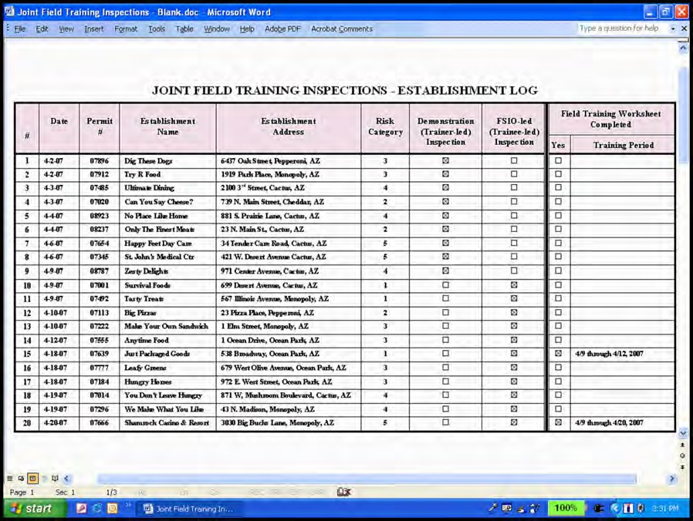

In the above example, the trainee-led inspections began with Establishment #10. The first Field Training Worksheet was completed after Establishment #15 and contains a collective set of observations of the trainee demonstrating competencies for Establishments 10 through 15, encompassing the period, April 9 through 12, 2007.

In this example, the jurisdiction’s training staff completes a Field Training Worksheet using 5 establishment inspection intervals. The second Field Training Worksheet was completed after Establishment #20 and the trainer’s observations again represented observations over a cumulative period of time. The notes from one Field Training Worksheet build on observations made on previous documents. The observations on the second Field Training Worksheet, therefore, represents the period when the

trainee began taking the lead during the training process on April 9, 2007 until the date the second Field Training Worksheet was completed on April 20, 2007.

The Field Training Worksheet is not intended to be used as a checklist during inspections nor should it drive the inspection approach used by the trainee. Continuous instruction is encouraged during each of the inspections led by a trainee. Trainers should take the opportunity to demonstrate and/or review correct procedures and skills for competencies that are not understood or properly performed by the trainee during each inspection.

REVIEWING FIELD TRAINING
Consistent and on-going feedback regarding inspection competencies is the cornerstone of the FSIO field training process presented in this manual. The trainer should share his/her observations with the trainee during each of the inspections. Discussions should include competencies successfully demonstrated by the trainee as well as those where additional training is needed. Trainers should provide continuous positive reinforcement for competencies correctly demonstrated by the trainee.

For areas where additional training is needed, the trainer should demonstrate to the trainee the competency during joint inspections and determine if other training methods may benefit the trainee’s understanding and application of the competency. Field training objectives should continually be reviewed with the trainee and updated as needed.

Equally as important, the field training process provides critical feedback to managers and trainers on the effectiveness of their retail food training and orientation programs. Competencies (job tasks) that are not consistently performed well by trainees may be an indication that the regulatory jurisdiction has significant gaps in their training program, coursework, or materials used to prepare staff for field inspections. Field training, where observations are made of a trainee demonstrating specific competencies, provides a framework for evaluating and enhancing the effectiveness of a jurisdiction’s existing regulatory retail food training programs.

DOCUMENTATION OF COMPLETION
The trainer’s and trainee’s signature in the header of the CFP Training Plan and Log indicates they both concur that all pre-requisite coursework has been completed and competencies listed on the jurisdiction’s training plan have been demonstrated.

When a FSIO has completed all the pre-requisite coursework and demonstrated all the competencies identified in the jurisdiction’s training plan, the retail food protection program managers has a basis for determining the FSIO’s readiness to conduct independent food safety inspections. The completed and signed CFP Training Plan and Log should be placed in the FSIO’s training file and a copy of the completed document given to the FSIO for their records.

Continuing Training
The pre-requisite coursework (see page 3), training plan, and field training inspection process presented in this manual are based on the minimum performance competencies a FSIO should be able to successfully demonstrate prior to conducting independent food safety inspections. This process should be considered but a first step in the development of inspection staff in a regulatory retail food protection program. Additional training opportunities and standardization should be provided on a continual basis to advance the development of a FSIO’s ability to implement a risk-based inspection approach and communicate food safety principles to the regulated industry and the public.

Additional Food Safety Courses
Over 100 food safety related courses are accessible from the FDA ORA U web site. The Conference for Food Protection has worked with FDA to identify courses that a FSIO should complete within the first 18 months of hire or assignment to the retail food program. It is expected that most FSIOs would complete this second phase of coursework after they have started to conduct independent inspections.

This additional coursework is part of the criteria contained in Standard 2 – Trained Regulatory Staff, FDA Voluntary National Retail Food Regulatory Program Standards and includes:
MICRIBIOLOGY EPIDEMIOLOGY
Food Microbiological Control (series): Foodborne Illness Investigation (series):
7C. Control by Retorting (90) MIC10 1. Collecting Surveillance Data (90) F101
- Technology-Based Food Processes (120) MIC11 2. Beginning the Investigation (90) F102
- Natural Toxins (90) MIC12 3. Expanding the Investigation (90) F103
4. Conducting a Food Hazard Review (90) F104
HACCP 5. Epidemiological Statistics (90) F105
Basics of HACCP (series): 6. Final Report (30) F106
- Overview of HACCP (60) FDA16
- Prerequisite Programs & Preliminary Steps (60) FDA 17
- The Principles (60) FDA18 EMERGENCY MANAGEMENT
FEMA – Incident Command System and National Incident Management System: Course available
ALLERGEN MANAGEMENT from FEMA web link:
- Food Allergens (60) FD252 http://training.fema.gov/IS/NIMS.asp
  - IS-100.a, Introduction to Incident Command System (180), ICS-100 or IS-100 for FDA
  - IS-200.a, ICS for Single Resources and Initial Action Incidents (180), ICS-200
  - IS-700.a, NIMS and Introduction (180), ICS- 700
Note: the estimated amount of time (in minutes) to complete each module is indicated in parenthesis followed by the course number.

The jurisdiction should also conduct or provide an opportunity for FSIOs to attend an Application of the Basics of Inspection/Investigations Course. This course addresses all retail food program inspection areas in which a FSIO should receive training and contains a practicum that provides an opportunity to demonstrate inspection techniques and

procedures. The Application Course provides an important confirmation that retail food safety program training objectives have been achieved.

A fully developed Application Course is available on CD through FDA’s Division of Human Resource Development’s lending library. A jurisdiction’s trainer can conduct their own Application Course using these materials or develop one that addresses at least 80% of the learning objectives and exercises contained in the course. In addition, the Association of Food and Drug Officials (AFDO), upon request, conducted the course for state and local retail food protection programs.

Standardization
Managers of regulatory retail food protection programs are encouraged to implement a standardization process similar to what is included in FDA’s Standardization Procedures for FSIOs to complete within 18 months of hire.

Conference for Food Protection TRAINING PLAN and LOG

Retail Food, Restaurant, and Institutional Foodservice Food Safety Inspection Officer

NOTE: The CFP Field Training Manual for Regulatory Retail Food Safety Inspection Officers (FSIOs) should be reviewed prior to using the CFP Training Plan and Log. The manual provides jurisdictions with information that will be helpful in customizing a FSIO training plan and implementing a training process that meets the specific needs of the jurisdiction.

Food Safety Inspection Officer’s (FSIO) Name: | Start Date of the Training Process:
Food Safety Inspection Officer’s (FSIO) Agency:
Trainer’s Name (if multiple trainers list all):  1. | Trainer’s Agency:
2.
3.
4.
Signatures below indicate FSIO has completed all curriculum and field training elements and is ready to conduct independent retail food and/or foodservice inspections
Completion Date of Pre--requisite Coursework:

OPTION 1: or OPTION 2:
Completion Date - (Performance Elements & Competencies):
Food Safety Inspection Officer’s (FSIO) Signature: | Trainer’s or Food Program Manager’s Signature:

The CFP Field Training Manual for Regulatory Retail Food Safety Inspection Officers includes two components. One includes completion of pre-requisite coursework outlined in Program Standard 2 – Trained Regulatory Staff, FDA Draft Voluntary National Retail Food Regulatory Program Standards. The second component focuses on the FSIO’s ability to demonstrate performance element competencies that are needed to conduct effective regulatory food safety inspections. A FSIO should successfully complete both components prior to conducting independent inspections.

PRE-REQUISITE COURSEWORK
The CFP Field Training Manual outlines the courses included in the pre-requisite curriculum and provides options for completing this component of the CFP training process. A jurisdiction can begin the field training process with FSIOs while they are still in the process of completing their pre-requisite coursework. The jurisdiction’s trainers and/or food program managers are given the discretion to determine the appropriate time frame within which FSIOs are to complete pre- requisite course work during the field training process.

TRAINING METHODS
The CFP Training Plan and Log is designed to incorporate a variety of training methods appropriate for each of the performance element competencies. A sufficient number of field training inspections should be conducted to provide an opportunity for the FSIO to successfully demonstrate the applicable competencies. The jurisdiction’s trainer can use the table below to identify the training methods that will be used.

JURISDICTION’S TRAINING METHODS
Code | Training Method

INSPECTION TRAINING AREAS
The CFP Training Plan and Log is divided into six (6) inspection training areas:
- Pre-Inspection
- Inspection Observations and Performance
- Oral Communication
- Written Communication
- Professionalism
- Additional Inspection Areas (Jurisdictions can add performance elements and competencies not contained in the CFP Training Plan and Log)

The Conference for Food Protection (CFP) has conducted a national research study and identified the minimum performance elements and competencies for each of the inspection training areas needed to perform regulatory retail safety inspections. The CFP Training Plan and Log contains a national model that regulatory retail food protection programs can readily integrate into their existing field training of Food Safety Inspection Officers (FSIOs).

The CFP Training Plan lists the basic performance elements (in BOLD font in the shaded areas of the Worksheet). Under each performance element is a list of competencies provided as examples of job tasks that a jurisdiction should ensure the FSIO receives training on in order to perform their job responsibilities effectively. The jurisdiction’s trainer should identify those performance element competencies that are applicable to the FSIO’s job responsibilities within their jurisdiction. A small box appears adjacent to each of the performance elements and competencies on the worksheet. If the performance element and/or competency is applicable to the jurisdiction it is to be checked and included as part of the training process.

INSPECTION TRAINING AREAS
  - Pre-Inspection

1. Has required equipment and forms to conduct inspection.
Training Method
Date Demonstrated By the Trainee
Trainee’s Initials
Training Officer
(Training method and selected competencies for this performance element are to be indicated below)
Necessary inspection forms and administrative materials.
Lab coat or equivalent protection to cover street clothes.
Head cover: baseball cap; hair net; or equivalent.
Calibrated thermocouple temperature measuring device.
Maximum registering thermometer or temperature sensitive tapes for verifying hot water warewashing final rinse temperature.
Chemical test kits for chlorine, iodophor, and quaternary ammonia sanitizers.
Flashlight.
Alcohol swabs.
ADDITIONAL (Jurisdiction specific competencies)
Comments:
Trainee has demonstrated acceptable performance for all competencies listed
Date:
Trainee’s Initials:
Trainer’s Signature:

2. Reviews establishment file for previous inspection report, complaints on file, and if applicable, required HACCP Plans or documents supporting the issuance of a variance by the agency.

Training Method
Date Demonstrated By the Trainee

Trainee’s Initials

Training Officer

(Training method and selected competencies for this performance element are to be indicated below)
Reviewed previous inspection report noting documented out of compliance observations.
Reviewed establishment file for complaint reports.
Reviewed establishment file for documentation indicating a need for a HACCP Plan.
Reviewed establishment file for documentation of food production or processes operating under a variance issued by the jurisdiction.
ADDITIONAL (Jurisdiction specific competencies)

Comments:

Trainee has demonstrated acceptable performance for all competencies listed
Date: Trainee’s Initials: Trainer’s Signature:

Inspection Observations and Performance

 | 1. Provides identification as a regulatory official to person in charge, confirming agency authority for inspection, and stating the purpose of visit. |  |  | Training Method | Date Demonstrated By the Trainee |  | Trainee’s Initials | Training Officer
(Training method and selected competencies for this performance element are to be indicated below)
 | Verbally provided name and agency to the person in charge.
 | Presented regulatory identification or business card.
 | Stated the purpose of the visit.
 | Requests and confirmed permission to conduct inspection from the person in charge prior to initiating the inspection.
 | ADDITIONAL (Jurisdiction specific competencies)
Comments:
Trainee has demonstrated acceptable performance for all competencies listed
Date: |  | Trainee’s Initials: | Trainer’s Signature:

 | 2. Has knowledge of jurisdiction’s laws, rules, and regulations required for conducting retail food/foodservice inspections. |  |  | Training Method | Date Demonstrated By the Trainee |  | Trainee’s Initials | Training Officer
(Training method and selected competencies for this performance element are to be indicated below)
 | Verified the correct critical limit and or standard specified in the jurisdiction’s rules/regulations to the observation made.
 | Correctly cited the rule/regulation for each out of compliance observation.
 | ADDITIONAL (Jurisdiction specific competencies)
Comments:
Trainee has demonstrated acceptable performance for all competencies listed
Date: |  | Trainee’s Initials: | Trainer’s Signature:

II. Inspection Observations and Performance (continued)

 | 3. Uses a risk-based inspection methodology to correctly assess regulations related to employee practices and management procedures essential to the safe storage, preparation, and service of food. |  |  | Training Method |  | Date Demonstrated By the Trainee | Trainee’s Initials | Training Officer
(Training method and selected competencies for this performance element are to be indicated below)
 | Verified Demonstration of Knowledge of the person in charge.
 | Verified approved food sources (e.g., food from regulated food processing plants; shellfish documentation; game animal processing; parasite destruction for certain species of fish intended for raw consumption; receiving temperatures).
 | Verified food safety practices for preventing cross-contamination of ready-to-eat food.
 | Verified food contact surfaces are clean and sanitized, protected from contamination from soiled cutting boards, utensils, aprons, etc., or raw animal foods.
 | Verified the restriction or exclusion of ill employees.
 | Verified no bare hand contact with ready-to-eat foods (or use of a pre- approved, alternative procedure).
 | Verified employee handwashing.
 | Verified cold holding temperatures of foods requiring time/temperature control for safety (TCS food), or when necessary, verified that procedures are in place to use time alone to control bacterial growth and toxin production.
 | Verified date marking of ready-to-eat foods TCS food held for more than 24 hours.
 | Verified cooking temperatures to destroy bacteria and parasites.
 | Verified hot holding temperatures of TCS food or when necessary, that procedures were in place to use time alone to prevent the outgrowth of spore-forming bacteria.
 | Verified cooling temperatures of TCS food to prevent the outgrowth of spore-forming or toxin-forming bacteria.
 | Verified reheating temperatures of TCS food for hot holding.
 | Verified the availability of a consumer advisory for foods of animal origin served raw or undercooked.
 | Identified food processes and/or procedures that require a HACCP Plan per the jurisdiction’s regulations.
 | ADDITIONAL (Jurisdiction specific competencies)
Comments:
Trainee has demonstrated acceptable performance for all competencies listed
Date: |  | Trainee’s Initials: | Trainer’s Signature:

II. Inspection Observations and Performance (continued)

 | 4. Obtains immediate corrective action for out of compliance employee practices and management procedures (listed in Item 3 above) essential to the safe storage, preparation, and service of food. |  |  | Training Method |  | Date Demonstrated By the Trainee | Trainee’s Initials | Training Officer
(Training method and selected competencies for this performance element are to be indicated below)
 | Notified the person in charge/employee(s) of the out of compliance observations.
 | Reviewed corrective actions with the person in charge/employee(s).
 | Observed the person in charge/employee(s) immediately take corrective action for out of compliance observations (e.g., movement of food to ensure product temperature or prevent contamination; reconditioning food; restriction/exclusion of ill employees; discarding of food product) in accordance with local jurisdiction’s procedures.
 | Identified conditions requiring issuance of an embargo/stop sale/food destruction order per jurisdiction’s administrative procedures.
 | ADDITIONAL (Jurisdiction specific competencies)
Comments:
Trainee has demonstrated acceptable performance for all competencies listed
Date: |  | Trainee’s Initials: | Trainer’s Signature:

 | 5. Correctly assesses compliance status of other regulations (not included in Item 4 – Good Retail Practices) that are included in jurisdiction’s prevailing statutes, regulations and/or ordinances. |  |  | Training Method |  | Date Demonstrated By the Trainee | Trainee’s Initials | Training Officer
(Training method and selected competencies for this performance element are to be indicated below)
 | Correctly assessed compliance status of other regulations (not included in Item 4 above - Good Retail Practices) that are included in jurisdiction’s prevailing statutes, regulations and/or ordinances.
 | ADDITIONAL (Jurisdiction specific competencies)
Comments:
Trainee has demonstrated acceptable performance for all competencies listed
Date: |  | Trainee’s Initials: | Trainer’s Signature:

- Inspection Observations and Performance (continued)

 | 6. Verifies correction of out of compliance observations identified during previous inspection. |  |  | Training Method |  | Date Demonstrated By the Trainee | Trainee’s Initials | Training Officer
(Training method and selected competencies for this performance element are to be indicated below)
 | Verified correction of out of compliance observations identified during previous inspection
 | ADDITIONAL (Jurisdiction specific competencies)
Comments:
Trainee has demonstrated acceptable performance for all competencies listed
Date: |  | Trainee’s Initials: | Trainer’s Signature:

 | 7. Correctly uses inspection equipment during joint inspections. |  |  | Training Method |  | Date Demonstrated By the Trainee | Trainee’s Initials | Training Officer
(Training method and selected competencies for this performance element are to be indicated below)
 | Used temperature measuring devices/probes in accordance with manufacturer’s instructions.
 | Cleaned and sanitized (alcohol swabs) temperature measurement probes to prevent food contamination.
 | Used infrared thermometer in accordance with manufacturer’s instructions. Verified any out of compliance product temperatures registered on the infrared with a thermocouple.
 | Used maximum registering thermometer or heat sensitive tapes in accordance with manufacturer’s instructions to verify final rinse dishwasher temperature.
 | Used chemical test strips in accordance with manufacturer’s instructions to measure sanitizer concentrations in manual and mechanical dishwashing operations; wiping cloth solutions; and spray bottle applicators.
 | Used flashlight to assess observations in areas with no or low light.
 | Photographs taken support regulatory findings or conditions observed.
ADDITIONAL (Jurisdiction specific competencies)
\
Comments:
Trainee has demonstrated acceptable performance for all competencies listed
Date: |  | Trainee’s Initials: | Trainer’s Signature:

- Oral Communication

 | 1. Asks questions and engages in a dialogue with person in charge/employees to obtain information relevant to inspection. |  |  | Training Method |  | Date Demonstrated By the Trainee | Trainee’s Initials | Training Officer
(Training method and selected competencies for this performance element are to be indicated below)
 | Asked open ended questions (questions that can not be answered with “yes” or “no”).
 | Did not interrupt when the person in charge/employee was speaking.
 | Paraphrased/summarized statements from the person in charge to confirm understanding.
 | ADDITIONAL (Jurisdiction specific competencies)
Comments:
Trainee has demonstrated acceptable performance for all competencies listed
Date: |  | Trainee’s Initials: | Trainer’s Signature:

 | 2. Provides the person in charge/employees with accurate  answers to inspection-related questions or admits not knowing the answer. |  |  | Training Method |  | Date Demonstrated By the Trainee | Trainee’s Initials | Training Officer
(Training method and selected competencies for this performance element are to be indicated below)
 | Answered inspection-related questions accurately.
 | Admitted not knowing the answer to a question and arranges to contact the establishment with the answer.
 | Used trainer as a resource when unsure of an answer.
 | ADDITIONAL (Jurisdiction specific competencies)
Comments:
Trainee has demonstrated acceptable performance for all competencies listed
Date: |  | Trainee’s Initials: | Trainer’s Signature:

III. Oral Communication (continued)

 | 3. Uses available means (e.g., interpreter, drawings, diagrams demonstrations, international food safety icons) to overcome language or communication barriers. |  |  | Training Method |  | Date Demonstrated By the Trainee | Trainee’s Initials | Training Officer
(Training method and selected competencies for this performance element are to be indicated below)
 | Avoided using jargon and acronyms, without explanation.
 | Used interpreter, drawings, demonstrations, or diagrams to overcome language or communication barriers.
 | Checked the person in charge’s understanding of information/instructions by asking the operator to paraphrase or demonstrate the information/instructions.
 | ADDITIONAL (Jurisdiction specific competencies)
Comments:
Trainee has demonstrated acceptable performance for all competencies listed
Date: |  | Trainee’s Initials: | Trainer’s Signature:

 | 4. Follows jurisdiction’s policy in regard to disclosure of confidential information. |  |  | Training Method |  | Date Demonstrated By the Trainee | Trainee’s Initials | Training Officer
(Training method and selected competencies for this performance element are to be indicated below)
 | Explained confidentiality laws, policies and procedures to the person in charge when necessary. (If the need to explain confidential laws did not occur during the joint field training inspections, the FSIO explained confidentiality laws, policies and procedures to the trainer).
 | Applied the confidentiality policy per the jurisdictional requirements (e.g., FSIO did not reveal confidential information to the operator during the inspection).
 | ADDITIONAL (Jurisdiction specific competencies)
Comments:
Trainee has demonstrated acceptable performance for all competencies listed
Date: |  | Trainee’s Initials: | Trainer’s Signature:

- Oral Communication (continued)

 | 5. Uses effective communication and conflict resolution techniques to overcome inspection barriers. |  |  | Training Method |  | Date Demonstrated By the Trainee | Trainee’s Initials | Training Officer
(Training method and selected competencies for this performance element are to be indicated below)
 | Identified challenges faced by the person in charge and offered possible solution(s).
 | Did not become argumentative (e.g., remained calm and focused).
 | Removed himself/herself from a confrontation or threat that may impact personal safety.
 | ADDITIONAL (Jurisdiction specific competencies)
Comments:
Trainee has demonstrated acceptable performance for all competencies listed
Date: |  | Trainee’s Initials: | Trainer’s Signature:

 | 6. Conducts exit interview explaining out of compliance observations and identifying corrective actions and timelines for all noted violations. |  |  | Training Method |  | Date Demonstrated By the Trainee | Trainee’s Initials | Training Officer
(Training method and selected competencies for this performance element are to be indicated below)
 | Explained the public health significance of the inspection observations.
 | Reviewed all findings with the person in charge with emphasis on contributing factors to foodborne illness and Food Code Interventions (listed in Section II, Item 3).
 | Used foodborne illness data to highlight contributing factors.
 | Answered all questions or concerns pertaining to items on the inspection report.
 | Provided contact information to the person in charge for follow up questions or additional guidance.
 | ADDITIONAL (Jurisdiction specific competencies)
Comments:
Trainee has demonstrated acceptable performance for all competencies listed
Date: |  | Trainee’s Initials: | Trainer’s Signature:

- Written Communication

1. Completes inspection form per jurisdiction’s administrative procedures (e.g., observations; corrective actions; public health reason; applicable code reference; compliance dates).

Training Method
Date Demonstrated By the Trainee

Trainee’s Initials

Training Officer
(Training method and selected competencies for this performance element are to be indicated below)
Used correct inspection form.
Completed a legible report.
Accurately documented observations made during inspection.
Completed inspection form in accordance with jurisdiction’s administrative procedures.
Cited correct code provisions/rules/regulations.
Documented immediate corrective action for out-of-compliance foodborne illness contributing factors and Food Code Interventions (listed in Section II, Item 3).
Documented time frames for correcting each out of compliance observation.
ADDITIONAL (Jurisdiction specific competencies)
Comments:
Trainee has demonstrated acceptable performance for all competencies listed
Date:
Trainee’s Initials:
Trainer’s Signature:

2. Includes with inspection report any compliance or regulatory documents (identified or cross-referenced in written statements e.g., exhibits, attachments, sample forms, embargo forms, destruction forms, suspension notices).

Training Method

Date Demonstrated By the Trainee

Trainee’s Initials

Training Officer
(Training method and selected competencies for this performance element are to be indicated below)
Referenced attached documents in inspection report.
Referenced documents are legible.
Referenced documents are accurate and reflect observations made during the inspection.
Attached referenced document(s) to the inspection report per jurisdiction’s administrative procedures.
ADDITIONAL (Jurisdiction specific competencies)
Comments:
Trainee has demonstrated acceptable performance for all competencies listed
Date:
Trainee’s Initials:
Trainer’s Signature:

- Written Communication (continued)

 | 3. Presents inspection report, and when necessary cross- referenced documents, to person in charge. |  |  | Training Method |  | Date Demonstrated By the Trainee | Trainee’s Initials | Training Officer
(Training method and selected competencies for this performance element are to be indicated below)
 | Presented complete inspection report, with referenced documents when necessary, to person in charge during exit interview.
 | Followed jurisdiction’s administrative procedures for delivering written inspection report.
 | Obtained signature of person in charge on inspection report.
 | ADDITIONAL (Jurisdiction specific competencies)
Comments:
Trainee has demonstrated acceptable performance for all competencies listed
Date: |  | Trainee’s Initials: | Trainer’s Signature:

- Professionalism

 | 1. Maintains a professional appearance consistent with jurisdiction’s policy (e.g., clean outer clothing, hair restraint). |  |  | Training Method |  | Date Demonstrated By the Trainee | Trainee’s Initials | Training Officer
(Training method and selected competencies for this performance element are to be indicated below)
 | Maintained a professional appearance consistent with jurisdiction’s policy (e.g., clean outer clothing, hair restraint).
 | ADDITIONAL (Jurisdiction specific competencies)
Comments:
Trainee has demonstrated acceptable performance for all competencies listed
Date: |  | Trainee’s Initials: | Trainer’s Signature:

 | 2. Demonstrates proper sanitary practices as expected from a food service employee. |  |  | Training Method |  | Date Demonstrated By the Trainee | Trainee’s Initials | Training Officer
(Training method and selected competencies for this performance element are to be indicated below)
 | Washed hands as needed (e.g., prior to conducting inspection, after using restroom, after touching dirty surfaces, after touching face/body, after sneezing/coughing).
 | Protected bandages on hands, when necessary, to prevent contamination of food or food contact surfaces.
 | Did NOT contact ready-to-eat foods with bare hands.
 | Did NOT show any obvious signs of illness in accordance with jurisdiction’s employee health policy and/or current food code.
 | ADDITIONAL (Jurisdiction specific competencies)
Comments:
Trainee has demonstrated acceptable performance for all competencies listed
Date: |  | Trainee’s Initials: | Trainer’s Signature:

- Professionalism (continued)

 | 3. Only reports substantiated findings as violations. |  |  | Training Method |  | Date Demonstrated By the Trainee | Trainee’s Initials | Training Officer
(Training method and selected competencies for this performance element are to be indicated below)
 | Only reported findings that were directly observed or substantiated in accordance with jurisdiction’s policies and procedures.
 | Findings are supported by fact (e.g., are NOT based on hunch or suspicion; are witnessed, are investigated).
 | Did NOT note violations without visiting the establishment.
 | Did NOT exaggerate details related to findings to support report conclusions.
 | Did NOT modify report after leaving the establishment except as allowed by jurisdiction’s administrative procedures.
 | ADDITIONAL (Jurisdiction specific competencies)
Comments:
Trainee has demonstrated acceptable performance for all competencies listed
Date: |  | Trainee’s Initials: | Trainer’s Signature:

- Additional Performance Elements – Jurisdiction Specific

1. Uses an aseptic food sample collection method consistent with criteria established by laboratory serving jurisdiction.

Training Method
Date Demonstrated By the Trainee

Trainee’s Initials

Training Officer

(Training method and selected competencies for this performance element are to be indicated below)
Used proper hygiene before and during sample process (e.g., washed hands prior to sampling; did not touch sample container opening, inside lip, inside cap or did not blow into the bag to open it up.)
Used sample collection method specified by the jurisdiction (e.g., original container if available; collection of a representative sample from a large quantity or container).
Used sterile, leak-proof lidded container or zipper-lock type bags. Used a separate sterile utensil to collect each different sample item.
Labeled all containers with required information (e.g., date, time, location, product name, FSIO initials) with corresponding information noted on inspection report or laboratory forms.
Initiated written chain of custody including use of evidence seal.
Stored and transported sample in a clean, refrigerated unit (e.g., ice chest with ice) within the prescribed time period.
Maintained sample refrigerated or frozen until transport or shipping to laboratory.
Sample packed and shipped in sterile, leak-proof, insulated container with refrigerant (wet or dry ice) via the most rapid and convenient means available (e.g., courier, bus, express mail).
ADDITIONAL (Jurisdiction specific competencies)

Comments:

Trainee has demonstrated acceptable performance for all competencies listed
Date: Trainee’s Initials: Trainer’s Signature:

VI. Additional Performance Elements – Jurisdiction Specific

 | 2. Uses an aseptic water sample collection method consistent with criteria established by laboratory serving jurisdiction. |  |  | Training Method |  | Date Demonstrated By the Trainee | Trainee’s Initials | Training Officer
(Training method and selected competencies for this performance element are to be indicated below)
 | Used proper hygiene before and during sample process (e.g., washed hands prior to sampling; did not touch sample container opening, inside lip, inside cap or did not blow into the bag to open it up.)
 | Sample taken at site closest to source of water (prior to any treatment) if possible, or at a site (post treatment) per jurisdiction’s procedures.
 | Sample taken from operational fixed type faucet – no swing type or leaking faucets.
 | Removed aerator (if present) from faucet prior to sampling.
 | Disinfected faucet with bleach or flame.
 | Ran water through faucet for several minutes to clear line.
 | Used a sterile, leak-proof lidded container, “whirl-pak” or zipper-lock type bag.
 | Sample taken from midstream of the flowing faucet.
 | Labeled all containers with required information (e.g., date, time, location, product name, FSIO initials) with corresponding information noted on inspection report or laboratory forms.
 | Initiated written chain of custody including use of evidence seal.
 | Stored and transported sample in a clean, refrigerated unit (e.g., ice chest with ice) within the prescribed time period.
 | Maintained sample refrigerated until transport or shipping to the laboratory.
 | Sample packed and shipped in sterile, leak-proof, insulated container with refrigerant via the most rapid and convenient means available (e.g., courier, bus, express mail).
 | ADDITIONAL (Jurisdiction specific competencies)
Comments:
Trainee has demonstrated acceptable performance for all competencies listed
Date: |  | Trainee’s Initials: | Trainer’s Signature:

- Additional Performance Elements – Jurisdiction Specific (continued)

 |  |  |  | Training Method |  | Date Demonstrated By the Trainee | Trainee’s Initials | Training Officer
(Training method and selected competencies for this performance element are to be indicated below)
Comments:
Trainee has demonstrated acceptable performance for all competencies listed
Date: |  | Trainee’s Initials: | Trainer’s Signature:

 |  |  |  | Training Method |  | Date Demonstrated By the Trainee | Trainee’s Initials | Training Officer
(Training method and selected competencies for this performance element are to be indicated below)
Comments:
Trainee has demonstrated acceptable performance for all competencies listed
Date: |  | Trainee’s Initials: | Trainer’s Signature:

 |  |  |  | Training Method |  | Date Demonstrated By the Trainee | Trainee’s Initials | Training Officer
(Training method and selected competencies for this performance element are to be indicated below)
Comments:
Trainee has demonstrated acceptable performance for all competencies listed
Date: |  | Trainee’s Initials: | Trainer’s Signature:

OPTIONAL - FSIO TRAINING LOG

Trainee’s Name:
Week: 1 Date Ending:
Training Areas Demonstrated | Planned Training Areas for Upcoming Week | Additional Comments
Trainee’s Initials: | Trainer’s Signature:

Week: 2 Date Ending:
Training Areas Demonstrated | Planned Training Areas for Upcoming Week | Additional Comments
Trainee’s Initials: | Trainer’s Signature:

Week: 3 Date Ending:
Training Areas Demonstrated | Planned Training Areas for Upcoming Week | Additional Comments
Trainee’s Initials: | Trainer’s Signature:

OPTIONAL - FSIO TRAINING LOG

Trainee’s Name:
Week: 4 Date Ending:
Training Areas Demonstrated | Planned Training Areas for Upcoming Week | Additional Comments
Trainee’s Initials: | Trainer’s Signature:

Week: 5 Date Ending:
Training Areas Demonstrated | Planned Training Areas for Upcoming Week | Additional Comments
Trainee’s Initials: | Trainer’s Signature:

Week: 6 Date Ending:
Training Areas Demonstrated | Planned Training Areas for Upcoming Week | Additional Comments
Trainee’s Initials: | Trainer’s Signature:

OPTIONAL - FSIO TRAINING LOG

Trainee’s Name:
Week: Date Ending:
Training Areas Demonstrated | Planned Training Areas for Upcoming Week | Additional Comments
Trainee’s Initials: | Trainer’s Signature:

Week: Date Ending:
Training Areas Demonstrated | Planned Training Areas for Upcoming Week | Additional Comments
Trainee’s Initials: | Trainer’s Signature:

Week: Date Ending:
Training Areas Demonstrated | Planned Training Areas for Upcoming Week | Additional Comments
Trainee’s Initials: | Trainer’s Signature:

OPTIONAL
JOINT FIELD TRAINING INSPECTIONS - ESTABLISHMENT LOG

# | Date | Permit  # | Establishment Name | Establishment Address | Risk Category | Demonstration (Trainer-led) Inspection | FSIO-led (Trainee-led) Inspection |  | Field Training Worksheet Completed
 |  |  |  |  |  |  |  |  | Yes | Training Period
1
2
3
4
5
6
7
8
9
10
11
12
13
14
15
16
17
18
19
20

OPTIONAL
JOINT FIELD TRAINING INSPECTIONS – ESTABLISHMENT LOG

# | Date | Permit  # | Establishment Name | Establishment Address | Risk Category | Demonstration (Trainer-led) Inspection | FSIO-led (Trainee-led) Inspection |  | Field Training Worksheet Completed
 |  |  |  |  |  |  |  |  | Yes | Training Period
21
22
23
24
25
26
27
28
29
30
31
32
33
34
35
36
37
38
39
40

Conference for Food Protection
FIELD TRAINING WORKSHEET

(Performance Elements and Competencies)
Retail Food, Restaurant, and Institutional Foodservice Food Safety Inspection Officer
NOTE: The CFP Field Training Manual for Regulatory Retail Food Safety Inspection Officers (FSIOs) should be reviewed prior to using the Field Training Worksheet. The manual provides jurisdictions with information that will be helpful in customizing the Field Training Worksheet and implementing a training process that meets the specific needs of the jurisdiction.

 | Establishment Name: | Establishment Address:
 | Food Safety Inspection Officer’s (FSIO) Name: | Food Safety Inspection Officer’s (FSIO) Agency:
 | Trainer’s Name: | Trainer’s Agency:
 | Date of Inspection led by Trainee: | Tine IN: | Tine OUT:

The Conference for Food Protection (CFP) has conducted a national research study and identified the basic minimum competencies needed to perform effective regulatory food safety inspections. The Field Training Worksheet has been designed as a trainer’s tool to be used in conjunction with the CFP Training Plan and Log. It provides a method for tracking a FSIO’s progress and accomplishments in successfully demonstrating performance element competencies during field training inspections.

There is no single correct way to use the worksheet. The CFP Field Training Manual provides examples of ways to incorporate the worksheet into existing retail food protection training programs.

The Field Training Worksheet lists the basic performance elements (in BOLD font in the shaded areas of the Worksheet). Under each performance element is a list of competencies provided as examples of job tasks that a jurisdiction should ensure a FSIO has received adequate training on in order to perform their job responsibilities effectively. The jurisdiction’s trainer should identify those performance elements and/or competencies that are applicable to the FSIOs job responsibilities within their jurisdiction. A small box appears adjacent to each of the performance element competencies on the worksheet; if the performance element and/or competency is applicable to the jurisdiction, it is to be checked and included as part of the training process.

Trainers should review with the FSIO the competencies that will be included as part of the field training inspections. FSIOs are expected to successfully demonstrate these minimum competencies correctly prior to conducting independent food safety inspections.

Pre-Inspection

2
 | 1. Has required equipment and forms to conduct inspection. | Opportunity occurred for FSIO to demonstrate competency during joint field training inspection |  |  | Competency demonstrated during joint field training inspection
 | 1. Has required equipment and forms to conduct inspection. | YES | NO |  | YES | NO
 | Necessary inspection forms and administrative materials.
 | Lab coat or equivalent protection to cover street clothes.
 | Head cover: baseball cap; hair net; or equivalent.
 | Calibrated thermocouple temperature measuring device.
 | Maximum registering thermometer or temperature sensitive tapes for verifying hot water warewashing final rinse temperature.
 | Chemical test kits for chlorine, iodophor, and quaternary ammonia sanitizers.
 | Flashlight.
 | Alcohol swabs.
 | ADDITIONAL (Jurisdiction specific competencies)
Comments:

2

2
 | 2. Reviews establishment file for previous inspection report, complaints on file, and if applicable, required HACCP Plans or documents supporting the issuance of a variance. | Opportunity occurred for FSIO to demonstrate competency during joint field training inspection |  |  | Competency demonstrated during joint field training inspection
 |  | YES | NO |  | YES | NO
 | Reviewed previous inspection report noting documented out of compliance observations
 | Reviewed establishment file for complaint reports.
 | Reviewed establishment file for documentation indicating a need for a HACCP Plan.
 | Reviewed establishment file for documentation of food production or processes operating under a variance issued by the jurisdiction. |  |  |  |  | 2
 | ADDITIONAL (Jurisdiction specific competencies)
Comments:

Inspection Observations and Performance

2
 | 1. Provides identification as a regulatory official to person in charge, confirming agency authority for inspection, and stating the purpose of visit. | Opportunity occurred for FSIO to demonstrate competency during joint field training inspection |  |  | Competency demonstrated during joint field training inspection
 |  | YES | NO |  | YES | NO
 | Verbally provided name and agency to the person in charge.
 | Presented regulatory identification or business card.
 | Stated the purpose of the visit.
 | Requests and confirmed permission to conduct inspection from the person in charge prior to initiating the inspection. |  |  |  |  | 2
 | ADDITIONAL (Jurisdiction specific competencies)
Comments:

 | 2. Has knowledge of jurisdiction’s laws, rules, and regulations required for conducting retail food/foodservice inspections. | Opportunity occurred for FSIO to demonstrate competency during joint field training inspection |  |  | Competency demonstrated during joint field training inspection
 |  | YES | NO |  | YES | NO
 | Verified the correct critical limit and or standard specified in the jurisdiction’s rules/regulations to the observation made. |  |  |  | 2
 | Correctly cited the rule/regulation for each out of compliance observation.
 | ADDITIONAL (Jurisdiction specific competencies)
Comments:

II. Inspection Observations and Performance (continued)

2
 | 3. Uses a risk-based inspection methodology to correctly assess regulations related to employee practices and management procedures essential to the safe storage, preparation, and service of food. | Opportunity occurred for FSIO to demonstrate competency during joint field training inspection |  |  | Competency demonstrated during joint field training inspection
 |  | YES | NO |  | YES | NO
 | Verified Demonstration of Knowledge of the person in charge.
 | Verified approved food sources (e.g., food from regulated food processing plants; shellfish documentation; game animal processing; parasite destruction for certain species of fish intended for raw consumption; receiving temperatures).
 | Verified food safety practices for preventing cross-contamination of ready-to-eat food.
 | Verified food contact surfaces are clean and sanitized, protected from contamination from soiled cutting boards, utensils, aprons, etc., or raw animal foods. |  |  |  |  | 2
 | Verified the restriction or exclusion of ill employees.
 | Verified no bare hand contact with ready-to-eat foods (or use of a pre-approved, alternative procedure).
 | Verified employee handwashing
 | Verified cold holding temperatures of foods requiring time/temperature control for safety (TCS food), or when necessary, verified that procedures are in place to use time alone to control bacterial growth and toxin production.
 | Verified date marking of ready-to-eat foods TCS food held for more than 24 hours.
 | Verified cooking temperatures to destroy bacteria and parasites.
 | Verified hot holding temperatures of TCS food or when necessary, that procedures were in place to use time alone to prevent the outgrowth of spore-forming bacteria.
 | Verified cooling temperatures of TCS food to prevent the outgrowth of spore-forming or toxin- forming bacteria.
 | Verified reheating temperatures of TCS food for hot holding.
 | Verified the availability of a consumer advisory for foods of animal origin served raw or undercooked.
 | Identified food processes and/or procedures that require a HACCP Plan per the jurisdiction’s regulations.
 | ADDITIONAL (Jurisdiction specific competencies)
Comments:

II. Inspection Observations and Performance (continued)

2
 | 4. Obtains immediate corrective action for out of compliance employee practices and management procedures (listed in Item 3 above) essential to the safe storage, preparation, and service of food | Opportunity occurred for FSIO to demonstrate competency during joint field training inspection |  |  | Competency demonstrated during joint field training inspection
 |  | YES | NO |  | YES | NO
 | Notified the person in charge/employee(s) of the out of compliance observations.
 | Reviewed corrective actions with the person in charge/employee(s).
 | Observed the person in charge/employee(s) immediately take corrective action for out of compliance observations (e.g., movement of food to ensure product temperature or prevent contamination; reconditioning food; restriction/exclusion of ill employees; discarding of food product) in accordance with local jurisdiction’s procedures.
 | Identified conditions requiring issuance of an embargo/stop sale/food destruction order per jurisdiction’s administrative procedures. |  |  |  |  | 2
 | ADDITIONAL (Jurisdiction specific competencies)
Comments:

 | 5. Correctly assesses compliance status of other regulations (not included in Item 4 – Good Retail Practices) that are included in jurisdiction’s prevailing statutes, regulations and/or ordinances. | Opportunity occurred for FSIO to demonstrate competency during joint field training inspection |  |  | Competency demonstrated during joint field training inspection
 |  | YES | NO |  | YES | NO
 | Correctly assessed compliance status of other regulations (not included in Item 4 above - Good Retail Practices) that are included in jurisdiction’s prevailing statutes, regulations and/or ordinances.
 | ADDITIONAL (Jurisdiction specific competencies)
Comments:

Inspection Observations and Performance (continued)

 | 6. Verifies correction of out of compliance observations identified during previous inspection. | Opportunity occurred for FSIO to demonstrate competency during joint field training inspection |  |  | Competency demonstrated during joint field training inspection
 |  | YES | NO |  | YES | NO
 | Verified correction of out of compliance observations identified during previous inspection
 | ADDITIONAL (Jurisdiction specific competencies)
Comments:

2
 | 7. Correctly uses inspection equipment during joint inspections. | Opportunity occurred for FSIO to demonstrate competency during joint field training inspection |  |  | Competency demonstrated during joint field training inspection
 |  | YES | NO |  | YES | NO
 | Used temperature measuring devices/probes in accordance with manufacturer’s instructions.
 | Cleaned and sanitized (alcohol swabs) temperature measurement probes to prevent food contamination.
 | Used infrared thermometer in accordance with manufacturer’s instructions. Verified any out of compliance product temperatures registered on the infrared with a thermocouple.
 | Used maximum registering thermometer or heat sensitive tapes in accordance with manufacturer’s instructions to verify final rinse dishwasher temperature. |  |  |  |  | 2
 | Used chemical test strips in accordance with manufacturer’s instructions to measure sanitizer concentrations in manual and mechanical dishwashing operations; wiping cloth solutions; and spray bottle applicators.
 | Used flashlight to assess observations in areas with no or low light.
 | Photographs taken support regulatory findings or conditions observed.
 | ADDITIONAL (Jurisdiction specific competencies)
Comments:

Oral Communication

2
 | 1. Asks questions and engages in a dialogue with person in charge/employees to obtain information relevant to the inspection. | Opportunity occurred for FSIO to demonstrate competency during joint field training inspection |  |  | Competency demonstrated during joint field training inspection
 |  | YES | NO |  | YES | NO
 | Asked open ended questions (questions that can not be answered with “yes” or “no”).
 | Did not interrupt when the person in charge/employee was speaking.
 | Paraphrased/summarized statements from the person in charge to confirm understanding.
 | ADDITIONAL (Jurisdiction specific competencies)
Comments:

2
 | 2. Provides the person in charge/employees with accurate answers to inspection-related questions or admits not knowing the answer. | Opportunity occurred for FSIO to demonstrate competency during joint field training inspection |  |  | Competency demonstrated during joint field training inspection
 |  | YES | NO |  | YES | NO
 | Answered inspection-related questions accurately.
 | Admitted not knowing the answer to a question and arranges to contact the establishment with the answer.
 | Used trainer as a resource when unsure of an answer.
 | ADDITIONAL (Jurisdiction specific competencies)
Comments:

III. Oral Communication (continued)

2
 | 3. Uses available means (e.g., interpreter, drawings, diagrams, demonstrations, international food safety icons) to overcome language or communication barriers. | Opportunity occurred for FSIO to demonstrate competency during joint field training inspection |  |  | Competency demonstrated during joint field training inspection
 |  | YES | NO |  | YES | NO
 | Avoided using jargon and acronyms, without explanation.
 | Used interpreter, drawings, demonstrations, or diagrams to overcome language or communication barriers.
 | Checked the person in charge’s understanding of information/instructions by asking the operator to paraphrase or demonstrate the information/instructions.
 | ADDITIONAL (Jurisdiction specific competencies)
Comments:

 | 4. Follows jurisdiction’s policy in regard to disclosure of confidential information. | Opportunity occurred for FSIO to demonstrate competency during joint field training inspection |  |  | Competency demonstrated during joint field training inspection
 |  | YES | NO |  | YES | NO
 | Explained confidentiality laws, policies and procedures to the person in charge when necessary. (if the need to explain confidential laws did not occur during the joint field training inspections, the FSIO explained confidentiality laws, policies and procedures to the trainer). |  |  |  | 2
 | Applied the confidentiality policy per the jurisdictional requirements (e.g., FSIO did not reveal confidential information to the operator during the inspection).
 | ADDITIONAL (Jurisdiction specific competencies)
Comments:

Oral Communication (continued)

2
 | 5. Uses effective communication and conflict resolution techniques to overcome inspection barriers. | Opportunity occurred for FSIO to demonstrate competency during joint field training inspection |  |  | Competency demonstrated during joint field training inspection
 |  | YES | NO |  | YES | NO
 | Identified challenges faced by the person in charge and offered possible solution(s).
 | Did not become argumentative (e.g., remained calm and focused).
 | Removed himself/herself from a confrontation or threat that may impact personal safety.
 | ADDITIONAL (Jurisdiction specific competencies)
Comments:

2
 | 6. Conducts exit interview explaining out of compliance observations and identifying corrective actions and timelines for all noted violations. | Opportunity occurred for FSIO to demonstrate competency during joint field training inspection |  |  | Competency demonstrated during joint field training inspection
 |  | YES | NO |  | YES | NO
 | Explained the public health significance of the inspection observations.
 | Reviewed all findings with the person in charge with emphasis on contributing factors to foodborne illness and Food Code Interventions (listed in Section II, Item 3).
 | Used foodborne illness data to highlight contributing factors.
 | Answered all questions or concerns pertaining to items on the inspection report. |  |  |  |  | 2
 | Provided contact information to the person in charge for follow up questions or additional guidance. |  |  |  |  | 2
 | ADDITIONAL (Jurisdiction specific competencies)
Comments:

Written Communication

2
 | 1. Completes inspection form per jurisdiction’s administrative procedures (e.g., observations; corrective actions; public health reason; applicable code reference; compliance dates). | Opportunity occurred for FSIO to demonstrate competency during joint field training inspection |  |  | Competency demonstrated during joint field training inspection
 |  | YES | NO |  | YES | NO
 | Used correct inspection form.
 | Completed a legible report.
 | Accurately documented observations made during inspection.
 | Completed inspection form in accordance with jurisdiction’s administrative procedures.
 | Cited correct code provisions/rules/regulations.
 | Documented immediate corrective action for out-of-compliance foodborne illness contributing factors and Food Code Interventions (listed in Section II, Item 3).
 | Documented time frames for correcting each out of compliance observation.
 | ADDITIONAL (Jurisdiction specific competencies)
Comments:

2

2
 | 2. Includes with inspection report any compliance or regulatory documents identified or cross-referenced in written statements (e.g., exhibits, attachments, sample forms, embargo forms, destruction forms, suspension notices). | Opportunity occurred for FSIO to demonstrate competency during joint field training inspection |  |  | Competency demonstrated during joint field training inspection
 |  | YES | NO |  | YES | NO
 | Referenced attached documents in inspection report.
 | Referenced documents are legible.
 | Referenced documents are accurate and reflect observations made during the inspection.
 | Attached referenced document(s) to the inspection report per jurisdiction’s administrative procedures. |  |  |  |  | 2
 | ADDITIONAL (Jurisdiction specific competencies)
Comments:

Written Communication (continued)

 | 3. Presents inspection report, and when necessary cross-referenced documents, to person in charge. | Opportunity occurred for FSIO to demonstrate competency during joint field training inspection |  |  | Competency demonstrated during joint field training inspection
 |  | YES | NO |  | YES | NO
 | Presented complete inspection report, with referenced documents when necessary, to person in charge during exit interview. |  |  |  | 2
 | Followed jurisdiction’s administrative procedures for delivering written inspection report.
 | Obtained signature of person in charge on inspection report.
 | ADDITIONAL (Jurisdiction specific competencies)
Comments:

- Professionalism

 | 1. Maintains a professional appearance consistent with jurisdiction’s policy (e.g., clean outer clothing, hair restraint). | Opportunity occurred for FSIO to demonstrate competency during joint field training inspection |  |  | Competency demonstrated during joint field training inspection
 |  | YES | NO |  | YES | NO
 | Maintained a professional appearance consistent with jurisdiction’s policy (e.g., clean outer clothing, hair restraint). |  |  |  | 2
 | ADDITIONAL (Jurisdiction specific competencies)
Comments:

 | 2. Demonstrates proper sanitary practices as expected from a food service employee. | Opportunity occurred for FSIO to demonstrate competency during joint field training inspection |  |  | Competency demonstrated during joint field training inspection
 |  | YES | NO |  | YES | NO
 | Washed hands as needed (e.g., prior to conducting inspection, after using restroom, after touching dirty surfaces, after touching face/body, after sneezing/coughing). |  |  |  | 2
 | Protected bandages on hands, when necessary, to prevent contamination of food or food contact surfaces.
 | Did NOT contact ready-to-eat foods with bare hands.
 | Did NOT show any obvious signs of illness in accordance with jurisdiction’s employee health policy and/or current food code. |  |  |  |  | 2
 | ADDITIONAL (Jurisdiction specific competencies)
Comments:

- Professionalism (continued)

2
 | 3. Only reports substantiated findings as violations. | Opportunity occurred for FSIO to demonstrate competency during joint field training inspection |  |  | Competency demonstrated during joint field training inspection
 | 3. Only reports substantiated findings as violations. | YES | NO |  | YES | NO
 | Only reported findings that were directly observed or substantiated in accordance with jurisdiction’s policies and procedures. |  |  |  | 2
 | Findings are supported by fact (e.g., are NOT based on hunch or suspicion; are witnessed, are investigated).
 | Did NOT note violations without visiting the establishment.
 | Did NOT exaggerate details related to findings to support report conclusions.
 | Did NOT modify report after leaving the establishment except as allowed by jurisdiction’s administrative procedures. |  |  |  |  | 2
 | ADDITIONAL (Jurisdiction specific competencies)
Comments:

Additional Performance Elements – Jurisdiction Specific

2
 | 1. Uses an aseptic food sample collection method consistent with criteria established by laboratory serving jurisdiction. | Opportunity occurred for FSIO to demonstrate competency during joint field training inspection |  |  | Competency demonstrated during joint field training inspection
 |  | YES | NO |  | YES | NO
 | Used proper hygiene before and during sample process (e.g., washed hands prior to sampling;  did not touch sample container opening, inside lip, inside cap or did not blow into the bag to open it up.) |  |  |  | 2
 | Used sample collection method specified by the jurisdiction (e.g., original container if available; collection of a representative sample from a large quantity or container).
 | Used sterile, leak-proof lidded container or zipper-lock type bags.
 | Used a separate sterile utensil to collect each different sample item.
 | Labeled all containers with required information (e.g., date, time, location, product name, FSIO initials) with corresponding information noted on inspection report or laboratory forms.
 | Initiated written chain of custody including use of evidence seal.
 | Stored and transported sample in a clean, refrigerated unit (e.g., ice chest with ice) within the prescribed time period.
 | Maintained sample refrigerated or frozen until transport or shipping to laboratory.
 | Sample packed and shipped in sterile, leak-proof, insulated container with refrigerant (wet or dry ice) via the most rapid and convenient means available (e.g., courier, bus, express mail).
 | ADDITIONAL (Jurisdiction specific competencies)
Comments:

VI. Additional Performance Elements – Jurisdiction Specific

2
 | 2. Uses an aseptic water sample collection method consistent with criteria established by laboratory serving jurisdiction. | Opportunity occurred for FSIO to demonstrate competency during joint field training inspection |  |  | Competency demonstrated during joint field training inspection
 |  | YES | NO |  | YES | NO
 | Used proper hygiene before and during sample process (e.g., washed hands prior to sampling; did not touch sample container opening, inside lip, inside cap or did not blow into the bag to open it up.) |  |  |  | 2
 | Sample taken at site closest to source of water (prior to any treatment) if possible, or at a site (post treatment) per jurisdiction’s procedures.
 | Sample taken from operational fixed type faucet – no swing type or leaking faucets.
 | Removed aerator (if present) from faucet prior to sampling.
 | Disinfected faucet with bleach or flame.
 | Ran water through faucet for several minutes to clear line.
 | Used a sterile, leak-proof lidded container, “whirl-pak” or zipper-lock type bag.
 | Sample taken from midstream of the flowing faucet.
 | Labeled all containers with required information (e.g., date, time, location, product name, FSIO initials) with corresponding information noted on inspection report or laboratory forms.
 | Initiated written chain of custody including use of evidence seal.
 | Stored and transported sample in a clean, refrigerated unit (e.g., ice chest with ice) within the prescribed time period.
 | Maintained sample refrigerated until transport or shipping to the laboratory.
 | Sample packed and shipped in sterile, leak-proof, insulated container with refrigerant via the most rapid and convenient means available (e.g., courier, bus, express mail).
 | ADDITIONAL (Jurisdiction specific competencies)
Comments:

VI. Additional Performance Elements – Jurisdiction Specific

 | ADDITIONAL (Jurisdiction Specific Performance Element) | Opportunity occurred for FSIO to demonstrate competency during joint field training inspection |  |  | Competency demonstrated during joint field training inspection
 | ADDITIONAL (Jurisdiction Specific Performance Element) | YES | NO |  | YES | NO
 | (Jurisdiction specific competencies for Performance Element listed above)
Comments:

 | ADDITIONAL (Jurisdiction Specific Performance Element) | Opportunity occurred for FSIO to demonstrate competency during joint field training inspection |  |  | Competency demonstrated during joint field training inspection
 | ADDITIONAL (Jurisdiction Specific Performance Element) | YES | NO |  | YES | NO
 | (Jurisdiction specific competencies for Performance Element listed above)
Comments:

Conference for Food Protection
ABBREVIATED - FIELD TRAINING WORKSHEET

(Performance Elements Only)
Retail Food, Restaurant, and Institutional Foodservice Food Safety Inspection Officer

The CFP Field Training Manual for Regulatory Retail Food Safety Inspection Officers (FSIOs) should be reviewed prior to using the Abbreviated Field Training Worksheet. The manual provides jurisdictions with information that will be helpful in customizing the Field Training Worksheet and implementing a training process that meets the specific needs of the jurisdiction.

The Conference for Food Protection (CFP) has conducted a national research study and identified the basic minimum competencies that are needed to perform effective regulatory food safety inspections. The Abbreviated Field Training Worksheet has been designed to be used in conjunction with the CFP Training Plan and Log as a trainer’s tool during field training inspections. It provides a method for tracking a FSIO’s progress and accomplishments in successfully demonstrating performance element competencies specific to their job responsibilities.

There is no single correct way to use the worksheet. The Field Training Manual provides examples of ways to incorporate the worksheet into existing retail food protection training programs.

This abbreviated version of the Field Training Worksheet provides another option for regulatory retail food protection program trainers. It simply lists the performance elements for each of the inspection areas. It is intended to be used in conjunction with the CFP reference document – “Competencies for Each Performance Element” included at the end of this Attachment. It is intended for experienced trainers who have a solid command of the FSIO competencies that comprise each of the performance elements. The jurisdiction should determine the specific performance elements that apply to the FSIOs within their jurisdiction prior to initiating the field training process

Included with this Abbreviated Field Training Worksheet is a reference document that lists examples of competencies for each performance elements. Trainers should review with the FSIO the competencies that will be included as part of the field training inspections. FSIOs are expected to successfully demonstrate these minimum competencies correctly prior to conducting independent food safety inspections.

Conference for Food Protection
ABBREVIATED - FIELD TRAINING WORKSHEET

(Performance Elements Only)
Retail Food, Restaurant, and Institutional Foodservice Food Safety Inspection Officer

 | Establishment Name: | Establishment Address:
 | Food Safety Inspection Officer’s (FSIO) Name: | Food Safety Inspection Officer’s (FSIO) Agency:
 | Trainer’s Name: | Trainer’s Agency:
 | Date of Inspection led by the Trainee: | Time IN: | Time OUT:

2
I. Pre-Inspection  PERFORMANCE ELEMENTS |  | Opportunity occurred for FSIO to demonstrate competency during joint field training inspection |  |  | Competency demonstrated during joint field training inspection
 |  | YES | NO |  | YES | NO
 | 1. Has required equipment and forms to conduct inspection.
 | 2. Reviews establishment file for previous inspection report, complaints of file, and if applicable, required HACCP Plans or documents supporting the issuance of variance.
 | ADDITIONAL (Jurisdiction Specific Performance Elements)
Comments:

II. Inspection Observations and Performance  PERFORMANCE ELEMENTS |  | Opportunity occurred for FSIO to demonstrate competency during joint field training inspection |  |  | Competency demonstrated during joint field training inspection
 |  | YES | NO |  | YES | NO
 | 1. Provides identification as a regulatory official to person in charge, confirming agency authority for inspection, and stating the purpose of visit. |  |  |  | 2
 | 2. Has knowledge of jurisdiction’s laws, rules, and regulations required for conducting retail food/foodservice inspections.
 | 3. Uses a risk-based inspection methodology to correctly assess regulations related to employee practices and management procedures essential to the safe storage, preparation, and service of food.
 | 4. Obtains immediate corrective action for out of compliance employee practices and management procedures (listed in Item 3 above) essential to the safe storage, preparation, and service of food |  |  |  |  | 2
 | 5. Correctly assesses compliance status of other regulations (not included in Item 4 – Good Retail Practices) that are included in jurisdiction’s prevailing statutes, regulations and/or ordinances.
 | 6. Verifies correction of out of compliance observations identified during previous inspection.
 | 7. Correctly uses inspection equipment during joint inspections.
 | ADDITIONAL (Jurisdiction Specific Performance Elements)
Comments:

III. Oral Communication  PERFORMANCE ELEMENTS |  | Opportunity occurred for FSIO to demonstrate competency during joint field training inspection |  |  | Competency demonstrated during joint field training inspection
 |  | YES | NO |  | YES | NO
 | 1. Asks questions and engages in a dialogue with person in charge/employees to obtain information relevant to the inspection. |  |  |  | 2
 | 2. Provides the person in charge/employees with accurate answers to inspection-related questions or admits not knowing the answer.
 | 3. Uses available means (e.g., interpreter, drawings, diagrams, demonstrations, international food safety icons) to overcome language or communication barriers.
 | 4. Follows jurisdiction’s policy in regard to disclosure of confidential information.
 | 5. Uses effective communication and conflict resolution techniques to overcome inspection barriers.
 | 6. Conducts exit interview explaining out of compliance observations and identifying corrective actions and timelines for all noted violations.
 | ADDITIONAL (Jurisdiction Specific Performance Elements)
Comments:

IV. Written Communication  PERFORMANCE ELEMENTS |  | Opportunity occurred for FSIO to demonstrate competency during joint field training inspection |  |  | Competency demonstrated during joint field training inspection
 |  | YES | NO |  | YES | NO
 | 1. Completes inspection form per jurisdiction’s administrative procedures (e.g., observations; corrective actions; public health reason; applicable code reference; compliance dates). |  |  |  | 2
2. Includes with inspection report any compliance or regulatory documents identified or cross-referenced in written statements (e.g., exhibits,
attachments, sample forms, embargo forms, destruction forms, suspension notices).
 | 3. Presents inspection report, and when necessary cross-referenced documents, to person in charge.
 | ADDITIONAL (Jurisdiction Specific Performance Elements)
Comments:

2
V. Professionalism  PERFORMANCE ELEMENTS |  | Opportunity occurred for FSIO to demonstrate competency during joint field training inspection |  |  | Competency demonstrated during joint field training inspection
 |  | YES | NO |  | YES | NO
 | 1. Maintains a professional appearance consistent with jurisdiction’s policy (e.g., clean outer clothing, hair restraint). |  |  |  | 2
 | 2. Demonstrates proper sanitary practices as expected from a food service employee.
 | 3. Only reports substantiated findings as violations.
 | ADDITIONAL (Jurisdiction Specific Performance Elements)
Comments:

2

VI. Additional Inspection Area– Sample Collection and Evidence Development  PERFORMANCE ELEMENTS |  | Opportunity occurred for FSIO to demonstrate competency during joint field training inspection |  |  | Competency demonstrated during joint field training inspection
 |  | YES | NO |  | YES | NO
 | 1. Uses an aseptic food sample collection method consistent with criteria established by laboratory serving jurisdiction. |  |  |  | 2
 | 2. Uses an aseptic water sample collection method consistent with criteria established by laboratory serving jurisdiction.
 | ADDITIONAL (Jurisdiction Specific Performance Elements)
Comments:

Conference For Food Protection REFERENCE DOCUMENT
Competencies For Each Performance Element PRE-REQUISITE TRAINING COURSES
Food Safety Inspection Officer (FSIO) has successfully completed pre-requisite training courses as specified in FDA Voluntary National Retail Food Regulatory Program Standards: Standard #2 – Trained Regulatory Staff.

- OPTION 1: Completed the FDA ORA-U pre-requisite (“Pre”) courses/examinations AND training on the jurisdiction’s prevailing statutes, regulations, and/or ordinances.

- OPTION 2: Submitted documentation of completing coursework equivalent to the FDA-ORA pre-requisite (“Pre”) curriculum, AND training on the jurisdiction’s prevailing statues, regulations, and/or ordinances, AND has certificate or documentation of successfully passing one of the written examination options in Program Standard #2.

NOTE: A jurisdiction can begin the field training process with FSIOs while they are still in the process of completing their pre- requisite coursework. However, the pre-requisite coursework should be completed prior to conducting any independent inspections of foodservice or retail food facilities.

INSPECTION AREAS

The Food Safety Inspection Officer Field Training Worksheet is divided into (six) 6 inspection areas:

- Pre-Inspection;
- Inspection Observations and Performance;
- Oral Communication;
- Written Communication;
- Professionalism; and
- Additional Inspection Areas (The Field Training Worksheet includes as an additional area Sample Collection and Evidence Development for those jurisdiction where Food Safety Inspection Officers are expected to take aseptic food and/or water samples.)

The performance elements for each of the 6 inspection categories were derived from research of current regulatory retail food protection program training curriculums and competency areas. Flexibility has been built into the training process to allow regulatory jurisdictions the ability to customize training so that it reflects a jurisdiction’s administrative policies, procedures, and inspection protocol. If a performance element competency is part of the FSIO’s job responsibility it should be included in the training plan.
Competencies that are applicable to the FSIO’s job should not be arbitrarily removed or deleted from the Field Training Worksheet.

The competencies listed under each performance element are intended to serve as examples of job tasks that should be successfully demonstrated by the FSIO during field training inspections. Some of the competencies listed for a performance element may not be applicable to a FSIO within a given jurisdiction. For example, infrared thermometers may not be part of the standard issued equipment for inspection staff. The FSIO would not, therefore, be responsible for using this type of equipment. In such cases this competency is not included as part of the training.

Conversely, there may be competencies not listed under the performance element that are important for a jurisdiction to include. The trainer should review these additional competencies with the FSIO and include him/her as part of the field training process.

.

INSPECTION AREAS

Pre-Inspection

1.Has required equipment and forms to conduct inspection.

- Necessary inspection forms and administrative materials.
- Lab coat or equivalent protection to cover street clothes.
- Head cover: baseball cap; hair net; or equivalent.
- Calibrated thermocouple temperature measuring device.
- Maximum registering thermometer or temperature sensitive tapes for verifying hot water warewashing final rinse temperature.
- Chemical test kits for chlorine, iodophor, and quaternary ammonia sanitizers.
- Flashlight.
- Alcohol swabs.

2.Reviews establishment file for previous inspection report, complaints on file, and if applicable, required HACCP Plans or documents supporting the issuance of a variance.

- Reviewed previous inspection report noting documented out of compliance observations.
- Reviewed establishment file for complaint reports.
- Reviewed establishment file for documentation indicating a need for a HACCP Plan.
- Reviewed establishment file for documentation of food production or processes operating under a variance issued by the jurisdiction.

INSPECTION AREAS

Inspection Observations and Performance

1. Provides identification as a regulatory official to person in charge, confirming agency authority for inspection, and stating the purpose of visit.

- Verbally provided name and agency to the person in charge.
- Presented regulatory identification or business card.
- Stated the purpose of the visit.
- Requests and confirmed permission to conduct inspection from the person in charge prior to initiating the inspection.

2. Has knowledge of jurisdiction’s laws, rules, and regulations required for conducting retail food/foodservice inspections.
- Verified the correct critical limit and or standard specified in the jurisdiction’s rules/regulations to the observation made.
- Correctly cited the rule/regulation for each out of compliance observation.

3. Uses a risk-based inspection methodology to correctly assess regulations related to employee practices and management procedures essential to the safe storage, preparation, and service of food.

- Verified Demonstration of Knowledge of the person in charge.
- Verified approved food sources (e.g., food from regulated food processing plants; shellfish documentation; game animal processing; parasite destruction for certain species of fish intended for raw consumption; receiving temperatures).
- Verified food safety practices for preventing cross-contamination of ready-to-eat food.
- Verified food contact surfaces are clean and sanitized, protected from contamination from soiled cutting boards, utensils, aprons, etc., or raw animal foods.
- Verified the restriction or exclusion of ill employees.
- Verified no bare hand contact with ready-to-eat foods (or use of a pre-approved, alternative procedure).
- Verified employee handwashing.
- Verified cold holding temperatures of foods requiring time/temperature control for safety (TCS food), or when necessary, verified that procedures are in place to use time alone to control bacterial growth and toxin production.
- Verified date marking of ready-to-eat foods TCS food held for more than 24 hours.
- Verified cooking temperatures to destroy bacteria and parasites.
- Verified hot holding temperatures of TCS food or when necessary, that procedures were in place to use time alone to prevent the outgrowth of spore-forming bacteria.
- Verified cooling temperatures of TCS food to prevent the outgrowth of spore-forming or toxin-forming bacteria.
- Verified reheating temperatures of TCS food for hot holding.
- Verified the availability of a consumer advisory for foods of animal origin served raw or undercooked.
- Identified food processes and/or procedures that require a HACCP Plan per the jurisdiction’s regulations.

- Notified the person in charge/employee(s) of the out of compliance observations.
4. Obtains immediate corrective action for out of compliance employee practices and management procedures (listed in Item 3 above) essential to the safe storage, preparation, and service of food.
- Reviewed corrective actions with the person in charge/employee(s).
- Observed the person in charge/employee(s) immediately take corrective action for out of compliance observations (e.g., movement of food to ensure product temperature or prevent contamination; reconditioning food; restriction/exclusion of ill employees; discarding of food product) in accordance with local jurisdiction’s procedures.
- Identified conditions requiring issuance of an embargo/stop sale/food destruction order per jurisdiction’s administrative procedures.

5. Correctly assesses compliance status of other regulations (not included in Item 4 – Good Retail Practices) that are included in jurisdiction’s prevailing statutes, regulations and/or ordinances.

- Correctly assessed compliance status of other regulations (not included in Item 4 above - Good Retail Practices) that are included in jurisdiction’s prevailing statutes, regulations and/or ordinances.

6. Verifies correction of out of compliance observations identified during previous inspection.

- Verified correction of out of compliance observations identified during previous inspection

7. Correctly uses inspection equipment during joint inspections.

- Used temperature measuring devices/probes in accordance with manufacturer’s instructions.
- Cleaned and sanitized (alcohol swabs) temperature measurement probes to prevent food contamination.
- Used infrared thermometer in accordance with manufacturer’s instructions. Verified any out of compliance product temperatures registered on the infrared with a thermocouple.
- Used maximum registering thermometer or heat sensitive tapes in accordance with manufacturer’s instructions to verify final rinse dishwasher temperature.
- Used chemical test strips in accordance with manufacturer’s instructions to measure sanitizer concentrations in manual and mechanical dishwashing operations; wiping cloth solutions; and spray bottle applicators.
- Used flashlight to assess observations in areas with no or low light.
- Photographs taken support regulatory findings or conditions observed.

- Asked open ended questions (questions that can not be answered with “yes” or “no”).
1. Asks questions and engages in a dialogue with person in charge/employees to obtain information relevant to inspection.
- Did not interrupt when the person in charge/employee was speaking.
- Paraphrased/summarized statements from the person in charge to confirm understanding.

2. Provides the person in charge/employees with accurate answers to inspection-related questions or admits not knowing the answer.

- Answered inspection-related questions accurately.
- Admitted not knowing the answer to a question and arranges to contact the establishment with the answer.
- Used trainer as a resource when unsure of an answer.

3. Uses available means (e.g., interpreter, drawings, demonstrations, diagrams, international food safety icons) to overcome language or communication barriers.

- Avoided using jargon and acronyms, without explanation.
- Used interpreter, drawings, demonstrations, or diagrams to overcome language or communication barriers.
- Checked the person in charge’s understanding of information/instructions by asking the operator to paraphrase or demonstrate the information/instructions.

4. Follows jurisdiction’s policy in regard to disclosure of confidential information.

- Explained confidentiality laws, policies and procedures to the person in charge when necessary. (if the need to explain confidential laws did not occur during the joint field training inspections, the FSIO explained confidentiality laws, policies and procedures to the trainer).
- Applied the confidentiality policy per the jurisdictional requirements (e.g., FSIO did not reveal confidential information to the operator during the inspection).

5. Uses effective communication and conflict resolution techniques to overcome inspection barriers.

- Identified challenges faced by the person in charge and offered possible solution(s).
- Did not become argumentative (e.g., remained calm and focused).
- Removed himself/herself from a confrontation or threat that may impact personal safety.

6. Conducts exit interview explaining out of compliance observations and identifying corrective actions and timelines for all noted violations.

- Explained the public health significance of the inspection observations.
- Reviewed all findings with the person in charge with emphasis on contributing factors to foodborne illness and Food Code Interventions (listed in Section II, Item 3).
- Used foodborne illness data to highlight contributing factors.
- Answered all questions or concerns pertaining to items on the inspection report.
- Provided contact information to the person in charge for follow up questions or additional guidance.

- Used correct inspection form.
1. Completes inspection form per jurisdiction’s administrative procedures (e.g., observations; corrective actions; public health reason; applicable code reference; compliance dates).
- Completed a legible report.
- Accurately documented observations made during inspection.
- Completed inspection form in accordance with jurisdiction’s administrative procedures.
- Cited correct code provisions/rules/regulations.
- Documented immediate corrective action for out-of-compliance foodborne illness contributing factors and Food Code Interventions (listed in Section II, Item 3).
- Documented time frames for correcting each out of compliance observation.
- Signed completed inspection report.

2. Includes with inspection report any compliance or regulatory documents identified or cross-referenced in written statements (e.g., exhibits, attachments, sample forms, embargo forms, destruction forms, suspension notices).

- Referenced attached documents in inspection report.
- Referenced documents are legible.
- Referenced documents are accurate and reflect observations made during the inspection.
- Attached referenced document(s) to the inspection report per jurisdiction’s administrative procedures.

3. Presents inspection report, and when necessary cross-referenced documents, to person in charge.

- Presented complete inspection report, with referenced documents when necessary, to person in charge during exit interview.
- Followed jurisdiction’s administrative procedures for delivering written inspection report.
- Obtained signature of person in charge on inspection report.

Professionalism
INSPECTION AREAS

1. Maintains a professional appearance consistent with jurisdiction’s policy (e.g., clean outer clothing, hair restraint).

- Maintained a professional appearance consistent with jurisdiction’s policy (e.g., clean outer clothing, hair restraint).

2. Demonstrates proper sanitary practices as expected from a food service employee.

- Washed hands as needed (e.g., prior to conducting inspection, after using restroom, after touching dirty surfaces, after touching face/body, after sneezing/coughing).
- Protected bandages on hands, when necessary, to prevent contamination of food or food contact surfaces.
- Did NOT contact ready-to-eat foods with bare hands.
- Did NOT show any obvious signs of illness in accordance with jurisdiction’s employee health policy and/or current food code.

3. Only reports substantiated findings as violations.

- Only reported findings that were directly observed or substantiated in accordance with jurisdiction’s policies and procedures.
- Findings are supported by fact (e.g., are NOT based on hunch or suspicion; are witnessed, are investigated).
- Did NOT note violations without visiting the establishment.
- Did NOT exaggerate details related to findings to support report conclusions.
- Did NOT modify report after leaving the establishment except as allowed by jurisdiction’s administrative procedures.

ADDITIONAL INSPECTION AREAS

Sample Collection and Evidence Development

1. Uses an aseptic food sample collection method consistent with criteria established by laboratory serving jurisdiction.

- Used proper hygiene before and during sample process (e.g., washed hands prior to sampling; did not touch sample container opening, inside lip, inside cap or did not blow into the bag to open it up.)
- Used sample collection method specified by the jurisdiction (e.g., original container if available; collection of a representative sample from a large quantity or container).
- Used sterile, leak-proof lidded container or zipper-lock type bags.
- Used a separate sterile utensil to collect each different sample item.
- Labeled all containers with required information (e.g., date, time, location, product name, FSIO initials) with corresponding information noted on inspection report or laboratory forms.
- Initiated written chain of custody including use of evidence seal.
- Stored and transported sample in a clean, refrigerated unit (e.g., ice chest with ice) within the prescribed time period.
- Maintained sample refrigerated or frozen until transport or shipping to laboratory.
- Sample packed and shipped in sterile, leak-proof, insulated container with refrigerant (wet or dry ice) via the most rapid and convenient means available (e.g., courier, bus, express mail).

2. Uses an aseptic water sample collection method consistent with criteria established by laboratory serving jurisdiction.

- Used proper hygiene before and during sample process (e.g., washed hands prior to sampling; did not touch sample container opening, inside lip, inside cap or did not blow into the bag to open it up.)
- Sample taken at site closest to source of water (prior to any treatment) if possible, or at a site (post treatment) per jurisdiction’s procedures.
- Sample taken from operational fixed type faucet – no swing type or leaking faucets.
- Removed aerator (if present) from faucet prior to sampling.
- Disinfected faucet with bleach or flame.
- Ran water through faucet for several minutes to clear line.
- Used a sterile, leak-proof lidded container, “whirl-pak” or zipper-lock type bag.
- Sample taken from midstream of the flowing faucet.
- Labeled all containers with required information (e.g., date, time, location, product name, FSIO initials) with corresponding information noted on inspection report or laboratory forms.
- Initiated written chain of custody including use of evidence seal.
- Stored and transported sample in a clean, refrigerated unit (e.g., ice chest with ice) within the prescribed time period.
- Maintained sample refrigerated until transport or shipping to the laboratory.
- Sample packed and shipped in sterile, leak-proof, insulated container with refrigerant via the most rapid and convenient means available (e.g., courier, bus, express mail).
Voluntary National Retail Food Regulatory Program Standards – January 2017

APPENDIX B-3: Risk Categorization of Food Establishments
2017 FDA Food Code – Annex 5, Conducting Risk-based Inspections

Table 1

Risk Category | Description | Frequency  #/Year
1 | Examples include most convenience store operations, hot dog carts, and coffee shops. Establishments that serve or sell only pre-packaged, non time/ temperature control for safety (TCS) foods. Establishments that prepare only non-TCS foods. Establishments that heat only commercially processed TCS foods for hot holding. No cooling of TCS foods. Establishments that would otherwise be grouped in Category 2 but have shown through historical documentation to have achieved active managerial control of foodborne illness risk factors. | 1
2 | Examples may include retail food store operations, schools not serving a highly susceptible population, and quick service operations. Most products are prepared/cooked and served immediately. May involve hot and cold holding of TCS foods after preparation or cooking. Complex preparation of TCS foods requiring cooking, cooling, and reheating for hot holding is limited to only a few TCS foods. Establishments that would otherwise be grouped in Category 3 but have shown through historical documentation to have achieved active managerial control of foodborne illness risk factors. Newly permitted establishments that would otherwise be grouped in Category 1 until history of active managerial control of foodborne illness risk factors is achieved and documented. | 2
3 | An example is a full service restaurant. Extensive menu and handling of raw ingredients. Complex preparation including cooking, cooling, and reheating for hot holding involves many TCS foods. Variety of processes require hot and cold holding of TCS food. Establishments that would otherwise be grouped in Category 4 but have shown through historical documentation to have achievedactive managerial control of foodborne illness risk factors. Newly permitted establishments that would otherwise be grouped in Category 2 until history of active managerial control of foodborne illness risk factors is achieved anddocumented. | 3
4 | Examples include preschools, hospitals, nursing homes, and establishments conducting processing at retail. Includes establishments serving a highly susceptible population or that conduct specialized processes (i.e. smoking and curing, reduced oxygen packaging for extended shelf-life). | 4

2-30

