Vessel Turn-In Program (VTIP) Application
Please complete the following application so staff can assess whether your vessel is eligible for destruction and disposal under the Vessel Turn-In Program (VTIP). If a particular question is not applicable, please write “NA” in the space provided.
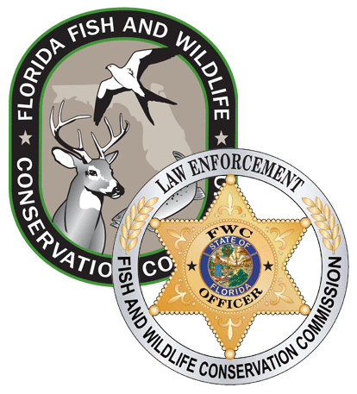

First Listed Owner on Title
First Name: Click or tap here to enter text. Middle Initial: Click Last Name: Click or tap here to enter text.
Street Address: Click or tap here to enter text. City: Click or tap here to enter text.
County: Click or tap here to enter text. E-mail Address: Click or tap here to enter text.
Home Phone Number: (XXX) XXX-XXXX Cell Phone Number: (XXX) XXX-XXXX

Second Listed Owner on Title
Last Name: Click or tap here to enter text. First Name: Click or tap here to enter text.
Street Address: Click or tap here to enter text. City: Click or tap here to enter text.
County: Click or tap here to enter text. E-mail Address¹: Click or tap here to enter text.
Home Phone Number: (XXX) XXX-XXXX Cell Phone Number: (XXX) XXX-XXXX

*If more than two owners are listed on the title, attach additional pages sufficient to provide all of the above requested information for each listed owner.

Vessel Make: Click or tap here to enter text. Vessel Registration / DOC Number: Click here to enter text.
Vessel Registration State: Click or tap here to enter text. Registration Expiration Date: Click or tap here to enter text.
Vessel Hull Identification Number (HIN): Click or tap here to enter text.
Vessel Length in feet: lick or tap here to enter text. Vessel Name If Any: Click or tap here to enter text.
Where is the vessel located (body of water)?: Click or tap here to enter text.
Vessel’s Location if by address or description of physical location: Click or tap here to enter text.
Vessel’s Location if by Latitude / Longitude: N:Click or tap here to enter text. W:Click or tap here to enter text.
Are you a titled owner(s) of the vessel? Yes ☐ No ☐
Do you have a valid copy of the vessel’s title? Yes ☐ No☐
Is the vessel floating? Yes ☐ No ☐
Is the vessel upon the waters of this State? Yes ☐ No ☐
Are there any lienholders on the vessel? Yes ☐ No ☐
How many years have you owned the vessel: Click or tap here to enter text.
Have you received a citation for a violation of section 327.4107, F.S. for this vessel? Yes ☐ No ☐
How many citations for a violation of section 327.4107, F.S. have you received for this vessel only? Click or tap here to enter text.
Have you received a written warning for a violation of section 327.4107, F.S. for this vessel? Yes ☐ No ☐
How many written warnings for a violation of section 327.4107, F.S. have you received for this vessel only? Click or tap here to enter text.

Applicant’s Name Printed: ____________________________________________________

Applicant’s Signature: ___________________________________ Date Signed: _________________

Additional Titled Owner’s Name Printed: __________________________________________________

Additional Titled Owner’s Signature: _________________________________ Date Signed: _________________

Additional Titled Owner’s Name Printed: __________________________________________________

Additional Titled Owner’s Signature: _________________________________ Date Signed: _________________
Scan and send this completed Application and all required documents listed in the FWC Vessel Turn-In Program (VTIP) Guidelines to VTIP@MyFWC.com or mail the package to:
Florida Fish and Wildlife Conservation Commission
Division of Law Enforcement
Boating and Waterways Section
Room-235 Attn: VTIP Program
620 S. Meridian Street
Tallahassee, Florida 32399-1600

An applicant is not required by law to provide an email address. Providing an email address will help to expedite communications between the program and the applicant. Under Florida law, e-mail addresses are public records. If you do not want your e-mail address released in response to a public records request, do not send electronic mail to this entity. Instead, contact this office by phone or in writing.

