Notice of Pre-Eligibility for VTIP Program
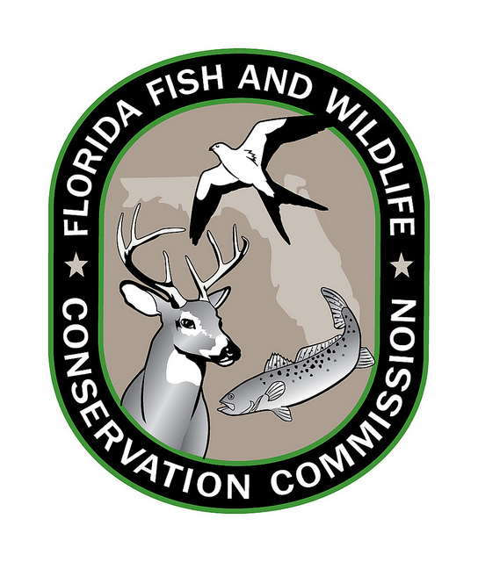
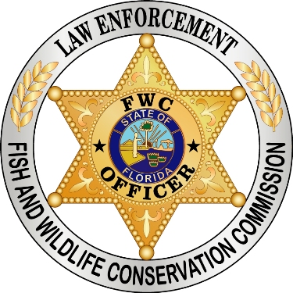
And Instructions for Delivery of Junked Title

Congratulations on the following vessel being determined to be pre-eligible for disposal by the Vessel Turn-In Program (VTIP):
___________________________________________________________________________________________________________________________________________________________________________________. One more important step is needed to make the vessel eligible for removal from the waters of this State and disposal by the Program. Please carefully follow the steps below.
- Using pen or marker, write the word “JUNKED” across the face of your vessel title in large, legible print, as in the example below.
- Sign and date the title document above the word “JUNKED,” as is done in the example below.
- Return the JUNKED title to the VTIP Program in the postage paid envelope enclosed.
- The return of the JUNKED title should be postmarked within 10 days of the receipt of this notification.
- Once the JUNKED title is received by VTIP staff, as long as the condition of the vessel has not changed such that it no longer meets the criteria contained in the FWC Vessel Turn-In Program Guidelines, the vessel will be fully eligible for and authorized for removal from the waters of this State, destruction, and disposal. Such removal, destruction, and disposal may proceed immediately. VTIP staff will contact you to acknowledge receipt of the JUNKED title.
- Should you have any questions, please contact VTIP staff at VTIP@myfwc.com and include your vessel’s registration number for reference.

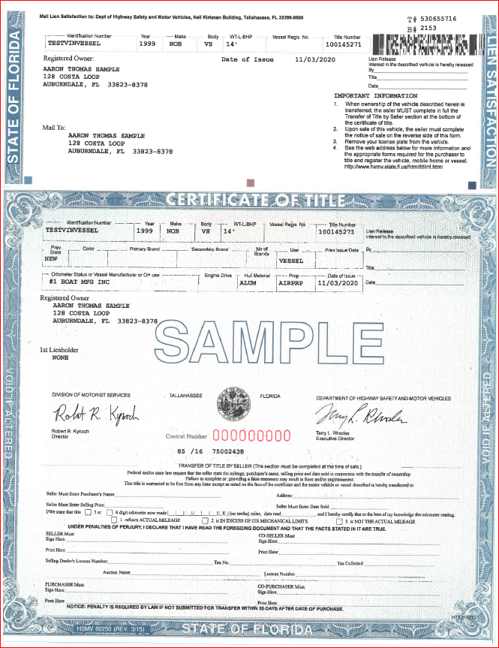
JUNKED
Aaron Thomas Sample 6/23/2022
The vessel and applicant must continue to meet all eligibility conditions listed in the FWC Vessel Turn-In Program (VTIP) Guidelines until the vessel is removed from the waters of this State by the VTIP in order to maintain eligibility.

