BASIS OF REVIEW FOR WATER USE
PERMIT APPLICATIONS WITHIN
THE SOUTH FLORIDA WATER MANAGEMENT DISTRICT
SEPTEMBER 26, 2012

1.0 Permitting Procedures
2.0 Water Need and Demand Methodologies
3.0 Water Resource Evaluations
4.0 Monitoring Requirements
5.0 Permit Conditions

1.0 PERMITTING PROCEDURES

1.1 Objectives

Chapter 373, Florida Statutes (F.S.), enables and directs the District to regulate the use of water within its jurisdictional boundaries. The purpose of the water use regulatory program is to ensure that those water uses permitted by the District are reasonable-beneficial, will not interfere with any presently existing legal uses of water, and are consistent with the public interest pursuant to Section 373.223, F.S. The District has adopted rules for regulating the consumptive use of water, which are set forth in Chapters 40E-2 and 40E-20, Florida Administrative Code. The Basis of Review is incorporated by reference into Chapter 40E-2. The Basis of Review must be read in conjunction with Chapters 40E-2 and 40E-20, as applicable. The objective of the Basis of Review is to further specify the general procedures and information used by District staff for review of water use permit applications. All criteria in the Basis of Review applies to processing individual permit applications, and specified criteria applies to processing of general permit notices of intent. The criteria contained herein are flexible, with the primary goal being to meet District water resource objectives.

In addition, procedures for processing water use permit applications are set forth in Rules 40E-1.603 and 40E-1.606. Rule 40E-1.610 provides procedures for permit renewals and Rule 40E-1.6107 sets forth procedures for permit transfers.

1.2 Pre-application Consideration

If the application is for a project which involves complex issues or if an applicant requires assistance in completing an application, a pre-application meeting between the Applicant and District Staff may be useful. A pre-application discussion may aid in expediting the application evaluation process by identifying items and issues that need to be addressed in more detail. This process allows the Applicant to submit a more complete application and may prevent or avoid delays in processing the application.

1.3 Other Factors Influencing Permit Applications

1.3.1 Third Party Interests

Frequently, other governmental entities, organizations, or affected citizens have an interest in the outcome of a permit action. Third party interests that would be substantially affected by issuance of a requested permit will have the opportunity to request an administrative hearing, pursuant to Rule 40E-1.521, prior to issuance of the permit. In order to obviate any delays in permit issuance, discussions with such entities regarding their water resource concerns prior to or during permit application review is encouraged. Issuance of a water use permit by the District does not relieve the Applicant of the responsibility to obtain all necessary federal, state, local, or other District permits or authorizations.

1.3.2 Competing Applications

Pursuant to Section 373.233, F.S., applications are considered to be competing when Staff evaluation indicates that the proposed use of water by two or more applicants will exceed the amount of water that is available for consumptive use due to water resource availability or interference with existing legal use concerns as defined in the Basis of Review. All permit applications that are pending at the same time prior to being deemed complete and are requesting water from a limited source will be considered competing. Once a competing application has been determined to be complete, such application will not be considered competing with applications filed after its completion date. Good faith effort must be shown by all applicants to complete pending, competing applications as expeditiously as possible. If good faith efforts are not made to complete the application, the application may be denied for lack of response pursuant to Rule 40E-1.603. Competing permit applications will be processed pursuant to Section 373.233, F.S.

1.3.2.1 Competition within the Central Florida Coordination Area

In adopting the interim CFCA rules, the District acknowledges the increasing stress on the water resources in the CFCA and the mandate of the Legislature to foster the development of additional water supplies and avoid the adverse effects of competition. However, the interim CFCA rules do not abrogate the rights of the Governing Board or of any other person under Section 373.233, F.S. The CFCA regulatory framework provides a comprehensive strategy for interim allocations of available groundwater and expeditious development of supplemental water supply projects, as defined in Section 1.8, to minimize competition and thereby provide greater certainty of outcome than competition.

1.3.3 Phased Projects

Many large-scale or long-term projects are developed over a number of years through a number of phases of development. The District encourages planning for long-term water needs in order to compare the projected demands of the project with water availability in a region. Applicants for projects that are to be developed in phases should consider their water needs for all phases of the proposed project. However, the District evaluates permit applications based on the demonstrated need of water for the project only through the recommended duration of the permit; therefore, applicants should focus their water use projections for the term of the permit and only for those phases of the project reasonably expected to utilize water under the permit during or prior to the permit expiration date. As additional phases are projected to be constructed, the existing water use permit can be modified to reflect the increasing demand associated with the new phase or phases pursuant to the criteria applicable at the time of the modification. The Permittee cannot rely on receiving permit authorization for unpermitted phases of a project due to issuance of a water use permit for a portion of the phased project.

1.4 Surface Water Management Concurrency

If the proposed water use is associated with a project for which a modification to an existing surface water management system is required or for which a new surface water management system is required, the water use permit application will not be considered complete until the surface water management (construction) or environmental resource (construction) permit application is deemed complete. If a new or modified surface water management (construction) or environmental resource (construction) permit is required in conjunction with the proposed water use, the water use permit may only be issued concurrently with the applicable surface water management (construction) or environmental resource (construction) permit or permit modification. A water use permit will not be issued in conjunction with a surface water management or environmental resource conceptual permit without a required construction permit.

The impact of withdrawals on the Applicant's surface water management system must be evaluated and submitted with the water use permit application. The cumulative withdrawals as a result of the water use request must be evaluated in conjunction with the cumulative drainage effects of the surface water management system.

1.5 Application Support Information

Pursuant to Rule 40E-1.603, F.A.C., additional information may be required to be submitted in support of water use applications for projects located in areas where there is a lack of available hydrologic information or for projects in which there are concerns regarding water resource availability or potential impacts as a result of proposed withdrawals. The District shall require detailed site-specific information in support of the application in order to satisfy the conditions for permit issuance. The supporting information may include aquifer performance tests, water quality surveys, well inventories, and environmental assessments, as required. The need for supporting information will be based, in part, on the amount of the proposed withdrawal, characteristics of the requested water source in the region, potential for environmental harm, potential for interference with existing legal uses, and proximity of applicable and relevant existing data.

1.6 Professional Certification of Supporting Documents

All final plans, calculations, analyses, or other geologic/engineering documents, submitted as part of a permit application are required to be signed and sealed by an appropriate registered professional pursuant to Section 373.117, or Chapter 492, F.S., as appropriate.

1.7 Application Review Process

The District has established two procedures for issuing permits based on the quantity of water permitted. These two procedures include permit issuance by (1) the Governing Board for individual permits and (2) District staff for general permits (minor standard general permits for uses of 3 million gallons per month or less, major standard general permits for uses greater than 3 million gallons per month up to 15 million gallons per month, and dewatering general permits). Individual permits must be obtained for water use activities that are not exempt pursuant to Rule 40E-2.051, F.A.C., and do not fall within the thresholds for general permits established in Rule 40E-20.302, F.A.C.

The permit application will be processed pursuant to Rule 40E-1.603, F.A.C., for individual and general permits. These rules set forth procedures for filing applications, requests for additional information, permit application modification, public noticing of permit applications, and requests for administrative hearings.

A water user should obtain one permit for all withdrawals that are intended to serve contiguous property. For example, an agricultural operation that has multiple wells on a contiguous parcel of land shall apply for one permit.

Applicants with legal control over multiple non-contiguous parcels within a county may apply for one permit encompassing all such parcels, provided that it is shown that the water use for each parcel is in the same water use classification. If multiple water use classifications, such as drinking water and landscape irrigation, are served by separate withdrawal facilities, separate water use permits shall be required for each use.

1.7.1 Proposed Water Uses

Proposed water uses for an individual permit must meet the conditions for issuance of permits pursuant to Rule 40E-2.301, and proposed water uses under a general permit must meet the conditions for issuance of authorization pursuant to Rule 40E-20.302. Applications for initial permits or permit renewals shall be processed as proposed water uses. Applications for existing unpermitted uses of water shall be processed as proposed water uses. An existing unpermitted use includes a use previously authorized by a permit that has expired due to failure to file an application for renewal prior to the permit expiration date. An application for a permit modification for an increased allocation will be processed as a proposed water use. Withdrawal facilities that have been constructed or that otherwise exist will not be taken into consideration in favor of issuance of a water use permit.

1.7.2 Permit Duration

1.7.2.1 General Duration Provision

Pursuant to Section 373.236, F.S., when requested by an applicant, a consumptive use permit shall have a duration of 20 years provided the applicant demonstrates reasonable assurance that the proposed use meets the conditions for issuance for the requested duration; otherwise, permits may be issued for a shorter duration that reflects the time period for which such reasonable assurances can be provided. This determination shall be made pursuant to requirements in Chapters 40E-2 and 40E-20, F.A.C., as applicable, and this Section.

1.7.2.2 Special Duration Factors

A. Unless revoked or otherwise modified, the duration of a water use permit issued pursuant to Chapter 40E-2 and Chapter 40E-20, F.A.C., is the lesser of:

1. The duration established in Subsections C., D. or E., below.

2. The time period for which the permit applicant demonstrates that water will be needed to meet the projected demands and during which the conditions for issuance of a permit in Rule 40E-2.301, F.A.C., will be met;

3. The time period for which the permit applicant demonstrates legal control pursuant to Section 2.1;

4. For irrigation uses permit applications filed before the applicable Basin Application Date in Section 1.7.3, the permit duration will be limited to the Basin Expiration Date;

5. For aquifer remediations, the period shall not exceed that required to complete the operation as specified in the Remedial Action Plan approved by the state or local agency having legal jurisdiction over such activities or 20 years, whichever is less;

6. For independent secondary use permits within a diversion and impoundment system, the duration will not exceed the expiration date of the associated diversion and impoundment permit;

7. Where the permittee must implement an action to correct noncompliance with the previous consumptive use permit, the permit duration shall be based on the time period necessary to ensure the success of the mitigative or remedial action; or

8. For minor standard general water use permits, the permit duration shall not exceed 20 years.

B. Sources of Limited Availability. For purposes of the Section, the following are Sources of Limited Availability:

1. Upper East Coast Regional Water Supply Planning Area: Surficial Aquifer System.

2. Lower East Coast Regional Water Supply Planning Area: Biscayne/Surficial Aquifer System to the extent that withdrawals result in induced seepage from the Central and Southern Florida Project, except when stormwater discharge or wet season discharge occurs; Lake Okeeechobee; Central and Southern Florida Project; the Caloosahatchee River/Canal; and the Saint Lucie River/Canal.

3. Lower West Coast Regional Water Supply Planning Area: Water Table Aquifer, Lower Tamiami Aquifer, Sandstone Aquifer, mid-Hawthorn Aquifer.

4. Kissimmee Regional Water Supply Planning Area Within the Central Florida Coordination Area; Groundwater.

C. The following uses shall receive a 20 year permit, if:

1. For uses from sources other than those listed in subparagraphs B. 1 through 4 above, the allocation necessary to meet the 20 year demands is consistent with Chapters 40E-2 and 40E-20, F.A.C., as applicable, provided that the demands are realized according to the schedule set forth in the permit, for the duration of the permit; or

2. The applicant is requesting a permit for "back-up" supplies addressing emergency or short-term interruption in service for reclaimed water end users per Section 3.2.3.3.; or,

3. The applicant is requesting renewal of a permit from a source of limited availability identified in subsection B., above, and the following conditions are satisfied:

a. For all use classes, the allocation satisfies the requirements of Chapter 40E-2 or Chapter 40E-20, F.A.C., as applicable, for the duration of the permit; and

b. For public water supply use class, the quantity of water to be allocated for a 20 year duration permit shall not exceed that quantity necessary to meet the demands of the population existing at the time of permit renewal at the per capita rate approved under the Basis of Review;

c. For the irrigation use class, the quantity of water to be allocated for a 20 year duration permit shall not exceed that quantity of water necessary to irrigate historically irrigated acreage, including documented intermittent irrigated acreage, as determined by section 2.3.2.; or,

d. For other use classes, the quantity of water to be allocated for a 20 year duration permit shall not exceed that quantity approved under Chapter 40E-2 or Chapter 40E-20, F.A.C., as applicable, and shall not exceed the allocation in the permit being renewed.

4. The applicant proposes groundwater withdrawals within the Central Florida Coordination Area to satisfy demands from that source up to its demonstrated 2013 demand and proposes to develop at least one specific supplemental water supply project to meet demands greater than the 2013 demand as set forth in subsection 3.2.1.F.3, or otherwise complies with subsection 3.2.1.F.3, and otherwise satisfies the requirements of Chapter 40E-2 or 40E-20, F.A.C., as applicable, for the duration of the permit.

D. Requests for Allocations in Excess of Subsection 1.7.2.2.C.3., Permit Modifications, or Initial Permits, from Sources of Limited Availability other than applicants governed by subsection 1.7.2.2.C.4:

The baseline duration under this Section shall be five years or as otherwise provided below. The following factors shall be considered and balanced in determining the duration of a permit:

1. Whether the permit will require the permittee to perform mitigative or remedial action for an impact caused or projected to be caused by the water use. Consideration of this factor will lead to a permit duration appropriate for ensuring the success of the mitigative or remedial action;
2. Whether the permittee is proposing to implement innovative and extraordinary water conserving measures that are beyond those generally feasible for the subject use such that the proposed demands are significantly reduced from the source of limited availability as a result of the innovative and extraordinary water conserving measures, including best management practices associated with peak or high efficiency systems. Where the permittee proposes to implement innovative and extraordinary water conservation measures, consideration of this factor will lead to a longer duration than the applicable duration as an incentive for the investment in innovative and extraordinary water conservation;
3. Whether increased impacts of the requested allocation on the source of limited availability will be offset through the implementation of an alternative source. Consideration of this factor will lead to a longer duration;
4. Whether the requested allocation is supplied by a brackish water source, consistent with the use of saline water in Section 3.4;

5. Whether the modification of the permit results in no more than a de minimis increase in impact to water resources and existing legal uses, as compared to the existing permit. Consideration of this factor will lead to a duration consistent with the permit being modified; or
6. A public supply utility applicant or similar applicant proposing groundwater withdrawals within the Central Florida Coordination Area and does not propose to satisfy demands greater than demonstrated 2013 demands with at least one specific supplemental water supply project as set forth in subsection 3.2.1.F.3, or does not otherwise comply with subsection 3.2.1.F.3. Consideration of this factor will lead to a maximum permit duration of up to 2013.

E. Pursuant to Section 373.236, F.S., the permit duration may be up to 50 years in the case of a municipality or other governmental body, or of a public works or public service corporation, where such a period is required to provide for the retirement of bonds for the construction of waterworks and waste disposal facilities, if the applicant provides reasonable assurances of compliance with Chapters 40E-2 and 40E-20, F.A.C., as applicable.
If only a portion of the requested allocation satisfies the conditions for a 20 year duration permit, the remaining allocation may be approved for a shorter duration, as appropriate.

1.7.2.3 Compliance Reports
A. Where necessary to maintain reasonable assurance that the conditions for issuance of a permit can continue to be met over the duration of a 20 year permit, the District shall require the permittee to submit a compliance report pursuant to subsection 373.236(3), F.S., no more than once every five years. The permit shall be conditioned to assure compliance with the initial conditions for issuance, including implementation of schedules for Water Need and Demand Methodologies under Section 2.0, maintaining updated water conservation and efficiency requirements, and updated allocation methodologies, pursuant to District rules.

The compliance report shall contain sufficient information to maintain reasonable assurance that the permittee's use of water will continue to meet Chapters 40E-2 and 40E-20, F.A.C., as applicable, for the remaining duration of the permit. The compliance report shall, at a minimum, include all of the information specifically required by the permit limiting conditions.

B. Following the District's review of this report, the District shall require the permittee to take such actions as necessary to ensure that the use of water will continue to meet the conditions for permit issuance.

C. Notwithstanding the above, the District is not prohibited from requiring reports at any time when necessary to ensure compliance with the terms of the permit or provisions in Chapters 40E-2 or 40E-20, F.A.C.

1.7.3 Basin Expiration Dates
1.7.3.1 Definitions
A. Irrigation Permit Expiration Basin -Geographic area where Individual and major Standard General Water Use Permits for the irrigation use class have a specified Irrigation Basin Expiration Date.

B. Basin Application Date -The date, specified below in Section 1.7.3.3, after which complete applications for Individual and major Standard General Water Use Permits for the irrigation use class shall be reviewed under newly adopted rules.

C. Basin Expiration Date -The date of expiration, specified below in Section 1.7.3.3, of Individual and major Standard General Water Use Permits for the irrigation use class located in the specified Irrigation Permit Expiration Basin.

1.7.3.2 Policy and Purpose
This Section addresses application and expiration procedures associated with Individual and major Standard General Water Use Permits for the irrigation use class during the transition from the use of Basin Expiration Dates to use of permit durations based on the date of permit application. These criteria establish Irrigation Permit Expiration Basins, Basin Expiration Dates, Basin Application Dates, and application procedures for Individual and major Standard General Water Use Permits for the irrigation use class.

The Irrigation Permit Expiration Basins are defined considering a number of factors including commonality of supply source, resource concerns, and work-load management. By establishing the Irrigation Permit Expiration Basins, the District specifically does not intend to establish any priority or preference between individual users or basins. The District recognizes individual user concerns regarding availability of shared resources across basin lines may warrant flexibility in the timing of permit application and review. Thus, procedures to address such concerns are detailed below.

1.7.3.3 Basin Expiration and Application Dates
A. An Individual and major Standard General Water Use Permit for the Irrigation Use Class shall expire on the Basin Expiration Date for the Irrigation Permit Expiration Basin in which the permitted project is located.

B. Individual and major Standard General Water Use Permits for the Irrigation Use Class issued pursuant to applications that are completed before the Basin Application Date shall have a permit expiration date commensurate with the Basin Expiration Date.

C. The District shall provide notice to Individual and major Standard General Water Use Permit holders for the Irrigation Use Class of the expiration date of their permits 30 days prior to the Basin Application Date applicable to their project. Notice shall be made by mail or by publication in a newspaper of general circulation in the affected area.

D. The following table identifies the Irrigation Permit Expiration Basins and states the applicable Basin Application Dates and Basin Expiration Dates.

Irrigation Permit Expiration Basin | Basin Application Date | Basin Expiration Date
Upper East Coast Basin A | October 30, 2003 | February 28, 2004
Upper East Coast Basin B | February 28, 2004 | June 30, 2004
Upper East Coast Basin C | June 30, 2004 | October 30, 2004
Lower West Coast Basin A | October 30, 2004 | February 28, 2005
Lower West Coast Basin B (excluding projects located within the Lake Okeechobee Basin) | February 28, 2005 | June 30, 2005
Lower West Coast Basin C | June 30, 2005 | October 30, 2005
Lower West Coast Basin D | October 30, 2005 | February 28, 2006
Lower West Coast Basin E (excluding projects located within the Lake Okeechobee Basin) | February 28, 2006 | June 30, 2006
Broward County Basin | June 30, 2006 | October 30, 2006
Dade / Monroe Basin | October 30, 2006 | February 28, 2007
Palm Beach County Basin | February 28, 2007 | June 30, 2007
Kissimmee Basin A | October 30, 2007 | February 28, 2008
Kissimmee Basin B | February 28, 2008 | June 30, 2008
Kissimmee Basin C | June 30, 2008 | October 30, 2008
Lake Okeechobee Basin | October 30, 2008 | February 28, 2009

1.7.3.4 Lake Okeechobee Basin
Permittees located within the Lake Okeechobee Basin using water, in whole or in part, from sources other than Lake Okeechobee, the Caloosahatchee River, the St. Lucie River/Canal, or integrated conveyance systems that are hydraulically connected to either Lake Okeechobee, the Caloosahatchee River or the St. Lucie River/Canal, may elect to have their permit applications reviewed concurrently with other water use applications located within the same Irrigation Permit Expiration Basin.
1.7.3.5 Irrigation Permit Expiration Basin Descriptions
(1) Lower West Coast Basin A is described in Figure 2.
(2) Lower West Coast Basin B is described in Figure 3.
(3) Lower West Coast Basin C is described in Figure 4.
(4) Lower West Coast Basin D is described in Figure 5.
(5) Lower West Coast Basin E is described in Figure 6.
(7) Upper East Coast Basins A, B, and C are described in Figure 7.
(8) Palm Beach County Basin is described in Figure 8.
(9) Broward County Basin is described in Figure 9.
(10) Kissimmee Basins A, B, and C are described in Figure 10.
(11) Dade/Monroe Basin is described in Figure 11.
(12) Lake Okeechobee Basin is described in Figure 12.

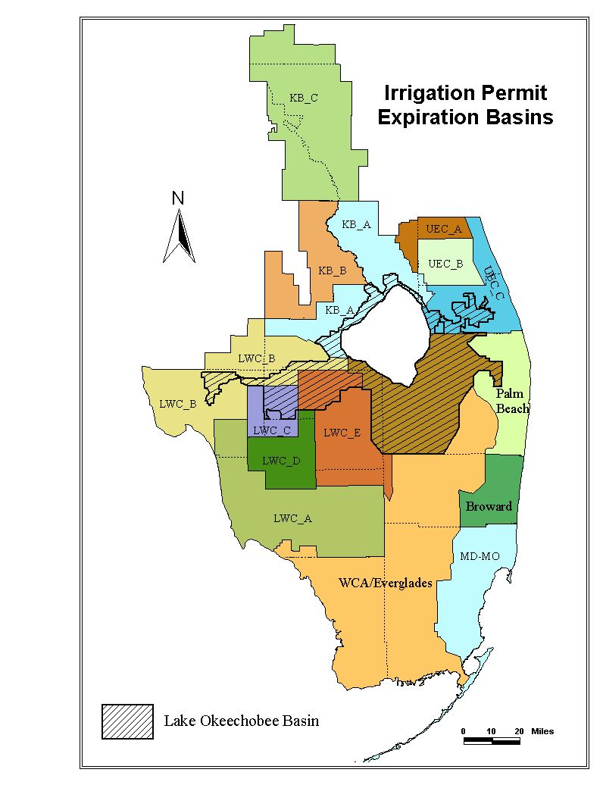

Figure 1

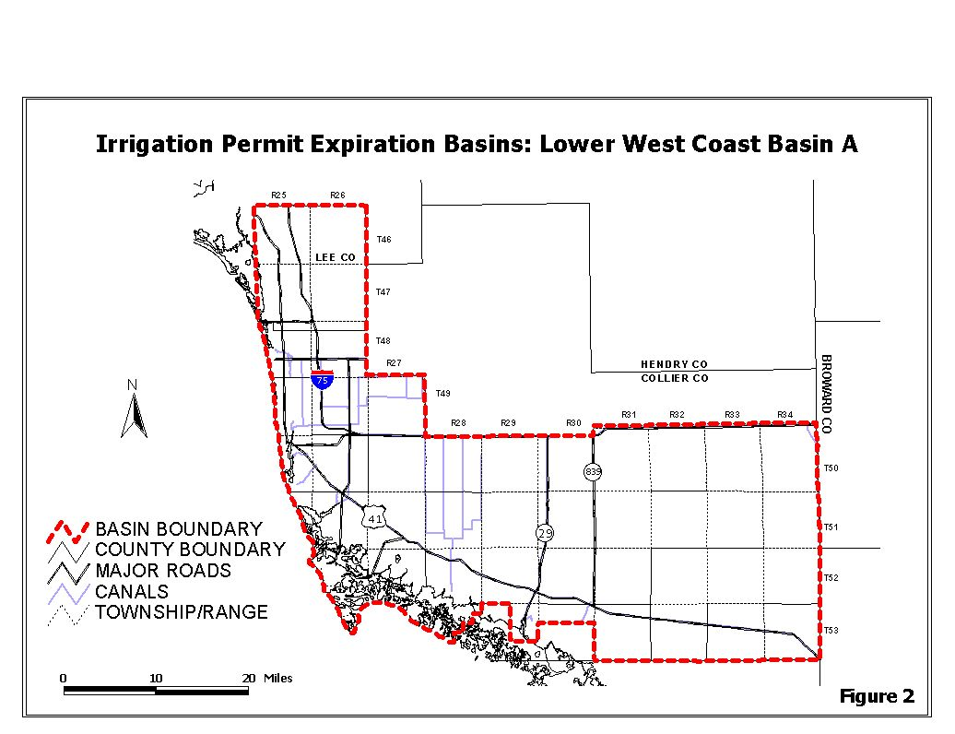
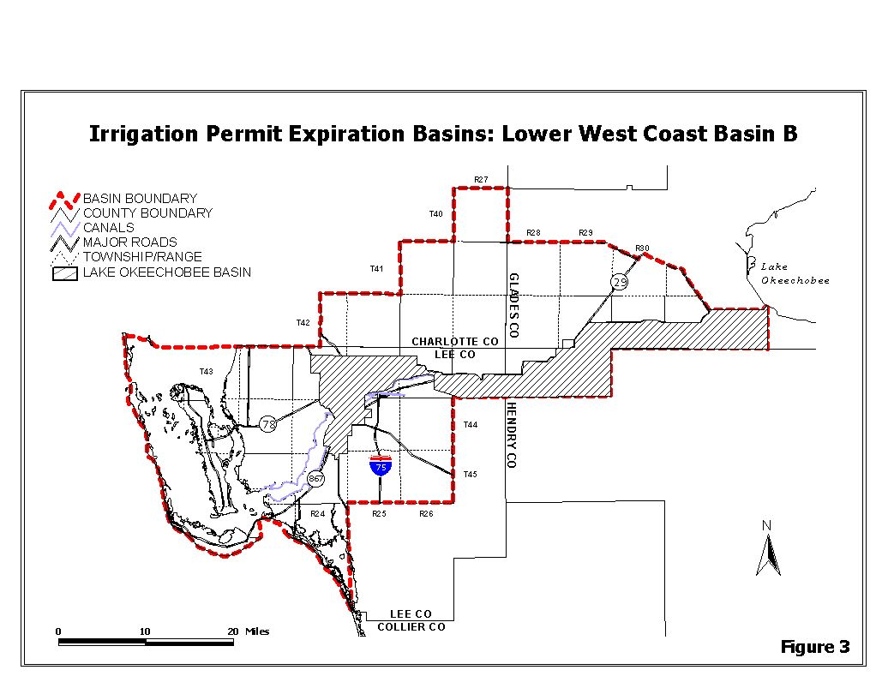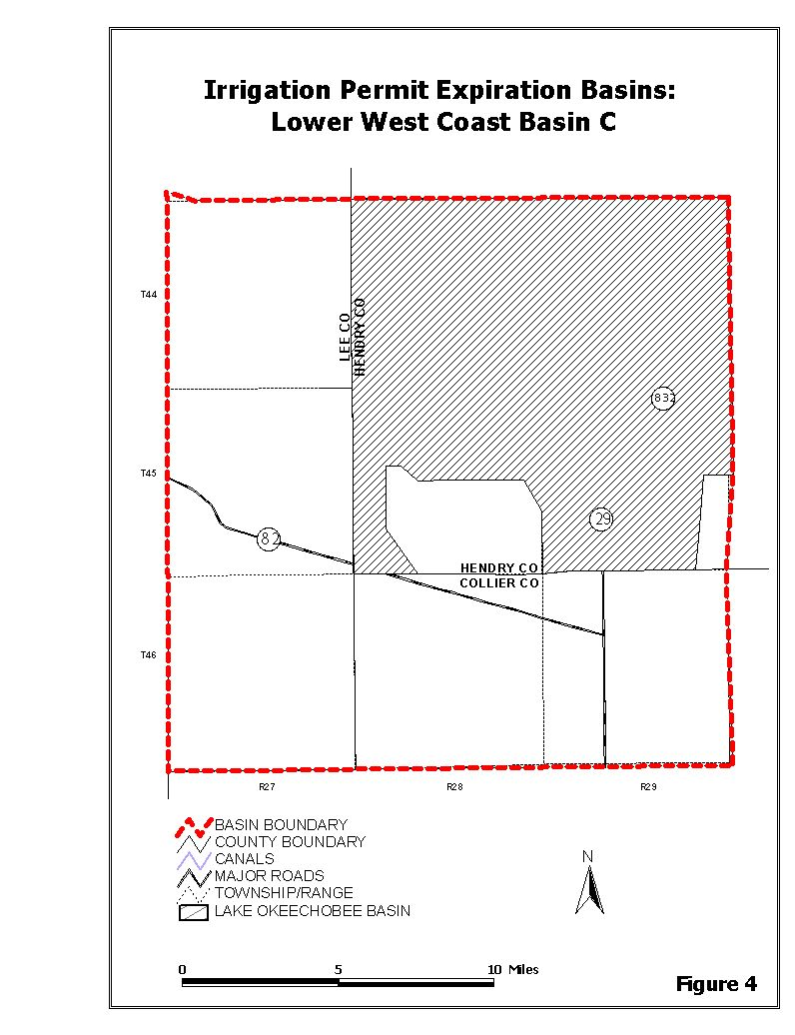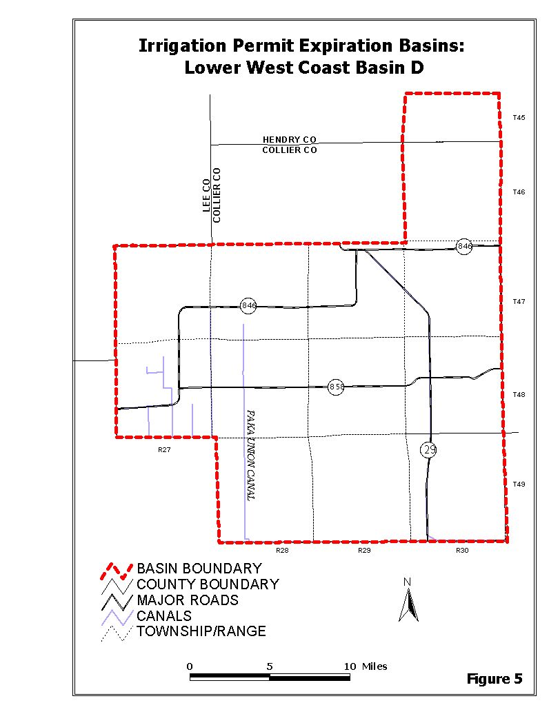
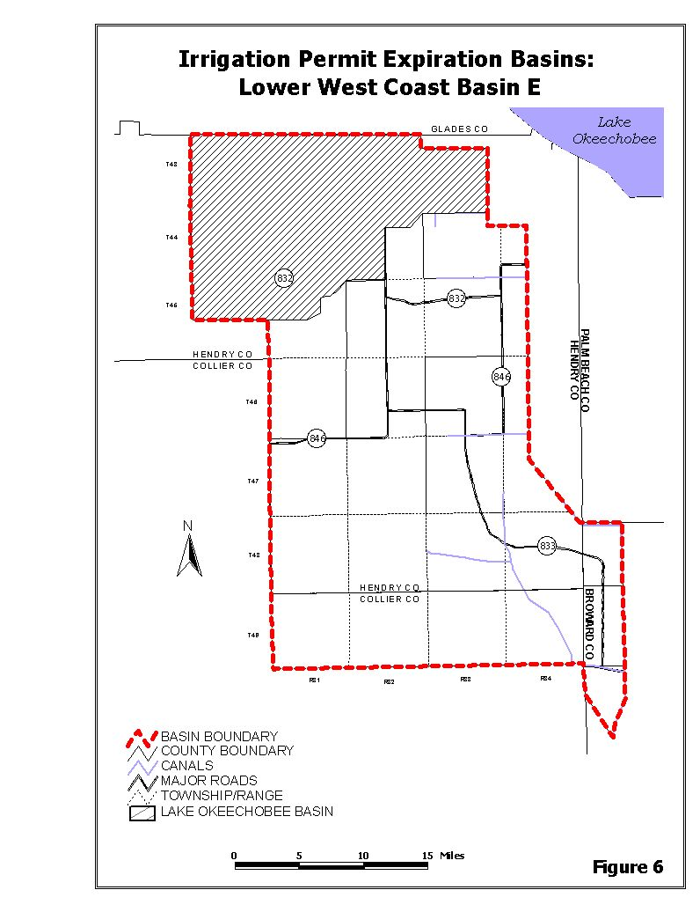

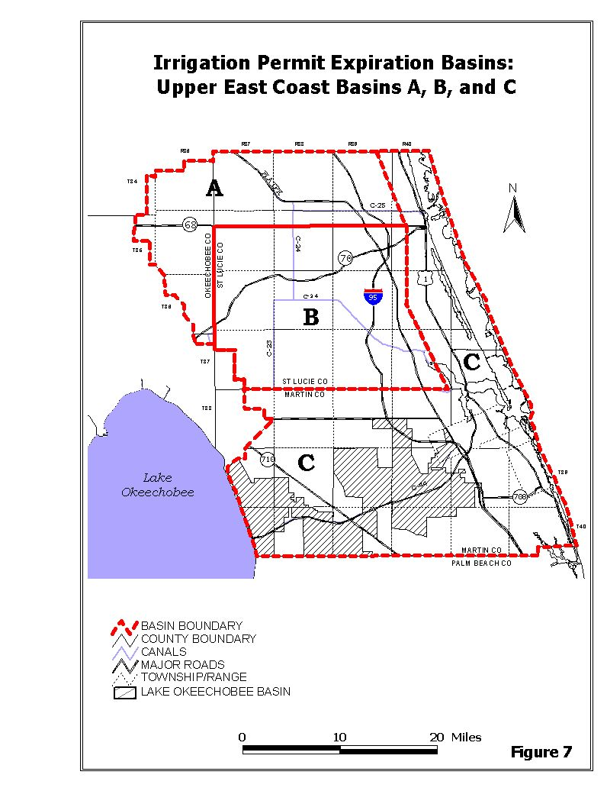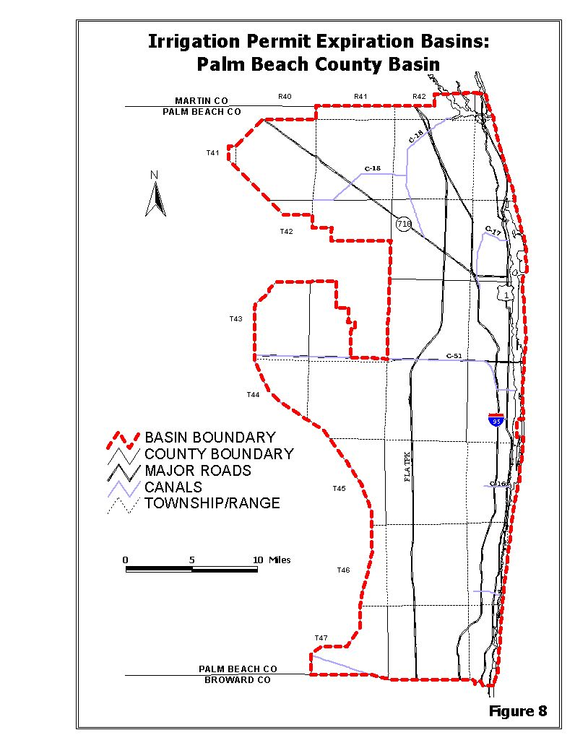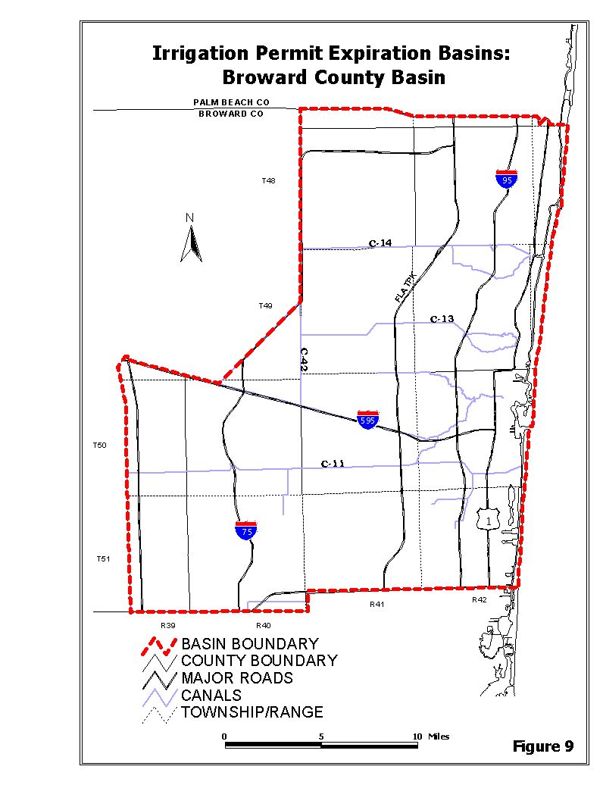
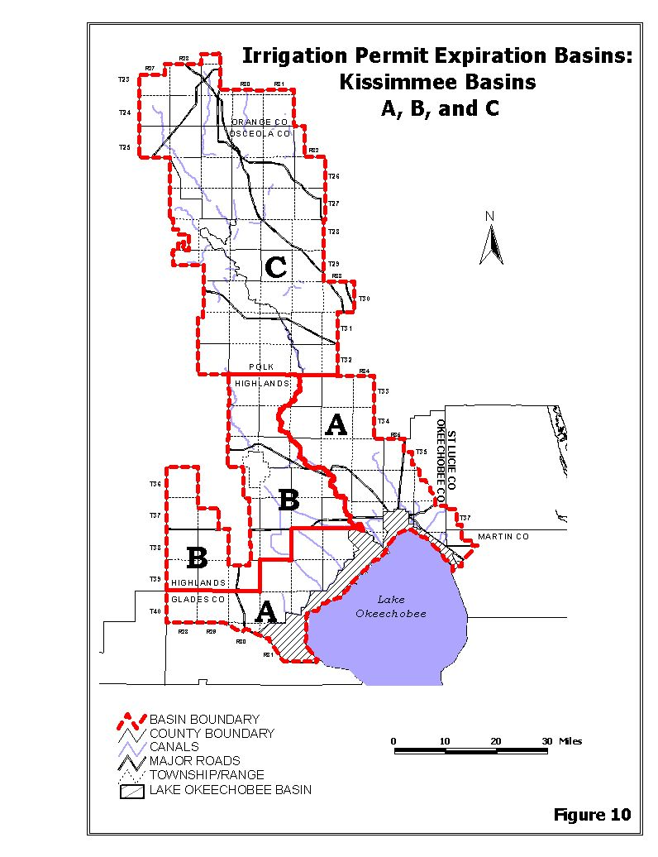
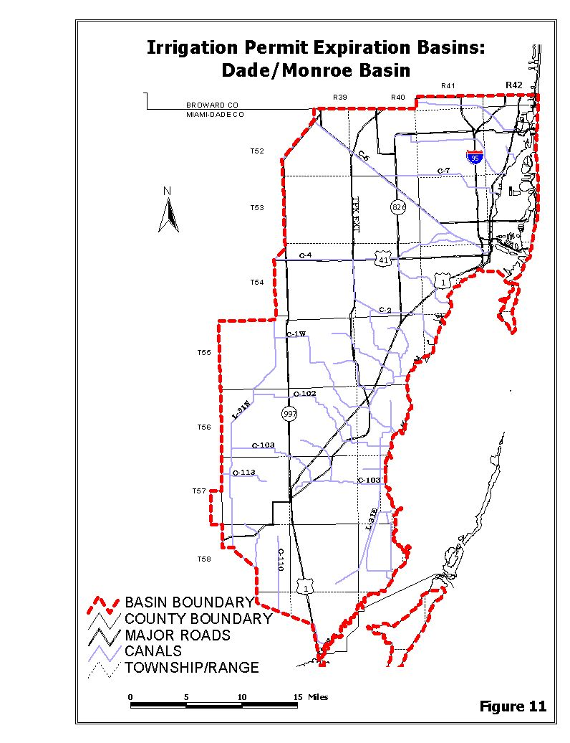

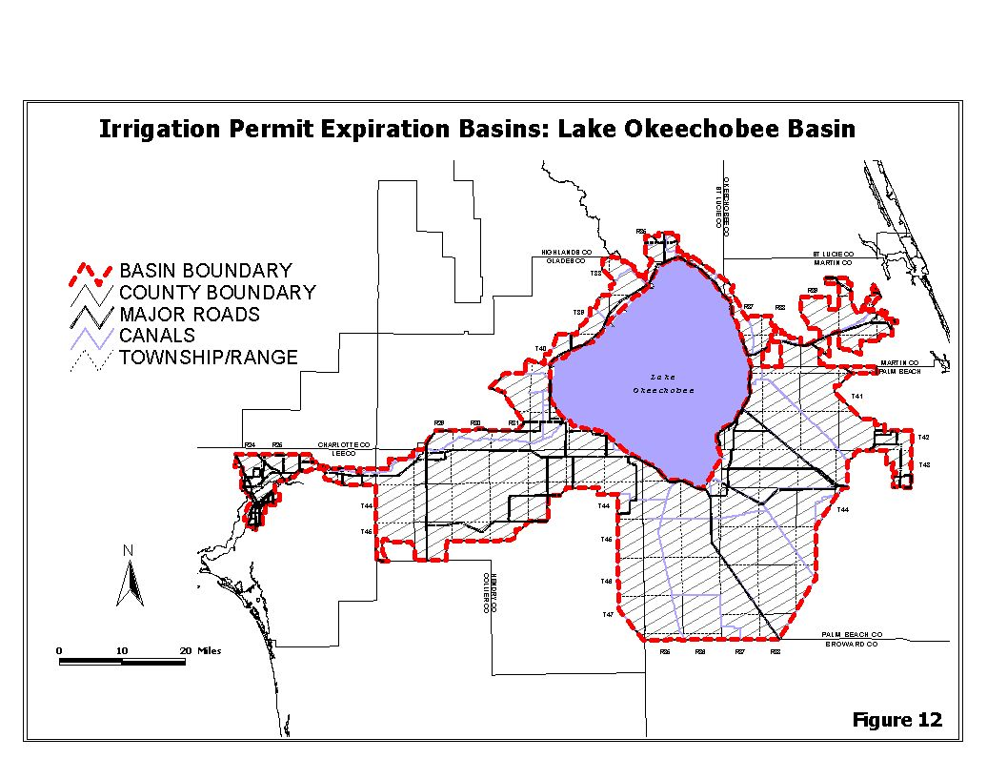1.7.3.6 Basin Boundary Overlap
For projects that cross Irrigation Permit Expiration Basin boundaries, the District shall assign a Basin Expiration Date and Basin Application Date that best addresses resource issues. A permit shall be assigned the Basin Expiration Date and Basin Application Date of the Irrigation Permit Expiration Basin in which:
i. adverse resource impacts are likely to occur;
ii. resource competition is a concern;
iii. the majority of the withdrawal facilities are located, or;
iv. the majority of the project's irrigated acreage is located if the withdrawal facilities are split equally between the basins.
1.7.3.7 User Rights
A. The District does not intend, by adoption of these rules, to create a priority or preference between water users within different basins, however, it is possible that projects located in an adjacent basin having an earlier Basin Expiration Date and Basin Application Date may affect user rights by providing the ability to apply, and get a permit, before another affected user outside the designated basin is otherwise authorized to apply for a permit. Thus, if due to basin boundary lines water user rights are affected, a water user may elect to have its permit application reviewed concurrently with other water use applications within an adjacent basin. The manner in which user rights may be affected include contribution to cumulative drawdown impacts which may trigger water resource protection rules such that there may be insufficient water available for allocation to all permit applicants.

B. Water users shall have the burden of identifying those projects which may affect their water use rights.
1.7.4 Permit Renewals

Applications for permit renewal shall be made pursuant to Rule 40E-1.610, F.A.C., any time within six months prior to permit expiration. Permittees are encouraged to apply for renewal at least 90 days prior to the expiration date, except as provided in Section 1.7.3. Permits for which renewal applications have been submitted shall remain in effect past the expiration date until final agency action on the application is taken.

1.7.5 Impact Evaluations

The following is intended to ensure that each permit application is based on consistent, reliable technical evaluations conducted using accepted industry or professional standards. When determining whether the permit applicant has provided reasonable assurances the conditions for permit issuance are met, the District will consider the projected impact of the proposed withdrawal, along with impacts from any existing legal uses and other pending applications for a consumptive use permit under conditions, up to and including a 1 in 10 year drought event. These assurances can be provided through applicable historic monitoring data or modeling data, as defined below.

1.7.5.1 Monitor Data

Monitor data in support of a permit application shall be accurate and verifiable, and collected at the represented withdrawal rates requested in the permit application during: (1) at least a 1 in 10 year drought, as defined by the yearly total rainfall accumulation for regulatory rainfall stations (pursuant to SFWMD, Part B Water Use Management System Design and Evaluation Aids, Part V,. Supplemental Crop Requirement and Withdrawal Calculation, within Volume 3, Permit Information Manual for Water Use Permit Applications,); or (2) 90 days without effective recharge.

Pumpage data collected from a calibrated accounting method authorized in the previous permit is considered accurate and verifiable.

Water level and quality data collected pursuant to limiting conditions in a permit must provide a sufficient basis to determine if conditions of permit issuance will be met. Additional assurances will be required in cases where the monitor data does not represent the conditions of the resource as affected by the past withdrawals. An example would include wetland photographs without corresponding hydrologic data necessary to determine the withdrawal impacts on wetland hydroperiod, or water quality data from monitor wells that have collapsed or are constructed into zones that do not relate to potential for salinity movement.

The use of historic monitor data to prove conditions of permit issuance are met may be applied to permit renewals and to that portion of a modification that represents the historic use that was monitored. Additional assurances will be required in case where a modification renders the historic data non-representative. An example would include the use of new source of supply, a significant relocation of the points of withdrawal, or an increase in the allocation.

Other relevant information regarding the actual use of water or impact of the actual use of water will be considered. Such information could include identification of irrigated acreage that occurred over time, wellfield operations, and the use of a state approved functional assessment of wetland or other surface waters, to determine impacts of prior consumptive uses.

1.7.5.2 Modeling Data

Applicable modeling data may consist of basic analytic impact assessments or calibrated numeric system simulation models. The modeling impact assessments shall be conducted for the proposed withdrawal alone, as well as the proposed withdrawal combined with all other permitted uses and pending applications within the cone of depression of the proposed use. The cone of depression is defined by the 0.1 foot drawdown contour for the proposed withdrawal from the water table aquifer and the 1.0 foot contour for the proposed withdrawal from a confined aquifer.

A. Basic analytic impact assessments: Basic analytic impact assessments utilize an approved analytic equation(s), such as the Theis or Hantush-Jacob equation, applied to the requested maximum month allocation that simulates continued withdrawal for 90 days without recharge (which is considered for purpose of these simulations to be equivalent to a 1 in 10 year drought condition). Aquifer characteristics derived from approved aquifer performance tests (APT) or specific capacity tests (SFWMD, Part B Water Use Management System Design and Evaluation Aids, Part II Aquifer Performance Test) located within one mile of the project site are acceptable. If more than one set of aquifer characteristics data exists within one mile of the site, the value measured closest to the proposed project will be used unless the applicant can demonstrate that hydrogeologic conditions at the project site are not represented by such data. If the location of the nearest site where aquifer characteristics were measured is greater than one mile from the project site, the average of the nearest three APT or specific capacity test sites is acceptable providing that two of the three values are within one standard deviation of the mean. If this is not the case, the applicant shall demonstrate that the conditions of permit issuance are met for the highest and lowest values of the three sites, or the applicant may opt to conduct an APT or specific capacity test at the site.

The use of numeric models such as Modflow without calibration is acceptable under the following configurations: (1) the model represents the aquifer or aquifer system as no more than two layers; (2) each layer uses a single value for transmissivity/permeability, storage/storativity and a single value is used for leakance between the layers; (3) the simulation time is 90 days with no recharge; and (4) surface water recharge features are not represented. The modeling shall include separate runs using the highest and lowest measured values of transmissivity/permeability, storage/storativity, and leakance from the region, based on published data and pump test values calculated as described above. The selected high and low aquifer values will be approved provided they significantly overestimate the withdrawal impacts that would occur on the site. The use of a numeric model without calibration is acceptable for representing seepage irrigation systems where the applicant models the portion of the irrigation water that returns to the water table aquifer, provided the model is configured as described in this paragraph and the change in the water table elevation predicted by the model is field verified with water level data from at least one water table piezometer located adjacent to the irrigated field.

B. Calibrated numeric system simulation models: For complex systems that cannot be accurately evaluated pursuant to paragraph A, above, the applicant may provide assurances that the conditions for issuance will be met through a calibrated numeric simulation model, as described herein. District approved numeric system simulation models are used to simulate withdrawals from complex aquifer systems, such as multiple layered aquifers with varying degrees of hydraulic conductivity, integrated surface and groundwater systems, and withdrawals that involve density dependent flows or transport of contaminants.

Staff will approve simulations that utilize documented model codes that have undergone professional peer review and accurately represent the physical system. In order to demonstrate that a model is representative of the physical system, the applicant shall calibrate the model. An acceptable calibration method shall be identified between the applicant and District staff while taking into consideration the range of water levels across the model domain, location of available water level monitor data, and the degree to which the monitor data accurately reflects area ground water conditions versus sporadic influences of local pumpage. Whenever possible, the numeric models should be calibrated to within ± 1 foot for at least three monitor wells distributed randomly within the model domain for each month of the simulation period.

For the purpose of model calibration, when using monitor data that has daily measurements, the applicant shall average those daily values for each month. For monitor wells in which a single measurement was made for the month, in determining whether the calibration is acceptable, the pumpage and rainfall conditions immediately preceding or during the single sampling event shall be considered.

Model calibrations will be conducted using monthly time steps for a calibration timeframe of at least 18 months. The applicant may select the calibration period for the model based on availability of representative time variant data. When long term water level monitoring data is not available, the applicant shall calibrate the model to site specific pump test data. This calibration shall be based on a comparison of actual pump test water level changes with calculated water level changes derived from the model. The pump test shall be run for a sufficient time for the water levels to approach equilibrium for the production zone and the surficial aquifer.

The simulation model run shall be conducted using monthly time steps starting with a minimum of three months of average annual demand and rainfall, followed by twelve months of 1 in 10 year drought conditions, followed by a minimum of six months of average annual demand and rainfall. The applicant shall utilize SFWMD, Part B Water Use Management System Design and Evaluation Aids, Part V, Supplemental Crop Requirement and Withdrawal Calculation, within Volume 3, Permit Information Manual for Water Use Permit Applications, to determine the 1 in 10 year drought and average rainfall conditions for the purpose of evaluating drought recharge rates.

When District staff evaluates a calibrated model for approval, the range of parameters used in the model will be checked against published ranges of values for each parameter evaluated in order to determine the reasonableness of the values used in the model. Calibrations that are achieved using parameters outside of the range of acceptable values for south Florida will not be accepted. Steady state numeric models are not acceptable for the purposes of providing reasonable assurances.

The location of all actual measured time invariant parameters used to estimate each data array shall be identified and documented for each layer in the model. Data arrays without at least three (3) actual measured values will require a sensitivity analysis to be conducted that evaluates the range of potentially acceptable values for the parameter in question. If a model is submitted that does not meet the calibration criteria, the applicant may collect additional data and revise the model. If a model is not calibrated to an acceptable level it will not be acceptable for providing reasonable assurances.

1.8 Definitions

Allocation Coefficient - A multiplier used in calculating permit allocations which accounts for the irrigation system efficiency and the effects on the relevant water storage system (see Resource Efficiency).

Annual Withdrawal - The quantity of water permitted to be withdrawn during any 12 month time period.

Aquifer - A geologic formation, group of formations, or part of a formation that contains sufficient saturated, permeable material to yield significant quantities of water to wells and springs.

Aquifer Remediation - A use of water involving the withdrawal of ground water for the authorized removal of contaminants for the purposes of restoring water quality.

Aquifer Storage and Recovery - Projects involving approved Class V injection wells for the injection and recovery of fresh water into a ground water reservoir.

Area of Influence – For groundwater systems the area of influence is defined by the cone of depression, and for surface water systems the area of influence is defined as the extent to which the withdrawal results in a measurable change in surface water levels or flows.

Brackish Groundwater - For purposes of the additional permitting requirements within the Central Florida Coordination Area (CFCA), brackish groundwater means groundwater in or below the Lower Floridan Aquifer that: has chloride concentrations at or above 1000 milligrams per liter (mg/L); has total dissolved solids concentrations at or above 1500 mg/L; or is located east of the C-35, C-36, and C-37 canals; south of latitude 28 degrees 7 minutes north; north of latitude 27 degrees, 54 minutes north and west of the District’s boundary lying between these two latitude lines as described in section 373.069(2)(e), F.S., delineated on Figure 3-3.

Certification or Certify – means the formal determination by the District, through a validation process consistent with state and federal law, of the total amount of water made available for consumptive use by a water resource development project or project phase.

Cone of Depression – The conical shape taken by the potentiometric surface showing the variation of drawdown with distance due to pumping from a well or wellfield.

Confined Aquifer - An aquifer that contains ground water which is confined under pressure and bounded between significantly less permeable materials, such that water will rise in a fully penetrating well above the top of the aquifer. In cases where the hydraulic head is greater than the elevation of the overlying land surface, a fully penetrating well will naturally flow at the land surface without means of pumping or lifting.

Confining Unit - A body of significantly less permeable material than the aquifer, or aquifers, that it stratigraphically separates. The hydraulic conductivity (K) may range from nearly zero to some value significantly lower than that of the adjoining aquifers.

Conservation - The beneficial reduction of water use through voluntary or mandatory altering of water use practices, reduction of distribution losses or installation and maintenance of low-volume water use systems, fixtures, or devices.

Constant Drawdown - In dewatering systems, the practice of pumping the source unit to a static level for a long duration. Also used in context with aquifer performance tests associated with flowing wells.

Consumptive Use - Any use of water which reduces the supply from which it is withdrawn or diverted.

Demand Management - Reducing the demand for water through activities that alter water use practices, improve efficiency in water use, reduce losses of water, reduce waste of water, alter land management practices and/or alter land uses.

Demonstrated 2013 Demand - For purposes of the additional permitting requirements within the Central Florida Coordination Area, demonstrated 2013 demand means the quantity of water that an applicant establishes it will need to meet demands in 2013.

Desalination - The process of removing or reducing salts and other chemicals from seawater or other highly mineralized water sources.

Detention - The delay of stormwater runoff prior to discharge into receiving waters.

Drawdown - The vertical distance between the static water level and the surface of the cone of depression.

Due Diligence - Taking all actions that a reasonably prudent person would take to meet the schedule requirements in the permit for developing and using all required supplemental water supplies. Particular circumstances beyond the permittee's control will be considered in determining whether due diligence has been exercised.

Effluent - Water that is not reused after flowing out of a wastewater treatment facility.

Elevation - The height in feet above mean sea level according to National Geodetic Vertical Datum (NGVD, 1929). May also be expressed in feet above mean sea level (MSL) as reference datum.

Evapotranspiration - The total loss of water to the atmosphere by evaporation from land and water surfaces and by transpiration from plants.

Existing Legal Use of Water - A water use that is authorized under a District water use permit or is existing and exempt from permit requirements.

Flow Meter - An instrument, when properly installed and calibrated, that is used for the accurate measurement of water flow through a closed pipe.

Freshwater - An aqueous solution with a chloride concentration equal to or less than 250 milligrams per liter (mg/L).

Heat Stress Damage - Exposure to high temperature extremes such that the crop or plant is economically damaged.

Hydraulic Conductivity (K) - For an isotropic medium and homogeneous fluid, the volume of water at the existing kinematic viscosity that will move in unit time under a unit hydraulic gradient through a unit area measured at right angles to the direction of flow.

Hydroperiod - The range of water level fluctuation coupled with the duration of the periods of inundation or saturation and drying in a wetland.

Irrigation Water Use - A water use classification which incorporates all uses of water for supplemental irrigation purposes including golf, nursery, agriculture, recreation and landscape.

Irrigation Return Flow - The flow of water under the influence of gravity, to a watercourse, which occurs as surface water flow or shallow ground water flow resulting from the application of water for supplemental irrigation purposes.

Irrigation System Efficiency - A measure of the effectiveness of an irrigation system in delivering water to a crop for irrigation and freeze protection purposes. It is expressed as the ratio of the volume of water used for supplemental crop evapotranspiration to the volume pumped or delivered for use.

Impoundment - Any lake, reservoir, or other containment of surface water occupying a depression or bed in the earth's surface and having a discernible shoreline.
Lake Recharge - The withdrawal of water for the purpose of replacing a volume of water removed from a lake system or other water body utilized as a source of water supply or indirectly as a source of wellfield recharge. Lake recharge does not include artificial maintenance of the water level of a surface water body at a desired elevation for aesthetic purposes, but may include augmentation of the volume of water stored within a surface water body that is effecting recharge to an adjacent wellfield.

Landscape Irrigation - The outside watering of shrubbery, trees, lawns, grass, ground covers, vines, gardens and other such flora, not intended for resale, which are planted and are situated in such diverse locations as residential and recreation areas, cemeteries, public, commercial and industrial establishments, and public medians and rights of way.

Leakance - The vertical movement of water from one aquifer to another across a
confining zone or zones due to differences in hydraulic head. Movement may be upward or downward depending on hydraulic head potential in source aquifer and receiving aquifer. This variable is typically expressed in units of gpd/cu.ft.

Letter Modification - An administrative process that allows for the modification of an existing permit to account for minor changes that do not result in significant change to the terms and conditions of the permit.

Linear Move Irrigation System - A type of self-propelled overhead irrigation system that utilizes laterals which emit water under low pressure at a distance of 3 - 4 feet above the crop at a rate ranging from 4 to 16 gallons per minute.

Listed species – Those animal species which are endangered, threatened or of special concern and are listed in Section 68A-27.003, 68A-27.004 and 68A-27.005, F.A.C., and those plant species listed in 50 Code of Federal Regulation 17.12, when such plants are found to be located in a wetland or other surface water.

Lower East Coast Everglades Waterbodies - as used in Section 3.2.1.E., is defined as the surface and ground water from Water Conservation Area 1, 2A, 2B, 3A and 3B, the Holeyland/Rotenberger wildlife management areas, and the freshwater portions of Everglades National Park, as depicted in Figure 3-1.

Maximum Daily Allocation - The maximum quantity permitted to be withdrawn in any single 24 hour period.

Maximum Monthly Allocation - The maximum quantity of water assigned to the permit to be withdrawn during the month in the growing season when the largest supplemental crop requirement is needed by the specific crop for which the allocation is permitted.

Micro-irrigation - The application of small quantities of water on or below the soil surface as drops or tiny streams of spray through emitters or applicators placed along a water delivery line. Micro-irrigation includes a number of methods or concepts such as bubbler, drip, trickle, mist or microspray and subsurface irrigation.
National Geodetic Vertical Datum (NGVD) - A geodetic datum derived from a network of information collected in the United States and Canada. It was formerly called the "Sea Level Datum of 1929" or "mean sea level". Although the datum was derived from the average sea level over a period of many years at 26 tide stations along the Atlantic, Gulf of Mexico, and Pacific Coasts, it does not necessarily represent local mean sea level at any particular place.

North Palm Beach County /Loxahatchee River Watershed Waterbodies - as used in Section 3.2.1.E., is defined as the surface and ground water from the Grassy Waters Preserve, Water Catchment Area, Pal-Mar and J.W. Corbett Wildlife Management Area, Loxahatchee Slough, Loxahatchee River, Riverbend Park, Dupuis Reserve, Jonathan Dickenson State Park, Kitching Creek, Moonshine Creek, Cypress Creek, and Hobe Grove Ditch, as depicted in Figure 3-2.

Other Surface Waters – Surface waters other than wetlands, as described and delineated pursuant to Section 62-340.600, F.A.C., as ratified by Section 373.4211, F.S.

Plume - A body of contaminated ground water originating from a specific source and influenced by such factors as the local ground water flow pattern, density of contaminant and character of the aquifer.

Portable Guns - Large sprinklers that discharge high volumes of water at high pressures through the air and are moved from location to location irrigating in a circular spray pattern and include truck or tractor mounted units.

Potable Water - Water that is suitable for drinking, culinary, or domestic purposes.

Potentiometric Surface - A surface which represents the hydraulic head in an aquifer and is defined by the level to which water will rise above a datum plane in wells that penetrate the aquifer.

Public Supply Utility - Any municipality, county, regional water supply authority, special district, public or privately owned water utility, or multi-jurisdictional water supply authority, that provides water for use by the general public.

Public Water Supply - Water that is withdrawn, treated, transmitted and distributed as potable or reclaimed water.

Reclaimed Water - Water that has received at least secondary treatment and is reused after flowing out of a wastewater treatment facility.

Reservation water body - Areas within the District as identified in Rules 40E-10.021 and 40E-10.041, F.A.C., for which a water reservation has been established.
Resource Efficiency – The efficient use of water as measured in terms of the net impact on the relevant water storage system. A relevant water storage system will include the surface water and ground water bodies which are determined by the District to provide storage, using the factors stated in Section 2.3.3.2 of the Basis of Review.

Restricted Allocation Area - Areas designated within the District for which allocation restrictions are applied with regard to the use of specific sources of water. The water resources in these areas are managed in response to specific sources of water in the area for which there is a lack of water availability to meet the projected needs of the region from that specific source of water.

Retention - The prevention of stormwater runoff from direct discharge into receiving waters; included as examples are systems which discharge through percolation, exfiltration, filtered bleed-down and evaporation processes.

Retrofit - The replacement or changing out of an existing irrigation system with a different irrigation system such as a conversion from an overhead sprinkler system to a micro-irrigation system.

Runoff - That component of rainfall which is not absorbed by soil, intercepted and stored by surface water bodies, evaporated to the atmosphere, transpired and stored by plants, or infiltrated to ground water, but which flows to a watercourse as surface water flow.

Saline Water - An aqueous solution with a chloride concentration greater than 250 mg/L and less than that of seawater.

Saline Water Interface - Hypothetical surface of chloride concentration between freshwater and saline water where the chloride concentration is 250 mg/L at each point on the surface.

Seasonal High Water Level - The elevation to which the ground water or surface water can be expected to rise due to a normal wet season.

Seawater or Saltwater - Groundwater or surface water with a chloride concentration at or above 19,000 mg/L.

Seepage Irrigation System - A means to artificially supply water for plant growth which relies primarily on gravity to move the water over and through the soil, and does not rely on emitters, sprinklers or any other type of device to deliver water to the vicinity of expected plant use.

Semi-Confined Aquifer - A completely saturated aquifer that is bounded above by a semi-pervious layer, which has a low, though measurable permeability, and below by a layer that is either impervious or semi-pervious.

Service Area - The geographical region in which a water supplier has the ability and the legal right to distribute water for use.

Similar Applicant - For purposes of the additional permitting requirements within the Central Florida Coordination Area (CFCA), a similar applicant means an applicant, other than a public supply utility, whose projected water demand after 2013 will exceed its demonstrated 2013 demand.

Staff Report - A written report prepared by District staff presenting the staff's conclusions and recommendations, based on review of the application.

Staged Drawdown - In dewatering systems, the practice of pumping the source unit to discrete, incremental levels.

Standby Facility - The minimal operation of a withdrawal facility to maintain the
mechanical integrity of the pumping apparatus as recommended by the manufacturer or for a limited time period each month.

Supplemental Irrigation Requirement (SIR) – The volume of water, usually expressed in acre-inches, representing the difference between the estimated evapotranspiration of a given crop and the effective rainfall available in a specific geographic area over some prescribed time period and climatic event.

Supplemental Water Supply – For purposes of the additional permitting requirements applicable within the Central Florida Coordination Area (CFCA), supplemental water supply means surface water, stormwater, water that is reused after one or more public supply, municipal, industrial, commercial or agricultural uses, and saltwater. Brackish groundwater may be considered a supplemental water supply if it can be developed in a manner that will not cause or contribute to harmful impacts from cumulative groundwater withdrawals in the CFCA. This definition shall not govern the District’s funding decisions made pursuant to section 373.1961(3), F.S.

Traveling Guns - Large sprinklers that discharge high volumes of water through the air above the level of the plant being irrigated at high pressures which are self-propelled and move slowly across the area being irrigated, such as lateral move or linear irrigation systems.

Treatment Facility - Any plant or other works used for the purpose of treating, stabilizing, or holding wastewater.

Unconfined Aquifer - A permeable geologic unit or units only partly filled with water and overlying a relatively impervious layer. Its upper boundary is formed by a free water table or phreatic surface under atmospheric pressure. Also referred to as Water Table aquifer.

Upconing - Upward migration of mineralized or saline water as a result of pressure variation caused by withdrawals.

Use of Reclaimed Water – The deliberate application of reclaimed water, in compliance with Florida Department of Environmental Protection (FDEP) and District rules, for a beneficial purpose.

Utility - Any legal entity responsible for supplying potable water for a defined service area.

Wastewater - The combination of liquid and water-carried pollutants from residences, commercial buildings, industrial plants and institutions together with any groundwater, surface runoff or leachate that may be present.

Water Table - The surface of a body of unconfined ground water at which the pressure is equal to that of the atmosphere; defined by the level where water within an unconfined aquifer stands in a well.

Water Use - Any use of water which reduces the supply from which it is withdrawn or diverted.

Water Well - Any excavation that is drilled, cored, bored, washed, driven, dug, jetted, or otherwise constructed when the intended use of such excavation is for the location, acquisition, development, or artificial recharge of ground water. This term does not include any well for the purpose of obtaining or prospecting for oil, natural gas, minerals, or products of mining or quarrying; for inserting media to dispose of oil brines or to repressure oil-bearing or natural gas-bearing formation; for storing petroleum, natural gas, or other products; or for temporary dewatering of subsurface formations for mining, quarrying or construction purposes. (373.303(7), F.S.).

Wetlands – Those areas that are inundated or saturated by surface water or groundwater at a frequency and a duration sufficient to support, and under normal circumstances do support, a prevalence of vegetation typically adapted for life in saturated soils. Soils present in wetlands generally are classified as hydric or alluvial, or possess characteristics that are associated with reducing soil conditions. The prevalent vegetation in wetlands generally consists of facultative or obligate hydrophytic macrophytes that are typically adapted to areas having soil conditions described above. These species, due to morphological, physiological, or reproductive adaptation, have the ability to grow, reproduce, or persist in aquatic environments or anaerobic soil conditions. Florida wetlands generally include swamps, marshes, bayheads, bogs, cypress domes and strands, sloughs, wet prairies, riverine swamps and marshes, hydric seepage slopes, tidal marshes, mangrove swamps and other similar areas. Florida wetlands do not include longleaf or slash pine flatwoods with an understory dominated by saw palmetto. The landward extent of wetlands shall be delineated pursuant to Sections 62-340.100 through 62-340.550, F.A.C., as ratified by Section 373.4211, F.S.

Wind Stress Damage - Exposure to high wind such that the crop or plant is economically damaged.

Xeriscape - A landscaping method that maximizes the conservation of water by the use of site-appropriate plants and an efficient watering system. The definitions set forth in Chapter 40E-8, F.A.C. shall be incorporated into the Basis of Review.

2.0 WATER NEED AND DEMAND METHODOLOGIES

2.1 Demonstration of Need

To receive a general or individual permit, an applicant must demonstrate that the proposed water use is a reasonable-beneficial use of water, as required by Section 373.223, F.S. In order to demonstrate that a water use is reasonable-beneficial, the Applicant must show "need" for the water in the requested amount. This chapter describes the factors involved in determining whether there is need and for determining the appropriate permit allocation, or "demand," for a particular water use.

For twenty year duration permits, the permitee shall ensure that, on a continual basis, the conditions for permit issuance are met for the duration of the permit, including requirements for attaining the maximum reasonable-beneficial use of water, preventing inefficient uses of water, and ensuring that uses continue to be consistent with the public interest. Every five years the permittee shall be required to evaluate and update the water use based on current District rules regarding efficiency of use and reasonable demands.

Demonstration of "need" requires consideration of several factors, including: 1) legal control over the project site, facilities, and for public water supplies, the proposed service area, and 2) compatibility of the proposed water use with the land use at the project site or area to be supplied water. Demonstration of "demand" is dependent on the specific water use classification requirements set forth in Sections 2.2 through 2.8.

2.1.1 Legal Control over Project Site

Applicants for irrigation, industrial, commercial, and dewatering general or individual permits must demonstrate the legal right to conduct the water use on the project lands or site. This is demonstrated through property ownership or other property interest, such as a leasehold, in the project site. Applicants are required to provide copies of legal documents demonstrating ownership or control of property. A demonstration of legal control throughout the requested permit duration must be provided. Permit duration shall be based on the time period of the legal interest in the property. The permit will expire upon termination of a non-renewable lease.

2.1.2 Legal Control over Withdrawal Facilities

All applicants for general or individual permits must be able to show legal control to use surface water pumps or ground water wells associated with the water use throughout the duration of the permit. If a withdrawal facility will be used by an entity other than the entity on whose land the facility is located, such user must demonstrate legal control to access and maintain the facility through an agreement, easement or contract.

2.1.3 Legal Control over Water Supply Uses

An applicant for a general or individual permit proposing to supply water to another entity, such as a public water supplier, must establish need for a water allocation through demonstration of the legal right and obligation to supply the requested allocation. This legal control can be established through service area designations, water sale or delivery contracts, or other proof of such legal obligation. Public water suppliers required to receive a service area certificate or order of exemption from the Public Service Commission, shall obtain such designation prior to issuance of a water use permit pursuant to Section 367.031, Florida Statutes. The Applicant's right to the requested allocation will expire upon termination of the legal obligation to supply water to the receiving entity. Requested water allocations must be supported with detailed demand information and plans of the supply system proposed for the permit duration. The permit Applicant must make a prima facie showing of legal control over the proposed service area. If a prima facie showing is demonstrated by two water suppliers, the service area dispute between such competing water suppliers must be resolved between the parties.

2.1.4 Compatible Land Use

To demonstrate need for the requested allocation, a general or individual permit applicant must provide reasonable assurances that the requested water use classification (irrigation, dewatering, or industrial) and the water demand projection are compatible with the land use of the project site, or in the case of a public water supplier, with the land use of the area to be supplied water. The land use of the project site or area to be supplied water must be that designated in the applicable local government zoning regulations and comprehensive plan. If the requested water use classification is prohibited due to incompatibility with the land use at the project site or area to be supplied water, the need for the requested allocation has not been demonstrated and staff cannot recommend approval. The permit Applicant is advised that the proposed water use, including the demand projections and water use classification, must be compatible with any Development of Regional Impact or Development Order issued for the project. Detailed hydrologic data that has been required in the DRI process may be utilized as a submittal in the water use permit application subject to review by the District. The approval of a DRI does not guarantee or ensure issuance of a water use permit.

2.2 Demonstration of Demand: Permitted Withdrawal Quantities

The requested allocation to serve the Applicant's need for water will be based upon the demonstrated demand. Sections 2.2 through 2.8 identify the components of demand that must be identified for applicants of individual and general permits for each water use type.

Applicants for individual and general permits must identify the quantities needed for each component of demand in order to justify the quantities requested in the permit application. Typically, the requested quantities are based on documented historical information. Applicants shall request quantities in gallons per day for each component of demand according to the terms listed below. The District will evaluate the quantities requested and identify the quantity allocated in gallons in each permit. The resulting allocation may be in one or more of the following designations:

1. Annual (MG)
2. Maximum Monthly (MG)
3. Maximum Daily (MG)

The annual allocation places a limit on the total annual withdrawals over any 12 month period of time. The maximum monthly quantity places a limit on total withdrawals in any one month. A maximum daily (24 hour) quantity shall be permitted for specific needs, such as freeze protection.

If the use of water is from multiple supply sources, each source should be identified as a primary, secondary or back-up source. The Applicant shall provide a breakdown of how the water will be distributed among the multiple sources as part of the application review process. Each of the identified primary sources will receive a separate allocation, the sum of which will not exceed the maximum monthly demand for the projected use. The secondary sources will be used based upon the need for alternative sources during high stress periods or in the event of temporary interruption of the use of the primary facilities. The secondary sources will receive an allocation based on the rated capacity of the secondary source withdrawal facilities or the maximum monthly demand, whichever is less. The back-up sources will not receive a specific allocation. The use of these facilities will be recognized in the permit based on the routine operation for maintenance purposes as recommended by the pump manufacturer.

2.2.1 Annual Allocation

The annual allocation is determined by calculating the quantity of water to be withdrawn over a 12 month time period under a 1 in 10 year drought condition for the associated use class. Applicants, other than irrigation uses, must determine the annual quantity by adding the quantities required by each component of demand for the particular use. The total demand is then considered along with other factors affecting withdrawals such as treatment losses; other sources of water; conservation practices employed and water purchased, sold, or transferred to determine the annual withdrawal quantity. For irrigation uses, the annual allocation is determined under Section 2.3.

2.2.2 Maximum Monthly Allocation

The maximum monthly allocation is the greatest quantity permitted to be withdrawn in any single month. The maximum monthly allocation is determined by identifying the peak month demand under the 1 in 10 year drought condition for the associated use class. For irrigation uses, the maximum monthly allocation is determined under Section 2.3.

2.2.3 Maximum Day Allocation

The maximum day allocation is the maximum quantity of water permitted to be withdrawn in any single 24 hour period. This quantity is permitted to account for frost/freeze protection for agricultural water use permits.

2.2.4 Wellfield Operations

Users that derive water supply from multiple withdrawal facilities shall submit a wellfield operating plan for review. The plan may include more than one configuration of withdrawals provided each configuration meets the conditions of permit issuance, the total withdrawals of each configuration do not exceed the allocation and each withdrawal configuration represents a normal operation protocol of the use (e.g. short term emergency operation plans are not required). Approved operational plans shall be incorporated as limiting conditions in the permit. Pursuant to Section 3.7, subsequent permit applicants shall not be allowed to interfere with an approved operational plan. Changes to an approved operational plan involving modifications to the normal operating protocols approved in the permit that would persist throughout the remaining permit duration shall be authorized through the issuance of a modification per Rule 40E-2.331 or 40E-20.331, F.A.C., as applicable. Short term changes in operations associated with emergencies or wellfield maintenance will not require modifications of the wellfield operating plan.

2.3 Irrigation Water Demand

Applicants for general or individual permit must demonstrate that the quantities requested represent reasonable irrigation, livestock and other agricultural water needs. This is demonstrated by providing information on the types and planted acreage of crops to be irrigated, planting dates and length of crop growing season, the irrigation system or systems utilized, frost/freeze protection, the type and number of livestock, and other specific use information. The reasonable demand for agricultural water use is composed of one or more demand components, depending on the specific agricultural use. Where more than one use is served by the same allocation, i.e., improved pasture irrigation and livestock watering, the allocation shall represent the sum of the components. The reasonable need for irrigation water use is equal to the supplemental crop requirement multiplied by the allocation coefficient except when the available water supply is restricted due to adverse resource impacts or the Applicant's limited need for or ability to use the water. If the total rated capacity of all existing and proposed withdrawal facilities is less than the calculated demand, the recommended allocation will be based on the lesser value. Applicants shall identify the crop type, net planted acreage, irrigation method, soil type, planting dates, and periods of irrigation.

2.3.1 Water Conservation Plans

All individual permit applicants for landscape and golf course irrigation projects shall develop a conservation program incorporating the following mandatory elements. This conservation program must be submitted at the time of permit application.

A. The use of Xeriscape landscaping principles for proposed projects and modifications to existing projects where it is determined that Xeriscape is of significant benefit as a water conservation measure relative to the cost of Xeriscape implementation and meets the requirements of section 373.185 (2)(a) -(f), F.S.

B. The installation and use of rain sensor devices, automatic switches or other automatic methods that have the capability to override the operation of the irrigation system when adequate rainfall has occurred is required. Systems which use soil moisture sensors to determine irrigation requirements are not required to also install rain sensors.

2.3.2 Supplemental Irrigation Requirement

The supplemental irrigation requirement for individual and general permits is the amount of water needed for a particular crop beyond the amount of water provided by effective rainfall. There are several ways to determine this amount:

A. Except as described in section B., the supplemental irrigation requirement for all crop types is determined using the Modified Blaney-Criddle method as described in the "Water Use Management System Design and Evaluation Aids: Supplemental Crop Requirement and Withdrawal Calculation". This procedure estimates the potential amount of water lost to evapotranspiration and determines the supplemental irrigation requirement using soil moisture capacity, rainfall, and other variables. The maximum month and annual allocation will be based on the supplemental irrigation requirement for a 1 in 10 year drought condition.

B. If the method described in Section A. above is not applicable due to localized allocation coefficients, soil characteristics, hydrologic conditions, crop type or crop coefficient, the supplemental irrigation requirement may also be determined based on specific reports related to evapotranspiration estimates published by the University of Florida, Institute of Food and Agricultural Sciences (IFAS), or other reliable source, such as the Soil Conservation Service or the Natural Resources Conservation Service.

2.3.3 Allocation Coefficient

The allocation coefficient for individual and general permits incorporates the type of irrigation and its efficiency. The supplemental irrigation requirement will be multiplied by the net irrigated acreage and the appropriate allocation coefficient listed in Table 2- 1 in determining the allocation requirements, if the alternative allocation coefficient described in Section 2.3.3.1., is not utilized.

2.3.3.1 Alternative Allocation Coefficient

Applicants may request an allocation coefficient different than the criteria outlined in section 2.3.3. In determining which allocation coefficient is appropriate, District staff will consider factors such as: site-specific soil characteristics, evapotranspiration and effective rainfall, depth to background water level, height of ground water mound, irrigation field boundary conditions, or other site-specific information as it relates to increased resource efficiency.

2.3.3.2 Resource Efficiency

Resource efficiency shall be evaluated by using the following factors: evaporation, runoff to areas other than the relevant water storage system, runoff and infiltration back into the relevant water storage system, aquifer recharge potential gained through the retention/detention of stormwater, the recycling of irrigation return flow, related environmental and operational factors such as the ability to maintain historical surface and ground water levels and, the ability to conserve the water resource.

2.3.3.3 Irrigation System Efficiency

The most efficient irrigation system shall be considered to be that which minimizes water lost to evaporation, relative to other irrigation systems in a region. Irrigation system efficiency shall be based on ratings published in Efficiencies of Florida Agricultural Irrigation Systems (Smajstrla et al. IFAS Bulletin 247). Applicants may demonstrate that a different factor is applicable for a particular system. This factor may be based on information provided by the manufacturer of the system. The irrigation system efficiency associated with water that is conveyed over large distances before being utilized for irrigation purposes is determined based upon a combined efficiency factor incorporating the efficiency of the system delivering the water to the point of diversion into an irrigation system and the efficiency of the irrigation system itself. The combined irrigation system efficiency is calculated based upon the appropriate allocation coefficient identified in Table 2-1 and a multiplying factor of 1.5 to account for conveyance losses. If the Applicant does not agree with the use of the 1.5 multiplying factor, another value shall be used if the Applicant provides sufficient documentation which supports the use of a different value.

TABLE 2-1

Allocation Coefficient Multiplier

Irrigation System Type | Allocation Coefficient Multiplier
Micro-irrigation
Drip | 1.18
Micro-sprinkler | 1.18
Overhead Sprinkler
Linear Move | 1.25
Solid Set Sprinkler | 1.30
Traveling Gun | 1.40
Portable Gun | 1.50
Nursery Container | 3.60
Subirrigation
Seepage, Furrow | 2.00
Semi-Closed Flow-Through | 2.00
Crown Flooding | 2.00

2.3.3.3.1 Standard Irrigation Systems

The accepted standard irrigation system for specific crop types will be required of all initial consumptive use permit applicants whose irrigation systems are not constructed. As new information is made available or new technologies are developed, irrigation standards for other crop types will be established by rule. Upon permit renewal, in Critical Water Supply Problem Areas, the irrigation standard will be required of acreage added to existing, permitted projects; when the existing water use permit contains irrigated acreage for which the allocation was not used and is proposed to be used or for that part of the irrigation system which is being retrofitted. The following two standards are incorporated into this rule.
A. The accepted irrigation methodology for citrus projects is a microirrigation
system such as drip, micro-sprinkler, or other system capable of meeting the equivalent irrigation system efficiency of a micro-irrigation system.

B. The accepted irrigation methodology for nursery container projects is a micro-irrigation system, overspray irrigation water recovery system, or other specific design elements capable of achieving the equivalent efficiency of a micro-irrigation system.

2.3.4 Frost/Freeze Protection

Freeze protection quantities for general and individual permits may be identified based on the number of acres to be protected and the type of freeze protection utilized. If the rated capacity of existing and proposed withdrawal facilities is less than the calculated freeze protection value, the total rated capacity of the existing and proposed withdrawal facilities will be the basis for the recommended maximum daily allocation for freeze protection. The freeze protection allocation will be made on the basis of a 24 hour maximum daily requirement per freeze event. The following values will be utilized for freeze protection calculations unless alternative, reasonable acceptable agricultural practices can be documented by the Applicant.

Flood: 0.10 MGD/acre
Sprinkler: 0.16 MGD/acre
Micro-sprinkler: 0.05 MGD/acre

The allocation calculated for freeze protection shall not be used to determine if the proposed use qualifies for a general or individual permit.

2.3.5 Improved Pasture Irrigation

Authorization of water use for improved pasture shall be given if the applicant documents that an irrigation system exists or is proposed and is capable of delivering the requested amount. For proposed systems, a schedule for implementation of the irrigation system is required. The applicant will be required to document the amount of improved pasture acreage reasonably expected to be irrigated in any given growing season as the basis for the net irrigated acreage. In determining the reasonable irrigation allocation for improved pasture under Section 2.3, the following specific requirements shall apply:

Overhead sprinkler irrigation: The allocation will be based on the number of acres of pasture grass that will be irrigated, the type of irrigation equipment utilized and its efficiency (Table 2-1), and the methodologies and crop coefficients for pasture grass as described in Section 2.3.2.A.
Subirrigation: The allocation will be based on the amount of water needed to maintain water levels of the irrigation canals that comprise the water delivery system. The applicant shall calculate the demands based on the number of acres pasture grass that will be irrigated using the methodologies and crop coefficients for pasture grass as described in Section 2.3.2. The irrigated acreage shall be determined from the extent to which the water is distributed over the land. Irrigation systems constructed with lateral ditch spacing of 60 to 400 feet are considered to provide irrigation to all the acreage incorporated within the system (U.S.D.A. Florida Conservation Service Florida Irrigation Guide, August 1982). Applicants may provide site specific information on soil and pasture grass type to support lateral spacing greater than 400 feet. For irrigation systems that consist of main ditches without laterals, or laterals with a spacing greater than is sufficient to provide irrigation to all the pasture grass, the irrigated acreage will be calculated by multiplying the length of the ditches by the effective irrigation area as determined by soil and turf type.
Applications for the irrigation of unimproved pasture will not be approved.

2.3.6 Livestock

The reasonable need for livestock use for individual and general permits is determined by multiplying the estimated total number of animals by gallons needed per day per animal as estimated by IFAS or other sources directly related to specific industry process requirements. Unless the Applicant can demonstrate that a different factor is appropriate for their particular needs, the livestock water use will be determined using the values identified in Table 2-2.

TABLE 2-2
Livestock Water Needs

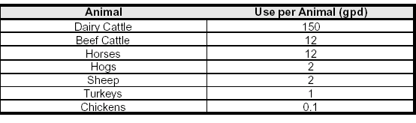
2.3.7 Aquaculture

The reasonable need for aquaculture is determined by the number and volume of ponds and tanks and their filling and recirculation requirements and other factors that may contribute to maintaining necessary water levels or water quality. An applicant for a general or individual permit must demonstrate that the requested allocation is a reasonable-beneficial use.

2.3.8 Other Agricultural Water Needs

The reasonable need for other agricultural uses, such as cooling of animals or product, is determined based on supporting information provided by the Applicant for a general or individual permit. The supporting information must demonstrate that the requested allocation is a reasonable-beneficial use.

2.3.9 Drainage Districts

Applicants for an individual or general permit who are dependant users pursuant to Section 2.7.3.A and are supplied water by a permitted Drainage or Water Control District do not need to be permitted separately for supplemental quantities unless there is a change in the withdrawal source for which the Drainage or Water Control District has no authority or permission to use. The allocation of the supply from the additional source will be authorized through the issuance of a separate permit specific to the new source classification.

2.3.10 Micro Irrigated Citrus

The annual allocation for micro irrigated citrus will be calculated using methodology and coefficients described in Section 2.3.2. The maximum month allocation will be defined by the highest month value for full evapotranspiration for either March, April or May, as determined using the methodology in Section 2.3.2. In the event that the allocation calculated by this methodology is insufficient to meet the supplemental irrigation requirements of an applicant’s grove under a 1 in 10 year drought condition, the applicant may apply for an allocation in excess of the allocation calculated by Section 2.3.2. In such circumstances, the applicant must affirmatively demonstrate the need for a higher allocation by provision of information such as: site specific soil hydrologic characteristics, depth to the water table, salinity of irrigation water (when additional water is needed to flush salts from the soil), calibrated historic pumpage data, or the results from an on-site irrigation efficiency evaluation conducted by a qualified irrigation auditor, such as a Mobile Irrigation Lab. In the event the irrigation water exceeds 1200 milligrams per liter total dissolved solids, the maximum month allocation will be increased to include 1 inch of water for the purposes of flushing accumulated salts from the soil.

2.4 Industrial / Commercial

Applicants for an individual permit must demonstrate that the quantities applied for relate to reasonable processing and manufacturing needs. The Applicant shall demonstrate need for the water by providing information on the water balance for the operation, including all sources of water and losses of water utilized in production processes, personal/sanitary needs of employees and customers, treatment losses, and unaccounted uses.

2.4.1 Water Conservation Plans

All individual permit applicants for a commercial or industrial water use permit must submit a water conservation plan at the time of permit application. The conservation plan shall be prepared and implemented for the Permittee's proposed use and, at a minimum, incorporate the following mandatory components:

A. An audit of the amount of water used in the Applicant's various operational processes. For new Permittees, an audit will not be required as a condition of permit issuance; however, such audit must be conducted within two years of permit issuance.

The following measures will be required within the first year of permit issuance or audit completion if found to be cost effective in the Applicant's audit:

1. implementation of a leak detection and repair program;

2. implementation of a recovery/recycling or other program providing for technological, procedural or programmatic improvements to the Applicant's facilities, and;

3. use of processes to decrease water consumption.

B. Develop and implement an employee awareness and consumer education program concerning water conservation.

C. Procedures and time-frames for implementation shall be included in the conservation plan.

2.4.2 Demand Components

Applicants for industrial/commercial uses must identify the demand for each of the following components:

A. Process requirements - water lost in processing and manufacturing where water is an input in the process. This quantity is determined through the calculation of a water balance. The water balance demonstrates where water is generated and in what quantities, where water is used in manufacturing or processing and the associated losses, and where and in what quantities water is disposed of or reused. The balance may be in the form of a spreadsheet or a flow diagram that indicates all water sources and losses. All sources of water that input to the activity must be listed.

B. Other uses - determined by calculating the total withdrawal quantity minus the quantity for the uses identified above. Other uses include lawn and landscape irrigation, outside use, air conditioning and cooling, water lost through leaks, and unaccounted uses.

2.4.3 Pollution Remediation
An Industrial Water Use Permit is required for remediation projects that include ground water or surface water withdrawals. The application for a pollution remediation use must include a copy of an approved state or federal remedial action plan. The volume of water to be withdrawn shall be consistent with the remedial action plan. The applicant must demonstrate that the treated water is discharged in a manner that is ultimately returned to the aquifer or is otherwise put to a reasonable-beneficial use, unless such discharge is technically or environmentally infeasible or is otherwise not practicable. Technical infeasibility exists if there is no reasonable access or capacity of permeable surface upon which the aquifer recharge could take place. Environmental infeasibility exists when there is no reasonable way of providing compatible quality discharge water to the receiving water, consistent with primary State Water Quality standards.

2.5 Dewatering

Dewatering activities that require a water use permit include withdrawals of water for construction activities, mining operations, and minor uses such as exploratory testing, short-term Remedial Action Plans, and aquifer performance tests. There are three types of District permits for dewatering projects that are primarily based on the duration and volume of water associated with the project. As summarized in Table 2-3, two of the permits are for short duration dewatering projects and the other is for long-term projects. The dewatering duration for a project is considered by Staff to be the period of time necessary to complete all dewatering for the project. Staff will not issue multiple short-term dewatering permits for a single project or different phases of a project.

2.5.1 “No-Notice" Dewatering Permits

“No-Notice” short-term dewatering permits apply to dewatering projects of less than 90 days with maximum daily pumpage of less than 5 million gallons per day and maximum total project pumpage of less than 100 million gallons, where all dewatering water is retained on the project site and there is no potential for resource harm. If a project does not qualify for a “No-Notice” permit, a Dewatering General Water Use Permit (Section 2.5.2) or a Dewatering Individual Permit (Section 2.5.3) must be obtained for the dewatering project. These permits are intended for projects of longer duration or larger dewatering pumpage, or for those projects where the potential for resource impact needs to be evaluated by District staff or off-site discharge of dewatering water is requested.

Proposed dewatering activities under the "No-Notice" permit must satisfy the following criteria, in addition to the Conditions of Issuance in 40E-20.301, F.A.C., and the “No- Notice” requirements in 40E-20.302(3), F.A.C.:

1. will retain all discharge on the project site. No off-site discharge is
authorized under “No-Notice” dewatering.

2. will not dewater to a depth below 0.0 feet NGVD within 1000 feet of saline water, except when dewatering saline water, as defined in Chapter 1 of this Basis of Review.

3. will not occur within 100 feet of a wastewater treatment plant rapid-rate land application system permitted under Part IV of Chapter 62-610, F.A.C.

4. will not occur within one mile of a known landfill or contamination.

5. will not occur within 1000 feet of a wetland.

The applicant is not required to submit a permit application for dewatering activities, if the “No-Notice” criteria are met. In proceeding with “No-Notice” dewatering, the applicant acknowledges that the dewatering operation is subject to the Standard Permit Conditions in Section 5.1 of the BOR, including responsibility for mitigating any harm that may occur as a result of the dewatering to existing legal uses, off-site land uses, or natural resources.

Linear projects, such as roads, utilities, or pipelines, may qualify for multiple “No-Notice” permits. The dewatering activity for these projects may have a rolling 90-day duration, in which the dewatering operation at the end of each 90-day period occurs more than 1 mile from the location at the beginning of each 90-day period.

2.5.2 Dewatering General Water Use Permit

Dewatering General Water Use Permits, as described in Rule 40E-20.302(2), F.A.C., are for dewatering projects, which a) cannot meet the conditions of issuance and requirements for “No-Notice” permits, b) have a proposed duration of less than one year, and c) propose to pump less than 10 million gallons per day with a total project volume of less than 1800 million gallons. A dewatering general water use permit application must be submitted to the District and Staff must issue the General Permit prior to the applicant beginning dewatering, unless portions of the project qualify for dewatering under the “No-Notice” permit described above. The applicant may elect to begin dewatering for a single period of only 90 days in areas of the project, which meet the “No-Notice” criteria, once an application for a Dewatering General Water Use Permit has been submitted to the District.

Permit applications for a Dewatering General Water Use Permit must:

(1) provide reasonable assurances that the project will not cause harm to the resource, existing legal uses, offsite land uses, and wetland environments or cause harmful saline water intrusion or movement of pollutants, as described in Chapter 3 of this Basis of Review. If the potential for harm exists, the applicant shall redesign the dewatering activities, including recharge trenches or storage areas to offset the potential drawdown impacts of the proposed activity.

(2) demonstrate that the requested allocations represent reasonable dewatering needs. These needs are generally demonstrated by providing information on the water budget for the operation, including all sources and losses of water utilized in the dewatering process. The water budget should demonstrate where and in what quantities water is generated to accomplish the dewatering, including any associated losses, and where and in what quantity water is stored, recharged, disposed, or reused. If processing of materials is associated with the dewatering, a separate water budget describing these activities is required. The water budget may be in the form of a spreadsheet or a flow diagram that indicates all water sources and losses.

(3) identify the areal extent and depth of the proposed excavation, the depth of dewatering, and the areal extent of the drawdown of the Water Table aquifer associated with the proposed dewatering.

(4) provide reasonable assurances that all dewatering water will be retained on the project site, unless the applicant demonstrates that it is not technically feasible to retain the dewatering water onsite. If any offsite discharge is requested due to demonstrated technical infeasibility of onsite retention, the applicant must provide the following information with the permit application:

a. documentation of authorization that allows the applicant to discharge directly into the receiving water body and/or adjacent lands, and a demonstration that the receiving water body or adjacent lands are capable of accepting the dewatering discharge;

b. an operational plan which demonstrates that the discharge to the receiving water body will meet all applicable State Water Quality standards prior to discharge;

c. an operational plan which demonstrates that the discharge to protected wetlands will not contain turbidity levels in violation of State Water Quality standards (must be less than 29 NTU above background levels) prior to discharge;

d. a monitoring plan which includes, at a minimum, proposed sampling locations and daily turbidity measurements of the discharge and background conditions in the receiving body and/or wetland; and

e. a contingency plan which includes procedures for ceasing dewatering operations and correcting the situation until monitoring demonstrates water quality standards are met.

(5) Demonstrate that reserved water will not be withdrawn pursuant to Rule 40E-20.301(1)(k), F.A.C., by retaining all water on site. If the Applicant demonstrates that retaining the water on site is not feasible, the application shall be processed as an individual permit pursuant to Section 2.5.3.

(6) Provide reasonable assurances that fresh dewatering water will not be discharged to saline tidal waters, unless the applicant demonstrates that it is not technically feasible to prevent discharge to saline water and requests specific authority from the District for discharge. Saline dewatering water, as defined in this Basis of Review, may be discharged to tidewater.

(7) Provide an operational plan which describes how stormwater will be handled during dewatering operations.

Dewatering applications will be reviewed concurrently with Environmental Resource or Surface Water Management construction permit applications, and the dewatering application will not be considered complete until both applications are complete. An applicant may request that the dewatering permit include a later “start” date to coincide with the actual start of dewatering activities at the project. Staff will recommend a permit expiration date, based on the proposed “start” date. Any temporary dewatering water holding areas must be constructed and operated using sound engineering practices to protect public health, safety, and welfare and, as necessary, dewatering activities must meet all applicable Environmental Resource or Surface Water Management criteria.

2.5.3 Long-Term Dewatering Individual Permits

Long-term dewatering individual permits apply to projects that exceed the thresholds and criteria described in Sections 2.5.1 and 2.5.2 above. These permits must be approved by the District Governing Board. Two types of individual dewatering permits are available from the District. For projects where all the dewatering activities are defined at the time of the permit application, the applicant may apply for a “standard” Individual Permit. For long-term, multi-phased projects, with undefined activities or no contractor at the time of the permit application, the applicant may apply for a “master” Individual Permit.

Applicants for all individual dewatering permits must satisfy the conditions of issuance for Individual Permits (Rule 40E-2.301, F.A.C.), and may not commence dewatering prior to approval of the permit by the Governing Board. In order to provide reasonable assurances that water reserved in Rule 40E-10.041, F.A.C., will not be withdrawn, all water from the dewatering activity shall be retained on site. If the applicant demonstrates that retaining the water on site is not feasible, the project shall be modified to demonstrate pursuant to Section 3.11 that reserved water will not be withdrawn. The applicant may elect to begin dewatering for a single period of only 90 days in areas of the project, that meet the No-Notice criteria specified in Section 2.5.1 of this Basis of Review, once an application for an Individual dewatering permit has been submitted to the District.

The applicant must provide the information required for the Dewatering General Permit, as specified in Section 2.5.2. In addition, the applicant shall provide estimates of the maximum monthly and annual dewatering withdrawals for the project and will be required to submit records of monthly withdrawals for each dewatering pump to the District. Staff shall not specify maximum monthly or annual withdrawal volumes in the recommended permit conditions presented to the Governing Board.

A. “Standard” Individual Permits

The applicant shall specify all proposed dewatering activities for the project in terms of depth, duration, and areal extent of dewatering and proposed routing of dewatering water, the estimated magnitude and extent of drawdown, proposed recharge/storage areas, and the potential for harm. The applicant may proceed with all dewatering activities once the permit has been approved by the Governing Board.

B. “Master” Individual Permits

Due to project uncertainties, the applicant may not be able to specify all aspects of the proposed dewatering activities at the time of the permit application. In order to receive a “master” dewatering permit, the applicant must meet all conditions of issuance and specify the depth, duration, and areal extent of dewatering, the proposed routing of dewatering water, the estimated magnitude and extent of drawdown, proposed recharge/storage areas, and the potential for harm for “typical” dewatering activities for the project. In addition, the applicant shall provide an estimated project schedule showing dewatering activities and calculated estimated maximum monthly and annual dewatering withdrawals. After approval of the permit by the Governing Board, the applicant shall be required by limiting condition to supply site-specific dewatering plans for each proposed dewatering activity to the District for review and approval at least two weeks prior to dewatering. The applicant may not initiate dewatering prior to receiving written notification from District Staff, that the proposed dewatering activity is consistent with the “master” permit approved by the Governing Board.

TABLE 2-3
Dewatering Permits

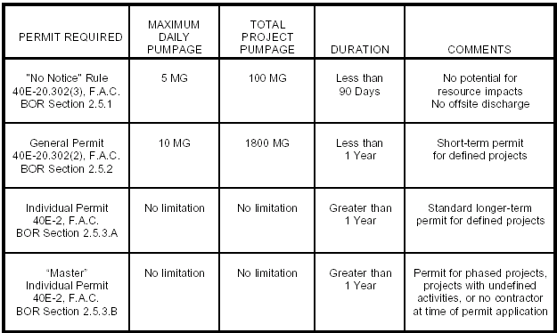

2.6 Public Water Supply

In order to accurately calculate demand, public water supply general or individual permit applicants must meet the criteria included in Section 2.1 of this manual and identify the demand for each of the uses listed in this section. Information required to demonstrate reasonable demand for each component includes the number, type, and size of service connections; past pumpage records; projected population data for the service area; data on the specific uses; and data specific to the forecasting models used. Demand quantities shall be based on raw water demand or that volume of water necessary to be withdrawn from existing or proposed sources. The quantities must be expressed in average gallons per day for each component of demand.

Where metering, billing, or other record-keeping methods do not provide accurate use estimates, the Applicant must provide the best estimates for each use type and must document the estimation method used.

In applications where a portion of the demand is derived from large use customers who redistribute water (e.g., a county utility sells water to a municipality), the Applicant must obtain and report demand information from each customer. This information is required to demonstrate that the quantities applied for are supported by reasonable demand. Per capita use guidelines and water use Conservation Plans in Section 2.6.1. apply to redistributing water customers as well as the Applicant.

2.6.1 Water Conservation Plans

All public water supply utilities applying for an individual permit are required to develop and implement a water conservation plan. The water conservation elements of each plan need to be identified as part of the application. A timetable outlining the implementation schedule of each of the required water conservation elements will be required to be submitted or shown to already exist prior to issuance or renewal of a public water supply water use permit. The conservation plan shall be prepared and implemented for the service area incorporating, at a minimum, the following mandatory components. For those components which require ordinance adoption, such ordinance should incorporate the entire boundary of the enacting jurisdiction. The Permittee shall provide a copy of the ordinances for each of the mandatory elements for which ordinances are adopted. The mandatory water conservation elements are as follows:

A. The limitation of all lawn and ornamental irrigation to the hours and days specified in Rule 40E-24.201, F.A.C., or alternative landscape irrigation conservation measures pursuant to Rule 40E-24.301, F.A.C.

B. Where the local government operating the public water supply utility, pursuant to section 125.568 or 166.048, F.S., determines that Xeriscape would be of significant benefit as a water conservation measure relative to the cost of Xeriscape implementation, the local government operating the public water supply utility is required to adopt a Xeriscape landscape ordinance meeting the requirements of section 373.185(2)(a)-(f), F.S. In the event such a Xeriscape ordinance is proposed for adoption, the permit Applicant shall submit the draft ordinance to the District for determination of compliance with section 373.185(2)(a) - (f), F.S. If the ordinance which the local government has or proposes to adopt includes an alternative set of requirements which do not encompass those contained in section 373.185(2)(a)-(f), F.S., eligibility for the incentive program will not be achieved. The District, in compliance with section 373.185, F.S., offers the following incentive program, to those local governments who are eligible, consisting generally of information and cost-benefit analysis assistance. Specifically, the information provided interested parties will consist of an explanation of the costs and benefits of Xeriscape landscapes; the types of plants suitable for Xeriscape landscapes within the local government's jurisdiction; the types of irrigation methods suitable for Xeriscape landscaping and the use of solid waste compost. Further, if requested, the
District will assist local governments in determining whether the benefits of requiring Xeriscape landscaping outweigh the costs within that local government's jurisdiction; this assistance may consist of economic considerations, technical information or referral to other agencies that can provide information the local government may need to perform its costbenefit determination. The Governing Board finds that the implementation and use of Xeriscape landscaping, as defined in section 373.185, F.S., contributes to the conservation of water. The Governing Board further supports adoption of local government ordinances as a significant means of achieving water conservation through Xeriscape landscaping.

C. The adoption of an ordinance requiring the installation of ultra-low volume plumbing fixtures in all new construction, such that plumbing fixtures are installed to comply with the following maximum flow volumes at 80 psi: Toilets: 1.6 Gal./Flush; Shower Heads: 2.5 Gal./Min.; and Faucets 2.0 Gal./Min.

D. The adoption of water conservation-based rate structures. Such rate structures should include at least one of the following alternative components: increasing block rates, seasonal rates, quantity based surcharges and/or time of day pricing as a means of reducing demands.

E. The implementation of leak detection programs by utilities with unaccounted-for water losses of greater than 10% is required. Such leak detection program must include water auditing procedures, in-field leak detection efforts and leak repair. The program description should include the number of man-hours devoted to leak detection, the type of leak detection equipment being used and an accounting of the water saved through leak detection and repair. It is the policy of the District to encourage public water supply systems to have no more than 10% unaccounted-for water losses.

F. For local government applicants, the adoption of an ordinance requiring any person who purchases and installs an automatic lawn sprinkler system to install, operate and maintain a rain sensor device or automatic switch which will override the irrigation cycle of the sprinkler system when adequate rainfall has occurred pursuant to Section 373.62, F.S.

G. The implementation of water conservation public education programs.

H. For those potable public water supply utilities who control, either directly or indirectly, a wastewater treatment plant, an analysis of the economic, environmental and technical feasibility of making reclaimed water available. Use of the Guidelines for Preparation of Reuse Feasibility Studies published by the Department in November, 1991 is suggested.

I. Procedures and time-frames for implementation shall be included in the conservation plan.

2.6.2 Demand Components

All public water supply applicants for an individual or general permit must identify the demand for the following components:

A. Residential Use - at a minimum, shall be divided into single-family residential use and multi-family residential use;

B. Other metered uses - include all uses other than residential accounted for by meter;

C. Unaccounted uses - the total water system output minus all accounted uses above. Unaccounted use includes unmetered use, water lost through leaks, water used to flush distribution lines, fire fighting, and other unidentified uses. This quantity should not exceed 10 percent of total distribution quantities. Applicants with unaccounted use greater than 10 percent are required to address the reduction of such use through the formation of a formal leak detection program;

D. Treatment and Distribution Losses - In some circumstances, not all water that is withdrawn is actually used. This circumstance may be a result of losses in the system during distribution, or because the water must undergo a treatment process before it is usable. This component should only be calculated when such losses are significant. Some water treatment technologies, such as desalination or sand filtration, may cause significant portions of the withdrawn water to be unusable. In such cases, the Applicant shall be required to indicate the withdrawal quantity treated, the percent product (usable) water, the percent reject (unusable) water, and the manner in which the reject water will be disposed.

E. Large User's Agreements - for those utilities which provide water to other entities through large user's agreements or other similar contracts, the quantity of water delivered to each end user (both average and peak day) and the duration of the water service delivery shall be identified. For those utilities which purchase supplemental water from another utility, the volume of water historically purchased (or contracted to be purchased for proposed uses) for both an average and maximum daily basis and the duration of the contract shall be provided.

2.6.3 Per Capita Daily Water Use

Per capita daily water use is a guideline used to measure the reasonable withdrawal requests of public water supply applicants for an individual or general permit. Per capita water use includes population-related withdrawals associated with residential, business, institutional, industrial, miscellaneous metered, and unaccounted uses. The average per capita daily use rate is calculated for the last five years or period of record, whichever is less, by dividing the average daily water withdrawals for each year of record by the permanent or seasonally adjusted population served by the utility for the same period of time. The per capita use rate that is most representative of the anticipated demands, considering the water conservation plans required by criteria in section 2.6.1, shall be identified and used for water demand projection purposes. The historical demand patterns may not always be appropriate for projection purposes. This may occur when there are current large users whose growth is not related to population, or when future development may take on characteristics very different than those of present development. In such cases, alternative per capita estimates, such as a design per capita based on dwelling unit type, population characteristics, seasonality of the population and comparison with adjacent similar developments, shall be presented accompanied by necessary documentation. If no historical water use data exists or in the case of proposed developments, a design per capita use shall be used based on the above alternative criteria. Per capita daily water use greater than 200 gallons per capita per day (gpcd) must be supported with additional information explaining the rate of use.

2.6.4 Maximum Monthly Peaking Ratio: Public Water Supply

The recommended maximum monthly allocation for a public water supply general or individual permit is based on the average monthly demand for the duration of the permit times the maximum monthly to average monthly peaking ratio.

Listed below are methodologies used to calculate the maximum monthly to average monthly peaking ratio depending on the available data. Extensive non-domestic use may cause variations in methodologies.

A. In cases where several years of pumpage records are available, the maximum monthly peaking ratio is calculated for each year. The ratio is generally the average of the peaking ratios of the last three years of record, unless changes in the historic water use patterns require the use of a more representative timeframe (such as when there is a projected significant increase for commercial/industrial demands or the applicant enters into a new large user agreement).

B. For proposed developments, a ratio between 1.3 and 1.7 will be used, depending upon the operation of the utility, although engineering documents justifying a different ratio will be considered.

C. When a utility operates more than one treatment plant and the plants operate independently (no interconnections), the maximum monthly peaking ratio must be determined for each treatment plant and its associated wellfield(s).

2.6.5 Population Estimates

In service areas without significant seasonal population fluctuations, the use of permanent population estimates is appropriate. In service areas where there are significant seasonal population changes, the general or individual permit applicant shall estimate the seasonal population for use in conjunction with permanent population in the calculation of per capita daily water demand. The Applicant is advised that if significant seasonal population fluctuations are not accounted for, per capita water daily water use may be over-estimated. Permanent and seasonal (if applicable) population growth must be projected for the requested duration of the permit, on a yearly basis, for the area served by the application.

When population estimates are required for years in between published or referenced estimates, the Applicant must interpolate the data. The Applicant may assume that population increases in equal increments in the years between established estimates.

2.6.5.1 Population Data

Population data should be derived from the prevailing Comprehensive Land Use Plan (developed under Chapter 9J-5, F.A.C.). If the Applicant's population estimate varies from the Comprehensive Plan, other accepted sources of population data to validate the variance include the following: (1) University of Florida Bureau of Economics and Business Research (BEBR), (2) Regional Planning Council (RPC), (3) County Planning Departments, or the (4) District Planning Department.

2.6.6 Health Review

The Applicant for a public water supply general or individual permit is advised that permits or certifications regarding water quality may be required by other governmental agencies, such as the Florida Department of Environmental Protection and Department of Health and Rehabilitative Services, for public health purposes.

2.7 Diversion and Impoundment

2.7.1. Scope and Intent

This Section contains criteria for calculating the allocation for diversion and impoundment systems and the criteria for users within diversion and impoundment systems to obtain consumptive use rights.

A diversion and impoundment permit is required for projects, excluding District operated facilities, that divert surface water through a pump or operable water control structure, or divert a combination of surface and ground water to a conveyance canal network system which the applicant has legal control to operate and maintain for the purposes of providing for the reasonable-beneficial demands of secondary users and consumptive and non-consumptive uses.

Users of surface water maintained through operation of a diversion and impoundment system are considered secondary users of the diversion and impoundment system. The District recognizes dependent and independent secondary users as the two categories of surface water users within a diversion and impoundment system that may attain water rights through the permitting process. The distinction between these two categories is related to the manner in which the secondary user attains its water right. Unless exempt, such secondary users must obtain a consumptive use right through an independent permit or by incorporation into the diversion and impoundment permit. Criteria for each of these methods are set forth below.

2.7.2 Demand Calculation for Diversion and Impoundment system

Reasonable demand calculations for diversion and impoundment systems will be based on the following factors: the extent (length, cross sections, and depth) of the canal network used to deliver the water associated with the diversion and impoundment operation; land use classifications within the area served by the diversion and impoundment system; surface water demands directly withdrawn from the diversion and impoundment system; seepage losses; water necessary to maintain groundwater elevations for the purpose of aquifer recharge and saltwater intrusion prevention; evaporation losses from the canal surfaces; and established control elevations during 1 in10 year drought events.

For permit renewals in which no changes are proposed over historic operations, the demands may be determined from historic pumpage records, consistent with the criteria in Section 1.7.5.1. For modifications where the proposed allocation is increasing, the demands shall be determined with the use of models consistent with the criteria in Section 1.7.5.2, using the applicable efficiency and conservation measures for each use type served by the project while considering cycling of water from project to project within the system.

In addition to the requirements of Application Form RC-1W, diversion and impoundment permit applicants must submit: (1) a map identifying the location of all secondary users of their system, including irrigated acreage and land use type; upon permit modification this map must be updated to reflect changes in secondary users of the diversion and impoundment system; and (2) copies of the agreements executed with dependent secondary users pursuant to Section 2.7.3.A.

2.7.3 Conditions of issuance for Secondary Users of a Diversion and Impoundment System

A. Dependent Secondary Users are users of surface water from a diversion and impoundment system that have elected to obtain their water right through the diversion and impoundment permittee's permit, as evidenced by a legal agreement in compliance with the following:

(1) Agreement that the secondary user will comply with water shortage restrictions imposed by District rule or order issued pursuant to Chapter 40E-21, F.A.C.,

(2) Agreement that the secondary user will comply with all applicable water conservation standards required in the diversion and impoundment permit;

(3) Agreement that the secondary user will notify the diversion and impoundment permittee of any changes in water use demands or sources;

(4) Agreement that the secondary user will continue to evaluate the feasibility of using reclaimed water in accordance with the requirements contained within the diversion and impoundment permit;

(5) Agreement that the secondary user will mitigate harm to the resources or existing legal uses caused by the secondary user;

(6) Agreement that the secondary user will submit a map identifying their system's location, irrigated acreage, and land use type; and

(7) Agreement that the dependent secondary user will comply with the above stated conditions and applicable conditions within the diversion and impoundment entities’ consumptive use permit or be subject to potential District enforcement action pursuant to Chapter 373, F.S.

B. Independent Secondary Users are users of surface water from a diversion and impoundment system that have obtained their water right through a separate consumptive use permit from the District. The District will utilize the applicable demand calculation criteria for the use class associated with the secondary use to determine the proposed project's demand, contained in the Basis of Review. Site specific resource evaluation must be conducted as required by Section 3.0. Impact evaluation associated with the diversion and impoundment system's withdrawal from the regional system will not be required. Resource impact evaluations must be conducted as required by Section 3.0. In addition, the requested allocation must be consistent with the diversion and impoundment permit as evidenced by demonstration of legal access to the diversion and impoundment system and by demonstration that the proposed secondary use will not cause the diversion and impoundment permittee to exceed its permitted allocation.

2.8 Transport and Use of Water Across County Boundaries

Sections 373.016, 373.223(3) and 373.1962, F.S., govern the review of water use permit applications for the transport and use of water across county boundaries, including provision of exemptions and limitations on the application of such requirements. The following provides specific guidance as to the applicability of certain statutory exemptions and limitations within these statutes:

A. A transport and use of ground water across county boundaries pursuant to Section 373.223(3), F.S., does not occur when: (1) a project withdraws groundwater for use on its overlying property and the drawdowns associated the groundwater withdrawals cross county boundaries; or (2) water is withdrawn from an underground water storage unit where it has been stored pursuant to an aquifer storage and recovery project and may, in its stored state, cross county boundaries.

B. Transport and use of water by self-suppliers of water for which the proposed water source and areas of use or application are located on contiguous private properties are exempt from review under the provisions in Section 373.223(3), F.S., including a project whose boundary straddles county borders and water from one part of the project serves another part of the same project in the neighboring county.

C. Transport and use of water across county boundaries by water supply authorities meeting the requirements of Section 373.1962(9), F.S., are exempt from Section 373.223(3), F.S.; and

D. The transport and direct or indirect use of water within the areas encompassed by the Central and Southern Florida Flood Control Project is exempt pursuant to Sections 373.016(4)(a) and 373.223(3), F.S.

3.0 WATER RESOURCE EVALUATIONS

Section 373.223, F.S., provides a three-pronged test for evaluating each proposed water use: (1) the use must be reasonable-beneficial, (2) must not interfere with any existing legal use of water, and (3) must be consistent with the public interest. Reasonable assurances that the proposed water use from both an individual and cumulative basis meets this three-pronged test are provided, in part, by the Applicant's compliance with the Conditions for Issuance, set forth in Rule 40E-2.301.

This section provides some technical guidelines for determining whether a water use meets the Conditions for Issuance set forth in Rule 40E-2.301. If the criteria described in this section are not met, applicants may consider reduction of withdrawal quantities, a pumpage rotation schedule, mitigation, change in withdrawal source or other means to bring the proposed use into compliance with the technical criteria.

3.1 Reasonable Demand

The proposed withdrawal of water must be supported by information specified in Section 2.0 of this manual, demonstrating that the withdrawal quantities are necessary to supply a certain reasonable need or demand. Only that portion of the requested demand that is supported by adequate documentation will be recommended for issuance through the time period specified by the permit duration.

3.2 Sources of Water

District permits are required for all non-exempt existing and proposed uses of fresh and saline sources. Sources are described as surface water or ground water which can be further identified with the name of the water body and/or aquifer. Applicants using seawater or reclaimed water to meet their total water needs are not required to obtain water use permits. However, if these sources are utilized, in part, to meet the Applicant's water demand, the Applicant should identify the quantities obtained from these sources that are used to meet the demand. If a source is not reliable throughout the year, the Applicant may request withdrawal quantities from secondary and standby sources of supply, which may be used when the primary supply is limited. The permit will identify the secondary and backup sources and the conditions and time periods for which they are likely to be required.

Consideration must be given to the availability of the lowest quality water, which is acceptable for the intended use. If a water source of lower quality is available and is feasible for all or a portion of an Applicant's use, this lower quality water must be used. Such lower quality water may be in the form of reclaimed water, recycled irrigation return flow, collected stormwater, saline water, or other sources.

3.2.1 Restricted Allocation Areas

Due to concerns regarding water availability, the following geographic areas are restricted with regard to the utilization of specific water supply sources. These areas and sources include the following:

A. Lake Istokpoga/Indian Prairie Canal System - No additional surface water will be allocated from District controlled surface water bodies over and above existing allocations. No increase in surface water pump capacity will be recommended.

B. C-23, C-24 and C-25 Canal System - No additional surface water will be allocated from District canals C-23, C-24 and C-25, or any connected canal systems that derive water supply from these District canals, over and above existing allocations. No increase in surface water pump capacity will be recommended.

C. L-1, L-2 and L-3 Canal System - No additional surface water will be allocated from District canals L-1, L-2 and L-3 over and above existing allocations. No increase in surface water pump capacity will be recommended.

D. Pumps on Floridan Wells - No pump shall be placed on a flowing Floridan well in Martin or St. Lucie County, except under the following guidelines:

1. If the pump was in place and operational prior to March 2, 1974, and is still in place or a replacement pump with a similar capacity is in place, or

2. The proposed pump is installed for the purpose of increasing pressure in attached piping (e.g., drip or micro-jet irrigation systems) and not for the purpose of increasing flow over and above that flow which naturally emanates from the well. The determination of the appropriate pump capacity must occur after well construction and measurement of the actual natural flow rate. Prior to any pump installation, the Permittee shall provide measurements of flow from each well using calibrated flow equipment. The method of accounting, calibration data, corrections for well losses, proposed pump information, and the basis for the requested flow rate shall be submitted to District Staff for review and approval, or

3. The Applicant conducts and provides the results of a study, approved by District staff, which shows that pump installation and subsequent withdrawals will not interfere with any presently existing legal use, as defined in Section 3.7, or

4. The proposed pump is installed to temporarily assist in producing the permitted allocation associated with freeze protection pursuant to Section 2.3.4, or

5. The proposed pump is installed to temporarily assist in meeting allowable withdrawals for the duration of a water shortage declared pursuant to Chapter 40E-21, F.A.C.

E. In addition to all other applicable consumptive use statutory and rule provisions, the following restrictions shall apply when allocating water by permit for water use withdrawals within the Northern Palm Beach County Service Area and Lower East Coast Service Areas 1, 2 or 3.

This section is a component of recovery strategies for minimum flows and levels for the Everglades and the Northwest Fork of the Loxahatchee River, as set forth in Chapter 40E-8, F.A.C., and assists in implementing the objective of the District to ensure that water necessary for Everglades restoration and restoration of the Loxahatchee River Watershed is not allocated for consumptive use upon permit renewal or modification under this rule.

(1) The additional restrictions in this section shall only apply to applications for new or modified permits or for permit renewals.

(2) Except as provided in this section, an applicant must demonstrate, pursuant to the impact evaluation provisions in Section 1.7.5.2., the requested allocation will not cause a net increase in the volume or cause a change in timing on a monthly basis of surface and ground water withdrawn from the Lower East Coast Everglades Waterbodies or the North Palm Beach County/Loxahatchee River Watershed Waterbodies (which are hereinafter referred to as the “Waterbodies”) over that resulting from the base condition water use.

The evaluation of water withdrawn from Waterbodies under this section shall address the impacts of the proposed use on surface and ground water from: (a) integrated conveyance systems that are hydraulically connected to the subject Waterbodies and are tributary to or receive water from such Waterbodies; and (b) the Waterbodies. Integrated conveyance systems that are hydraulically connected to the subject Waterbodies include primary canals used for water supply including, but not limited to, the Central and Southern Florida Project Canals, and secondary and tertiary canals that derive water from primary canals.

(3) The “base condition water use” shall be as provided below, but in no case shall exceed the withdrawal permitted to the applicant as of April 1, 2006:

(a) for the public water supply use class, the maximum quantity of water withdrawn by the applicant from the permitted source during any consecutive twelve month period during the five years preceding April 1, 2006. If a permit allocation existing as of April 1, 2006 contains an allocation based on a conversion of a water treatment system, the base condition water use shall be increased to account for the additional volume used as if the modified treatment system was operational as of April 1, 2006;

(b) for the irrigation use class, the quantity of water calculated using Section 2.3.2 to meet demands for the following: 1) the number of acres actively irrigated by the applicant over the duration of the irrigation permit existing as of April 1, 2006; or 2) if the irrigation project, or a portion thereof, has not yet been constructed pursuant to a required surface water management construction permit or environmental resource permit as of April 1, 2006, the number of acres authorized to be irrigated by such project when constructed, consistent with a water use permit existing as of April 1, 2006;

(c) for the diversion and impoundment use class, the demands of the applicant calculated pursuant to Section 2.7.2 for the physical conditions of the diversion and impoundment system as of April 1, 2006; or

(d) for other use classes, the quantity of water withdrawn by the applicant during the twelve months preceding April 1, 2006.

In determining the base condition water use, pursuant to subsections (a) through (d) above, the District shall consider and allow adjustments if the applicant demonstrates that such use is not representative of normal operations due to unanticipated conditions affecting the actual quantity of water withdrawn, such as extreme climatic conditions or equipment failure. Only uses conducted consistent with the existing consumptive use permit limiting conditions shall be considered in identifying the base condition water use. The base condition water use shall not exceed that permitted as of April 1, 2006.

The base condition water use shall include water made available through implementation of offsets, alternative water supplies, or terminated or reduced base condition water uses, specifically required by permit limiting condition to prevent increased water from being withdrawn from the subject Waterbodies. Under these circumstances, the applicant shall demonstrate that such actions were implemented and function as required by the permit.

(4) Applicants shall conduct a preliminary evaluation to determine whether the proposed use has the potential for increasing the withdrawal of water from the Waterbodies over the applicant’s base condition water use. Such preliminary evaluations may include a basic analytic impact assessment described in Section 1.7.5.2.A. or other acceptable evaluation pursuant to Section 1.7.5.

If based on a preliminary evaluation the proposed use has the potential for increasing the withdrawal of water from the Waterbodies, the following two evaluations will be compared to identify any changes in location, timing and volume of the withdrawals from the Waterbodies:

(a) A quantification of the withdrawal of surface and ground water from the Waterbodies under the base condition water use; and
(b) A quantification of the withdrawal of surface and ground water from the Waterbodies under the requested allocation.

In conducting this evaluation, the applicant shall consider the timing of the withdrawals as they affect the Waterbodies, i.e., the public water supply use class requires water throughout the year based on seasonal demand trends of the service area, versus the agriculture use class which uses water based on growing cycles of the particular crop.

When evaluating the affects of the proposed use on the Waterbodies, the applicant shall evaluate the resource efficiency of the use, i.e., the public water supply class demands are based on the demands of the service area and the type of treatment, and generally do not provide return flow to the source at the location of the withdrawal; whereas, the agricultural use class demands are based on the crop type, irrigation method and soil conditions, and typically provide some component of recharge at or near the point of withdrawal. The location component is evaluated based on the distance of the withdrawal from and the specific individual area of the subject Waterbodies as depicted in Figures 3-1 and 3-2, e.g., Water Conservation Area 1, 2A, or 2B, or the Northwest Fork of the Loxahatchee River or Loxahatchee Slough.

(5) If the comparison of the evaluations identified in Paragraph (4) identifies an increase in the volume or change in timing of water requested to be withdrawn from the Waterbodies, the applicant shall do one or more of the following:

(a) Certified project water. Identify that additional water from the Waterbodies has been made available through implementation of a project for water resource development, as defined in Section 373.019(22), Florida Statutes, and such water has been certified as available by the Governing Board, as defined in Section 1.8.

(b) Offsets. Propose, identify a schedule for implementation, and construct and operate adequate offsets to eliminate the projected increase in volume or change in timing of withdrawals from the Waterbodies over the base condition water use. An offset will be approved if it prevents an increase in volume or change in timing of surface and groundwater withdrawn from the Waterbodies over the base condition water use. Offsets include the use of recharge systems and seepage barriers that meet the above requirement;

(c) Alternative water supply. Propose, identify a schedule for implementation, and construct and operate alternative water supplies, as defined in Section 373.019(1), Florida Statutes. An alternative water supply will be approved under this rule if it is adequate to meet the reasonable increased demands without causing an increased volume or change in timing of the withdrawal from the Waterbodies over the base condition water use;

(d) Terminated or reduced base condition water use. Identify terminated or reduced base condition water uses as stated below. The request will be approved if the applicant demonstrates that the requested allocation does not cause an increase in volume or change in timing of withdrawals from the Waterbodies over the applicant’s base condition water use due to the reduction or elimination of other base condition water uses that existed on April 1, 2006. The applicant must demonstrate that water is available through providing documentation of the modification or termination of the historic consumptive use permit prior to issuance of the proposed permit under this rule; or,

(e) Available wet season water. Identify water is available during the wet season as set forth below. The wet season water will be approved if the applicant demonstrates that water is available under the conditions described below during the wet season, provided the applicant demonstrates that such water is not required to achieve the restoration benefits to the Waterbodies pursuant to the Comprehensive Everglades Restoration Plan, North Palm Beach County Comprehensive Water Management Plan, and the Acceler8 program. Water available under these conditions shall be limited to the wet season discharges that are projected to persist following implementation of the entire Comprehensive Everglades Restoration Plan, North Palm Beach County Comprehensive Water Management Plan, and the Acceler8 program.

1. Available surface water discharges during the wet season shall be identified based on best available information at the time of permit application evaluation used to quantify surface water flows from or to the restored Waterbodies, as reflected in the Comprehensive Everglades Restoration Plan, North Palm Beach County Comprehensive Water Management Plan, and the Acceler8 program, in their entirety;

2. Available wet season surface water discharges will be identified based on 1 in 10 drought conditions during May 1st through November 1st, as determined by annual rainfall statistics measured from gauges that are proximal to the applicant’s point of withdrawal defined in Part B Water Use Management System Design and Evaluation Aids, Part IV Supplemental Crop Requirement and Withdrawal Calculation; and,

3. Wet season surface water requested by the applicant must be derived within the same hydrologic area where the available surface water is identified.

The District will assist the permit applicant in identifying the best available information necessary to make the determination of wet season water availability. Offsets, alternative water sources and terminated or reduced base condition water uses implemented after April 1, 2006 shall be considered in addressing requested increases in withdrawals from Waterbodies under this section. Notwithstanding, as stated in Paragraph (3), water made available from the permitted source through offsets, alternative water supplies and terminated or reduced base condition water uses implemented consistent with permit limiting conditions to prevent increased water from being withdrawn from the subject Waterbodies, shall be considered in the base condition water use.

(6) Consistent with subsection (5), the permit applicant may obtain an allocation for additional water from the Waterbodies over the applicant’s base condition water use, as identified below:

(a) Certified project water. Water certified by the Governing Board as available for consumptive use through operation of a water resource development project, as provided in Section (5)(a);

(b) Temporary allocation. Water temporarily required to meet the applicant’s reasonable demands while implementing an alternative water supply pursuant to subsection (5)(c) or while implementing an offset identified pursuant to subsection (5)(b). The permit will be conditioned with dates and milestones for development of the alternative water supply or offset. A temporary allocation shall be reduced to be consistent with this section when the alternative source is projected to be available, consistent with permit limiting conditions. The temporary allocation shall be adjusted, as necessary, to reflect the offset on the Waterbodies when the offset is projected to be available, consistent with the permit limiting conditions.

The limiting conditions governing the quantity and time period for the temporary allocation shall be based on expected due diligence of the permit applicant, as determined by applying the factors in subparagraphs 1. through 3., below, to implement the alternative water supply or offset in an expeditious manner, not to exceed five years unless specifically approved by the Governing Board. The time period shall be determined considering the following factors:

1. The projected time period for design, receipt of necessary authorizations, and construction of the alternative supply or offset;

2. The timing of demands to be met from the alternative supply or offset;

3. Other factors that indicate the reasonable period required to develop the alternative supply or offset.

(c) Water made available through implementation of offsets or the termination or reduction of base condition water use withdrawals. Water made available through implementation of offsets pursuant to subsection (5)(b) or water made available through the termination or reduction of other users’ base condition water use withdrawals pursuant to subsection (5)(d), consistent with permit limiting conditions; or,

(d) Available wet season water. Water available during the wet season, provided the applicant demonstrates that such water is not required to achieve the restoration benefits to the Waterbodies pursuant to the Comprehensive Everglades Restoration Plan, North Palm Beach County Comprehensive Water Management Plan, and the Acceler8 program, pursuant to subsection 5(e). Pursuant to permit limiting conditions, additional surface water withdrawals will be permitted only when flood control regulatory releases are being made, and not when water supply deliveries are being made, from the Waterbodies.

(7) Permit applicants must meet the requirements of any established minimum flow and level and water reservation, if applicable.

3.2.1 Restricted Allocation Areas

Due to concerns regarding water availability, the following geographic areas are restricted with regard to the utilization of specific water supply sources. These areas and sources include the following:

A. Lake Istokpoga/Indian Prairie Canal System - No additional surface water will be allocated from District controlled surface water bodies over and above existing allocations. No increase in surface water pump capacity will be recommended.

B. C-23, C-24 and C-25 Canal System - No additional surface water will be allocated from District canals C-23, C-24 and C-25, or any connected canal systems that derive water supply from these District canals, over and above existing allocations. No increase in surface water pump capacity will be recommended.

C. L-1, L-2 and L-3 Canal System - No additional surface water will be allocated from District canals L-1, L-2 and L-3 over and above existing allocations. No increase in surface water pump capacity will be recommended.

D. Pumps on Floridan Wells - No pump shall be placed on a flowing Floridan well in Martin or St. Lucie County, except under the following guidelines:

1. If the pump was in place and operational prior to March 2, 1974, and is still in place or a replacement pump with a similar capacity is in place, or

F. Groundwater Allocation in the Central Florida Coordination Area (CFCA) –

1. Overall Intent:
The Central Florida Coordination Area (“CFCA”) is located within portions of three water management districts and includes Polk, Orange, Osceola and Seminole Counties, and southern Lake County. Within the South Florida Water Management District, the CFCA is the area delineated in Figure 3-4. As shown in Figure 3-4, the boundary for the portion of the CFCA located within this District is that portion of the south line of Polk County and the South line of Osceola County as said county boundaries are described in Sections 7.53 and 7.49, F.S., respectively, lying within the boundaries of the South Florida Water Management District as described in Subsection 373.069(2)(e), F.S. In this area, stress on the water resources is escalating because of rapidly increasing withdrawals of groundwater. The public interest requires protection of the water resources from harm. The CFCA rules address the public interest by providing an interim regulatory framework to allow for the allocation of available groundwater in the area, subject to avoidance and mitigation measures to prevent harm, and by requiring the expeditious implementation of supplemental water supply projects (as defined in Section 1.8). This interim regulatory framework is one component of a comprehensive, joint water management district strategy for regional water resource management that also includes regional water supply planning, alternative water supply project funding, and water resource investigations and analysis that will result in a long-term approach for water supply within the CFCA. The interim CFCA rules (as listed in section 3.2.1 (F) 1. (a) below) shall remain in effect only through December 31, 2012, except that if the District initiates rulemaking to provide a long-term regulatory framework to replace the interim rules and a petition challenging all or part of the proposed rules is filed under section 120.56 of the Florida Statutes before that date, the interim rules shall remain effective until 100 days after a final determination of the validity or invalidity of the proposed rules.

(a) Special additional rules apply to public supply utility applicants and similar applicants (see definitions in section 1.8) proposing to withdraw groundwater in the CFCA. These rules are found in section 1.3.2.1, subsections 1.7.2.2 B.4., 1.7.2.2 C.4., 1.7.2.2 D.6., section 1.8 , the Definitions for Brackish Groundwater, Demonstrated 2013 Demand, Due Diligence, Public Supply Utility, Saltwater, Similar Applicant and Supplemental Water Supply, subsection 3.2.1 F, and subsection 5.3 F.

2. Maximum Allocation:
Public supply utility applicants and similar applicants proposing to withdraw groundwater in the CFCA, are restricted to a maximum allocation of groundwater in an amount no greater than its demonstrated 2013 demand, however, an applicant may seek a duration that extends beyond 2013 for that level of allocation. This restriction shall not limit permitted groundwater withdrawals from:
a. Aquifer storage and recovery wells that receive only surface water, stormwater, or reclaimed water, when the volume of water withdrawn does not exceed the volume of water injected; or
b. The surficial aquifer immediately below or adjacent to a stormwater management system or surface water reservoir where any drawdown in the surficial aquifer will be offset by recharge from the system or reservoir; or
c. An injection / recovery wellfield that injects surface water, stormwater, or reclaimed water that is not required under criteria 3.2 or 3.2.3 to be provided to other uses through one or more wells for storage within an aquifer zone and subsequently recovers it through wells from the same aquifer zone and in the same wellfield, when the volume of water withdrawn does not exceed the volume of water injected; or
d. A recharge / recovery project that receives only surface water, stormwater, or reclaimed water that is not provided to users in accordance with District rules, when the volume of water recovered does not exceed the volume of water recharged, and the drawdown due to recovery of water from the Floridan aquifer will be offset in the:
i. surficial aquifer by recharge from the project, and
ii. Floridan aquifer by recharge from the project, except immediately adjacent to the recovery well(s).

3. Water Supply Project Development:
Any applicant seeking a permit duration extending beyond 2013 whose projected water demand after 2013 will exceed its demonstrated 2013 demand must:
a. Identify at least one specific supplemental water supply project that the applicant will develop (either singly or in concert with others) and use to meet all the increase in quantity above its demonstrated 2013 demand, for the duration of the permit; and provide for each identified project, a project development schedule with milestones that when followed will result in the applicant's using supplemental water supply by the end of 2013; or
b. Demonstrate that the development (either singly or in concert with others) of a sufficient supplemental water supply to meet all the increase in quantity above its demonstrated 2013 demand is not economically, environmentally, or technologically feasible; and establish that it will maximize the use of supplemental water supply to meet as much of the increase as is economically, environmentally, or technologically feasible and will obtain any remaining portion of the increase by using water from one or more supplemental water supply projects when provided by others at a cost that is economically feasible. The affordability of an increase in water rates for a public supply utility's customers is a consideration in evaluating economic feasibility; however, an increase in water rates shall not, by itself, constitute economic infeasibility.

c. In determining the amount of supplemental water that must be used as set forth in subsection 3.2.1.F.3, the applicant may subtract the portion of its demand that the applicant demonstrates will be satisfied by water conservation under subsection 2.6.1 and the sources identified in subsections 3.2.1.F.2.a., b., c., and d., in effect after 2013.

4. Due Diligence:
A permittee that will lack sufficient supplemental water supplies after 2013 from which to obtain the increase in quantity above its demonstrated 2013 demand shall be allocated a temporary amount of groundwater to meet that increase only if it has exercised due diligence to meet all schedule requirements in the permit for developing and using supplemental water supply and providing that other conditions for issuance in Rule 40E-2.301, F.A.C., and this Basis of Review are met. Any such temporary allocation shall cease when water from the supplemental water supply project becomes available.

5. Change In Use Type:
If an application includes a request to change the use type, or the use within a use type, supplied by groundwater during the term of a permit, such change shall not trigger the requirements to develop and/or use supplemental water supply pursuant to subsections 3.2.1.F. 2. or 3. and the corresponding permit duration provisions of 1.7.2.2 and the CFCA permit condition described in subsection 5.3.F.4., provided:
(a) the application does not propose an increase in groundwater withdrawal above that permitted for 2013; and
(b) the groundwater drawdown is no greater than that associated with the use permitted for 2013. However, this subsection 3.2.1.F.5. shall not be construed to affect any condition in the existing permit regarding the development and/or use of supplemental water supply.

6. Lower Quality Sources Analysis:
In reviewing a proposed consumptive use of groundwater in the CFCA under subsection 3.2 regarding utilization of lowest acceptable quality water sources, the District will confine its analysis of lower quality sources to those sources listed in the definition of “supplemental water supply” in subsection 1.8.

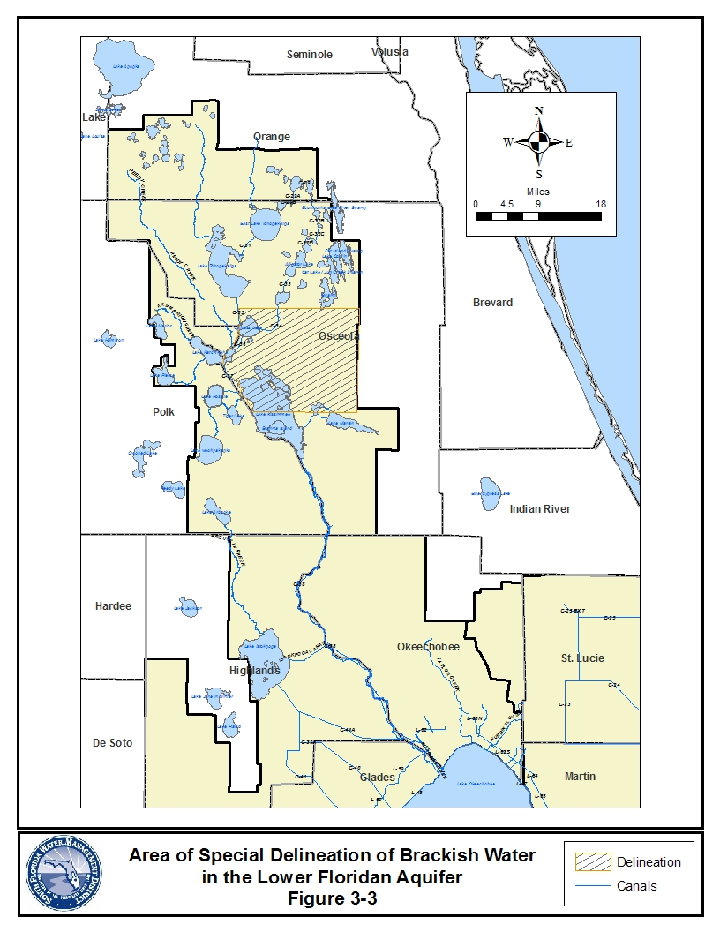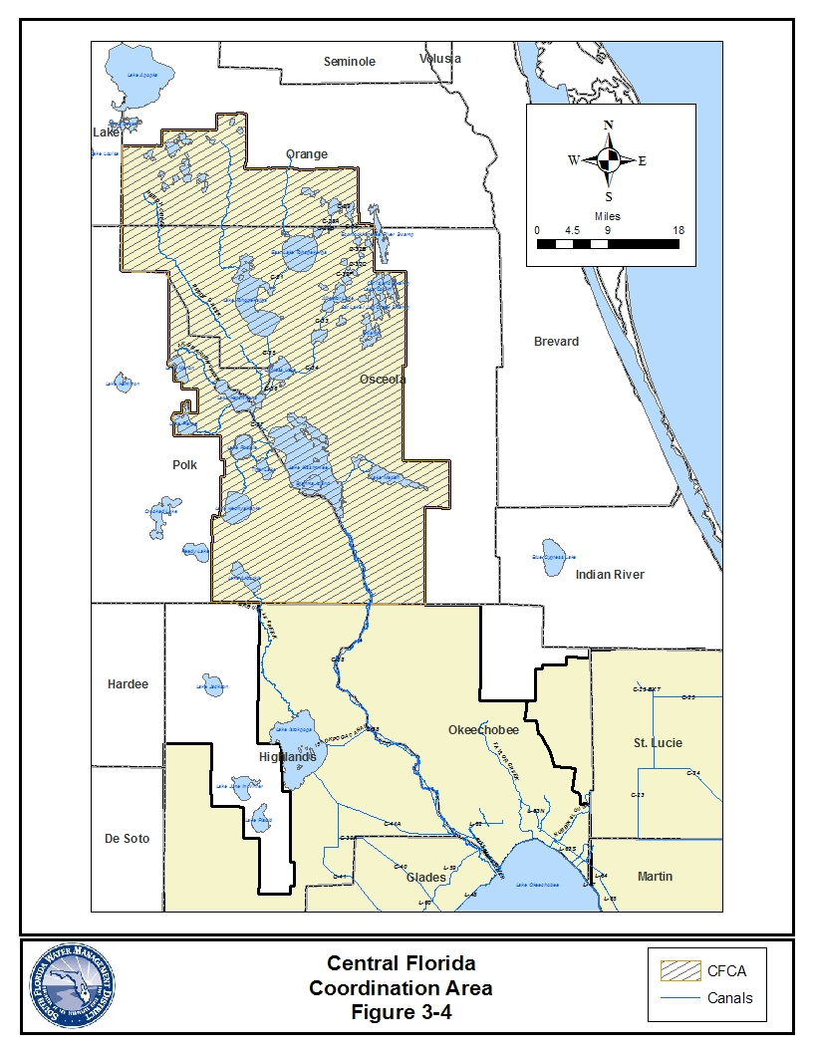

(G) The following restrictions shall apply when allocating surface water derived from the Lake Okeechobee Waterbody for consumptive use within the Lake Okeechobee Basin as defined in Section 1.7.3. This rule is a component of the recovery strategy for minimum flows and levels for Lake Okeechobee, as set forth in Chapter 40E-8, F.A.C., to address lower lake management levels and storage under the U. S. Army Corps of Engineers’ interim Lake Okeechobee Regulation Schedule (LORS), adopted to protect the public health and safety (April 28, 2008). Compliance with this rule along with the other criteria contained in the Basis of Review implements the objectives of the District to protect the public health and safety, to prevent interference among legal users of Lake water, to be consistent with the MFL recovery strategy as defined in Rule 40E-8.421, F.A.C., and to ensure that water necessary for Everglades restoration is not allocated for consumptive use.
(1) The rule applies to applications for new projects, existing unpermitted projects, modifications to existing projects, and permit renewals for existing projects located within the Lake Okeechobee Basin as described in Section 1.7.3, that propose to use surface water from the “Lake Okeechobee Waterbody,” defined as:
(a) Lake Okeechobee as identified in Rule 40E-8.021(12); or
(b) Integrated conveyance systems that are hydraulically connected to and receive water from Lake Okeechobee such as the Caloosahatchee River, the St Lucie Canal, or secondary canal systems that receive Lake Okeechobee water for water supply purposes via gravity flow or by pump.
This section does not apply to groundwater withdrawals such as withdrawals from wells, mining, and dewatering, or to projects that request to use a volume of water from the Lake Okeechobee Waterbody at or below the threshold contained in Subsection 40E-20.302(1)(a).
(2) Except as otherwise provided in this section, an applicant must demonstrate the requested allocation will not cause a net increase in the volume of surface water withdrawn from the Lake Okeechobee Waterbody over the entire "base condition water use" as defined in subsections (a) through (d), below. In determining the base condition water use, pursuant to subsections (a) through (d) below, the District shall consider and allow adjustments if the applicant demonstrates that such use is not representative of normal operations due to unanticipated conditions affecting the actual quantity of water withdrawn, such as extreme climatic conditions or equipment failure.
(a) Public Water Supply Use Class: the maximum quantity of water withdrawn by the applicant from the Lake Okeechobee Waterbody during any consecutive twelve month period between April 1, 2001 and January 1, 2008, consistent with the conditions of the existing permit. If a permit allocation existing on January 1, 2008 contains an allocation based on a conversion of a water treatment system, the base condition water use shall be increased to account for treatment losses of the new treatment plant as if the treatment system was operational during the above stated time interval;
(b) Irrigation Use Classes: the quantity of water calculated using Section 2.3.and 3.9.1 considering:
(i) The maximum number of acres actively irrigated by the applicant between April 1, 2001 and January 1, 2008 along with the associated crop type and irrigation method used. When determining the numbers of acres actively irrigated, data regarding historic crop plantings will be evaluated however short term reductions in historic plantings caused by disease or poor market conditions are not to be used in determining the actively irrigated acreage; or
(ii) If the irrigation project, or a portion thereof, has been authorized but not yet constructed pursuant to the conditions of a surface water management construction or environmental resource permit or authorization existing on January 1, 2008, the base condition water use will be calculated based on the number of acres and crop type identified in the environmental resource and water use permit or authorization in place as of January 1, 2008;
(c) Diversion and Impoundment Use Class: the demands of the applicant calculated pursuant to Section 2.7.2 for the physical conditions of the diversion and impoundment system as of January 1, 2008. In situations where historic uses were supplied by the diversion and impoundment project but not expressly identified or incorporated in the diversion and impoundment permit, the base case condition water use will be as calculated to include the historic demands served by the diversion and impoundment project between April 1, 2001 and January 1, 2008, consistent with the conditions of the existing permit.
(d) Other Use Classes: the maximum quantities of water withdrawn by the applicant (annual and maximum month) between April 1, 2001 and January 1, 2008, consistent with the conditions of the existing permit.
(3) Applicants shall provide reasonable assurances that the requested allocation will not cause a net increase in the volume of surface water withdrawn from the Lake Okeechobee Waterbody over the entire base condition water use. This demonstration is provided when the following criteria are met on a project by project scale as calculated pursuant to subsection 3.2.1 (G)(2), above:
(a) Permit Renewals: Those projects which timely seek re-issuance of a previous permit without modifications.
(b) Modifications that Maintain or Reduce Base Condition Water Use Calculated Pursuant to the Existing Permit: Examples of such modifications include changes to withdrawal facilities, irrigated acreage, crop type within the permitted use class, or irrigation efficiency that results in an allocation that is equal to or less than the project’s base condition water use calculated pursuant to the existing permit. In the event that the modification results in a use that is less than the project’s base condition water use, the applicant will be required to calculate the reduction from the project’s base condition water use associated with the requested modification.
(c) New Projects, Existing Unpermitted Projects, or Modifications Requesting Base Condition Water Use in Excess of the Amount Calculated Pursuant to the Previous Permit: Except for those uses as identified in (4) as an incompatible use, allocations will be provided from the following sources:
(i) Certified Project Water. Water provided from an operational water resource development project, as defined in Section 373.019(22), Florida Statutes, that has been certified by the Governing Board for allocation to consumptive uses, as defined in Section 1.8;
(ii) Lake Okeechobee Waterbody Withdrawals Offset by Alternative Sources. An alternative source of water that is demonstrated to replace the volume, including timing, of water proposed to be withdrawn from the Lake Okeechobee Waterbody over the base condition water use. Examples of offsets include recharge provided by reclaimed water applied to provide recharge to the Waterbody in equal or greater amounts than the proposed increase over the base condition water use;
(iii) Alternative Water Supply. Water provided from a source not restricted under this section such as groundwater, reclaimed wastewater or stored stormwater; or
(iv) Unassigned, Terminated, or Reduced Base Condition Water Use. The requested allocation is for available base condition water use calculated pursuant to subsection 3.2.1(G)(2), above, that was not authorized by an existing permit (i.e. “unassigned”), permitted base condition water use that has been made available through a permit which was terminated after January 1, 2008, or water made available pursuant to a modification made after January 1, 2008 which reduced the permitted base condition water use of an existing permit. In the event of competition for allocation of available base condition water use, those projects that seek an allocation of water in volumes equal to or less than that which was previously permitted to that project and/or used by that project shall be a positive consideration when determining which project best serves the public interest. Prior to February 28, 2010, the Governing Board reserves the right to restrict the re-allocation of terminated base condition water use if it determines that such water is demonstrated to improve the performance of an MFL waterbody under recovery in terms of shortening the frequency or duration of projected MFL violations or improve the performance of meeting a restoration target as defined in an approved District restoration plan or project while also considering if alternative water supplies are available, whether the proposed use is ancillary to an agricultural use and other relevant public interest considerations. On or after February 28, 2010, the Governing Board reserves the right to restrict the re-allocation of unassigned, terminated, or reduced base condition water use, if it determines that such water is demonstrated to improve the performance of an MFL waterbody under recovery in terms of shortening the frequency or duration of projected MFL violations or improve the performance of meeting a restoration target as defined in an approved District restoration plan or project while also considering if alternative water supplies are available, whether the proposed use is ancillary to an agricultural use and other relevant public interest considerations.
(4) Incompatible Use Type: Requested allocations for new public water supply uses that exceed the thresholds in Subsection 40E-20.302(1)(a), F.,A.C., or increases in existing uses above the project’s base condition water use calculated pursuant to Subsection (2)(a), above, shall not be permitted from the Lake Okeechobee Waterbody. Requests for temporary increases over the project’s base condition water use from the Lake Okeechobee Waterbody shall be granted to accommodate increased demands during a reasonable time period while alternative sources are constructed provided all other consumptive use permit criteria are satisfied. The duration of the temporary increase shall be determined based on a construction schedule for the alternative source to be implemented with due diligence and defined in permit conditions. Additionally, the permit shall include requirements to reduce the allocation to the base condition water use in accordance with this construction schedule.

3.2.2 Area of Special Concern

If the District determines that the application is in an area of special water concern because of either limitations on water availability or other potentially adverse impacts associated with the proposed withdrawal, then:

A. allocation of water shall be restricted or denied for irrigation purposes when reclaimed water is available and is economically, technically and environmentally feasible,

B. irrigation shall be restricted to the use of a micro- irrigation system or the irrigation allocation limited to the quantity of water equivalent to the efficiency achieved by a micro-irrigation system, or

C. monitoring programs shall be imposed to delineate the cone of depression surrounding a withdrawal.

3.2.3 Reclaimed Water Reuse Criteria

The encouragement and promotion of water conservation and use of reclaimed water are state objectives and considered to be in the public interest. In Section 373.250, F.S., the Legislature finds that use of reclaimed water provided by domestic wastewater treatment plants, permitted and operated under a reuse program approved by the Florida Department of Environmental Protection is environmentally acceptable and not a threat to public health and safety.

3.2.3.1 Public Water Utilities with associated wastewater treatment plants

Public water supply utilities that control, either directly or indirectly, a wastewater treatment plant, and which have determined, in accordance with Section 403.064, F.S., that use of reclaimed water is feasible, must provide the District with each of the following:

A. The existing reuse feasibility study or plan applicable to the utility's service area. Examples of such studies or plans include a reuse feasibility study prepared for the Department pursuant to Section 403.064, F.S., or a reuse project plan prepared for the Public Service Commission pursuant to Section 367.0817, F.S.

B. A copy of the schedule of implementation for reuse, including any available information regarding areas to be served, construction of reclaimed water distribution lines and associated capacities.

C. Documentation of the amount of presently uncommitted reclaimed water supply that is currently generated and is projected to be generated by the treatment plant over the duration of the permit.

D. Information regarding whether or not a local ordinance concerning use of reclaimed water has been enacted pursuant to either Chapter 125 or Chapter 180, F.S., which establishes a mandatory reclaimed water zone. Information should include a copy of the ordinance and applicable maps or legal description that delineates the zone.

3.2.3.2 Reuse Requirements

Permit applicants must evaluate the feasibility of using reclaimed water to meet all or a portion of their needs, as follows:

A. Mandatory Reclaimed Water Zones. For projects located either wholly or in part within areas designated by local ordinance as a mandatory reclaimed water zone and required by such local ordinance to use reclaimed water, permit applicants will only be allocated that quantity of water necessary to meet remaining reasonable-beneficial demands, if necessary, and a quantity necessary for emergency backup. When an ordinance exists, but reclaimed water supplies are not available at the time of permit application, the District will allocate water from conventional sources of supply and condition the permit to use the reclaimed water when it becomes available. At that time, the permit will be modified to reduce the allocation commensurate with the amount of reclaimed water provided.

B. End User Feasibility Evaluation: When reclaimed water is readily available it must be used in place of higher quality water sources, unless it is demonstrated by the Applicant that its use is either not environmentally, economically or technically feasible. The following criteria are used to demonstrate feasibility:

- Environmental Feasibility: Reclaimed water reuse is considered environmentally feasible if the Department has permitted the reuse facility that will provide the reclaimed water supply and has permitted the use or discharge of the reclaimed water to the receiving water body, if applicable.

- Technical Feasibility: In performing the technical feasibility portion of the evaluation, the applicant shall contact the applicable reuse utility and request a letter stating that reclaimed water is not available or provide the following information and consider the response provided by the reuse utility in its evaluation:

(a) Whether a reclaimed water distribution line is at the applicant’s project boundary.

(b) If a reclaimed water distribution line is not at the project boundary, then:

(i) Estimate the distance in feet from applicant’s project to the nearest potential connection point to a reuse line.

(ii) The date the reuse utility anticipates bringing the connection to the applicant’s project boundary.

(c) If reclaimed water is available at the project boundary, then:

(i) The minimum quantity in gallons per day of reclaimed water supply available from the nearest potential connection point under a 1-in-10 year drought condition.

(ii) The reliability of the potential reclaimed water supply (i.e., on-demand 24/7, or bulk-interruptible diurnal or seasonal, length of supply agreement, or other basis).

(iii) The typical operating pressures at which the reuse utility will provide reclaimed water at the nearest connection point to the applicant’s project, including any typical seasonal or other fluctuations in the operating pressure.

(iv) The water quality parameters of the reclaimed water for the constituents that the applicant has identified as pertinent to the intended use.

Reclaimed water reuse is considered technically feasible if reclaimed water is available at the site of the proposed use to meet all or part of the applicant's water needs as defined herein. In the event the supply of reclaimed water available is not adequate to fully meet the project's 1-in-10 year drought demands, the applicant may request a partial allocation of water from a non-reclaimed water source. However, such partial allocation will not exceed that amount necessary to compensate for the shortfall in reclaimed water supply, in light of total project demands calculated pursuant to the Basis of Review. Available at the project site means the utility has initially provided the distribution facilities at its cost to the project boundary. In the event distribution lines are not provided at the project boundary, the applicant must then provide an assessment of extending the lines to the project as a part of the economic feasibility analysis.

3. Economic Feasibility: If the applicant asserts that reuse is not economically feasible, then the applicant must provide the District with an assessment of the economic feasibility of use of reclaimed water use. In performing the assessment, the applicant shall contact the applicable reuse utility and request a letter stating that reclaimed water is not available or provide the following information and consider the response provided by the reuse utility in its analysis:

(a) The reclaimed water rate(s) the reuse utility would charge the applicant (e.g., the cost per/1000 gallons) and any other periodic, fixed, or minimum charges for use of reclaimed water by the applicant.

(b) The reclaimed water availability charges the reuse utility would charge the applicant in lieu of connection to the reclaimed system.

(c) Other one-time charges for the connection to the reuse.

(d) Whether the reuse utility helps fund potential reclaimed customers’ costs to connect to the reclaimed line or convert its operation to use reclaimed water.

The applicant's economic feasibility analysis must consider all of the following:

(a) Costs associated with purchase of a reclaimed water supply source including: i. pump and distribution costs, ii. storage costs, iii. monthly rates charged for the reclaimed water supply, and iv. costs associated with risk of loss of reclaimed supply;

(b) Costs associated with development of an otherwise permittable supply source including: i. well, pump, and distribution; and ii. operational costs including increased fertilizer costs, where applicable, power costs, pumping, and system operation and maintenance costs;

(c) Alteration in the rates charged by the permit applicant's business to account for costs associated with using reclaimed water; and

(d) Other factors affecting the economic feasibility of using reclaimed water as proposed by a permit applicant in light of their particular situation.

If the reuse utility fails to respond or does not provide the information within 30 days after receipt of the applicant’s request, the applicant shall 1) provide the District a copy of the applicant’s written request and a statement that the reuse utility failed to provide the requested information; and, 2) complete the end user feasibility evaluation with the best available information.
3.2.3.3 Unanticipated Loss of Reclaimed Water Supply

A. Emergency / short-term interruption of service: In order to account for such interruption of service, the reclaimed water end-user may request a permit for a "back-up" supply. The amount of water allocated for such use will be based upon historic reclaimed water treatment plant delivery performance or a 30 day supply, as determined by criteria described in Section 2.3.2, whichever is less. A "back-up" allocation will be issued for a duration of 20 years.

B. Long-term interruption / cancellation of service: The reclaimed water end-user may apply for a temporary or conventional water use permit. Should competition arise between a permit applicant who has lost its reclaimed water supply source and another permit applicant, the District shall consider the former reclaimed water end-user who has lost its supply to best serve the public interest under Section 373.233, F.S.

3.2.4 Maximum Developable Limits

Reasonable assurances shall be provided that the proposed use shall not cause harmful drawdowns so as to mine semi-confined freshwater aquifers on the Lower West Coast. The potentiometric head within the Lower Tamiami aquifer, Sandstone aquifer and mid-Hawthorn aquifer shall not be allowed to drop to less than 20 feet above the top of the uppermost geologic strata that comprises the aquifer at any point during a 1 in 10 drought condition. This criteria must be met except in areas closer than 50 feet from any existing pumping well. Reasonable assurances shall consider actual measured water level data for the affected area for the most recent 1 in 10 drought condition combined with the calculated drawdowns for all permits issued since that drought located within the area of influence of the requested allocation combined with the requested allocation.

3.3 Evaluation of Impacts to Wetlands and Other Surface Waters

This Section establishes the standards and thresholds for protection of wetlands and other surface waters from harm pursuant to the condition for permit issuance in Rule 40E-2.301(1)(c), F.A.C., including ensuring a water use shall not be harmful to the water resources of the area and is otherwise consistent with the overall objectives of the District. The standards and thresholds specified herein shall apply to all water uses, including applications for the initial use of water and modifications and renewals of consumptive use permits, and authorized water uses, herein referred to as the "water use". In its evaluation of the applicant’s water use, the District shall consider the extent of hydrologic alterations caused by the applicant’s water use, except as otherwise provided herein.

To provide reasonable assurances of compliance with the condition of issuance in Rule 40E-2.301(1)(c), F.A.C., an applicant must demonstrate that hydrologic alterations caused by the water use shall not adversely impact the values of wetland and other surface water functions so as to cause harm to the:

A. abundance and diversity of fish, wildlife and listed species; and

B. habitat of fish, wildlife, and listed species.

For purposes of this Section, an adverse impact to the value of wetland and other surface water functions in violation of the above shall constitute "harm."

This Section requires assessment of whether impacts of a water use constitute harm. If a water use would cause harm, then the applicant must comply with the elimination or reduction of harm provisions pursuant to Section 3.3.5, and mitigation requirements of Section 3.3.6.

Impacts to wetlands and surface water bodies associated with wetland enhancement, restoration, creation, preservation or other mitigation permitted pursuant to Part IV of Chapter 373, F.S., or other wetland regulatory program implemented by a local, regional, or federal governmental entity, shall be considered under this Section.

Impacts on wetlands and other surface waters not caused by the water use, including, but not limited to, impacts caused by existing surface water management activities, drainage, water table lowering, roads, levees and adjacent land uses, are not considered under this Section.

The hydrologic characteristics resulting from construction or alterations undertaken in violation of Chapter 373, F.S., or District rule, order or permit, shall be evaluated based on historic, pre-violation conditions, as if the unauthorized hydrologic alteration had not occurred.

3.3.1 Wetlands and Other Surface Waters

A. Delineation. Wetlands and other surface waters within the area of influence of the water use, delineated pursuant to Sections 62-340.100, F.A.C. through 62-340.600, F.A.C. as ratified by Section 373.4211, F.S., are subject to this Section, except as provided in subsection B below.

In accordance with Rule 62-340.300(1), F.A.C., reasonable scientific judgement shall be used to evaluate the existence and extent of a wetland or other surface water, including all reliable information, such as visual site inspection and aerial photo interpretation, in combination with ground truthing. In addition, relevant information submitted pursuant to Rule 62-340, F.A.C, in support of an Environmental Resource Permit/Surface Water Management Permit shall be considered. Field delineations of wetlands and other surface waters boundaries shall be required if such boundaries are in dispute.

In determining the location and category of wetlands and other surface waters, the applicant may consult several sources of information for guidance, as part of the information identified in Section 3.3.2. This includes the staff reports of previously issued Environmental Resource and Surface Water Management Permits for the site and adjacent sites, National Wetland Inventory (NWI) Maps, Land Use/Land Cover maps, Natural Resource Conservation Service soils maps, formal and informal wetland determinations conducted by the District, and wetland maps produced by local governments. District staff may inspect the site to confirm the location, categorization and delineation of wetlands and surface waters, and other site specific information. Site specific topographical data including elevations of hydrologic indicators, wetland boundary and bottom elevations shall be required in the event that the categorization of a wetland or other surface water is in question. In the event that access to offsite wetlands or other surface waters has been denied by the property owner, the District and the applicant shall mutually agree on a method of establishing the locations, categorizations and delineations of the offsite wetlands or other surface waters.

B. Exclusions. Harm to the following wetlands and other surface waters shall not require elimination or reduction of harm and mitigation, under this Section:

1. Isolated wetlands one half (1/2) acre or less in size unless:

(a) The wetland or other surface water is used by threatened or endangered species; (Nothing herein is intended to relieve an applicant of the obligation to comply with the Florida Fish and Wildlife Conservation Commission (FWC) rules pertaining to listed species, and with the Federal Endangered Species Act.)

(b) The wetland or other surface water is located in an area of critical state concern designated pursuant to Chapter 380, F.S.; or

(c) The wetland or other surface water is connected by standing or flowing surface water at seasonal high water level to one or more wetlands, where the combined wetland acreage is greater than one half acre.

2. Wetlands or other surface waters which have been authorized to be impacted to the extent established in a construction approval through an Environmental Resource Permit or a Surface Water Management Permit issued under Part IV of Chapter 373, F.S.

3. Constructed water bodies including borrow pits, mining pits, canals, ditches, lakes, ponds, and water management systems, not part of a permitted wetland creation, preservation, restoration or enhancement program. However, consideration of the design functions of water management systems shall be considered by Section 3.6, Existing Offsite Land Uses.

4. Wetlands or other surface waters to the extent they have been specifically authorized to be impacted or mitigated pursuant to Sections 3.3.5, 3.3.6, or 3.3.7 in a consumptive use permit, unless the applicant proposes additional impacts.

3.3.2 Permit Application Submittals

The following shall be included in the applicant's submittal:

A. For purposes of determining whether the wetland or other surface water is excluded under Section 3.3.1.B., the applicant shall provide supporting documentation, including a scaled map and recent aerial photograph marked with the wetland or other surface water location and reason for being excluded under Section 3.3.1.B. If it is demonstrated that the wetland or other surface water is excluded under Section 3.3.1.B., no additional information submittals shall be required under this Section.

B. For wetlands or other surface waters that are not excluded under Section 3.3.1.B, scaled maps and recent aerial photographs that identify:

1. The area of influence of the water use;

2. In accordance with Section 3.3.1.A., the locations of all wetlands and other surface waters that occur within the area of influence of the water use, including wetlands and other surface waters located outside the applicant’s property boundaries;

3. The locations of existing and proposed withdrawal facilities; and

4. The categorization of each wetland or other surface water located within the area of influence of the water use as described in Section 3.3.3.

C. Information about the current condition of the wetlands and other surface waters and the hydrology.

D. Information regarding the potential impact of the water use on the wetland or other surface water in its current condition.

E. Information regarding site specific considerations required to be submitted pursuant to Section 3.3.4.3.

F. Where there is potential for harm, information required to determine the extent of elimination or reduction of harm pursuant to Section 3.3.5 and mitigation required under Section 3.3.6, including an assessment of the use of the wetlands and other surface waters by listed species.

G. A monitoring plan to assess the effects of the water use, if required. A monitoring plan shall be required when necessary to provide continued verification that no harm is occurring due to the water use, such as when the cumulative impacts of water uses approach the numeric thresholds in Section 3.3.4.2 or when the applicant elects to use an alternative simulation condition or evaluation methodology pursuant to the narrative standard of Section 3.3.4.1.

H. If the applicant asserts the exclusions in Sections 3.3.1.B.2 or 3.3.1.B.4 or considerations in Section 3.3.7 apply to wetlands or other surface waters within the cone of influence of the proposed water use, the applicant must provide appropriate information supporting this assertion, including relevant information from the permit file.

3.3.3 Categorization of Wetlands and Other Surface Waters

Wetlands and other surface waters subject to consideration under this Section are grouped into three categories based on their normal hydrologic characteristics and their susceptibility to harm as a result of hydrologic alteration from water use withdrawals. Normal hydrologic characteristics are defined as the hydropattern that would occur without the impact of any authorized or unauthorized water uses.

In cases where existing surface water management “works” have permanently altered the normal hydrologic characteristics of the wetland or other surface water, the categorization shall be based on the resulting hydrology caused by the permanent alteration. Alterations that can effect wetland hydrology include canals, ditches, roads, structures or levees. The hydrologic characteristics resulting from construction or alterations undertaken in violation of Chapter 373, F.S., or District rule, order or permit, shall be evaluated based on historic, pre-violation conditions, as if the unauthorized hydrologic alteration had not occurred.

Wetlands and other surface waters are subject to evaluation under this Section, in accordance with the following:

Category 1: Natural lakes, deep ponds, rivers, streams, deepwater slough systems, coastal intertidal wetlands, and cypress strands that are permanently flooded throughout the year, except in cases of extreme drought. These include "permanently flooded" and "intermittently exposed" surface waters in the National Wetland Inventory maps.

Category 2: Seasonally inundated wetlands including cypress domes, emergent marshes, cypress strands, mixed hardwood swamps, or shrub swamps and exhibit standing water conditions throughout most of the year. These include "semi-permanently flooded" or "seasonally flooded" wetlands in the National Wetland Inventory maps.

Category 3: Temporarily flooded and saturated wetlands including wet prairies, and shallow emergent marshes, as well as seepage slopes, bayheads, hydric hammocks, and hydric flatwoods. These include "temporarily flooded" and "saturated" wetlands in the National Wetland Inventory maps.

This subsection shall be applied on a case by case basis to categorize wetlands and other surface waters based on their normal hydrologic characteristics and susceptibility to harm as a result of hydrologic alterations from water use withdrawals.

3.3.4 "No Harm" Standards and Thresholds

To demonstrate that no harm will occur to wetlands and other surface waters, reasonable assurances must be provided by the applicant that the narrative standard for Category 1, 2 and 3 wetlands and other surface waters in Section 3.3.4.1. is met.

For Category 2 wetlands, demonstration that the narrative standard is met shall be achieved through complying with the numeric threshold set forth in Section 3.3.4.2., unless such threshold is deemed by the District to be inapplicable due to the site specific considerations identified in Section 3.3.4.3. Site specific considerations may render the numeric threshold inapplicable. In these cases, the applicant shall demonstrate that harm as defined in the narrative standard in Section 3.3.4.1 will not occur, notwithstanding the numeric threshold.

The analysis for determining harm shall include an assessment of the projected hydrologic alterations caused by the water use and a cumulative assessment encompassing other existing legal uses, and resulting impact on the wetlands and other surface waters. In circumstances of cumulative contributions to harm, an applicant shall only be required to address its relative contribution of harm to the wetlands and other surface waters.

In the evaluation of the applicant’s water use, the District shall consider the extent of hydrologic alterations to wetlands and other surface waters caused by the applicant's water use based upon analytical or numerical modeling, or monitoring data, as required by Section 1.7.5., and this Section.

The determination of harm shall consider the temporary nature of water use drawdowns and seasonal application of certain water uses. Such consideration includes a determination of whether the hydrologic alteration is constant or if it recovers seasonally.

3.3.4.1 Narrative Standard

For Category 1, 2, and 3 wetlands and other surface waters, an applicant shall provide reasonable assurances that hydrologic alteration caused by the water use shall not adversely impact the values of wetland and other surface water functions so as to cause harm to the:

A. abundance and diversity of fish, wildlife and listed species; and

B. habitat of fish, wildlife, and listed species.

3.3.4.2 Numeric Thresholds for Category 2 Wetlands

Unless site specific considerations identified pursuant to Section 3.3.4.3 exist indicating the following numeric threshold for Category 2 wetlands is not applicable, the water use shall not be considered harmful when the modeled drawdown resulting from cumulative withdrawals in the unconfined aquifer beneath all portions of the wetland is less than 1.0 feet.

Water use withdrawals shall be modeled based on a maximum monthly allocation simulated for 90 days without recharge and as otherwise directed under Section 1.7.5.2. If the applicant chooses to use an alternative simulation condition, the narrative standard in Section 3.3.4.1 shall apply.

3.3.4.3 Site Specific Considerations

Site specific information shall be submitted by the applicant, if requested by the District or if otherwise deemed relevant by the applicant, for determining whether the narrative standard in Section 3.3.4.1. is met, including whether the numeric threshold in Section 3.3.4.2 is applicable. The applicant shall provide site specific information on the local hydrology, geology, actual water use or unique seasonality of water use, including, but not limited to:

A. Site specific hydrologic or geologic features that affect the projected drawdown shall be evaluated, including the existence of clay layers that impede the vertical movement of water under the wetland, preferential flow paths, seepage face wetlands that receive high rates of inflow, or the effects of soil depth and type on moisture retention, to the degree that actual field data support how these factors affect the potential for impacts of the water use on the wetland or other surface water.

B. If the applicant asserts that the actual water use has not caused harm to wetlands or other surface waters, site specific information on the condition of the wetlands or other surface waters in question must be provided in conjunction with pumpage records or other relevant evidence of actual water use to substantiate the assertion. Applicable monitoring data as described in Section 1.7.5.1 shall be submitted, if available.

C. Other relevant factors or information in assessing the potential for harm to wetlands and other surface waters, such as the condition, size, depth, uniqueness, location, and fish and wildlife utilization, including listed species, of the wetland or other surface water.

3.3.5 Elimination or Reduction of Harm

To the extent that harm is determined, the applicant shall modify the project design or water use, to the extent practicable, to eliminate or reduce harm to protected wetlands and other surface waters.

Modifications to the project or water use include developing alternative water supply sources, modification of pumpage, relocation of withdrawal facilities, implementation of water conservation measures and creation of hydrologic barriers.

A proposed modification that is not technically capable of being implemented, not economically viable, or adversely affects public safety through the endangerment of lives or property, is not considered “practicable”. In determining whether a proposed modification is practicable, consideration shall be given to:

A. Whether the wetlands and other surface waters have been impacted by authorized activities other than the water use (such as development, adjacent land use, drainage activities, operations of Works of the District, or an Environmental Resource or Surface Water Management Permit), and will continue to be impacted by such activities;

B. The cost of the modification for elimination or reduction of harm compared to the environmental benefit such modification would achieve, including consideration of existing infrastructure; and

C. As applicable for permit renewals, the considerations provided in Section 3.3.7.

The District shall not require the applicant to implement design modifications to reduce or eliminate harm when the ecological value of the functions provided by the wetlands and other surface waters to be adversely affected is low based on site specific analysis, and the proposed mitigation will provide greater long term ecological value.

3.3.6 Mitigation of Harm

Upon determination by the District that elimination or reduction of harm is not practicable, the District shall consider proposals for mitigation. Mitigation is required to offset the harm to the functions of wetlands and other surface waters caused by the water use as described herein.

In certain cases, mitigation cannot offset impacts sufficiently to yield a permittable project. Such cases often include activities that harm Outstanding Florida Waters, habitat for listed species, or wetlands or other surface waters not likely to be successfully recreated.

Mitigation shall not be required for impacts to wetlands and other surface waters previously mitigated through federal, state or local permit authorizations, such as other consumptive use permits or Environmental Resource or Surface Water Management Permits.

The District shall assess the condition of the wetland or other surface water as it exists at the time of the application submittal when determining mitigation requirements.

For permit renewals, mitigation requirements shall also be determined based on the provisions in Section 3.3.7.

3.3.6.1 Application of Environmental Resource Permit Provisions in Determining Mitigation Requirements

A. In the application of this Section, the following Environmental Resource Permit provisions within the Basis of Review for Environmental Resource Permit Applications within the South Florida Water Management District, regarding mitigation, shall be applied:

Section 4.2.2.3 regarding Assessment of Impacts;

Section 4.3.1 regarding Types of Mitigation, specifically Sections 4.3.1.1, 4.3.1.3 and 4.3.1.8;

Section 4.3.2 regarding Mitigation Ratio Guidelines;

Section 4.3.3 regarding Mitigation Proposals;

Section 4.3.4 regarding Monitoring Requirements for Mitigation Areas;

Section 4.3.5 regarding Protection of Mitigation Areas;

Section 4.3.6 regarding Mitigation Success; and

Section 4.3.7 regarding Financial Responsibility for Mitigation;

The above sections are herein incorporated by reference through Rule 40E-2.091, F.A.C.

B. Mitigation to offset the proposed harm shall be provided within the same drainage basin as the proposed harm, unless the applicant demonstrates that mitigation proposed outside of the drainage basin can fully offset the harm. Drainage basins, for purposes of this section, are set forth in Figure 4.2.8-1 of the Basis of Review for Environmental Resource Permit Applications, herein incorporated by reference.

C. In determining whether mitigation proposed outside of the drainage basin fully offsets the harm, consideration shall be given to the effect on the values of the remaining wetland and other surface water functions within the drainage basin, if the harm is mitigated outside of the drainage basin.

3.3.7 Consideration of Elimination or Reduction, and Mitigation of Harm, for Consumptive Use Permit Renewals

In addition to the considerations in Sections 3.3.5 and 3.3.6, for renewal of a consumptive use permit, the determination of whether elimination or reduction, and mitigation, will be required for impacts to wetlands or other surface waters not identified or expressly authorized to be impacted by the previous consumptive use permit, shall be made considering the following:

A. The existing wetland and surface water functions;

B. The degree to which the wetland or other surface water functions are reasonably expected to recover if the withdrawal is reduced or eliminated;

C. The projected impacts on the existing functions of the wetlands or other surface waters from continuing the water use;

D. Whether the wetland or other surface water is connected by standing or flowing surface water to, or is part of, an Outstanding Florida Water, Aquatic Preserve, state park, or other publicly owned conservation land with significant ecological value; and

E. As part of the fish and wildlife utilization considerations in subsections A, B, and C, above, special consideration shall be given to whether the wetland or other surface water is used for resting, nesting, breeding, feeding or denning by listed species.

3.4 Saline Water Intrusion

A water use permit application will be denied if the application requests freshwater withdrawals that would cause harm to the water resources as a result of saline water intrusion. Harmful saline water intrusion occurs when:

A. Withdrawals result in the further movement of a saline water interface to a greater distance inland toward a freshwater source except as a consequence of seasonal fluctuations; climatic conditions, such as drought; or operation of the Central and Southern Flood Control Project, secondary canal systems, or stormwater systems.

B. Withdrawals result in the sustained upward movement of saline water. Sustained upward movement is the level of movement that persists when the withdrawals have ceased. When the saline interface occurs beneath the point of withdrawal, the maximim amount of pumpage from any well shall be constrained as follows:

Q = 2π (b-l)² Δρ K
3 ρ

Where: Q is the maximum safe yield of well
b is the thickness of fresh water
l is the distance between top of aquifer and well screen
p is the density of fresh water
Δρ is the change in density of fresh water
K is the hydraulic conductivity of the aquifer

In order to provide reasonable assurances that harmful saline water intrusion will not occur, the Applicant shall demonstrate that:

1. A ground water divide (mound of fresh water) greater than one foot higher than the potentiometric head at the saline water source exists between the withdrawal point and the saline water source (defined by the location of the 250 mg/l isochlor); or

2. A hydrologic analysis of groundwater flow demonstrates that there will be no further net inflow of groundwater from the saline water source toward the withdrawal point; except as a consequence of seasonal fluctuations; climatic conditions, such as drought; or operation of the Central and Southern Flood Control Project, secondary canal systems, or stormwater systems, or

3. Other evidence shows saline water intrusion will not cause harm to the wellfield and water resource, if pumpage is allowed or increased. Should the Applicant’s proposed withdrawals occur in an area where the saline water interface is unstable (as demonstrated by increases in measured chloride concentration levels within the influence of the proposed use), the applicant shall determine the cause of the saline movement and the extent of future movement through the duration of the permit and shall demonstrate that the proposed withdrawal will not cause harmful saline intrusion through the duration of the permit.

3.4.1 Use of Saline Water

The District encourages the use of the lowest water quality for the use intended, while also providing for the long-term protection of the water resources. The use of saline water is permitted by the District as a source of supply for all uses. The use of saline water may cause limited increases in salinity but not to the extent of interfering with any presently existing legal use of water, otherwise harming water resources, or rendering the resource no longer usable by the Permittee. In order to provide reasonable assurances that harmful increases in salinity will not occur in violation of this section, the Applicant must demonstrate that:

A. The quality of the proposed source will be adequate for the intended use throughout the duration of the permit;

B. The proposed use will not cause harm to presently existing legal use of water as defined in section 3.7 of this Basis of Review; and

C. The proposed use of water will not cause harm to freshwater sources that come in contact with saline water as a result of the proposed use. Under the following conditions, the use of saline water will not be considered harmful to the receiving water body under this subsection:

i. the affected receiving water body is non-productive or low yielding in nature (hydrologic conductivity of less than 10 feet per day);

ii. the saline source water will discharge directly to tide after use;

iii. the saline source water will be diluted to less than 200 mg/L chloride concentration prior to use; or

iv. the impacts of the saline water use are compatible with surrounding
land uses.

Any use of saline water that comes into contact with fresh water as a result of the proposed use will require a detailed water quality monitoring program as a limiting condition of any permit issued. This rule is not intended to allow the District to consider disposal of concentrate resulting from desalination of saline water in determining compliance with the consumptive use permit conditions for issuance.

3.5 Pollution of the Water Resources

The issuance of a water use permit shall be denied if the withdrawals would cause significant degradation of surface or ground water quality through the induced movement of pollutants into a water resource that is not polluted. Significant water quality degradation may result from altering the rate or direction of movement of pollutants, as evidenced by the predicted influence the water withdrawals would have on inducing movement of the pollutants or as indicated by a sustained increase in background levels in pollutant concentrations.

3.6 Existing Offsite Land Uses

3.6.1 General Considerations

Pursuant to Rule 40E-2.301(1)(b), F.A.C., a permit applicant must demonstrate that the proposed withdrawal will not cause harm to offsite land uses, as defined in this Section. This Section does not establish a property right in water; but prohibits harm from a consumptive use withdrawal to certain land uses that are dependent upon water being on or under the land surface based on the considerations set forth below.

3.6.2 Specific Considerations

Whether a particular offsite land use is considered under this Section depends on whether there is a reasonable expectation that water will continue to exist on or under the land surface. When determining whether there is a reasonable expectation in the occurrence of water for a particular offsite land use, the District will consider: (1) the historic natural and artificial hydrologic variations on the property; (2) the purpose and nature of the water or water source, such as surface water management or water quality treatment; and (3) the practicability of protecting the land use without supplementation (for example, restricting consumptive uses from impacting water levels in a cow pond versus supplementing water levels in the cow pond with another water source). This Section is not intended to protect wetlands and other surface waters, which are protected against harm pursuant to Rule 40E-2.301(1)(c), F.A.C., and Section 3.3.

Only land uses that existed prior to the initiation of the consumptive use are protected under this Section. When a permit modification is considered under this Section, only the land use existing at that time of the pending application is considered. The responsibility to mitigate for harm to an offsite land use only extends to offsite land uses that predate the request for modification and only applies to harm projected to occur due to the requested modification. For permit renewals, the applicant is required to demonstrate that the allocation being renewed will not cause harm to land uses that existed at the time the allocation or portions of the allocation were first authorized either through an original permit or permit modification, consistent with the above provisions.

The following offsite land uses are protected from harm caused by a consumptive use withdrawal under this Section, when consistent with the considerations identified above:

A. Significant reduction in water levels on the property to the extent that the designed function of the water body and related surface water management improvements are damaged; not including aesthetic values. The designed function of a water body is that identified in the original permit or other governmental authorization issued for the construction of the water body. In cases where a permit was not required, the designed function shall be determined based on the purpose for the original construction of the water body (e.g., fill for construction, mining, or drainage canal).

B. Damage to agriculture, including damage resulting from reduction in soil moisture resulting from consumptive use; or

C. Land collapse or subsidence caused by reduction in water levels associated with consumptive use.

The applicant must identify those land uses that are potentially impacted from the withdrawal, such as sinkhole prone areas, seepage irrigated crop lands, and surface water management systems. The applicant must demonstrate that the resulting change in water levels related to the proposed consumptive use will not cause harm, as described above.

In order to receive protection under this rule, the impact on a land use must be the result of a consumptive use withdrawal. Impacts to land use can occur as a result of many different activities, such as drainage activities, reduced rainfall, regional trends, and other non-consumptive use related influences. Impacts from these non-consumptive use influences will not be protected or mitigated for under this Section. Sufficient technical and scientific proof of the cause and effect of the alleged land use impact must exist, demonstrating that associated consumptive use harms the offsite land use.

If the applicant cannot provide reasonable assurance that a proposed withdrawal will not harm an offsite land use, the applicant must submit a mitigation plan. The mitigation plan shall identify actions necessary to mitigate once the impact has occurred, or is imminent. Such actions must be sufficient to provide water consistent with the authorized use and will require a permit modification if required by Rule 40E-2.331, F.A.C. As necessary to offset the harm, mitigation will include pumpage reduction, replacement of the impacted individual's equipment, relocation of wells, change in withdrawal source, or other means.

The Permittee shall mitigate harm to offsite land uses that was caused in whole or in part by the permittee's withdrawals, consistent with the approved mitigation plan. The mitigation plan will require a permittee to mitigate immediately, or upon the actual occurrence of harm. The determination of when mitigation is required is based upon the likelihood that the harm is projected to occur.

3.7 Interference with Existing Legal Users

To obtain a water use permit the applicant must provide reasonable assurance that it will not interfere with any existing legal use of water, pursuant to Section 373.223(1)(b), F.S. In general, a permit applicant must provide reasonable assurances that the proposed withdrawal of water, together with other exempt or permitted withdrawals within the cone of influence of the proposed withdrawal, will not result in interference with existing legal uses.

A. Definition of "Existing Legal Use"

The determination of whether a water use is an existing legal use in the relation to the proposed withdrawal must be made under this analysis. Existing legal uses are protected from interference from other existing legal uses established subsequent to the establishment of the existing legal use. An existing legal use is defined by the terms and limiting conditions of the permit authorizing the withdrawal, if any. A use of water not permitted nor exempt pursuant to Part II of Chapter 373, F.S., is not an existing legal use.

The following criteria describe application of the existing legal use protection when permit modifications or renewals occur:

(1) When a permit modification is considered under this rule, only the existing legal uses existing at that time of the pending application are considered existing legal uses. The responsibility to mitigate for interference to an existing legal use only extends to interference to existing legal uses that predate such request and only applies to impacts that occur due to the requested modification.

(2) For permit renewals, the applicant is required to demonstrate that the allocation being renewed will not interfere with existing legal uses that existed at the time the allocation, or portions of the allocation, were first authorized either through an original permit or permit modification, consistent with the above provisions.

(3) Individual uses served by a permitted diversion and impoundment permit, are considered to be existing legal uses for purposes of this rule. However, interruption of service to uses served by a diversion and impoundment project, when such interruption is due to project operations of the diversion and impoundment project, shall not be considered interference under this Section.

B. Definition of Interference with Existing Legal Use

Interference to an existing legal use is defined as an impact that occurs under hydrologic conditions equal to or less severe than a 1 in 10 year drought event that results in the:

(1) Inability to withdraw water consistent with provisions of the permit or exempt use, such as when remedial structural or operational actions not materially authorized by existing permits must be taken to address the interference;

(2) Change in the quality of water pursuant to primary State Drinking Water Standards to the extent that the water can no longer be used for its authorized purpose, or when such change is imminent; or

(3) Inability of an existing legal user to meet its permitted demands without exceeding the permitted allocation.

C. Mitigation Requirements for Interference with Existing Legal Uses
If the permit applicant cannot provide reasonable assurance that a proposed withdrawal will not interfere with existing legal uses, the applicant must submit a mitigation plan. The mitigation plan shall identify actions necessary to mitigate for interference once the impact has occurred, or is imminent. Such actions must be sufficient to provide water consistent with the authorized use and will require a permit modification if required by Rule 40E-2.331, F.A.C. As necessary to offset the interference, mitigation will include pumpage reduction, replacement of the impacted individual's equipment, relocation of wells, change in withdrawal source, or other means.

Once the permit is issued, the Permittee shall mitigate interference with existing legal uses that was caused in whole or in part by the permittee's withdrawals, consistent with the approved mitigation plan. The mitigation plan will require a permittee to mitigate immediately, or upon the actual occurrence of an interference. The determination of when mitigation is required is based upon the likelihood that the interference is projected to occur.

3.8 Otherwise Harmful

The issuance of a permit shall be denied if the withdrawal or use of water would otherwise be harmful to the water resources.

3.9 Minimum Flows and Levels

Applications for consumptive use permits for water uses that directly or indirectly withdraw water from MFL water bodies must meet the criteria in this section, in addition to all other conditions for permit issuance in Chapters 40E-2 or 40E-20, as applicable. Applications that meet the criteria contained in this section are considered to comply with Rule 40E-2.301(1)(I), F.A.C. Consumptive use permit applications shall be reviewed based on the recovery or prevention strategy approved at the time of permit application review.

3.9.1 Evaluations for MFL Water Bodies Subject to a Recovery Strategy

Evaluations for direct or indirect withdrawals from MFL water bodies that are subject to a recovery strategy:

A. Permit Renewals: A request for renewal of an existing permitted allocation, which directly or indirectly withdraws water from a MFL water body, shall meet the requirements of this section if: (1) the impact of the withdrawal of water will be corrected through implementation of a recovery strategy; and (2) the level of impacts from the allocation approved in the expiring permit are no greater under the requested renewal.

If the level of certainty under the expiring permit is changed to a 1 in 10 year level of certainty by rule (e.g. a golf course irrigation level of certainty changed from a 1 in 5 to a 1 in 10 year level of drought) the levels of impact from the withdrawal of water under the expiring permit shall be normalized to a 1 in 10 drought level of certainty in order to evaluate the impact of the withdrawal of water.

B. New or Modified Permits – Direct Withdrawals. A request for a new or increased permit allocation which directly withdraws water from a MFL water body, shall meet the requirements of this section, if:

(1) Sufficient additional water has been made available for the new or increased portion of the requested allocation via certification of a project or project phase of the recovery strategies, as certified by the District, pursuant to Rule 40E-8.421(1)(e), F.A.C. Water made available from a certified project or project phase of a recovery strategy for new or increased uses will be allocated based on the criteria in the Basis of Review and Chapter 40E-2 or 40E-20, F.A.C.; or

(2) The request incorporates a District approved alternative measure or source that prevents additional impacts to the MFL water body from the new or increased portion of the requested allocation. An example of an acceptable alternative measure is an aquifer storage and recovery system, which stores excess water during the wet season in order to minimize new or increased withdrawals during the dry season. The permit conditions shall require the District approved alternative measure or source to be operating or otherwise available concurrently with the new or increased use.

C. New or Modified Permits – Indirect Withdrawals. A request for a new or increased permit allocation which indirectly withdraws water from a MFL water body, shall meet the requirements of this section, if the new or increased use is consistent with the recovery strategy as delineated in the applicable regional water supply plan.

3.9.2 Evaluations for MFL Water Bodies Subject to a Prevention Strategy

Evaluations for direct or indirect withdrawals from MFL water bodies that are subject to a prevention strategy:

A. Permit Renewals - A request for renewal of an existing permitted allocation that directly or indirectly withdraws water from a MFL water body shall meet the requirements of this section if the level of impacts from the allocation approved in the expiring permit are no greater under the requested renewal. If the level of certainty under the expiring permit is changed to a 1 in 10 year level of certainty by rule (e.g. a golf course irrigation level of certainty changed from a 1 in 5 to a 1 in 10 year level of drought) the levels of impact from the withdrawal of water under the expiring permit shall be normalized to a 1 in 10 drought level of certainty in order to evaluate the impact of the withdrawal of water.

B. New or Modified Permits – A request for a new or increased permit allocation that directly or indirectly withdraws water from a MFL water body, shall meet the requirements of this section if the request is consistent with the prevention strategy(ies) as delineated in the applicable regional water supply plan.

3.10 Aquifer Storage Recovery Systems

Applicants for Aquifer Storage and Recovery (ASR) systems authorized per Rule 40E-5.041, F.A.C., shall demonstrate that the provisions of Rule 40E-2.301, F.A.C., are met during: a)diversion of the water for storage; b) the time period in which the water is introduced into an aquifer for storage and stored within the aquifer; and c) recovery of the stored water. Unless otherwise noted below, the criteria used to demonstrate that the provisions of Rule 40E-2.301, F.A.C., are met are contained in applicable sections in the Basis of Review.

Impact evaluations shall be based on the reasonable demand for water associated with the proposed ASR system. The reasonable demand for ASR water will be based on the volume of water needed for recovery by the ASR system considering losses related to the initial volume stored for recovery.

A. Reasonable Demand: The allocation for the proposed project without ASR shall be calculated using methods contained in Section 2.0 for the appropriate use class such that the total project allocation with the ASR component provides for the 1 in 10 year drought demands of the project. The final allocation for the project will be adjusted, if necessary, for storage losses based on the nature of the demand for water as described as follows.

- For projects with water demands that are expected to increase over the duration of the permit, the incremental demands shall be calculated in five-year increments. The volume of water calculated at the end of each five-year period (Q) is available for seasonal storage during that five-year cycle. For each of the five years, the amount of water stored combined with the amount of water used shall not exceed the annual average permitted volume of the fifth year (Q). This allows the user to store both the unused portion of the allocation and the seasonal component of the demand. By the end of the five year cycle, a sufficient buffer zone in the storage horizon should be built up to provide for efficient recovery of the seasonal demand component. However, should the applicant demonstrate through past ASR performance or documentation of unique aquifer characteristics of the storage horizon (such as high permeability and poor confinement) that high losses of the stored fresh water occur, a supplemental allocation to account for the losses may be requested. The amount of supplemental water needed to account for the ASR losses shall be evaluated as to the overall efficiency of the water supply system. In the event that the volume of water lost during injection and storage is large (30% or more), the applicant shall evaluate and implement options to reduce the losses to an acceptable level.

- For projects that will achieve the build out demand within five years of permit issuance or which have demands that are not expected to increase, the reasonable demand shall be determined by the seasonal shift in demand combined with a supplemental allocation to account for losses should site specific characteristics of the storage horizon warrant.

For projects where the site specific characteristics of the storage horizon result in the need for additional allocation to cover storage losses, the applicant shall quantify the losses and request an adjustment in the annual allocation to account for reasonable storage losses. The losses shall be based on the degree to which the recovered water, combined with the conventional supply, produces a water quality that is usable for the permitted demand based on federal, state and local water quality standards.

B. Resource Protection: The applicant shall demonstrate that the diversion of water for storage in an ASR system shall not cause harm to the water resource as outlined in Rule 40E-2.301(1), F.A.C., during the wet and dry seasons. As part of this demonstration, the applicant shall provide reasonable assurances that the wet season demands for the ASR diversions do not cause harm to wetlands and other surface waters or harmful saline water intrusion.

C. Impacts to Existing Legal Users: The applicant shall identify the area of influence based on the volume of water calculated under subsection A., above. The area of influence of an ASR system shall address two factors: i) the area affected by the pressure change resulting from the injection and removal of stored water; and ii) the orientation of the stored fresh water and associated buffer zone. The applicant shall identify all existing legal uses within the area of influence and provide reasonable assurance that the operation of the proposed ASR system will not cause interference per the criteria contained in Section 3.7.

D. An ASR monitoring program will be required in the event there is a potential for interference with an existing legal user or harm to the water resources. Such a monitoring program will include monitor well(s) to measure aquifer pressure and water quality. In addition, monitoring of the quantities of water that is stored and recovered shall be measured and reported for permitted ASR systems.
3.11 Water Reservations

3.11.1 Picayune Strand and Fakahatchee Estuary

A permit applicant shall provide reasonable assurances that the proposed use will not withdraw water reserved under Rules 40E-10.041 (1) and (2), F.A.C., except that water uses less than 100,000 gallons per day associated with land management or public access/recreation shall be permittable. Compliance with the following criteria constitutes reasonable assurances that water reserved in Rules 40E-010.041 (1) and (2), will not be withdrawn. Water not reserved under Rules 40E-10.041 (1) and (2), F.A.C., shall be allocated pursuant to Subsections A and B.

For this section, the following definitions apply:

Direct Withdrawals from Groundwater: Water pumped from a well(s) constructed within the boundaries of the Picayune Strand or Fakahatchee Estuary into the water table or unconfined portions of the Lower Tamiami aquifer.

Indirect Withdrawals from Groundwater: a) a groundwater withdrawal from a well(s) constructed outside the boundaries of Picayune Strand and Fakahatchee Estuary into the water table or Lower Tamiami aquifer that results in a 0.1 foot or greater drawdown in the water table aquifer at any location underlying the Picayune Strand or the Fakahatchee Estuary, as determined by an evaluation conducted pursuant to Section 1.7.5.2.A.; or b) a groundwater withdrawal that causes a water table drawdown of 0.1 foot or greater underlying any canal identified in Figure 3-5, as determined by an evaluation conducted pursuant to Section 1.7.5.2.A.

Direct Withdrawals from Surface Water: Withdrawal of surface water from facilities physically located within the Picayune Strand or Fakahatchee Estuary boundaries.

Indirect Withdrawal from Surface Water: Withdrawal of surface water from any canal identified in Figure 3-5.

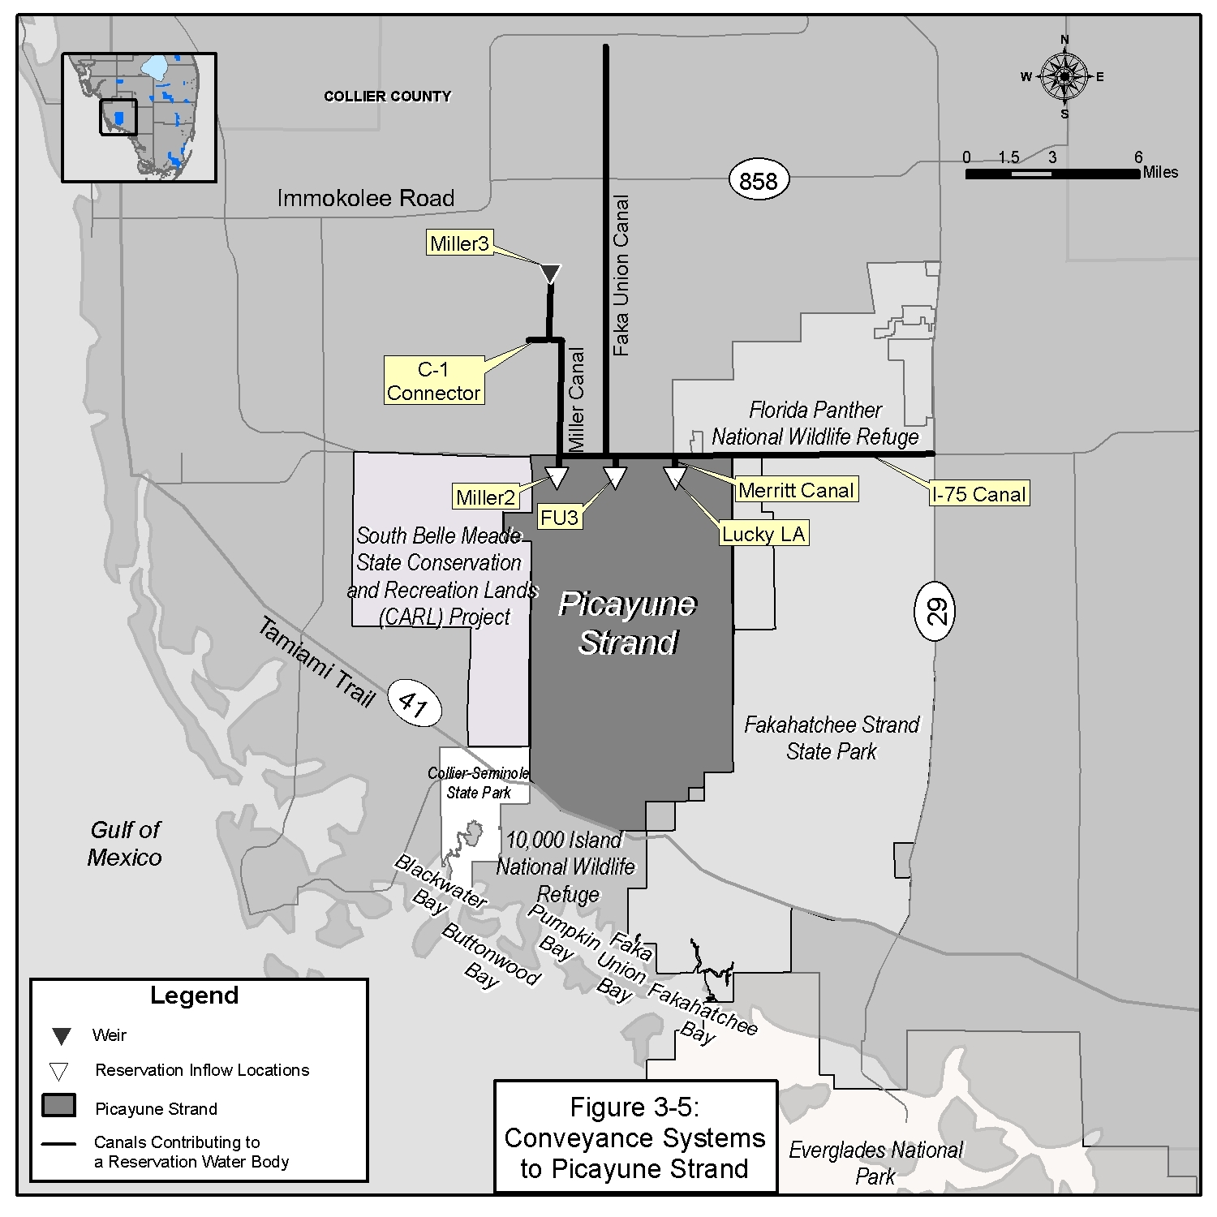
A. The following uses do not withdraw reserved water:

1. Withdrawals from the Sandstone aquifer, Mid-Hawthorn aquifer or the Floridan Aquifer Systems;

2. Withdrawals authorized by Rule 40E-20.302(3), F.A.C. (No-Notice Short-Term Dewatering General Water Use Permit);

3. A renewal of a water use authorized by a permit existing on July 2, 2009. If the level of certainty under the permit being renewed is changed to a 1 in 10 year level of certainty pursuant to Section 2.3.2 (e.g. a golf course irrigation level of certainty changed from a 1 in 5 to a 1 in 10 year level of drought), the resulting 1 in 10 year allocation shall be authorized;

4. A permit modification that does not change the source, increase the allocation or change withdrawal locations, such as replacement of existing wells with similar construction and at similar locations, crop changes that do not change the allocation or timing of use, or decrease in allocation;

5. A permit modification that does not result in a direct or indirect withdrawal as demonstrated through an analysis conducted consistent with Section 1.7.5.2.A. When a modification to an existing permit is requested, the 0.1 foot threshold for determining a direct or indirect withdrawal will be applied to the effect of the modification only. The change in the drawdown solely associated with the applicant’s proposed modification is calculated at the location of the 0.1 foot drawdown contour associated with the existing permit. If the change in drawdown associated with the proposed modification is less than 0.1 foot, the applicant’s modification does not withdraw reserved water;

6. A proposed new use that does not result in a direct or indirect withdrawal as demonstrated through an analysis conducted pursuant to Section 1.7.5.2.A.

7. A proposed new use with a direct or indirect withdrawal and no greater impact, including changes in timing, on a reservation water body than the terminated or reduced permit existing on July 2, 2009 within the same project site. This evaluation will be conducted pursuant to Section 1.7.5.2.

8. A proposed new use or proposed modification of a permit with an indirect withdrawal that does not withdraw reserved water from the Picayune Strand or the Fakahatchee Estuary. The determination that reserved water is not withdrawn shall be demonstrated by conducting the Model Impact Evaluation in Section B.

B. Model Impact Evaluation. If required by Section A, the applicant shall demonstrate water reserved for the Picayune Strand and Fakahatchee Estuary will not be withdrawn by conducting the following Model Impact Evaluation. A pre-application meeting between the Applicant and District staff is strongly recommended to be conducted prior to initiating model development.

1. Defining Scope of Model Evaluation
- For groundwater withdrawals, identify the cone of influence of the proposed withdrawal per Section 1.7.5.2.A. Based on this analysis, the Applicant shall identify which reservation inflow locations (set forth in Figures 1 and 2 in Rule 40E-10.021, F.A.C.) and conveyance system(s) identified on Figure 3-5 are potentially influenced by the proposed withdrawal.

- For surface water withdrawals, identify the reservation inflow locations, reservation water body (set forth in Figures 1 and 2 in Rule 40E-10.021, F.A.C.), and conveyance system(s) identified on Figure 3-5 that are potentially influenced by the proposed withdrawal.

2. Conditions of Model Development
- Boundary Conditions: The model domain and resolution of grid cell size shall be identified using professional standards for model development considering the area of influence, while avoiding boundary condition biases. At a minimum, boundaries shall be situated sufficiently distant from the area of interest or in such a manner as to prevent non-representative impacts from specified boundary conditions on predicted stages and/or flow in the area of interest.

- Surface and groundwater interactions: Surface and groundwater model codes that have undergone professional peer review and are representative of the physical system being simulated shall be used. Where integrated surface water and groundwater models are applied, time steps will be selected with consideration given to the resolution of the available data and the resolution necessary for quantifying flow volumes. Surface waters and overland flow time steps not exceeding 4 hours in length, canal flows time steps not exceeding 3 minutes, and groundwater time steps not exceeding 6 hours in length shall be considered acceptable. Alternative time steps may be used providing they produce an acceptable calibration as described in Subsection 3.11.1B.2(f). For the purposes of model calibration, the time steps used for simulating stages shall be averaged and flows shall be summed to produce daily values for comparison to measured data.

- Hydrologic Conditions: Rainfall and evapotranspiration shall be simulated based on data collected from 1988 through 2000 for the model domain.

- Land Use/Water Use: The model shall simulate 2000 land use existing on December 31, 2000 within the model domain (as identified in Subsection (a), above). The water use withdrawal data used for the model calibration shall reflect actual use during the period of 1988 through 2000. In the case of irrigation type uses, a supplemental crop irrigation module from the model code selected per Subsection (b) shall be acceptable for calculating variable demands.

- Project Features and Operations: Model simulations shall include project features and operations of the Picayune Strand Restoration Project utilized to simulate the flows identified in Rule 40E-10.041, F.A.C.

- Model Calibration: To calibrate the model, the model output shall be compared to the affected flow probability distribution(s) in Rule 40E-10.041 and surface water, groundwater stage, and flow data from monitoring sites located within the model domain. The model shall be considered calibrated when surface water and groundwater stage and flow are calibrated as required by Subsections (i), (ii) and (iii), below, and the resulting flow probability distribution curves from the Applicant’s model are consistent with the magnitude and timing of flows in the flow probability distribution curves identified in Rule 40E-10.041, F.A.C., for the time period including 1988 through 2000. In the event that the simulated model output for a monitoring site(s) or the flow probability distribution(s) does not meet these criteria, the Applicant shall provide a justification of the deviation. If such justification adheres to documented physical conditions in the field and comports with professionally accepted principles of hydrology, the monitoring sites or flow probability distribution(s) that do not meet the criteria shall be accepted.

    - Groundwater Stage Data: The mean error determined by comparing the model calculated groundwater stage as described in Subsection 3.11.1.B.2.(b) with the corresponding measured data shall not exceed 1.0 foot for the time period including January 1, 1995 through December 31, 1999. If the mean error is exceeded at a monitoring location, the groundwater calibration shall be considered acceptable when the absolute mean error of all the groundwater monitoring locations within the model domain do not exceed 1.0 foot and the deviation between the model simulation value and the measured value is explained as set forth in Subsection 3.11.1.B.2.(f).
    - Canal Stage Data: The average mean error determined by comparing the model simulated surface water stages as described in Subsection 3.11.1.B.2.(b) with the corresponding measured data should not exceed 0.3 foot for the time period including January 1, 1995 through December 31, 1999.
    - Flow Data: The mean error determined by comparing the model simulated surface water flow as described in Subsection 3.11.1.B.2.(b) with the corresponding measured data shall not exceed ten percent for the time period including January 1, 1995 through December 31, 1999.

3. Impact Evaluation
Once the model is calibrated, Applicants shall demonstrate that water reserved for the Picayune Strand and Fakahatchee Estuary will not be withdrawn, based on the following:

- “Without scenario”: All existing legal uses at the effective date of the rule shall be represented using the allocation in the permit. For the purposes of this evaluation and Subsection (b,) the annual allocation shall be distributed on a monthly basis based on the use type. For a public water supply use type, the monthly distribution shall be calculated based on the measured monthly pumpage divided by the annual total pumpage using the average of the three most recent representative years. Representative years shall not include years with water shortage restrictions, years with plant failures or other years that are not representative of normal pumpage. For an irrigation use type, the monthly distribution shall be determined using the Blaney-Criddle distribution calculated for each project pursuant to “Part B Water Use Management System Design and Evaluation Aids” of the “Basis of Review for Water Use Permit Applications within the South Florida Water Management District”, incorporated by reference in Rules 40E-2.091 and 40E-20.091, F.A.C., the annual allocation and the associated monthly distribution shall be simulated using the calibrated model developed in accordance with the criteria identified in Subsection 3.11.1.B.2 in order to generate a daily flow data for each represented inflow location identified in Subsection 3.11.1. These data shall be presented as daily hydrographs as well as seasonal and period of record flow probability curves.

- “With Scenario”: The “with scenario” includes all existing legal uses at the time of the evaluation of the application and the proposed use and pending applications for which the evaluation under this subsection is being conducted. The annual allocation and the associated monthly distribution shall be simulated using the calibrated model developed in accordance with the criteria identified in Subsection 3.11.1.B.2 in order to generate a daily flow data for each represented inflow location identified in Subsection 3.11.1. These data shall be presented as daily hydrographs as well as seasonal and period of record flow probability curves.

- The resulting flow volume distributions of the “with” and “without” scenarios shall be compared to determine whether the proposed use withdraws reserved water. Withdrawals of reserved water occur when the simulated flow volume probability curve(s) of the “with scenario” differs in flow distribution when compared to the “without scenario” at any of the inflow locations identified in Subsection 3.11.1.B.1

4. Alternative Model Evaluations
Applicants may propose alternative modeling evaluations in order to provide reasonable assurances that the proposed project does not withdraw water reserved under Rule 40E-10.041 F.A.C. Such modeling shall evaluate the impacts of the proposed project on the reservation water body under a representative range of hydrologic conditions for which the water reservations have been established (e.g. wet, average, dry hydrologic conditions). Proposed alternative modeling evaluations shall be submitted in writing to the District for review and comment prior to conducting such modeling either in a pre-application meeting or as part of the permit application. District staff shall approve those model approaches which utilize documented model codes that have undergone professional peer review and accurately represent the physical system; are calibrated consistent with the criteria contained in subsection 3.11.1.B.2(f) i., ii., and iii. or other appropriate criteria; accurately represents impacts to inflows of reserved water into the reservation water body as described in Rule 40E-10.041 F.A.C.; and represents existing legal uses and the proposed project withdrawals.

5. Reduced or Terminated Permit Impacts
If an existing legal use at the effective date of the rule has been reduced or terminated and results in increased inflows that result from the reduced or terminated use into the reservation water body, the applicant may seek an allocation that withdraws such increased inflows at any of the inflow locations identified in subsection 3.11.1.B.1. provided that the waters reserved in Rule 40E-10.041, F.A.C. are not reduced as demonstrated through an analysis conducted pursuant to subsection 3.11.1.B.3. or 4.. The quantity of increased inflow shall be available for allocation unless the Governing Board determines that allocation of the water is not consistent with the public interest under Section 373.223(1)(c), F.S.

In the event these criteria cannot be met, the applicant shall modify the application to otherwise meet the requirements of this Section.

3.11.2 North Fork of the St. Lucie River

The North Fork of the St. Lucie River water reservation, as stated in Rule 40E-10.051, F.A.C., protects Comprehensive Everglades Restoration Plan project water needed for protection of fish and wildlife within the North Fork of the St. Lucie River. Applications deemed complete prior to the conditions identified in subsection 40E-10.051(1), F.A.C., and which otherwise satisfy the requirements of Chapter 40E-2 or Chapter 40E-20, F.A.C., as applicable, are determined not to use the water reserved pursuant to Rule 40E-10.051, F.A.C.

4.0 MONITORING REQUIREMENTS

To ensure continuing compliance with the conditions of permit issuance, monitoring and reporting activities shall be required as special limiting conditions of the permit pursuant to Section 5.0 of this Basis of Review. The details of all required monitoring plans shall be submitted by the Applicant for District review and approval as part of the water use permit application and shall be a condition of permit issuance. The permit will require implementation of the approved monitoring programs.

4.1 Withdrawal Quantity

Proper accounting for water use is essential to establish that the use is a reasonable-beneficial use of the resource and in the public interest. In addition, proper accounting of the various water uses enables the District to better estimate water use and to implement water shortage plans.

All Permittees with a maximum monthly allocation of greater than 3.0 million gallons, or irrigation water users located within the South Dade County Water Use Basin (as designated in Figure 21-11, Chapter 40E-21, F.A.C.), with a maximum monthly allocation of greater than 15.0 million gallons, are required to monitor and report withdrawal quantities from each withdrawal facility or point of diversion. A reliable, repeatable water use accounting system must be identified to monitor water usage from all withdrawal facilities, in accordance with permit conditions. The District considers a reliable water use accounting method to be accurate within +/- 10 per cent of the actual flow. For pumped systems, acceptable water use accounting systems include flowmeters, or clocks which totalize pump operation. For gravity flow systems, acceptable methods include the use of rated water control structures. Water control structure rating curves certified by a professional engineer shall be submitted at the time of permit application and updated at a minimum of the five years as required in the permit limiting conditions. Rating curves for water control structures shall consider multiple headwater/tailwater conditions indicative of their site specific conditions. Irrigation quantities will be calculated based on the measured headwater/tailwater conditions to the water control structure rating curves and submitted to the District at the frequency specified in the permit limiting conditions.

Permit applicants must submit documentation of the water use accounting method and calibration method as a part of the permit application. Prior to the use of any authorized facility, the approved water use accounting method must be operating and the initial calibration submitted to the District. Recalibration results for the water use accounting method shall be submitted to the District every five years from permit issuance.

Withdrawal quantities for each permitted withdrawal facility shall be calculated monthly and reported to the District quarterly, unless otherwise conditioned on a greater frequency due to the potential for resource harm. Permittees, whose full demands are met through a combination of their own withdrawals or other sources, such as reclaimed water or water sales agreements, shall report the monthly totals supplied from sources other than their own withdrawals, unless the use of those sources are reported to another state agency, in which case the District shall obtain the water use information from said agency.

For special districts with withdrawal facilities that supply several individual users, such as diversion and impoundment systems and sub-basins within the Everglades Agricultural Area Water Use Basin which collectively derive their water supply from District operated structures, the water use shall be monitored at the primary withdrawal facilities. Individual surface water users within such systems do not need to submit individual pumpage reports, unless otherwise required by a water shortage order or as a part of a District permit compliance action.

The District advises diversion and impoundment permit applicants and surface water users within such systems that retaining accurate records of the types of crops, irrigated acreage, and duration of irrigation of such crops is relevant information for assessing system efficiency. In the event the District determines the diversion and impoundment system is inefficiently using water, then the District, at a minimum, will require the diversion and impoundment system or surface water users within such systems, as appropriate, to implement additional monitoring and conservation measures. Inefficient use of water by a diversion and impoundment permittee includes consideration of such factors as withdrawals in excess of the permit conditions in a drought condition less severe than a 1 in 10 year drought event and use of water in excess of that quantity of water calculated pursuant to Section 2.3.2. Such additional measures could include internal surface water quantity withdrawal monitoring or irrigation system efficiency assessment by a mobile irrigation lab.

For those special districts in which water is passed through the project, the permittee may be required to report the volumes of water that flow out of the project if necessary to quantify the water consumed by the project.

4.2 Saline Water Monitoring

The purpose of saline water monitoring is to ensure that harmful saline water intrusion, whether lateral from a surface or groundwater saline source, vertical from an aquifer containing lower quality water, or a combination of both, does not occur. Saline water monitoring is accomplished by routine sampling of the discharge water from production wells or from separate monitor wells. However, in areas of known saline water movement, separate monitor wells are required to be designed and constructed expressly for the purpose of saline water intrusion monitoring. The dissolved chloride concentration and the water level elevation, referenced to National Geodetic Vertical Datum, shall be measured. Frequency of measurements may be weekly, monthly, or quarterly, and will be identified in the permit limiting conditions.

Applicants shall submit a saline water monitoring program for review and approval
when:

A. The withdrawal facility is within one mile of a brackish or saltwater body including canals and tidal creeks;

B. The withdrawal facility is located seaward of the 250 mg/l chloride line mapped at the base of the aquifer or located seaward of a line between two adjacent salinity control structures;

C. The land on which the withdrawal facility is located is between the Intracoastal Waterway and the Atlantic Ocean; between a tidal creek and the Gulf of Mexico; or between the Intracoastal Waterway and the Gulf of Mexico;

D. Saline water is located either above or below the producing zone ;

E. A history of saline water intrusion or increasing chloride concentrations exists for either ground water or surface water in the vicinity of the withdrawal facility;

F. Staff evaluation indicates that, at projected withdrawal rates, saline water intrusion may occur to the extent that the existing treatment process will no longer be capable of producing potable water;

G. Staff evaluation indicates that, at projected withdrawal rates, saline water intrusion may occur in neighboring withdrawal facilities; or

H. Staff evaluation indicates saline water may come in contact with a fresh water source (per Section 3.4.1 of this Basis of Review) as a result of the proposed use.

Guidelines for establishing a saline water monitoring program, as well as sampling, sample handling, and analysis guidelines, are available from the District.

4.3 Pollution Source Monitoring

The purpose of pollution source monitoring is to ensure withdrawals do not cause harmful movement of contaminants in violation of state water quality standards. Movement of contaminants consistent with a state approved remediation plan is not considered harmful. In order to effectively monitor a pollution source, separate monitor wells must be installed and monitored to evaluate withdrawal effects on movement of the pollution. The Applicant shall submit a pollution source monitoring program identifying chemical constituents, monitoring frequencies, and well construction details and locations to the District for review and approval when the project’s withdrawals have the potential for a direct influence on a contaminant plume.

4.4 Water Level Monitoring

The purpose of water level monitoring programs is to ensure existing legal uses, offsite land use, and water resources, are not harmed by lowered water levels. Applicants shall submit a water level monitoring program to the District for review and approval when:

A. A saline water monitoring program or a pollution source monitoring program is required (see Sections 4.2 and 4.3);

B. A wetland hydrobiologic monitoring program is required (see Section 4.5); or

C. Uncertainty in computer modeling or data exists to define the drawdown resulting from withdrawals from ground water or surface water sources and to ensure that existing legal uses, offsite land use, water resources, and wetland and surface water functions are not harmed by withdrawals.

4.5 Wetland and Other Surface Waters Monitoring

Wetland monitoring shall be required to ensure that harm to wetland and other surface waters does not occur. Monitoring shall consist of various types of data collection, such as ground water and surface water levels, surface water quality, biological parameters, ground and aerial photography, rainfall, pumpage, and land cover assessments. Guidelines for establishing a wetland hydrobiologic monitoring program are available from the District. The Applicant shall submit a wetland hydrobiologic monitoring program to the District for review and approval when:

The impacts of the proposed use, either individually or cumulatively with other permitted users, produces drawdowns approaching the applicable drawdown criteria in Section 3.3.

5.0 PERMIT CONDITIONS

Water use permits shall be conditioned as necessary so that the use is consistent with the overall objectives of the program and are not harmful to the water resources of the area. There are two categories of permit conditions that will be applied to water use permits. Standard Conditions contain general information and operational constraints that apply to all uses of water. Special Conditions address project specific considerations that may vary among use classes, sources of supply and geographic locations.

5.1 Standard Permit Conditions

A. This permit shall expire on (expiration date)

B. Application for a permit modification may be made at any time.

C. Use classification is (primary water use type and secondary water use types).

D. Source classification is: (source classification) and the water use basin is (water use basin).

E. Allocations

1. Allocation for public water supply, and industrial use types

Total annual allocation shall not exceed (recommended actual allocation).

Total maximum monthly allocation shall not exceed (recommended maximum monthly allocation).

2. Allocation for agriculture, golf, landscape, and nursery irrigation, diversion/impoundment, livestock watering and aquaculture

Total annual allocation is (recommended actual allocation).

Total maximum monthly allocation is (recommended maximum monthly allocation).

These allocations represent the amount of water required to meet the water demands as a result of rainfall deficit during a drought with the probability of recurring one year in ten. The Permittee shall not exceed these allocations in hydrologic conditions less than a 1 in 10 year drought event. If the rainfall deficit is more severe than that expected to recur once every ten years, the withdrawals shall not exceed that amount necessary to continue to meet the reasonable-beneficial demands under such conditions, provided no harm to the water resources occur and:

(a) All other conditions of the permit are met; and

(b) The withdrawal is otherwise consistent with applicable declared Water Shortage Orders in effect pursuant to Chapter 40E-21, F.A.C.

3. Allocation from a specific source (aquifer, water body, facility or facility group)

Maximum annual allocation from (a specific source) shall not exceed (the recommended maximum annual allocation by source).

Maximum monthly allocation from (a specific source) shall not exceed (recommended maximum monthly allocation by source).

Maximum daily allocation from (a specific source) shall not exceed (the recommended maximum daily allocation by source).

F. In the event of a declared water shortage, water withdrawal reductions will be ordered by the District in accordance with the Water Shortage Plan, Chapter 40E-21, F.A.C. The Permittee is advised that during a water shortage, pumpage, water levels, and water quality data shall be collected and submitted as required by District orders issued pursuant to Chapter 40E-21, F.A.C.

G. Withdrawal facilities are:

H. Permittee shall mitigate interference with existing legal uses that was caused in whole or in part by the permittee's withdrawals, consistent with the approved mitigation plan. As necessary to offset the interference, mitigation will include pumpage reduction, replacement of the impacted individual's equipment, relocation of wells, change in withdrawal source, or other means.

Interference to an existing legal use is defined as an impact that occurs under hydrologic conditions equal to or less severe than a 1 in 10 year drought event that results in the:

(1) Inability to withdraw water consistent with provisions of the permit, such as when remedial structural or operational actions not materially authorized by existing permits must be taken to address the interference; or

(2) Change in the quality of water pursuant to primary State Drinking Water Standards to the extent that the water can no longer be used for its authorized purpose, or such change is imminent.

I. Permittee shall mitigate harm to existing off-site land uses caused by the permittee’s withdrawals, as determined through reference to the conditions for permit issuance. When harm occurs, or is imminent, the District will require the permittee to modify withdrawal rates or mitigate the harm. Harm as determined through reference to the conditions for permit issuance, includes:

(1) Significant reduction in water levels on the property to the extent that the designed function of the water body and related surface water management improvements are damaged, not including aesthetic values. The designed function of a water body is identified in the original permit or other governmental authorization issued for the construction of the water body. In cases where a permit was not required, the designed function shall be determined based on the purpose for the original construction of the water body (e.g. fill for construction, mining, drainage canal, etc.)

(2) Damage to agriculture, including damage resulting from reduction in soil moisture resulting from consumptive use; or

(3) Land collapse or subsidence caused by reduction in water levels associated with consumptive use.

J. Permittee shall mitigate harm to the natural resources caused by the permittee’s withdrawals, as determined through reference to the conditions for permit issuance. When harm occurs, or is imminent, the District will require the permittee to modify withdrawal rates or mitigate the harm. Harm, as determined through reference to the conditions for permit issuance includes:

(1) Reduction in ground or surface water levels that results in harmful lateral movement of the fresh water/salt water interface,

(2) Reduction in water levels that harm the hydroperiod of wetlands,

(3) Significant reduction in water levels or hydroperiod in a naturally occurring water body such as a lake or pond,

(4) Harmful movement of contaminants in violation of state water quality standards, or

(5) Harm to the natural system including damage to habitat for rare or endangered species.

K. If any condition of the permit is violated, the permit shall be subject to review and modification, enforcement action, or revocation pursuant to Chapter 373.

L. Authorized representatives of the District, with advance notice to the permittee, shall be permitted to enter, inspect, and observe the permitted system to determine compliance with permit conditions.

M. Permittee is advised that this permit does not relieve any person from the requirement to obtain all necessary federal, state, local and special district authorizations.

N. The permit does not convey any property right to the Permittee, nor any rights and privileges other than those specified in the permit and Chapter 40E-2, F.A.C.

O. Permittee shall notify the District in writing within 30 days of any sale, conveyance, or other transfer of ownership or control of the real property on which the permitted activities are located. All transfers of ownership are subject to the requirements of section 40E1-1.6107, F.A.C.

P. Permittee shall notify the District in writing 30 days prior to any changes to the project that could potentially alter the reasonable demand reflected in the permitted allocation. Such changes include, but are not limited to, change in irrigated acreage, crop type, irrigation system, large users agreements, or water treatment method. Permittee will be required to apply for a modification of the permit for any changes in permitted allocation.
5.2 Special Permit Conditions

Permittee shall submit all data as required by the implementation schedule for each of the limiting conditions to: S.F.W.M.D., Supervising Hydrogeologist – Water Use Compliance, Water Use Division (4320), P.O. Box 24680, West Palm Beach, FL 33416-4680 or by e-mail to wucomp@sfwmd.gov.

5.2.1 Public Water Supply

A. Permittee shall notify the District within 30 days of any change in service area boundary that results in a change in demand that affects its permitted allocation. The allocation shall be modified to effectuate such change.

B. Permittee shall implement the wellfield operating plan submitted in support of the permit application, as described in the District staff report.

C. Permittee shall implement the following wellfield operating plan:

D. Permittee shall determine unaccounted-for distribution system losses. Losses shall be determined for the entire distribution system on a monthly basis. Permittee shall define the manner in which unaccounted-for losses are calculated. Data collection shall begin within six months of Permit issuance. Reporting shall be submitted to the District on a yearly basis from the date of Permit issuance.

E. Permittee shall maintain an accurate flow meter at the intake of the water treatment plant for the purpose of measuring daily/monthly inflow of water. The monthly total inflow to the treatment plant shall be reported to the District quarterly.

F. Within two years of permit issuance, the Permittee shall submit a long-term water supply plan to the District for the purpose of assessing future water supply development activities within the water supply planning region. Prior to (board date + 1 year), the Permittee shall submit to the District an outline of the proposed plan. At a minimum, the plan shall address consideration by the Permittee of resource protection, water supply alternatives, plans for water shortages or wellfield failures, and conservation measures.

G. The following elements in the Water Conservation Plan required by Section 2.6.1 of the Basis of Review for Water Use Permit Applications within the South Florida Water Management District, must be implemented in accordance with the following approved implementation schedule:

H. For uses with an annual allocation greater than 10 MGD and a permit duration of 20 years, every five years from the date of permit issuance, the permittee shall submit a water use compliance report for review and approval by District Staff, which addresses the following:

1. The results of a water conservation audit that documents the efficiency of water use on the project site using data produced from an onsite evaluation conducted. In the event that the audit indicates additional water conservation is appropriate or the per capita use rate authorized in the permit is exceeded, the permittee shall propose and implement specific actions to reduce the water use to acceptable levels within timeframes proposed by the permittee and approved by the District.

2. A comparison of the permitted allocation and the allocation that would apply to the project based on current District allocation rules and updated population and per capita use rates. In the event the permit allocation is greater than the allocation provided for under District rule, the permittee shall apply for a letter modification to reduce the allocation consistent with District rules and the updated population and per capita use rates to the extent they are considered by the District to be indicative of long term trends in the population and per capita use rates over the permit duration. In the event that the permit allocation is less than allowable under District rule, the permittee shall apply for a modification of the permit to increase the allocation if the permittee intends to utilize an additional allocation, or modify its operation to comply with the existing conditions of the permit.

5.2.2 Dewatering

A. Prior to initial dewatering, the Permittee shall contact the District to allow for a site visit to verify:

(1) The water use accounting method used by the contractor and receive results of the calibration testing of the identified method,

(2) The location and design of the recharge trenches and on-site retention areas where dewatering water will be retained,

(3) The location of monitoring facilities, and

(4) Other site-specific issues related to the protection of the resource or other existing legal users.

Dewatering may commence upon written approval from the District that the preceding conditions have been satisfied as permitted.

A site visit can be scheduled by contacting: (water use permitting staff member).

B. All dewatering water shall be retained on the Permittee's land. Off-site discharge of dewatering effluent shall not be made.

C. Off-site discharge may be made via the facilities and conditions that follow:

D. Turbidity measurements of the dewatering water shall be made daily prior to discharge and submitted to the District weekly. If turbidity levels in the dewatering water exceed 29 NTU above background conditions in the receiving water body, the Permittee is required to cease dewatering operations and correct the situation until monitoring demonstrates turbidity standards are met.

E. Permittee shall not lower the water table below ___ feet NGVD, which is ____ feet below ground surface. The depth of the excavation shall not exceed ____ feet below ground surface. (blanks filled in based on project specifications).

F. Permittee shall construct the proposed recharge trenches prior to dewatering and maintain water levels during active dewatering operations within one foot of land surface. Obstructions and sediments within the recharge trenches shall be removed to increase effectiveness of the recharge system.

G. The excavation and associated dewatering facilities (such as impoundments and recharge trenches) shall be constructed using sound engineering practice. If the excavation or dewatering activities endanger the properties of adjacent owners (through erosion, side wall collapse, flooding, etc.), the Permittee shall cease operation until a method to prevent such occurrences is found and instituted. The Permittee shall be responsible for finding and instituting methods to stop such occurrences.

H. Permittee shall immediately cease dewatering when continued dewatering would create a condition hazardous to the health, safety, and general welfare of the people of the District.

I. Permittee shall be responsible for clearing shoaling, if the Permittee's dewatering operation creates shoaling in adjacent water bodies.

J. Permittee shall conduct dewatering activities in adherence to the following operating plan: (determined based on project specifications)

K. Following the dewatering operation, all dewatering facilities (such as impoundments, conveyances, and recharge trenches) shall be filled and regraded to ground elevation or to otherwise comply with the Environmental Resource Permit.

5.2.3 Irrigation

A. Landscape and golf course Permittees must comply with the water conservation plan requirements in section 2.3.1 of the Basis of Review for Water Use Permit Applications Within the South Florida Water Management District.

B. Landscape and golf course irrigation is prohibited between the hours of 10:00 A.M. and 4:00 P.M., except as follows:

a) Irrigation using a micro-irrigation system is allowed anytime.

b) Users whose average annual allocation is made up of 75% or greater volume of reclaimed water for irrigation may irrigate at anytime.

c) Irrigation of, or in preparation for, planting, new golf courses and recreational areas is allowed at any time of day for one 30-day period provided irrigation is limited to the amount necessary for sod or plant establishment. Irrigation of newly seeded or sprigged golf course areas is allowed any time of day for one 60-day period.

d) Watering in of chemicals, including insecticides, pesticides, fertilizers, fungicides, and herbicides, when required by law, recommended by the manufacturer or constituting best management practices, is allowed anytime within 24 hours of application.

e) Irrigation systems may be operated anytime for maintenance and repair purposes.

C. The allocation in this permit is for irrigation only, not the artificial maintenance of lake levels. The use of surface water lakes is for water quality treatment only. Therefore, the ratio of the number of gallons per day withdrawn from the groundwater wells to the number of gallons per day withdrawn from the surface water pumps shall not exceed 1:1 on a monthly basis.

D. The permittee shall complete a "Report of Planting and Harvest of Seasonal Crops" form and submit it with the appropriate "Quarterly Report of Withdrawals From Wells and Surface Water Pumps" form.

E. For uses with an annual allocation greater than 10 MGD and a permit duration of 20 years, every five years from the date of permit issuance the permittee shall submit a water use compliance report for review and approval by District Staff, which addresses the following:

1. The results of an on-site irrigation efficiency evaluation that estimates the efficient use of water on the project site, based on the method of irrigation that was permitted. Based on the evaluation, the permittee shall identify and implement specific actions to achieve the efficient use of water for the duration of the permit. In the event that based on the onsite irrigation efficiency evaluation an additional water allocation may be necessary, the permittee shall apply for a modification of the permit if the permittee intends to utilize an additional allocation, or modify its operation to comply with the existing conditions of the permit.

2. A comparison of the permitted allocation and the allocation that would apply to the project based on current District allocation rules. In the event the permit allocation is greater than the allocation provided for under District rule, the permittee shall apply for a letter modification to reduce the allocation consistent with District rules. In the event that the permit allocation is less than allowable under District rule, the permittee shall apply for a modification of the permit to increase the allocation if the permitee intends to utilize an additional allocation, or modify its operation to comply with the existing conditions of the permit.

F. For new or increased allocations over previously permitted allocations from sources not categorized as sources of limited availability, the permit shall expire within five years of issuance to the extent that permitted acreage has not been planted consistent with the timelines contemplated in the Permit, or to the extent the allocation has otherwise been abandoned pursuant to Section 373.243, F.S.

5.2.4 Industrial / Commercial

Industrial/Commercial Permittees must comply with the water conservation plan requirements in section 2.4.1 of the Basis of Review for Water Use Permit Applications within the South Florida Water Management District.

5.2.5 Reclaimed Water Feasibility

A. Upon notification from the District of the availability of reclaimed water pursuant to Section 373.250, F.S., the Permittee shall investigate the feasibility of obtaining reclaimed water and actively participate in discussions and negotiations with potential suppliers of reclaimed water when the supplies become available.

B. Should reclaimed water become unavailable, the Permittee shall apply to the District for an emergency water use permit prior to temporarily increasing withdrawals above the permitted allocation.

C. If reclaimed water becomes available prior to the expiration date of this permit, the Permittee shall apply for a modification of the water use permit to reflect that portion of the allocation which is to be provided for by reclaimed water. The permittee is required to request a permit modification when an agreement has been executed between both parties, the transmission lines are constructed to the project site, and the necessary on-site modifications and authorizations are obtained.

5.2.5.1 Reclaimed Water End Use

A. The permittee shall continue to investigate the feasibility of utilizing reclaimed water as an alternative water supply for this project. To this end, the permittee, or its successor, shall provide the District with periodic reclaimed water feasibility reports, to be submitted at five (5) year intervals commencing on (date 5 years from permit issuance) and continuing through the duration of this water use permit. Such reclaimed water feasibility reports shall evaluate the feasibility of utilizing reclaimed water and specifically consider: (1) whether a suitable reclaimed water supply source is available and permitted; (2) whether reclaimed water supply lines are available at the property boundary in sufficient capacity to serve permittee’s needs; (3) whether the permittee is capable of accessing the reclaimed water source through distribution lines; (4) whether use of reclaimed water is technically, environmentally, and economically feasible; and (5) whether use of reclaimed water would adversely affect requirements contained in permittee’s surface water drainage permit, if appropriate.

B. Upon notification from the District of the availability of reclaimed water pursuant to Section 373.250, F.S., the Permittee shall investigate the feasibility of obtaining reclaimed water and actively participate in discussions and negotiations with potential suppliers of reclaimed water when the supplies become available.

C. Should reclaimed water become unavailable, the Permittee shall apply to the District for an emergency water use permit prior to temporarily increasing withdrawals above the permitted allocation.

D. If reclaimed water becomes available prior to the expiration date of this permit, the Permittee shall apply for a modification of the water use permit to reflect that portion of the allocation which is to be provided for by reclaimed water. The permittee is required to request a permit modification when an agreement has been executed between both parties, the transmission lines are constructed to the project site, and the necessary on-site modifications and authorizations are obtained.

5.2.5.2 Public Water Utilities Reuse Information Updates

A. Public water utilities that control, either directly or indirectly, a wastewater treatment plant, and which have determined pursuant to Section 403.064, F.S., that use of reclaimed water is feasible, must provide the District with annual updates of the following information: (1) the status of distribution system construction, including location and capacity of lines; (2) a summary of uncommitted supplies for the next year; (3) copies of any new or amended local mandatory reclaimed water reuse zone ordinances; and (4) a list of end-users who have contracted to receive reclaimed water and the agreed upon quantity of water to be delivered.

B. Public water utilities that control, either directly or indirectly, a wastewater treatment plant, and which had determined, at the time of issuance of its consumptive use permit and pursuant to Section 403.064, F.S., that reuse of reclaimed water was not feasible must advise the District of any change in this determination that may occur during the term of the consumptive use permit. In the event the utility determines reuse has become feasible, then the District will require the utility to provide the information listed in Sections 3.2.3.1. and 5.2.5.2.A.

5.2.6. Diversion and Impoundment

5.2.6.1 Independent Secondary User Permits

The permittee must advise the diversion and impoundment permittee prior to applying to the District for a proposed change in surface water allocation from the diversion and impoundment system.

5.2.6.2 Dependent Secondary Users

A. The Dependent secondary users listed herein must advise the District and the diversion and impoundment permittee prior to any change in demands.

B. The diversion and impoundment system permittee is responsible for all violations of diversion and impoundment permit terms, except the violations of the dependent secondary users.

C. Within 90 days of the diversion and impoundment permittee agreeing to the inclusion of a dependent secondary user consistent with the requirements in Section 2.7.3.A., the diversion and impoundment permittee is responsible for submitting a request for a permit modification to the District to include the dependent secondary user.

D. All dependent secondary users must comply with the terms of their agreement with the diversion and impoundment entity and applicable terms of this permit.

5.2.7 Water Level, Saline Water Intrusion, Contamination, and Wetland Hydrobiologic Monitoring and Data Collection

One of the following Special Conditions shall be added to require monitoring when necessary to ensure the use of water authorized in the permit is not causing harm to the resource, the user, or other existing legal users:

A. Permittee shall implement the (water level, saline water intrusion, contamination, or wetland hydrobiologic) monitoring program described in the District staff report prepared in support of recommendation for permit issuance,
B. Permittee shall implement the following (water level, saline water intrusion, contamination, or wetland hydrobiologic) monitoring program:

5.2.8 Well Construction

A. Permittee shall secure a well construction permit prior to construction, repair, or abandonment of all wells, as described in chapters 40E-3 and 40E-30, F.A.C.

B. If a proposed well location is different from a location specified in the application, the Permittee shall submit to the District an evaluation of the impact of pumpage from the proposed well location on adjacent existing legal uses, pollution sources, environmental features, the saline water interface, and water bodies one month prior to all new well construction. The Permittee is advised the proposed well locations and resulting impacts must be in compliance with all permitting criteria and performance standards in effect at that time.

C. Permittee shall submit to the District an updated Well Description Table (Table "A") within 90 days of completion of the proposed wells identifying the actual total and cased depths, pump manufacturer and model numbers, pump types, intake depths and type of meters.

D. Permittee shall submit to the District an updated Well Description Table (Table "A") within six months of permit issuance, identifying which wells have been properly plugged and abandoned according to subsection 40E-3.531 (3), F.A.C. and which wells are to be maintained as water level monitoring wells.

E. Within six months of permit issuance, the Permittee shall plug and abandon the following wells in accordance with Chapters 40E-3 or 40E-30, F.A.C.: (individual wells identified based on project specifications).

F. Permittee shall submit to the District a well survey that shall include the following: well cased depth, well total depth, and chloride ion concentration of the water in wells not having this information listed in Well Description Table (Table "A"). This survey shall be submitted for the following wells within six months of permit issuance: (individual wells identified based on project specifications).

G. Within one month of new well construction, Permittee shall perform a step drawdown test. Prior to conducting the test, the Permittee shall submit a plan for the test to District staff for review and comment. Permittee shall submit step drawdown test information for the following wells to the District within one month of completion of the test: (individual wells identified based on project specifications). Information on performing step drawdown tests is available from the District.

H. Permittee shall perform an aquifer performance test on the proposed wells. Prior to conducting the test, the Permittee shall submit a plan for the test to District staff for review and comment. The test data for the following wells shall be submitted to the District within one month of completion of testing. Permittee shall submit the pumping rate, duration of test, and the drawdown at the end of the test. Information on performing aquifer performance tests is available from the District.

5.2.9 Flowing Floridan Aquifer Wells

A. Permittee shall submit to the District an artesian well survey that shall include the well cased depth, well total depth, and chloride ion concentration of the water in each well. This survey shall be submitted for the following wells within six months of permit issuance: (individual wells identified based on project specifications).

B. Prior to any permanent pump installation on Floridan aquifer wells in Martin or St. Lucie counties, the Permittee shall provide measurements of flow from each well using calibrated flow equipment. The method of accounting, calibration data, corrections for well losses, proposed pump information, and the basis for the requested flow rate shall be submitted to the District for review and approval. Staff approval will be granted if the natural flow rate of the well is greater than that of the proposed pump.

C. Temporary pumps installed on Floridan aquifer wells in Martin or St. Lucie counties to increase flow for freeze protection withdrawals must be removed within 72 hours of the conclusion of the freeze event.

5.2.10 Water Use Accounting (for permits with maximum monthly allocations greater than 3 million gallons)

A. Prior to any withdrawals at the project, the Permittee shall provide the results of the calibration testing of the identified water accounting method(s) and equip all existing and proposed withdrawal facilities with approved water use accounting method(s) pursuant to Section 4.1 of the Basis of Review for Water Use Permit Applications.

B. Every five years from the date of Permit issuance, the Permittee shall submit re-calibration data on each withdrawal facility.

C. Monthly withdrawals for each withdrawal facility shall be reported to the District quarterly. The water accounting method and means of calibration shall be stated on each report.

D. Permittees, who are dependent on other sources of water supply such as reclaimed water or water sale agreements to meet a portion of their demands, shall include the monthly volumes from all other sources in the report to the District, unless the use of those sources is reported to another state agency, in which case the District will obtain the water use information from said agency. The water accounting method and means of calibration shall be stated on each report.

E. Permittee shall maintain records of the calibrated daily withdrawals from each withdrawal facility. These records shall be available for review upon request by District staff.

F. Daily withdrawals for each withdrawal facility shall be reported to the District on the following schedule. The water accounting method and means of calibration shall be stated on each report.

5.3 Specific Region Special Conditions

A. A "Water Rights Compact Among the Seminole Tribe of Florida, the State of Florida, and the South Florida Water Management District", which confirms tribal rights has been approved. Exercise of tribal rights in the future may impact allocations sought by the Permittee in future permit modifications and renewals.

B. The property which is the subject of this Permit is located in the area covered by Chapter 40E-63, F.A.C, (Works of the District within the Everglades). This special condition is intended to notify the Permittee that this property may be subject to additional or new permitting or water quality requirements as specified in Chapter 40E-63, F.A.C.

C. Permittee shall be subject to all the stipulations agreed to in any executed landowner agreement reached between the Permittee, the District and the Seminole Tribe of Florida. Such stipulations may impact allocations sought by the Permittee in future Permit modifications and renewals.

D. Permittee and the Lake Worth Drainage District have previously entered into an interlocal agreement for mitigation of impacts. It is acknowledged and agreed by the Permittee that this modification of the permit shall be incorporated into and made part thereof the interlocal agreement.

E. Permittee will be responsible for mitigation to domestic uses, including but not limited to those shown in the District staff report for this permit, in the event that declining water levels result in domestic uses suffering a loss of water supply and the event is confirmed by application of the following factors by District staff. Factors used in determining mitigation responsibility include, but are not limited to, water level monitoring data, local pumpages, and climatic conditions. Failure by the Permittee to mitigate any adverse impacts that occur as a result of the Permittee's withdrawals, for which mitigation responsibility has been determined, will be considered a permit violation.

F. In addition to the general and other special conditions described in this part, permits for public supply utility applicants and similar applicants withdrawing groundwater in the CFCA shall include special conditions that address the following:
1. Implementation of a plan to monitor hydrology, ecology, and water quality in areas subject to impacts from the permitted withdrawal, with at least annual data reporting and analysis.

2. Implementation of specific measures to mitigate or avoid harm that would otherwise occur as a result of the permitted allocation.

3. Implementation of mitigation or avoidance actions to address any unanticipated harm, if the District finds that harm will occur or has occurred as a result of the permit allocation.

4. Development and use of supplemental water supply to meet water demands in an expeditious manner as described in 3.2.1.F.3.

5. Submittal of five-year compliance reports for 20 year duration permits as described in subsection 373.236(4), F.S.

6. The reduction in allocation or other modification to the permit, after review of each five-year compliance report or at any other time during the term of the permit, if needed to abate observed or projected harmful impacts as a result of the permitted use, unless the harmful impacts can be mitigated by the permittee. The permittee shall be provided with notice and an opportunity for a hearing under chapter 120, F.S., if the District makes such a reduction or other modification.

5.4 Surface Water Management

This is an existing project. An Environmental Resource or surface water management permit will be required prior to any change in land use or modification of the drainage system.

