Appendix I:

Protection of Threatened and Endangered
Species in Portions of the Suwannee, Withlacoochee, Santa Fe, New, and
St. Johns Rivers

Protection of Threatened and Endangered

Species in Portions of the Suwannee, Withlacoochee, Santa Fe, New, and

St. Johns Rivers

March 2013

Prepared by:
Florida Department of Environmental Protection
Division of Environmental Assessment and Restoration

Table of Contents

1. Introduction 1
2. Summary of Existing DO Conditions in Portions of the Suwannee, Santa Fe,
New, and Withlacoochee Rivers 1
3. Determining Whether DO Values Have Decreased Below the Baseline
Distribution Protective of the Gulf Sturgeon and Oval Pigtoe Mussel 2
4. Protection of the Atlantic and Shortnose Sturgeon 7

Protection of Threatened and Endangered Species in
Portions of the Suwannee, Withlacoochee, Santa Fe,
New, and St. Johns Rivers

Introduction
The purpose of the Endangered Species Act (ESA) passed by Congress in 1973 is to protect and promote recovery of imperiled species and the ecosystems upon which they depend. To accomplish this objective, the ESA affords additional protection to threatened and endangered species to prevent: 1) damage to, or destruction of, a species’ habitat; 2) overutilization of the species for commercial, recreational, scientific, or educational purposes; 3) disease or predation; 4) inadequacy of existing protection; and 5) other natural or manmade factors that affect the continued existence of the species.
During the development of the proposed dissolved oxygen (DO) criteria, FDEP has worked with the U.S. Fish and Wildlife Service (FWS) and NOAA's National Marine Fisheries Service (NMFS) to assure that the threatened and endangered species occurring in Florida are provided adequate protection. During their review of the proposed freshwater criteria, FWS and NMFS determined that four endangered species may not be fully protected by the proposed DO criteria. These species are the young of the year Gulf sturgeon (Acipenser oxyrinchus desotoi) that can be found in portions of the Suwannee, Santa Fe, and Withlacoochee Rivers, the oval pigtoe mussel (Pleurobema pyriforme) that inhabits portions of the Santa Fe and New Rivers, and young Atlantic (Acipenser oxyrinchus) and shortnose sturgeon (Acipenser brevirostrum) that can inhabit the St. Johns River. The specific areas where the Gulf sturgeon and mussel may be found are illustrated in Figure 1.
The St. Johns River represents the southern extent of the range for the Atlantic and shortnose sturgeon. Even though the evidence suggests that the sturgeon occurring in the St. Johns River are transient individuals that do not spawn in the St. Johns, the ESA still requires that the portions of the river where spawning may occur in the future be afforded additional protection. A map showing the portions of the St. Johns River where the sturgeon could potentially spawn is provided in Figure 2.

Summary of Existing DO Conditions in Portions of the Suwannee, Santa Fe, New, and Withlacoochee Rivers
Because relatively little information is available concerning the specific DO requirements of these species, especially for the mussel, and since the populations of the sturgeon and mussel are stable and may actually be increasing in these river systems, it is reasonable to assume that maintaining the existing DO conditions would provide adequate protection in the future.
To summarize the existing DO conditions, data for each river segment in the potential range of the young sturgeon and mussel were obtained from the Impaired Waters Rule (IWR) database for the period since 1966. After reviewing the data for the entire period of record (i.e., 1966 – 2011), the period from 1991 through 2011 was chosen for use in summarizing the existing conditions. The 1991 to 2011 period was selected because the 21 year period is long enough to capture the expected range of temporal variability and covers a significant portion of the period when the sturgeon population in the region has been stable or increasing. Additionally, the monitoring conducted prior to 1991 was conducted less frequently and often only covered portions of the year. Data collection after 1990 was more consistent, with a greater amount of data being collected that generally covered all months of the year. Therefore, to avoid biasing the summary of the existing DO conditions, the data collected prior to 1991 were omitted from further data analyses.
A summary of the existing DO conditions during the period from 1991 through 2011 for the portions of the Santa Fe and New Rivers potentially utilized by the Oval Pigtoe mussel is provided in Table 1 by river system and individual river segment (River km/WBID). Similarly, the summary statistics for the portions of the Suwannee, Santa Fe, and Withlacoochee Rivers potentially utilized by the gulf sturgeon are provided in Table 2 by river system and individual river segment.

Determining Whether DO Values Have Decreased Below the Baseline Distribution
To evaluate whether DO values have decreased below the baseline distribution, it is recommended that a) no more than 10 percent of the DO measurements be below the 10th percentile of the existing data distribution for that river segment, b) no more than 50 percent of the measured values to be below the median of the existing data distribution for that river segment. The 10th percentiles and median DO values for each of the affected river segments are provided in Table 3.
The recommended rule language is:
In the portions of the Suwannee, Withlacoochee (North), and Santa Fe Rivers utilized by the Gulf Sturgeon, and in the portions of the Santa Fe and New Rivers utilized by the oval pigtoe mussel, DO levels shall not be lowered below the baseline distribution such that more than 50 percent of measurements are below the median of the baseline distribution or more than 10 percent of the daily average values are below the 10th percentile of the baseline distribution for the applicable waterbody. The baseline distributions are provided in Appendix I of the Technical Support Document for the Derivation of Dissolved Oxygen Criteria to Protect Aquatic Life in Florida’s Fresh and Marine Waters, which is incorporated by reference.
When assessing these waters in the future, compliance with both the 10th percentile and median DO values will be evaluated using a binomial hypothesis test at the 80 percent and 90 percent confidence levels necessary to place a water segment on the Planning List and Verified Lists, respectively, for TMDL development. The use of the binomial hypothesis test is consistent with the assessment for other water quality parameters conducted under Chapter 62-303, F.A.C. The number of exceedances required to have 80 percent and 90 percent confidence that more than 10 percent of the measurements are below the applicable 10th percentile value are provided in Chapter 62-303, F.A.C. Tables 1 and 3, respectively. The number exceedances required to have 80 percent and 90 percent confidence that more than 50 percent of the measurements are below the applicable median value for sample sizes up to 419 are provided in Table 4.

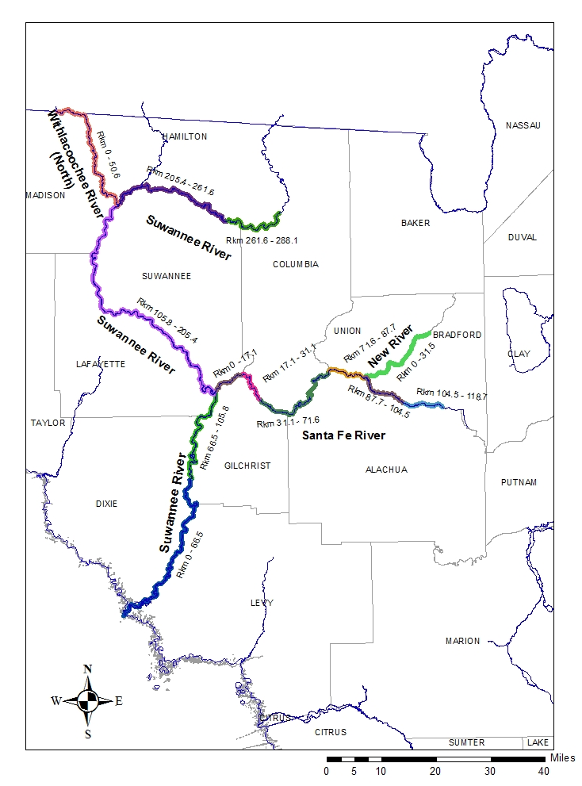
Figure 1. The portion of the Suwannee, Santa Fe, New, and Withlacoochee North Rivers utilized by the Gulf Sturgeon and oval pigtoe mussel requiring alternative DO criteria.
Table 1. Summary statistics for existing DO conditions in the portions of the Santa Fe and New Rivers utilized by the Oval Pigtoe mussel for the period from 1991 through 2011.

Table 2. Summary statistics for existing DO conditions in the portions of the Suwannee, Santa Fe and Withlacoochee Rivers utilized by the Gulf Sturgeon for the period from 1991 through 2011.

Table 2. Continued.

Table 3. Baseline DO conditions for portions of the Suwannee, Santa Fe, New, and Withlacoochee Rivers utilized by the Gulf Sturgeon and Oval Pigtoe Mussel. The 10th percentile and median percent DO saturation values were determined from data collected from 1991 through 2011.

Table 4. Minimum number of samples not meeting applicable median criterion needed to put a water on the planning list with 80% confidence and on verified list with 90% confidence that more than 50% of measurements are below median.

Table 4. Continued.

Table 4. Continued.

Protection of the Atlantic and Shortnose Sturgeon
Based on discussions with NOAA's National Marine Fisheries Service (NMFS) staff responsible for the protection of the Atlantic and shortnose sturgeon, the area in the St. Johns River between the U.S. Highway 17 Bridge in Palatka north to the Shands Bridge (U.S. Highway 16) bridge near Green Cove Springs (Figure 2) is an area where both species could potentially spawn in the future. According to the NMFS, any future spawning of the sturgeon in the St. Johns River would occur during the period from February through March.
To assure no adverse effects on the Atlantic and shortnose sturgeon juveniles, the current 5.0 mg/L DO criterion will be maintained in the St. Johns River between the U.S. Highway 17 Bridge in Palatka north to the Shands Bridge (U.S. Highway 16) bridge near Green Cove Springs during the months of February and March. During the other times of the year when the sturgeon are less sensitive, the DO criteria proposed for the Northeast and Big Bend bioregion would apply.

Sturgeon in the St. Marys River
Historically, Atlantic and shortnose sturgeon have occasionally been found in portions of the St. Marys River. According to NMFS staff, most of the sturgeon captures in the St. Marys have occurred between river km 26 and 44. However, there is no evidence that spawning has occurred in the St. Marys River due to natural conditions not being favorable. Even though the portions of the Marys River where sturgeon have been captured have very limited anthropogenic inputs, the DO levels are naturally low with significant portions of the river commonly exhibiting DO concentrations below 3 mg/L as a result of the natural conditions including wetland inputs, high color, high degree of shading/canopy cover, low flow, etc. Additionally, NMFS staff have indicated that sturgeon have been captured in the St. Marys at DO concentrations as low as 2.7 mg/L.
While the natural DO levels in the St. Marys may not be ideal for the widespread occurrence of the sturgeon, FDEP is prohibited by state statute from implementing regulations that would require natural background conditions to be ameliorated. Since the DO criteria proposed for the Northeast and Big Bend bioregion are protective of the natural DO levels found in the St. Marys River, no additional modification was deemed necessary.

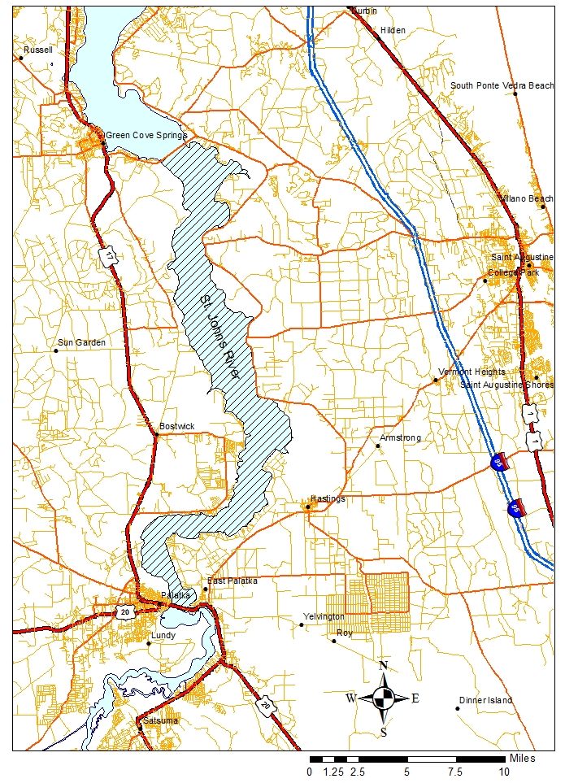
Figure 2. The portion of the St. Johns River between the U.S. Highway 17 Bridge in Palatka north to the Shands Bridge (U.S. Highway 16) bridge near Green Cove Springs (shown by hatching) requiring alternative DO criteria to assure potential sturgeon spawning habitat is protected.

