Technical Support Document:

Derivation of Dissolved Oxygen Criteria

to Protect Aquatic Life in Florida’s

Fresh and Marine Waters

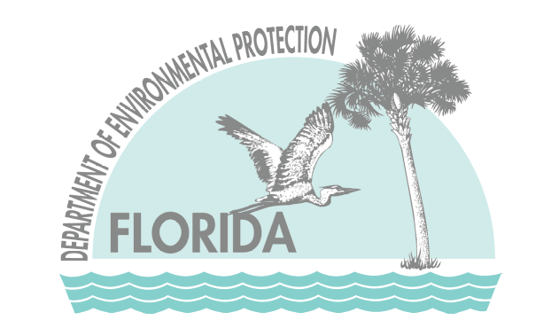

March 2013
DEP-SAS-001/13

Prepared by:
Florida Department of Environmental Protection
Division of Environmental Assessment and Restoration

5.4 Summary of Proposed DO Criteria for Florida’s Marine Waters
In accordance with guidance from the USEPA, the Virginian Province Method was applied to data available for Florida specific species. The results of the analyses are provided in Figure 26 for concentration based data and Figure 27 for percent saturation based data. A CMC value of 42 percent saturation and a CCC value of 64 percent saturation were calculated using the recommended EPA approach. To avoid unacceptable acute effects (i.e., mortality) to sensitive organisms, the daily average DO level shall not be allowed to fall below the 42 percent saturation CMC value (unless the low DO is determined to be a natural condition). Note that when a daily average is calculated, half of the values during the day tend to be above the average and the other half of the values tend to be below the average.
Concentrations above the 64 percent saturation CCC are protective of all adverse chronic effects resulting from exposure to low DO concentrations, although many healthy Florida marine systems exhibit periods that naturally fall below this level. At DO concentrations between the CMC and CCC, the allowable duration of exposure is provided by the FRC. Durations of exposure at or above those described by the FRC are protective against adverse larval recruitment effects for sensitive species (no more than a 5% reduction in sensitive taxa recruitment due to low DO).
There are several options for incorporating the durations of exposure provided by the FRC into DO criteria. For example, in the DO SSAC for the lower St. Johns River, continuous monitoring is required to develop an annual cumulative frequency distribution for DO concentrations between the CMC and CCC. The frequency of low DO levels within specified ranges are then compared to those predicted by the FRC to evaluate compliance with the SSAC. Because requiring continuously deployed DO Sondes is not feasible for statewide criteria, DEP considered other ways to incorporate the FRC information. In a simpler application, several states have derived minimum 7- and/or 30-day average DO concentrations from the FRC and apply those without the need for continuous monitoring. The minimum 7- and 30-day average concentrations, which DEP expresses as weekly and monthly averages, taken from the FRC developed for Florida’s marine waters are 51 percent saturation and 56 percent saturation, respectively.
Due to the better relationship found between the biological response (i.e., SCI) and DO saturation compared to concentration in the freshwater analysis, as well as the inherent adjustment of the DO levels to account for the natural seasonal (i.e., temperature) effects, the DO Peer Review Committee recommended that the saturation based DO criteria be adopted for marine waters. Figure 28 provides the DO concentrations over the range of water temperatures expected in Florida resulting from the three components of the percent DO saturation criteria for predominately marine waters at a salinity of 15 ppt. DO data collected as concentrations can be converted to percent saturation using temperature and salinity data collected in conjunction with the DO measurements using the equations as provided in APHA, 1989:
DO_{sat} = (Exp((-139.34411 + (157570.1/Temp) - (66423080/Temp²) + (12438000000/Temp³) - (862194900000/Temp⁴)) - (Sal * (0.017674-(10.754/Temp)+(2140.7/Temp²)))))
% DO = (DO_{measure/} DO_{sat})*100
Where:
DO_{sat} = DO concentration in mg/L at 100 % saturation,
Temp = water temperature in °K (°C + 273.15 = °K)
DO_{measure} = Measured DO concentration in mg/L.
Sal = Salinity in part per thousand (ppt)

Therefore, the proposed DO criteria for Florida’s Class II and III marine waters could be expressed as:
The daily average DO concentration shall not be below 42 percent saturation in more than 10 percent of the values.
AND
The weekly and monthly average DO percent saturations shall not be below 51 and 56 percent, respectively.
It is recognized that while EPA’s Virginian Province approach provides a method for criteria development that would be protective of sensitive species that inhabit Florida’s estuarine/coastal waters, some Florida waters exhibit natural DO levels below those derived using this approach. Although these naturally low DO systems are healthy and often highly productive, the early life stages of the sensitive species used in the development of the revised DO criteria may naturally not occur in these waters during the periods of naturally low DO levels (although older life stages may be unaffected). These waters will still require additional efforts to develop Site Specific Alternative Criteria (SSAC) that consider the species naturally found there during low DO conditions, or be assessed by the “deviation from background” approach, discussed below.

Figure 26. Results of the application of USEPA’s Virginian Province Approach to data for Florida specific species to develop revised DO concentration criteria for Florida’s marine waters. The three components (i.e., CMC, CCC, and FRC) of the criteria are provided.

Figure 27. Results of the application of USEPA’s Virginian Province Approach to data for Florida specific species to develop revised DO percent saturation criteria for Florida’s marine waters. The three components (i.e., CMC, CCC, and FRC) of the criteria are provided.

Figure 28. Temperature dependent DO concentrations at 15 ppt salinity resulting from proposed marine DO criteria developed using the Virginian Province Approach.

