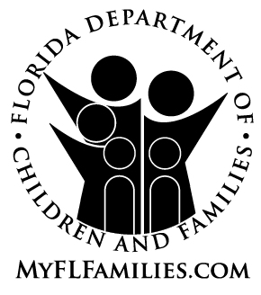

RELEASE OF INFORMATION

I(we) hereby authorize the release of any information requested by the Department of Children and Families to be utilized in determining my(our) suitability to become

a licensed out-of-home caregiver, or an adoptive parent.

I(we) hereby grant permission to the Department of Children and Families to obtain information from local, state, or federal law enforcement agencies to help determine my(our) suitability to serve as a foster parent or as an adoptive parent. I(we) understand, however, that a history of arrest reported by any of these agencies will not necessarily prohibit my(our) participation in

the licensed out-of-home care program, or the adoption program.

Applicant |  | Date
Applicant |  | Date
Adult Household Member |  | Date
Adult Household Member |  | Date
NOTE: All adult members (age 18 and over) of the household will be responsible for granting consent to these record checks.

