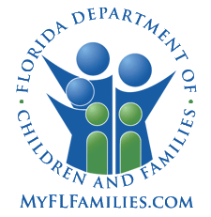 | State of Florida  Department of Children and Families  APPLICATION FOR LICENSE TO PROVIDE  OUT-OF-HOME CARE FOR DEPENDENT CHILDREN

Date: ____________________

I / We ____________________________________________________________________________________________
Applicant One: First Name Middle Name Last Name
also known as _____________________________________________________________________________________

____________________________________________________________________________________________
Applicant Two: First Name Middle Name Last Name
also known as _____________________________________________________________________________________

Residing at _______________________________________________________________________________________

County _____________________ Phone _________________ E-mail ______________________________________

Hereby apply for a license to provide Licensed Out-Of-Home Care for children in accordance with the provisions of Section 409.175, Florida Statutes, and agree to cooperate with the study of our home to determine if it
meets standards of the Department for licensed out-of-home care for dependent children.

_______________________________________________________________
Applicant One Signature Social Security Number¹

_______________________________________________________________
Applicant Two Signature Social Security Number¹

(All applicants living in the home must sign the application in his/her own handwriting.)

This application may be withdrawn at any time the applicant(s) desires.

IMPORTANT NOTE: Pursuant to the Multi-Ethnic Placement Act of 1994 and the Small Business Job Protection Act of 1996, Section 1808, Removal of Barriers to Interethnic Adoption, “race, culture or ethnicity may not be used as a basis for any denial of placement, nor may such factors be used as a reason to delay any foster or adoptive placement. Discrimination is not to be tolerated, whether it is directed toward adults who wish to serve as foster or adoptive parents, toward children who need safe and appropriate homes, or toward communities or populations which may have previously been under-utilized as a resource for placing children.”

