DBPR HR–7031i

INSTRUCTIONS FOR COMPLETING DBPR HR–7031
APPLICATION FOR MOBILE FOOD DISPENSING VEHICLE LICENSE WITH Plan Review

Application begins on page 7

Congratulations on your decision to consider a new business venture! As you explore this opportunity, the Department of Business and Professional Regulation’s (DBPR) Division of Hotels and Restaurants (H&R) is ready to assist you through the licensing and regulatory process.

Our responsibility is to work with the business community to achieve the highest levels of health and safety for all Floridians and tens of millions annual visitors. Toward that goal, we are a resource you can use to see that your new business operates within the requirements of the law.

Plan reviewers will assist you in meeting the design and fire safety requirements in the law, and inspectors will provide educational support on site to help you meet the minimum requirements for healthy and safe conditions and products.

This packet contains information regarding the legal requirements of operating your business. It is very important that you familiarize yourself with this information before you begin operating. If you have questions, or need any clarification, please contact the DBPR Customer Contact Center at 850.487.1395 Monday through Friday between 8AM and 6PM or go online to www.MyFloridaLicense.com/dpbr/hr. Because our knowledge and authority are in state government requirements, it is very important that you also contact local officials regarding any city and county requirements for a new business.

We wish you the best of luck and success in your venture.

GENERAL INSTRUCTIONS

A Mobile Food Dispensing Vehicle (MFDV) is a vehicle-mounted public food service establishment. Some MFDVs are self-propelled and built to travel on public streets. Other MFDVs are not self-propelled but can be moved from place to place. MFDVs may even be watercraft.

All MFDVs need a support site called a commissary. A commissary is a public food service establishment licensed by the division or a food establishment permitted by the Department of Agriculture and Consumer Services where the MFDV goes for services that are not done on the vehicle. A commissary may provide a potable water source or a wastewater disposal site. You may prepare, package or store food at this location or use a three-compartment sink on the premises to wash and sanitize equipment or utensils. Food containers or other supplies may be stored at the commissary. YOU MAY NOT CONDUCT FOOD SERVICE ACTIVITIES IN A PRIVATE RESIDENCE.

To begin Florida's food service licensing process, the law requires the division to review unit plans for sanitation and safety concerns. Plan review is required when the unit is:

- Newly built,
- Converted from another use,
- Remodeled or
- Re-opened after being closed at least 1 year.

Please use the checklist below to make sure you provide all necessary requirements for plan review.

APPLICATION
- Form DBPR HR-7031 Application for Mobile Food Dispensing Vehicle License with Plan Review. For other types of food service, including fixed establishments and caterers, please complete form DBPR HR-7030 Application for Public Food Service License with Plan Review (this may be found in a separate application packet). Please be sure to complete all items on the application, especially finishes for the floors, walls and ceiling.

FILING SEPARATE APPLICATIONS–This application packet includes everything necessary to apply for a mobile food service license and plan review at the same time. Usually, we recommend you apply for plan review prior to building or remodeling your establishment, and then apply for license at least 30 days before you begin operations. If you want to apply for your plan review and food service license separately, please complete form DBPR HR-7006, Mobile Food Dispensing Vehicle Plan Review Application, and form DBPR HR-7007, Application for Public Food Service License, instead of this form.
- Form DBPR HR-7022—Division of Hotels and Restaurants Commissary Notification for all commissaries to be used by this vehicle to store food, dump wastewater, etc. See page 11 for separate instructions on completing this form. We cannot approve the plans without the information on this form.

- Water and wastewater information and approval for the commissary where you will get potable water, dump wastewater or prepare food. You may submit a copy of your water and/or sewer bill as proof of approval. If your commissary is on a well or septic tank, use the Evaluation of Onsite Sewage (Septic) and Water Supply Capacity form. You may also use this form if you do not have a copy of the water or sewer bill. The local authority must sign this form. The local Department of Health and Department of Environmental Protection handle well and septic tank approvals.

- Equipment specifications, if the proposed equipment is not customary for food service operations.

FEES

Fees are listed in rule 61C-1.008, Florida Administrative Code. For your convenience, we provide an automated license fee calculator and fee tables on our website at www.MyFloridaLicense.com/dbpr/hr. If you are unsure of the fee, please contact the DBPR Customer Contact Center at 850.487.1395 for the correct license fee amount. In addition to the license fee, there is a one-time application processing fee of $50 and a plan review fee of $150. Please make your check or money order for your fees made payable to the Department of Business and Professional Regulation. The division does not accept cash payments.

PLANS
- At least two (2) scaled drawings. The division will keep one and return any additional sets to the applicant.
- Label all areas of the vehicle and equipment (e.g., stoves, refrigerators, steam tables, prep tables, barbeque grills, portable fire extinguishers, ventilation hoods, etc.).
- Label all plumbing fixtures. Plans must include a hand wash sink and a three-compartment sink for dishwashing (if applicable).
- Indicate size and location of the service opening(s) and how the opening(s) will be protected when not in use.
- Indicate size (in gallons) of the potable water and wastewater holding tanks. Wastewater holding tanks must be at least 15% larger than the potable water holding tank.
- Indicate the location of the gas supply and/or water heating device, if applicable.
- For hot dog carts, indicate the type of overhead protection provided (e.g., umbrella, etc.).
- Include a side view of the vehicle.

OPENING INSPECTION

Once we have received and processed all of the above requirements, we will contact you for an opening inspection.
- If you have 1) completed plan review, 2) submitted your application and fees, 3) you are ready to open your establishment, and 4) you have not heard from us about your inspection, please contact the DBPR Customer Contact Center at 850.487.1395 to request an inspection.
- Inspectors do not routinely conduct pre-opening or courtesy inspections. Do not call to schedule an opening inspection unless absolutely ready to open.
- If opening a newly built, converted or reopened vehicle, do not begin to serve food to the public until a satisfactory inspection and a receipt for license to operate have been obtained.
- Change of ownership applications do not require an inspection if the previous owner received a satisfactory inspection within 120 days before the application is processed. If there was no inspection within this time period, we will conduct the opening inspection after you legally become the new owner. See page 6, section 2 for the appropriate application type.
- Ensure that all required equipment is installed and functional prior to the inspector’s visit and all the necessary licensing information has been obtained, including owner’s name and social security number, Federal Employers Identification Number and/or sales tax number. Have proof of other approvals on site, such as building, electrical, fire, plumbing, etc.
- After achieving a satisfactory inspection, please allow 30 days to receive the license in the mail. You will receive a temporary license after your satisfactory inspection that will allow you to operate until the actual license arrives.

HOW TO DRAW A FLOOR PLAN

The completed drawing should be a good representation of exactly how your vehicle looks in real life or how you intend it to look when completed. By following these simple instructions, you will be able to draw an accurate, scaled floor plan yourself.

A floor plan is a measured drawing that is an exact miniature representation of your unit as seen from an overhead view and/or side view. The plan must be drawn “to scale”, which means that everything must be in the correct proportions. For example, if the unit is 20 feet long and 10 feet wide, then the length would be drawn twice as long as the width on your paper. The same is true for all of the equipment and sinks.

Begin by measuring the length and width of your unit with a tape measure as well as the lengths and widths of all equipment, etc. Note: Write down all the measurements taken on a piece of paper for future reference. If your unit does not yet exist, or you have not yet decided upon the exact equipment, your measurements will be estimates.

You may use any size graph paper, but the most common (and simple) graph paper is labeled as ¼ inch grid. Each small square is ¼ inch long. You can find this type of graph paper in office supply stores. To draw your plan “to scale”, make each ¼ inch square equal to a real life distance. For example, if you decide that 1 foot is equal to a ¼ inch square, then a grill 2-feet long and 1-foot wide is drawn to cover 2 squares across and 1 square deep. Remember to show all doors and windows.

Identify all pieces of equipment with a number and create a list identifying to what each number refers. As an alternative, you may label each item like in the sample to the right. Provide two (2) copies of the floor plans to include the location of all sinks, potable and wastewater tanks, food storage areas, refrigerators, cooking equipment, work surfaces, propane tanks (if applicable), doors, windows and any other equipment present. Wastewater holding tanks must be 15% larger than the potable water holding tank (indicate size in gallons).
30’
- Potable water tank – 20 gallons
- Water heater
- Three-compartment sink
w/drainboards
- Wastewater tank – 25 gallons
- Handwash sink
- Waste receptacle
- Flat top griddle
- Stove
- Propane tank
- Generator
- Work table
- Refrigerator
- Service counter
- Service window
- Fire extinguisher
Hot and cold water, hand wash sink
SIDE VIEW
MOBILE FOOD DISPENSING VEHICLE
HOT DOG CART
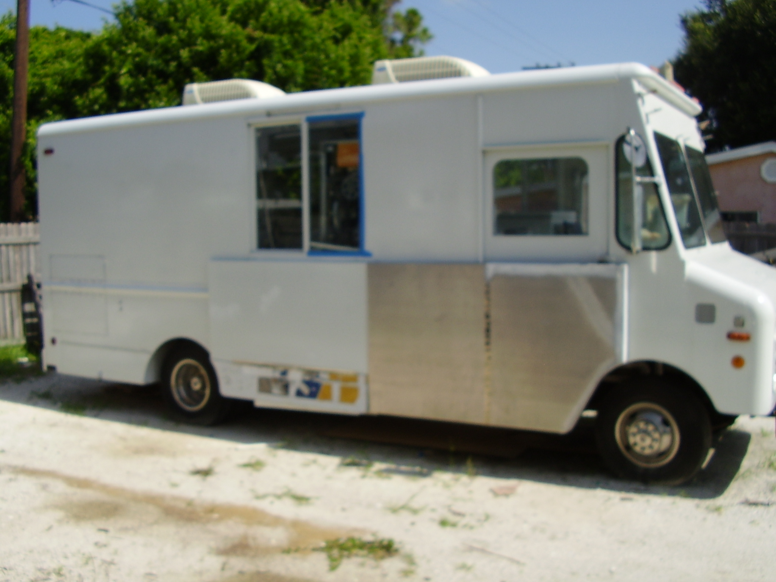
INSTRUCTIONS FOR COMPLETING THE MFDV PLAN REVIEW APPLICATION

SECTION 1 – OFFICE USE ONLY
This is for division office use only. Please do not complete this section.

SECTION 2 – FOOD SERVICE LICENSE TYPE
Indicate the type of license that best describes your vehicle. A mobile food dispensing vehicle is an enclosed trailer or vehicle mounted unit that contains equipment and is closed up when not in operation. A hot dog cart is an open-air vehicle that prepares frankfurters only. A theme park food cart must be located in a theme park or entertainment complex. (Required)

SECTION 3 – APPLICATION INFORMATION
- Application Type – indicate the type of application to be processed. For newly constructed establishments,or facilities converted from another previous usage, choose “New Vehicle(s).” For all establishments previously licensed within the last year, choose “Change of Ownership.”

- License Number and Previous Business Name – for applications for change of ownership, please indicate the previous license number and previous business name if known. This information will facilitate the processing of the application.

- Federal Employers Identification Number (FEIN) – required for business/corporate applicants.

- Social Security Number – at least one social security number is required. Under the Federal Privacy Act, disclosure of social security numbers is voluntary unless specifically required by federal statute. In this instance, disclosure of social security numbers is mandatory pursuant to Title 42 United States Code, sections 653 and 654; and sections 409.2577, 409.2598, and 559.79, Florida Statutes. Social security numbers are used to allow efficient screening of applicants and licensees by a Title IV-D child support agency to assure compliance with child support obligations. Social security numbers must also be recorded on all occupational license applications and are used for licensee identification purposes pursuant to the Personal Responsibility and Work Opportunity Reconciliation Act of 1996 (Welfare Reform Act), 104 Pub.L.193, Sec. 317.

- Sales Tax Number – required by the Florida Department of Revenue to do business. If exempt, please mark the checkbox accordingly.

- Opening Date – please indicate the date the establishment will be opened for business.

SECTION 4 – OWNER AND MAIN ADDRESS
Complete this information for the establishment owner as completely as possible. Incomplete information will result in the application being delayed or denied.

- Owner Name – individual person or organization that currently owns the establishment. Also, check the appropriate box indicating whether the owner is legally a corporation, partnership or individual person. For establishments owned or operated by partnerships, corporations or cooperatives, please attach a separate sheet or sheets listing the name, address, and social security number of each person who owns 10% or more of the outstanding stocks or equity interest in the licensed activity. (Required)
- Routing Name – if contact name is different than the owner, please indicate in the space provided. (Optional)
- Street Address or Post Office Box, City, State, Zip Code, Florida County (if applicable), Country – address of record for purpose of official communications from the department. (Required)
- Phone Number – primary contact number for questions or concerns about the application. (Required)
- E-Mail Address – additional means of contacting applicant. (Optional)

SECTION 5 – ESTABLISHMENT LOCATION INFORMATION
Complete the establishment information as completely as possible. Incomplete information will result in the application being delayed or denied.

- Establishment Name (Doing Business As [DBA]) – the name of establishment. If the establishment is part of a chain, please indicate a unique identifier (for example, Burger King #103). (Required)
- Street Address, City, Zip Code, Florida County – address of the establishment. For mobile food dispensing vehicles, this should be the commissary address in Florida. (Required)
- Phone Number and E-Mail Address – alternate contact information if available. (Optional)

SECTION 6 – MAILING INFORMATION
This is an optional additional address for mailing if applicable. If this information is the same as Section 3 or Section 4, please indicate.

- Routing Name – if correspondence should be mailed to a different name than the owner, please indicate in the space provided. (Optional)
- Street Address or Post Office Box, City, State, Zip Code, Florida County (if applicable), Country – address of record for purpose of official communications from the department. (Required)
- Phone Number and E-Mail Address – alternate contact information if available. (Optional)

SECTION 7 – LICENSE MODIFIERS
Please answer these questions. If the facility is intended to operate for a limited amount of time each year (i.e., seasonal), indicate approximate start and end dates for operation. (Required)

SECTION 8 – SUPPORTING DOCUMENTS

This section is a checklist of the additional documents that you must provide with the plan review application. (Required)

SECTION 9 – PLAN REVIEW TYPE
Indicate the type of plan review requested that best describes your unit. When reopening or remodeling an existing vehicle, please provide the name of the previous owner and their license number (if known). This information will help us process your plan review faster.

SECTION 10 – GENERAL INFORMATION
Complete all information as indicated. Approved plans are valid for one (1) year. The division may grant a one-time extension up to an additional six months if requested in writing before expiration of the initial one-year approval. (Required)

SECTION 11 – SIGNATURE
Please print your name, and then sign and date the application before submitting. (Required)

When complete, please submit your application, plans, supporting documents and applicable fees to:

Department Of Business and Professional Regulation
Division of Hotels and Restaurants
1940 North Monroe Street
Tallahassee, Florida 32399-1011

Reminder: Please use the entire 9-digit zip code in the address above to ensure proper handling. An incomplete application will result in the application being delayed or denied. Please allow up to 30 days for processing after mailing.

Approval of your plans means that your plans appear to meet the minimum requirements of the Division of Hotels and Restaurants. You must make sure that you meet all other requirements that apply. Plan approval does not guarantee that the division will approve the completed vehicle’s structure or equipment. See rules 61C-1.002, FAC, and 61C-1.008, FAC, for more licensing information.

Be sure to send the completed plan review application, supporting documents and required fees (license fee + $50 application fee + $150 plan review fee). Providing complete information will help us process your plan review faster.

NOTE: All units are required to meet the sanitation and safety standards provided by law.
- All refrigeration must maintain potentially hazardous foods at 41°F or colder. You must install thermometers in the warmest part of all refrigeration/freezer units. A probe-type thermometer that is scaled for its intended use is required for employees to check food temperatures. Be sure all thermometers are calibrated and present at the time of the opening inspection.
- If you intend to have bare hand contact with ready-to-eat food, you must first have an approved Alternative Operating Procedure (AOP). DBPR Form HR 5022-049, AOP Application, found on the division’s website, and rule 61C-1.004(1), FAC, explains the requirements. If you do not have an approved AOP, food employees may not touch ready-to-eat foods with their bare hands. Employees in units without an AOP must use utensils such as deli tissue, spatulas, tongs, single-use gloves or other dispensing equipment.
- A self sufficient Mobile Food Dispensing Vehicle includes:
  - A three compartment sink for dishwashing;
  - A separate handwashing sink;
  - Adequate refrigeration and storage;
  - Full utilities including electrical, LP gas or a portable power generation unit;
  - Potable water holding tank; and
  - A wastewater tank in accordance with subparts 5-3 and 5-4 of the FDA Food Code.

