SOUTHWEST FLORIDA WATER MANAGEMENT DISTRICT

2379 BROAD STREET
BROOKSVILLE, FLORIDA 34604-6899
(352) 796-7211 or 1 –800-423-1476 (FL only)
TDD only: 1-800-231-6103 (FL only)

APPLICATION TO RENEW A
SMALL GENERAL WATER USE PERMIT
FOR AGRICULTURAL USE WITH NO CHANGES
THIS FORM CAN BE COMPLETED BY ALL APPLICANTS TO RENEW EXISTING SMALL GENERAL WATER USE PERMITS FOR AGRICULTURAL USE WHEN THERE ARE NO CHANGES TO THE EXISTING WUP, PROVIDED THE EXISTING WUP MEETS THE FOLLOWING CRITERIA:
- Annual Average Demand (total gallons in one year divided by 365 days), whether that demand is met solely with ground water, or it is met with a combination of ground water, surface water, and alternative water supply (e.g., reclaimed water, stormwater) meets the following criteria:
- The total ground water demand is less than 100,000 gallons per day (gpd),
- The total drought annual average demand is less than 100,000 gpd in the Southern Water Use Caution Area, or
- The primary withdrawal is from a surface water source and the annual average demand is less than 50,000 gpd.
    - The Maximum Daily Demand (maximum gallons used in one 24-hour period) quantities are less than 3,000,000 gpd for crop protection or other use.
    - In the Dover/Plant City Water Use Caution Area, where there are no frost/freeze protection quantities, and the use does not typically require frost/freeze protection.
Note: Applicants may apply for a twenty (20) year permit term.
THE INFORMATION REQUESTED IN THIS APPLICATION IS REQUESTED PURSUANT TO CHAPTER 373, FLORIDA STATUTES (F.S.), AND RULES 40D-2.091, 40D-2.101 AND 40D-2.301, FLORIDA ADMINISTRATIVE CODE (F.A.C.).
I. GENERAL INFORMATION
Water Use Permit Number:: ______________________ Permit term requested: ________________________
The applicant must be listed as a landowner for the property covered by this application. If there are multiple landowners, all must be listed as applicants. Provide information regarding the applicant below, and provide the same information for all co-applicants on an attachment. The permit will be issued in the name(s) of all persons or entities listed on the deed for the property. If the applicant wants to include the name of their lessee(s), they may be also be listed. All correspondence will be addressed to the Applicant listed here with copies to all co-applicants and contacts or consultants. This application must be signed by all applicants.
1. APPLICANT
NAME TELEPHONE ( )
ADDRESS COUNTY
CITY, STATE, ZIP
Check here if additional applicants are to be listed on the permit and attach this information for them.
2. CONTACT OR CONSULTANT
NAME COMPANY
ADDRESS TELEPHONE ( )
CITY, STATE, ZIP
II. PROPERTY CONTROL
1. The property to be included in this permit is:
Owned by the applicant(s)
Applicant has other legal control (an application made on a leased property by a lessee must be a joint application in the name of the lessee and the property owner(s) or be only in the name of the property owner(s).
2. Provide documentation of ownership or legal control over the property (control that is other than direct ownership) Attached
3. Leased property: If a lessee of the applicant/owner's property is to continue to be a co-applicant, provide a copy of either (check type of document that is attached):
Copy of lease Letter signed by the property owner describing the lease arrangement and duration.
NOTE: Permits will not be issued for a duration longer than the lease when a lessee is listed as a co-applicant, unless the lease is renewable. If renewable, the applicants may be required to provide a copy of the renewed lease at the appropriate time. All property owner(s) and the lessee must sign this application.

4. Number of acres: Owned: __________; Leased:* _____________ Serviced:** _____________.

* Leased land applies to land leased by the applicant/owner on which there is to be water used by the permittee.
** Serviced land is land owned by another party, not leased by this applicant, and not included in any WUP for which this applicant proposes to provide water for the other party's use. Provide a copy of the service agreement:
- Attached. N/A
III. WATER USE

1. Agriculture - (Note: Fill out a separate table for each crop type grown and for each growing season)
Crop 1 Crop 2 Crop 3 Crop 4
Crop Type (e.g. tomatoes): 1. ____________ 2. ____________ 3. ____________ 4. ____________
Acres Irrigated per Crop: 1. ____________ 2. ____________ 3. ____________ 4. ____________
Planting Date (Day/Month): 1. ____________ 2. ____________ 3. ____________ 4. ____________
Days Grown: 1. ____________ 2. ____________ 3. ____________ 4. ____________
Irrigation Method: 1. ____________ 2. ____________ 3. ____________ 4. ____________
(overhead sprinkler, under-tree sprinkler, under-tree spray-jet, traveling gun, ditch, drip)
Animal watering: list types of animals watered and the number of head of each type:
__________________ __________________ ___________________ _________________
__________________ __________________ ___________________ _________________
__________________ __________________ ___________________ _________________
__________________ __________________ ___________________ _________________

Other uses (e.g. maintenance, washing, spray mixing, cooling, etc.): _______________________________________
______________________________________________________________________________________________
Frost-freeze protection - Crop:________ _____acres; Crop: ________ _____acres.
2. Aquaculture: complete the Aquaculture Section Agricultural Attachment, Form No. LEG-R.037.01(12/10)
3. Indicate the requested Annual Average Quantity in gallons per day (gpd). This is the quantity of water you will use in an entire year, divided by 365. This quantity should reflect the amount needed ten years hence or for the peak demand years, or for the remainder of permit duration, if the application is for a modification:
10 years or peak year: ______________gpd; Modification: _______years ___________gpd.
4. Indicate the requested Peak Month quantity. This is the largest quantity you will use in any month, divided by 30.
10 years or peak year: _____gpd; Modification: ______years _____gpd.

SECTION A - Location
1. If there are no changes to the property included on this application, continue. If there are any changes, the Application for a Small General for New, Modifications and Renewal with Modification must be used.
2. Describe the location of the property contained in the application by Section, Township and Range, down to the ¼ section:
Section __________________ Township __________________ Range__________________ 1/4 Section_________________
SECTION B – Withdrawal Points
3. Groundwater Wells. Include all wells on property greater than 2 inches in diameter, whether active or inactive, and whether existing or proposed, in the table below. Wells shall be constructed in a manner that does not interconnect aquifers at different water quality, and to produce water from the aquifer zone of the quality than can be used. If there are any changes to the ground water wells listed on this application, the Application for a Small General for New, Modifications and Renewal with Modification must be used.
IV. SITE/WITHDRAWAL INFORMATION

TABLE LEGEND

SWFWMD I.D. No. - the withdrawal number assigned by the District, if existing.
Owner I.D. No. - the owner's I.D. number.
Construction Date - the approximate date that the withdrawal point became operable.
Average Withdrawal Rate - the total quantity of water to be withdrawn in one year divided by 365, in gpd.
Peak Monthly Withdrawal Rate - the maximum quantity to be withdrawn in a single month, in gpd.
Standby - refers to status of wells that would not be used unless another well becomes inoperable.
Cap - the well is capped.
Meter - refers to whether a flow meter is installed: if several withdrawals are connected to the same meter. (ganged), indicate by placing a letter character (a, b, etc) instead of a check mark, linking those interconnected withdrawals by like characters. If an indirect flow measuring device (e.g. an elapsed time meter, etc) is used, place an I (indirect) in space provided.
Monitor - refers to water level or water quality monitors. Indicate the type of monitor by placing an L (level), Q (quality), or both in the space provided. The absence of checkmarks or letters indicates active status.
Proposed - check if the withdrawal point is proposed rather than existing.
Mainline Diameter - refers to the outside diameter of the main discharge pipe.

I.D. No. SWFWMD | I.D. No. Owner | Casing Diameter | Depth Cased | Total Depth | Constr. Date | Pump Capacity (gpm) | Withdrawal Rate |  | Status (check) |  |  |  |  | Proposed | Mainline Diameter
 |  |  |  |  |  |  | Average Annual | Peak Month | Mon. | Stdby | Cap. |  | Meter | Proposed | Mainline Diameter
4. Indicate the future use of any capped source: _____________________________________________________________________
5. Surface Water Withdrawal Points – See the Ground water well section above for explanation of most terms. Source name is the name of a lake, stream or other water body.
I.D. No.  SWFWMD | I.D. No.  Owner | Source Name | Intake Diameter | Lake Acreage | Pump Capacity (gpm) | Withdrawal Rate |  | Proposed | Mainline Diameter
 |  |  |  |  |  | Average Annual | Peak Month | Proposed | Mainline Diameter
6. If you have any historical information about the quantity pumped from your withdrawal facilities, individually or for the entire system, please provide this information, unless you have already been sending it to the District as a requirement of your permit.
Attached None Available
7. Other Sources. Describe any other sources of water, such as purchases from utilities, treated waste water effluent, etc. List annual average and peak month quantities for each additional source: ______________________________________________________
_________________________________________________________________________________________________________
_________________________________________________________________________________________________________

V. IMPACTS

1. Are you aware of any adverse impacts that your withdrawals have or may have on other water users, offsite land uses, the water resources, or environmental features? If so, provide a detailed explanation of the impact and your plans to deal with it.
None Anticipated Explanation Attached
VI. CONSERVATION

By submitting this application, the applicant agrees to implement all water conservation measures that are economically, technically, and environmentally feasible, including:
1. Conversion to low volume irrigation methods where appropriate;
2. Increased system management, including the use of devices such as tensiometers to determine application frequency and duration;
3. Increased evening hour irrigation;
4. Utilization of reclaimed water or stormwater to provide all or part of the irrigation requirements;
5. Limiting frequent irrigation to water-critical areas, and limiting irrigation of other areas;
6. An ongoing water audit program to find/fix system leaks
7. Utilization of lowest quality water for the intended use
8. Water use efficiency assessment

VII. APPLICANT CERTIFICATION

All owners of the property described in this application are included as co-applicants of this permit. I hereby certify that the information contained herein is true and accurate and that all persons who own or legally control the property described in this application are included as applicants

____________________________________________________________________ ___________________
(Applicant* / Authorized Agent ** Signature) (Date)
____________________________________________________________________
(Print Name)
* If there are multiple landowners, either submit their signatures on a document that attests to their agreement to this application or provide documentation that gives the applicant affixing their signature above authority to act on this application on their behalf.
** An Authorized Agent must include signed documentation of authority to sign and submit this application.

BUSINESS ENTITY AS APPLICANTS – If the permit applicant is a business entity, indicate the type of business entity below and provide the name and title of the person signing on behalf of the business entity. Attach documentation of the status of the business entity to legally operate in the State of Florida, such as a copy of the last corporate annual report submitted to the Florida Department of State or a Certificate of Status issued by Florida Department of State.
BUSINESS ENTITY:
Florida Corporation Florida General Partnership Florida Limited Liability Company
Florida Limited Partnership Foreign Corporation/Partnership Trust
Other:_____________________________________________________________________________________

I hereby certify that the information contained herein is true and accurate and that I have legal authority to undertake the activities described herein and execute this application.

___________________________________ _________________________________
Applicant Signature Date

________________________________________________________________________________________________
Name and title if signing as business entity applicant

VII. APPLICANT CERTIFICATION
APPLICANT CHECK LIST:

Attachments requested in support of this application:

Attached N/A
1. Copy of Legal Description
2. Other Legal Property Control Description
Applicants for water use and environmental resource permits may submit their applications to any District Permitting Office; however, it is recommended to submit them to the Permitting Office within the Service Region where their property is located. All activities concerning these permits will be conducted at these Permitting Offices. Applications for well construction permits may also be submitted to any Permitting Office; however, applications for well construction permits in Marion, Sarasota and Manatee Counties are evaluated and issued locally by county agencies.
Resource Regulation Service Regions  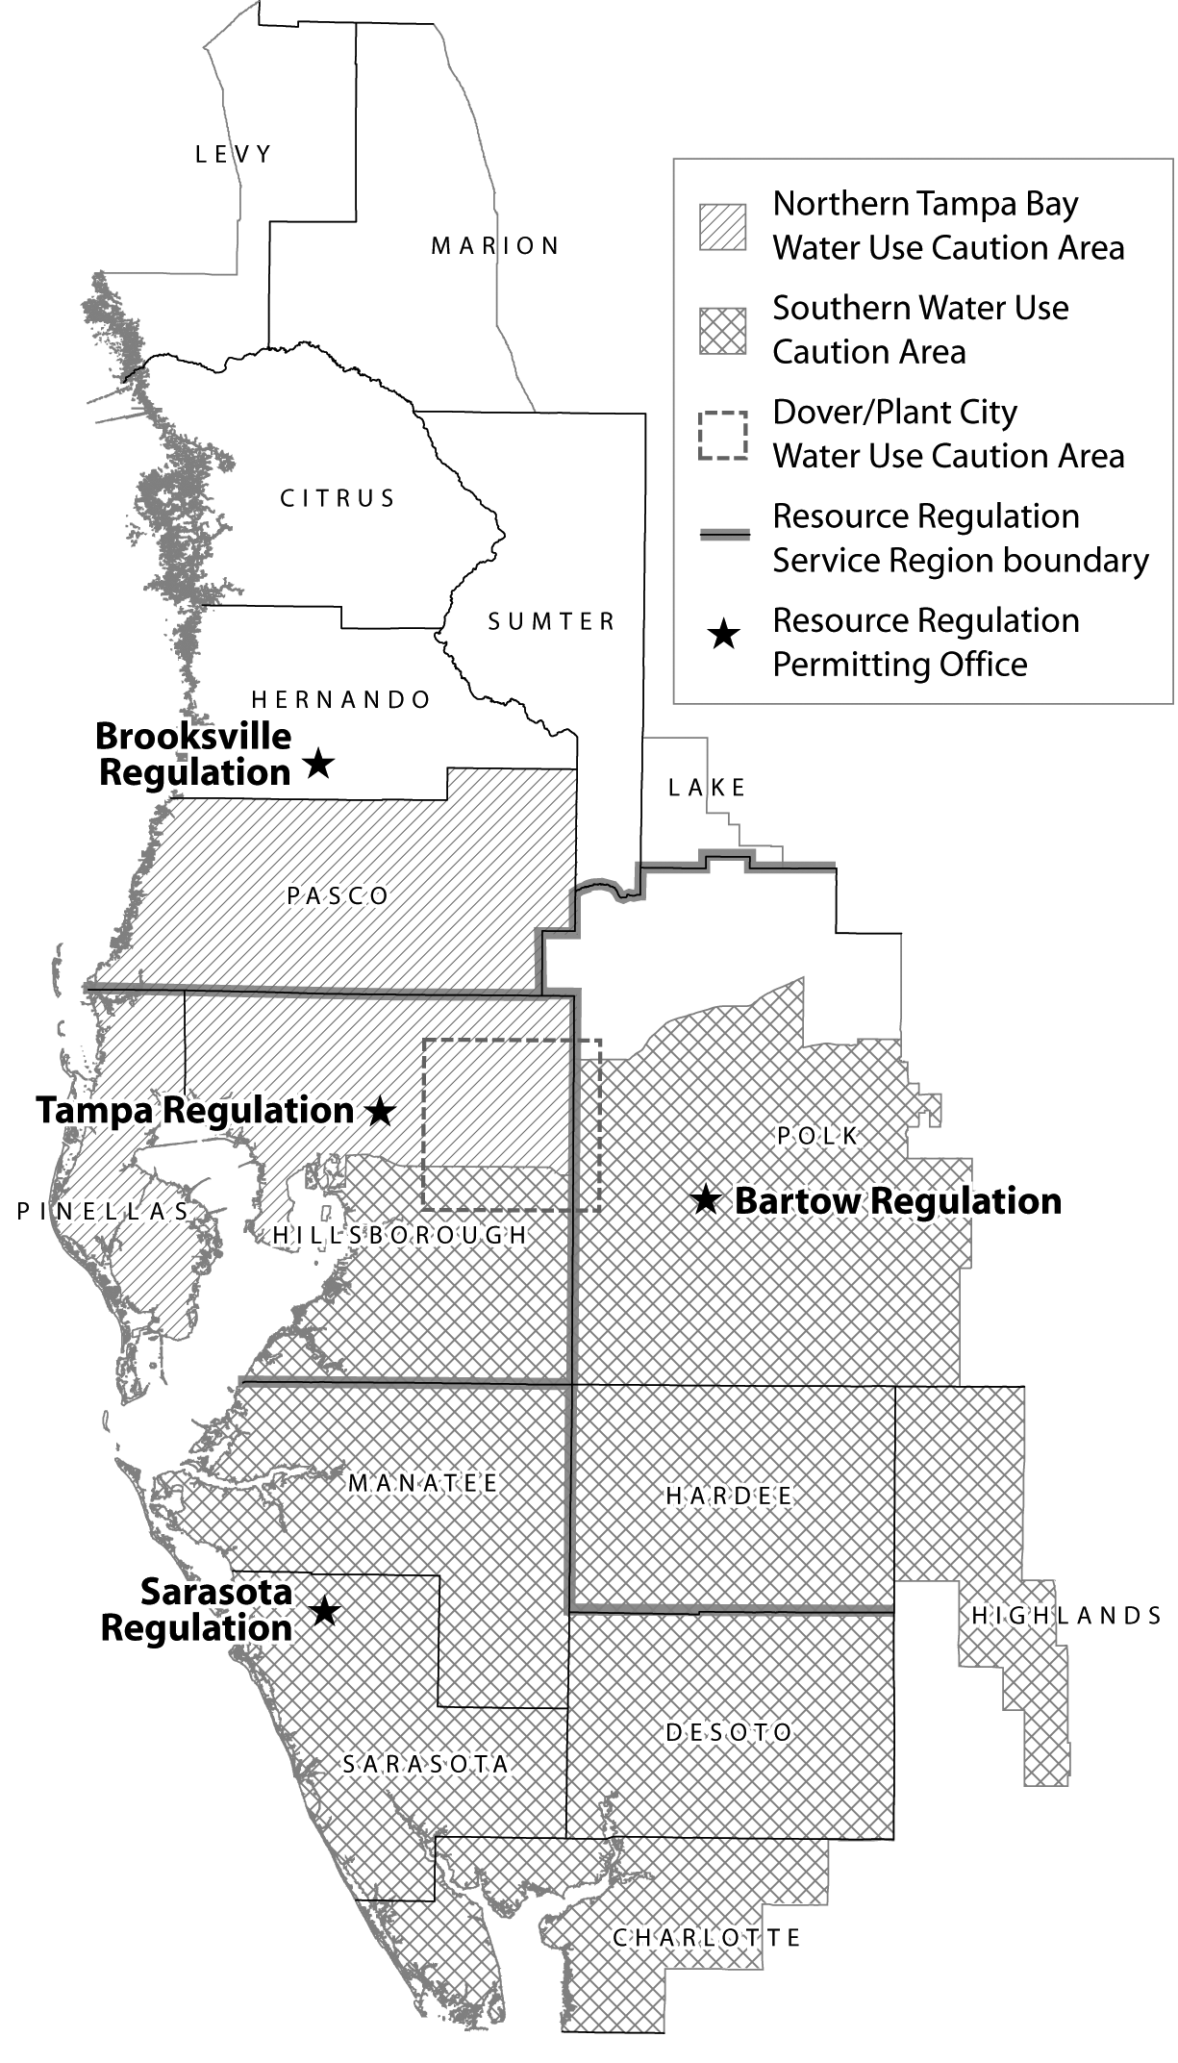 | Resource Regulation Permitting Offices  Brooksville Regulation Department  Citrus, Hernando, Lake, Levy, Marion, Pasco, Sumter counties.  2379 Broad Street  Brooksville, FL 34604-6899  (352) 796-7211 or 1-800-423-1476 (FL only)  Fax: (352) 540-6027; Suncom: 628-4150  Tampa Regulation Department  Hillsborough, Pinellas counties.  7601 U.S. Hwy. 301  Tampa, FL 33637-6759  (813) 985-7481 or 1-800-836-0797 (FL only)  Fax: (813) 987-6747; Suncom: 587-2070  Bartow Regulation Department  Hardee, Highland, Polk counties.  170 Century Boulevard  Bartow, FL 33830-7700  (863) 534-1448 or 1-800-492-7862 (FL only)  Fax: (863) 534-7058; Suncom: 572-6200  Sarasota Regulation Department  Charlotte, DeSoto, Manatee, Sarasota counties.  6750 Fruitville Road  Sarasota, FL 34240-9711  (941) 377-3722 or 1-800-320-3503 (FL only)  Fax: (941) 373-7660; Suncom: 531-6900  TDD: 1-800-231-6103 (FL only) for hearing assistance for all locations.
The Southwest Florida Water Management District (District) does not discriminate on the basis of disability. This nondiscrimination policy involves every aspect of the District's functions, including access to and participation in the District's programs and activities. Anyone requiring reasonable accommodation as provided for in the Americans with Disabilities Act should contact the District's Human Resources Director, 2379 Broad Street, Brooksville, Florida 34604-6899; telephone (352) 796-7211, ext. 4702 or 1-800-423-1476 (FL only), ext. 4702; TDD (FL only) 1-800-231-6103; or email to ADACoordinator@swfwmd.state.fl.us

